**Enhancing Equity and Impact in AI-Supported Language Education: A Study on Accessibility, Satisfaction, and Perceived Impact of TARI AI Tools**

**Abstract**

As Artificial Intelligence (AI) continues to reshape higher education, understanding its impact on learners' experiences becomes essential—particularly in terms of accessibility, satisfaction, and perceived educational benefits. This study investigates student perceptions of the TARI AI tools developed at HUFLIT University, with a focus on three constructs: Accessibility, Satisfaction, and Perceived Impact. Using a quantitative survey design complemented by open-ended responses, data were collected from 337 students engaged in language education. Exploratory and confirmatory factor analyses validated the three-factor structure, and reliability and convergent validity were established for all constructs. The findings indicate that while the tools are generally accessible and foster high levels of user satisfaction, challenges remain related to offline access and inclusivity for students with disabilities. Users reported increased academic confidence, improved critical thinking, and stronger research capabilities, highlighting the tools’ transformative potential. The study concludes by emphasizing the importance of user-centered design, iterative feedback integration, and inclusive innovation in future AI tool development for education.

**Keywords:** Artificial Intelligence, Accessibility, User Satisfaction, Perceived Impact, TARI AI, Educational Technology

1. **Introduction**

As Artificial Intelligence (AI) fundamentally transforms educational paradigms, it is imperative to investigate its multifaceted influence on learning experiences. In language education, AI is particularly prominent, enabling personalized learning pathways, providing immediate feedback, and fostering multimodal interactions. Although numerous studies have examined the usability and effectiveness of AI tools in language learning contexts, there remains a critical gap regarding accessibility for diverse learner populations, overall satisfaction with these tools, and their perceived impacts on educational success and individual learner development.

Accessibility in educational technology transcends mere technical aspects; it includes the extent to which learners with varying backgrounds, abilities, and technological skills can effectively engage with digital tools. Prior research underscores the importance of trust and user experience in AI interactions, highlighting that user satisfaction often emerges as a function of perceived utility and satisfaction with the learning tools (Almufarreh, 2024). Additionally, satisfaction denotes the emotional and cognitive responses of learners using AI-driven educational technologies, including aspects such as motivation and confidence (Alsanousi et al., 2023). Moreover, the perceived impact interrogates whether students believe that these AI tools significantly enhance their academic performance, research skill sets, and long-term educational aspirations.

At HUFLIT University in Vietnam, the Training and Applied Research Institute (TARI) has developed a comprehensive suite of AI tools aimed at enhancing language education. These innovations incorporate intelligent tutoring systems, automated feedback mechanisms, and advanced speech technologies, finding application across various language programs at the university. In extending the previous research focused on user perceptions of usability and engagement, this study will comprehensively examine three pivotal dimensions: Accessibility, Satisfaction, and Perceived Impact. By addressing these dimensions, this research aims to bridge crucial gaps in the existing literature by evaluating users’ perceptions concerning the inclusivity, emotional engagement, and educational ramifications of TARI's AI tools. The study is guided by specific research questions:

- How do users perceive the accessibility of the TARI AI tools in language education?

- To what extent are users satisfied with their experiences using these tools?

- What is the perceived impact of TARI AI tools on learners’ academic development and learning outcomes?

Through the exploration of these areas, this study aspires to contribute to a comprehensive understanding of AI-supported educational environments and provide actionable insights for enhancing equity, boosting learner satisfaction, and maximizing pedagogical effectiveness in future AI tool developments.

**2. Literature review**

**2.1 Accessibility and Universal Design for Learning (UDL)**

The discussion on accessibility in education is profoundly intertwined with Universal Design for Learning (UDL), which advocates for instructional practices that cater to diverse learner needs, ensuring that all students can equally engage in the learning process. In the contemporary educational landscape, particularly with the integration of Artificial Intelligence (AI), the principles of UDL are paramount in addressing accessibility challenges faced by learners from varied backgrounds and abilities.

Firstly, UDL emphasizes the importance of providing multiple means of engagement, representation, and action and expression in educational contexts. This multidimensional approach aligns well with the capabilities of AI technologies, particularly in enhancing personalized learning experiences. For instance, Mohammadi et al. discuss the adoption of generative AI to create accessible instructional resources, such as video content and guides, aimed at bolstering student engagement and skills in leveraging AI tools effectively Mohammadi et al. (2024). This development illustrates UDL's core tenets by ensuring diverse resources are available to accommodate varied learning preferences and abilities, thus enhancing accessibility.

Moreover, the role of AI in fostering accessibility is underscored by its potential to analyze vast data arrays to tailor educational experiences suited to individual learner profiles. The integration of AI not only personalizes learning but also improves learning efficacy for all students, including those with disabilities or learning challenges. For example, Zahara et al. highlight that AI, specifically through tools like ChatGPT, can provide personalized, immediate feedback to students, fostering inclusivity and improving engagement, as these technologies adapt to the unique needs of each learner (Zahara et al., 2024). Such advancements are critical in implementing UDL principles, creating learning environments that recognize and accommodate individual learner differences.

Furthermore, the connection between accessibility in educational tools and student satisfaction can be elucidated through Expectancy-Disconfirmation Theory (EDT), which posits that satisfaction arises from the comparison of expected performance versus perceived effectiveness. Studies have shown that when educational tools meet or exceed learners' expectations, as conferred by UDL principles, satisfaction levels rise significantly (Kesharwani et al., 2021; Hasan et al., 2024; Pan & Ha, 2022). This connection is vital for ensuring that technology integration in educational settings is perceived positively by all learners, thus fostering motivation and continued engagement.

The necessity of feedback loops in educational systems, as highlighted by Nooij et al., emphasizes the need for continuous evaluation of educational tools against UDL benchmarks. By doing so, educators and institutions can more effectively adapt their approaches to suit the dynamic needs of their diverse student populations (Nooij et al., 2022). An iterative feedback mechanism promotes a culture of constant improvement, aligning with UDL's foundational goal of creating adaptive and inclusive learning environments.

Incorporating UDL in the design of AI tools aligns with the broader goal of educational equity. By ensuring that technological innovation does not exclude learners with different needs or resources, AI developers and educators can foster a more inclusive and effective learning environment. Within the context of HUFLIT University’s TARI AI tools, evaluating accessibility through the lens of UDL provides valuable insights into how well the tools serve a diverse student population and where further improvements may be needed.

**2.2 Satisfaction and Expectancy-Disconfirmation Theory**

Satisfaction in educational contexts, particularly in relation to advanced technologies like Artificial Intelligence (AI), has become increasingly critical. One of the dominant theoretical frameworks for understanding satisfaction is Expectancy-Disconfirmation Theory (EDT), which posits that satisfaction results from comparing what individuals expect with what they experience. This theory applies across various domains, including public services, consumer behavior, and education. Several studies have illustrated how the gap between expectation and perception—positive or negative—can significantly influence overall satisfaction levels (Duffett & Cromhout, 2022; Chen et al., 2022; Pan & Ha, 2022).

In the educational field, the application of Expectancy-Disconfirmation Theory reveals that learners form expectations about the performance of AI tools based on prior experiences or information, which informs their satisfaction. For instance, positive disconfirmation occurs when the actual performance of these AI-driven educational tools exceeds learners' expectations, leading to increased satisfaction. Conversely, negative disconfirmation triggers dissatisfaction when the experience fails to meet anticipated outcomes, which can result in potential disengagement from the learning process (Favero & Kim, 2020; Jia-sheng et al., 2021; Hien et al., 2024). The research underscores that the nature of disconfirmation—whether positive or negative—can significantly affect students’ emotional responses and subsequent attitudes toward educational technologies (Alsanousi et al., 2023; Daradkeh, 2023).

Recent studies also highlight that elements of service quality and individual expectations are pivotal in shaping satisfaction levels in educational settings. For example, Nooij et al. emphasized the influence of educators' expectations on their experiences within activity-based learning environments, reinforcing that higher-order expectations significantly dictate satisfaction outcomes (Nooij et al., 2022). These findings align with previous research conducted by Chen et al., which demonstrated that high expectations can lead to notable declines in satisfaction when unmet (Chen et al., 2022).

Moreover, transitioning to a digital learning landscape intensifies the relevance of such theories, as students interact with numerous digital tools that promise personalized and efficient learning experiences. Insights from Expectancy-Disconfirmation Theory can provide valuable guidance for stakeholders in education to refine their AI tools, ensuring they meet and exceed learner expectations, thereby fostering a more engaging and effective educational atmosphere (Hasan et al., 2024; Qin et al., 2021).

In evaluating the TARI AI tools developed at HUFLIT University, the Expectancy-Disconfirmation Theory provides a meaningful lens through which to examine learner satisfaction. By comparing users’ expectations with their reported experiences, the study can assess the degree to which the tools deliver on their promises and identify specific areas where user satisfaction can be further enhanced.

**2.3 Perceived Impact and Kirkpatrick’s Four Levels of Evaluation**

Perceived impact in educational contexts can be comprehensively understood through the lens of Kirkpatrick's Four Levels of Evaluation, a well-established framework that assesses the effectiveness of training and educational programs. This model evaluates effectiveness across four levels: reaction, learning, behavior, and results. Each level serves to illuminate how educational interventions translate into meaningful outcomes, thus providing a structured approach to assess perceived impact (Hanna & Semple, 2024) Lamont et al., 2023; Ghannam et al., 2020; Almeneessier et al., 2021).

At the first level, "Reaction," participants' immediate responses to the educational experience are measured. This feedback captured from learners can provide insights into their satisfaction and perceived value of the training or educational intervention. Studies such as those by Ghannam et al. indicate that understanding initial reactions is crucial, as it sets the foundation for more profound learning outcomes (Ghannam et al., 2020). Positive reactions often correlate with increased motivation and engagement, which are essential for deeper learning.

The second level, "Learning," assesses the extent to which participants acquire relevant knowledge and skills following the intervention. Hanna and Semple’s evaluation highlights the importance of perceived knowledge growth and self-efficacy in determining educational efficacy. This suggests that when learners feel they have gained substantial knowledge, their likelihood of applying that knowledge in practice increases (Hanna & Semple, 2024). Thus, the perceived learning outcomes can significantly influence the broader assessment of educational impact.

Moving to the third level, "Behavior," the model examines whether the knowledge or skills learned have translated into real-world applications. As noted by Lamont et al., many educational initiatives often focus predominantly on the initial levels of reaction and learning, neglecting the subsequent behaviors changed due to the training (Lamont et al., 2023). A more robust analysis that includes the assessment of behavioral changes is crucial for comprehending the lasting implications of educational programs.

Finally, the fourth level, "Results," evaluates the ultimate impact of educational interventions on organizational or societal outcomes. Kreuze et al. illustrate this by noting the potential positive effects on community mental health when school personnel are adequately trained in suicide prevention, indicating that the right educational interventions can lead to significant improvements at this level (Kreuze et al., 2024). This level is often the most challenging to measure, yet it provides the most substantial evidence for the effectiveness of educational programs.

Notably, while Kirkpatrick's model provides a comprehensive framework for evaluating educational impact, some criticisms exist regarding its simplicity in capturing the multifaceted nature of learning experiences. Blum et al. argue that the model might overlook contextual factors that influence learning outcomes (Blum et al., 2020). However, its structured approach remains invaluable for systematically assessing various dimensions of educational effectiveness across a multitude of settings (Asghar et al., 2022; Zhao et al., 2023; Golfiroozi et al., 2023).

By grounding the analysis in Kirkpatrick’s model, this study not only assesses the tools’ effectiveness in knowledge acquisition but also captures their influence on learners’ habits, behaviors, and academic confidence, offering practical insights into the sustained impact of AI integration in higher education.

**2.4 TARI AI tools**

As part of its strategic commitment to educational innovation and digital transformation, the Training and Applied Research Institute (TARI) at HUFLIT University has developed a robust suite of Artificial Intelligence (AI) tools tailored to support language education and linguistics research. These tools are designed with a focus on interactivity, intelligence, and user-centered learning, addressing the evolving demands of students and educators in the digital era. The full suite is publicly accessible via <https://tari.huflit.edu.vn>.

The TARI AI ecosystem includes a diverse range of tools for both general and specialized educational purposes. Foundational applications such as the TARI Chatbot provide conversational support for language practice and general inquiries, while multimodal tools like Text-to-Image, Text-to-Speech, and Speech-to-Text allow learners to interact with content through visual and auditory channels. These features enhance accessibility, promote comprehension, and support pronunciation development.

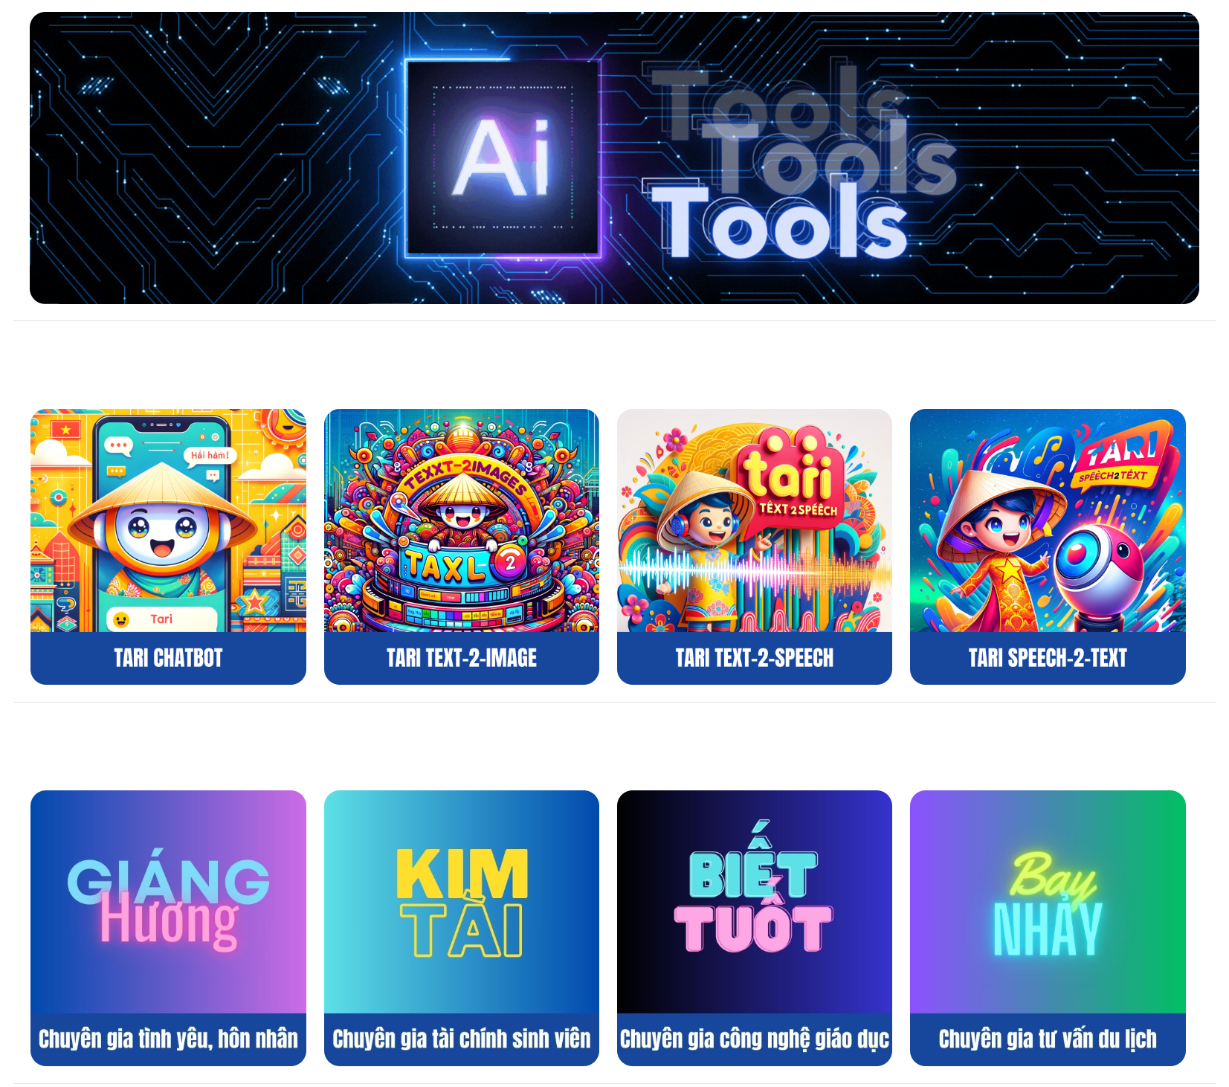

Figure 1: Screenshot of TARI AI Tools

In addition to these core tools, TARI has introduced a set of advanced educational assistants aimed at specific subfields within linguistics. These include TESOL TA, Computational Linguistics TA, Applied Linguistics Research TA, and Cognitive Linguistics TA—each designed to provide expert support in theoretical exploration, academic skill-building, and linguistic analysis.

Specialized modules grounded in Cognitive Linguistics allow learners to explore abstract conceptual systems such as Conceptual Metaphor, Conceptual Metonymy, Embodiment, Semantic Frames, and Construction Grammar. Likewise, tools based on Systemic Functional Linguistics (SFL) enable learners to investigate language in social contexts through modules like Mood Analysis, Modality Analysis, Grammatical Metaphor, Metafunctions Analysis, Transitivity Analysis, Cohesion Analysis, Genre Analysis, Register Analysis, and Appraisal Analysis.

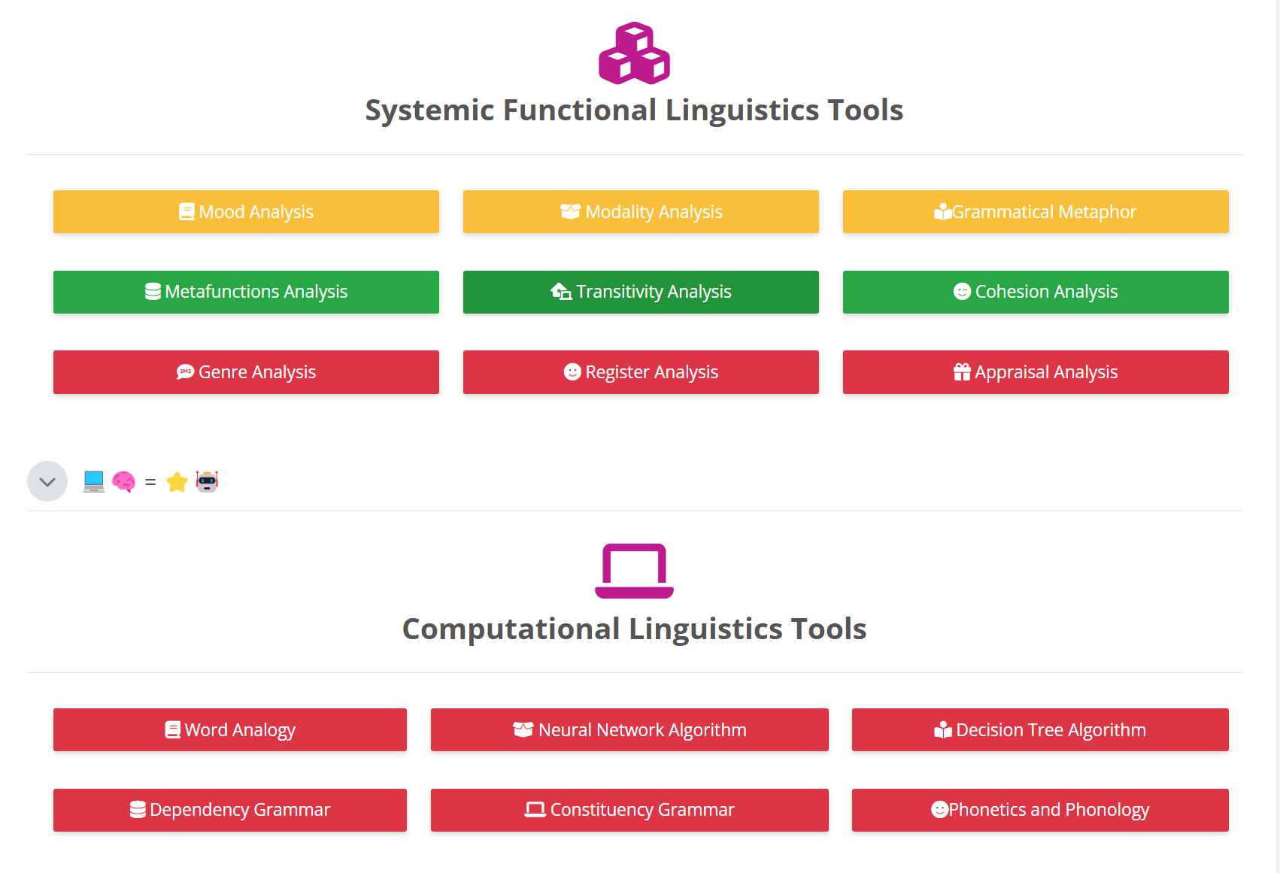

Figure 2: TARI AI tools for linguistics analysis

The ecosystem also features a suite of Computational Linguistics tools, including modules for Word Analogy, Neural Network Algorithms, Decision Tree Algorithms, Dependency Grammar, Constituency Grammar, and Phonetics and Phonology. These tools help bridge theoretical linguistics with computational modelling, offering students hands-on experience with AI-based parsing and analysis.

Beyond linguistics, TARI has expanded its offerings with pragmatic and pedagogical support tools, including a Pragmatic Analysis tool, ELLA – Lesson Plan Expert, and ORION – a science subject lesson planning assistant. Additionally, domain-specific advisory tools support areas such as career counselling, student finance, education technology, tourism consultancy, and healthcare advice, highlighting the platform’s interdisciplinary reach.

Collectively, these tools represent a pioneering model of localized AI integration in education, grounded in learner-centered pedagogy and digital competence development. By embedding these tools into its academic infrastructure, HUFLIT University demonstrates how AI can be meaningfully applied to enhance language education, support cognitive engagement, and promote inclusive learning experiences.

**3. Methodology**

This study adopted a quantitative survey design to examine user perceptions of TARI AI tools in linguistics education. A structured questionnaire comprising 36 Likert-scale items was distributed to 337 participants. The instrument was originally developed to explore six core constructs: Usability, Effectiveness, Engagement, Accessibility, Satisfaction, and Perceived Impact. While prior studies using this dataset have focused on the first three constructs, the current study specifically analyzes responses related to Accessibility, Satisfaction, and Perceived Impact.

To complement the quantitative data, the questionnaire also included several open-ended questions, allowing participants to elaborate on their experiences, challenges, and recommendations regarding the AI tools. These qualitative responses enriched the analysis by providing deeper insights into how users engage with and perceive the broader educational value of the tools.

**3.1 Data Cleaning**

The raw data were cleaned using Python. Numerical variables were checked for outliers using Mahalanobis distance, low standard deviation, and pattern-based inconsistencies (e.g., constant or sequential responses). Rows with only missing values were removed, and clean data were exported for analysis.

**3.2 Reliability**

Internal consistency was assessed using Cronbach’s Alpha. All three constructs demonstrated excellent reliability: Accessibility (α = 0.902), Satisfaction (α = 0.916), and Perceived Impact (α = 0.910), with an overall scale alpha of 0.951.

**3.3 Exploratory Factor Analysis (EFA)**

To examine construct validity, EFA was conducted in SPSS using Principal Component Analysis with Varimax rotation. The Kaiser-Meyer-Olkin (KMO) value was 0.934 and Bartlett’s Test of Sphericity was significant (χ² = 4983.4, p < .001), confirming sampling adequacy. EFA supported a three-factor structure aligned with the theoretical model, with items loading cleanly on their respective constructs.

**3.4 Confirmatory Factor Analysis (CFA)**

To validate the underlying measurement model for the constructs of Accessibility, Satisfaction, and Perceived Impact, Confirmatory Factor Analysis (CFA) was conducted using AMOS. The CFA aimed to assess the adequacy of the proposed three-factor model by examining model fit indices, factor loadings, and reliability measures. The initial model included three latent variables, each representing a construct measured by multiple observed items. Maximum likelihood estimation was used as the estimation method.

The CFA model demonstrated acceptable but improvable fit, as indicated by the following indices:

* Chi-square (CMIN) = 672.536, df = 132, p < .001
* CMIN/df (Relative Chi-square) = 5.095 (acceptable threshold < 5 for large samples)
* Root Mean Square Error of Approximation (RMSEA) = 0.110; 90% CI: [0.101, 0.118], PCLOSE = .000
* Comparative Fit Index (CFI) = 0.890
* Incremental Fit Index (IFI) = 0.891
* Tucker-Lewis Index (TLI) = 0.858
* Normed Fit Index (NFI) = 0.868
* Relative Fit Index (RFI) = 0.829
* Parsimony-Adjusted CFI (PCFI) = 0.687

Although the RMSEA value slightly exceeded the preferred cutoff of 0.08, the CFI and IFI values approached the recommended threshold of 0.90, indicating marginal model fit suitable for exploratory research. The Hoelter’s critical N values were 82 at the 0.05 level and 88 at the 0.01 level, suggesting the sample size (n = 337) was adequate to support the model structure. Given the exploratory nature of the research and the emerging focus on constructs not yet extensively validated in previous literature, the model provides a reasonable basis for further interpretation. Minor model adjustments and refinement may enhance fit in future research.

**3.5 Convergent Validity and Composite Reliability**

To evaluate the convergent validity of the measurement model, Average Variance Extracted (AVE) and Composite Reliability (CR) were calculated for each latent construct—Accessibility, Satisfaction, and Perceived Impact—based on the standardized factor loadings obtained from Confirmatory Factor Analysis (CFA).

Following the guidelines of Fornell and Larcker (1981), convergent validity is considered acceptable when:

* AVE ≥ 0.50, indicating that more than half of the variance in the indicators is captured by the latent construct.
* CR ≥ 0.70, indicating adequate internal consistency.

The results are presented in Table 1.

|  |  |  |  |  |
| --- | --- | --- | --- | --- |
| ***Construct*** | ***Number of Items*** | ***AVE*** | ***CR*** | ***Interpretation*** |
| *Accessibility* | 6 | 0.524 | 0.845 | Acceptable convergent validity and strong reliability |
| *Satisfaction* | 5 | 0.568 | 0.872 | Strong convergent validity and internal consistency |
| *Perceived Impact* | 5 | 0.495 | 0.792 | AVE slightly below threshold; CR acceptable—convergent validity marginally supported |

Table 1. AVE and CR for Each Construct

Although the AVE value for Perceived Impact falls marginally below the recommended threshold of 0.50, the CR exceeds the 0.70 benchmark, suggesting that the construct retains an acceptable level of internal consistency. This pattern is commonly deemed acceptable in early-stage scale development or exploratory studies (Hair et al., 2019). The findings overall support the convergent validity and reliability of the instrument used in this study.

**4. Results**

**4.1 Accessibility**

While the tools were generally accessible across devices, users highlighted the need for better offline functionality and improved support for learners with disabilities.



Figure 3: User feedback on Accessibility of TARI AI tools

Overall, the data reveal that while accessibility is generally viewed positively, there remains a considerable proportion of respondents who are either neutral or express reservations. The statement “I can access the AI tools anytime and anywhere I need them” yielded 46.6 percent agreement and 22.0 percent neutrality, suggesting that although most users find the tools available when needed, a notable segment does not fully endorse this aspect. Similarly, the item “The AI tools are compatible with the devices I use (e.g., smartphone, tablet, computer)” received 48.4 percent agreement and 22.3 percent neutrality, indicating that while device compatibility is relatively well-established, some users may encounter limitations depending on their specific platforms or operating systems.

The statement “The AI tools are available to me without technical issues” reflects a more varied distribution, with 46.9 percent indicating agreement and 26.4 percent neutrality. This suggests that although the majority experience reliable functionality, a significant portion remains unsure or has encountered occasional performance issues. The item “I can use the AI tools even with a slow internet connection” shows a more balanced response, with only 33.8 percent agreement and a substantial 29.7 percent neutrality, while 19.3 percent disagreed. This finding suggests that internet connectivity remains a limiting factor for some users, and enhancing offline accessibility or optimizing tools for low-bandwidth environments may be necessary.

Regarding inclusivity, “The AI tools are accessible for all students, including those with disabilities” garnered 49.3 percent agreement and 20.2 percent neutrality, while 22.8 percent of respondents disagreed. This relatively high level of disagreement suggests a need to improve support for students with disabilities and ensure that inclusive design principles are more thoroughly integrated. The item “The AI tools offer language options that cater to my needs” received the most polarized responses in this set, with 57.9 percent agreement but 24.3 percent disagreement. This indicates that while many users appreciate the multilingual features of the tools, a considerable minority find the available language options insufficient or not adequately aligned with their preferences.

**4.2 Satisfaction**

High satisfaction levels were reported, with many users expressing willingness to recommend the tools and continue using them in the future.



Figure 4: User feedback on Satisfaction for TARI AI tools

The data indicate a generally high level of satisfaction among users. The item “The AI tools have increased my confidence in my linguistic abilities” demonstrates the strongest positive response, with 62.3 percent selecting “Agree” and 15.4 percent selecting “Strongly Agree.” This suggests that the tools have had a significant psychological impact on users, reinforcing their sense of academic competence. Similarly, the statement “The AI tools have improved my critical thinking skills in linguistics” received 58.8 percent “Agree” and 16.6 percent “Strongly Agree,” further underscoring the perceived contribution of the tools to users' cognitive development.

The perceived effect of the tools on academic performance is also notable. In response to the statement “I have noticed an improvement in my grades since using the AI tools,” 54.6 percent of participants indicated “Agree” and 18.1 percent indicated “Strongly Agree,” reinforcing the tools' role in supporting measurable academic outcomes. This is complemented by responses to “The AI tools have enhanced my ability to conduct linguistic research,” where 55.2 percent selected “Agree” and 16.3 percent chose “Strongly Agree,” highlighting the tools’ applicability to more advanced and discipline-specific academic tasks.

The data also reflect a strong sense of personal growth and autonomy. The item “The AI tools have made me more independent in my studies” garnered 54.0 percent agreement and 18.7 percent strong agreement, indicating that users perceive the tools as empowering self-directed learning practices. In addition, 57.9 percent of respondents “Agree” and 12.8 percent “Strongly Agree” that “The AI tools have fostered a deeper interest in the field of linguistics,” suggesting that the tools not only support academic tasks but also stimulate intellectual curiosity and sustained interest in the discipline.

The low percentage of disagreement across all items further reinforces the overall positive evaluation. Neutral responses remain within a moderate range, indicating that while some users may not have experienced transformative benefits, the tools are largely seen as effective and valuable.

In summary, the chart reflects a high level of user satisfaction with the TARI AI tools. Users not only appreciate the tools’ functional contributions to their learning but also perceive significant improvements in confidence, independence, and motivation. These findings underscore the importance of integrating AI tools into higher education curricula, not only for content delivery but also for fostering learner development and engagement at a deeper level.

**4.3 Perceived Impact**

Respondents noted enhanced confidence, critical thinking, and independent learning. The tools were also seen as catalysts for deeper interest in linguistics research.



Figure 5: User feedback on Perceived Impact for TARI AI tools

The results suggest a strong consensus that the tools have had a positive influence on users' learning trajectories. The statement “The AI tools have increased my confidence in my linguistic abilities” received the highest proportion of positive responses, with 62.3 percent of participants selecting “Agree” and 15.4 percent selecting “Strongly Agree.” This response highlights the tools’ role in fostering academic self-assurance among learners. Similarly, “The AI tools have improved my critical thinking skills in linguistics” was endorsed by 58.8 percent “Agree” and 16.6 percent “Strongly Agree,” underscoring the tools’ contribution to promoting higher-order thinking.

Perceptions of academic performance also align with this trend. The statement “I have noticed an improvement in my grades since using the AI tools” recorded 54.6 percent “Agree” and 18.1 percent “Strongly Agree.” While these responses reflect a generally positive view, the neutral segment remains sizeable, indicating that not all students have experienced equally tangible academic gains. Nevertheless, the consistent presence of agreement across all statements reflects a favorable impact at the broader group level.

In terms of research competency, “The AI tools have enhanced my ability to conduct linguistic research” garnered 55.2 percent “Agree” and 16.3 percent “Strongly Agree,” indicating that students perceive the tools as valuable resources beyond routine coursework, extending into more advanced academic tasks. Additionally, learners reported increased autonomy, as reflected in the statement “The AI tools have made me more independent in my studies,” with 54.0 percent “Agree” and 18.7 percent “Strongly Agree.” These findings suggest that the tools support a transition toward more self-regulated and exploratory learning approaches.

Finally, the item “The AI tools have fostered a deeper interest in the field of linguistics” underscores the tools’ affective impact, with 57.9 percent “Agree” and 12.8 percent “Strongly Agree.” This suggests that beyond instrumental benefits, the tools also function as motivational catalysts, inspiring further intellectual engagement with the subject matter.

**4.4 Desired Features and Functionalities for Enhancing AI Tools in Linguistics Studies**

The qualitative responses to this question offer rich insights into user expectations for the development of more sophisticated, context-aware, and learner-centered AI tools in linguistics education. Several major themes emerged from the analysis, reflecting a range of pedagogical, technical, and experiential needs expressed by users.

A dominant theme was the desire for improved contextual understanding and handling of nuanced language. Many respondents called for enhancements in AI's ability to interpret idiomatic expressions, sarcasm, figurative language, cultural references, and dialectal variation. One respondent noted the need for “better understanding of context, idiomatic expressions, and cultural nuances” (S23), while another emphasized the importance of “contextual disambiguation in text analysis” (S87). Others suggested integrating deeper semantic and discourse-level analysis, such as automatic discourse analysis, turn-taking analysis, and cross-linguistic pragmatics. Another significant theme was multilingual support and language diversity. Users advocated for broader coverage of underrepresented and low-resource languages, enhanced translation accuracy, and improved dialect recognition. As S45 noted, “I would like AI tools to offer better support for multilingual analysis, especially for underrepresented or less-resourced languages.” This reflects a growing interest in inclusive linguistic technologies capable of addressing linguistic inequality and expanding research possibilities across language varieties.

Several respondents also emphasized the importance of enhanced personalization and adaptability. Suggested improvements included tailored learning paths, customizable interfaces, and adaptive feedback based on user performance. S64 requested “more personalized learning paths and adaptive interaction based on student levels,” while S90 proposed “tailoring AI models to specific linguistic research needs.” Many responses highlighted the need for greater explainability and transparency in AI decision-making processes, particularly for educational and research purposes. Respondents expressed the need for clear rationales behind AI outputs to increase trust and improve interpretability. As S38 pointed out, “Improved Explainability: More transparent and explainable models that can clearly show how and why they arrive at specific linguistic outputs.”

There was also strong interest in integrating multimodal and interactive learning tools, including audio-visual elements, speech-to-text and text-to-speech functions, image recognition, video generation, and interactive simulations. Respondents suggested integrating tools that allow AI to “draw illustrations for linguistic concepts” (S11), support “speech-to-text transcription for spoken language data” (S58), and “generate videos, slides, and podcasts automatically for teaching purposes” (S73). Some respondents proposed practical academic tools such as plagiarism checkers, APA citation generators, thesis writing assistance, automatic test and quiz generation, and interactive lesson plan creators. S7 stated, “Self-check plagiarism and APA citation tools would be useful,” while S69 requested “a function to generate exercises from reading passages to support teaching skills.”

Several users called for better integration with existing academic resources and systems, including Moodle compatibility, access to mainstream journals, and synchronization with treebanks, linguistic corpora, and annotation platforms. S29 suggested, “integration with academic databases and libraries for literature review and citation support.” Users also emphasized the importance of user experience enhancements, such as intuitive and attractive interfaces, smoother cross-platform accessibility, and faster, more accurate response time. S55 noted, “The interface is too basic and not eye-catching,” and others requested mobile-friendly tools and better system compatibility.

Finally, some respondents suggested advanced collaborative and project management tools, such as real-time group work support, virtual assistants, automatic student ability classification for differentiated instruction, and ethical AI design features, including bias detection, privacy settings, and responsible usage guidelines.

**5. Discussion**

This study set out to evaluate users’ perceptions of the accessibility, satisfaction, and perceived impact of the TARI AI tools developed at HUFLIT University, contributing to the growing body of research on the integration of artificial intelligence in language education. Drawing on a mixed-methods approach that combined quantitative survey responses and qualitative feedback, the findings illuminate both the strengths and areas for development in AI-supported educational technologies.

**5.1 Accessibility: Achievements and Gaps**

The findings related to accessibility indicate that the TARI AI tools have generally succeeded in providing functional access across devices and learning environments, aligning partially with the principles of Universal Design for Learning (UDL). Most users acknowledged that the tools were available across platforms and could be accessed at their convenience. However, significant reservations were raised regarding internet dependence and support for users with disabilities.

Although nearly half of the respondents agreed that the tools were inclusive, a substantial proportion expressed concerns about technical reliability, offline availability, and support for students with disabilities. These findings suggest that while the tools reflect an intent toward inclusivity, deeper integration of UDL principles—particularly in the areas of multimodal access, accessibility for low-bandwidth environments, and assistive features for diverse learners—remains necessary. This aligns with previous research emphasizing the importance of adaptive and inclusive design in AI tools (Mohammadi et al., 2024; Zahara et al., 2024).

**5.2 Satisfaction: Bridging Expectations and Experience**

The satisfaction levels reported in this study were high, supporting the core tenets of Expectancy-Disconfirmation Theory (EDT). Most users indicated that the AI tools exceeded or met their expectations, resulting in increased academic confidence, motivation, and overall satisfaction. The strong positive responses to items related to self-confidence and critical thinking suggest that learners perceive the tools as both emotionally supportive and intellectually stimulating.

These findings echo prior work by Chen et al. (2022) and Daradkeh (2023), who found that positive disconfirmation significantly increases learner satisfaction in digital learning environments. Importantly, satisfaction in this context appears to stem not only from technical performance but also from the sense of empowerment the tools provide. Students reported feeling more independent, confident, and interested in linguistics after using the tools, reinforcing the emotional and cognitive dimensions of satisfaction.

However, it is essential to recognize that a minority of users reported neutral responses, indicating potential mismatches between expected and actual functionality. These discrepancies suggest a need for clearer onboarding, expectation management, and personalized user experiences.

**5.3 Perceived Impact: Toward Transformational Learning**

The dimension of perceived impact yielded particularly promising results. The study found that learners attributed improvements in academic performance, research skills, and independent learning to their use of the TARI AI tools. These outcomes reflect the deeper levels of Kirkpatrick’s Four-Level Evaluation Model, particularly Level 2 (Learning) and Level 3 (Behavior), which focus on knowledge acquisition and behavioral transformation, respectively.

Learners not only felt more confident in their linguistic abilities but also demonstrated increased motivation to pursue research and engage with linguistics content. The tools were perceived as catalysts for curiosity, exploration, and self-regulation, indicating that AI technologies can foster meaningful, long-term educational development when effectively implemented.

Still, the impact was not universally experienced. A considerable portion of students remained neutral on whether the tools improved their academic performance, which may reflect differences in learning styles, digital literacy, or contextual use. These findings reinforce the need for differentiated support mechanisms and adaptive learning pathways, ensuring that the perceived impact is consistent across diverse learner populations.

**5.4 Implications for Design and Policy**

The study's qualitative feedback further highlighted users’ desires for greater contextual understanding, multilingual support, explainability, and integration with academic systems. These user-centered insights suggest a clear roadmap for future development. Addressing these needs can enhance not only accessibility and satisfaction but also deepen the tools’ long-term educational impact.

From a policy perspective, institutions should invest in AI governance frameworks that ensure tools are inclusive, explainable, and pedagogically aligned. Instructors must be trained not only in the technical use of AI tools but also in pedagogical integration strategies that amplify learner engagement and equity.

**6. Conclusion**

This study explored students’ perceptions of the Accessibility, Satisfaction, and Perceived Impact of TARI AI tools in language education at HUFLIT University. As AI continues to reshape educational practices, it is critical to ensure that these technologies are not only functionally effective but also accessible, satisfying, and impactful for diverse learners. The findings reveal that while the TARI AI tools are generally perceived as accessible, there remain areas for improvement—particularly regarding offline functionality, support for students with disabilities, and device compatibility. These insights highlight the importance of aligning AI tool development with Universal Design for Learning (UDL) principles to ensure equity in educational access. In terms of satisfaction, the study found strong evidence that users' experiences often exceeded their expectations, consistent with Expectancy-Disconfirmation Theory (EDT). Learners expressed a high degree of confidence in their academic abilities and motivation, attributing this to the tools’ ease of use, relevance, and support for independent learning. The perceived impact of the tools was also overwhelmingly positive. Users reported gains in academic performance, research capability, critical thinking, and autonomy—outcomes that correspond to Levels 2 (Learning) and 3 (Behavior) in Kirkpatrick’s Four Levels of Evaluation. These results suggest that the TARI AI tools are not merely supplementary aids, but transformational assets capable of shaping cognitive and behavioral growth in learners.

Importantly, the qualitative data emphasized a forward-looking vision for the continued evolution of AI in education. Users expressed interest in features such as improved context awareness, multilingual and multimodal support, adaptive learning paths, explainable AI, and greater integration with academic systems. Taken together, this research contributes to a deeper understanding of how AI tools are experienced by learners, and how educational technology can be enhanced to promote inclusion, satisfaction, and meaningful impact. Future efforts should focus on iterative improvements, user feedback integration, and pedagogical alignment to ensure that AI continues to support equitable, engaging, and effective learning experiences for all.

**Declaration of Conflicting Interests**

The authors declared no potential conflicts of interest with respect to the research, authorship, and/or publication of this article.

**Funding**

The authors received no financial support for the research, authorship, and/or publication of this article.

**References**

Almeneessier, A., Alyousefi, N., Alwatban, L., Alodhayani, A., Alzahrani, A., Alwalan, S., others, & Alonezan, A. (2021). Evaluation of educational workshops for family medicine residents using the kirkpatrick framework. *Advances in Medical Education and Practice*, *12*, 371–382. https://doi.org/10.2147/amep.s283379

Almufarreh, A. (2024). Determinants of students’ satisfaction with ai tools in education: a pls-sem-ann approach. *Sustainability*, *16*(13), 5354. https://doi.org/10.3390/su16135354

Alsanousi, B., Albesher, A., Do, H., & Ludi, S. (2023). Investigating the user experience and evaluating usability issues in ai-enabled learning mobile apps: an analysis of user reviews. *International Journal of Advanced Computer Science and Applications*, *14*(6). https://doi.org/10.14569/ijacsa.2023.0140602

Asghar, M., Afzaal, M., Iqbal, J., Waqar, Y., & Seitamaa-Hakkarainen, P. (2022). Evaluation of in-service vocational teacher training program: a blend of face-to-face, online and offline learning approaches. *Sustainability*, *14*(21), 13906. https://doi.org/10.3390/su142113906

Blum, E., Stenfors, T., & Palmgren, P. (2020). Benefits of massive open online course participation: deductive thematic analysis. *Journal of Medical Internet Research*, *22*(7), e17318. https://doi.org/10.2196/17318

Chen, W., Dong, B., Hsieh, C., Lee, M., Liu, N., Walker, R., others, & Jia-sheng, Z. (2022). A replication of “an experimental test of the expectancy-disconfirmation theory of citizen satisfaction.” *Public Administration*, *100*(3), 778–791. https://doi.org/10.1111/padm.12860

Daradkeh, M. (2023). Navigating value co-destruction in open innovation communities: an empirical study of expectancy disconfirmation and psychological contracts in business analytics communities. *Behavioral Sciences*, *13*(4), 334. https://doi.org/10.3390/bs13040334

Duffett, R., & Cromhout, D. (2022). The influence of a student-led advertising agency service-learning project on smme client satisfaction: an expectancy–disconfirmation paradigm. *Education Sciences*, *12*(12), 847. https://doi.org/10.3390/educsci12120847

Favero, N., & Kim, M. (2020). Everything is relative: how citizens form and use expectations in evaluating services. *Journal of Public Administration Research and Theory*, *31*(3), 561–577. https://doi.org/10.1093/jopart/muaa048

Ghannam, J., Afana, A., Ho, E., Al-Khal, A., & Bylund, C. (2020). The impact of a stress management intervention on medical residents’ stress and burnout. *International Journal of Stress Management*, *27*(1), 65–73. https://doi.org/10.1037/str0000125

Golfiroozi, S., Hojjati, H., Noei, F., Kabusi, M., Shikhnejad, F., & Latifi, N. (2023). The effectiveness of in-service training course on adult cardiopulmonary resuscitation based on the Kirkpatrick model. *Journal of Health Reports and Technology*, *9*(3). https://doi.org/10.5812/jhrt-137933

Hanna, J., & Semple, C. (2024). Mixed-methods evaluation of a face-to-face educational intervention for health and social care professionals to deliver family-centred cancer supportive care when a parent with dependent children is at end of life. *Psycho-Oncology*, *33*(7). https://doi.org/10.1002/pon.6374

Hasan, Z., Asri, M., Bashirun, S., & Mustakim, N. (2024a). Re-visiting the e-serval and expectancy disconfirmation theory in the context of the service industry in Malaysia. *Information Management and Business Review*, *16*(3), 981–993. https://doi.org/10.22610/imbr.v16i3(i)s.4168

Hien, N., Long, N., Liem, V., & Luu, D. (2024). Customer responses to airline service failure: perspectives from expectation disconfirmation theory. *Sage Open*, *14*(2). https://doi.org/10.1177/21582440241248334

Jia-sheng, Z., Chen, W., Petrovsky, N., & Walker, R. (2021). The expectancy-disconfirmation model and citizen satisfaction with public services: a meta-analysis and an agenda for best practice. *Public Administration Review*, *82*(1), 147–159. https://doi.org/10.1111/puar.13368

Kesharwani, A., Mani, V., Gaur, J., Wamba, S., & Kamble, S. (2021). Service quality measurement in information systems. *Journal of Global Information Management*, *29*(6), 1–19. https://doi.org/10.4018/jgim.20211101.oa30

Kreuze, E., York, J., Lamis, D., Jenkins, C., Quinnett, P., Mueller, M., others, & Ruggiero, K. (2024). Gatekeeper training for youth suicide prevention: a mixed method comparative analysis of two online programs. *Psychology in the Schools*, *62*(2), 492–511. https://doi.org/10.1002/pits.23335

Lamont, S., Murray, A., Tetik, E., Yeo, J., & Blair, B. (2023). Mapping quality improvement education initiatives to standards for quality improvement reporting excellence (squire) guidelines. *Journal of Clinical Nursing*, *32*(15–16), 5126–5134. https://doi.org/10.1111/jocn.16610

Mohammadi, Y., Malik, S., & Shibani, A. (2024). Students as collaborative partners. *Ascilite Publications*, 125–126. https://doi.org/10.14742/apubs.2024.1196

Nooij, B., Kingma, S., & Veenswijk, M. (2022). How teachers’ expectations influence their experiences with activity-based workplaces in higher education. *Facilities*, *40*(7/8), 551–570. https://doi.org/10.1108/f-06-2020-0067

Pan, H., & Ha, H. (2022). An empirical test of educational donors’ satisfaction levels in donating for education before and after the covid-19 era. *Sustainability*, *14*(19), 12874. https://doi.org/10.3390/su141912874

Qin, C., Jin, J., & Yan, X. (2021). Understanding online review behaviors of patients in online health communities: an expectation-disconfirmation perspective. *Information Technology and People*, *35*(7), 2441–2469. https://doi.org/10.1108/itp-04-2021-0290

Zahara, A., Hasanah, F., Habib, H., & Sabarrudin, S. (2024). The influence of advancements in ai chat gpt technology in students’ learning process. *BICC_Proceedings*, *2*, 132–137. https://doi.org/10.30983/bicc.v1i1.117

Zhao, W., Liu, Z., Wang, T., Yin, X., Sun, Y., Zhang, X., others, & Yang, H. (2023). Assessment of a training project of English as a media of instruction(Emi) using Kirkpatrick model. *BMC Medical Education*, *23*(1). https://doi.org/10.1186/s12909-023-04204-5