**UTILIZING ARTIFICIAL INTELLIGENCE TO IMPROVE SPEAKING SKILLS FOR HUFLIT STUDENTS**

*Nguyễn Thị Phương Anh*

**Abstract**

Artificial Intelligence (AI) is revolutionizing various aspects of education, including language learning. Learners' well-being is influenced by various factors, including technological, personal and contextual elements. This paper aims to explore the use of AI chatbots, specifically AI tool called ChatGPT as an AI-powered English speaking assistant for students learning English as the foreign language (EFL). In this research, ChatGPT is employed as self-regulated learning for facilitating students’ speaking performance and interactions during the learning process in a university speaking classroom. The research is conducted on 40 freshmen at Ho Chi Minh city University of foreign Languages and Information Technology (HUFLIT), and the results of the research is collected through a questionnaire sent via google form after the AI tools were applied to search students’ reaction as well as their improvements in speaking skills. Three-thirds of students believe that AI Chatbot tools have helped them learn more efficiently as they are imitating human natural conversations interacting with diverse people, learning things, trying to make them believe that it is a human person behind the screen. The findings reveal that integrating AI tools such as ChatGPT, Replika, Duolinggo into the learning process not only enhances students’ speaking skills but also reduces their anxiety and boosts their confidence when communicating in English.

***Key words:***Artificial Intelligence (AI), chatbots, ChatGPT, HUFLIT

1. **Introduction**

One of the most significant barriers to English learning for EFL (English as a Foreign Language) students is a lack of practice environments; HUFLIT students are not the exceptional cases. Additionally, in the (EFL) classroom, emotions such as speaking anxiety and language enjoyment may influence students’ performance. Nowadays, with the development of technology, there is a growing interest in Artificial Intelligence (AI) and Chatbot, which have been widely adopted in different areas such as e-commerce, healthcare and education. Engeström's (1987) assumed that the AI-mediated interactive speaking activities effectively enhanced the EFL learners' speaking skills. AI professionals are also beginning to implement AI technology in foreign-language education and second-language learning. Artificial Intelligence (AI) advancements present an opportunity to solve students’ hinders in learning foreign language, especially speaking skills. AI Chatbot tools are capable of deciphering the meanings of users’ comments and responding appropriately and have been built to engage with users using natural language. The term Chatbot can be misleading as it may refer to a wide variety of programs used in different formats and with different purposes. Generically, a Chatbot could be defined as a computer program based on AI that simulates human conversation via a textual and/or auditory method. According to Amoah and Yeboah, students have trouble speaking up in class because they worry about making mistakes that would reflect poorly on them. Some of them are worried about receiving negative feedback from peers or instructors; therefore, some kinds of Chatbot tools can support them overcome those difficulties. In this case, teachers have crucial responsibilities in creating a language environment in which students can practise speaking inside outside the classroom by providing them with a variety of linguistic settings or social contexts with the assistant from ChatGPT tools. To EFL students, when speaking with their close friends and relatives, they either employ their mother tongue or a regional dialect to solve their own problem; therefore, ChatGPT tools assist them overcome these hinders. According to Abu Alyan, students experience difficulties in communicating when they come across a lexical item they are unfamiliar with, a grammatical construction they are unsure about, or the realization that they cannot express what they mean. Lack of self-confidence and anxiousness also manifest as speech issues among students. The insecurity, shyness, anxiety, nervousness, and worry that they typically experience when communicating in English may surface. Those are substantial issues that college students face nowadays. According to Putera *et al*., a person's emotional state might have an impact on their ability to convey ideas clearly. Therefore, with the assistance from the ChatGPT tools, students have more ideas to practise in English. They let students practise their speaking abilities with peers, teachers, and even native speakers. ChatGPT helps users improve their vocabulary, grammar, and pronunciation in learning speaking skills as well as writing and reading ones. For years, AI tools have been used to help learners learn languages. Conversational AI, also known as conversational agents, can be described as smart software programs that learn through communication like humans. They originally gave standardized answers to typical questions but later evolved into more sophisticated programs thanks to Natural Language Understanding (NLU), neural networks and deep-learning technologies. They constitute an advanced dialog system which simulates conversation in writing and/or speech with human users, typically over the internet. They can be text-based and/or read from and respond with speech, graphics, virtual gestures or haptic-assisted physical gestures. Conversational AI could become useful tools as language-learning partners as well as tireless tutors available anytime and anywhere, particularly in contexts and settings where formal education and access to native speakers are not an option.

In summary, AI may offer greater and more enticing possibilities for learners to speak the target language. Recently, affordable and reliable AI technologies have made exploring this idea in regular classrooms possible. This paper investigated the difficulties of learners face in learning speaking skills and the use of AI tools to improve their speaking abilities. The first year students at HUFLIT seem to have trouble in learning speaking skill due to their simple ideas, poor vocabulary and pronunciation. The purpose of this study is to adjust some appropriate teaching methods to enhance students’ speaking skill. It was conducted by letting students use AI tools, especially, ChatGPT to improve their speaking ability. The feedback questionnaire would be delivered via google form after eight weeks to search students’ opinion on the teaching technique.

To answer for the aim of the research, three research questions are raised to help the writer learn the effects of AI tools in teaching speaking skill.

1. How do students react to the implementation of AI tools in speaking class?
2. What achievement have students got from practising AI tools in their lessons?
3. What are the possible difficulties and limitations in integrating ChatGPT into the classroom?

The study opens with an introduction about the students’ learning situation and its purpose. It then goes on with the analysis of the results and the discussion. Finally, it is presented with the conclusion and some recommendations for later research.

**2. Literature Review**

Language proficiency in the four broad areas of reading, listening, speaking and writing is all bolstered by technology usage among students in English language acquisition. According to the study of Urrutia and Vega (2006), they admitted that speaking is the most difficult skill to develop. The first year students in HUFLIT are shy and lack of confidence to speak English. Some are sociable and enthusiastic in communication, but they have trouble in pronunciation. Hennessy, Ruthven, and Brindley (2005) and Pourhosein Gilakjani (2017) indicated that technology integration is defined in terms of how teachers use technology to perform familiar activities more effectively and how this usage can re-shape these activities. Dockstader (2008) defined technology integration as the use of technology to improve the educational environment. It supports the classroom teaching through creating opportunities for learners to complete assignments on the computer rather than the normal pencil and paper. Nowadays, it can be stated that AI's function can have an impact on a human's language quality (UNESCO, 2019). Students can benefit from the usage of artificial intelligence (AI) in the form of apps, websites, and other tools to help them interpret difficult words, construct a sentence, improve their speaking and listening abilities, and learn other language skills. As a result, it is an important area that educational institutions may be considered the advancement of AI-based learning to enhance performance and innovation. AI is constantly growing end evolving and there are firm indications that ways of teaching and learning along with the teaching tools we use will be profoundly transformed. Teacher guidance and creativity, allied with AI technology tools, are a powerful means to encourage students’ development in their language learning journey. Technology is an effective tool for learners, and learners must use technology as a significant part of their learning process. Teachers should model the use of technology to support the curriculum so that learners can increase the true use of technology in learning their language skills (Costley, 2014; Murphy, DePasquale, & McNamara, 2003). Learners’ cooperation can be increased through technology. Cooperation is one of the important tools for learning, and learners cooperatively work together to create tasks and learn from each other through reading their peers’ work (Keser, Huseyin, & Ozdamli, 2011). Bennett, Culp, Honey, Tally, and Spielvogel (2000) asserted that the use of computer technology lead to the improvement of teachers’ teaching and learners’ learning in the classes. The use of computer technology helps teachers meet their learners’ educational needs.

The effect of AI technology on language education has accelerated particularly after the release of ChatGPT in November 2022 (Xiao & Zhi, 2023). Therefore, it was inevitable to transform language learning and teaching into innovative ways. This transform will be conducted through AI technologies by improving language learning and teaching, providing personalized learning experience, and offering accurate assessments (Cong, 2024). The use of AI technologies in language learning means using chatbots, customized plans for studying, language-learning games, and virtual trainers which are a few examples of this implementation (Rukiati, Wicaksono, Taufan, & Suharsono, 2023). It helps both teachers and students to enrich language learning (Gawate, 2019). With the development of society, the need for personalization in learning English communication is increasing, ChatGPT tools can support pressure-free, non-judgmental communication practice and help students who lack confidence easily access language. According to Susikaran (2013), basic changes have come in classes beside the teaching methods because chalk and talk teaching method is not sufficient to effectively teach English. Raihan and Lock (2012) state that with a well-planned classroom setting, learners learn how to learn efficiently. Technology-enhanced teaching environment is more effective than lecture-based class. Teachers should find methods of applying technology as a useful learning instrument for their learners although they have not learned technology and are not able to use it like a computer expert. The application of technology has considerably changed English teaching methods. It provides so many alternatives as making teaching interesting and more productive in terms of advancement (Patel, 2013).

The usage of ChatGPT in classroom assists learners become familiar with vocabulary and language structures, and pronunciation. It can create a learning atmosphere centered around the learner rather than the teacher that in turn creates positive changes. AI tools encourage learners to learn individually and to acquire responsible behaviors. Some English-speaking students who are too nervous to speak up in class for fear of embarrassing themselves in front of their teachers or peers can submit recorded video clips to their instructors as an alternative to speaking up in front of the whole class. With the support from the ChatGPT, students can communicate in English with their friends and teacher on social media like Facebook, WhatsApp, Twitter, Zalo group, Moodle and so on. When it comes to learning and teaching strategies like inquiring learning, self-directed learning, and formative assessment, Kusmaryani *et al*., concludes that devices on apps provide some benefits to both teachers and students. Applications of this technology including Chatbots, virtual assistants, speech recognition, machine translation can help teachers raise their students' achievement levels by allowing them to publish materials for students to study and administer tests of their spoken communication abilities. The fear of mispronunciation is a common obstacle for students, they can refine and improve their speech with the help of speech recognition software and from AI tools. In this case, ELSA is an AI English tutor and provides pronunciation, vocabulary, and grammar exercises. Conversational AI could become useful tools as language-learning partners as well as tireless tutors available anytime and anywhere, particularly in contexts and settings where formal education and access to native speakers are not an option.

To bridge this gap, this research aims to examine the knowledge, level of satisfaction and perceptions concerning the use of Chatbots in foreign language learning among students. Ethical considerations regarding data privacy and security must be addressed to protect intellectual property (Lund & Wang, 2023; Ray, 2023; Rodrigues, 2020). Additionally, students need to develop critical thinking skills to evaluate the quality and reliability of AI-generated content and avoid over-reliance on automated tools. Proper training and education on using AI technology effectively and responsibly are crucial (Chan, 2023; Tlili et al., 2023). According to Gawate (2019), advantages of AI tools in English language learning can be listed as follows: User friendly tools, easy to produce language learning and teaching materials, effective support for both teachers and students, quick feedback, the role of teacher as a guide, anytime and anywhere accessibility, personalization of learning, and no limit for learning English.

**3. Methodology**

***3.1. Participants***

The research was conducted with 40 students including boys and girls in their early twenties at the same level of knowledge. All of them were the first-year students of class A24201 at HUFLIT. Each week, they had three periods to be instructed to talk on the topics in the syllabus named “Reflex Listening and Speaking”, and then they all had to take turns practicing with one another in the class about some new English structures as well as to be familiar with the language culture. At last, they were chosen randomly to make a role-play in front of the class, or given a topic to make a group discussion.

***3.2. Instruments***

The tools aiding during the research were using of AI tools such as ChatGPT, language apps like ELSA Speak, Duolingo Max to assist students improve speaking skills and a feedback questionnaire from students to make sure that the research had brought valid results. It also helped researcher know students’ reaction when the AI tools have been used during the experiment as well as their attitudes toward AI technology.

A 7-question questionnaire was handed out to forty students after the study to help the researcher collect the data and students’ feedback towards the teaching methods applied during the experiment.

***3.3.******Procedure of the study***

The study was taking place in eight weeks. Two first weeks, students were instructed about the activities they had to perform during the course such as playing role, performing drama and even making a short presentation; therefore, they were guided to watch films or short video clips so that they could imitate the language culture. Some functional language structures and English phrases were instructed during this stage, too. An instant practice was carried out after each teaching method applied to assist students to learn some certain structures used in everyday situation and foreign communicative culture. By the scripts of different situations in the films, or video clips, students could learn English pronunciation and develop their speaking ability by predicting what they saw, heard and then respond in the coming situation. During students’ interactive activities or role-play, lecturer would guide them how to use the right language and recognized students’ speaking ability without using AI ChatGPT.

The research was seriously carried out from the third week to the eighth week after the lecture was given. During this research phase, students were allowed to use ChatGPT or any tools they had already used in language learning. The exercises and the instructions were given as the following lesson plans for each week.

Activity 1 (the third week): Self-introduction and campus life

+ Speak for 2 minutes: “Introduce yourself and describe your typical day at university.”

+ Ask ChatGPT (with voice): “Evaluate my fluency, grammar, and structure. Suggest improvements.”

In Activity 1, students would engage in a self-introduction by speaking for two minutes about themselves and their typical day at university. This activity aimed to develop their oral communication skills and confidence in sharing personal information. Additionally, students could use voice input to ask ChatGPT to evaluate their fluency, grammar, and overall structure of their speech, receiving constructive feedback for improvement.

Activity 2 (the fourth week): Role-play

+ Scenario: “You are meeting a new classmate at orientation.”

+ Ask ChatGPT: “Pretend you are a new student and we are meeting for the first time.”

In Activity 2, students would participate in a role-play scenario where they imagined meeting a new classmate during orientation. They could ask ChatGPT to simulate this interaction by portraying the perspective of a new student, which allowed students to practice conversational skills, appropriate greetings, and introduce themselves in an authentic context. Overall, these activities were designed to enhance speaking skills, foster confidence, and simulate real-life social interactions within a university setting.

Activity 3 (the fifth week): Problem-solving and reflection

+ Topic: “Describe a problem you faced at university and how you solved it.”

+ Ask ChatGPT: “How well did I structure the story?”

In Activity 3, students were encouraged to reflect on a personal experience by describing a problem they had encountered at university and explaining the steps they had taken to resolve it. This activity aimed to enhance their storytelling, problem-solving, and reflective skills while practicing clear and logical narration. Students could then ask ChatGPT to evaluate how effectively they structured their story, providing insights into coherence, sequencing, and clarity.

Activity 4 (the sixth week): Making a presentation

+ Topic: “Talk for 2 minutes about your favorite movie.”

**+ Use voice feedback tool (**ELSA app or Duolingo Max) to give pronunciation feedback immediately.

In Activity 4, students would prepare and deliver a two-minute presentation about their favorite movie. During their presentation, they would use the voice feedback tool available through the ELSA app or Duolingo Max, which provided immediate pronunciation feedback. This helped students improve their clarity and accuracy in pronunciation, boosting their confidence in spoken English. Together, these activities foster storytelling ability, presentation skills, and spoken language proficiency in a supportive and interactive manner.

Activity 5 (the seventh week): Role-play - Ordering food

+ Scenario: “Pretend to order from a restaurant menu.”

+ Ask ChatGPT: "Pretend you're a waiter and I’m ordering lunch. Let’s role-play this scene."

In Activity 5, students would practice their conversational skills through a role-play scenario where they pretended to order food from a restaurant menu. They could ask ChatGPT to simulate being a waiter, allowing students to practice polite requests, asking questions about the menu, and confirming their orders in a realistic context. This activity helped improve their confidence and fluency in ordering food in English.

Activity 6 (the eighth week): Plan a 2-day trip

+ Form small groups of students

+ Each group gets a Chatbot-facilitated task

In Activity 6, students would work in small groups to plan a two-day trip, with each group receiving a different task facilitated by a Chatbot. These tasks might include selecting destinations, creating itineraries, or budgeting for the trip. This collaborative activity encouraged teamwork, practical planning skills, and the use of language for discussion and decision-making, all supported by Chatbot interaction for guidance and suggestions. These activities aimed to develop both conversational and planning skills in engaging, real-world contexts.

Finally, A 7-question questionnaire was handed out to 40 students to search for their attitudes toward using AI tools while learning speaking skills.

**4. Results**

In the eight-week phase of observation, It was seen that students had some better changes in their attitude toward learning speaking skills. In comparison with the first two weeks, they were more confident, active and motivated. ChatGPT provided them an accessible and non-judgmental platform for unlimited speaking practice, allowing them to engage in conversational exchanges, discussions at their own pace and convenience.

The results collected from the questionnaire shows that 100% of freshmen of class A24201 at HUFLIT like using AI tools in learning speaking skills. They said that the AI tools provided rich ideas, saved time and made them interested in learning. In addition, the AI tools also helped them practice pronunciation more accurately, gave vocabulary suggestions when they had difficulties and helped them get more confidence in speaking.

**Figure 1**

*Speaking activities that students need AI tools’ support*

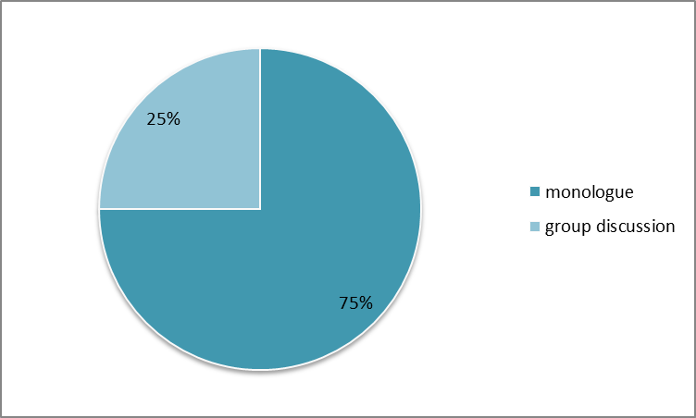

Figure 1 displays the number of students is interested in the support of the AI tools. It was seen that 75% of students would like to get the assistance from the AI tools such as ChatGPT, ELSA app or Duolingo Max in monologue activity. It appeared that when they had to speak alone, they often had a pressure of being observed, and they ran out of words and ideas to express their thoughts. Therefore, the AI tool supported them by suggesting content, correcting grammar and pronunciation errors; thereby, their speech was prepared more effectively. 25% of students agreed that they would like to get the support from AI tools as they practised working in groups. It seems to them that AI tools helped them have more ideas to debate with a diverse view of an issue. It was believed that more members meant more ideas. None of students, 0%, indicated that they needed AI tools’ assistance in pair work as this activity required a real interaction between two members to practice listening and communication skills. In addition, they assured that if using AI tools, they would lose their initiative and naturalness in the learning process.

**Figure 2**

*The fields students get supports most from AI tools*

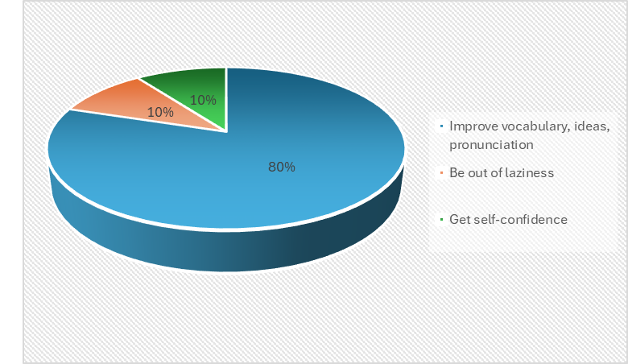

Figure 2 presents the fields that students get the most support from the AI tools, in which 80% of students could improve the vocabulary, the ideas, and pronunciation, 10% could be out of laziness, and the rest 10% got back their belief. They assumed that with the help of ChatGPT, they were quite confident to express their ideas without fear of making mistakes. Some of them thought that ChatGPT gave them some motivation to study more actively, no longer feeling lazy.

**Figure 3**

*The negative effects of misuse of AI tools*

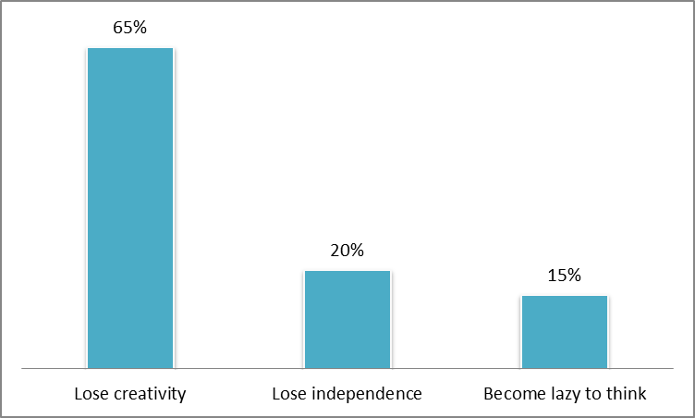

Figure 3 shows the negative effects that AI tools bring to the freshmen while learning speaking skills. 65% of students assumed that they would gradually lose their creativity due to over-reliance on AI tools. 20% of students said they lost their independence, and 15% became lazy to think.

This proves that the overuse of AI tools can make students lack the motivation to think independently, limit their ability to speak naturally. In addition, sometimes the words suggested by AI are not appropriate to the context or cultural characteristics, leading to misunderstandings during communication. Moreover, the excessive use of AI can reduce direct human-to-human interaction, affecting social communication skills and flexible reflexes.

**Figure 4**

*Teacher’s strategies when AI tools used in classroom*

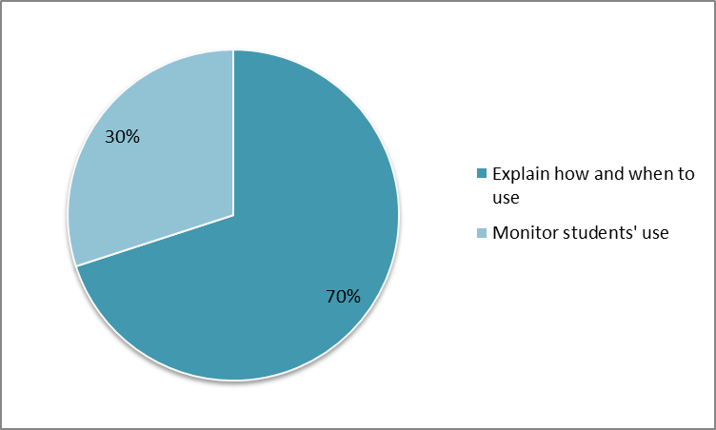

Figure 4 shows the essential things teacher should do when letting students use AI tools in speaking classroom. 70% of students assumed that teacher should clearly explain how and when they can use AI tools so as to help students understand its side-effects. 30% of students thought that teacher should monitor students’ use of AI tools to help them improve their creativity and self-learning. In addition, students should be encouraged to combine the use of AI tools with natural reflex skills to improve their speaking ability.

From the result of the questionnaire, it is clearly seen that 100% of students affirmed that no matter how useful AI tools are, they cannot replace teachers. Teachers are not only the ones who convey knowledge but also guide students in learning methods, adjust their learning attitudes, and create inspiration to promote interaction among students, and students and teachers.

1. **Discussion**

AI tools offer a plethora of benefits for EFL learners in general, HUFLIT freshmen in particular. They revolutionize language acquisition through personalized learning experiences, instant feedback, and enhanced accessibility. They can adapt to individual proficiency levels, provide targeted exercises for grammar and pronunciation, and offer constant practice with virtual tutors and interactive scenarios. This customization fosters engagement, accelerates learning, and makes education more efficient. HUFLIT freshmen have gained remarkable achievements in learning speaking skills and have more opportunities to practice spoken language in all contexts. There is no denying that students get many benefits from interacting with ChatGPT, ELSA, Duolingo. It has a positive impact on freshmen' s learning state since it helps their speaking ability improve significantly from their confidence, fluency, pronunciation and reflexes. However, the increasing reliance on AI also presents several negative impacts. It can lead to over-dependence, potentially weakening critical thinking and independent problem-solving skills. It may reduce essential human interaction, which is crucial for developing communicative competence and cultural understanding, especially to freshmen. Furthermore, ethical concerns such as data privacy, algorithmic bias, and the risk of academic dishonesty through AI-generated content also pose significant challenges for HUFLIT learners and teachers alike. The question raised here is how teachers can help students clearly perceive their learning role to develop their critical thinking without being too dependent on AI tools in the era of technology 4.0.

**6. Conclusion**

The application of AI tools into education brings new looks to both learning and teaching. With the findings from the research, the writer recognizes that 100% of freshmen of class A24201 at Huflit are satisfied with using ChatGPT tools in learning speaking skills although there is one speaking activity that they do not need the support from ChatGPT tools - it is the pair-work one.

In speaking skills, AI tools do not help 100% of students in vocabulary, finding ideas, correcting pronunciation, but they are used as a companion to assist 80% of freshmen overcome difficulties and pressure in studying. In the age of technological development, AI tools help create a sophisticated educational environment where learning may be more personalized, teaching more flexible, and management more inclusive. They make the learners develop the knowledge and skills not only in language learning but enhance their modern technology. From the results of the study, it appears that most of students were excited with the AI tools’ support as they helped students relieve stress to look up words, to be scared of wrong pronunciation while speaking activities were taking place. However, with the development of artificial intelligence technology, there are many challenges for the education sector in general, lecturers and students in particular. When using artificial intelligence tools, learners must consider carefully to avoid abusing the AI tools that lead to dependence. After all, AI is only a support tool, it cannot completely replace the role of lecturers in conveying emotions, motivating and creating personal connections with students. Over-reliance on AI can lead students to lacking creative thinking skills and reduce problem-solving ability.

Future research can be recommended and encouraged in light of the findings of the current study by including a larger number of participants divided into control and experimental groups, in addition to comparing the benefits or challenges of using some more AI tools in promoting students’ speaking proficiency.

**REFERENCES**

Baidoo-Anu, D., and L. O. Ansah (2023). “Education in the Era of Generative Artificial Intelligence (AI): Understanding the Potential Benefits of ChatGPT in Promoting Teaching and Learning.” *Journal of AI,* **7**(1), 52–62.

Bryman, A. (2008) - *Social Research Methods (3rd ed.)* - Oxford, UK: Oxford University Press.

Burton, E., Goldsmith, J., Koenig, S., Kuipers, B., Mattei, N., & Walsh, T. (2017). “Ethical considerations in artificial intelligence courses.” *AI Journal*, 38(2), 22-34.

Chen, X., Xie, H., & Hwang, G. J. (2020). “A Multi-Perspective Study on Artificial Intelligence in Education.” *Educational Technology & Society*, 23(4), 1-15.

Fathi, J., M. Rahimi, and A. Derakhshan (2024). “Improving EFL Learners' Speaking Skills and Willingness to Communicate Via Artificial Intelligence-Mediated Interactions.” *In System*121: 103254.

Gerring, J. (2007) - *Case Study Research: Principles and Practices -* Cambridge, UK: Cambridge University Press.

Godwin-Jones, R. (2017). “Emerging Technologies: Autonomy and Language Learning.” *Language Learning & Technology*, 21(3), 4-17.

Lin, M. H., & Lin, H. (2019). “Evaluation of AI-Based Language Learning Platforms.” *Journal of Educational Technology Development and Exchange*, 12(1), 15-30.

Lu, X., & Doshi, P. (2017). “Interactive Conversational Agents for Learning.” *In IEEE Transactions on Learning Technologies*, 10(1), 1-14.

McCrocklin, S. M. (2016). “Pronunciation Learner Autonomy: The Potential of Automatic Speech Recognition.” *In System*, 57, 25-42.

UNESCO, (2019). “Artificial intelligence in education: challenges and opportunities for sustainable development.” Digital library.

Russell, S. J. & Norvig, P. (2010) - *Artificial Intelligence: A Modern Approach (3rd ed.)*- Upper Saddle River, New Jersey: Prentice Hall.

Wei, L. 2023. “Artificial Intelligence in Language Instruction: Impact on English Learning Achievement, L2 Motivation, and Self-Regulated Learning.” *Frontiers in Psychology,* 14: 1261955.

Zhang, C., Y. Meng, and X. Ma. 2024. “Artificial Intelligence in EFL Speaking: Impact on Enjoyment, Anxiety, and Willingness to Communicate.” *In System* 121: 103259.

**Bionote**

Ms. Nguyễn Thị Phương Anh is a lecturer of English at the Faculty of Foreign Languages, Ho Chi Minh City University of Foreign Languages and Information Technology (HUFLIT). She holds a Master’s degree in TESOL from Victoria University and has nearly 20 years of experience teaching English to both major and non-major students at Huflit.

**Appendix**

**QUESTIONNAIRE**

***Please answer the following questions by ticking the box with explanations below***

1. Do you like using AI tools in speaking class?

Yes

Why? ……………………………………………………………………………

No

Why? ……………………………………………………………………………

1. Among speaking activities in class (single speaking, pair speaking, group discussion), which activity do you like most supported by AI tools?

Single speaking

Pair speaking

Group discussion

Why?…………………………………………………………………………..

1. What activities do you think AI tools should not intervene in??

Single speaking

Pair speaking

Group discussion

Why?…………………………………………………………………………..

4. Which of the following fields have AI tools helped you improve your speaking skills? (You can choose more than 1 answer)

Vocabulary

Ideas

Pronunciation

Confidence

Laziness

Shyness

Others?…………………………………………………………………

5. In your opinion, besides the necessary support of AI tools, do you think that AI tools also have negative aspects that students encounter?

Yes

In what aspects?

….………………………………………………………………………………….

No

Why?…………………………………………………………………………..

1. In your opinion, what methods should lecturers help students use AI tools as a support tool, rather than completely relying on it?

Limit the time

Explain clearly how to use it, and when to use it.

Monitor students while using

Other methods? ………………………………………………………

1. Do you think AI tools can completely replace lecturers?

Yes

How? ……………………………………………………………………………

No

Why?…………………………………………………………………………….

**Thank you for your cooperation!**