Smart Teaching: The Integration of AI Tools in English Language Education

Irina Vardanyan[1]

Abstract

In the age of the internet and rapid technological change, keeping students engaged in the language classroom has become both essential and increasingly challenging. The days of relying solely on textbooks—no matter how colourful or interactive—are behind us. Today’s learners are used to fast, easily digestible content like TikTok videos and Instagram Reels that deliver information in under a minute. Compared to these, traditional grammar exercises and lengthy explanations are considered outdated and uninspiring.

This paper explores how AI-powered tools can help TESOL teachers to bridge this gap by making English language teaching more interactive, personalized, and aligned with students' digital habits. Drawing on a mixed-methods, classroom-based action research methodology—combining quantitative data from a Likert-scale survey with qualitative insights from focus groups and teacher reflections—the study evaluates a selection of tools——including Diffit.me, PlayPhrase.me, TalkPal.ai, Napkin.ai, and others—used with intermediate English learners across multiple skill areas.

The article outlines practical implementation strategies, learner feedback, and pedagogical outcomes. Key results indicate increased student engagement, reduced learning anxiety, and greater learner autonomy, as well as a strong preference for continued use of AI in future lessons. These findings highlight how such technologies can complement communicative language teaching.

The findings suggest that purposeful integration of AI not only fosters engagement but also reinforces the teacher’s role as a guide and facilitator in an increasingly automated learning environment.

***Keywords:*** artificial intelligence, TESOL, digital language learning, student engagement, edtech tools, personalized learning

1. Introduction

In this digital era, scholars all over the world face challenges in adapting traditional teaching methods and approaches to meet the expectations of a tech-savvy generation. This issue is more apparent in ESL classrooms, where the contrast between textbook-driven instruction and students' fast-paced digital media engagement is especially dramatic. The young generation today is deeply immersed in platforms such as TikTok, Instagram, and YouTube, with their bite-sized, highly visual, and therefore easily memorable content.

In light of this, paper-based engagement alone—even when paired with contemporary teaching methods and approaches— often fails to capture students’ attention or foster deep engagement, particularly among digital natives. This shift in learners' behaviour calls for innovative pedagogical strategies that blend language instruction with digital fluency, thus catalysing the growing interest in integrating AI into educational settings.

**This paper aims** to explore how AI-powered tools can help TESOL teachers bridge this gap by making English language teaching more interactive, personalized, and aligned with students' digital habits.

**Novelty:** Drawing on classroom-based applications, the study evaluates a selection of tools—including Diffit.me, PlayPhrase.me, TalkPal.ai, Napkin.ai, and others—used with intermediate English learners to support reading, writing, speaking, and vocabulary development across a six-week instructional cycle.

2. Literature Review

2.1 The Role and Potential of AI in TESOL

Artificial intelligence has emerged as a transformative force in education. Scholars across all educational sectors actively examine the revolutionary potential of AI in teaching, which, in addition to enhancing personalization and lesson interactivity, also redefines the teacher's role in the classroom, particularly in the TESOL context (Tammets et al., 2023; Aljemely, 2024; Zawacki-Richter et al., 2019). AI can support teachers in developing more adaptive, interactive, and individualized instructional approaches.

While considerable attention is being directed toward the potential of generative AI in education (Khserti, 2023), it is equally important to explore how current AI tools—such as Diffit.me, TalkPal.ai, Napkin.ai and PlayPhrase.me—can support specific classroom practices. These tools, already in use, provide targeted support for language skills such as reading, speaking, writing, and grammar, making them directly relevant to daily instruction.

AI-powered applications present new opportunities to supplement communicative language teaching with technology that aligns with learners' digital habits. These tools benefit teachers as well, enhancing instruction by enabling educators to focus more on innovation and student interaction (Kshetri, 2023; van Leeuwen et al., 2022).

2.2 Challenges and Considerations in Classroom Use

Despite these benefits, concerns have emerged regarding students’ misuse of AI, particularly the tendency to rely on systems like ChatGPT to generate answers, thereby bypassing critical thinking and authentic learning processes (Chan & Tsi, 2023). Rather than viewing AI solely as a source of ready-made solutions, it is imperative to guide learners in using these technologies responsibly—as tools for exploration, practice, and self-directed study. Educators must also be supported in developing pedagogical strategies that leverage AI to enhance learning while upholding academic integrity.

While the promise of artificial intelligence in education continues to grow, a gap persists between theoretical capabilities and real-world classroom implementation. Many AI interventions are developed without input from educational institutions or teachers, resulting in limited relevance to daily teaching practice (Kabudi et al., 2021; Bates et al., 2020; Sarmiento & Wise, 2022). Several literature reviews have also highlighted a lack of pedagogical grounding in AIEd research, much of which originates from STEM domains and lacks incorporation of educational theories or language-teaching frameworks (Zawacki-Richter et al., 2019; Chen et al., 2020; Tang et al., 2021; Tsai & Martinez-Maldonado, 2022).

2.3 Teacher Preparedness and Pedagogical Relevance

Although extensive research is being conducted on the application of AI tools in education, little attention is paid to teacher training on how to use these technologies effectively in the classroom. Given the teacher's crucial role in education, their proficiency in AI technologies is essential for delivering high-quality instruction. Professional development should aim to help teachers build the skills needed to evaluate and integrate AI tools purposefully and ethically.

The concept of professional vision—teachers’ ability to notice, interpret, and respond to key events in the classroom—offers a useful framework for understanding how educators interact with AI-enhanced environments (Van Es & Sherin, 2002; Seidel & Stürmer, 2014; Edwards & Cheok, 2018).

Developing this vision in AI contexts requires more than technological exposure; it demands sustained engagement with pedagogy, reflection, and practical support.

To ensure meaningful integration, teachers should be directly involved in the development and evaluation of AI tools through human-centered, participatory design approaches (Tsai & Martinez-Maldonado, 2022; Sarmiento & Wise, 2022; Chiu et al., 2023).

3. Methodology

This study employed a classroom-based action research approach that combined both qualitative and quantitative methods to investigate the impact of AI-powered tools on learner engagement, language skill development, and pedagogical outcomes. While the overall design was grounded in qualitative inquiry, the study incorporated quantitative perception data from student surveys and qualitative insights gathered through focus group discussions and teacher reflection journals. This mixed-methods approach provided a more holistic understanding of classroom experiences and instructional dynamics.

Participants

Participants were 30 intermediate-level English learners (CEFR B1–B2), aged 18–45, enrolled in a general English course at Universe Language and Training Centre in Yerevan, Armenia. They included university students, professionals, and adult learners preparing for workplace communication or language certification exams. Three TESOL-trained instructors facilitated the intervention and contributed reflective observations throughout the study.

Procedure

The integration of AI tools into classroom instruction followed a structured, six-week plan, with each week dedicated to a specific language skill and a corresponding digital tool. This approach allowed for focused skill development while gradually familiarizing learners with different types of AI applications. The tools were purposefully selected to support reading, writing, speaking, and listening using communicative, learner-centered methods.

Prior to implementation, all participating instructors completed a targeted professional development session on AI tool integration. These sessions addressed not only tool functionality, but also pedagogical applications, ethical considerations, and classroom management strategies in technology-rich environments. Teachers were encouraged to adapt the tools to their specific student groups, incorporate them flexibly into lessons, and reflect weekly on their instructional impact.

Students completed scaffolded in-class activities using the designated tools and were encouraged to explore them independently outside of class for reinforcement. By Week 5, learners selected a preferred tool to complete a personalized project. Week 6 was dedicated to structured reflection, allowing both learners and teachers to share their insights on the experience.

**Week 1** introduced **Diffit.me**, which was used to generate topic-based reading texts tailored to learners’ proficiency levels. Students engaged with AI-generated materials on current global issues, followed by vocabulary-focused exercises and comprehension questions. This helped scaffold reading practice and expose learners to levelled, authentic content without overwhelming them.

In **Week 2**, **PlayPhrase.me** was incorporated into pronunciation and listening activities. Students searched for common idiomatic expressions and phrasal verbs, watched video clips demonstrating their natural use in context, and practiced mimicking the pronunciation. The tool facilitated interactive listening and speaking tasks that mirrored real-world language use, enhancing both comprehension and production.

**Week 3** focused on **speaking fluency and confidence-building** through **TalkPal.ai**, an AI-powered chatbot designed for language learners. Students participated in structured, theme-based conversations—such as describing daily routines or planning a trip—and received real-time feedback on grammar and vocabulary. These interactions were later reflected upon in class discussions, allowing students to share insights and learning challenges.

In **Week 4**, the emphasis shifted to writing. **Napkin.ai** was introduced as a pre-writing support tool. Students submitted brainstorming ideas or essay prompts into the platform, which generated visual outlines and diagrams. These visuals helped learners organize their thoughts before writing paragraphs or short opinion essays. The use of AI-generated mind maps encouraged more coherent writing and reduced planning anxiety.

During **Week 5**, learners were given the freedom to choose their preferred AI tool to complete an individual mini-project. Projects included digital presentations, chatbot dialogues, audio recordings, and infographic-supported essays. This choice-based model promoted learner autonomy and encouraged students to apply tools in ways that matched their personal interests and strengths.

Finally, **Week 6** was dedicated to reflection, discussion, and feedback. Students completed a survey on their experience with the tools and participated in focus group discussions. Teachers also reflected on instructional outcomes, tool effectiveness, and areas for improvement.

Throughout the six-week period, teachers played a pivotal role in facilitating the integration of AI tools. They modeled tool use, provided individualized scaffolding, adapted activities to suit learner needs, and served as reflective practitioners. Their guidance ensured that the use of AI remained pedagogically purposeful and ethically grounded, reinforcing the teacher’s central role in a digitally enhanced language classroom.

4. Data Collection

Data collection followed a multi-source approach to ensure both breadth and depth of insight into learner and teacher experiences:

* A seven-item Likert-scale questionnaire was distributed via Google Forms to gather student feedback on the perceived effectiveness of each tool, classroom engagement, anxiety reduction, confidence building, and independent usage.
* Two semi-structured student focus groups, involving twelve participants, were conducted in English and recorded with consent. These sessions captured learners’ reflections on tool preferences, ease of use, and impact on their learning.
* The three participating teachers maintained weekly reflection journals, documenting classroom observations, learner behavior, challenges, and pedagogical responses during the AI-integrated lessons.

This combination of instruments enabled the study to capture both quantitative trends in student perceptions and qualitative insights into instructional outcomes and classroom dynamics.

Survey Design and Instrument Validity

The student survey was designed specifically for this study and aimed to capture learner perceptions of AI tools across multiple dimensions, including engagement, confidence, anxiety reduction, and autonomous use. The seven Likert-scale items were adapted from existing research instruments on technology integration in language education and were aligned with the study’s instructional goals. To strengthen content validity, the survey was reviewed by two TESOL experts and revised based on their feedback. Although it was not formally piloted with a separate test group due to time constraints, minor wording adjustments were made after initial review to ensure clarity and consistency in student understanding.

4. Results

***4.1 Quantitative Findings: Student Survey Result***

The sociological survey was carried out anonymously using a pre-designed questionnaire consisting of seven Likert-scale questions, distributed via Google Forms. These questions aimed to capture student feedback on several dimensions: lesson engagement, speaking comfort, anxiety reduction, independent tool use, confidence gains, visual learning support, and overall willingness to use AI tools in future educational settings.

All student participants had taken part in a six-week classroom intervention in which four specific AI tools—Diffit.me, PlayPhrase.me, TalkPal.ai, and Napkin.ai—were integrated into weekly lessons targeting different language skills. The survey was completed by 28 out of 30 students, reflecting a 93% response rate.

Below is a summary of the results, presented question by question. Each response was rated on a scale of 1 (strongly disagree) to 5 (strongly agree):

Question 1: Were lessons more engaging with AI tools?

According to the survey results (**Figure 1**), a significant majority of students—25 out of 30 respondents (83%)—agreed to some extent that the lessons became more engaging with the integration of AI tools. Specifically, 42% of students (13 respondents) chose *"Strongly Agree"*, while 40% (12 respondents) selected *"Agree"*. This overwhelming positive response suggests that AI integration had a substantial impact on student motivation and classroom interest.

Meanwhile, only 10% (3 respondents) were neutral, indicating that they did not perceive a notable change in lesson engagement. A small minority, 5% (1 respondent) chose *"Disagree"*, and 3% (1 respondent) selected *"Strongly Disagree"*. These lower figures may reflect students who either preferred traditional formats or faced challenges adapting to new tools.

The high percentage of agreement may be attributed to the interactive, personalized nature of the AI platforms used—such as Diffit.me and TalkPal.ai—which likely aligned well with the students’ digital habits and learning preferences.

**Figure 1**

Student Responses: Lessons were more engaging with Al tools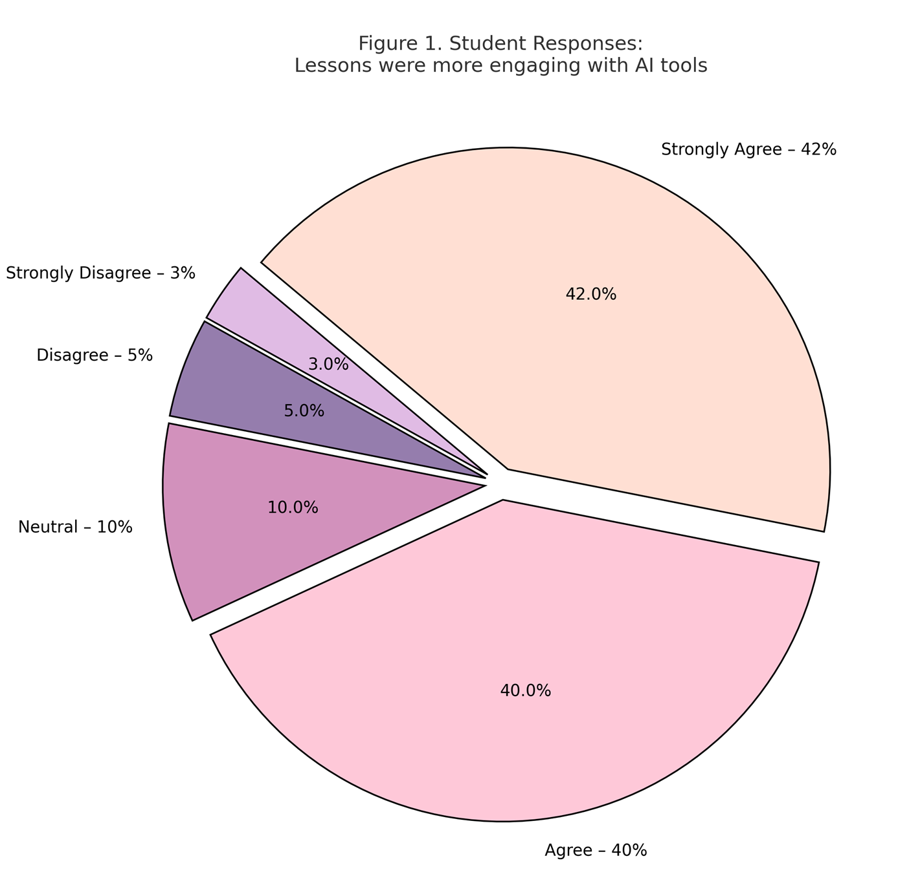

Question 2: Do you feel more comfortable speaking English using AI chatbots?

The survey results (**Figure 2**) show that 78% of students (23 out of 30) reported feeling more comfortable speaking English when using AI chatbots. Among them, 40% (12 students) selected “Strongly Agree”, and 38% (11 students) responded with “Agree”. This strong positive response suggests that AI-supported dialogue tools, such as TalkPal.ai, provide a low-pressure, nonjudgmental environment for practicing spoken English.

12% of students (4 respondents) chose “Neutral”, indicating that for some learners, the chatbot experience did not significantly affect their speaking comfort. Meanwhile, a small minority—6% (2 students) selected “Disagree” and 4% (1 student) chose “Strongly Disagree”—possibly reflecting individual preferences for human interaction or unease with digital tools.

Overall, the data implies that AI chatbots can play a supportive role in helping learners develop oral fluency and confidence, especially in contexts where speaking anxiety is a barrier.

**Figure 2**

*Student Responses: Comfort speaking English using Al chatbots*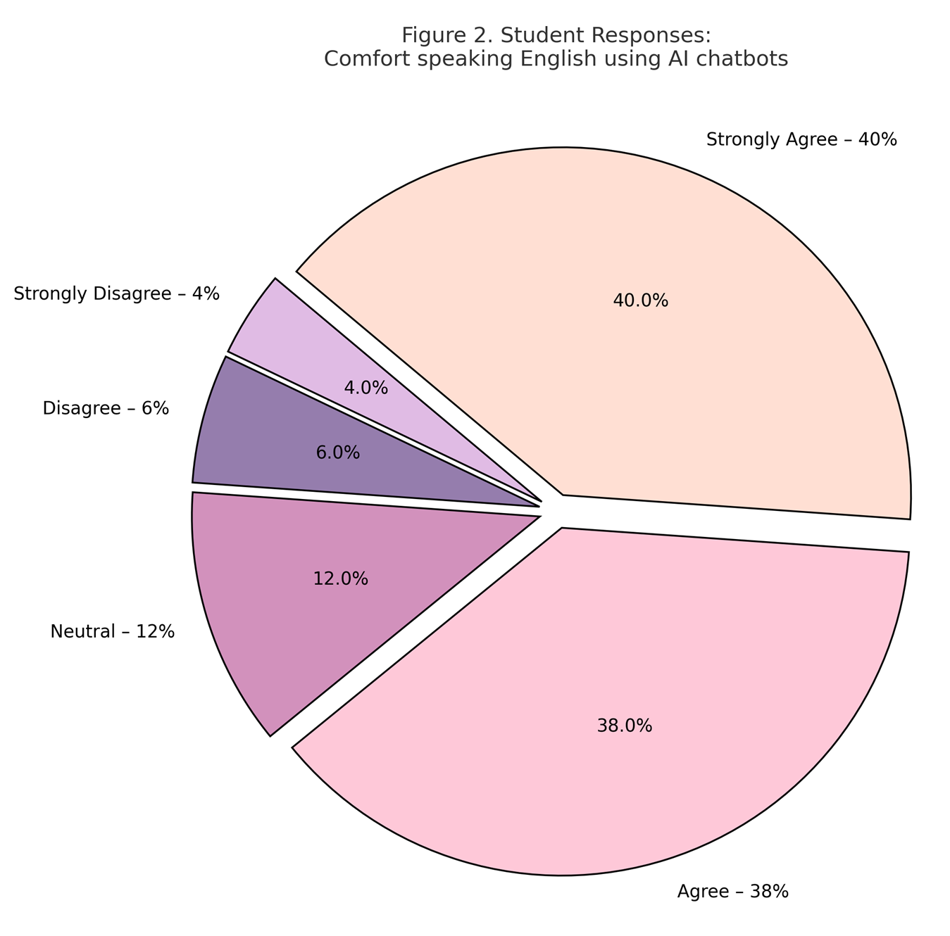

Question 3: Did AI tools reduce your anxiety during English learning?

The responses (**Figure 3**) indicate that **72% of students (22 out of 30)** felt that AI tools helped reduce their anxiety in the classroom. Of these, **37% (11 students)** *strongly agreed* and **35% (10 students)** *agreed* with the statement. This suggests that the integration of AI created a more psychologically safe and supportive learning environment.

Meanwhile, **15% of students (5 respondents)** selected *neutral*, implying that the AI tools may not have significantly influenced their anxiety levels—either positively or negatively.

A smaller portion of the group expressed dissent: **8% (2 students)** selected *disagree* and **5% (1 student)** chose *strongly disagree*. These views may reflect individual challenges with technology, discomfort with non-human interaction, or a preference for traditional teaching methods.

Overall, the results suggest that AI tools—especially those offering private, repetitive, and nonjudgmental practice opportunities—may serve as useful mechanisms for **reducing language learning anxiety**, particularly in speaking and grammar-focused activities.

**Figure 3**

*Student Responses: Al tools reduced my anxiety*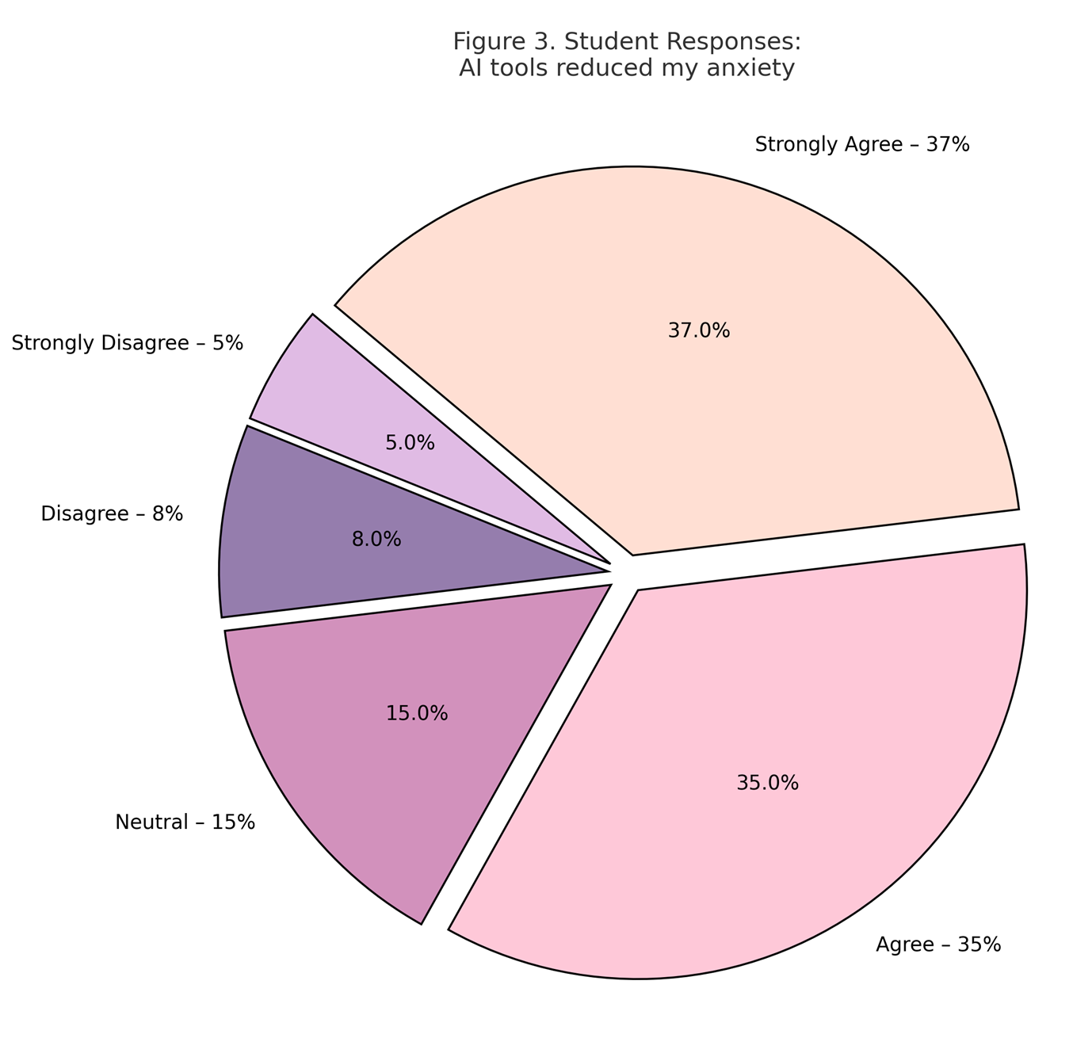

Question 4: Did you use AI tools outside of class?

Survey responses (**Figure 4**) show that **67% of students (20 out of 30)** reported using AI tools independently outside the classroom. This includes **33% (10 students)** who *strongly agreed* and **34% (10 students)** who *agreed* with the statement. These findings suggest that many learners found the AI tools accessible, helpful, and motivating enough to explore beyond formal lesson time.

At the same time, **18% of students (5 respondents)** chose *neutral*, indicating a more passive or situational use of AI—perhaps using the tools only when prompted or needing extra help.

A smaller group expressed reluctance or resistance: **9% (3 students)** selected *disagree*, and **6% (2 students)** chose *strongly disagree*. These responses may reflect individual differences in learning habits, lack of time, or technical barriers.

Overall, the data indicates that AI tools—particularly those offering chat-based or visual content like **TalkPal.ai** and **Napkin.ai**—hold potential for fostering learner autonomy and extending language practice into informal learning spaces.

**Figure 4**

*Student Responses: Used Al tools outside class*

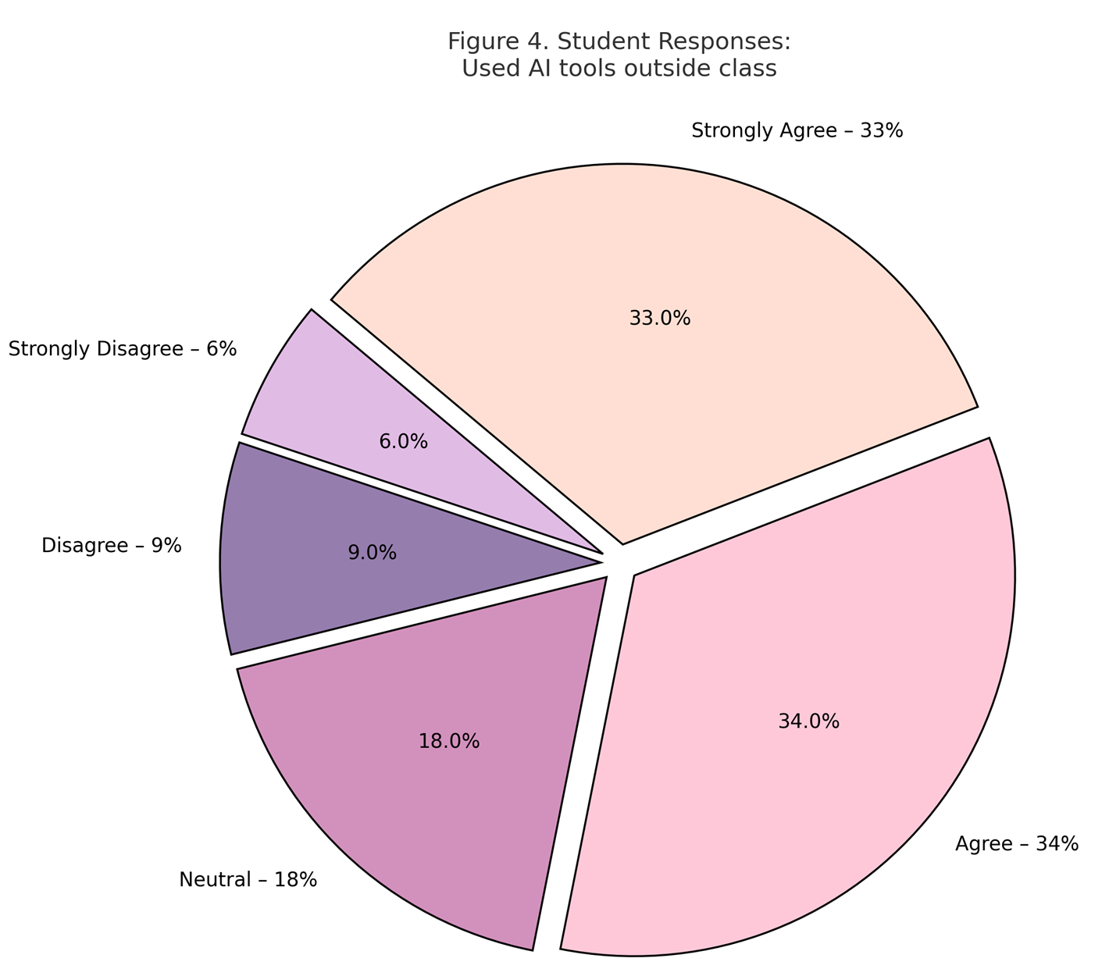

Question 5: Do you feel more confident using new words and expressions after using AI tools?

The results (**Figure 5**) show that **80% of students (24 out of 30)** reported feeling more confident using new vocabulary and expressions as a result of AI tool integration. Specifically, **40% (12 students)** *strongly agreed* and another **40% (12 students)** *agreed* with this statement. This reflects a strong affirmation of the tools’ role in reinforcing language acquisition and supporting expressive competence.

**11% (3 students)** responded with *neutral*, which may suggest a moderate or uncertain impact on their language confidence—perhaps due to limited use or already existing comfort with vocabulary.

Only **6% (2 students)** selected *disagree*, and **3% (1 student)** *strongly disagreed*. These minimal negative responses could reflect learners who prefer more structured or teacher-led vocabulary input, or who did not engage deeply with the AI content.

The overwhelmingly positive responses point to the value of interactive AI tools—like **Diffit.me** and **TalkPal.ai**—which expose learners to frequent, contextualized language use and provide low-pressure opportunities to test new expressions in dialogue and writing tasks.

**Figure 5**

*Student Responses: More confident using new expressions*

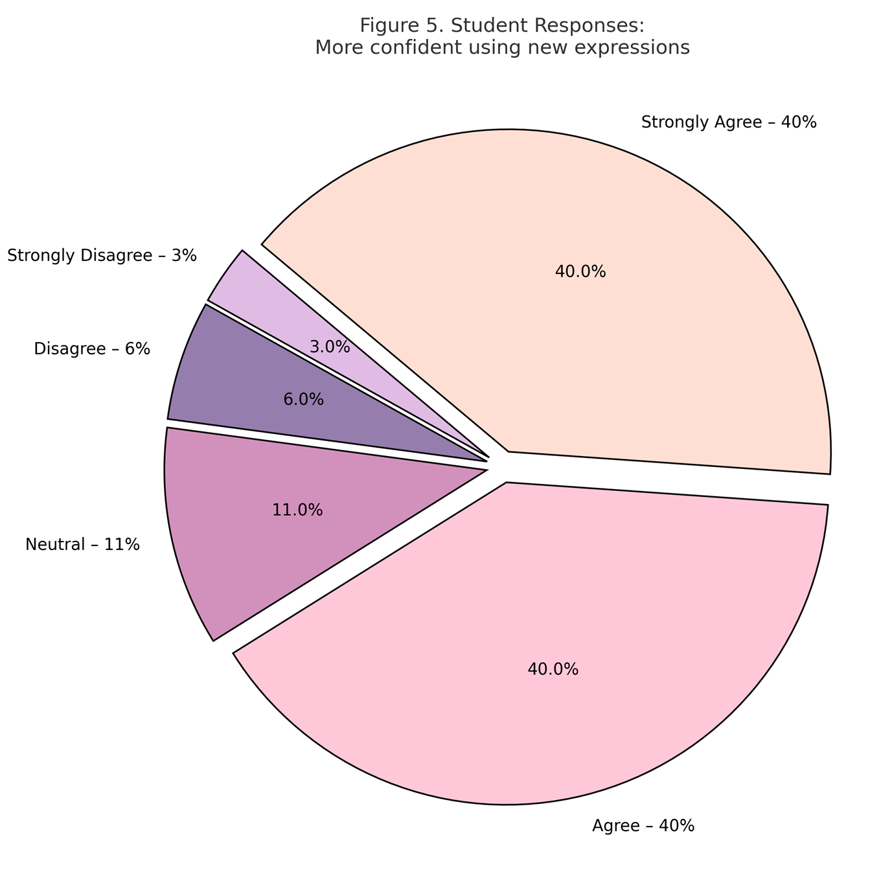

Question 6: Did visual AI tools help you better understand grammar?

The data (**Figure 6**) reveals that a substantial majority—**84% of students (25 out of 30)**—felt that visual tools supported their grammar learning. Among these, **46% (14 students)** *strongly agreed* and **38% (11 students)** *agreed* with the statement. This strongly positive trend suggests that visual representation of grammar rules, structures, and examples through tools like **Napkin.ai** was highly effective in aiding comprehension.

**10% (3 students)** responded *neutral*, possibly indicating that they did not experience a noticeable difference, or had an already solid grasp of the grammar being taught.

Only a small fraction of students disagreed: **4% (1–2 students)** selected *disagree*, and just **2% (1 student)** chose *strongly disagree*. These outliers may reflect a preference for traditional, text-based grammar explanations or challenges with visual-spatial learning formats.

Overall, these results support the pedagogical value of **visual AI tools** in simplifying complex language structures, especially for visual learners and for abstract grammar topics that benefit from diagrammatic representation.

**Figure 6**

*Student Responses: Visual tools helped understand grammar*

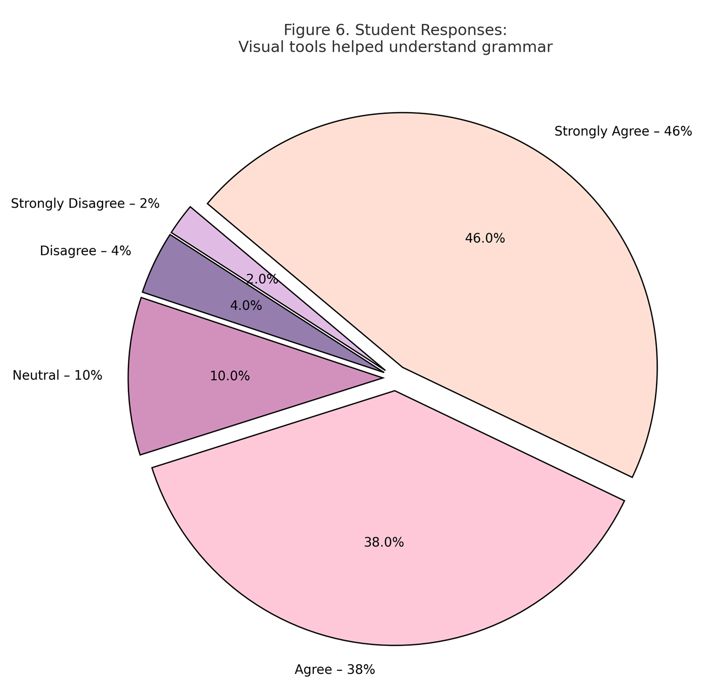

Question 7: Would you like to use AI tools in future English classes?

The results (**Figure 7**) show overwhelming student support for continuing the use of AI tools in English learning. A remarkable **88% of students (26 out of 30)** expressed a clear preference to use AI tools again, with **53% (16 students)** selecting *strongly agree* and \**35% (10 students)* choosing *agree*. This strong endorsement reflects not only satisfaction with the tools but also students’ readiness to adopt them as part of their regular learning experience.

A small number of students—**8% (2 students)**—chose *neutral*, suggesting they may be open but undecided, perhaps dependent on the type or frequency of AI use.

Only **3% (1 student)** *disagreed*, and **1% (1 student)** *strongly disagreed*. These outliers may reflect individual preferences for traditional instruction or discomfort with technology.

Overall, this result underscores the tools’ perceived value across the learning process—from comprehension and practice to confidence and engagement—and suggests that incorporating AI into long-term curriculum planning would likely be welcomed by students.

**Figure 7**

*Student Responses: Want to use Al tools in future classes*

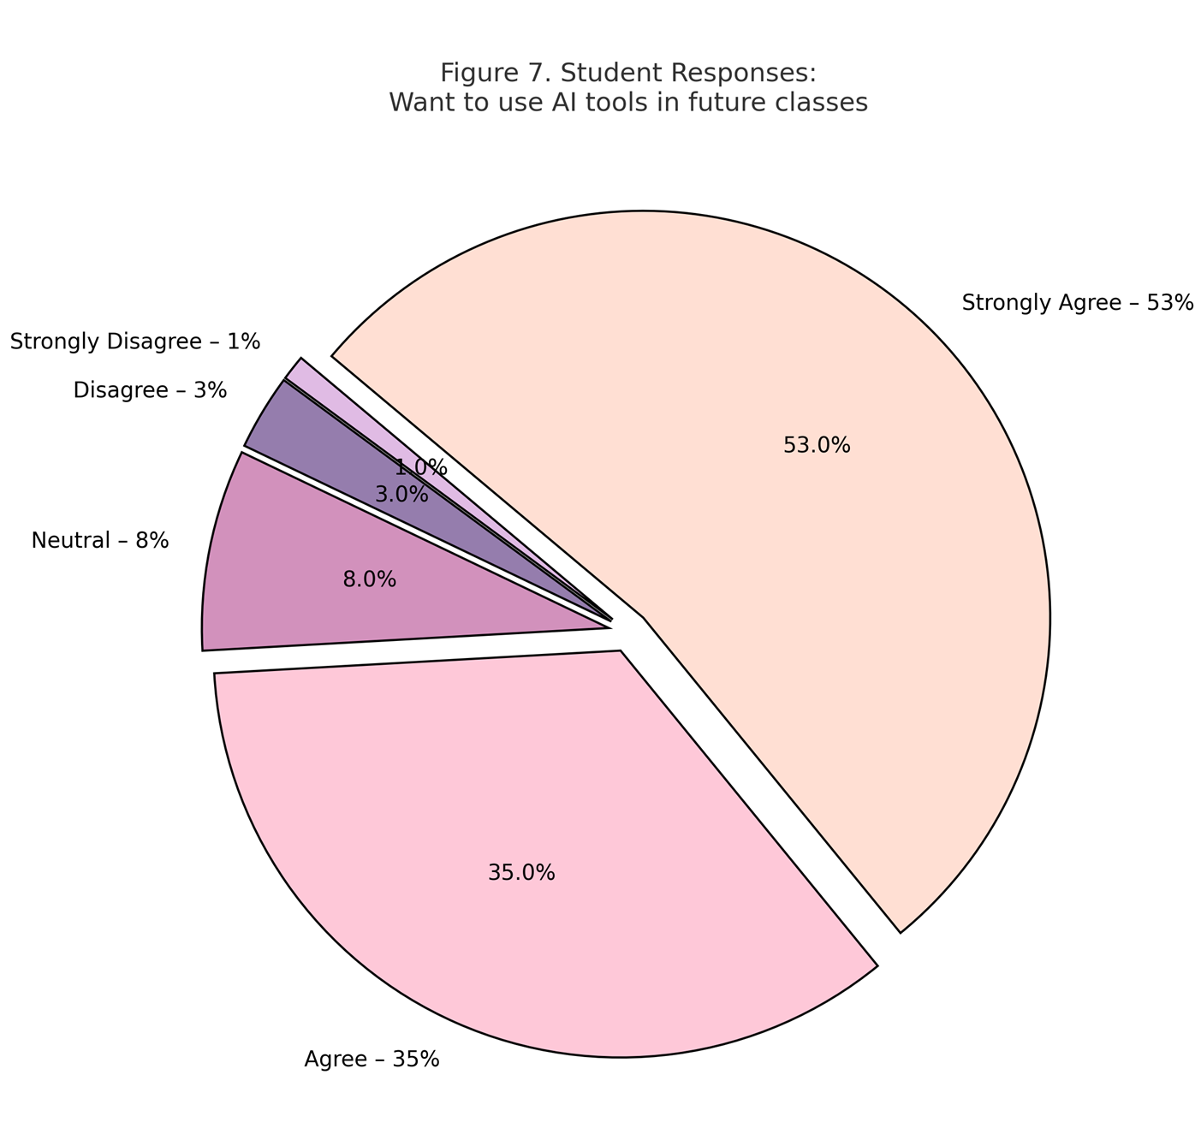

4.2. Qualitative Observations: Focus Group and Teacher Reflections

To complement the survey findings, qualitative data were collected from two student focus group sessions involving twelve participants, as well as from reflective journals maintained by the three participating teachers throughout the intervention. Transcripts and journal entries were thematically analyzed to identify recurring insights into learner engagement, skill development, and pedagogical dynamics.

***Theme 1: Increased Student Confidence and Autonomy***

Students frequently described how the AI tools supported their confidence and autonomy. They expressed this in comments such as:

*I felt more comfortable trying new words with the chatbot because I knew it wouldn’t judge me. I could make mistakes without embarrassment.*

*Talking to the AI helped me stop being afraid of speaking. It was like practicing in private before going public.*

*Before, I would wait for the teacher to correct me, but with TalkPal I could try again and again until it sounded right.*

***Theme 2: Personalized Learning Preferences***

Students emphasized how personalized and adaptive content improved their motivation and engagement. Their feedback included:

*The articles were interesting and not too difficult. I liked choosing topics and reading at my level — it made me want to read more.*

*I usually get bored with grammar tasks, but when I picked something I cared about, it was different.*

*Napkin helped me organize my writing better. I used to hate planning, but the mind maps made it easier to start.*

*For me, seeing the structure of my writing made it feel less chaotic. I finally knew where to begin.*

***Theme 3: Role of Teacher Mediation and Scaffolding***

Teachers offered meaningful reflections on how AI tools supported instruction and the importance of guided implementation. Their own words illustrate this:

*TalkPal was a breakthrough for many quieter students. I saw them engaging more and coming to class with new vocabulary they had practiced on their own. But the tool only worked because we framed each activity with clear objectives.*

*The tools opened new possibilities, but it was my job to make them meaningful — to connect each tool to our curriculum goals and guide students to use them responsibly.*

Teachers and students also noted challenges, particularly the need to scaffold students' use of technology. As they reflected:

*We noticed that students who were less independent struggled at first. They needed modeling and reminders to stay on track.*

*Some students were distracted at first. They needed structure and purpose. Once that was in place, their focus improved dramatically.*

*When the teacher explained what to do with the tool, it helped a lot. I didn’t feel lost or waste time figuring it out.*

Taken together, the focus group responses and teacher reflections demonstrate that AI tools contributed to a more confident, motivated, and autonomous learning environment. Students valued the ability to experiment with language in a non-judgmental setting, engage with content tailored to their interests and levels, and use planning tools that reduced anxiety and improved task initiation. Teachers emphasized the importance of guidance and intentional integration, noting that the effectiveness of AI was enhanced when scaffolded within meaningful pedagogical frameworks. These findings affirm that AI, when thoughtfully applied, can complement communicative language teaching by promoting both learner independence and teacher-led structure.

5. Data Analysis and Research Limitations

Quantitative data from the student survey were analysed using descriptive statistics. Mean scores were calculated for each of the seven Likert-scale questions, and the distribution of responses was presented using pie charts. These visualizations helped identify trends in learners’ perceptions across engagement, confidence, motivation, and the perceived effectiveness of various AI tools.

Focus group transcripts were thematically analysed to explore student experiences with AI tools, highlighting common patterns in learner preferences, perceived impact, and challenges encountered. Teacher reflection journals were reviewed to identify recurring observations regarding student behaviour, engagement, and instructional outcomes. This multi-source approach enabled the study to capture both measurable trends in student perception and rich, interpretive accounts of the instructional process.

While the study provides meaningful insights into the integration of AI tools in TESOL instruction, it has several limitations. The sample consisted of 30 learners from a single institution, and the intervention period was limited to six weeks. Consequently, the findings may not be generalizable across broader educational settings or learner demographics. Additionally, because the data were self-reported, there is potential for response bias.

Moreover, the study did not include direct assessment of language proficiency or skill improvement through standardized testing, speaking samples, or writing rubrics. This was a deliberate decision, consistent with the exploratory, classroom-based design, which prioritized learner experience, engagement, and autonomy as key indicators of instructional impact. However, the absence of formal performance data limits the ability to draw conclusions about measurable language gains. Future research could address this by incorporating pre- and post-testing, recorded speaking tasks, or rubric-evaluated writing samples to gain a more comprehensive understanding of AI’s role in language development.

It is also important to note that, while student perceptions formed the core of the data, teacher reflection journals provided ongoing observational evidence of learner behaviour, participation, and language use in real-time classroom settings. These insights were not anecdotal but structured and thematically analysed to triangulate the student feedback and add instructional depth to the findings.

Future studies should consider larger and more diverse samples, longer implementation periods, and the inclusion of comparative or control-group designs to validate and expand upon these results.

6. Recommendations and Practical Implications

The findings of this study suggest that AI tools can play a valuable role in enhancing learner engagement, scaffolding skill development, and promoting learner autonomy in English language instruction. Based on classroom observations, student feedback, and teacher reflections, several practical implications emerge for language educators and curriculum designers.

First, AI tools should be aligned with specific language learning objectives. For example, Diffit.me proved effective for reading comprehension and vocabulary development, while TalkPal.ai supported fluency and confidence in speaking. Teachers should select tools that directly reinforce the skill focus of a lesson and integrate them into purposeful, communicative tasks rather than isolated tech activities.

Second, teacher guidance remains essential in facilitating meaningful AI use. In this study, instructors modeled tool use, scaffolded tasks, and adapted AI-generated content to suit learner levels. This underscores the importance of professional development in AI literacy for language educators, enabling them to critically evaluate tools and design activities that meet both pedagogical goals and learner needs.

Third, learners benefit from structured exposure followed by autonomous use. Introducing tools gradually and pairing them with class-based tasks (e.g., summarizing AI texts, practicing dialogues with chatbots) helped build learner confidence. Encouraging students to revisit the tools independently outside of class further reinforced their skills and promoted ownership of the learning process.

Additionally, incorporating student choice—as done in the Week 5 mini-project—was particularly motivating and allowed learners to engage more deeply with tools they found personally relevant. Providing opportunities for project-based or creative applications of AI supports differentiated instruction and learner agency.

Finally, schools and institutions implementing AI-enhanced instruction should ensure accessibility and ethical integration, especially when dealing with data privacy or AI-generated feedback. Establishing clear digital usage guidelines, discussing tool limitations, and maintaining human oversight are essential to ensuring responsible use.

These recommendations suggest that AI tools, when thoughtfully selected and teacher-guided, can enrich English language classrooms by diversifying instructional strategies and supporting learner-centered outcomes. Future work should explore ways to integrate these tools into broader curriculum frameworks and assess their long-term impact on skill acquisition and learner identity.

7. Conclusion

The findings of this study demonstrate that the thoughtful integration of AI tools into English language instruction can significantly enhance student engagement, reduce learning anxiety, and foster greater learner autonomy. Through classroom implementation, formal performance tracking, and student-centered feedback, it became clear that AI-powered platforms—such as Diffit.me, TalkPal.ai, and Napkin.ai—can support the development of core language skills in meaningful and personalized ways.

The data gathered from the sociological survey revealed overwhelmingly positive student perceptions. A large majority of learners reported that AI tools made lessons more engaging, improved their comfort in speaking English, and helped them better understand grammar and vocabulary. Furthermore, many expressed a strong desire to continue using such tools in future classes, highlighting the importance of aligning language education with students' digital habits and learning preferences.

Importantly, this study also reaffirmed the evolving role of the teacher—not as a passive observer, but as an active facilitator who guides, adapts, and curates technological tools to suit pedagogical goals. AI should not replace instruction but rather enhance it by offering diverse, multimodal, and individualized learning pathways. Teacher reflections and classroom observations further underscored this role, revealing how instructors contributed to skill development and classroom culture through active mediation of AI use.

As educational environments continue to shift in the direction of digital and hybrid learning, the integration of AI technologies in TESOL not only reflects a timely innovation but also a necessary evolution in pedagogy. To maximize the benefits of AI in TESOL, it is essential to invest in ongoing teacher training, curriculum innovation, and ethically-informed tool development.

References

Aljemely, Y. (2024). Challenges and best practices in training teachers to utilize artificial intelligence: A systematic review. *Frontiers in Education, 9*, Article 1470853. <https://doi.org/10.3389/feduc.2024.1470853>

Bates, T., Cobo, C., Mariño, O., & Wheeler, S. (2020). Can artificial intelligence transform higher education? *International Journal of Educational Technology in Higher Education, 17*, Article 42. <https://doi.org/10.1186/s41239-020-00218-x>

Chan, C. K. Y., & Tsi, L. H. Y. (2023). The AI revolution in education: Will AI replace or assist teachers in higher education? *arXiv*. <https://doi.org/10.48550/arXiv.2305.01185>

Chen, Y. (2024). Effects of technology-enhanced language learning on reducing EFL learners' public speaking anxiety. *Computer Assisted Language Learning, 37*(4), 789–813. https://doi.org/10.1080/09588221.2022.2055083

Chiu, T. K. F., Xia, Q., Zhou, X., Chai, C. S., & Cheng, M. (2023). Systematic literature review on opportunities, challenges, and future research recommendations of artificial intelligence in education. *Computers and Education: Artificial Intelligence, 4*, Article 100118. https://doi.org/10.1016/j.caeai.2022.100118

Edwards, B. I., & Cheok, A. D. (2018). Why not robot teachers: Artificial intelligence for addressing teacher shortage. *Applied Artificial Intelligence, 32*(4), 345–360. https://doi.org/10.1080/08839514.2018.1464286

Kabudi, T., Pappas, I., & Olsen, D. H. (2021). AI-enabled adaptive learning systems: A systematic mapping of the literature. *Computers and Education: Artificial Intelligence, 2*, Article 100017.

Kshetri, N. (2023). The future of education: Generative artificial intelligence’s collaborative role with teachers. *IT Professional, 25*(6), 8–12. https://doi.org/10.1109/MITP.2023.3333070

Seidel, T., & Stürmer, K. (2014). Modeling and measuring the structure of professional vision in preservice teachers. *American Educational Research Journal, 51*(4), 739–771. https://doi.org/10.3102/0002831214531321

Sarmiento, J. P., & Wise, A. F. (2022). Participatory and co-design of learning analytics: An initial review of the literature. In *LAK22: 12th International Learning Analytics and Knowledge Conference* (pp. 535–541). ACM. https://doi.org/10.1145/3506860.3506899

Tammets, K., & Ley, T. (2023). Integrating AI tools in teacher professional learning: A conceptual model and illustrative case. *Frontiers in Artificial Intelligence, 6*. https://doi.org/10.3389/frai.2023.1255089

Tang, K.-Y., Chang, C.-Y., & Hwang, G.-J. (2023). Trends in artificial intelligence-supported e-learning: A systematic review and co-citation network analysis (1998–2019). *Interactive Learning Environments, 31*(4), 2134–2152. <https://doi.org/10.1080/10494820.2021.1875001>

Tsai, Y. S., & Martinez-Maldonado, R. (2022). Human-centered approaches to data-informed feedback. In C. Lang, G. Siemens, A. F. Wise, D. Gasevic, & A. Merceron (Eds.), *The handbook of learning analytics* (pp. 213–222). Society for Learning Analytics Research.

van Es, E. A., & Sherin, M. G. (2002). Learning to notice: Scaffolding new teachers’ interpretations of classroom interactions. *Journal of Technology and Teacher Education, 10*, 571–596.

van Leeuwen, A., Teasley, S. D., & Wise, A. F. (2022). Teacher- and student-facing learning analytics. In C. Lang, G. Siemens, A. F. Wise, D. Gašević, & A. Merceron (Eds.), *The handbook of learning analytics* (pp. 187–199). Society for Learning Analytics Research.

Zawacki-Richter, O., Marín, V. I., Bond, M., & Gouverneur, F. (2019). Systematic review of research on artificial intelligence applications in higher education: Where are the educators? *International Journal of Educational Technology in Higher Education, 16*, Article 39. https://doi.org/10.1186/s41239-019-0171-0

**Bionote**

**Irina Vardanyan, PhD, Associate Professor of English Philology, Yerevan State University**

Irina Vardanyan is an Associate Professor at Yerevan State University and Director of Studies at Universe Language and Training Centre. She holds a PhD in English Philology and a TESOL Diploma from INTESOL UK, and is a graduate of the American University of Armenia (AUA). Her academic expertise includes English language teaching, curriculum development, stylistics, and the integration of educational technologies, particularly AI in TESOL. With more than 20 years of experience in teaching and teacher training, she is an active contributor to research and international conferences in applied linguistics and digital pedagogy.

1. Irina Vardanyan, PhD, Associate Professor of English Philology, Department of English Philology, Faculty of European Languages and Communication, Yerevan State University, Yerevan, Armenia;

   *Email: irina_vardanyan03@alumni.aua.am*