**APPLICATION OF INFORMATION TECHNOLOGY IN TEACHING HISTORY UNDER THE 2018 GENERAL EDUCATION PROGRAM**

*Author: 1. Dr. Nguyen Ngoc Huyen, teacher at Phuoc Kien High School, Nha Be District, Ho Chi Minh City*

*Phone: 0857.070.349; Mail: huyenngocnguyen221202@gmail.com*

*Author 2: Phung Thi Tuong Van, English teacher at CAMBRIDGE Vietnam Authorized Testing Center 043.*

*Phone: 0915.031.484; Mail: phungtuongvan1972@gmail.com*

**Abstract:**

*In recent years, artificial intelligence (AI) has developed rapidly and gradually become an effective support tool in education. AI helps teachers and students realize creative ideas and enhance problem-solving skills — one of the core competencies required by the 2018 General Education Program. In an effort to explore the potential of applying AI in History education, this study employs document analysis, theoretical and case study research methods to analyze AI tools and the content of the high school History curriculum. The results reveal the application potential of several representative AI tools and propose ideas for leveraging them to foster student competencies and improve the quality of History teaching.*

**Keywords:** artificial intelligence (AI); History teaching; problem-solving and creativity.

**1. INTRODUCTION**

In the era of booming information technology, the application of software and technological tools in teaching has become increasingly common, contributing to enhanced educational effectiveness. Information technology brings both opportunities and challenges to education, especially in subjects like History, which requires both teachers and students to effectively leverage technology to create active and creative learning experiences in the 4.0 era. The 2018 General Education Program identifies the central goal of developing learners’ qualities and competencies, with problem-solving and creativity being core competencies for high school students.

History, with its two primary lesson types — new knowledge lessons and practice lessons — and a rich content system, provides a favorable foundation for stimulating critical thinking and creating creative learning scenarios. Based on the interrelation between information technology, the History curriculum, and competency development requirements, this study poses the following research question: How can information technology be effectively applied in History education to foster students’ problem-solving and creative competencies, thereby contributing to the successful implementation of the educational program's objectives?

**2. RESEARCH FINDINGS**

**2.1. Information Technology and Its Applicability in History Teaching**

The field of information technology research began at a conference at Dartmouth College in 1956. Attendees Allen Newell (CMU), Herbert Simon (CMU), John McCarthy (MIT), Marvin Minsky (MIT), and Arthur Samuel (IBM) became the founders and leaders of AI research. Since then, AI has attracted numerous researchers.

Today, AI has various definitions. According to Luckin R., AI is "a computer system designed to interact with the world through capabilities (e.g., visual perception and speech recognition) and intelligent behaviors (e.g., evaluating available information and then taking the most rational action to achieve a stated goal) that we associate with human intelligence" (Luckin, R & Holmes, W, 2016). According to the Britannica Encyclopedia, Artificial Intelligence (AI) is the ability of a computer or computer-controlled robot to perform tasks that typically require human intelligence and insight (Copeland, B, 2023). Thus, Artificial Intelligence refers to machine intelligence that simulates human intelligence and performs tasks like a human being.

The application of AI in education (AIEd) has been a subject of academic research for over 30 years. AIEd is an interdisciplinary study “at the intersection of computer science, education, and psychology” (Underwood, J & Luckin, R, 2011). It promotes rigorous research and the development of interactive and adaptive learning environments for learners of all ages and across various fields (Society, I. A, 2010). AIEd supports learning anywhere — in traditional classrooms or workplaces — and contributes to both formal education and lifelong learning. AI in education inherently integrates multiple disciplines (education, psychology, neuroscience, linguistics, sociology, and anthropology) to foster the development of adaptive learning environments. AIEd tools are applied in flexible, comprehensive, personalized, engaging, and effective ways.

There are many forms of AI that support educational activities: AI personalizes learning pathways; diversifies content delivery methods through multidimensional interaction, visualization, and constant knowledge updates; provides virtual assistants for teachers and students such as chatbots and assessment tools; and integrates into the management of educational infrastructure systems.

In History education, information technology stands out in its ability to simulate, enhance visualization, and reduce the time required to design teaching materials. It also supports the development of critical thinking through language-assisted discussion tools. We propose several information technology tools that can support the teaching of History, such as:

(*Note: The list of tools seems to be cut off in your input. If you'd like, I can help you expand this section with specific suggestions.*)

Let me know if you’d like to continue translating the rest or need help developing the next parts.

**Table 1. Some Information Technology Tools Supporting History Teaching**

| **Support Methods for History Teaching** | **Information Technology Tools** | **Main Features** |
| --- | --- | --- |
| Creating visual products in history teaching and learning | Dreamstudio.ai | Drawing with information technology. |
|  | Runway.ml | Creating drawings and videos using IT. |
|  | Clipchamp | Editing videos using IT. |
|  | D-ID | Creating videos with pre-designed characters. |
| Voice conversion | FPT.ai | Generating speech from text. |
| Idea generation and discussion of historical issues | ChatGPT | Chatbot that supports answering questions. |
|  | Learnt.ai | AI tool that suggests ideas tailored for specific teaching needs. |

The tools listed above were selected based on the criteria of being easy to use, offering free trial options, and being capable of producing products with characteristics aligned with history teaching and learning. History education at the high school level is conducted through two basic types of lessons: knowledge acquisition and history practice lessons. In all types of history lessons, information technology can support teaching and learning activities by optimizing visualization and enhancing students' ability to solve real-life learning tasks in creative ways. Specific application suggestions and procedures will be presented in Section 2.3 of this study.

**2.2. Problem-Solving and Creative Competency of High School Students**

The 2018 General Education Program was designed and developed with a focus on cultivating students’ competencies and qualities. According to the program, competency is defined as "a personal attribute formed and developed through innate qualities and the learning and training process, enabling individuals to mobilize knowledge, skills, and other personal traits such as interests, beliefs, and willpower to successfully carry out certain activities and achieve desired outcomes under specific conditions" (Ministry of Education and Training, 2018). The 2018 curriculum aims to develop both general and subject-specific competencies. In theory, these competencies are categorized into three developmental levels — primary, lower secondary, and upper secondary — based on the learners' cognitive development and complexity of thinking. Among the three groups of general competencies that must be developed throughout students’ education is the ability to solve problems and demonstrate creativity.

Enhancing problem-solving and creative competency is aimed at developing students' thinking abilities and creativity. According to Nguyễn Văn Cường, problem-solving competency is reflected through the process where “students are presented with a problematic situation and, by solving that problem, they acquire knowledge, skills, and cognitive methods” (Meier, B & Nguyễn Văn Cường, 2020). The problem-solving process includes three main stages: encountering a problem, identifying and solving the problem, and achieving the objective. Therefore, in history learning, students engage their own thinking to propose new solutions to historical problems, which helps them develop a multifaceted and objective perspective on historical events.

Based on previous studies and the competency descriptors in the curriculum, enhancing problem-solving and creativity in history learning can be understood as the students' ability to apply knowledge, skills, and a positive attitude to solve problems and create new learning products. Based on specific manifestations of this competency, we present a description of each component of the competency in the context of history teaching in the following table:

(*Note: The referenced table seems to follow, but it was not included in your text. Let me know if you want help translating or creating that table as well.*)

Let me know if you’d like to continue with Section 2.3 or need the competency component table translated or developed.

**Table 2. Indicators of Enhancing Problem-Solving and Creativity Competence in History**

| **Competency Component** | **Manifestations in History Learning** |
| --- | --- |
| **Identifying New Ideas** | - Able to identify and clarify complex and novel information and ideas from historical sources and documents.  - Able to analyze sources and documents to verify their historical value and extract new ideas for learning history. |
| **Identifying and Clarifying Problems** | - Analyze learning situations in history.  - Detect and articulate problem-based situations in history learning. |
| **Generating and Developing New Ideas** | - Present ideas in history learning.  - Think of problem-solving approaches in history that are not conventional; generate new elements based on different ideas, form and connect ideas; explore different solutions in learning history. |
| **Proposing and Selecting Solutions** | - Able to collect and clarify information related to issues in learning history.  - Able to propose and analyze various solutions to address problems during the learning process. |
| **Designing and Organizing Activities** | - Develop plans with clear goals, content, formats, and suitable means to solve learning tasks in history.  - Know how to adjust and implement plans, methods, and processes to address issues and learning tasks effectively.  - Evaluate the effectiveness of solutions and activities in addressing history learning issues. |
| **Independent Thinking** | - Ask valuable questions, not easily accept one-sided information or perspectives in historical learning.  - Be unbiased when reviewing or evaluating historical characters, events, or viewpoints.  - Pay attention to well-reasoned arguments and convincing evidence about characters, events, or perspectives in history.  - Willing to review and reassess issues in historical learning. |

Thus, enhancing students’ problem-solving and creative abilities in high school history learning is demonstrated through specific indicators aimed at developing high-level thinking in learners:

1. Students identify and present issues in history learning.
2. Students find multiple solutions and outcomes to problems.
3. Emphasis is placed on both the process and strategy of problem-solving—from recognizing ideas, identifying and clarifying problems, proposing solutions, implementing them, thinking independently, to creating learning products.
4. Students work collaboratively in groups to discuss and solve problems in history learning.

Components that enhance problem-solving and creativity can be developed through history learning with the support of artificial intelligence tools. Information technology helps teachers and students easily plan activities and create personalized products. In history teaching—both in lessons that provide new knowledge and in practice-based lessons—IT can be flexibly and creatively applied. Below is a table suggesting ideas for using IT tools in different types of high school history lessons to foster problem-solving and creative competencies.

**Table 3. Suggested Applications of Information Technology in High School History Lessons to Enhance Problem-Solving and Creativity**

| **Lesson Type** | **Competency Components** | **Ideas for Applying Information Technology** | **IT Tools** |
| --- | --- | --- | --- |
| **New Knowledge History Lesson** | - Identifying new ideas.  - Identifying and clarifying problems.  - Independent thinking. | - Activities to form new knowledge: Teachers guide students to discuss and debate issues based on existing knowledge and various AI-informed perspectives.  - Application activities: Teachers guide students to use historical knowledge and information to design IT-based videos illustrating historical events and issues. | ChatGPT, Learnt.ai  Clipchamp, FPT AI |
| **History Practice Lesson** | - Identifying new ideas.  - Identifying and clarifying problems.  - Generating and developing new ideas.  - Proposing and selecting solutions.  - Designing and organizing activities.  - Independent thinking. | - Objective: Stimulate interest in learning.  - Activity: Design visual products using IT (films, illustrations, maps, etc.).  - Objective: Consolidate and deepen historical knowledge/practice subject skills/develop historical competence/foster learning interest.  - Activity: + Use IT to design games or history projects based on preset requirements.  + Guide students to use historical sources provided by teachers, combined with IT tools, to create videos, posters, comics, etc. | Clipchamp, FPT AI  Learnt.ai, Dreamstudio.ai |

Let me know if you'd like this in a presentation format or want help creating visuals or lesson plans based on this material.

**2.3. Some Measures for Applying Artificial Intelligence (AI) in History Teaching to Develop Problem-Solving and Creative Competence for High School Students**

**2.3.1. Applying AI in Teaching Lessons That Provide New Historical Knowledge**

According to the History Curriculum, content strands must meet clearly defined learning requirements. Lessons that provide new knowledge are a fundamental and central type in the history teaching process, helping students explore, analyze, and extract new knowledge. At the same time, these lessons serve as a foundation for history practice lessons, which further develop essential student competencies.

The application of information technology in teaching history with a focus on enhancing problem-solving and creativity competence must simultaneously meet subject knowledge requirements and reflect specific competency components. To effectively apply information technology in teaching new historical knowledge lessons for competence development, we propose the following process:

**Diagram 1. Process for Applying Technology in Teaching New Historical Knowledge Lessons Aimed at Developing Problem-Solving and Creative Competence in Students**

**Example: Thematic Lesson – War and Peace in the 20th Century (Grade 11 History, High School)**

**Objectives:**

* Apply acquired knowledge and skills to design a video that recreates and evaluates the consequences of World War II (1939–1945);
* Be able to gather and clarify information related to the consequences of the world war in history learning.

**AI Tools Used:** Clipchamp and ChatGPT

**Teacher's Role:**  
Guide students in using ChatGPT and Clipchamp to design a short video recreating part of the consequences of World War II from the perspective of a soldier on the Fascist side, including personal reflections and evaluations of the war.

**Student Task:**  
Use ChatGPT to write a storyline for the video using the prompt:  
**"Assume the role of a soldier from the Fascist side in World War II and recount the consequences of the war. Write it as a historical character's memoir with a clear storyline."**

Let me know if you'd like the translated diagram or a visual version of the process as well.

**Figure 1. Example of a Response Generated by ChatGPT**  
From reviewing ChatGPT’s response, students adjust the information to ensure historical accuracy and add their own reflections and evaluations on the consequences of World War II.

After revising the storyline and the speech of the Fascist character narrating the consequences of World War II, students use the Clipchamp tool to design a video based on the following suggestions:

**Figure 2. Creating and Adding Images in Clipch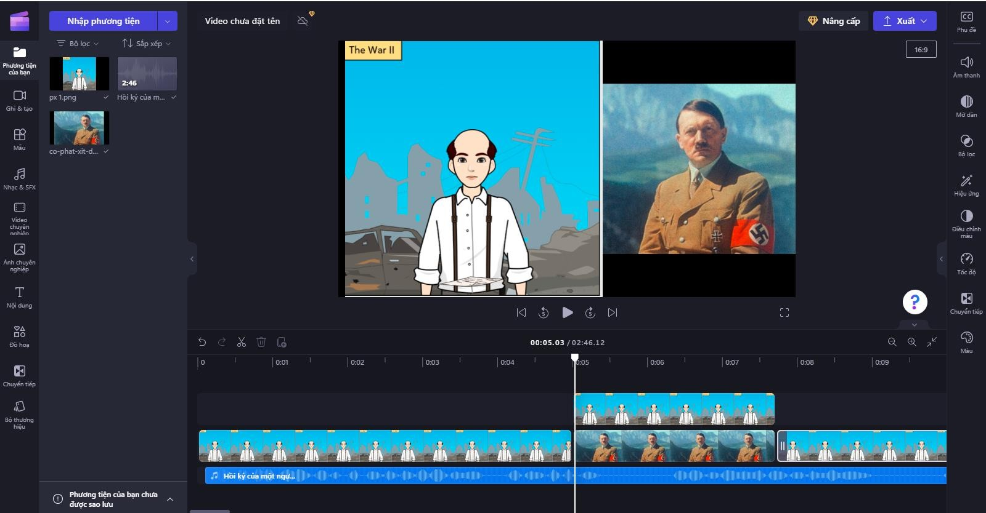a**

*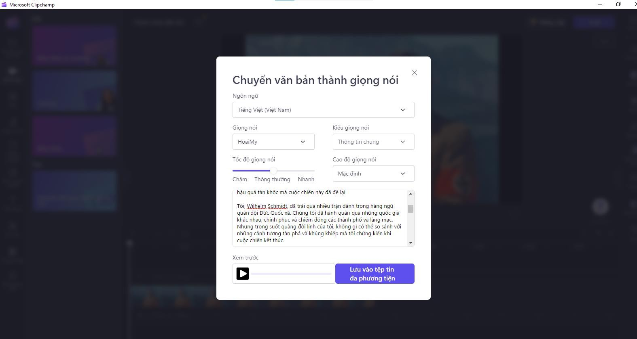***Figure 3. Adding the Story and Selecting an AI Voice**

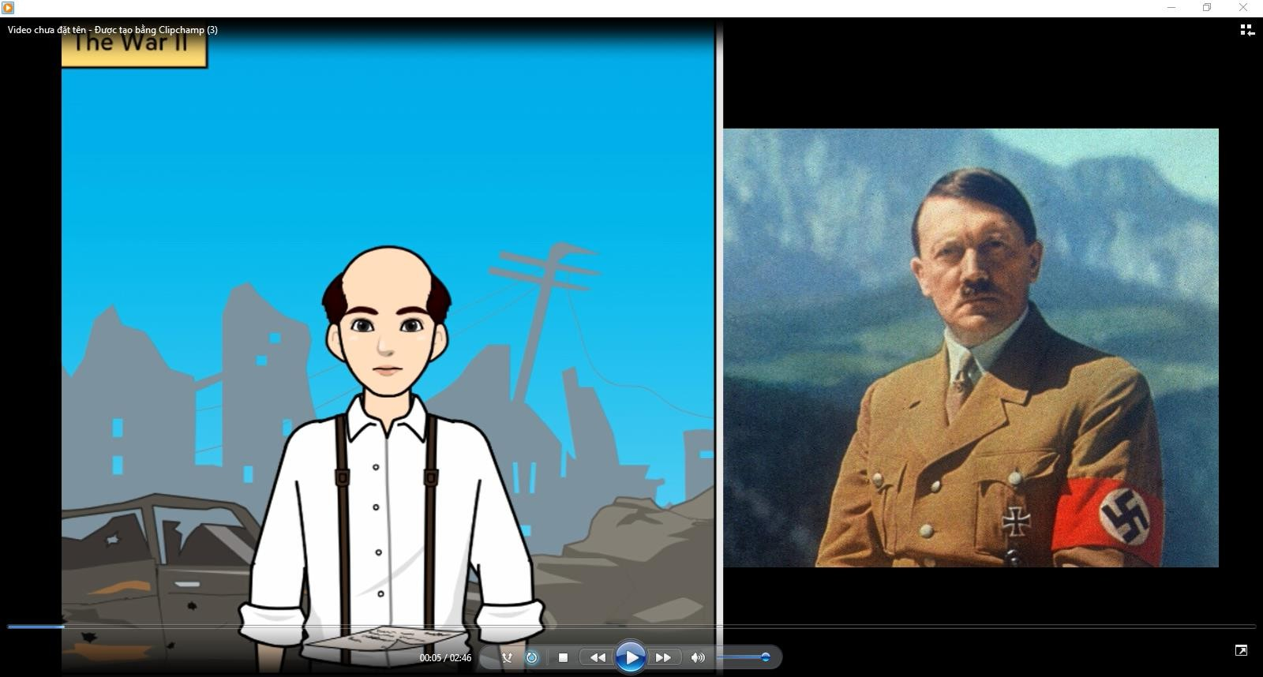

**Figure 4. Sample Video Product Created by Students Using Clipchamp**

Through this process, students use two IT tools—ChatGPT and Clipchamp—to design a short video recreating part of the consequences of World War II from the perspective of a Fascist soldier, including personal reflections and evaluations of the war. This helps students develop the ability to propose and choose solutions.

**Phase One:** Students review the storyline generated by ChatGPT. This task helps them build the ability to gather information from various sources and verify the accuracy of content provided by AI tools, thus fostering their skills in selecting accurate historical information.

**Phase Two:** Making evaluations of the historical event deepens students’ understanding of the issue.

**Phase Three:** Selecting images and designing the video encourages students to filter information streams and propose creative video production ideas.

By going through these three phases, students gradually develop components of enhanced problem-solving and creativity competence through the practical application of a lesson aimed at exploring new historical knowledge.

**2.3.2. Measures for Applying Information Technology in Organizing History Practice Lessons**

One of the innovations in the 2022 History Curriculum is the emphasis on **History Practice** content. According to Circular No. 13/2022/TT-BGDĐT, the practical component is clearly defined in terms of expected learning outcomes, organization methods, and allocated time.

The basic expected outcomes of history practice activities include:

Consolidating and deepening historical knowledge;

Practicing subject-specific skills and developing historical competencies;

Creating interest and engagement in learning.

Accordingly, history practice lessons can be conducted in various formats, such as:

Organizing classroom-based history practice activities;

Conducting educational activities linked with field trips to historical and cultural heritage sites;

Learning at museums, watching historical documentaries;

Organizing clubs and competitions such as "I Love History", "Young Historian", or historical games.

To ensure that history practice lessons effectively enhance students’ problem-solving and creative competencies, teachers can utilize IT tools following this process:

**Diagram 2. AI Application Process in Teaching History Practice Lessons to Develop Students’ Problem-Solving and Creativity Competence**

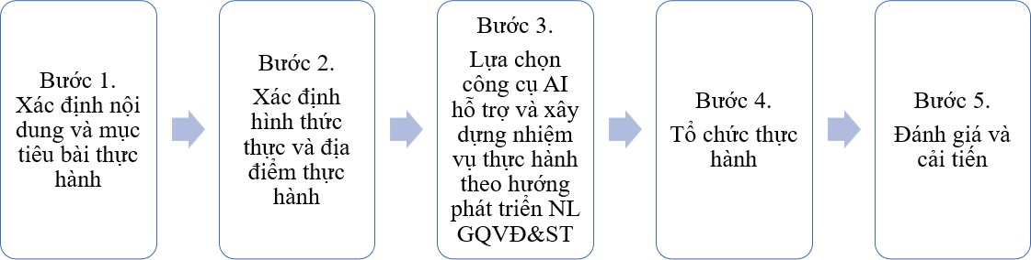

**Example: Teaching a History Practice Lesson on “Ancient Eastern Civilizations” (Grade 10, High School)**  
Using the process outlined above, the practice lesson can be organized as follows:

**Practice Content:** Aligned with the theme *“Some Ancient Eastern Civilizations.”*

**Objectives:**

* Reinforce knowledge about the cultural achievements of ancient India, China, and Egypt. Stimulate interest in learning. Train students in analyzing and interpreting historical sources.
* Encourage students to ask valuable questions, avoid accepting one-sided information or perspectives, and consider strong arguments and evidence related to historical figures, events, and viewpoints (Independent Thinking).

**Format and Location:** History game activity conducted in the classroom within one lesson period.

**Supporting IT Tool:** **Learnt.ai** – assists teachers in designing history practice games.

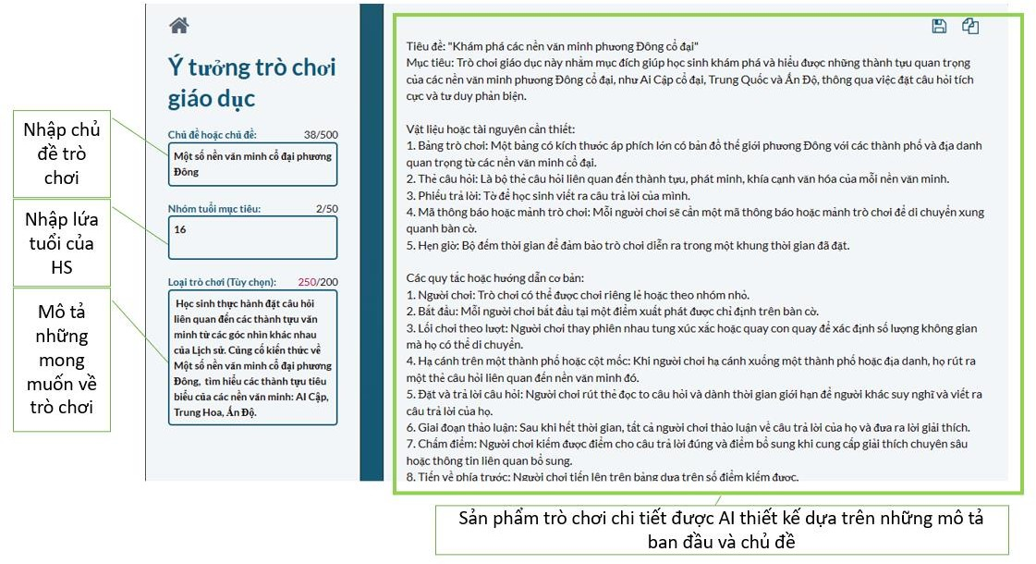Let me know if you'd like help designing a sample history game or instructional plan based on this lesson.

**Figure 4. Interface for Entering Game Information for Learnt.ai to Suggest a Detailed History Practice Game Idea**

After entering the theme, game description, and student age group, **Learnt.ai** suggested an idea for organizing a history practice game titled: **"Exploring Ancient Eastern Civilizations"**, including objectives, support tools, and detailed instructions. Specifically as follows:

**Materials or Resources Needed:**

1. **Game Board**: A large poster-sized board featuring a map of the Eastern world with major cities and landmarks from ancient civilizations.
2. **Question Cards**: A set of cards with questions related to achievements, inventions, and cultural aspects of each civilization.
3. **Answer Sheets**: Paper for students to write down their answers.
4. **Tokens or Game Pieces**: Each player needs a token or game piece to move around the board.
5. **Timer**: A countdown timer to keep the game within a set time limit.

**Basic Rules or Guidelines:**

1. **Players**: The game can be played individually or in small groups.
2. **Starting Point**: Each player begins at a designated starting point on the game board.
3. **Turn-Based Play**: Players take turns rolling a die or spinning a spinner to determine how many spaces they move.
4. **Landing on a City or Landmark**: When a player lands on a city or landmark, they draw a question card related to the corresponding civilization.
5. **Pose and Answer the Question**: The player reads the card aloud and everyone has a limited time to think and write down their answers.
6. **Discussion Phase**: After time is up, all players discuss their answers and provide explanations.
7. **Scoring**: Players earn points for correct answers and bonus points for in-depth explanations or additional related information.
8. **Progressing on the Board**: Players advance on the board based on the points they earn.
9. **Special Spaces**: The game board may include special spaces like “Invention Point” or “Cultural Achievement Point,” where players can earn bonus points or draw additional question cards.
10. **Winning**: The player or team with the highest score at the end of the game is declared the winner.

The teacher can modify the game to suit actual classroom conditions and organize it during a History Practice session. Special attention is given to Steps 4, 5, and 6 of the game:

**Step 4:** When a player lands on a city or landmark, they draw a question card related to that specific civilization.

**Step 5:** The player reads the question aloud and allows a limited amount of time for others to think and write down their answers.

**Step 6:** After time is up, all players discuss their answers and provide explanations.

By engaging students in active questioning, critical thinking, and discussion, this game encourages learners to explore in greater depth the achievements of ancient Eastern civilizations. The game also promotes cooperation and healthy competition among players, making the exploration of ancient civilizations an engaging and enjoyable experience. It fosters students' **independent thinking** and contributes to the development of their **problem-solving** and **creativity** through practical history lessons.

**3. CONCLUSION**

Through the study of applying information technology in teaching History with the aim of developing **problem-solving** and **creative competence** for high school students, we have drawn several important conclusions:

**First**, the content structure and lesson types in the high school History curriculum offer significant potential to foster students' problem-solving and creativity. This is especially true when teachers flexibly apply IT tools and design suitable learning tasks that stimulate thinking and creativity. Open-ended lessons that place students in problem-solving scenarios, combined with technological support, encourage students to actively explore, analyze, and propose solutions, thereby shaping and enhancing the core competencies required by the curriculum.

**Second**, many current IT tools are highly suitable for integration into the design and delivery of History lessons. Tools such as **ChatGPT**, **Clipchamp**, **Learnt.ai**, and **Dreamstudio.ai** share the common advantage of AI integration, offering effective support in idea generation, content creation, and quick, intuitive design of images and videos. These tools not only save teachers time in preparing lessons but also provide engaging learning experiences for students, encouraging creativity and personal expression through multimedia learning products.

**Third**, to effectively leverage technology in History teaching for competency development, teachers must focus on designing learning tasks with **clear objectives** aligned with the curriculum’s expected outcomes. These tasks should clearly reflect specific indicators of the competencies to be developed and offer opportunities for students to actively investigate, analyze, evaluate, and propose contextually appropriate historical solutions. The integration of academic content with technology tools should be carefully balanced to avoid over-reliance on technology at the expense of essential knowledge and thinking skills.

**Fourth**, the proposed strategies in this study have shown feasibility when applied in real-life high school History teaching contexts. However, for effective implementation, teachers should be flexible in selecting and adjusting the frequency of technology use, depending on infrastructure conditions, students’ tech proficiency, and lesson objectives. Most importantly, the use of technology should aim to enhance **student engagement, interest, and creativity**, rather than simply serving as a tool for display or information illustration.

In conclusion, this research affirms that **information technology**, when used appropriately, can become a powerful ally in renewing History teaching methods in the direction of **competency development**, contributing to the **improvement of educational quality** in the modern context.

**REFERENCES**

[1]. Ministry of Education and Training. (2018). *General Education Curriculum Framework*.  
[2]. Ministry of Education and Training. (2022). *History Subject Curriculum – General Education Program*.  
Issued together with Circular Circular No. 13/2022/TT-BGDĐT issued by the Ministry of Education and Training  
[3]. Copeland, B. (2023). *Artificial Intelligence*. Encyclopedia Britannica. <https://www.britannica.com/technology/artificial-intelligence>  
[4]. Luckin, R., & Holmes, W. (2016). *Intelligence Unleashed: An Argument for AI in Education*.  
[5]. Meier, B., & Nguyễn Văn Cường. (2020). *Modern Teaching Theory: Foundations for Innovation in Objectives, Content, and Teaching Methods*. Pedagogical University Publishing House.  
[6]. International AIED Society. (2010). *About the Society*. <http://iaied.org/about/>  
[7]. Underwood, J., & Luckin, R. (2011). *What is AIED and Why Does Education Need It?* Report for the Teaching and Learning Research Programme: Technology-Enhanced Learning – Artificial Intelligence in Education. United Kingdom. Retrieved from http://tel.ioe.ac.uk/wp-content/uploads/2011/06/telaied_whyaied.pdf