**Artificial Intelligence and Critical Thinking in Language Learning: A Study of HUFLIT Students**

*Nguyễn Minh Tuấn*

**Abstract**

This article presents students’ feedback to understand the relationship between artificial intelligence (AI) and students’ critical thinking in the context of language learning at Ho Chi Minh City University of Foreign Languages and Information Technology (HUFLIT). The feedback centers on the importance of critical thinking in language acquisition, common AI tools, and the role of AI in supporting the development of critical thinking skills. The research findings were collected from a combination of questionnaire responses and direct observations of over 200 students studying at HUFLIT. The results indicate that students have adapted their approach to coursework requiring critical thinking by applying AI tools to assist in brainstorming, selecting appropriate prompts, and constructing relevant arguments. Moreover, students have also encountered difficulties in evaluating and verifying the content suggested by AI or worrying about the level of dependence on AI tools in learning language. The study is a foundation for integrating critical thinking with AI tools in language education. In addition, it highlights the challenges related to the adaptation of language teaching and learning practices in the context of advanced artificial intelligence.

***Keywords:*** artificial intelligence, critical thinking, language acquisition, adaptation

1. **Introduction**

In Vietnam’s fast-growing and globalized society, critical thinking is an important skill for students. It helps them understand and judge information, solve problems, and make smart decisions in both school and real life (Quinn et al., 2020; Shanta & Wells, 2022). In the past, the Vietnamese education system focused more on memorizing lessons and teacher-centered learning. However, people are starting to see the need to help students think more deeply and independently. This change can be seen in new educational reforms.

At the same time, the development of Artificial Intelligence (AI) brings new chances to improve education, especially as Vietnam moves toward Industry 4.0. AI can help learning more personalized and give students feedback right away (Alam, 2022; Kamalov et al., 2023). AI tools can change lessons to match each student’s learning style and speed, which is helpful because students in Vietnam have different ways of learning. This may make learning more interesting and effective, moving beyond old teaching methods.

Also, AI give feedback quickly, so students can fix their mistakes right away. This is very useful in large classes, which are common in Vietnamese universities. Teachers can also see which students need more help and give them support on time. These new ways of learning can help students become more active and better prepared for today’s world.

At Ho Chi Minh City University of Foreign Languages and Information Technology (HUFLIT), critical thinking is very important. The school focuses on foreign languages and technology and wants students to become “global citizens” who can think well, solve problems, and make good decisions. These skills are very important because Vietnam is becoming more connected to the world, and the job market needs people who can think clearly and work creatively. HUFLIT also supports students in gaining real-world experience and learning how to grow on their own, which helps build these skills.

AI gives HUFLIT a chance to improve its teaching methods. Because HUFLIT students come from different backgrounds and study different subjects, AI can help them learn in ways that suit their needs. Tools like ChatGPT or Grammarly can give fast feedback and guide students as they learn. HUFLIT has already shown interest in AI through events like “Critical Thinking in the AI Era” and “AI-Powered Learning.” The university has also done research on how teachers feel about using AI tools for English teaching and testing.

This study looks at how HUFLIT students feel about critical thinking in language learning, especially when using AI tools. As students use more tools like ChatGPT, Grammarly, and translation apps, it is important to understand how these tools affect their thinking. The study will focus on what students think about AI’s benefits, how it helps them learn, and what problems it may cause. The research will answer these questions:

* 1. What are HUFLIT students’ perceptions of critical thinking in language acquisition?
  2. How do HUFLIT students perceive the benefits of AI tools in supporting or enhancing their critical thinking skills during language learning?
  3. What drawbacks do HUFLIT students identify when using AI tools to develop critical thinking in language acquisition?

1. **Literature Review**
   1. **Perceptions of AI in education**

AI is a field of science and technology that focuses on building computer systems that can do tasks usually done by humans, such as recognizing images, making decisions, and learning from experience (Minsky, 1985). AI is developing quickly and is becoming more important in many areas, including education (Russell & Norvig, 2020). The main goal of AI is to create machines that can understand their surroundings, make decisions, and adjust to changes in a way that is similar to how people think (Nilsson, 1998).

Some main parts of AI include machine learning, natural language processing, image recognition, and automation. Machine learning helps computers learn from data without being directly programmed (Bishop, 2006). Natural language processing allows computers to understand and respond to human language (Jurafsky & Martin, 2023).

In education, AI tools like smart tutoring systems, learning platforms that adapt to students, and language tools can help students improve their critical thinking. These tools give students personalized lessons, quick feedback, and chances to explore on their own, which support critical thinking (Holmes et al., 2019). For example, AI systems can give students real-life problems to solve, help them look at data, and guide them in thinking about different solutions. This hands-on and flexible learning helps students not only learn information but also think about it in deeper ways (Luckin et al., 2016).

* 1. **Perceptions of critical thinking in education**

Critical thinking is an important skill that helps students judge information carefully and make smart decisions, especially in today’s fast-changing world. For university students, strong critical thinking skills are key to success in both study and future careers. As Chen (2020) explained, critical thinking allows students to solve problems by coming up with creative solutions. At university, students face a large amount of information and many challenges, which gives them good chances to develop these skills.

Critical thinking means being able to process information in a logical way to make good decisions. Everyone needs this skill to solve problems and handle difficult situations (Papathanasiou et al., 2014). Critical thinking is not something people are born with, it can be taught, practiced, and improved through learning (Khan et al., 2023).

Paul (1985) described critical thinking as learning how to ask and answer deep questions, including those that involve analysis and evaluation. Brookfield (1987) added that it includes identifying and questioning assumptions and thinking about different ideas. Similarly, Pithers and Soden (2000) said that critical thinking includes many abilities such as recognizing a problem, examining the assumptions behind it, analyzing information, and judging whether sources are reliable.

Schafersman (1991) explained that critical thinking is similar to the scientific method used in everyday life. Like scientists, critical thinkers ask questions, make guesses, gather evidence, test their ideas, and draw conclusions. In this way, critical thinking follows the same steps as scientific thinking.

One important part of critical thinking is the ability to look at information carefully, judge arguments, and reflect on your own thinking. AI tools—like advanced language models such as ChatGPT—can help students do this by asking good questions, offering new ideas, and encouraging deeper thinking (Zawacki-Richter et al., 2019). When students interact with AI, they are asked to explain their thoughts, respond to different views, and improve their reasoning. This ongoing process of questioning and reflection helps students build stronger critical thinking skills (Fischer et al., 2013).

* 1. **Previous research on the impacts of AI on critical thinking**

AI is now widely used in education, including in language learning. Tools like ChatGPT, Grammarly, and translation apps help students improve their writing, grammar, vocabulary, and reading skills. As these tools become more common, it is important to understand how they affect students’ critical thinking, especially in language classrooms.

AI can support the development of critical thinking by personalizing learning. It can analyze students' strengths and weaknesses and offer practice activities that match their needs (Holmes et al., 2019). For example, a student who struggles with sentence structure may get extra grammar exercises, while another student may be asked to write longer essays or respond to open-ended questions. This type of support can help students think more carefully about how they use language, which is an important part of critical thinking in communication (Luckin et al., 2016).

However, some researchers warn that too much use of AI can reduce students’ ability to think critically when learning a language (Holmes et al., 2019; Selwyn, 2022). If students always rely on AI to correct their writing, suggest ideas, or translate texts, they may not learn how to solve language problems on their own. Carr (2020) found that over-reliance on AI can weaken students' independent thinking, which is important in both academic and real-life communication. Selwyn (2019) also pointed out that AI tools often give fast answers, which can stop students from thinking deeply about grammar, meaning, or context.

In language learning, critical thinking includes understanding the meaning behind texts, questioning word choices, comparing different writing styles, and expressing ideas clearly. If students accept AI-generated answers without thinking or making changes, they may miss the chance to develop these skills (Williamson et al., 2020). For example, when using AI to generate an essay or translation, students may not evaluate whether the content is accurate, appropriate, or creative. This can lead to less engagement with the language.

Studies also show that AI might reduce creativity in writing tasks. Holmes et al. (2019) explained that language learners develop critical thinking when they brainstorm ideas, choose words carefully, and organize their thoughts clearly. But AI often gives ready-made solutions, which may limit opportunities for original thinking. Selwyn (2022) found that students who use AI too much often write less creatively and reflect less on their choices, which weakens their critical language skills.

Another issue is the passive use of AI in language learning. Solon (2003) noted that students who do not actively think while using learning tools may show weak analysis and rely only on memory. In language classes, this may appear when students memorize grammar rules but cannot use them correctly in real situations. Johnson (2021) added that this surface-level learning reduces students' ability to apply language in flexible and meaningful ways.

Chen (2020) explained that without strong critical thinking, students tend to accept information or translations without asking whether they are accurate or appropriate for the context. This can affect how they understand texts, build arguments, or communicate ideas in another language skills that are essential for successful language use in academic and professional settings.

1. **Methodology**
   1. **Participants**

The participants of this study consisted of 240 students from Ho Chi Minh City University of Foreign Languages and Information Technology (HUFLIT), all of whom are majoring in English. According to data from the Faculty of Foreign Languages, there are currently more than 3,000 English-major students enrolled at HUFLIT all year levels. The sample size of 240 students represents approximately 8% of the total English-major population. Although this is a small percentage, it provides a useful overview for a small-scale study and helps reflect general trends among students.

Participants were selected through convenience-based sampling from various classes that focus on language learning and critical thinking. Among them, 25% were first-year students, 62% were sophomores, and the remaining 13% were in their third year of study. The majority of the courses in their curriculum focus on academic English, and many of these courses incorporate elements of critical thinking starting from the first semester. As critical thinking plays a vital role in both language acquisition and academic success, it is considered an essential skill for English majors at HUFLIT. In recent years, students have increasingly accessed AI tools, which they are now able to use not only to enhance their critical thinking abilities but also to support their overall academic performance.

* 1. **Data collection**

This study adopted a qualitative approach and used questionnaires as the main tool for data collection. The questionnaire consisted of ten items: eight closed-ended questions and two open-ended questions. The closed-ended items aimed to collect information regarding students’ use of AI in relation to critical thinking. Specifically, they explored how students use AI in their studies, how their critical thinking has changed before and after the introduction of AI, and the overall impact of AI on their thinking skills.

Some of these questions required students to choose a single answer from a list, while others allowed for multiple selections. In addition, two open-ended questions were included to gather students’ opinions on effective methods for using AI to develop critical thinking.

The questionnaire items were developed by the researcher, based on key themes from the literature on AI in education and critical thinking (Papathanasiou et al., 2014; Chen, 2020), but were adapted to fit the specific context of HUFLIT students and language learning. The combination of both question types allowed for a more comprehensive understanding of students' experiences and perspectives.

* 1. **Data Analysis**

The questionnaires were created using Google Forms due to its convenience and reliability in collecting responses. The forms were distributed to students during their regular class sessions, accompanied by clear explanations. The data collection process lasted for four weeks.

After the responses were gathered, the data were carefully analyzed and categorized according to the purpose of each question. Responses were grouped based on different aspects such as the students’ perceptions of critical thinking without AI, the impacts of AI on students’ critical thinking in language acquisitionand, and their suggested methods for improving thinking skills through AI. The findings were presented using visual charts, accompanied by descriptive summaries to help interpret the results clearly and effectively.

1. **Results**

The collected responses were organized into two main categories: students’ critical thinking without using AI, the impacts of AI on students’ critical thinking, which show benefits and challenges associated with using AI for critical thinking. The data are presented through charts and tables; each accompanied by a brief description explaining the participants’ responses and highlighting key findings in each category.

* 1. **The students’ perceptions of critical thinking without AI**

**Figure 1**

*The importance of critical thinking in language learning*

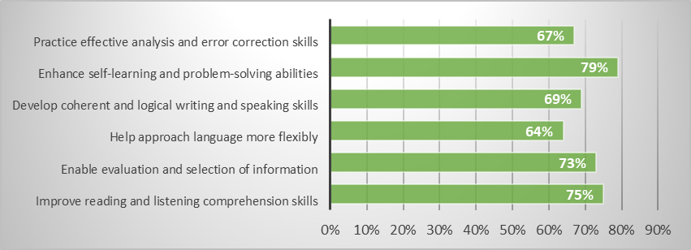

Figure 1 suggests that students view critical thinking as an important part of language learning. Many students (79%) reported that it supports self-learning and problem-solving. Similarly, 75% believed it improves reading and listening comprehension, while 73% stated that it helps them evaluate and select information more effectively. In addition, 69% noted that critical thinking contributes to clearer and more logical writing and speaking, and 67% said it helps with analyzing and correcting errors. Finally, 64% agreed that it allows for more flexible use of language. These results indicate that students recognize the wide-ranging benefits of critical thinking in developing their language skills.

**Figure 2**

*Ways to practice critical thinking without using AI*

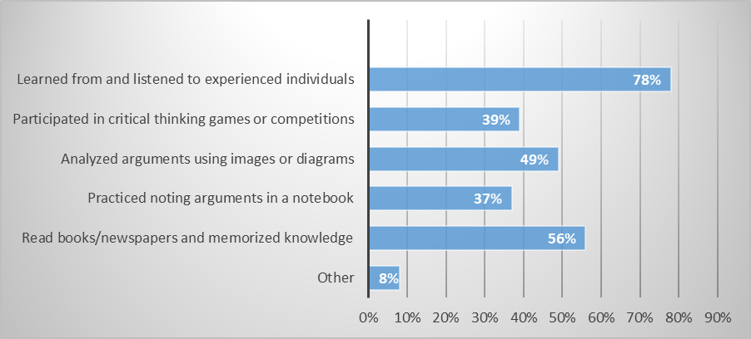

Before using AI tools, HUFLIT students practiced critical thinking in many traditional ways. The most common method, chosen by 78% of students, was learning from and listening to experienced people. This shows that personal interaction and advice were seen as helpful for improving thinking skills. Other popular methods included reading books or newspapers and memorizing information (56%), using images or diagrams to understand arguments (49%), and joining critical thinking games or competitions (39%). Also, 37% of students said they wrote down arguments in notebooks to organize their ideas. Only 8% chose “Other,” which means most students followed common ways to build their thinking skills. These results show that before AI became popular, students mostly depended on their own effort, traditional learning, and advice from others to improve critical thinking.

* 1. **The impacts of AI on students’ critical thinking in language acquisition**

**Figure 3**

*The frequency of using AI to support critical thinking*

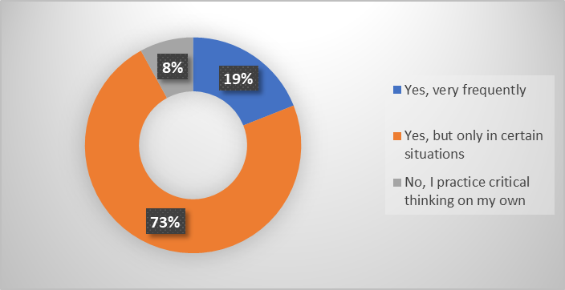

Based on Figure 3, a significant majority of students (73%) reported that they use AI to support their critical thinking skills, but only in specific situations where they find it necessary or helpful. Meanwhile, 19% of respondents indicated that they rely on AI very frequently when engaging with subjects that demand critical thinking, suggesting a strong dependence on technological tools for cognitive support. In contrast, a small minority of 8% stated that they do not use AI at all, preferring instead to develop and practice critical thinking skills independently. These findings highlight a growing trend in blended learning approaches, where most students balance AI assistance with their own analytical abilities.

**Figure 4**

*The measurement of using AI to complete writing*

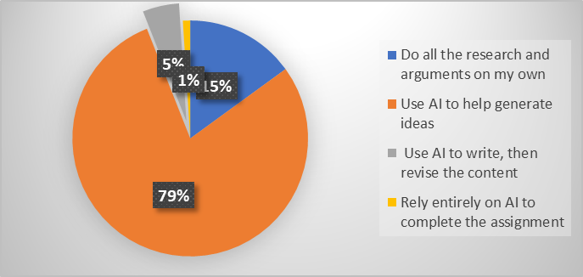

In figure 4, many respondents (79%) said they use AI to help generate ideas. This shows that many students see AI as a useful tool in the brainstorming stage. Only 15% of students said they do all the research and arguments on their own, which suggests that traditional, independent work is less common. A small number of respondents (5%) use AI to write the essay first and then revise the content, while just 1% rely entirely on AI to complete the whole assignment. Overall, the results show that while AI is widely used to support idea generation, most students keep control over the final content of their essays.

**Figure 5**

*The advantages of using AI in developing critical thinking skills*

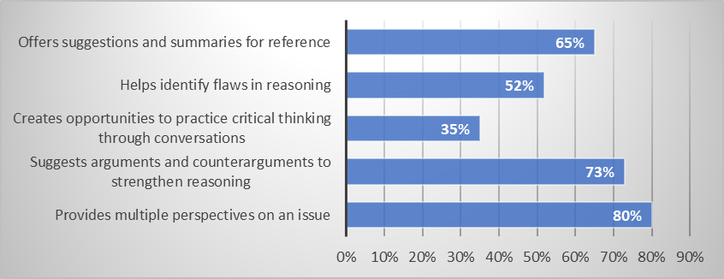

Figure 5 indicates that students see AI as a valuable tool for developing critical thinking skills in several ways. The most common benefit, chosen by 80% of respondents, is that AI provides multiple perspectives on an issue, helping students view topics from different sides. Additionally, 73% believe AI supports students to explain reasons by suggesting arguments and counterarguments, which strengthens their ability to analyze both sides of a topic. About 65% of students find AI useful for offering suggestions and summaries, which serve as helpful references during the thinking process. Furthermore, 52% say AI helps them identify flaws in their reasoning, allowing for improvement. Although less commonly selected, 35% still appreciate that AI creates opportunities to practice critical thinking through interactive conversations. Overall, these findings show that students value AI for both guiding and improving their critical thinking skills.

**Figure 6**

*The benefits of using AI in enhancing critical thinking skills*

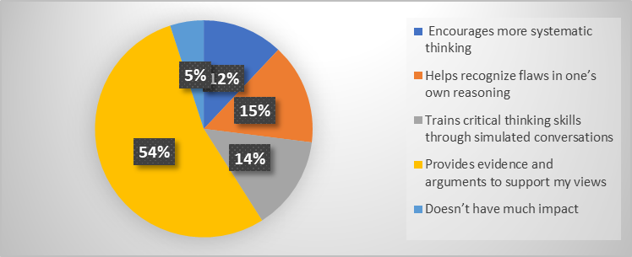

Figure 6 shows that over half of the students (54%) believe AI enhances their critical thinking by providing evidence and arguments that support their viewpoints, helping them build stronger, more logical ideas. A smaller portion, 15%, feel that AI helps them recognize flaws in their own reasoning, while 14% think it trains critical thinking skills through simulated conversations. Additionally, 12% say AI encourages more systematic thinking. Only 5% of students believe AI does not have much impact on their critical thinking. Overall, most students see AI as a helpful tool for supporting and improving how they think and reason.

**Figure 7**

*Students’ level of independence when using AI*

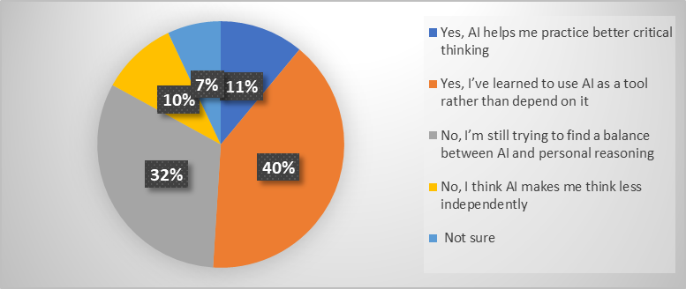

Figure 7 suggests mixed feelings about AI’s impact on students’ independence in critical thinking. While 40% of students say they have learned to use AI as a tool rather than depend on it, and 11% feel AI helps them practice better critical thinking, a significant portion (32%) admit they are still trying to find the right balance between using AI and relying on their own reasoning. Meanwhile, 10% believe AI reduces their ability to think independently, and 7% remain unsure. These results highlight that although many students see AI as a helpful aid, concerns about overreliance and maintaining personal thinking skills still exist.

**Figure 8**

*The challenges of using AI on students’ critical thinking skills*

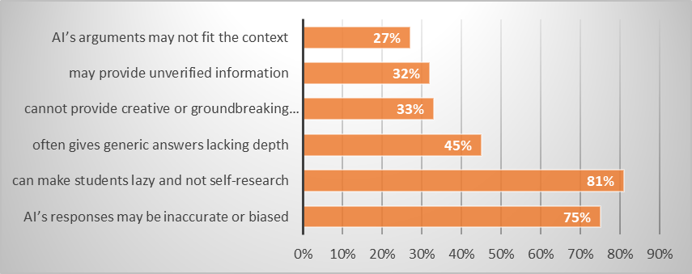

Figure 8 highlights several key limitations of AI that students believe could negatively affect their critical thinking skills. The most reported concern, noted by 81% of respondents, is that AI may encourage laziness and reduce students' motivation to conduct their own research. Additionally, 75% are concerned that AI’s responses may be inaccurate or biased, which can mislead students and weaken their reasoning. About 45% feel that AI often gives generic answers that lack depth, while 33% think AI cannot provide creative or original arguments. Furthermore, 32% worry that AI may offer unverified information, and 27% believe its arguments may not always fit the context. These findings suggest that while AI can be a helpful tool, its limitations must be understood and managed to avoid hindering students’ independent and critical thinking development.

**Table 1**

*Students’ views on whether AI can replace human critical thinking*

|  |  |  |  |
| --- | --- | --- | --- |
| **AI replaces human critical thinking skills in the future.** | **%** | **Because AI…** | **%** |
| Yes | 18% | processes information quickly | 31% |
| has access to a lot of knowledge | 22% |
| has more logical and fair thinking | 20% |
| supports complex problem-solving | 13% |
| others | 14% |
| No | 82% | cannot feel emotions or ethics | 48% |
| lacks human creativity | 21% |
| does not understand context deeply | 11% |
| relies on existing information | 11% |
| others | 8% |

According to Table 1, most respondents (82%) believe that AI cannot replace human critical thinking skills in the future. The main reason is that AI cannot feel emotions or ethics, chosen by 48% of those who answered “No.” Other reasons include that AI lacks human creativity (21%), does not understand context deeply (11%), and relies only on existing information (11%).

On the other hand, only 18% of respondents believe that AI can replace human critical thinking. Among them, 31% say this is because AI can process information quickly. In addition, 22% think AI has access to a large amount of knowledge, 20% believe AI shows more logical and fair thinking, and 13% say it can support complex problem-solving. This shows that while some people recognize the strengths of AI, most still believe that human critical thinking is unique and cannot be fully replaced by machines.

1. **Discussion**

The objectives of this study are to explore HUFLIT students’ perspectives on critical thinking in language learning, assess their views on the benefits of using AI tools, and identify any limitations associated with these technologies. The findings are structured into following key areas: students’ perceptions of critical thinking and its role in their language acquisition; the advantages of AI in supporting or enhancing their critical thinking skills; and the challenges or drawbacks students associate with the use of AI tools during language learning. In addition, this discussion reflects on how students’ digital literacy, their ability to effectively use, evaluate, and interact with digital technologies affects their critical thinking with AI tools across different year levels.

The results of this study show that HUFLIT students clearly understand the importance of critical thinking in learning languages. Most students said that critical thinking helps them learn by themselves, understand better, express ideas more clearly, and check their language use. These findings agree with Papathanasiou et al. (2014) and Chen (2020), who explained that critical thinking supports problem-solving and helps students deal with complex learning situations. Students also believed that thinking critically allows them to use language more flexibly and logically, which supports Brookfield’s (1987) idea that critical thinking involves questioning assumptions and making careful decisions.

Before using AI, students practiced critical thinking through traditional methods such as reading, writing notes, and learning from experienced people. These activities show that students already have a strong base for thinking actively and deeply. This supports Schafersman’s (1991) view that critical thinking is a process of asking questions and finding answers through careful thought and observation. However, students' ability to transfer these habits into digital environments, especially when using AI tools varied their level of digital literacy.

The findings also show that many students believe AI can support their critical thinking. Students said that AI helps them come up with ideas, see topics from different sides, and create better arguments. This matches what Holmes et al. (2019) and Luckin et al. (2016) suggested that AI can give personalized help and guide students in their thinking. In particular, the fact that 80% of students appreciated AI’s ability to offer many viewpoints supports Zawacki-Richter et al. (2019), who said AI can help students reflect by simulating conversations. However, not many students said they used AI for real conversations, which shows that students may not fully use AI as a thinking partner. This means that more support is needed to teach students how to use AI in a more interactive and reflective way, as recommended by Fischer et al. (2013).

At the same time, students also showed serious concerns about using AI too much. Over 80% worried that using AI might make them less interested in doing their own research. Digital literacy also influenced students’ awareness of AI limitations. More experienced or digitally literate students also said AI sometimes gives general or incorrect answers. They were more likely to double-check information, compare outputs, or refine their prompts. These concerns are similar to what Selwyn (2019, 2022) and Carr (2020) warned about: that depending too much on AI could lead to shallow learning and weaker thinking. Students also said AI cannot give creative or detailed responses as humans can, which supports the opinion of Rose et al. (2022) that AI still lacks the ability to think in flexible and original ways.

Students gave multiple answers when asked if they still felt independent while using AI. Some (about 40%) said they used AI as a helpful tool, but others were still trying to find the right balance. This supports Solon’s (2003) view that using technology passively can weaken mental performance.

In addition, most students (82%) believed AI cannot replace human critical thinking. They said AI lacks emotional understanding, creativity, and the ability to understand context. This agrees with the ideas of Paul (1985), who said real critical thinking includes moral thinking and self-awareness, things that current AI cannot do. A small number of students (18%) believed that AI might replace human thinking in the future because of its speed and knowledge. However, most students and many researchers believe that AI should be used as a tool to support, not replace, human thinking.

The findings of this study suggest that students can benefit more from AI tools when they are used in critical thinking. Instead of relying completely on AI-generated support, students are encouraged to use AI as a useful tool to generate ideas, check arguments, or explore different perspectives while still taking responsibility for analyzing, evaluating, and improving their own work. Therefore, they can strengthen their critical thinking skills and avoid the risk of becoming passive learners. Students should also develop their digital literacy by learning how to ask better questions, assess AI suggestions critically, and recognize when information is too general or incorrect. In this way, students can make the most of AI’s advantages without weakening their own ability to think clearly and independently.

1. **Conclusion**

The research studied how HUFLIT students think about the use of AI and its effect on their critical thinking in language learning. The results show that students understand the importance of critical thinking. They believe it helps them learn better, understand language more deeply, and express their ideas more clearly. Before using AI, students practiced critical thinking through traditional ways such as reading books, taking notes, and asking for advice from experienced people.

Many students confirmed that AI supports their critical thinking. They use AI to get new ideas, see different opinions, and build better arguments. These findings agree with past studies, which said that AI can help students think more clearly and organize their thoughts. However, the study also found some problems. A lot of students worry that using AI too much can make them lazy and less interested in learning by themselves. They also said that AI sometimes gives simple, wrong answers and cannot think creatively like humans.

Most students do not believe that AI can replace human critical thinking. They think that AI cannot understand emotions, think creatively, or understand situations like people do. Only a few students believed that AI could replace human thinking in the future because of its speed and large amount of information. In general, students see AI as a helpful tool, but not something that can fully replace their own thinking.

This study adds to the discussion about how AI affects learning. It also shows that students need to be guided on how to use AI in the right way. In the future, more research can look at how students use AI in a more active and thoughtful way, so it can support learning without reducing their own thinking skills.

1. **Limitations and Future Directions**

Although this study provides useful feedback on how HUFLIT students view and use AI to support critical thinking in language learning, there are some limitations that should be considered.

First, the study focused only on students from one university, which may limit how the findings apply to students in other institutions or regions. Future research could include participants from different universities and majors to compare results across a wider group of learners.

Second, the data were mainly collected through self-reported surveys. While these provide valuable personal views, they may not fully describe how students use AI in practice. Future studies could include classroom observations or interviews to gain a deeper understanding of how students apply AI tools in their learning situations.

Finally, this study did not explore the impact of different types of AI tools in detail. Some students may use AI for grammar correction, others for content generation or summarizing ideas. Future research could look more closely at how each type of AI tool supports or limits students’ critical thinking.

Despite these limitations, this study offers a useful point for understanding how students interact with AI in language learning. In the future, more research should focus on helping students use AI in independent and creative ways that truly support their academic growth.

**References**

Alam, A. (2022). Employing adaptive learning and intelligent tutoring robots for virtual classrooms and smart campuses: Reforming Education in the age of Artificial Intelligence. In *Lecture notes in electrical engineering* (pp. 395–406). <https://doi.org/10.1007/978-981-19-2980-9_32>

Bishop, C.M. 2006. Pattern Recognition and Machine Learning. Springer.

Brookfield, S. (1987). Developing critical thinkers. Milton Keyes: Open University Press.

Carr, N. (2020). The Shallows: What the Internet is Doing to Our Brains. New York, NY: W. W. Norton and Company.

Chen, L., Chen, P., & Lin, Z. (2020). Artificial Intelligence in Education: A Review. IEEE Access, 8, 75264–75278. https://doi.org/10.1109/ACCESS.2020.2988510

Fischer, F., Kollar, I., Stegmann, K., & Wecker, C. (2013). Toward a script Theory of Guidance in Computer-Supported Collaborative Learning. Educational Psychologist, 48(1), 56–66. <https://doi.org/10.1080/00461520.2012.748005>

Holmes, W., Maya, B., & Fadel, C. (2019). Artificial Intelligence in Education Promises and Implications for Teaching. In Journal of Computer Assisted Learning (Vol. 14, Issue 4).

Johnson, M., & Smith, K. (2021). Traditional Education in the Digital Age: Perceptions of Educators. Educational Technology & Society, 24(3), 152-168.

Jurafsky, D., Martin, J.H. 2023. Speech and Language Processing (3rd ed.). Prentice Hall.

Kamalov, F., Calonge, D. S., & Gurrib, I. (2023). New era of Artificial intelligence in Education: Towards a sustainable Multifaceted Revolution. *Sustainability*, *15*(16), 12451. <https://doi.org/10.3390/su151612451>

Khan, Z. A., Adnan, J., & Raza, S. A. (2023). Cognitive Learning Theory and Development: Higher Education Case Study. Education, 13.

Luckin, R., Holmes, W., Griffiths, M., & Forcier, L. B. (2016). Intelligence-Unleashed-Publication.

Minsky, M. 1985. The Society of Mind. New York: Simon and Schuster.

Nilsson, N. 1998). Artificial Intelligence: A New Synthesis. Morgan Kaufmann.

Papathanasiou, I., Kleisiaris, C., Fradelos, E., Kakou, K., & Kourkouta, L. (2014). Critical Thinking: the development of an essential skill for nursing students. *Acta Informatica Medica*, *22*(4), 283. https://doi.org/10.5455/aim.2014.22.283-286

Paul, R. W. (1985). Bloom’s taxonomy and critical thinking intervention. Educational Leadership, 42(8), 36–39.

Pithers, R. T., & Soden, R. (2000). Critical thinking in education: A review. Educational Research, 42, 237–249.

Quinn, S., Hogan, M., Dwyer, C., Finn, P., & Fogarty, E. (2020). Development and Validation of the Student-Educator Negotiated Critical Thinking Dispositions Scale (SENCTDS). *Thinking Skills and Creativity*, *38*, 100710. <https://doi.org/10.1016/j.tsc.2020.100710>

Russell, S., Norvig, P. 2020. Artificial Intelligence: A Modern Approach (4th ed.). Pearson.

Schafersman. (1991). An introduction to critical thinking. Retrieved March 16, 2010 from: [www.freeenquiry/criticalthinking.html](http://www.freeenquiry/criticalthinking.html)

Selwyn, N. (2022). The future of AI and education: Some cautionary notes. European Journal of Education, 57(4), 620–631. https://doi.org/10.1111/ejed.12532

Shanta, S., & Wells, J. G. (2020). T/E design based learning: assessing student critical thinking and problem solving abilities. *International Journal of Technology and Design Education*, *32*(1), 267–285. <https://doi.org/10.1007/s10798-020-09608-8>

Solon, T. (2003). Teaching critical thinking: The more, the better! The Community College Enterprise, 9(2), 25-38.

Williamson, B., Bayne, S., & Shay, S. (2020). The datafication of teaching in Higher Education: critical issues and perspectives. Teaching in Higher Education, 25(4), 351–365. https://doi.org/10.1080/13562517.2020.1748811

Zawacki-Richter, O., Marín, V.I., Bond, M., Gouverneur, F. 2019. Systematic review of research on artificial intelligence applications in higher education. International Journal of Educational Technology in Higher Education, 16(1), 1-27.

**Bionote**

**Nguyen Minh Tuan** holds a master’s degree in TESOL and is currently an English lecturer at the Faculty of Foreign Languages, Ho Chi Minh City University of Foreign Languages and Information Technology (HUFLIT). He has over 12 years of experience teaching English to both majoring and non-majoring students. His research interests include English language pedagogy, English for Specific Purposes (ESP), and the integration of technology in English language teaching (ELT).

**Appendix: Survey Questionnaire**

**SURVEY QUESTIONNAIRE**

**Title:** Artificial Intelligence and Critical Thinking in Language Learning: A Study of HUFLIT Students

**Target group:** English majoring students at HUFLIT

**Purpose:** To investigate the extent to which AI affects students' learning in subjects related to critical thinking, logical reasoning, and argumentation skills.

1. **In your opinion, what is the importance of critical thinking in language learning?** (You may select multiple answers)

* Improves reading and listening comprehension skills
* Enables evaluation and selection of information
* Helps approach language more flexibly
* Develops coherent and logical writing and speaking skills
* Enhances self-learning and problem-solving abilities
* Practices effective analysis and error correction skills

1. **Before AI, what did you usually do to practice critical thinking?** (You may select multiple answers)

* Read books/newspapers and memorized knowledge
* Practiced noting arguments in a notebook
* Analyzed arguments using images or diagrams
* Participated in critical thinking games or competitions
* Learned from and listened to experienced individuals
* Other

1. **How do you usually complete argumentative or critical thinking essays?**

* Do all the research and arguments on my own
* Use AI to help generate ideas
* Use AI to write, then revise the content
* Rely entirely on AI to complete the assignment

1. **Do you think AI helps students develop critical thinking skills?**

* Yes, AI helps with deeper thinking and better arguments
* Yes, but sometimes students rely on AI too much
* No, because AI reduces independent reasoning
* Not sure

1. **In your opinion, how does AI help students develop critical thinking skills?** (You may select multiple answers)

* Provides multiple perspectives on an issue
* Suggests arguments and counterarguments to strengthen reasoning
* Creates opportunities to practice critical thinking through conversations
* Helps identify flaws in reasoning
* Offers suggestions and summaries for reference

1. **How do you think AI enhances students’ critical thinking skills?**

* Encourages more systematic thinking
* Helps recognize flaws in one’s own reasoning
* Trains critical thinking skills through simulated conversations
* Provides evidence and arguments to support my views
* Doesn’t have much impact

1. **When using AI to support critical thinking, do you feel you’re becoming more independent in your reasoning?**

* Yes, AI helps me practice better critical thinking
* Yes, I’ve learned to use AI as a tool rather than depend on it
* No, I’m still trying to find a balance between AI and personal reasoning
* No, I think AI makes me think less independently
* Not sure

1. **What limitations of AI could affect students’ critical thinking skills?** (You may select multiple answers)

* AI’s responses may be inaccurate or biased
* can make students lazy and not self-research
* often gives generic answers lacking depth
* cannot provide creative or groundbreaking arguments
* may provide unverified information
* AI’s arguments may not fit the context

1. **Do you think AI can completely replace human critical thinking skills?**

* Yes
* No

1. **Why or why not AI can completely replace human critical thinking skills?**

**Your answer:……………….**

*Thank you for your contribution. We will keep them for privacy*