THE IMPACTS OF AI-POWERED TOOLS ON STUDENTS’ LEARNING AND IMPROVEMENT IN SPECIAL ENGLISH FOR BUSINESS COURSE.
Linh Mỹ Thái
Abstract: AI development has significantly innovated the ways educators approach teaching. AI tools enable teachers to create more individualized and flexible learning experiences. As a result, AI-powered systems contribute greatly to the improved learning results and increased student engagement. The applications of AI in Special English for Business course- a compulsory subject in the training program for the Business English major, Faculty of Foreign Languages at Ho Chi Minh City University of Foreign Languages and Information Technology- have made students’ learning process more personalized, interactive, and efficient. This study aimed at exploring the effectiveness of AI tools in providing personalized language practice, automated assessments and instant feedback for students, as well as their effects on students' motivation and improvement of language skills. Data collected from surveys and classroom observations provide insights into the effectiveness of these tools.
Keywords: Special English for Business, AI’s applications, impacts
- Introduction
The integration of Artificial Intelligence (AI) into education has brought amazing benefits to teachers and learners. AI-powered tools, like Magic school AI, Education Co-Pilot offer automated processes and innovative features, which greatly support teachers in the process of preparing lectures and activities as well as designing tests and tasks. They provide a variety of tools to create customized content, such as quizzes. They play a significant role in reducing the burden on teachers thanks to features like generating feedback on student writing based on custom criteria or a rubric, generating text dependent questions based on any text, or generating a rubric for any assignment. In Business English courses, students have to deliver several presentations and this is a great tool to help them know their strengths and weaknesses. Various aspects of public speaking skills are assessed, including pace, volume, filler words, vocabulary choice, and interaction. This automatic feedback helps them make improvements. Similarly, students in these courses have to complete writing tasks. Writing in business is quite challenging for them because it requires formal style and tone. Grammarly is a widely used tool that helps improve writing accuracy, clarity, and style. It helps students identify, correct errors and learn from their mistakes as well. These personalized, flexible, and communicative learning experiences enable students to have active involvement and increased motivation in their learning process. In courses for specific purposes, such as Special English for Business, proficiency in both language and professional communication is of great importance.
At Ho Chi Minh City University of Foreign Languages and Information Technology (HUFLIT), the application of AI tools in teaching is encouraged to boost students' motivation and academic performance. Thanks to features like individualized learning paths, immediate feedback, and diversed practice tasks, these AI-enhanced language learning platforms enable students to make their learning more enjoyable and effective, helping them improve their skills and stay motivated.
This study aimed at investigating the impacts that AI tools have brought in providing personalized language practice, automated assessments and immediate feedback for students, as well as their effects on students' motivation and improvement of language skills in Special English for Business course.
This research aims at answering the following questions:
1. What impacts does the use of AI-driven tools have in providing personalized language practice, automated assessments and instant feedback for students?
2. To what extent do AI-driven assessments and instant feedback influence students’ motivation and improvement in core business English skills (reading, writing, listening, and speaking)?
2. Literature Review
AI has been applied into language learning in accordance with conceptual frameworks, including Vygotsky’s Zone of Proximal Development (ZPD), constructivist learning theories, and principles in Computer-Assisted Language Learning (CALL). According to Vygotsky (1978), the ZPD is the gap between what a learner can do independently and what they can do with guidance or support from a more knowledgeable other. With traditional teaching approaches, more knowledgeable others include their teachers, peers, or even family members. Thanks to the great development of AI tools, this more knowledgeable source is AI platforms. Recent studies conducted by Holmes, Bialik, & Fadel (2019) show that AI systems can serve as “more knowledgeable others” by providing instant feedback and personalized learning experiences that suit students’ specific needs. Additionally, according to Qu, M. (2025), AI-powered learning tools can serve as dynamic supports within Vygotsky’s Zone of Proximal Development because they offer personalized learning experiences that fills the gap between what learners can do independently and what they can achieve with guidance.
In a research conducted in 2023, Li, X., & Hafner, C. A. highlighted the significance of the immediate feedback and adaptive interaction provided by AI chatbots and writing assistants like Grammarly. These tools enable students to receive instant support, which allows them to perform at higher linguistic levels than they could without such timely assistance.
In a constructivist context, AI tools promote active participation of students thanks to the dynamic content and tailored tasks. Wang, Y., & Vasquez, C. (2022) demonstrated that AI - driven learning platforms enhance learners’ active engagement and motivate them through cognitive monitoring and individualized feedback. Another research by Chen, H. I. (2021) validated that intelligent tutoring systems showcase constructivist learning, as students take part in problem-solving tasks while receiving timely guidance based on their individual learning preferences.
These technologies also align with CALL principles because they emphasize learner self-directed learning, interaction, and authentic language use (Li & Zhang, 2023). Additionally, Qu (2025) confirmed that because AI-generated platforms can provide personalized guidance and constructive feedback, students are motivated in their learning process. Their diverse needs and expectations are met. Beatty, K. (2010) stated that AI applications represent CALL evolution, which promotes learner-centeredness, interactivity, and authentic communication, which are considered to be the most important elements of effective CALL principles. Moreover, Stockwell, G. (2022) found that AI-driven tools align with fundamental CALL principles because they provide immediate feedback and methods for students to develop their self study skills.
As AI continues to evolve, it is not only a technological tool but also an intelligent partner for students in the process of language acquisition.
2.1. Personalized Learning
- Adaptive difficulty, progress tracking, and content customization
An enormous benefit of using AI-powered tools for learners is that their learning progress is personalized. These tools continuously monitor learners’ performance, engagement, and preferences. As a result, they offer adaptive content with modified complexity or suitable learning materials based on learners’ competency. In addition, the level of difficulty in tests or quizzes are tailored based on learners’ previous performance in order not to overwhelm or under-challenge the students. Research shows that thanks to the feature of individualized training, AI-powered platforms can dramatically improve students’ performance. According to a research carried out by Luckin et al. (2016), intelligent tutoring systems could improve student learning by recognizing their weaknesses and offering individualized support.
Additionally, the use of AI in language learning and teaching has proved to bring encouraging results. AI-driven language learning applications like Elsa and Duolingo produce interactive and motivational learning environments. Loewen (2020) discovered that these tools improve language acquisition and retention by offering tailored lessons. Another research conducted by Chaudhary (2021) indicated that AI-powered language learning resources can raise students' confidence and proficiency in a foreign language.
2.2. AI-Driven Assessments and Instant Feedback
2.2.1. Overview of AI-based assessment
AI- driven tools have made great contributions to teaching and learning process because they provide rubric for any tests, automated writing scoring and pronunciation analysis. In writing, apart from identifying grammartical as well as spelling mistakes, AI- driven platforms also give comments about styles and tone, which is very crucial in business. They also suggest ways to make it more professional and appropriate for the target readers. As a result, students can improve their writing skill significantly. Similarly, in speaking skill, when a student delivers a presentation, his/ her pronunciation, filler words, vocabulary choice, and delivery skills are analyzed to help him/ her have a better version. According to a research by Ahmed, Zaki & Bentley (2024):
AI is revolutionizing higher education by providing personalized grading criteria, analyzing student data, and adjusting assessment criteria to accommodate diverse learning styles. This approach promotes student engagement, fairness, and equity, enabling educators to tailor teaching strategies and address learning gaps.
2.2.2. Feedback and learning outcomes
An outstanding feature of AI- driven tools is providing immediate feedback. Corrective feedback plays a critical role in enhancing language skills. However, there’s a fact that teachers have to work with large class sizes of 60 to 70 students and this often hinders the ability to provide personalized feedback. AI-generated feedback is an ideal solution to reduce the workload for lecturers and assist students in self study. Holmes, Bialik, and Fadel (2019) showed the benefits of AI-driven feedback.
AI-enabled assessment systems provide continuous and immediate feedback, allowing learners to recognize and address gaps in knowledge more promptly than traditional testing methods. This timely intervention supports a more effective learning process, promoting deeper understanding and academic success. The scalability of AI tools also democratizes access to high-quality educational support, bridging gaps in resource availability. (p. 63)
2.3. Impacts on student motivation and improvement
    - The motivational role of personalized feedback
Personalized feedback provided by AI language apps encourages students to improve their competency. They do not have to face with the fear of losing face when receiving teacher-generated feedback in class because of their peers’ presence. Vietnamese students have a tendency to ask other peers about the results and comments from the teachers. Therefore, AI-generated feedback helps them avoid this issue and become more confident in the self study process. Kulik & Fletcher (2016) demonstrated that adaptive learning platforms boost student motivation and engagement. Another research by Luckin et al. (2016) emphasized this role of AI- generated feedback in education:
Artificial intelligence technologies facilitate a shift from one-size-fits-all instruction to highly personalized learning environments, delivering tailored content and support that responds dynamically to learner behavior and needs. This personalization enhances student motivation and engagement, ultimately leading to meaningful academic improvements and higher achievement levels across diverse student populations. (p. 21)
2.3.2. Impacts on academic improvement
AI-powered tools have been beneficial in developing specialized language skills required for professional settings. These tools help users to improve their business communication skills. Research by Crossley et al. (2017) indicates that such tools can significantly improve the clarity and effectiveness of written communication. Additionally, AI-driven platforms can also help learners enhance their oral communication skill.
According to the findings of a study, VanLehn (2011) stated:
Across a range of subject areas, intelligent tutoring systems powered by AI have demonstrated consistent effectiveness at improving student learning outcomes. Meta-analyses reveal that these systems produce learning gains that are comparable or superior to human tutors, indicating that AI can play a critical role in augmenting academic improvement where human resources are limited or unavailable. (p. 259)
- Methodology
The survey was conducted in four classes of Special English for Business that the researcher was in charge of teaching in the third semester of the school year 2023-2024. The learners were second-year students majoring in Business English, Faculty of Foreign Languages, HUFLIT. This is the first course for Business majors. This course equipped students with specialized vocabulary, knowledge and skills in reading and understanding business-related documents, drafting correspondence in business transactions, discussing specialized topics, etc. 151 out of 195 students in four classes completed the questionnaire.
A questionnaire was designed in Google form and sent to students to the system of Moodle of the university in the last week of the semester. The researcher asked the students to complete the questionaire in order to collect quantitative information on their experiences. In depth interviews were also conducted to help the researcher have deep understanding of the results of the survey. 10 students from each class were invited randomly for the interviews.
- Results
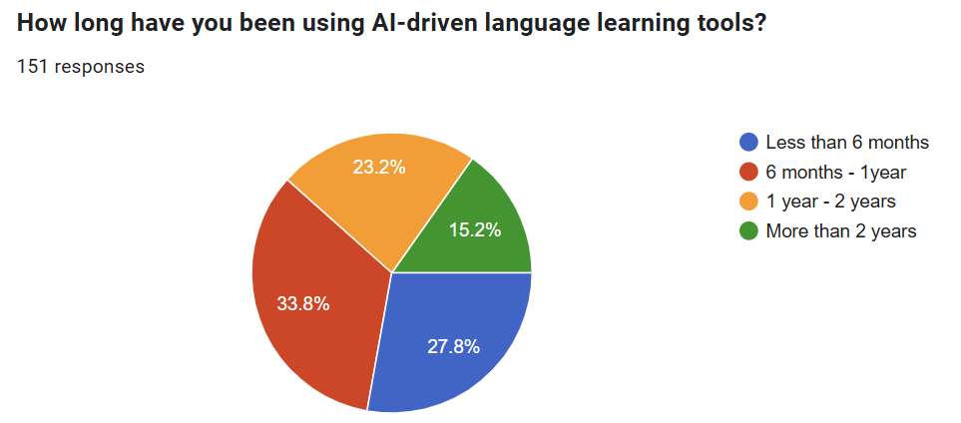
Figure 1 : How long students have been using AI-driven language learning tools
Figure 1 demonstrates how long students have been using AI-driven language learning tools to support their study. Surprisingly, the highest percentage of students, accounting for 33.8% have used AI- generated tools for only six months to one year. It is noticeable because at the time of completing the questionaires, they have learnt at university for almost two years. According to the interviewees, they didn’t use these tools in the first year of university because in this period, there were only compulsory courses of four basic skills ( Listening, Speaking, Reading, Writing) and they assumed that these tools are not necessary at this stage. They began to familiarize themselves with these tools when entering the second academic year. More surprisingly, the second highest proportion of respondents (27.8%) have used these tools for less than six months. It means that they had not known the benefits of these tools in language learning until finishing four semesters at university. The great features of these tools seemed to be quite new to them in this period. Based on the notes taken from the interviews, it can be understood that they did not know how to use and exploit these tools effectively in their self study process. The number of students who have used these tools for more than two years was comparatively small, only 15.2%. It can be implied that before entering university, only a very tiny minority of students had the opportunity to secure the benefits of these AI- powered tools. Nearly a quarter of them have used these tools for one to two years.
This indicates that an overwhelming number of students overall did not use these tools in the first year of university. It can be explained that these students could not be equipped with the knowledge of how to gain considerable advantage from using these tools in language learning before. These conclusions are further supported by the notes from the interviews.

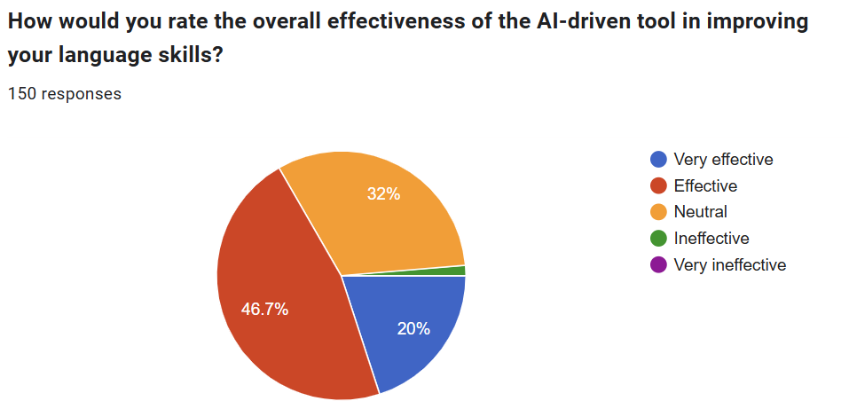
Figure 2: The overall effectiveness of the AI-driven tool in improving language skills

Figure 2 shows students’ opinions about the overall effectiveness of the AI-driven tools in improving their language skills. It is noticeable that a rather small number of students confirmed that the application of these tools are very effective in improving their language skills, accounting for only 20%. According to their opinions in the interviews, they did not know how to write prompts to exploit ChatGPT or Copilot. Moreover, did not know how to exploit these tools to improve specific skills like writing in business or giving a presentation in a meeting. These is a fact that even though some of them took the courses to learn how to write prompts and therefore, their instructions are clear and detailed enough, they found that the information they got from these tools are not always accurate and reliable. Take learning vocabulary in business an example. When being asked to list the synonyms of a word in business settings, ChatGPT or Copilot provides several suggested options, some of which are not appropriate to use in specific contexts. A more specific example to illustrate is the prompt to list all the synonyms of “competitor”. “Contender” and “adversary” are two among the several words listed, to name just a few, with different meanings from the original word in business context. Nearly half of the students agreed that these tools are effective in assisting their study. One third of them had no idea about the benefits of these tools. Even though a very tiny minority of students believed that these tools are ineffective, it needs to take into consideration because the benefits of these tools are obvious and undeniable for almost everyone. This proportion can be implied that students need more practical trainings about how to use these tools effectively to support their study.
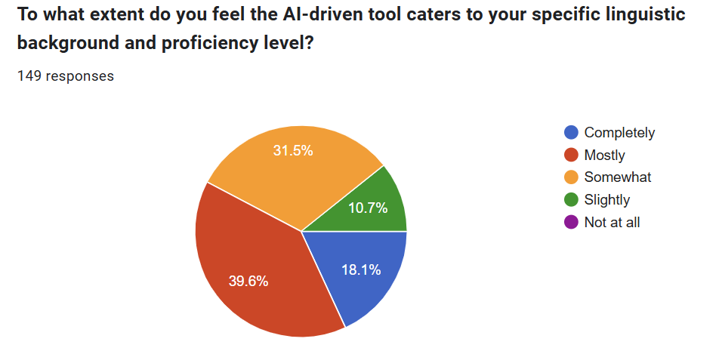
Figure 3: The extent to which the AI-driven tool caters to students’ specific linguistic background and proficiency level

Figure 3 demonstrates the extent to which the AI-driven tool caters to students’ specific linguistic background and proficiency level from their perspectives. According to the data, less than one fifth of respondents, accounting for 18.1%, felt that the AI-driven tools completely cater to their linguistic background and competency. It can be seen that this is worth more analysis. Based on the notes from the interviews, the researcher discovered that there are some reasons for this low level of satisfaction with regard to AI’s ability to modify to learners’ language background and ability. First of all, AI-generated tools provide exercises, tests, or tasks based on the available resources and they cannot modify the level of complexity or content to suit the learners’ level and needs. This lack of customization or adaptability may lead students to feel disappointed. Some exercises or tasks are too advanced or quite simple for certain learners. Another reason is that these tools are not connected with the specific curriculum. As a result, students may feel that the knowledge or information they get from these tools are irrelevant or unhelpful. The number of students who agreed that these tools mostly cater to their level and somewhat satisfied them with the extent of catering was not significantly different, accounting for 39.6% and 31.5% respectively. One out of ten students thought that these tools slightly cater to their level.
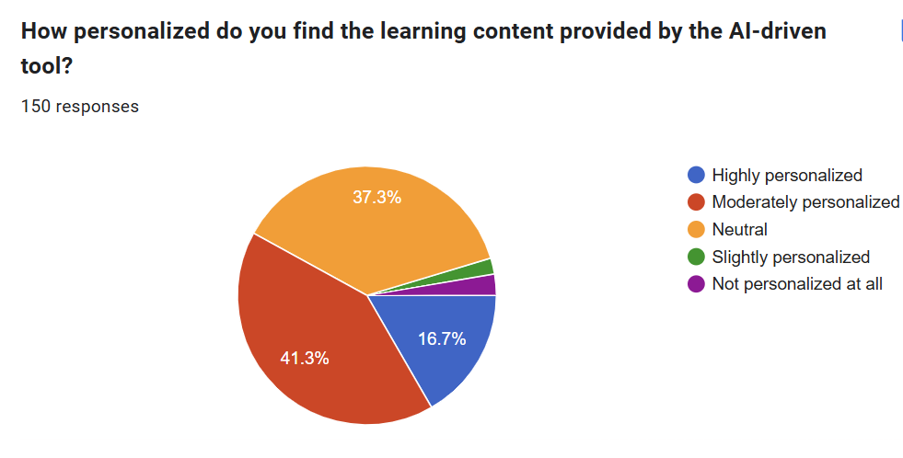
Figure 4: Level of personalization of the learning content provided by the AI-driven tool.

Figure 4 shows the students’ opinions about the level of personalization of the learning content provided by the AI-driven tools. It is evident from Figure 4 that more than half of the students acknowledged the level of personalization of the learning content provided by the AI-driven tools. 16.7% and 41.3% students respectively highly appreciated and moderately appreciated that the AI-driven tools are able to personalize the content to align with their needs. 37.3% evaluated that this level is acceptable. 2.7% confirmed that these tools are not personalized at all. It can be explained that some tools rely on basic data without deeper insights into background knowledge and skills of the students. In addition, many systems don’t continuously update or refine user models based on real-time learning progress or mistakes, which leads to the lack of adaptation. In summary, the results shown in Figure 4 and data from the interviews clearly indicate that the majority of respondents felt satisfied with this feature provided by AI tools.
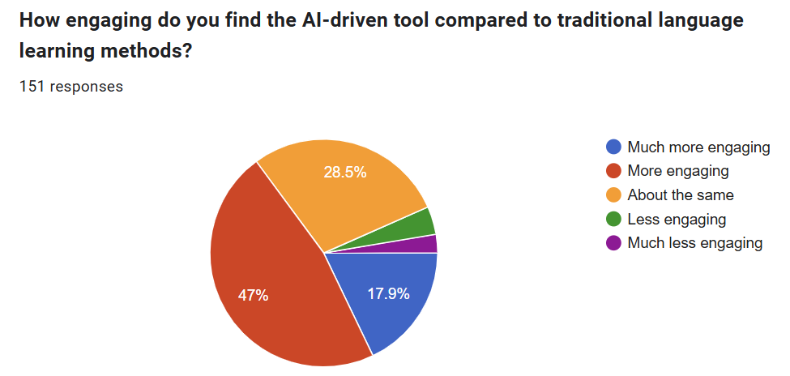
Figure 5: Level of engagement of the AI-driven tools compared to traditional language learning methods

Figure 5 illustrates the students’ opinions about the level of engagement of the AI-driven tools compared to traditional language learning methods. As can be seen from the data, the number of respondents who had positive feedback about this is promising. Nearly half of them agreed that these AI tools enable them to feel more engaged in learning. 17.9% confirmed that these tools are much more engaging. Nearly one third of them, accounting for 28.5% thought that this level is almost the same compared with the traditional methods. Much to the surprise, 4% and 2.6% respondents felt that these tools are less engaging and even much less engaging respectively. Based on the answers in the interviews, it can be explained that AI tools lack the human interaction. This interaction can create a sense of personal connection which makes students feel engaged. AI tools, on the other hand, can feel impersonal and isolating because they may fail to evoke emotional or social responses, leading to reduced engagement. Another reason is that although AI tools can provide instant feedback, the feedback may not always be as meaningful or constructive as feedback from a teacher who understands the student’s individual background and can provide personalized responses. In addition, some students said that they do not trust the accuracy or reliability of AI evaluations, which can reduce their interest to engage fully. Another barrier to them is that they may encounter technical problems with AI tools, such as confusion with how to use the platform effectively. These frustrations can detract from the overall learning experience.
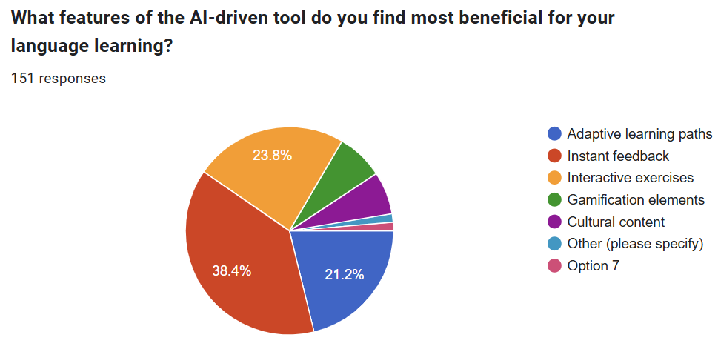
Figure 6: The most beneficial features of the AI-driven tool for language learning

Figure 6 shows the students’ opinions about the most beneficial features of the AI-driven tools for language learning. The highest percentage of students agreed that instant feedback is the most valuable feature of AI-generated tools, accounting for 38.4%. With instant feedback, students are constantly engaged and motivated in the learning process. They are interested in reflecting on their answers, trying again, and improving continuously. Based on the result of the interviews, the researcher found that immediate feedback fosters a deeper learning experience and increase motivation. In English for Business courses, students are more likely to stay engaged and persist through difficult tasks when they know how they're doing in real time. Take Elsa- an AI-powered language learning tool- an example. Students feel interested every time they try again and the results are improved thanks to the Progress Tracking function. Learners’ improvement is shown over time. Another great benefit of this feature of AI-driven tools is that immediate feedback reduces anxiety and uncertainty. When students have to wait hours or days for teacher’s feedback and evaluation, it can create anxiety and uncertainty. Instant feedback reduces this stress by offering clarity and direction as soon as the task is completed. Moreover, AI systems analyze student responses and adapt the difficulty or content accordingly. Instant feedback allows the tool to tailor the learning experience in real time, ensuring that students work at their own pace and level.
The number of students who appreciated adaptive learning paths and interactive exercises are nearly the same, 21.2% and 23.8% respectively. Similarly, the proportion of respondents who valued gamification elements and cultural content did not differ greatly, accounting for 7.3% and 6.6% respectively.
- Discussion
According to this research, it can be seen that students majoring in language need more training in how to exploit AI-generated tools as soon as they enter university. Based on the data collected, more than 60% of respondents did not use AI-driven tools until the second year at university. It means that they wasted the first year without knowledge about using these tools to support their self study. There is a fact that students coming from other provinces, especially from remote areas did not have the chance to access high-tech tools when they were in high schools because of objective conditions. There is a lack of equipment, shortage of teachers who have professional and technical expertise in this field. Despite the fact that there is an orientation week when students are introduced and familiarized with learning methods at university, there is no training course on how to exploit AI tools in this week.
Another recommendation is that students should be trained how to write prompts. According to the findings and answers from the interviews, students did not have positive feedback about the level of personalization and the extent to which the AI-driven tool caters to their specific linguistic background and proficiency level because they were not able to write prompts that provide sufficient information for these tools to process. As a results, students feel that the information they get is not suitable with their background.
In order to help students exploit the AI tools effectively to improve their language skills, teachers need to guide them specific tools to practice and improve each skill. It is obvious that they know the benefits of AI tools and popular tools like ChatGPT, Elsa, Duolingo or Grammaly but do not know tools to improve skills like presentation skill or listening. Therefore, teachers need to provide them with more detailed information about these tools.
Last but not least, in order to tackle the problem of inaccurate or irrelevant AI evaluations, there should be teachers’ support. Teachers should choose and recommend students to use AI systems with clear, interpretable scoring rubrics. Moreover, teachers also need to spend time to review AI-generated feedback to immediately support students with confusing or inappropriate feedback to motivate them. If not, they might feel demotivated when receiving such feedback. Most importantly, AI-generated feedback should be used for preliminary evaluation or assistance, not as the final decision-maker to evaluate students’ competency.
6. Conclusion
The findings from this study highlight the importance of helping students exploit the use of AI-generated tools effectively to support their study. Prompt-writing training and practical sessions on AI tools need to be incorporated into orientation programs. Teachers should be responsible for introducing appropriate tools for specific language skills and supporting students in interpreting AI-generated feedback. Most importantly, AI should be seen as a supplementary resource, with teachers’ comments and evaluation on the AI tools’ accuracy and relevance to support students in the learning journey.

References
Ahmed, S., Zaki, A., & Bentley, Y. (2024). Utilizing AI for Assessment, Grading, and Feedback in Higher Education. IGI Global
Chaudhary, V., Adhikari, B. R., Chaudhary, P., Dorji, T., & Poudel, R. (2021). Ecosystem-Based Adaptation (EbA) in the Hindu Kush Himalaya: Status, Progress, and Challenges. In M. Mukherjee & R. Shaw (Eds.), Ecosystem-Based Disaster and Climate Resilience (pp. 29-52). Springer. https://doi.org/10.1007/978-981-16-4815-1_2
Chen, H. I. (2021). Adaptive learning technologies and constructivist approaches in language education. Computer Assisted Language Learning, 34(7), 865–885. https://doi.org/10.1080/09588221.2019.1704785
Crossley, S. A., Kyle, K., & McNamara, D. S. (2017). The tool for the automatic analysis of lexical sophistication (TAALES): Version 2.0. Behavior Research Methods, 49(2), 717-729. https://doi.org/10.3758/s13428-016-0747-6 .
Holmes, W., Bialik, M., Fadel, C. (2019). Artificial Intelligence in Education: Promises and Implications for Teaching and Learning. Center for Curriculum Redesign, Boston, MA
Kulik, J. A., & Fletcher, J. D. (2016). Effectiveness of intelligent tutoring systems: A meta-analytic review. Review of Educational Research, 86(1), 42–78. https://doi.org/10.3102/0034654315581420
Li, J., & Zhang, W. (2023). The integration of AI into CALL: From automation to collaboration. Computer Assisted Language Learning, 36(1), 15–35. https://doi.org/10.1080/09588221.2021.1959589
Li, X., & Hafner, C. A. (2023). AI-powered writing tools and the development of learner autonomy in EAP writing. ReCALL, 35(1), 25–40. https://doi.org/10.1017/S0958344022000151
Liu, S. (2023). Research on the Innovation of Business English Teaching Mode in Colleges and Universities under the Background of Artificial Intelligence. Applied Mathematics and Nonlinear Sciences, 9(1), 1–15. https://doi.org/10.2478/amns.2023.2.01628
Loewen, S., Isbell, D. R., & Spino, L. A. (2020). The effectiveness of app-based language instruction for developing receptive and productive language skills: A meta-analysis. Language Learning & Technology, 24(2), 1-26. https://doi.org/10.125/73595
Luckin, R., Holmes, W., Griffiths, M., & Forcier, L. B. (2016). Intelligence Unleashed: An Argument for AI in Education. Pearson. https://discovery.ucl.ac.uk/id/eprint/1475756/
Mingmei, Q. (2025). Future of Language Learning: Unveiling the Power of AI-Driven Adaptive Platforms to Tailor Language Learning Based on Learners' Needs, Proficiency and Learning Styles. The European Journal of Education, 60(2)
Qu, M. (2025). Future of language learning: Unveiling the power of AI-driven adaptive platforms. European Journal of Education, 60(2), e70116. https://doi.org/10.1111/ejed.70116
Smith, M. S., & Truscott, J. (2018). The Modular On-line Growth and Use of Language (MOGUL) framework. In Second Language Acquisition: Theoretical Foundations (pp. 123-145). Routledge. https://doi.org/10.4324/9781315676786
Stockwell, G. (2022). Artificial intelligence in CALL: The changing landscape of language teaching. CALICO Journal, 39(2), 263–280. https://doi.org/10.1558/cj.40713
VanLehn, K. (2011). The Relative Effectiveness of Human Tutoring, Intelligent Tutoring Systems, and Other Tutoring Systems. Educational Psychologist, Volume 46, Issue 4. https://doi.org/10.1080/00461520.2011.611369
Vygotsky, L. S. (1978). Mind in society: The development of higher psychological processes. Harvard University Press.
Wang, Y., & Vasquez, C. (2022). Exploring the integration of AI chatbots in EFL instruction: A constructivist perspective. Language Learning & Technology, 26(1), 1–20. https://doi.org/10125/73400

Bionote
The researcher is a full- time lecturer in Ho Chi Minh city University of Foreign languages and Information technology. She has nearly 30 years experience teaching Business English. She’s interested in methodology, language testing and related fields. She regularly attends conferences to learn from other researchers.

