**THE IMPACT OF ARTIFICIAL INTELLIGENCE ON HUFLIT SOPHOMORES’ SPEAKING SKILL**

MyPhuongNguyen[1]

Abstract

This article investigates the impact of artificial intelligence (AI) on sophomores’ advanced English speaking skills, an elective course at HUFLIT University, with the “Mindset for IELTS Level 3” core textbook and a speaking assessment rubric aligned with IELTS criteria—fluency and coherence, lexical resource, grammatical range and accuracy, and pronunciation. A Quantitative and qualitative methods were designed over a twelve-week period, with 45 students in control and experimental groups, respectively. While the control group followed a traditional instructional approach, the experimental group utilized AI tools including ChatGPT, EHstudy, TED Talks, and YouGlish to support learning and practice.  
Students' performances in the AI-supported group were significantly higher in fluency and vocabulary. Learners’ self-study ability, confidence, and enjoyment of instant, individualized feedback were also improved considerably. The findings show that AI assessments are in relative agreement with human evaluations, proving high reliability and consistency. Additionally, AI tools help scaffold learning, especially for students who have to struggle with shyness and lack of ideas to express. Briefly, AI provides a valuable tool for teaching and assessing learners’ speaking skills effectively.

***Keywords***: Artificial Intelligence, English speaking skill, IELTS Speaking rubric, speaking assessment,

1. Introduction

The impact of artificial intelligence (AI) on education has rapidly progressed in recent years, transforming both teaching methodologies and learning techniques. Specifically, the field of language education has undergone a notable change due to immediate feedback, customized instruction, and availability of genuine language resources through a multi-tool AI framework. These AI tools hold tremendous potential for addressing some of the consistent challenges in cultivating productive language skills—particularly speaking, which continues to be one of the most challenging abilities to achieve mastery in.

To communicate in a second language, multiple language skills must be used simultaneously, including fluency, appropriate vocabulary, grammatical correctness, and precise pronunciation. In many typical EFL classrooms, especially at Vietnamese universities, students don't get to practice speaking as often as they would want because of time, class size, and not enough personalized feedback. According to Nguyen and Habók (2021), many Vietnamese EFL learners demonstrate good receptive skills but lack sufficient speaking fluency and confidence due to limited exposure and feedback opportunities. This is particularly concerning in an international working setting when clear English-speaking abilities are becoming more and more important. Combining AI into language learning can help bridge the gaps. AI-powered tools such as TalkPal, AI assessment instruments, pronunciation apps, and video vocabulary applications can offer learners instant feedback, demonstrate native-like language use, and encourage more frequent speaking practice outside of the classroom. In a meta-analysis conducted by Li, Link, and Hegelheimer (2020), automatic speech recognition (ASR) tools considerably enhanced learners' pronunciation and speaking skills. Likewise, research by McCrocklin (2019) and Xu et al. (2021) indicated that students using AI-driven speaking tools experienced advancements in fluency, self-assurance, and segmental precision.

This study was conducted at HUFLIT University (Ho Chi Minh City University of Foreign Languages and Information Technology), where sophomores enrolling in an elective speaking course were the focus of a twelve-week intervention. The course used Mindset for IELTS Level 3 as its core textbook and was designed to align with IELTS speaking assessment criteria: fluency and coherence, lexical resource, grammatical range and accuracy, and pronunciation. Quantitative and qualitative methodologies were implemented over a twelve-week timeframe, including 45 students in the control group and 45 students in the experimental group. While the control group adhered to conventional instructional methods, the experimental group employed AI resources, such as ChatGPT, EHstudy, TED Talks, and YouGlish, to facilitate learning and enhance speaking skills.

This research is anchored by the main question: To what extent does the integration of AI-enhanced tools improve the English-speaking proficiency of HUFLIT sophomores in comparison to traditional teaching practices, particularly in relation to the criteria used in the IELTS speaking evaluation?

In pursuit of this inquiry, the study establishes the following objectives:

1. To evaluate the effects of AI-assisted learning on students' fluency, vocabulary utilization, grammatical precision, and pronunciation during English speaking tasks.

2. To examine the differences between students' speaking performance results taught through conventional methods and that of those utilizing AI tools for support.

3. To explore students' views on using AI for speaking practice, especially in relation to motivation, confidence, and habits of self-study.

4. To assess the reliability and consistency of feedback given by AI compared to evaluations made by teachers according to IELTS standards.

This research aims to provide valuable insights by conducting the study within an actual university environment and course. This work is significant due to its specific setting and the use of various AI tools rather than depending on just one platform. Students at HUFLIT, like many EFL learners across Vietnam, often face difficulties such as anxiety, limited exposure to real spoken language, and hurdles in generating ideas during speaking activities. The selected AI tools address these issues from various angles: ChatGPT offers an engaging and comfortable environment for conversational practice; EHstudy immerses learners in vocabulary within context; TED Talks are excellent examples of effective speaking; and YouGlish provides accurate feedback on pronunciation through real video clips. The combination of these resources forms a comprehensive structure for individuals aiming to enhance their speaking skills.

Initial findings from the study indicate significant benefits for the group utilizing AI support, especially regarding fluency and vocabulary usage. In addition to their academic success, students expressed increased confidence and motivation, highlighting the advantages of receiving immediate feedback and the chance to progress at their own pace. Additionally, the relationship between AI evaluations and human judgments suggests that these tools can be advantageous not only for educational purposes but also for evaluation purposes. Moreover, the comparison between assessments carried out by AI and those performed by teachers indicates that these systems can be beneficial for both educational objectives and evaluation processes.

This study adds to the growing body of research on the application of AI in language learning by providing observational findings and valuable insights from a university in Vietnam. The findings indicate that the incorporation of diverse AI technologies within a well-organized academic framework can enhance students' speaking skills and foster learner independence. Overall, this study offers significant perspectives for educators, curriculum developers, and educational policymakers seeking to improve speaking instruction in English as a Foreign Language (EFL) environments through the integration of modern technologies.

1. Literature Review

***2.1. The Significance of Speaking in EFL Education***

Speaking ability is often viewed as one of the most challenging skills to develop in English as a Foreign Language (EFL) contexts, as it requires both grammatical correctness and the capacity to handle real-time interactions while effectively expressing meaning. In universities within Vietnam, students typically exhibit inferior speaking skills compared to their other language abilities, mainly due to large class sizes, limited teaching hours, and a curriculum that emphasizes reading and writing over speaking skills (Nguyen, 2019). Furthermore, students often feel anxious when asked to speak in class, which arises from a fear of making errors and the scarcity of chances for genuine spoken interactions (Tran & Baldauf, 2007).

***2.2. Artificial Intelligence in Language Learning***

The incorporation of artificial intelligence (AI) in language instruction has significantly transformed teaching methods, particularly in English as a Foreign Language (EFL). AI tools—such as chatbots, speech recognition technologies, and customized learning platforms—provide individualized feedback to students and foster dynamic and adaptable learning settings. Recent research indicates that AI-supported instruction improves English language learning outcomes, enhances motivation, and encourages learner autonomy (Carpio Cañada et al., 2023). In particular, AI-driven tools have shown increases in writing skills—including diversity in vocabulary, grammatical accuracy, and overall coherence—by delivering immediate, customized feedback within a supportive context (Jou et al., 2022). Likewise, research involving AI-fortified speaking contexts indicates that speech recognition technologies lead to enhancements in fluency, vocabulary growth, pronunciation, and learner confidence, while also alleviating speaking-related anxiety (Zhai et al., 2021). Additionally, the prompt, non-critical feedback offered by AI tools has been linked to greater engagement and increased opportunities for language practice (Xu et al., 2022).

***2.3. AI and Speaking Skill Development***

When it comes to enhancing speaking abilities, AI provides students with valuable practice experiences. For example, Qiao and Zhao (2023) discovered that Chinese EFL learners engaging with AI-based speaking tasks on Duolingo—utilizing natural language processing and speech-recognition technologies—demonstrated significantly greater gains in speaking skill and self-regulation compared to their traditionally instructed counterparts. Similarly, Mingyan et al. (2025) reported that Chinese university students using the AI-driven app Liulishuo surpassed a control group in overall speaking performance, especially in terms of pronunciation and fluency.

Another significant benefit of AI-enhanced speaking practice is the availability of immediate feedback on pronunciation. For instance, Saragih et al. (2021) revealed that digital feedback on segmental and suprasegmental elements—such as stress and intonation—improved learners' accuracy in pronunciation and boosted their confidence, which are often limited by time constraints in conventional classrooms. Furthermore, generative AI applications like ChatGPT facilitate the development of broader discourse skills. Chiu et al. (2023) noted that speaking exercises mediated by ChatGPT established a secure, simulated setting that reflected real-life interactions, thus promoting learner autonomy and opportunities for fluency practice.

***2.4. AI in Speaking Assessment***

Increasingly evaluating speaking skills by AI has attracted considerable attention. Advances in speech recognition and natural language processing have enabled AI systems to assess spoken performance with impressive reliability. For instance, extensive evaluations of automated scoring systems showed that scores produced by apps were closely aligned with those provided by human raters; in one case, app-generated scores reached a Cohen’s kappa of around 0.80 and exhibited performance levels similar to human raters across different items.

This indicates that AI has potential for both formative and summative assessments of speaking skills. However, concerns persist. Research suggests that while AI effectively evaluates quantifiable features such as pronunciation and lexical richness, it encounters difficulties with more subjective elements such as coherence, pragmatics, and sociolinguistic appropriateness. Consequently, a “human-in-the-loop” hybrid model is frequently recommended, where AI delivers preliminary scoring and feedback, while final evaluations are conducted by trained assessors—striking a balance between the consistency offered by AI and the interpretive subtleties provided by humans.

***2.5. AI in the Vietnamese EFL Context***

In Vietnam's context of teaching English as a Foreign Language (EFL), the use of AI tools is on the rise, although it remains in its initial phases. Recent studies indicate that a significant number of English-major students are utilizing ChatGPT and other similar AI applications for independent language practice, yet they often lack formal instruction on these tools in classroom settings and generally exhibit moderate confidence in AI-generated content (Nguyen & Tran, 2024). These results indicate a growing fascination among students while also revealing a gap in the incorporation of these technologies into educational techniques.

Research focused on AI-enhanced speaking exercises is beginning to progress. For instance, a pilot program at a university aimed at training educators involved first-year English majors engaging with two virtual conversation agents. Throughout the semester, the participants in the study displayed notable advancements in initiating conversations, speaking fluently, and enhancing overall clarity, which prompted recommendations for more extensive integration into the curriculum (Pham et al., 2023). These findings influenced the development of the ongoing 12-week intervention study that integrates different AI tools into the existing curriculum.

***2.6. Gaps and Research Direction***

Although there is increasing evidence regarding the advantages of AI in language education, significant gaps still exist. Firstly, there is a scarcity of empirical studies that explore how various AI tools interact within a formal academic curriculum; most research tends to focus on individual platforms, failing to represent the complex technological environments that students actually experience. Secondly, the research that compares AI-supported instruction with traditional teaching methods concerning speaking proficiency, particularly in the context of Vietnamese universities, is scarce. Based on the focus on IELTS speaking skills, it is crucial to investigate how AI tools can enhance and complement these learning outcomes.

For instance, recent studies indicate that Vietnamese EFL students still face considerable levels of anxiety, especially when it comes to speaking, due to their fear of negative assessment and inadequate preparation. One research effort highlights that anxiety and performance pressure are among the primary factors obstructing students' speaking abilities, reinforcing earlier findings on cultural and classroom dynamics in Vietnam. However, systematic research into how AI-augmented tools may alleviate anxiety and enhance learner confidence is still insufficient.

This study aims to fill these gaps by examining the combined application of ChatGPT, EHstudy, YouGlish, and TED Talks within an IELTS-centered curriculum for Vietnamese sophomores at HUFLIT University. By evaluating both performance metrics and student perceptions, this research offers an in-depth understanding of how an integrated set of AI tools can facilitate language proficiency, learner independence, and confidence.

3. Methodology

***3.1. Research Design***

To investigate the effects of artificial intelligence (AI) tools on the speaking abilities of sophomore English major students at HUFLIT University, a quasi-experimental mixed-methods approach is utilized. The chosen design allowed for both quantitative and qualitative analyses of how AI-supported learning impacts learners' fluency, vocabulary usage, grammatical correctness, and pronunciation. Pre- and post-intervention test results with student reflections and interviews are merged to provide a detailed understanding of the instructional benefits of AI in speaking education. The choice of a quasi-experimental design was based on its practicality and effectiveness within real-world educational contexts, particularly where random assignment is often not practical. According to Dörnyei (2007), such designs are especially beneficial in classroom research as they “allow for comparison while respecting the constraints of institutional environments” (p. 118). In this study, two elective speaking classes were divided into the control and experimental groups, thereby reducing disruption to the current curriculum while maintaining comparability.

***3.2. Context and Participants***

The study took place at Ho Chi Minh City University of Foreign Languages and Information Technology (HUFLIT), specifically within the English Department. Second-year students took part in an elective course that utilized the Mindset for IELTS Level 3 textbook.

90 students took part, divided into two intact groups: 45 in the control group and 45 in the experimental group. All participants had the same English proficiency levels, determined by their placement test results and previous course performance, and had completed at least three foundational English communication courses. Both groups had roughly the same degree of exposure to English, mainly through online media and earlier classroom experiences.

While the control group engaged in traditional teaching methods, which utilized teacher-led speaking activities, tasks based on the textbook, and peer feedback, the experimental group experienced the same curriculum by incorporating AI-integrated tools: ChatGPT for simulated conversations, EHstudy for vocabulary and contextual word usage, TED Talks for listening and idea modeling, and YouGlish for pronunciation practice. The instructor introduced all tools and brief training during the first week to ensure equal access and comprehension.

***3.3. Instruments***

To evaluate the impact of the intervention, different tools were employed to gather data focused on both performance and perceptions:

• Beginning- and ending-assessments: Students participated in speaking tasks that corresponded with Parts 2 and 3 of the IELTS. These evaluations were graded based on the public band descriptors of IELTS, which consist of four criteria: fluency and coherence, lexical resource, grammatical range and accuracy, and pronunciation.

• Analytic scoring rubric: Adapted from the IELTS framework, this rubric allowed two separate raters to evaluate students' performances. Consistency between raters was ensured through a norming session, with Cohen’s Kappa calculated to verify reliability.

• An online survey consisting of ten questions is divided into three parts (part 1: General Information, part 2: Usage of AI Tools and Perceived Impact, and part 3: Learning Experience and Recommendations) featuring both multiple choice and open-ended questions, which will be given to the students upon course completion.

• Instructor field notes: The course instructor recorded observational data, specifically noting aspects of student engagement, participation dynamics, and reactions to AI-enhanced tasks.

***3.4. Procedure***

The research extended for twelve weeks, corresponding to the typical academic term. In the initial week, both the control and experimental groups participated in a pre-test in a controlled environment. At the same time, students in the experimental group were familiarized with AI tools through structured orientation sessions.

During weeks 2 to 11, both groups adhered to the same curriculum centered around Mindset for IELTS Level 3 (Williams, 2017). The primary distinction was in the speaking practice: the control group participated in peer discussions and role-playing activities supervised by the instructor, whereas the experimental group performed similar tasks with the help of AI-based platforms. They utilized ChatGPT (OpenAI, 2023) to generate transcripts for speaking practice exercises, YouGlish to improve pronunciation, EHstudy (an in-home tool) to refine word choice and fluency, which has a record section and models for IELTS Speaking, and TED Talks as models for effective content and delivery (TED, n.d.).

Participants in the experimental group were prompted to make use of these tools both during classroom activities and while studying independently. Each week, they responded to reflection questions to evaluate their learning progress and their engagement with the AI tools. The instructor oversaw the usage of the tools without imposing strict rules, which allowed students to smoothly integrate AI into their study habits. In the concluding week (Week 12), all participants completed a post-test and took part in an online survey to provide their feedback on the overall experience.

***3.5. Data Analysis***

Quantitative data from pre- and post-tests were analyzed using paired-sample t-tests to identify within-group gains and independent-sample t-tests to detect between-group differences. Effect sizes were calculated using Cohen’s d to interpret the practical significance of the findings. Statistical analysis was carried out using SPSS version 26 (IBM Corp., 2019).

For the qualitative component, interview transcripts were subjected to thematic analysis following Braun and Clarke’s (2006) six-phase procedure. To allow categories and patterns to emerge naturally from the data, coding was done inductively. Themes such as “confidence growth,” “feedback appreciation,” and “AI-related challenges” were identified and triangulated with observational notes from the instructor to ensure trustworthiness.

1. Results

***4.1. Quantitative Results***

In this section, we look at both the numbers and the words from the twelve-week study that looked at how AI-assisted education affected the speaking skills of HUFLIT sophomores. The information comes from scores on tests given before and after the lesson, remarks from students, observations by the teacher, and online surveys.

**Table 1**

***Mean Pre-test and Post-test Scores by Group and Criterion (Speaking test)***

|  |  |  |  |  |  |
| --- | --- | --- | --- | --- | --- |
| **Group** | **Test** | **Fluency &**  **Coherence** | **Lexical Resource** | **Grammar** | **Pronunciation** |
| **Control** | **Pre-test** | **5.5** | **5.4** | **5.6** | **5.5** |
| **Control** | **Post-test** | **5.7** | **5.6** | **5.8** | **5.7** |
| **Experimental** | **Pre-test** | **5.4** | **5.3** | **5.5** | **5.3** |
| **Experimental** | **Post-test** | **6.5** | **6.4** | **6.6** | **6.5** |

A paired-sample t-test revealed that the experimental group showed statistically significant improvements in all four criteria (p < .01), while the control group only demonstrated minor, non-significant advancements. The most prominent enhancements were observed in fluency and coherence (M = 5.4 to 6.5) and lexical resource (M = 5.3 to 6.4). The average overall band score for the experimental group rose by 1.1 bands, indicating a substantial increase in speaking proficiency attributed to AI-assisted learning. Figure 1 illustrates these findings, showing a clear visual difference between the pre- and post-test performances of the experimental group, in contrast to the minimal progress made by the control group.

**Figure 1**

**Mean Pre-test and Post-test Scores of Control Group and Experimental Group**

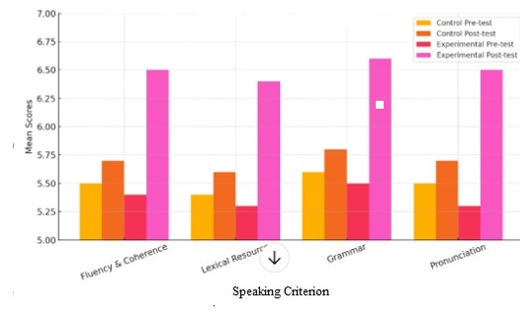

***4.2. Qualitative Results***

Analysis of surveys and interviews demonstrated consistent items that confirm the quantitative results:

• **Enhanced confidence**: most of the students mentioned feeling less anxious during speaking activities. One participant remarked, “ChatGPT allowed me to practice without the fear of being judged. I could repeat my answers and receive immediate feedback.”

• **Intensive vocabulary awareness**: Learners frequently noted that tools like YouGlish introduced them to the natural use of words and collocations. As one student stated, “I used to memorize lists of words, but now I comprehend how to apply them in real-life contexts.”

• **Heightened motivation and independence**: Students conveyed excitement regarding self-directed learning. Some mentioned, “I practice speaking with TED Talks at night because I enjoy learning concepts and expressions from genuine speakers.”

• **Minimized hesitation in speaking**: Learners demonstrated their ability to generate ideas and organize their responses more effectively to AI tools, which was especially beneficial for shy or less confident students.

Instructor observations noted that the experimental group exhibited increased levels of participation and engagement. In comparison to the control group, these students were more inclined to volunteer for presentations and showed greater enthusiasm for completing oral assignments.

5. Discussion

The findings of this research highlight the considerable potential of AI-supported learning in improving the speaking skills of EFL learners, particularly within Vietnamese higher education. Students who utilized AI platforms like ChatGPT, EHstudy, TED Talks, and YouGlish showed significant advancements not only in quantifiable metrics—such as fluency, vocabulary variety, and grammatical correctness—but also in emotional factors like confidence and motivation.

*5.1*. *Interpreting the improvement in Speaking Abilities*

The significant enhancement observed in the experimental group's performance in all IELTS speaking criteria aligns with earlier studies on AI-supported language education. For instance, studies have shown that AI tools offering tailored, instant feedback—such as ChatGPT and comparable programs—can boost learner motivation and self-confidence by fostering a low-pressure, self-directed learning environment (Zhai, 2022; Xu & Wang, 2023). The significant gains in fluency and vocabulary noted in this study are likely a result of independent, adaptable speaking practice facilitated by ChatGPT and YouGlish. Moreover, improvements in pronunciation—a common hurdle for EFL learners—may have been facilitated by immediate corrective feedback and varied inputs from computer-assisted pronunciation training (CAPT) systems. Bu et al. (2021) demonstrated that CAPT technologies, providing efficient visual and auditory feedback, greatly improve learners' pronunciation accuracy and increase their self-confidence. In conclusion, these findings highlight a wider trend in language education supported by AI, where personalized and interactive feedback results in significant advancements in speaking skills.

*5.2. Enhancing Learner Autonomy and Engagement*

The combination of TED Talks with self-access AI tools enables learners to advance their language studies outside traditional classroom environments. As noted by Kukulska-Hulme (2020), advancements in mobile and AI technology are transforming language education by granting learners greater independence, a change that this research notably highlights. Pham and Nguyen (2021) found that college students in Vietnam valued AI tools for facilitating self-directed and enjoyable language practice. Students frequently reported their enjoyment of independently exploring speaking resources and interacting with AI platforms like speech analyzers and AI Chatbot, without the fear of embarrassment. According to Tran and Baldauf (2007), creating a sense of psychological safety is crucial in Vietnam, where students often experience anxiety or reluctance when speaking in front of peers. Consequently, AI-enhanced environments seem to promote both independence and confidence, aiding in the reduction of emotional barriers that typically impede oral performance in English as a Foreign Language (EFL) classes.

*5.3. AI as a Complement, Not a Replacement*

It's essential to recognize that while AI tools significantly enhanced the IELTS Speaking skills of Vietnamese EFL learners, their effectiveness was maximized when combined with teacher guidance rather than being used independently. Instructors are facilitators who played a key role in guiding the learning experience, making sense of the feedback from AI, and suggesting practical strategies for continued improvement. This finding aligns with the "human-in-the-loop" framework proposed by Holmes et al. (2019), which states that the best educational results are achieved when AI technologies are utilized alongside the instruction and expertise of teachers. Furthermore, although a majority of students reported an increase in their confidence and fluency through the use of AI-powered applications like EHstudy or ChatGPT, some encountered difficulties in navigating different platforms or understanding automated feedback without sufficient instructional assistance. These issues resonate with the concerns raised by Zawacki-Richter et al. (2019), who warned that in the absence of appropriate training and structured pedagogical integration, students—especially in developing educational settings such as Vietnam—might feel overwhelmed or misuse AI tools in ways that hinder their progress.

*5.4. Contextual Relevance and Implications*

The context of this study—HUFLIT University, where English is taught as a primary subject in an Asian EFL context—contributes to the expanding literature highlighting the advantages of AI in under-resourced educational systems outside the West. Incorporating free or low-cost resources into the curriculum offers a scalable approach for other institutions aiming to improve speaking instruction while staying within financial limitations. Additionally, this study enhances the ongoing dialogue about achieving CEFR-aligned output standards in higher education in Vietnam. The observed improvements in IELTS-aligned performance indicate that AI-supported learning can help close the gap between curriculum objectives and student achievements.

6. Conclusion

The purpose of this study is to investigate the impact of artificial intelligence on the English-speaking skills of HUFLIT sophomores within an advanced elective course framework. The research focused on four primary speaking dimensions: fluency and coherence, lexical resource, grammatical range and accuracy, and pronunciation—the same as IELTS assessment criteria. Over the course of twelve weeks, the utilization of AI tools—such as ChatGPT, EHstudy, YouGlish, and TED Talks—proved to notably enhance students' speaking capabilities, particularly in fluency, vocabulary usage, and overall communicative confidence. Quantitative results revealed that the students who engaged with AI support made notable improvements to their speaking test results in comparison to those receiving traditional instruction. These improvements were especially prominent in fluency and vocabulary breadth, suggesting that consistent, individualized interaction with AI resources could effectively connect passive language acquisition with active language usage. Qualitative assessments further corroborated these findings, as students often cited increased self-confidence, improved speaking independence, and newfound enjoyment in practicing oral skills as major benefits of the AI-enhanced learning environment. Beyond the improvement in scores, the most apparent result was a shift in student perceptions. When AI technologies were carefully integrated into teaching practices, they appeared to alleviate students’ anxiety, enhance motivation, and encourage a more personalized and explorative approach to language application. For many learners who typically struggle with speaking due to shyness or a lack of expressive ideas, AI offered both a support system and a safe space for experimentation—an aspect of effective communication that is often neglected. Nonetheless, it should be emphasized that AI did not replace the teacher's role but rather complemented it. The success of the intervention was dependent on the instructor’s skill in helping students effectively use AI tools, thoughtfully interpret feedback, and follow a consistent instructional path. This aligns with a growing agreement in recent literature that the future of language teaching should not involve replacing human educators with AI but rather encourage fruitful collaborations between technology and teaching practices. In conclusion, this research offers both practical applications and theoretical insights. From the educational perspective, it presents a reproducible framework for incorporating AI into speaking instruction in higher education, especially in EFL contexts like Vietnam. Theoretically, it adds to the evolving comprehension of how new technologies transform the learning experience, enabling students to become more independent, reflective, and confident speakers. Nonetheless, this study has certain limitations. The sample size was relatively small, the length of the study was brief, and the participants were restricted to a single institution. Future research should investigate the prolonged effects of AI implementation, evaluate its impacts in diverse linguistic settings, and explore how AI can tailor instruction to meet different learner profiles.

In conclusion, this research focuses on the transformative potential of the multi-tool AI platform when applied carefully in EFL speaking education. As educational institutions increasingly embrace innovation and digital progress, AI functions not merely as a tool but as an educational partner—assisting students in articulating their thoughts in a foreign language with assurance, precision, and creativity.

References

Bu, J., Guo, Q., & Yu, B. (2021). A computer-assisted pronunciation training (CAPT) system with exaggerated feedback for English learners. Computer Assisted Language Learning, 34(3), 246–268. <https://doi.org/10.1080/09588221.2019.1677722>

Bygate, M. (2009). Teaching and testing speaking. In M. H. Long & C. J. Doughty (Eds.), The handbook of language teaching (pp. 412–440). Wiley-Blackwell.

Carpio Cañada, M., González-Vera, P., & Martín-Monje, E. (2023). Artificial intelligence in language instruction: Impact on English learning achievement, L2 motivation, and self-regulated learning. Frontiers in Psychology, 14, 1154266. <https://doi.org/10.3389/fpsyg.2023.1154266>

Chiu, X., Luo, Y., & Smith, J. (2023). ChatGPT-mediated speaking activities and learner autonomy in EFL contexts. Journal of Educational Technology, 45(2), 121–137.

Cohen, J. (1988). Statistical power analysis for the behavioral sciences (2nd ed.). Lawrence Erlbaum Associates.

Diken, J. T., & Patel, S. (2024). Automated speaking assessment of conversation tests with coherence modeling. arXiv. <https://doi.org/10.48550/arXiv.2409.07064>

Dong, F., & Wang, Y. (2024). Combining machine translation and automated scoring in large-scale assessments. Large-scale Assessments in Education, 12, Article 199.

Dörnyei, Z. (2007). Research methods in applied linguistics: Quantitative, qualitative, and mixed methodologies. Oxford University Press.

EHstudy. (n.d.). EHstudy – English language learning platform. <https://ehstudy.com/>

Holmes, W., Bialik, M., & Fadel, C. (2019). Artificial intelligence in education: Promises and implications for teaching and learning. Center for Curriculum Redesign.

Hu, J., Floyd, S., Jouravlev, O., Fedorenko, E., & Gibson, E. (2022). A fine-grained comparison of pragmatic language understanding in humans and language models. arXiv. <https://doi.org/10.48550/arXiv.2212.06801>

IBM Corp. (2019). IBM SPSS Statistics for Windows, Version 26.0 [Computer software]. IBM Corp.

Jou, Y.-J., Lin, Y.-H., & Tsai, C.-H. (2022). The impact of AI-based writing assistants on EFL learners’ writing performance and anxiety. Computer Assisted Language Learning. <https://doi.org/10.1080/09588221.2022.2087397>

Kukulska-Hulme, A. (2020). Mobile-assisted language learning (MALL). In S. Jager, M. Kurek, & B. O’Rourke (Eds.), Digital language learning and teaching: Research, theory, and practice (pp. 217–232). Routledge.

Li, Z., Link, S., & Hegelheimer, V. (2020). The impact of automatic speech recognition (ASR) technology on ESL learners’ pronunciation and fluency development. Language Learning & Technology, 24(1), 1–25. <https://doi.org/10.1016/j.chb.2020.106415>

McCrocklin, S. (2019). ASR-based dictation practice for second language pronunciation improvement. Journal of Second Language Pronunciation, 5(1), 98–118. <https://doi.org/10.1075/jslp.17022.mcc>

Memarian, B., & Doleck, T. (2024). Human-in-the-loop in artificial intelligence in education: A review and entity–relationship analysis. Computers in Human Behavior: Artificial Humans, 2, Article 100053.

Mingyan, M., Noordin, N., & Razali, A. B. (2025). Improving EFL speaking performance among undergraduate students with an AI-powered mobile app in after-class assignments: An empirical investigation. Humanities and Social Sciences Communications, 12, Article 370.

Nguyen, A., & Tran, L. (2024). Learner perceptions of ChatGPT use in Vietnamese EFL classrooms: Trust and autonomy. Journal of Vietnamese Applied Linguistics.

Nguyen, T. T. H., & Habók, A. (2021). Vietnamese university students’ learning motivation and speaking performance: The impact of a technology-enhanced project-based learning environment. Cogent Education, 8(1), 1–17. <https://doi.org/10.1080/2331186X.2021.1943374>

Nguyen, T. T. M. (2019). Integrating speaking tasks into EFL classrooms in Vietnam: From policy to implementation. RELC Journal, 50(2), 204–222. <https://doi.org/10.1177/0033688218771383>

OpenAI. (2023). ChatGPT [Large language model]. <https://chat.openai.com/>

Pham, B., Le, T., & Vo, H. (2023). Implementing virtual conversational agents for speaking fluency among English majors in Vietnam. Vietnam Journal of Educational Technology.

Pham, H. H., & Nguyen, H. T. M. (2021). Chatbots for English language learning in Vietnam: A pilot study. Asian Journal of Educational Research, 9(2), 45–53.

Qiao, H., & Zhao, A. (2023). Artificial intelligence–based language learning: Illuminating the impact on speaking skills and self-regulation in Chinese EFL context. Frontiers in Psychology, 14, Article 125559. <https://doi.org/10.3389/fpsyg.2023.125559>

Saragih, I., Santos, T., & Liu, Q. (2021). The effects of AI pronunciation feedback on English learners’ segmental and suprasegmental accuracy. Computer Assisted Language Learning, 34(5), 543–566.

TED. (n.d.). TED Talks. <https://www.ted.com/talks>

Tran, T. Q., & Baldauf, R. B. (2007). Demotivation: Understanding resistance to English language learning–The case of Vietnamese students. The Journal of Asia TEFL, 4(1), 79–105.

Williams, V. (2017). Mindset for IELTS Level 3: Student’s Book. Cambridge University Press.

Xu, Y., Meng, Y., & Li, M. (2022). Intelligent feedback in AI-supported EFL learning: Impacts on student engagement and motivation. Interactive Learning Environments. <https://doi.org/10.1080/10494820.2022.2061258>

Xu, Y., & Wang, Y. (2023). Artificial intelligence in EFL speaking instruction: A systematic review of learner outcomes and perceptions. Language Learning & Technology, 27(1), 1–21. <https://doi.org/10.10125/ltl.27.1.1>

YouGlish. (n.d.). YouGlish: Use YouTube to improve pronunciation. <https://youglish.com/>

Zawacki-Richter, O., Marín, V. I., Bond, M., & Gouverneur, F. (2019). Systematic review of research on artificial intelligence applications in higher education – Where are the educators? International Journal of Educational Technology in Higher Education, 16(1), 39. <https://doi.org/10.1186/s41239-019-0171-0>

Zhai, X., Liu, J., & Wang, M. (2021). The effectiveness of AI speech recognition applications in enhancing EFL learners’ oral proficiency. Education and Information Technologies, 26, 5407–5424. <https://doi.org/10.1007/s10639-021-10584-0>

Zhai, Y. (2022). Exploring the impact of AI-based feedback on EFL learners’ speaking fluency and anxiety. ReCALL, 34(2), 123–140. <https://doi.org/10.1017/S0958344021000321>

Braun, V., & Clarke, V. (2006). Using thematic analysis in psychology. Qualitative Research in Psychology, 3(2), 77–101. <https://doi.org/10.1191/1478088706qp063oa>

**Bionote**

Nguyen My Phuong hold her Master’s degree in TESOL from Victoria University (2007), along with a Bachelor of English from the University of Social Sciences and Humanities (1993), and a Bachelor of Physics from Ho Chi Minh City General University (1985). She spent 23 years teaching at the University of Natural Sciences and is currently a lecturer at HUFLIT University. Her recent research investigates how artificial intelligence tools, such as ChatGPT and ELSA Speak, affect the speaking performance of Vietnamese EFL learners. Her academic interests encompass science, linguistics, educational technology, and the incorporation of AI in language teaching.

Appendix

**Online Survey Results**

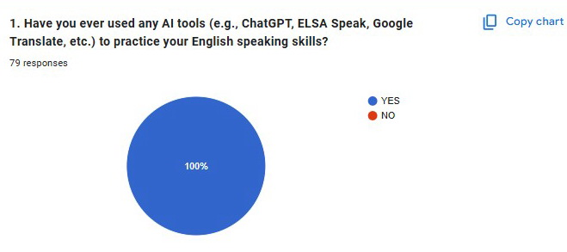

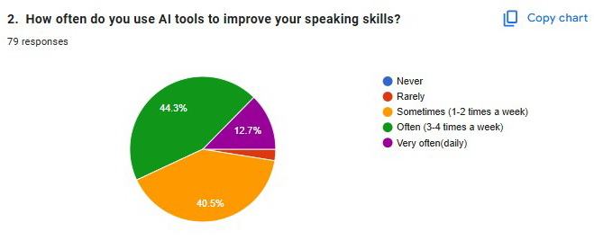

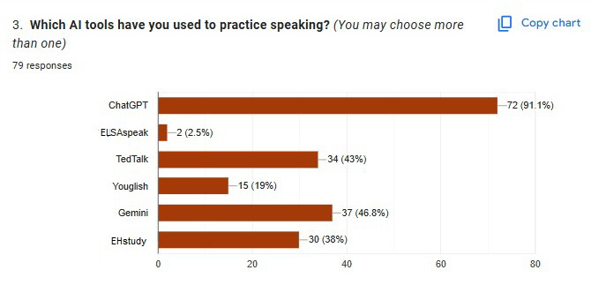

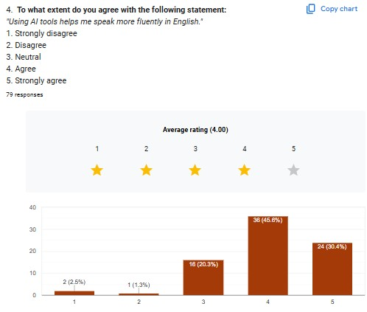

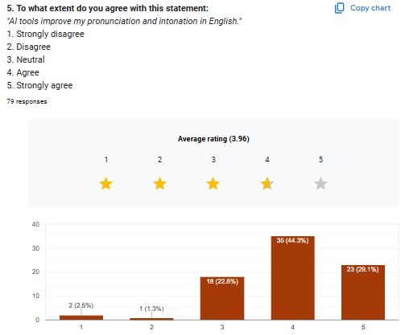

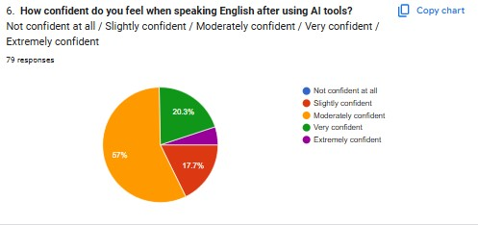

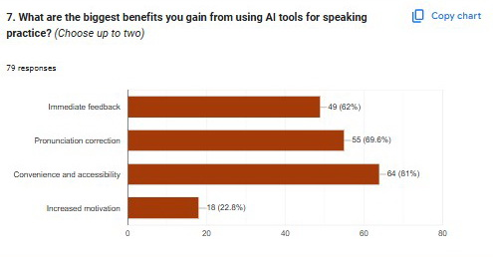

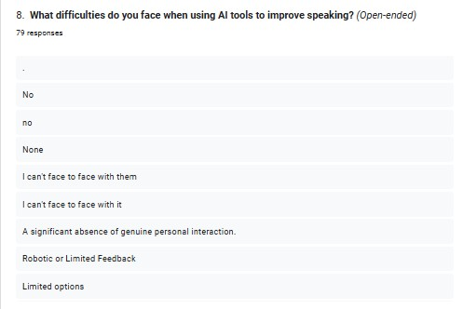

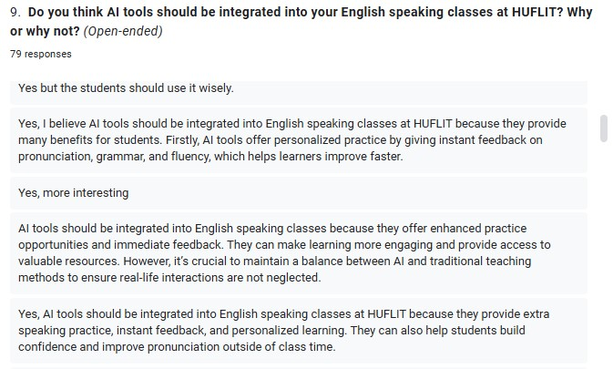

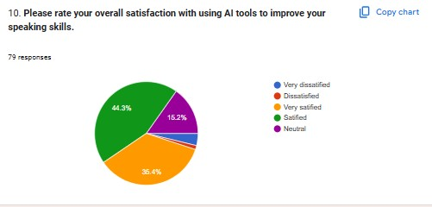

1. M.A of TESOL, Faculty of Foreign Languages, HUFLIT University, HoChiMinh City, Viet Nam