**AI as a Writing Partner: Investigating the Role of Artificial Intelligence in English Presentations for Computer Science Students**

*Su Thi Ai My, M.A.; Hua Tran Phuong Thao, M.A.*

Ho Chi Minh City University of Technology and Education

**Abstract**

In an era where artificial intelligence (AI) is increasingly shaping academic practices, this study examines the integration of AI tools as writing and presentation partners among undergraduate computer science students enrolled in ESP courses. In computer science, students are increasingly required to deliver academic presentations in English, yet they often struggle with limited vocabulary, low confidence, and difficulties in structuring complex content for diverse audiences. Although AI platforms such as ChatGPT, Grammarly, QuillBot, and DeepL offer promising support, little empirical research has examined how students use these tools, which tasks they prioritise, and what outcomes they experience. Adopting a mixed-methods approach, this research draws on survey data (n ≈ 110), student interviews, and textual analysis of presentation drafts to explore AI’s impact on grammar correction, vocabulary enhancement, logical organisation, technical explanation, and persuasive delivery. Findings reveal that over 80% of students use AI mainly for surface-level improvements, while fewer tap into its potential for enhancing technical explanations or tailoring content to audience needs. Notably, many students (nearly 60%) report feeling less confident when AI is removed, indicating growing dependence. Beyond language concerns, students express specific anxieties about the reliability and accuracy of AI-generated computer science content, fearing that factual errors could undermine their credibility. These insights have significant implications for TESOL in the age of AI. Educators are encouraged to foster critical AI literacy, promote reflective and strategic AI use that supports authentic learning, and design assessments balancing human creativity with machine-assisted efficiency.

***Keywords:*** artificial intelligence, English for specific purposes, academic presentations, AI literacy

**1. Introduction**

The rapid advancement of artificial intelligence (AI) has fundamentally reshaped the landscape of language education, particularly in academic contexts where learners must navigate complex communicative tasks. In recent years, the proliferation of generative AI tools, such as ChatGPT, Grammarly, QuillBot, and DeepL, has opened new avenues for supporting learners in accessing, processing, and producing English with greater fluency and efficiency. These developments are particularly salient in English for Specific Purposes (ESP) courses, where students are required not only to master general language proficiency but also to communicate discipline-specific content to specialised or non-specialist audiences.

For undergraduate students in computer science, the ability to communicate technical knowledge effectively in English is increasingly essential, not only through written documentation but also via oral academic presentations. Such presentations demand a combination of linguistic accuracy, rhetorical clarity, audience awareness, and domain-specific articulation. However, many learners in these contexts face persistent challenges, including limited lexical resources, low confidence in public speaking, and difficulty in structuring complex ideas coherently. These barriers often hinder their ability to convey technical concepts persuasively and professionally in English.

AI-powered writing tools have emerged as promising supports for addressing these challenges. By offering functionalities such as grammar correction, paraphrasing, summarisation, and vocabulary enhancement, these tools can assist learners in refining their language output and improving the clarity of their presentations. More recently, platforms like ChatGPT have further expanded the possibilities for AI-assisted learning by enabling students to generate, revise, and personalise content in real time. Within the context of ESP, such tools hold the potential to act not merely as mechanical correctors but as cognitive scaffolds that support both language development and subject-matter communication.

Despite this potential, the integration of AI into language learning, especially in ESP courses within STEM fields, remains under-theorised and insufficiently documented. Existing studies tend to focus either on general writing enhancement or on student perceptions in isolated use cases, without fully exploring how learners interact with AI throughout the academic presentation process. Key questions persist: Which tasks do students delegate to AI, and which do they retain as their own? Do students engage AI tools critically, or rely on them unreflectively? How do students perceive the balance between performance support and genuine language learning? And to what extent does growing dependence on AI affect learners’ confidence, autonomy, and ethical awareness?

This study seeks to address these questions by investigating how undergraduate computer science students in Vietnam use AI tools during the preparation of English academic presentations. Employing a mixed-methods approach, the research examines patterns of AI usage, task preferences, perceived benefits and limitations, and the psychological and ethical dimensions of AI-assisted learning. In doing so, the study contributes to the broader conversation about the role of AI in language education, highlighting both its transformative potential and the pedagogical complexities it introduces. Ultimately, the findings aim to inform ESP practitioners, curriculum designers, and educational policymakers on how to harness AI not only as a productivity tool but also as a catalyst for responsible, strategic, and learner-centred language development.

**2. Literature Review**

The integration of artificial intelligence (AI) into language education has gained considerable attention in recent years, especially following the widespread adoption of large language models (LLMs) such as ChatGPT. Emerging research has begun to examine not only the linguistic affordances of these tools but also their broader cognitive, emotional, and pedagogical implications for learners. This section reviews relevant studies in three key areas: AI in ESP, task-specific use of AI tools, and the psychological and ethical considerations surrounding AI-assisted learning.

## *2.1. AI and ESP*

In ESP contexts, particularly those situated in technical disciplines such as computer science, AI tools have demonstrated notable potential in helping students comprehend domain-specific content and communicate effectively with specialised audiences (Raza et al., 2023). Tools like ChatGPT have been recognised for their ability to simulate audience feedback, suggest appropriate rhetorical structures, and rephrase complex explanations in more accessible language. Nevertheless, as Kohnke and Moorhouse (2022) argue, while AI may facilitate short-term improvements in fluency and coherence, its long-term contribution to language acquisition is conditional upon learners’ critical engagement and degree of autonomy.

Further insights are provided by Aryadoust et al. (2025), who investigated the use of generative AI tools, specifically ChatGPT and Grammarly, among English-major students at Indonesian universities. Their study revealed that these tools were effective in supporting key stages of academic writing, including drafting, vocabulary enhancement, and structural editing. However, the authors emphasised the risk of over-reliance, calling for explicit instruction in critical evaluation to ensure that learners retain control over their writing processes and maintain their cognitive agency.

A related study by *Technology, Knowledge & Learning* (2024) examined the AI-assisted writing processes of both native and non-native English speakers. The participants praised ChatGPT for accelerating writing speed, reducing cognitive load, stimulating idea generation, and refining sentence construction. Nonetheless, many noted that the tool often lacked nuance in tone and depth, necessitating iterative prompting and human revision. These findings suggest that while AI tools can serve as valuable cognitive aids, their effectiveness depends largely on the user’s ability to engage in reflective and strategic usage.

## *2.2. Task-Specific Use of AI Tools*

Empirical research to date indicates that learners primarily engage AI tools for surface-level linguistic tasks such as grammar correction, vocabulary enhancement, and paraphrasing (Jia, 2023; Dizon, 2023). Only a minority of students appear to use these tools for higher-order activities, including idea generation, audience adaptation, and the evaluation of factual accuracy in technical content. This limited engagement may hinder the development of critical academic literacy and rhetorical flexibility, both of which are essential in ESP contexts (Bikowski, 2022).

## *2.3. Student Confidence and AI Dependency*

AI tools have been widely credited with boosting learners’ confidence in writing and public speaking tasks, particularly in academic settings (Nguyen & Bui, 2023). However, recent studies have also raised concerns about the psychological effects of AI dependency. Zhang (2024) describes this phenomenon as a “confidence–complacency tradeoff,” whereby students feel more prepared with AI assistance but less confident when required to perform independently. This paradox poses a challenge for educators aiming to cultivate sustainable communicative competence.

## *2.4. Ethical and Pedagogical Considerations*

The increased reliance on AI tools has led to growing discourse around academic integrity, authorship, and fairness. In response, scholars have emphasised the importance of developing AI literacy, defined as the ability to use AI tools ethically, responsibly, and critically (Blau & Shamir-Inbal, 2023). This includes understanding the limitations of AI-generated content, avoiding plagiarism, evaluating the quality of AI output, and striking a balance between technological support and human creativity. Educators are thus urged to move beyond mere tool familiarisation and design instruction that fosters reflective, autonomous, and ethically informed use of AI.

**3. Methodology**

This study employed a mixed-methods research design to investigate the integration of AI-powered writing tools into English academic presentation preparation among undergraduate computer science students. By combining quantitative survey data with qualitative insights, the study sought to capture both the functional and attitudinal dimensions of AI use in ESP contexts.

## *3.1. Participants*

A convenience sampling method was employed to select participants for this study. All participants were second-year undergraduate students majoring in computer science at a university in Vietnam. At the time of data collection, they were enrolled in English for Specific Purposes (ESP) courses following a communicative curriculum based on the *Personal Best B1* textbook. This suggests that their English proficiency was approximately equivalent to the B1 threshold of the Common European Framework of Reference for Languages (CEFR), characterised by intermediate competence in academic reading, writing, speaking, and listening. A total of 110 valid responses were obtained via an online questionnaire, forming a robust dataset for analysis.

## *3.2. Instruments*

The study employed a multi-instrument design to comprehensively examine how students engage with AI tools in the preparation of English academic presentations. The primary instrument was a bilingual (Vietnamese–English) questionnaire consisting of 20 items. These items were structured to elicit information in three key domains. First, demographic items captured students’ academic profiles, including their year of study and self-reported English proficiency. Second, a series of closed-ended questions, comprising multiple-choice and five-point Likert-scale items, explored students’ frequency of AI tool usage, the specific tasks for which they employed these tools (e.g., grammar correction, vocabulary enhancement, content organisation), as well as their perceived benefits, challenges, and ethical concerns. Third, open-ended prompts encouraged students to articulate their reflections, concerns, and suggestions regarding their AI-assisted learning experiences.

To enrich and triangulate the survey findings, semi-structured interviews were conducted with a purposive sub-sample of participants. These interviews explored students’ motivations for using AI, perceived affordances and limitations of various tools (e.g., ChatGPT, Grammarly, QuillBot, DeepL), and their evolving attitudes toward AI’s role in content generation, technical explanation, and persuasive communication. Interview data were used to deepen the interpretation of survey trends and highlight nuanced learner perspectives.

Additionally, a corpus of student-generated presentation drafts was collected and subjected to textual analysis. These drafts were examined to identify AI-assisted modifications in grammar, vocabulary, coherence, and rhetorical structuring. The triangulation of questionnaire data, interview insights, and text-based evidence enabled a more holistic understanding of both the functional and attitudinal dimensions of AI use in ESP learning contexts.

To ensure content validity and instrument clarity, the questionnaire items were adapted from existing validated instruments used in previous AI and ESP-related studies (e.g., Aryadoust et al., 2025; Jia, 2023). A panel of seven ESP instructors reviewed the questionnaire for content relevance, linguistic clarity, and cultural appropriateness. Additionally, a pilot test was conducted with 15 students from a different ESP class. The internal consistency of the Likert-scale items was measured using Cronbach’s alpha (α = 0.84), indicating satisfactory reliability.

## *3.3. Data Collection and Analysis*

Data were collected over a two-week period in May 2025 from three ESP classes. Quantitative data from the questionnaire were analysed using descriptive statistics to determine frequencies, percentages, and usage patterns. These results were visualised through bar charts and pie graphs to facilitate interpretation and comparison across categories.

Qualitative responses from open-ended survey items were subjected to thematic analysis. An open coding approach was employed to identify recurring themes, such as students’ perceived limitations of AI tools, concerns regarding academic integrity, and the tension between AI assistance and learner autonomy. This thematic analysis provided insight into students’ emotional and ethical orientations toward AI use in academic contexts.

To further enrich the analysis, textual data from students’ English presentation drafts were also examined. A purposive sample of these drafts, created using AI-assisted support, was analysed to identify patterns in language refinement (e.g., grammar, vocabulary), discourse organisation, technical clarity, and rhetorical structure. The textual analysis focused on tracing how AI-generated input was incorporated or revised by students, providing empirical evidence of AI’s role in shaping academic discourse production.

The triangulation of quantitative survey results, qualitative reflections, and textual evidence enabled a comprehensive understanding of students’ functional, cognitive, and ethical engagement with AI tools in ESP presentation preparation. This multi-layered approach contributed to the study’s validity and offered a nuanced perspective on the pedagogical implications of AI integration in language learning.

**4. Results**

This section presents the results of a survey conducted with 110 undergraduate computer science students enrolled in ESP courses. The purpose of the survey was to investigate students’ patterns of AI tool usage, the specific tasks for which these tools were employed, perceived benefits and drawbacks, ethical concerns, and students’ confidence in presenting with and without AI support. The findings are organised into five thematic categories: usage frequency and tool preferences, task-specific functions, perceived benefits, ethical challenges, and learner confidence.

## *4.1. AI Usage Frequency and Tool Preferences*

The data revealed a remarkably high level of engagement with AI-powered writing tools among the student participants. A total of 94.5% of respondents indicated that they had used at least one AI application when preparing English presentations, underscoring the ubiquity of AI in students’ academic routines. Among the range of available tools, ChatGPT emerged as the most frequently utilised platform, with 91% of students reporting its use. Other prominent tools included Grammarly (75%), valued for its grammar and punctuation checking features, QuillBot (50%), often used for paraphrasing tasks, and DeepLor other machine translation tools (43%). Additionally, integrated features within Microsoft Word/PowerPoint (35%) and Google Docs/Slides (28%) were also reported as part of students’ digital writing environments.

In terms of usage frequency, 63% of students stated that they "often" relied on AI tools when preparing their presentations, while another 31% reported using them "sometimes." Only a small minority, 6%, reported rare or no engagement with AI, highlighting the widespread normalisation of AI in academic writing and communication tasks.

The bar chart below illustrates the percentage of students who reported using various AI tools in the process of preparing English presentations. ChatGPT was the most widely used tool, followed by Grammarly and QuillBot. The least-used tools were embedded features in Google Docs/Slides and Microsoft Office applications.

**Figure 1**

*AI Tools Used for English Presentations*

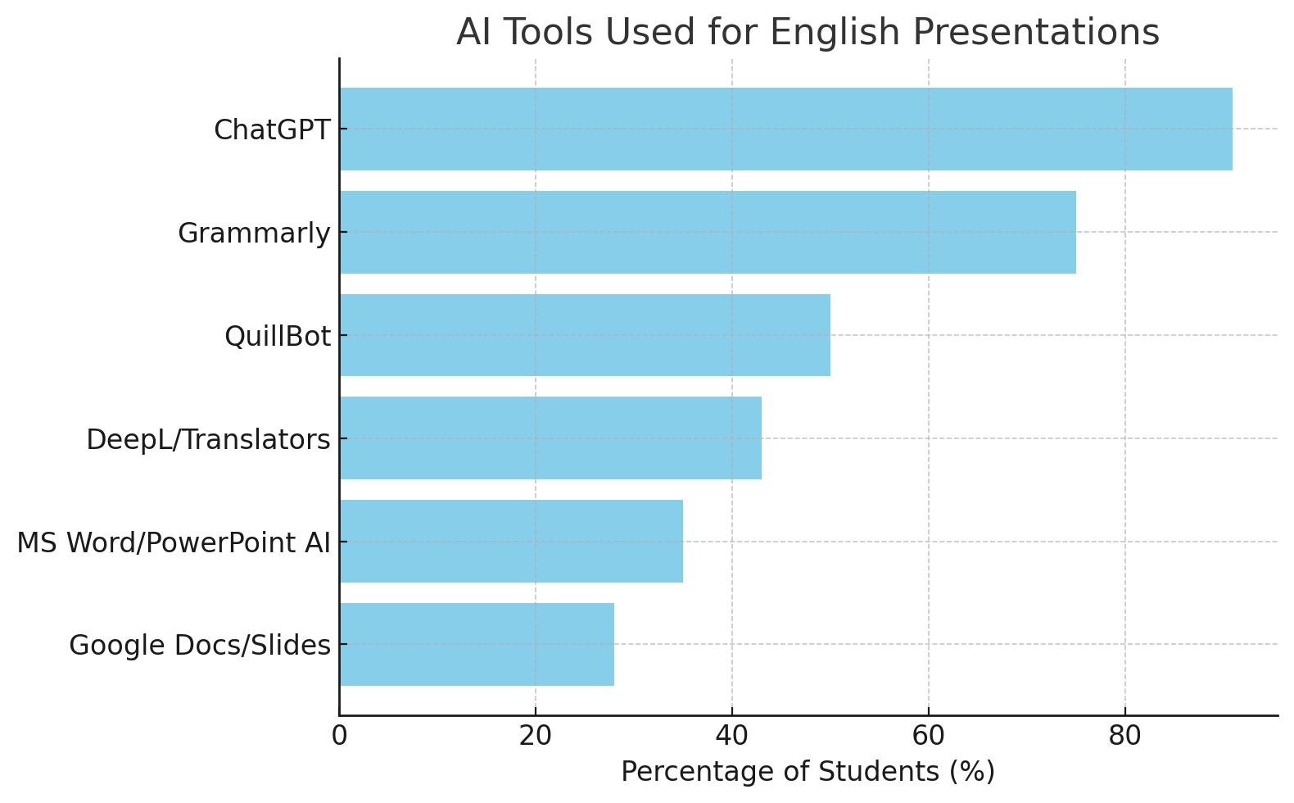

## *4.2. Tasks Supported by AI*

Students reported using AI tools to support a wide range of tasks throughout the presentation preparation process. However, the most commonly cited uses were concentrated on surface-level linguistic support**.** Specifically, grammar correction was reported by 84% of participants, followed by vocabulary enhancement (71%) and paraphrasing (66%). These tasks primarily address formal accuracy and fluency, suggesting that many students rely on AI for immediate linguistic refinement.

Beyond these surface-level functions, a moderate proportion of students indicated that they used AI for content planning, including idea generation and outlining (58%). Tasks that require more advanced cognitive processing or audience awareness, such as summarisingcontent (42%) and practising deliverythrough simulations or speech scripts (29%), were less frequently reported. Strikingly, only 22% of students used AI to support slide design, and a mere 17% used it for explaining technical concepts, despite the technical nature of their discipline.

These findings suggest that while students readily adopt AI tools to polish language output, relatively few are exploring the full potential of AI as a cognitive scaffold for content organisation, technical clarity, or rhetorical adaptation, critical components of effective academic presentations in STEM contexts.

## *4.3. Perceived Impact and Benefits*

When asked about the perceived advantages of AI tool usage, students highlighted several functional benefits. The most frequently cited benefit was time efficiency, mentioned by 38% of participants, who viewed AI as a means to expedite the drafting and editing process. Improved language accuracy was the second most reported benefit (31%), followed by an increase in presentation confidence (24%), reflecting the role of AI in reducing linguistic anxiety.

A smaller proportion of respondents (7%) identified idea expansion and content clarity as notable gains, suggesting that some students do perceive AI as contributing to the conceptual quality of their work. Overall, 72% of respondents agreed that the use of AI had enhanced the final quality of their English presentations. However, when asked whether AI had positively influenced their long-term English learning, only 44% answered affirmatively. This discrepancy points to a clear distinction in students’ minds between AI as a performance aid and AI as a learning tool.

This utilitarian orientation, prioritising efficiency and linguistic output over conceptual or metacognitive development, raises pedagogical questions about how students understand and position AI within their learning process.

The following chart presents students’ perceptions of the main benefits gained from using AI tools. Time-saving was the most frequently cited benefit, followed by improved language accuracy and increased confidence in presentation performance. A smaller portion of students acknowledged AI’s role in idea expansion and content clarity.

**Figure 2**

*Biggest Perceived Benefit of AI Use (N=110)*

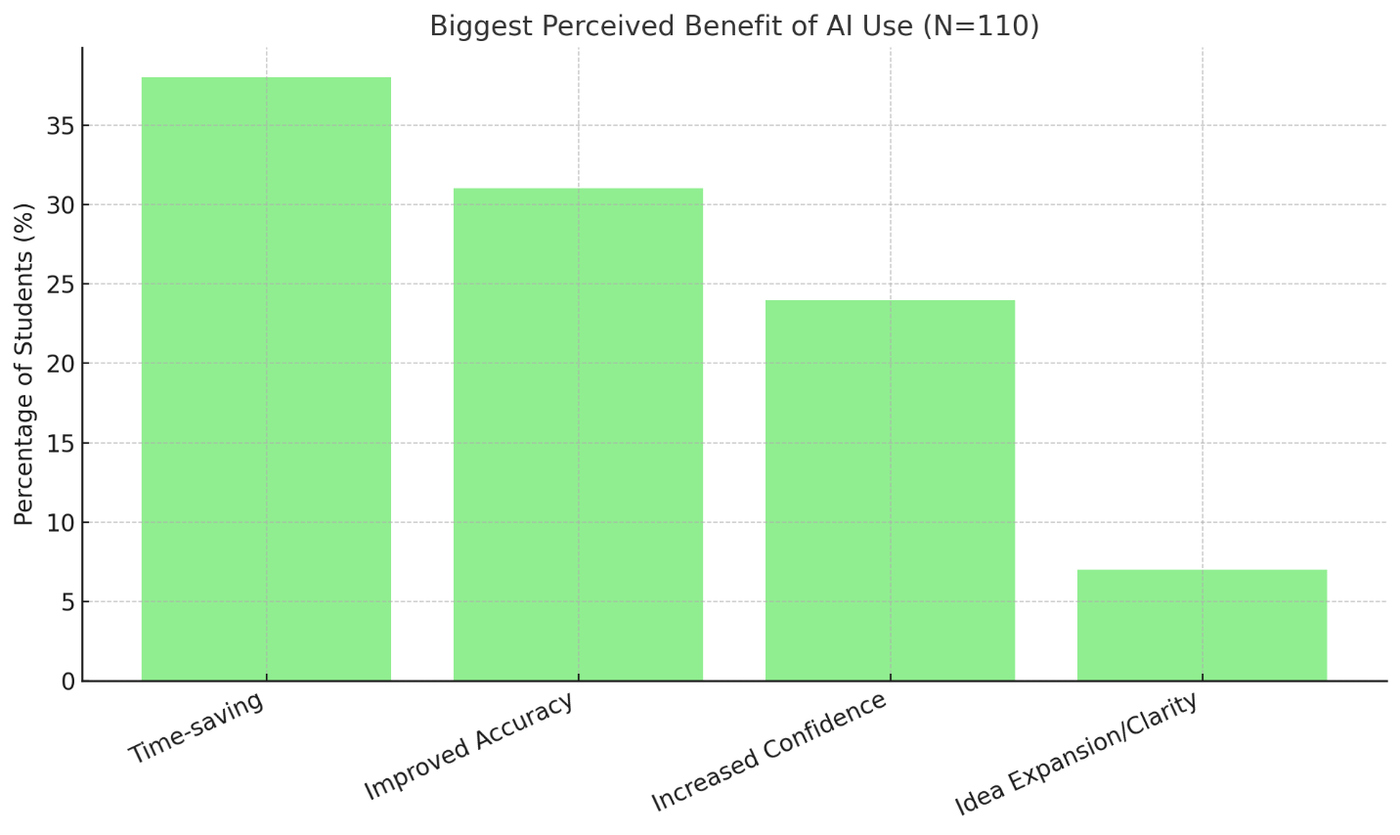

## *4.4. Challenges and Ethical Concerns*

Despite the reported benefits, students also articulated several challenges and ethical dilemmas associated with AI usage. Over-reliance on AI was the most prominent concern, reported by 30% of students, who expressed apprehension that dependence on AI might diminish their autonomy and critical language skills. Issues of originality and potential plagiarism were noted by 27%, reflecting broader concerns about academic integrity and authorship in AI-supported work.

Additionally, 25% of students questioned the accuracy and domain knowledge of AI tools, particularly in relation to technical content. This is a critical consideration in computer science education, where factual precision and conceptual clarity are paramount. Some students (18%) also reported difficulty in balancing their own voice with AI-generated content, suggesting a struggle to maintain authenticity in their writing and speaking.

Significantly, nearly two-thirds of respondents (65%) expressed ethical concerns regarding the fairness and transparency of AI usage. In response to these issues, an overwhelming 86% of students supported the incorporation of instructor-led guidance to help them use AI tools more responsibly and effectively. This reflects a clear need for educational institutions to embed AI literacy and ethical awareness into ESP curricula.

The chart below highlights key difficulties encountered by students when using AI in their academic tasks. Over-reliance, plagiarism concerns, and technical inaccuracy were the top three reported challenges. Additionally, some students struggled to maintain a balance between their own ideas and AI-generated content.

**Figure 3**

*Main Challenges Faced When Using AI*

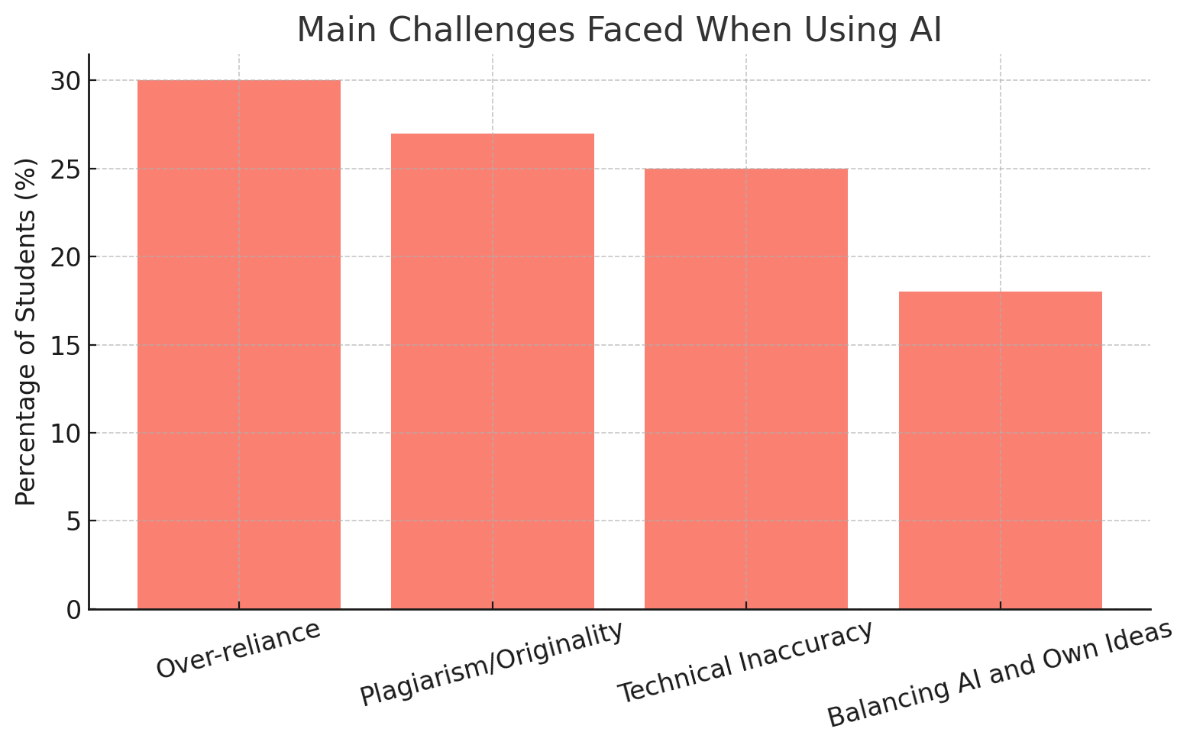

## *4.5. Student Confidence*

The final set of findings concerns students’ self-reported confidence in delivering presentations without AI assistance. Only 18% of respondents reported feeling "confident" when presenting in English independently. In contrast, 59% described themselves as "somewhat confident," while 23% admitted to lacking confidence altogether. This distribution suggests a growing psychological dependence on AI tools, not merely as convenience tools, but as perceived prerequisites for successful communication**.**

Such findings underscore a critical challenge: while AI may empower learners in the short term, it may also erode their long-term confidence and capacity to perform autonomously in academic or professional settings. This insight strengthens the case for integrating critical reflection, peer feedback, and AI-optional assignments to help students build independent competence alongside AI-supported learning.

**4.6. Qualitative Insights from Interviews and Drafts**

Qualitative data obtained from semi-structured interviews and AI-assisted presentation drafts yielded four prominent themes. Each theme reflects students' attitudes, behaviours, and challenges when using AI in academic presentation preparation. Representative student quotes and examples from presentation drafts are included to illustrate key insights.

**4.6.1. Theme 1: Strategic vs. Passive Use of AI**

Some students used AI strategically, employing tools like ChatGPT to generate outlines and then rewriting content in their own words. However, a substantial number admitted to using AI in a passive or even "copy–paste" manner, particularly under time pressure.

*“I try to use ChatGPT for brainstorming and then rewrite it in my own words. But sometimes I just copy it if I’m short on time.”* (Student E)

*“AI saves time, but I feel I don’t really learn anything new.”* (Student A)

Draft analysis confirmed this behaviour. For instance:

Original sentence: *“We can write program to sort number.”*

AI-generated revision: *“We developed a program that efficiently sorts numbers using a bubble sort algorithm.”*

The revised version was often accepted wholesale without modification, reflecting passive adoption of AI input.

**4.6.2. Theme 2: Authenticity Struggles**

Many students expressed internal conflict about whether their AI-supported presentations still represented their own voice.

*“When ChatGPT writes so well, I don’t feel like it’s my words anymore. It’s useful, but I worry it’s not me.”* (Student C)

*“Even though the grammar is perfect, I don’t feel like it’s my own work.”* (Student H)

This theme was also visible in drafts where polished language lacked the personal style or tone typically present in earlier student writing.

**4.6.3. Theme 3: Confidence Boost with Hidden Anxiety**

Students acknowledged that AI tools helped reduce anxiety and increased their confidence in English delivery. However, this confidence was often superficial, masking underlying insecurity.

*“Without Grammarly, I feel scared I will make silly grammar mistakes and lose marks.”* (Student G)

*“With Grammarly, I feel safe. Without it, I panic.”* (Student B)

This paradox illustrates a growing psychological dependency on AI for linguistic correctness and fluency.

**4.6.4. Theme 4: Ethical Ambiguity**

Several participants raised concerns about academic integrity. They were aware of the ethical boundaries surrounding AI use but found them difficult to navigate under academic pressure.

*“I know I shouldn’t copy the whole thing, but it's tempting when the deadline is close.”* (Student F)

*“Is it cheating if I only use AI to check my grammar?”* (Student D)

Draft reviews confirmed occasional heavy AI rewriting with minimal student revision. This raises questions about authorship and fairness, especially when no clear guidelines are in place.

Textual analysis of 25 student group presentation drafts revealed patterns of heavy AI intervention in sentence-level grammar correction and vocabulary enhancement. However, most students made minimal changes to AI-generated phrasing, suggesting a tendency toward accepting AI output passively. Very few drafts showed AI-assisted improvements in rhetorical structuring or technical content clarity, reinforcing earlier quantitative findings.

**4.7. Triangulation of Findings**

The study's use of survey data, interview responses, and textual analysis allowed for effective triangulation, strengthening the validity of findings. For example, the survey revealed that 84% of students primarily used AI for grammar correction, a pattern echoed in interviews where students admitted relying on Grammarly and ChatGPT for error-free writing.

Similarly, concerns about over-reliance and ethical dilemmas were not only voiced in open-ended survey responses (e.g., 30% worried about dependency and 27% raised plagiarism concerns) but also appeared in interviews and were observable in the unchanged nature of many student drafts.

The integration of these three sources confirmed a shared pattern: students benefit from AI support but often struggle to engage critically or ethically. This convergence highlights the urgent need for pedagogical scaffolds that address these concerns from multiple angles.

**5. Discussion**

This study provides a comprehensive examination of how undergraduate computer science students engage with AI-powered writing tools in the preparation of English academic presentations. The findings confirm the near-universal adoption of such tools, particularly ChatGPT (91%) and Grammarly (75%), with over 94% of respondents reporting at least occasional use. These results echo global trends in language education, where generative AI is increasingly seen as a key support mechanism for learners (Dizon, 2023; Farid, 2023). However, beyond adoption rates, the findings uncover important insights into how AI is used, what purposes it serves, and what concerns it raises, both pedagogically and ethically.

## *5.1. Superficial vs. Deep Cognitive Engagement*

While students demonstrate a high level of engagement with AI tools, the nature of this engagement remains largely superficial. The majority of participants reported using AI primarily for grammar correction (84%), vocabulary enhancement (71%), and paraphrasing (66%). These tasks, though valuable, reflect surface-level linguistic improvements that do not necessarily foster deeper communicative competence. In contrast, cognitively demanding tasks such as supporting technical explanations (17%) or designing structured presentations (22%) were underutilised, suggesting a limited understanding of how AI can be leveraged for content-oriented learning.

This pattern aligns with concerns raised in prior research (e.g., Kohnke & Moorhouse, 2022; Jia, 2023), which warn that without explicit pedagogical scaffolding, AI tools may reinforce formulaic or mechanical language use rather than promoting higher-order skills such as argument development, audience adaptation, or discipline-specific discourse strategies. Moreover, only a small proportion of students reported using AI to clarify technical content, indicating a potential disconnect between the language-focused capabilities of AI and the content-rich demands of ESP instruction in STEM fields.

## *5.2. The Confidence Paradox*

A central tension that emerged from the data concerns learner confidence. While 72% of students agreed that AI tools improved the overall quality of their presentations, only 44% believed that AI use contributed significantly to their long-term English learning. This finding suggests a distinction between short-term performance enhancement and sustainable skill development. More strikingly, only 18% of students felt confident presenting in English without AI support, compared to 59% who felt “somewhat confident” and 23% who lacked confidence entirely. This trend points to a growing psychological dependence on AI tools as scaffolds for academic communication.

This phenomenon reflects what Zhang (2024) terms the “confidence–complacency tradeoff,” where increased reliance on AI may lead to a reduction in learners’ self-efficacy and willingness to take linguistic risks. While AI support can offer comfort and perceived fluency, it may simultaneously diminish learners’ belief in their ability to perform independently, particularly in high-stakes or real-time communication contexts. Such dependency has implications for both learning outcomes and graduate readiness, especially in professional domains where real-world performance cannot always rely on AI augmentation.

## *5.3. Ethical Literacy and Pedagogical Support*

The findings also highlight substantial ethical concerns among participants. Approximately 65% of students expressed worry about fairness and the risk of dependency, while 27% raised specific concerns regarding originality and potential plagiarism. These concerns reflect broader anxieties in academia about the implications of AI for authorship, academic integrity, and equitable access to learning resources (Blau & Shamir-Inbal, 2023).

At the same time, a significant majority (86%) of students endorsed the need for instructor-led guidelines on responsible AI use. This finding reveals a clear demand for structured AI literacy education, an area still underdeveloped in many ESP programs. Teaching students how to critically evaluate AI-generated output, cross-check factual accuracy (especially in technical fields), and reflect on the authorship process is essential in ensuring ethical and autonomous engagement with AI tools (Nguyen & Bui, 2023).

Moreover, the 25% of students who questioned AI’s ability to accurately process domain-specific content underscore the limitations of relying on AI in technical communication tasks. This reinforces the importance of human oversight and discipline-specific judgement, particularly in contexts such as computer science, where precision and factual accuracy are critical.

Importantly, the triangulation of survey, interview, and text analysis results provides converging evidence that students’ AI usage is functionally beneficial but ethically and cognitively shallow. This cross-validation strengthens the interpretation that while AI helps with immediate output, it may simultaneously hinder students’ reflective learning and personal development.

## *5.4. Implications for ESP Curriculum Design*

Taken together, these findings suggest a pressing need to reconfigure ESP curriculum design to address both the opportunities and challenges posed by AI integration. First, embedding AI literacy modules within ESP syllabi can equip students with the skills to use AI responsibly and strategically. These modules should go beyond tool demonstration to include critical analysis of AI’s capabilities, limitations, and ethical ramifications.

Second, assessment practices may need to evolve to reflect the dual realities of AI-supported and independent performance. For instance, instructors might consider implementing dual-mode assessment tasks, where students complete one version of an assignment with AI support and another without. This comparison can raise students’ metacognitive awareness of their own language competencies and highlight areas where AI may be compensating for deeper learning gaps.

These implications are particularly relevant for ESP instruction at Ho Chi Minh City University of Technology and Education (HCMUTE), where students often struggle with balancing technical precision and English fluency. Embedding AI literacy into local curricula can help address learners’ over-reliance, promote academic integrity, and bridge the performance gap. For Vietnamese ESP contexts, such localized integration can empower students to critically harness global technologies while navigating context-specific constraints such as limited AI literacy and diverse linguistic backgrounds.

## *5.5. AI Tools as Scaffolds or Crutches?*

While AI-powered writing tools have undeniably streamlined the writing and presentation preparation process, a critical issue emerges around whether these technologies function as **learning scaffolds** or **performance crutches**. The former implies that AI supports learners’ cognitive development by guiding them toward independent competence; the latter suggests that AI displaces authentic learning by offering ready-made solutions.

This dilemma is particularly salient in the context of ESP, where students must not only exhibit surface-level linguistic fluency but also engage with complex content, discipline-specific terminology, and rhetorical precision. When students primarily use AI for grammar correction or paraphrasing tasks cited by over 80% of participants, they risk outsourcing cognitive effort rather than internalizing communicative strategies. Drawing on Sweller’s (1988) Cognitive Load Theory, one might argue that AI reduces extraneous cognitive load, thereby freeing learners to focus on core ideas. However, without explicit metacognitive training, students may bypass this deep processing entirely, leading to what Warschauer and Grimes (2008) call “linguistic autopilot.”

Consequently, educators must critically examine **how** AI is integrated into learning environments. If students perceive AI as a shortcut to product completion rather than a partner in meaning negotiation, the long-term educational value of these tools becomes questionable. This reinforces the need for structured instructional support that cultivates both **critical AI literacy** and **self-regulated learning behaviours.**

**6. Limitations**

Despite its insights, this study presents several limitations that warrant consideration. First, while the survey and interviews offer valuable perspectives on student experiences, the study does not incorporate the viewpoints of **instructors or curriculum designers,** who play a pivotal role in shaping students’ engagement with AI. Understanding how teachers scaffold or constrain AI use in the classroom could offer a more holistic view of the learning ecology.

Second, the analysis does not account for differences in students’ **AI literacy levels**, which may significantly influence how effectively they interact with these tools. Students who use AI critically and strategically may experience qualitatively different learning outcomes from those who rely on it passively or uncritically.

Third, demographic variables such as **gender, prior experience with programming tools, or access to high-performing devices** were not explored, though these factors could shape students’ attitudes and competencies with AI. Finally, while textual analysis was used to trace AI’s influence on student drafts, this process was limited to a single round of writing. Future longitudinal studies could capture how students’ dependence on or resistance to AI evolves over time.

**7. Conclusion and Future Directions**

This study examined the role of AI-powered writing tools in supporting English academic presentation preparation among undergraduate computer science students in an ESP context. Through a mixed-methods approach, the research uncovered patterns of AI usage, perceived benefits, and ethical concerns, while also highlighting the psychological dynamics associated with AI reliance.

Findings revealed that while AI tools such as ChatGPT and Grammarly were widely adopted for surface-level language enhancement, their use remained limited in tasks requiring higher-order thinking, such as structuring technical explanations or adapting content to specific audiences. Students largely valued AI for its time-saving and corrective functions, yet expressed ambivalence about its role in long-term language development. Notably, a confidence paradox emerged: students felt more assured with AI assistance but significantly less confident when asked to present without it. This pattern suggests an increasing psychological dependence on AI that may undermine learners’ autonomy and communicative resilience.

Furthermore, the study brought to light a number of ethical and pedagogical challenges. Concerns regarding originality, plagiarism, and fairness were prevalent, especially in light of the rapid, unregulated integration of AI into students’ academic workflows. Encouragingly, the majority of participants expressed a desire for more explicit instruction on responsible AI use, underscoring the urgent need to embed AI literacy into ESP curricula.

To operationalize these recommendations, an AI literacy module can be embedded into ESP syllabi, comprising: (1) ethical use and attribution of AI-generated content, (2) critical evaluation of AI output for factual and rhetorical accuracy, (3) strategies for combining AI suggestions with personal voice, and (4) reflective exercises comparing AI-supported and independent writing. Optimal classroom use should balance AI assistance for scaffolding (e.g., grammar or outlining) with human-led development of content depth and audience adaptation. Educators should design scaffolded tasks to gradually reduce AI dependence while promoting metacognitive awareness.

Looking forward, this study opens several promising avenues for future research. Longitudinal studies could investigate how sustained exposure to AI tools affects students’ language proficiency and academic performance over time. Experimental designs comparing AI-assisted and AI-independent learning outcomes would offer a more rigorous understanding of AI’s pedagogical impact. Furthermore, cross-disciplinary studies could explore how learners in different academic domains use AI differently, thereby informing the development of tailored instructional approaches. Finally, future research should also consider the role of teachers and institutions in mediating AI use, examining how attitudes, policies, and classroom cultures influence student behaviours and beliefs.

To sum up, this study sheds light on the pedagogical, psychological, and ethical dimensions of integrating AI tools into English academic presentations for computer science undergraduates. It confirms that while AI platforms like ChatGPT and Grammarly enhance surface-level linguistic performance and offer psychological comfort, their pedagogical value is constrained by how students perceive and employ them.

Crucially, the findings illuminate a growing **confidence gap** and **cognitive outsourcing** tendency, symptoms of a broader shift in how learners interact with language learning technologies. If left unaddressed, this could undermine learners’ communicative autonomy and critical thinking, particularly in STEM contexts where linguistic precision and content mastery are deeply intertwined.

To respond proactively, educators should **embed AI literacy** into ESP syllabi, not simply as a technical skill but as a reflective practice. AI tools should be framed not as oracles but as **dialogic collaborators**, aids to reasoning, not substitutes for it. Pedagogical innovations such as dual-mode assignments (AI-supported vs. AI-independent), reflective writing logs, and peer feedback protocols can foster this shift.

Ultimately, this study argues that the future of AI in language education must balance technological affordances with pedagogical intentionality. Only then can we transform AI from a crutch for linguistic insecurity into a catalyst for deep, ethical, and enduring language development.

Future research should also continue leveraging triangulated data to deepen the understanding of students' evolving AI literacy. Studies could investigate how overlapping perspectives from learners, educators, and textual outputs inform more effective instructional strategies. Triangulation, when systematically applied, offers a robust lens for exploring the dynamic interplay between AI use, learner agency, and ethical awareness.

**Acknowledgments**

The authors would like to express their sincere gratitude to the students of the Faculty of Information Technology at Ho Chi Minh City University of Technology and Education for their enthusiastic participation in the study. Special thanks are also extended to the ESP instructors who provided valuable feedback on the survey instrument and supported data collection. This research was conducted as part of the faculty's initiative on digital transformation in English language education.

**References**

**Aryadoust, V., et al.** (2025). Generative AI as a cognitive copilot in English language learning in higher education. Teaching and Teacher Education.

**Bikowski, D.** (2022). Technology in English for Specific Purposes instruction: Pedagogical affordances and learner engagement. TESOL Quarterly, 56(2), 389–410. <https://doi.org/10.1002/tesq.3019>

**Blau, I., & Shamir-Inbal, T.** (2023). AI literacy for future-ready education: Teacher and student perspectives. Computers & Education: Artificial Intelligence, 4, 100136. <https://doi.org/10.1016/j.caeai.2023.100136>

**Dizon, G.** (2023). Exploring the use of ChatGPT as an AI-based writing assistant for English learners. TESL-EJ, 27(1), Article 2. https://www.tesl-ej.org/pdf/ej105a2.pdf

**Farid, S.** (2023). AI-driven writing support in ESP: Boon or crutch? Asian ESP Journal, 19(2), 88–107.

**Jia, J.** (2023). Assessing student use of AI-based paraphrasing tools in academic writing: Opportunities and risks. Journal of English for Academic Purposes, 63, 101219. <https://doi.org/10.1016/j.jeap.2023.101219>

**Kohnke, L., & Moorhouse, B. L.** (2022). Exploring the affordances of AI writing assistants in English language education. Language Learning & Technology, 26(1), 34–51. <https://doi.org/10.1016/llt.2022.0034>

**Nguyen, M. H., & Bui, T. T.** (2023). Developing AI literacy in university ESP courses: A pedagogical framework. VNU Journal of Foreign Studies, 39(4), 1–22.

**Raza, M., Soomro, A., & Aslam, R.** (2023). Enhancing ESP writing performance through AI tools: Evidence from engineering students. English Language Teaching, 16(5), 45–59. <https://doi.org/10.5539/elt.v16n5p45>

**Technology, Knowledge & Learning.** (2024). Exploring students’ generative AI-assisted writing processes. (“in press”, updating citation when available.)

**Zhang, X.** (2024). ChatGPT in higher education: Bridging or widening the confidence gap? International Journal of Educational Technology in Higher Education, 21(1), 17. <https://doi.org/10.1186/s41239-024-00487-w>

**Bionotes**

**Ms. Su Thi Ai My, M.A.,** is a lecturer in English for Specific Purposes at Ho Chi Minh City University of Technology and Education. With over 25 years of experience, she has taught English to students from diverse academic and professional backgrounds. Her specialisation is in English for Mechanical Engineering, and she has designed and taught courses in English for IT, technical English, and workplace communication. She is dedicated to helping learners enhance their English proficiency and achieve academic and career success. She actively seeks collaboration with fellow ESP practitioners and researchers to advance innovation and best practices in the field.

**Ms. Hua Tran Phuong Thao, M.A.,** is a university lecturer specialising in English Linguistics and Translation–Interpretation Studies. She holds a Master’s degree in English Language Teaching Methodology and has extensive experience teaching phonetics, syntax, and translation methodologies. Her research interests include discourse analysis, translation strategies in multilingual contexts, and the integration of information technology and AI in language education. Passionate about teaching, she is actively involved in curriculum development and academic mentoring. Committed to improving students’ linguistic competence and intercultural communication, she contributes to bridging the gap between linguistic theory and real-world application in both classroom and professional settings.