**Using AI Tools to Support Teaching and Learning Business English**

Dang Thi Anh Tuyet[1]

Abstract

In this digital era, the application of Artificial Intelligence (AI) tools has become increasingly significant in education and training. Particularly in tertiary education, teaching and learning currently face challenges of using AI effectively to optimize learning outcomes. This paper examined how AI could support teaching and learning in Business English courses. There is a phenomenon that students usually lack experience of the business world, and thus they find it difficult to come up with ideas for communication in business settings. Using action research with the qualitative and quantitative methods, the study was conducted with 120 second-year students from four Business English classes at the Faculty of Foreign Languages of HUFLIT. They were allowed to employ AI tools for generating ideas and content so that they could carry out oral communication in business scenarios. According to the students’ feedback, the support of AI tools have made tasks on Business English easier for them both in class and self-study, thereby enhancing their learning outcomes. In addition to many benefits from the utilization of AI tools, the study’s findings showed that the majority of students enjoyed the practice. Therefore, further research on similar AI applications in Business English teaching and learning should be encouraged on a large scale to offer more implications and insights into the effectiveness of the approach.

***Keywords*:** AI tools, Business English communication, learning outcomes

1. Introduction

In this digital era, new technologies continue to have a tremendous influence on various aspects of life, of which Artificial Intelligence (AI) increasingly prevails in various sectors, including education and training. AI applications have proved to be powerful in enhancing productivity in various fields including pedagogical approach. The new trends have prompted teachers to make adaptations in teaching and learning practices. However, to what extent we can integrate AI into education and how we can make it work effectively remain a matter of debate. Although AI applications have come to life in recent years, the freedom for utilizing them in academic work has encountered contradictory views. In spite of that, in teaching and learning English, necessary transformations have taken shape to adapt to the new trends as well.

In the settings of HUFLIT Faculty of Foreign Languages (FFL), I am often in charge of Business English courses. It is noted that many students have trouble when it comes to working on business scenarios, doing role-play, making a presentation or having case-based interactions with their partners. Delving into the phenomenon, I realized one of the major causes lied in the fact that many students are not familiar with realistic business situations due to their lack of exposure to work life. This poses challenges for them in creating appropriate content and language for communication in business context. According to traditional pedagogy, many teachers would mostly give scaffolding ideas, providing useful phrases and language functions, facilitating students to carry out the communication tasks. However, this pedagogical practice seemingly falls short of current trends in the digital era where AI has provided powerful support for students’ exploration. When AI tools initially came into existence, their applications were cautiously restricted to some extent in education due to the fear of abuse and cheating. Nevertheless, their appeal was so prevailing to students, and instructors can only attempt to moderate their utilization instead of prevention; teachers are supposed to change their mindset to accordingly adapt to the new trends.

Business English course is a compulsory module being designed for students majoring in Business English, and it plays an essential role in building the basics for subsequent English for Specific Purposes (ESP) courses. Despite students’ eagerness in exploring the vividness of business world, most of them show inadequacy in business-related knowledge and experiences, giving rise to difficulties in working on business scenarios. Confronted with the phenomenon, I had to take it into consideration and adapted my pedagogical approach to the new trends. I intentionally empowered students with AI exploration, allowing them to consult with AI-powered platforms while working on their tasks. With the freedom to explore technology in academic work, learners’ autonomy and engagement are enhanced. I hold that this approach will also provide the opportunities for students to open their eyes to the so-called authentic business situations being suggested from AI tremendous resources. In line with the perceptions, the research aims to explore the effects which AI utilization has brought to the students in learning Business English communication, specifically, how students benefit and what common difficulties they encounter in employing AI tools for learning Business English communication. Accordingly, my research addresses the two core research questions as follows:

1. *How do students enjoy and in what aspects do they benefit from using AI tools’ support in generating ideas and creating content for business communication?*
2. *What are common challenges they may face while employing AI tools for generating ideas and creating content for business communication?*

2. Literature Review

With the core research questions in mind, I embarked on Literature Review to investigate and learn from other researchers in this practice. It is noted that integrating AI into Business English teaching and learning has become popular as it supports Business English communication in many ways, thereby helping students improve their communication skills in Business English. In light of literature review, AI’s capacity has proved to enhance many aspects in teaching and learning Business English. AI tools have recently become so powerful that they tend to dominate other available counterparts in terms of using frequency.

2.1. The Application of AI in Business English Teaching and Learning

The wave of emerging AI tools in recent years has prompted teachers and instructors to change their mindset as to applying AI in teaching and learning English, especially Business English which is considered significant for students’ future work life. According to Huang (2024), by providing dynamic and context-based sentence structures, AI-driven tools helps teaching Business English more effectively. It is thanks to the fact that these tools can facilitate learners in generating ideas and content for authentic business settings such as interactive liaisons, negotiations, and presentations, thereby improving learning outcomes. There is a common phenomenon among Business English students that they lack real work life experience and are not yet familiar with business settings. Generating ideas and content for communicating in business scenarios is usually a challenge for them, and therefore AI tools have become wholeheartedly welcomed by learners thanks to their enormous valuable resources of data and instant processing. Cui and Yue (2024) argued that AI boosts interaction for learners as it suggests authentic cases in business settings and contextual content so that students can employ to practice their language use for specific areas, for instance, in finance, marketing, and international trade. AI-powered platforms also assist students with many realistic business tasks essential for business communication such as creating persuasive sales pitches, preparing formal reports, and coming up with negotiation strategies (Liu, 2023). In terms of innovation, AI has performed a critical role in transforming teaching and learning mindsets for both teachers and learners. With AI facilitation, the traditional pedagogy with theory-based teaching methods has dramatically transformed to learner-centered approach.

2.2. AI Tools Enhancing Communication and Creativity for Learners

Communication skills are particularly essential for Business English learners because these skills place among the top competencies required at the work place. However, good spoken English does not ensure good Business English communication skills. It takes specialized language and professional business styles in addition to linguistic functions. As Jiang (2022) put it, besides grammar, AI tools also provide constructive comments on style and tone suitable for business-specific communication as well. He stressed, in addition, the support of AI tools in brainstorming and refining ideas whereby more professional communication can be achieved. Another noted finding was about the synergy between generative AI and real-world business education. AI provides scaffoldings for developing ideas and giving prompt suggestions for creating content in performing Business English tasks such as writing business correspondence, proposals, or summaries. Regarding the aspects of nurturing learners’ creativity and motivation in Business English, Lijie et al. (2024) pointed out how those aspects are achieved through cognitive flexibility. Their finding results affirmed AI’s capacity in enhancing students’ critical thinking and innovative content creating suited to different business situations.

2.3. The Trends of Using AI and Pedagogical Transformation

According to Hidayat et al. (2023), there is a trend of growth in employing AI in English language teaching (ELT) such as writing, speaking and conducting tasks that require content generating. Likewise, in examining AI-based language learning tools, Woo and Choi (2021) stated that AI-powered writing assistants and speech simulators are tremendously helpful to business English learners with low-risk, AI-supported environments for their practice. Similarly, in writing, it is supported by empirical evidence that AI-powered writing assistants enhance learners’ academic writing outcomes as well (Nazari et al., 2021). From a broader perspective, while discussing AI-based needs analysis in English for Specific Purposes (ESP), Tang (2023) emphasized AI’s extraordinary capacity in tailoring content to the relevant industry, roles, and according to communication needs for more effective language practice.

2.4. The Challenges of AI Application and Integration

Although no one can deny the popular benefits of AI application in teaching and learning, particularly for Business English, we are currently faced with many challenges attributable to AI employment. Ting and Mengqi (2024) recommended combining AI with data analytics for more precise feedback and generating targeted content. That will help increase more accuracy in simulating authentic business scenarios. Another point is that rapid integration of AI has posed many concerns for teachers and educators. Teachers have difficulties to adapt themselves to AI applications, harmonizing AI tools with pedagogical aims; besides, they have to face the matters of data privacy and learner engagement (Owoc, Sawicka, and Weichbroth, 2021). In fact, the availability and easy access to AI applications, exploring enormous resources instantly have become easier than ever before. The more students are eager to explore AI tools, the more heavily they tend to rely on them. For effective implementation and optimal learning outcomes, it takes thoughtful integration of technology with pedagogical strategies.

3. Methodology

***3.1. Study Setting and Participants***

The participants in this study were students at HUFLIT Faculty of Foreign Languages (FFL), majoring in Business English. They were second-year students from four classes with a total number of 120 participants being randomly selected. This Business English course is a compulsory module providing the basics for Business English-majored students to subsequently advance to other ESP courses.

As mentioned above, the students’ lack of experience on the business environment prompted me to adapt my pedagogical approach by allowing them to utilize AI tools to support them in business communication tasks. However, before referring to AI assistance, students were asked to work in groups, brainstorming ideas and content for the contextual business settings based on their background knowledge and experiences. Then, they were allowed to search further, employing AI tools. Working this way made students more active and engaged in their tasks. The AI-generated outputs would be used as references for follow-up group discussion so that students could refine the ideas and content to properly suit their communication tasks – role-playing, giving a presentation or problem solving, etc. Finally, such AI-generated refined content would be developed into conversations or presentations by the students themselves. For most productive utilization, relevant tips of how to employ AI tools for such purpose was communicated to the students in advance. To maximize learning outcome while minimizing underlying risks and disadvantages, at the outset, I explicitly explained so-called guidelines as to how to use AI applications properly in ESP courses. For demonstration, I took one example of business scenario from the textbook, analyzing the situation, brainstorming ideas with the whole class for the required content. Then, I showed them how they could use popular AI tools like ChatGPT, Gemini, Magic School, etc. to search for more desired content. In the guidelines, the most striking feature is that students were asked to insert the command “Do not provide full sentence(s). Just prompts.” when they were making prompts for AI-powered platforms. To ensure students’ compliance, I raised their awareness of the benefits of employing AI this way; it could save them from over-reliance, leading to detrimental effects on their critical thinking and analytical reasoning skills. It is also noted to students that AI-assisted results should be used as references, the data should be double-checked for accuracy where necessary, and AI-generated structures should be tailored in association with students’ ideas and thoughts as well to suit the language nuances of the contextual situations.

***3.2 Research Instruments***

This study employed action research, aiming to improve pedagogical practices and learning outcomes in Business English courses through the integration of Artificial Intelligence (AI) tools. On the grounds of the literature review, I hold that action research is particularly suited to educational contexts where iterative reflections and refinement of teaching methods are necessary. Action research can help me gain valuable insights into teaching practices and improve student learning outcomes. As my epistemology is mostly interpretative, I focused on qualitative research methodology. On the other hand, I also observed some quantitative aspects because I wish to explore how much the students enjoyed and benefited from the approach. In other words, my research is based on mixed methods. To ensure comprehensive data collection, methodological triangulation was applied through the use of multiple qualitative and quantitative research instruments. The primary tools included:

* Classroom Observations: These were conducted throughout the study period to record student engagement, interaction, and behavior while performing AI-supported tasks.
* Focus Group Interviews: Semi-structured interviews were held with a group of nine volunteer students to explore their attitudes, the related benefits and challenges, and their suggestions related to AI use in Business English communication tasks.
* Surveys: A well-structured questionnaire was developed based on preliminary observations. It included Likert-scale items, multiple-choice questions, and short-answer prompts to gather students’ perceptions and experiences.

These instruments collectively allowed for a rich and in-depth data collection, offering multiple perspectives on the teaching and learning process..

***3.3 Data Collection and Analysis***

The data was collected over nine weeks during the course. The data analysis employed a qualitative, iterative process with thematic analysis techniques. I took field notes during classroom observations when the students were working on business communication scenarios, incorporating the use of AI into their tasks. During the process of data collection, preliminary analysis was conducted, which informed the development of survey and focus group interview protocols, ensuring alignment with observed classroom dynamics. The prominent data suggested from the observations were used for further investigation through surveys and interviews. Based on the salient points generated from the observations, a well-designed questionnaire was prepared, including Likert-scale items, multiple-choice questions, and short-answer prompts allowing for eliciting perceptions and comments from the participants. The survey was conducted by means of Google forms being sent by email. The interviews involving open-ended questions were conducted in person or via video calls. All the interviews were recorded with the participants’consent and transcribed for data analysis.

Emergent themes from the interview data included: (a) AI applications as supportive tools of language learning, (b) perceived benefits such as increased confidence and vocabulary development, (c) concerns regarding overreliance on AI and diminished originality, and (d) students’ suggestions for enhancing the use of AI tools in language education. These themes provided meaningful insights into students’ attitudes toward AI integration, reflecting both opportunities and challenges in the application of AI technologies within Business English instruction.

In addition, the survey data—collected via Google Forms—was reviewed to identify trends in student attitudes and perceived benefits. The mix of quantitative (Likert-scale) and qualitative (short-answer) responses provided both breadth and depth to the analysis.

Overall, the data analysis provided triangulated insights into how AI tools supported the teaching and learning of Business English and informed conclusions and recommendations for future practice.

4. Results

Based on empirical investigation, the findings reveal four central themes as follows.

***4.1 Students’ Interest and the Usefulness of Employing AI in Learning Business English Communication***

**Figure 1**

*Students’ showing interest in using AI for learning business English communication*

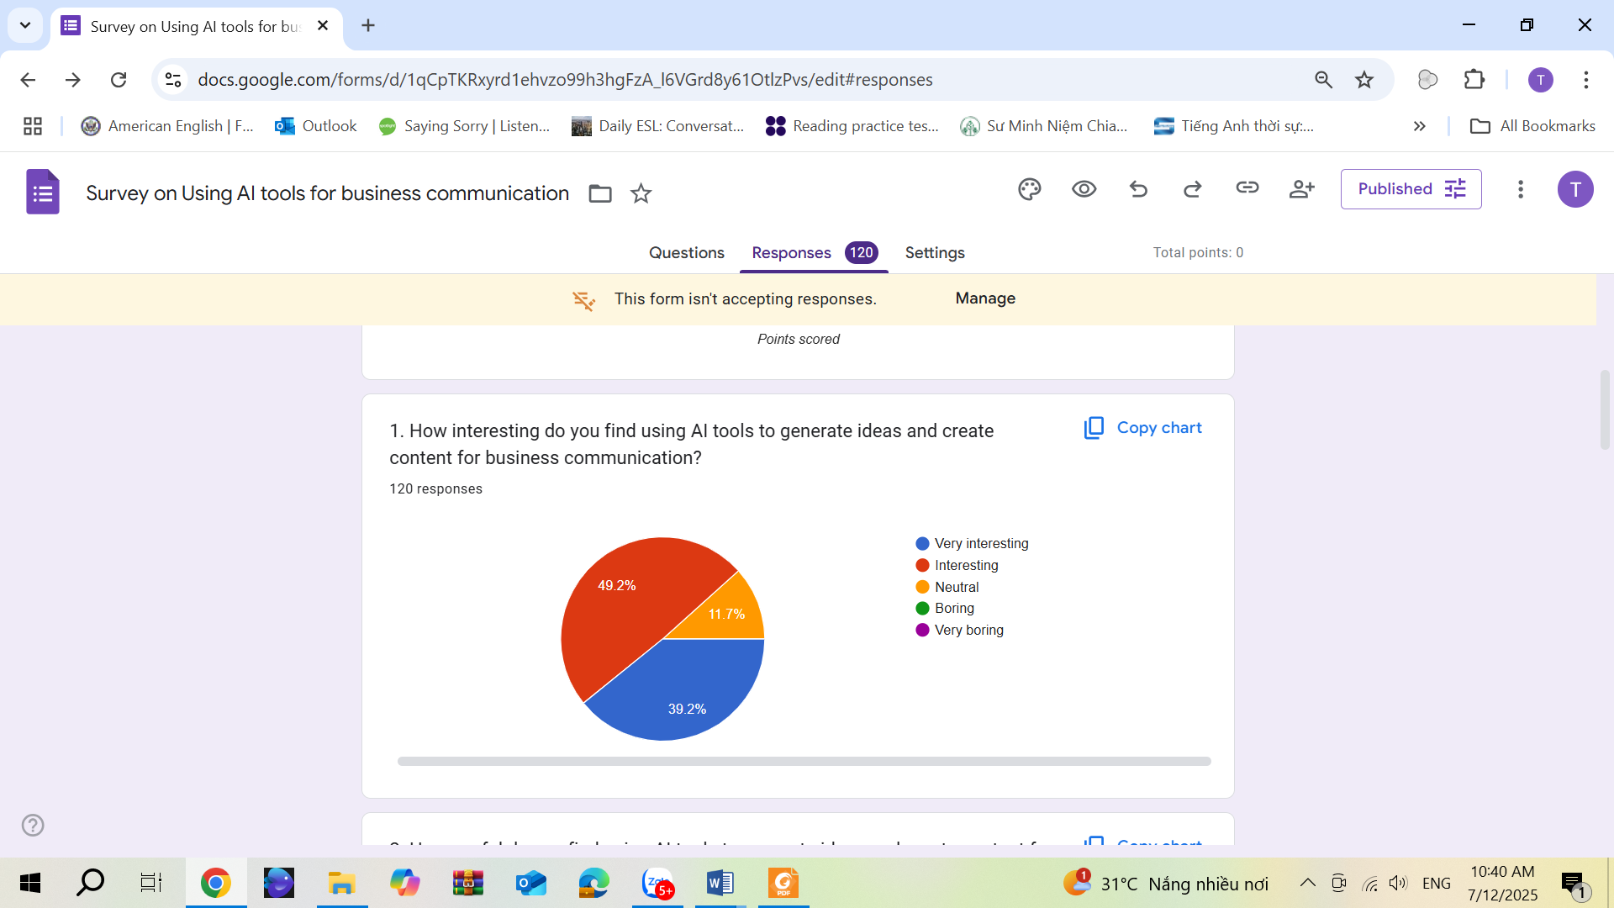

Figure 1 shows that the majority of participants welcomed the practice, enjoying utilizing AI to support in generating ideas and content for business communication. The majority of students enjoyed the practice, learning and improving their Business English communication with AI support; interestingly, approximately 90% of students found the practice *interesting* and *very interesting*. This figure aligns with the data generated from classroom observations where most students demonstrated high level of interest and engagement in group work while interacting with AI tools for business communication tasks.

**Figure 2**

*High level of usefulness of AI tools’ support in learning business communication*

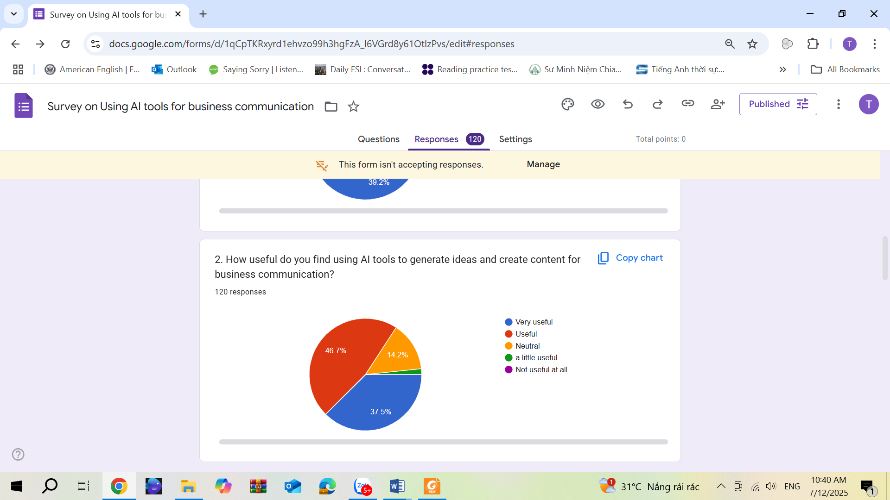

Figure 2 presents students’ perception about the usefulness of AI-assisted tools in learning business communication. In terms of usefulness of employing AI tools in generating ideas and content for business communication scenarios, all the participants found the practice useful; most of them confirmed high level of usefulness of this practice with 84% rating as *useful* and *very useful* while 0% rated as *not useful at all*. These figures confirm the findings from the literature review that AI can effectively support learning Business English in many ways including generating ideas, creating content for situational communication in business contexts.

***4.2 Perceived Benefits in Using AI for Generating Ideas and Content in Learning Business English Communication***

**Figure 3**

*Common benefits of employing AI tools in learning business English communication*

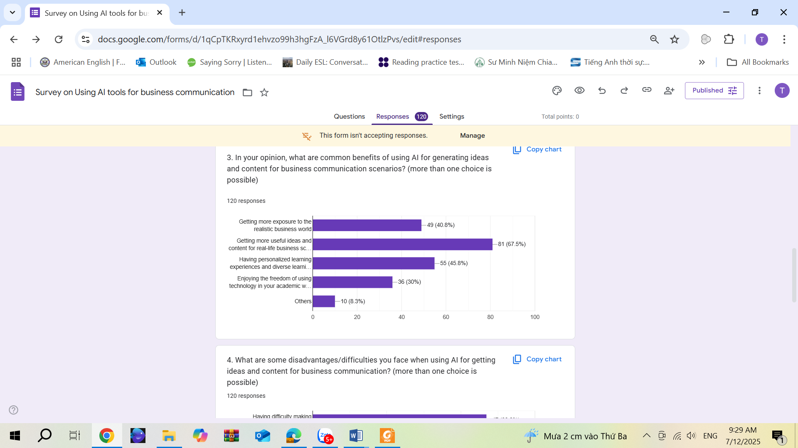

With regard to common benefits of AI employment in generating the required information for Business English communication, many students agreed to such benefits as *“getting more exposure to the realistic business world”* (41%), a large number confirmed the benefit of *“getting more useful ideas and content for real-life business scenarios”,* representing 68% of the students. Many students pointed to the activity’s benefits such as *“having personalized learning experiences and diverse learning resources”,* and *“enjoying the freedom of using technology in your academic work”* with the proportion of 46% and 30% respectively. These results align with the data from the literature review that AI-powered platforms also assist students with many realistic business tasks essential for business communication (Liu, 2023). Some students stated:

*“AI helps learners improve Business English by simulating real tasks like writing emails, reports, and pitches. It allows users to practice, get instant feedback, explore tone variations, and refine content efficiently. With clear goals, AI becomes a smart tool for building professional communication skills.” (S4)*

*“AI is a powerful tool for learning business English. It helps generate ideas, correct grammar, and improve vocabulary quickly.” (S2)*

*“…Having personalized learning experiences and diverse learning resources.” (S6)*

*“Using AI can greatly support students in generating ideas, studying independently, and searching for information…” (S5)*

***4.3 Common Challenges for Students When Employing AI Tools in Learning Business Communication***

**Figure 4**

*Common difficulties/disadvantages in employing AI tools in learning business communication*

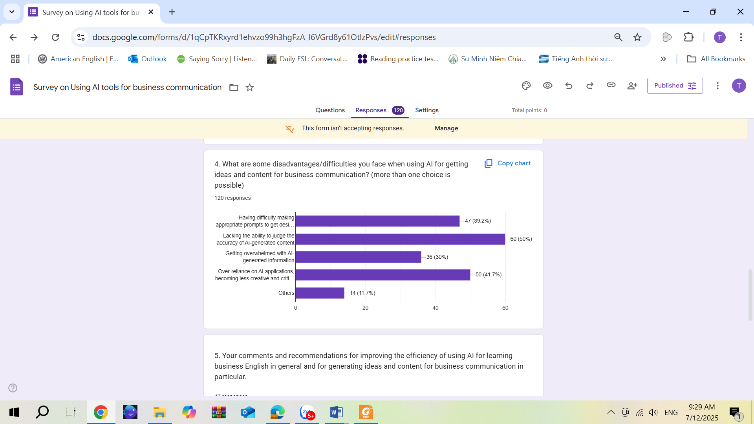

With regard to difficulties/disadvantages in employing AI tools for these purposes, *“lacking the ability to judge the accuracy of AI-generated content”* represents the utmost difficulty facing the students, with 50% claiming, followed by *“over-reliance on AI applications, becoming less creative and critical-thinking*”, with 42% claiming the underlying risk. Besides, 39% of students confirmed *“having difficulty making appropriate prompts to get desired content”;* the figure echoes the observation-generated fact showing a phenomenon that some students were apparently confused about making prompts for AI actions. Also, 30% of students admitted *“getting overwhelmed with AI-generated information”*. Some students commented in the survey:

*“I think it’s good, but sometimes the information is not correct and messy.”*

*“AI-generated content can sound fluent but may lack tone, nuance, or cultural fit for a specific situation (e.g., investor pitch vs. internal report vs. customer support). You need to review and adapt outputs with the target audience in mind.”*

The survey results reflect similar findings from group interviews. Whereas the majority of participants really enjoyed and benefited from the learning practice, some expressed their concerns over possible challenges in exploring AI resources. One striking feature noted during AI exploration is that AI may excel in multiple tasks, including effectively supporting in business communication, it shows shortcomings in emotional aspects; for instance, it failed to appropriately generate specialized language use in more complex contextual business scenarios. One student from the interview stated:

*“I’m a regular AI user since AI tools came to life. While appreciating extradinary benefits they’ve brought, I note that AI supposedly has higher IQ than EQ”. (S1)*

***4.4 Students’ Recommendations for Improvements***

The most striking features were noted when it came to giving suggestions and recommendations for improving the efficiency of employing AI tools in learning Business English in general and for generating ideas and content in business communication in particular. Multiple interesting inputs from students centering around the utilization of AI applications signified students’ profound insights in integrating AI into their study. According to the survey results, some constructive comments were noted as follows.

*“You could use AI as reference point, do not trust 100% the results because AI can’t replace human completely. To use it efficiently, you should not rely solely on AI but use it as a tutor asking for explanations, customizing prompts, and revising outputs.”*

*“It’s great for generating content ideas and saving time. Just be sure to adjust the output to match your own style. For best results, combine real-life use with AI support.”*

*“However, to learn effectively, we should use AI actively — by practicing writing, asking for feedback, and simulating real business situations. This makes learning more engaging and useful for real communication.”*

In addition, some other interesting experiences were shared among focus group interviews as follows:

*“Combining AI feedback with human input and encouraging critical thinking will improve both content quality and language skills.” (S5)*

*“To learn business English with AI effectively, use clear prompts, practice real situations, and ask for feedback. Treat AI as a smart partner to help you write better, sound natural, and grow more confident in communication.”(S8)*

*“If you only copy AI-generated answers or phrases without engaging with them, your progress will be slow. You need to practice speaking, rewriting, and explaining ideas using those phrases.” (S3)*

*“To use AI more effectively in Business English, tools should reflect real-world language and tone. Learners need clear prompts, guidance on editing AI output, and training in prompt writing. Combining AI feedback with human input and encouraging critical thinking will improve both content quality and language skills.” (S9)*

5. Discussion

***5.1 Discussion of Findings***

The empirical research has given me some insights into one of the currently noteworthy matters- integrating AI into pedagogical approach. Despite the pros and cons of employing AI tools in creating content for business communication as mentioned in the research findings, AI applications have been most welcomed as supplementary addition to teaching and learning by both teachers and learners. In terms of benefits brought to students, AI tools, in many aspects, prevails over other available technology tools that have been in place. According to students’ comments, using AI tools save them considerable time as they can render results instantly with remarkably satisfying data, providing that appropriate prompts are given. Students’ remarks align with the statement from Woo and Choi (2021) claiming that AI-powered writing assistants and speech simulators are tremendously helpful to Business English learners. From group interviews, another striking feature of using AI for these purposes is noted that AI-generated data from popular tools like ChatGPT is frequently updated, providing useful and relatively reliable resources in many areas. These findings align with Tang (2023) emphasizing AI’s extradinary capacity in tailoring content to the relevant industry, roles, and according to communication needs for more effective language practice. For Business English-majored students, they benefit considerably since many of them lack hands-on experience and real-world knowledge. With AI-powered resources, they can get access more easily to simulated business scenarios with appropriate business language for communication. With AI powerful support, students now have a chance to get more exposure to realistic business settings, which somehow helps them open their eyes to the vivid business world. Furthermore, nurturing learners’ creativity and motivation in Business English, which are achieved through cognitive flexibility, is the fact being pointed out by Lijie et al. (2024). Last but not least, among the notable benefits, the synergy between generative AI and real-world business education was also mentioned in the literature review.

With regard to the challenges facing both educators and students, the research findings also revealed several negative aspects. Apart from the difficulties reflected by students, a major challenge for instructors is how to integrate AI into pedagogical practices while maintaining students’ cognitive engagement and skill development. To curb and limit those drawbacks, it is recommended that students should be trained to utilize AI tools properly, for instance, how to elicit targeted content, how to evaluate the accuracy of AI-generated data, etc. Notably, most students have familiarized themselves with AI applications; however, many explored them spontaneously without prior guidance. From an instructor’s perspective, I realized that students actually need guidelines. Therefore, students should be provided so-called guidelines for AI employment in a particular course. Students should be encouraged to trigger their experiences about the subject matter first, sketching some relevant ideas before consulting with AI. Then, students can develop AI-generated content further to suit the assigned communication tasks. During the course of action, students should also be urged to use their judgement to evaluate whether the AI-generated ideas and content are relevant. More importantly, they should be made aware of major issues related to AI tools’ utilization such as ethics, data privacy, bias and overreliance which may adversely affect their critical thinking and problem solving skills in the long term. This concern was raised by Phuong, H. Y. et al. (2024) that AI is giving rise to passive learning practices, leading to reducing students’ engagement with complex linguistic challenges and their problem-solving abilities. However, these matters can be alleviated if students are taught to balance AI assistance and their own capacity (Werdiningsih et al., 2024). Ultimately, students should keep in mind that in all respects, AI can assist but cannot replace human beings; therefore, AI-created content should be evaluated and refined properly, using our critical thinking and analytical reasoning. In other words, AI-generated data should be considered supportive resources for reference only. In teaching roles, teachers’ proficiency in technology is essential for ultimate learning outcomes. Thus, teachers may have difficulties in adapting themselves to AI applications, integrating AI-assisted tools into pedagogical aims (Owoc et al., 2021).

As far as I am concerned, new applications of advanced technology may inevitably entail some risks. In reality, there has been much talk about the underlying risks and challenges in integrating AI into education and training; however, in light of literature review and empirical investigation, this study implies that the benefits supposedly outweigh the disadvantages in many respects. In spite of the pros and cons in AI employment, I suppose we can reconcile them by taking necessary measures, for instance, making it clear to students: to what extent they can employ AI applications in academic work. Despite current drawbacks, incorporating technological applications such as AI tools into instructional pedagogy apparently benefit both teachers and learners. Whether we advocate the practice or not, it remains a contemporary trend that should be welcomed in ELT in general and in ESP courses in particular. After all, this pedagogical practice is also in line with the learner-centered philosophy in education, in which learners’ autonomy and benefits should be promoted.

***5.2 Limitation of the Study***

Like many other studies, my research may contain some limitations. To begin with, this is my first attempt to investigate the effects of AI employment in teaching and learning business English. I am just a novice researcher in these advanced digital applications, attempting to keep pace with and integrating AI into pedagogical practices. Therefore, the study implications may require further comments of holistic view from more experienced practitioners in this field. Another drawback is that the study setting was at HUFLIT FFL only, which may not be suited for broader generalizations. In order to gain more empirical insights and profound pedagogical implications for AI use in teaching and learning Business English communication, further study should be conducted on a larger scale and in different study settings, incorporating other higher educational institutions from different regions for a broader perspective. In addition, it is recommended that further research should focus on investigating negative aspects of AI application such as misleading use, bias and over-reliance, etc. to provide more insights into AI tools’ effectiveness, especially in ESP courses.

1. Conclusion

In summary, the wave of emerging AI tools coming to life in recent years has prompted teachers and instructors to change their mindset as to integrating AI into teaching and learning. Particularly in teaching and learning business communication, the study looked into the benefits and challenges of employing AI-powered tools to support in generating content and language functions for business communication scenarios. In Business English courses, connecting theory with the reality has become increasingly essential, which is considered significant for students’ future work. While there is a gap between students’ business-related knowledge and the realistic business world, the introduction of AI-powered platforms to education seems most welcomed due to their extradinary benefits. I suppose AI tools can serve as a virtual bridge for students to associate the philosophy and perceptions learned with vivid business context and work environment. Whereas there is a discrepancy between student’s vision and the real business settings, students really need supportive tools like AI-powered platforms that could assist them in simulated scenarios with useful ideas and language structures to help them perform better in business communication tasks. In that sense, the support from AI tools will not only add more flavor to the classroom climate, but also enhance students’ autonomy and creativity in self-study if used properly. There are inevitably some challenges and underlying risks in new teaching and learning endeavors with AI-powered tools; however, appropriate measures can be taken to maximize AI’s benefits while mitigating its negative aspects. For instance, teachers can set rules or put restrictions on AI utilization, limiting the use of AI for learning and studying, and not for testing, etc. Despite the negative aspects, with all the advantages and benefits that AI has brought, integrating AI tools into teaching and learning practices for ESP courses should be a contemporary trend. From my perspective as a practitioner in business English teaching, this trend should be welcomed. Since the ultimate goal of our strivings at tertiary level is to direct students towards their future careers, instructors ought to take advantage of any handy and resourceful tools to facilitate learning process. Subject to available facilities and settings, instructors should exploit AI-powered tools in pedagogical strategies while empowering students with these advanced technologies. With the insights in mind, I hold that instructors should keep pace with and make the most of these technology advances to maximize the efficiency of ESP courses and optimize learning outcomes.

References

Acosta-Enriquez, B. G., Arbulú Pérez Vargas, C. G., Huamaní Jordan, O., Arbulú Ballesteros, M.A., & Paredes Morales, A. E. (2024). Exploring attitudes toward ChatGPT among college students: An empirical analysis of cognitive, affective, and behavioral components using path analysis. *Computers and Education: Artificial Intelligence*, *7*.  
<https://doi.org/10.1016/J.CAEAI.2024.100320>

Burns, A. (2009*). Doing action research in English language teaching: A guide for practitioners.* Routledge. https://doi.org/10.4324/9780203863466

Cui, Y., & Yue, S. (2024). Business English teaching with intelligent assistance—Research on case‑driven and artificial intelligence application improvement. *Journal of Educational Research and Policies*. <https://doi.org/10.53469/jerp.2024.06(10).18>

Hidayat, D. N., Ramadhan, S., Mahlil, M., Mason, J., Hartono, R., & Muslimin, A. I. (2023). Research trends in artificial intelligence in English language teaching (ELT): A bibliometric analysis. *Studies in English Language and Education*, *10*(2), 421‑445.

Huang, Y. (2024). Using artificial intelligence technology to improve business English language teaching effectiveness. *Applied Mathematics and Nonlinear Sciences*, *9*(1). <https://doi.org/10.2478/amns-2024-2365>

Jiang, R. (2022). How does artificial intelligence empower EFL teaching and learning nowadays? A review on artificial intelligence in the EFL context. *Frontiers in Psychology*, 13. <https://doi.org/10.3389/fpsyg.2022.1049401>

Lijie H, Kun T, Leng H C, et al. The mediating effects of critical thinking on the motivation and creativity of Business English learners in the age of AI: Cognitive flexibility theory [J]. *Thinking Skills and Creativity*, 2024, 53101578-101578.

Liu, S. (2023). Research on the innovation of business English teaching mode in colleges and universities under the background of artificial intelligence. *Applied Mathematics and Nonlinear Sciences*, *9*(1). <https://doi.org/10.2478/amns.2023.2.01628>

Nazari, N., Shabbir, M. S., & Setiawan, R. (2021). Application of artificial intelligence‑powered digital writing assistant in higher education: Randomized controlled trial. *Heliyon*, *7*(5), e07014. <https://doi.org/10.1016/j.heliyon.2021.e07014> [apjbhe.segi.edu.my](https://apjbhe.segi.edu.my/index.php/segi/article/view/138?utm_source=chatgpt.com)

Owoc, M. L., Sawicka, A., & Weichbroth, P. (2021). Artificial intelligence technologies in education: Benefits, challenges and strategies of implementation. <https://arxiv.org/abs/2102.09365>

Phuong, H. Y., Thu, H. T. A., Thi, N. A., Tra, N. H., Thao, L. T., & Thuy, P. T. (2024). Universityteachers’ perceptions on the integration of ChatGPT in language education assessment:Challenges, benefits, and ethical considerations. Proceedings of the 20th International Conference of the Asia Association of Computer-Assisted Language Learning (AsiaCALL2023), 7–21. <https://doi.org/10.2991/978-94-6463-396-2_2>

Tang, J. (2023). Artificial intelligence‑based needs analysis for English specific purposes in digital environment. *Learning and Motivation*, *83*, 101914. <https://doi.org/10.1016/j.lmot.2023.101914> [apjbhe.segi.edu](https://apjbhe.segi.edu.my/index.php/segi/article/view/138?utm_source=chatgpt.com)

Ting D, Mengqi Z. Business English Teaching Reform Under the Background of Artificial Intelligence + Big Data [J]. International Journal of Web-Based Learning and Teaching Technologies (IJWLTT),2024,19(1):1-19.

Wang, N. C. (2025). *Scaffolding creativity: Integrating generative AI tools and real‑world experiences in business education* [Unpublished manuscript]. <https://arxiv.org/abs/2501.06527> [arxiv.org](https://arxiv.org/abs/2501.06527?utm_source=chatgpt.com)

Woo, J. H., & Choi, H. (2021). Systematic review for AI‑based language learning tools. <https://arxiv.org/abs/2111.04455>

Werdiningsih, I., Marzuki, & Rusdin, D. (2024). Balancing AI and authenticity: EFL students  
experience with ChatGPT in academic writing. Cogent Arts & Humanities, 11(1), 1-15.  
<https://doi.org/10.1080/23311983.2024.2392388>

**Bionote**

Dang Thi Anh Tuyet is a Master of TESOL and a Bachelor of Economics with almost 20 years of teaching English in both academic and business settings. Tuyet is currently a lecturer at Falculty of Foreign Languages, HUFLIT, a dynamic working environment. She is a devoted lecturer, passionate about bringing values to learners, connecting theory with the reality.

**Appendices**

**Appendix A. Classroom Observation Checklist**

Observation Criteria High/Moderate/Low Notes

1. Students show interest in interacting with AI-powered tools. ☐ ☐ ☐

2. Students enjoy employing AI tools such as ChatGPT, Gemini, etc. ☐ ☐ ☐

in generating content for business communication tasks.

3. Students exhibit engagement, actively working in groups during ☐ ☐ ☐

communication tasks with AI assistance.

4. In groups, students discuss and refine AI’s generated outputs before ☐ ☐ ☐

incorporating them into business scenarios.

5. In terms of relevant content, students perform better in business ☐ ☐ ☐

communication situations after consulting with AI’s powered platforms.

6. In integrating AI use into business communication tasks, students ☐ ☐ ☐

exhibit autonomy working in groups with minimal instructor’s support.

7. Students have difficulty in making appropriate prompts for AI. ☐ ☐ ☐

8. Students have difficulty in evaluating the accuracy of AI outputs. ☐ ☐ ☐

**Appendix B. Survey Questionnaire**

**Survey on Using AI Tools for Business Communication**

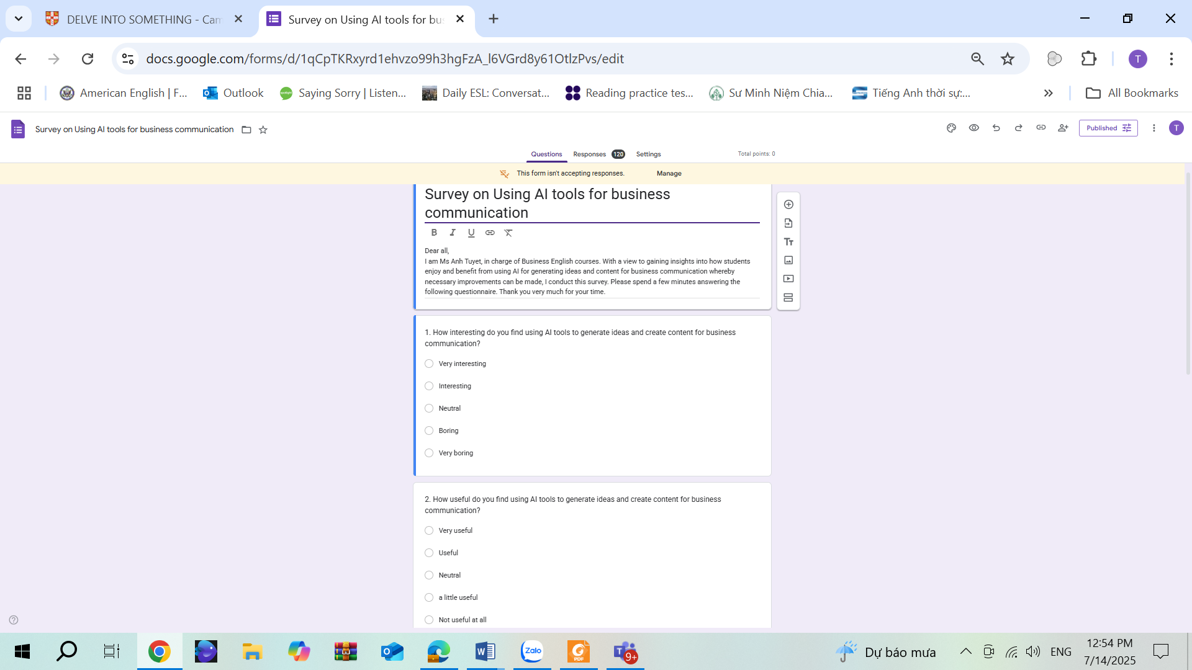

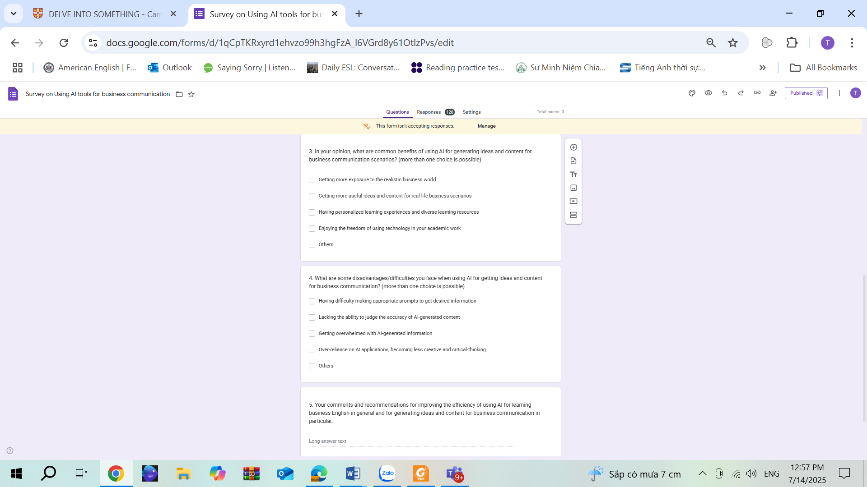

**Appendix C. Interview Questions**

1. In your opinion, what are common benefits of using AI for generating ideas and creating content for business communication scenarios?

2. What are some disadvantages/difficulties you face when using AI for generating ideas and creating content for business communication?

3. Your comments and recommendations for improving the efficiency of using AI for learning business English in general and for generating ideas and content for business communication in particular.

1. Lecturer, Faculty of Foreign Languages, Ho Chi Minh City University of Foreign Languages and Information Technology (HUFLIT), Ho Chi Minh City, Vietnam