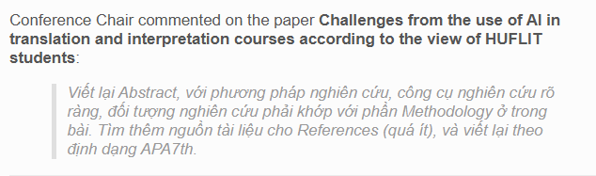

**Challenges from the use of AI in translation and interpretation courses**

**according to the view of HUFLIT students**

Le Uyen Nguyen[1]

Abstract

The rapid and remarkable development of artificial intelligence along with its useful and free applications has brought human beings numerous benefits in a variety of fields, most importantly in education sector. However, along with positive aspects of using AI in education are challenges and negative effects that lecturers and students need to consider and find solutions for. In teaching and learning translation and interpretation at undergraduate level, the use of AI is necessary and inevitable. However, students need to be aware of the undesirable impacts of overusing AI while learning and practicing translation and interpretation. This study was the results of a survey via Google form conducted within a week by 205 English Language students at HUFLIT in 5 classes majored in translating and interpreting. It is to find out the challenges and drawbacks of AI overuse in doing translation and interpretations tasks, and seek feasible remedies to overcome those disadvantages. The results of this study can be used by students and educators on how to use AI to achieve the highest efficiency for each individual in translation and interpretation courses at tertiary level.

*Keywords:* AI, translation, interpretation, English language students, challenges

1. Introduction

Recent development in technology with the integration of Artificial Intelligence into the learning process of higher education students has changed profoundly how they learn, practice, and apply knowledge in various majors. Machine translation (MT) engines such as Google Translate and DeepL, AI-based chatbot, ChatGPT, as well as other AI applications have gained widespread popularity among language learners. These tools give immediate feedback and real time available assistance, which can function effectively to improve the learning experience of students. However, along with efficiency and convenience, AI brings up some issues including students’ dependency, contextual inaccuracies, digital inequality, and ethical issues. Since AI is continually improving, it is necessary to investigate the challenges when exploiting these tools in the field of translation and interpretation learning and how they may affect students’ language acquisition and academic integrity.

According to (Hazaea & Qassem, 2024), since the translation industry inevitably employs AI tools, programs at universities should introduce an effective use of AI in translation to students at the same time promote their critical thinking and ethical standards. Beside the role of language instructors, in this new era of AI, teachers also need to guide students in applying translation machines to do related tasks (Phuong, 2024). To train competent translators and improve the quality of translation process, computer – assisted translation (CAT) tools are vital and universal. (Omar et al., 2020). In addition, (Alharbi, 2023) noted that those tools also promote language acquisition as well as provide professional training. A comprehension of the AI role will bridge the gap between professional translation environment and the academic one. (Tian, 2024). Also, Bates et al. (2023) emphasize the crucial role of AI in filling the gap in academic translating and interpreting training.

This proposed research explores the usage of AI tools of undergraduate students in translation and interpreting major when doing assignments. It includes examining the frequency, reasons behind their usage, and impacts of the utilization. It aims to find out what problems most likely arise among students (for example over reliance, contextual inaccuracies, and ethical issues) and evaluate their values of such restrictions. Also, this study examines how well students can point out the failures of AI translations and whether can fix them by themselves. Finally, it provides an outline of how AI would be introduced more efficiently into translation and interpretation training, and raises students’ critical thinking, ethical understanding, and digital literacy.

The participants of this study are 205 undergraduate students in 5 classes majored in translating and interpreting at HUFLIT (Ho Chi Minh City University of Foreign Languages and Information Technology). Although there is a range of research devoted to students’ behavior and attitudes toward the use of AI tools in translation-based tasks, this study suggests how to deal with the self-report of such behavior and corresponding attitude. It does not measure the technical capability of given AI platforms, nor does it involve professional translators or interpreters beyond academic purposes.

2. Literature Review

A number of researchers have discussed these issues and prospects of AI in teaching and learning translation and interpretation. According to Garcia (2010) and Koby (2014), relying too much on any AI tool can prevent students from critical thinking and decision-making. Moorkens (2018) reminds the practical drawbacks of machine translations when working with idiomatic and cultural sensitive texts. According to Kukulska-Hulme (2020) and Ball (2014), another major obstacle is digital inequity manifested in the fact that students without means of accessing AI tools or lacking the corresponding skills do not have access to them. Additionally, Floridi and Cowls (2019) and McKinley and O Hara (2017) support the view of ethical frameworks to achieve fair and duty-bound AI application in education. The literature on these studies offers a theoretical background behind the investigation of the interaction of students with AI and how pedagogical changes might be required.

## **2.1. Challenges of Using AI in Translation and Interpretation Training**

Artificial Intelligence (AI) incorporation into translating and interpreting education has changed the minds of students when it comes to tackling language tasks. Although AI assistance tools namely Google Translate, DeepL, and ChatGPT are the most popular AI tools that are used to facilitate translating and interpreting tasks, their excessive usage and associated issues address various pedagogical and ethical questions.

## **2.1.1. Overreliance on AI**

A significant problem is that students tend to be too reliant on AI tools. Though these tools are fast, convenient, and mostly free of charge, excessive use discriminates against students on their ability to translate or interpret by themselves. According to research, students often fail at translation on their own or cannot practice critical thinking and creating language when using AI. Garcia (2010) warns that this kind of dependency might be a barrier to developing deep linguistic analysis among students. Koby (2014) also emphasizes that AI must not be treated as an alternative to the ability of humans to make a judgment in translation. In line with this, Tavares et al. (2023) and Zhang (2023) noted the over dependence of students on AI has affected their critical thinking, analytical skills, and autonomy.

**2.1.2. Contextual Inaccuracies**

The second critical issue is that AI tools will not always be able to grasp cultural distinctive features, figurative language, or contextual language, and AI-generated translations do not sound contextually appropriate. It proves to be very troublesome especially where a high level of precision is needed like in the case of law, literary, or medical translation. According to Moorkens (2018), AI can frequently be used to generate blatant surface translations as opposed to depict a higher level of meaning. Likewise, Garcia (2010) draws attention to the fact that idiomatic, culturally rooted language should be noted as a shortcoming of machine translation tools as well. In terms of accuracy and context limitation, Bouguesmia (2020), Liu and Afzaal (2021) said that it is a popular case that AI tools misinterpret cultural nuances, idioms, and domain – specific content.

## **2.1.3. Digital Inequity**

A fact is that not all students have the same access to technologies even though the use of AI is increasingly becoming prevalent. Whereas some claim that they find themselves using AI tools much more frequently, others might hardly or even never use it at all as they do not have an opportunity or the required digital literacy. Kukulska-Hulme (2020) underlines the inequality in learning outcomes can be caused by the inequality in digital access and literacy. Ball (2014) also points out that because there is a gap in knowledge, teachers should be informed about it and introduce inclusive classroom practices. Digital inequality may restrict the capacity of specific students to use AI in studying to the fullest extent and, accordingly, increase the educational gap. According to Odacioglu and Kokturk (2015) and AlRumaih (2021), in general view of the whole world, there is inequality in access to digital devices, AI tools, and available internet which hinders students’ integration between technology and translating.

## **2.1.4. Ethical and Privacy Concerns**

There are critical ethical concerns over the use of AI tools, especially in terms of data privacy and bias shown in algorithms. Students without their knowledge might post confidential information on AI systems and lose it. Also, there can be biases in AI systems either based on society or language thus influencing the translation. Floridi and Cowls (2019) believe that ethical frameworks are necessary to keep users secure and retain trust. McKinley and O Hara (2017) require transparent policies in education as a way of the fair and responsible application of AI, particularly these areas which are language-related, where people should be sensitive to cultural and linguistic concerns.

# **2.2. Addressing the Challenges**

In order to successfully employ the deployment of AI in the field of translation and interpreting training, educators and schools should adapt a strategic approach that would lead to the development of both digital competence and critical thinking in students.

**2.2.1. Hybrid Approaches**

Assigning AI tools and human labor allows making the learning process balanced and effective. Students are to be allowed to make independent translations initially with the help of AI generating the same output corresponding in their effort to acquire a lesson based on differences. Moorkens (2018) promotes this so-called hybrid model, in which machines perform regular job routine, and when it comes to contextual and cultural appropriateness, people are becoming responsible. Koby (2014) acquiesces and notes that students must perfect their judgment prior to asking computers to help.

## **2.2.2. Ethical Frameworks**

Training on ethics is crucial in equipping students to learn on how to be responsible in using AI. The best way to address the problem of data privacy, informed consent, and AI bias is to refer to their teaching in an educational setting. Floridi and Cowls (2019) come up with ethical models that can be modified to be used in teaching contexts as such students are conscious of the consequences of decision-making regarding AI usage. McKinley and O Hara (2017) advise language programs to provide effective rules to safeguard learners and uphold the quality of their writings.

## **2.2.3. Focus on Critical Thinking**

Learning the process of translation has to be based on the development of students’ critical thinking and evaluation abilities. It is necessary to teach students how to recognize flaws in AI-based translations and correct them. This fairly qualifies as a good point brought in by Garcia (2010) who emphasizes the need to encourage students to challenge the quality of machine output. Pym (2010) goes further to say that the translation training should not be focused on the product but rather the development of abilities to think, solves problems, and makes decisions.

## **2.2.4. Digital Literacy and Access**

In order to eliminate digital inequity, institutions are expected to give students equal chances in accessing AI tools. This may involve training sessions, online literacy and the availability of facilities including computer labs. Kukulska-Hulme (2020) emphasizes that there is a need to improve the digital competencies of students, whereas Ball (2014) encourages schools to consider inclusive technology policies that should benefit students with disadvantaged backgrounds.

3. Methodology

The research method adopted in this study is quantitative, and the study aims at estimating perceived disadvantages of using AI to study translation and interpretation and the potential remedies to limit negative effects. The participant group consists of 205 English major students at HUFLIT who have enrolled translation and interpretation courses and have had experience in using tools like Google Translate, DeepL, AI Chatbots, etc. to assist their translating and interpreting tasks.

The study applies structured questionnaires to gather data related to the frequency of AI usage perceived challenges as well as recommendations on how to improve the application of AI tools in translation and interpretation training. The survey was distributed through the use of online communication, and it was made available to a total of 205 participants. Data was obtained on a one week collection period in order to make responses anonymous in maintaining objectivity.

The data were analysed through descriptive statistics in terms of percentage distribution and counts of frequencies. Bar and pie charts were used to visualize the results and they helped discover students’ usage patterns, key issues of concern, and the overall influences of AI on students’ skill acquisition in translating and interpreting. **4. Results**

This section includes findings of a survey carried out by about 205 English language students at HUFLIT evaluating their perceptions on the drawbacks and remedies in terms of using AI tools when doing translation and interpretation tasks.

*Figure 1 – AI applications used by students when doing translating and interpreting tasks*

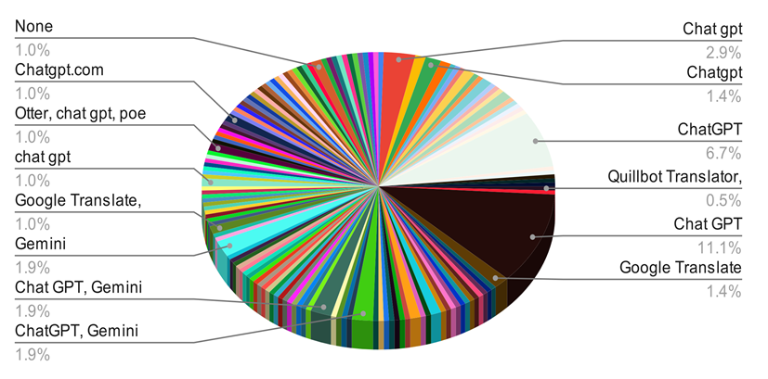

The pie chart shows allocation of AI applications commonly utilized by students in order to help them with tasks in the area of translating or interpreting. It demonstrates an evident prevalence of some AI instruments and at the same time presents a multitude of the other less prominent uses of a great number of other tools. In general, the different versions of ChatGPT and Google Translate can be considered the most popular AI use by students. Gemini also plays a prominent role in its own right alongside ChatGPT. In sharp contrast, there are many other AI applications and unique combinations including Quillbot, Gemini, Copilot, DeepL, Deepseek, Grok, Black box AI, Ryne, Albeit, Matecat, Mochi mochi, Poe, Deepside, etc. The size of the niche tools numbers alone underlines the tremendous variety of tools that are currently available yet when combined they do not amount to the same share of usage as the top ones.

*Figure 2 – The frequent use of AI applications by students when translating and interpreting*

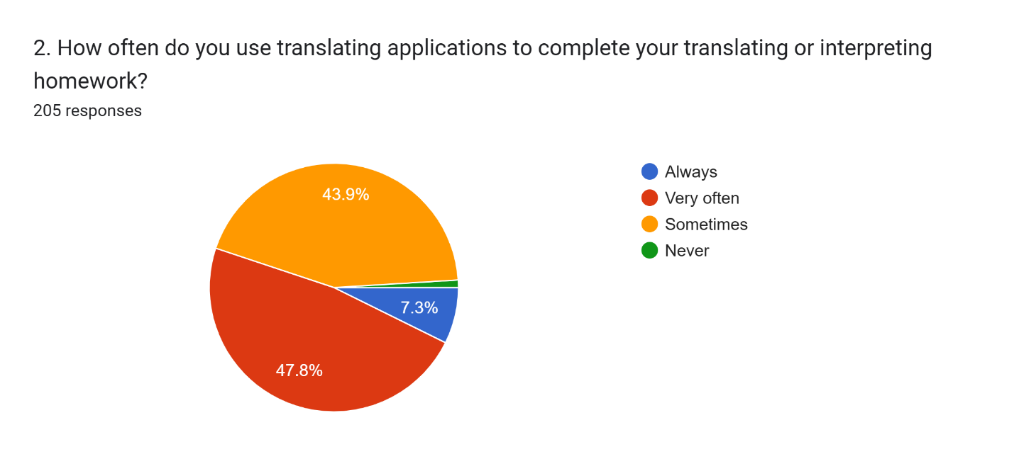

The pie chart shows the percentages of times that each of 205 students uses applications to get his or her translation or interpreting tasks done. On the whole, the use of these tools is frequent among students with a minimal number claiming not to use it frequently. Based on the data, 47.8 percent of students responded that they very often use translating applications; it was the highest number of responses. Close behind are 43.9 percent that reported to use such tools occasionally. A smaller part, 7.3, replied that they always use the application to translate, and again barely any percentage of the students, less than 1, respond to be never using an application to translate. These answers indicate that the use of translation technology by students is extremely high as almost all of the respondents apply it when doing their academic assignments.

*Figure 3 – The causes of inaccuracies when using AI machines for translating and interpreting*

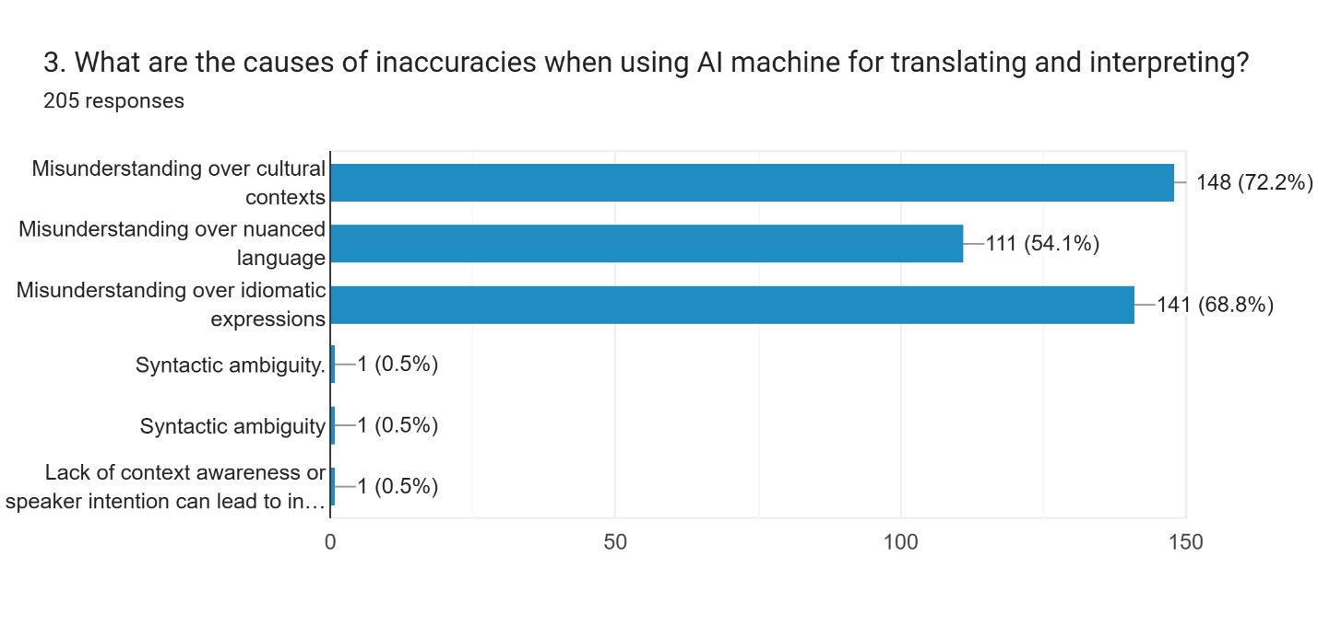

The bar chart indicates the perceived reasons of inaccuracy in application of AI tools by respondents in terms of translation and interpretation with the responses of 205 participants. In general, the majority of the respondents suggested that the errors were caused by the fact that AI can hardly process cultural, idiomatic, and nuanced language. About 72.2 percent of respondents pointed to the most frequently mentioned reason of misunderstanding cultural contexts. Right after this, there was mixed up idiomatic, spoken of by 68.8 percent. In the meantime, 54.1 percent of respondents referred to the inability of the AI to respond to subtle language, and it is probable that the subtleties of meaning are frequently out of the grasp of machine-created translation. Fewer than 1 out of 205 people (0.5%) cited syntactic ambiguity and the absence of context or speaker intention as the cause of inaccuracy. These findings indicate that cultural and linguistic depth of an AI can also be seen as a significant problem in the execution of translation activities.

*Figure 4 – The drawbacks to students’ translating and interpreting skills*

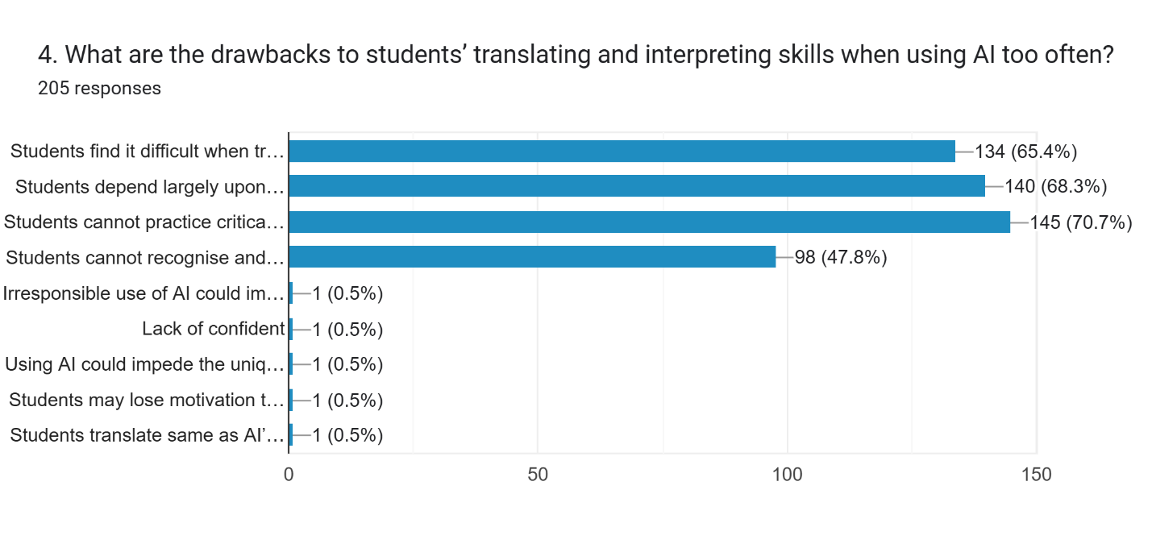

Responses of the 205 participants were used to create the bar chart that shows the demerits students have in their ability in translating and interpreting languages through overusing of AI tools. In general, the most frequently cited problems are associated with a decrease in critical thinking and excessive reliance on AI. Based on the collected information, the most serious disadvantage as selected by 70.7 percent of the respondents is the inability to practice critical thinking. Very much in the same footsteps is the overdependence on AI, reported by 68.3%, and difficulty when translating without AI, mentioned by 65.4%. Also, 47.8 % of students claimed that intensive use of AI worsens their chances of detecting and rectifying their mistakes autonomously. Other negative experiences, including loss of inspiration, less confidence, or low quality reproduction of AI translations were cited by only half a percent of the participants each, and are, thus, less frequently regarded as negative issues. Such findings indicate that the use of AI can be rather helpful but the high degree of its usage could severely inhibit students in acquiring necessary translation and interpretation skills.

*Figure 5 – How to overcome challenges of using AI translating or interpreting tools*

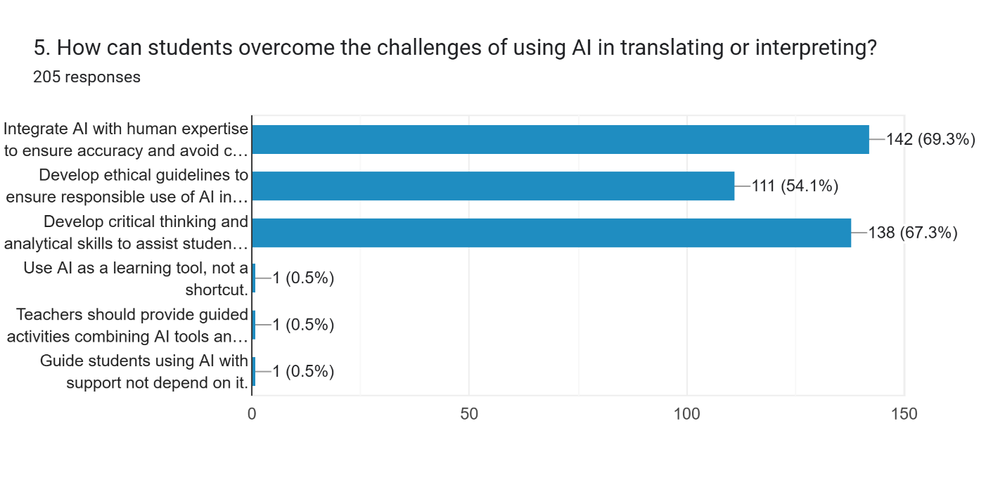

The bar graph shows difficulties faced by students when using AI in translation and interpretation tasks at the undergraduate level with regard to 205 responses given during the survey. In general, the combination of AI and expertise of human knowledge, development of critical thinking and analytical abilities, and ethical rules are considered the most important issues. Conversely, believing in AI as a form of shortcut, deficiency in directed activities, and excessive dependency on the use of AI are seen as minor considerations. The popular limitless challenge is to integrate AI with human expertise to promote reliability and prevent lapses because 142 respondents (69.3%) mention this as the limitations. Closely followed, 138 respondents (67.3%) stressed the relevance of cultivating critical thinking and analytical skills among the students in order to make effective use of the AI tools. Moreover, quite a significant portion of the participants, 111 (54.1%), stated that one of the most important problems is to formulate ethical principles according to which the use of AI should be responsible. Other issues were informed by a few responses among the participants (0.5 percent or 1 response) such as the delays, unsatisfactory quality, and communications problems are the most affecting issues. These students do not see AI as a means for shortcuts but as a learning tool and teachers play the role of providing guided activities using a combination of AI tools and human proficiencies, and instructing students on how to use AI as a support not rely on it excessively.

*Figure 6 – How to exploit the use of AI assistance in translating or interpreting*

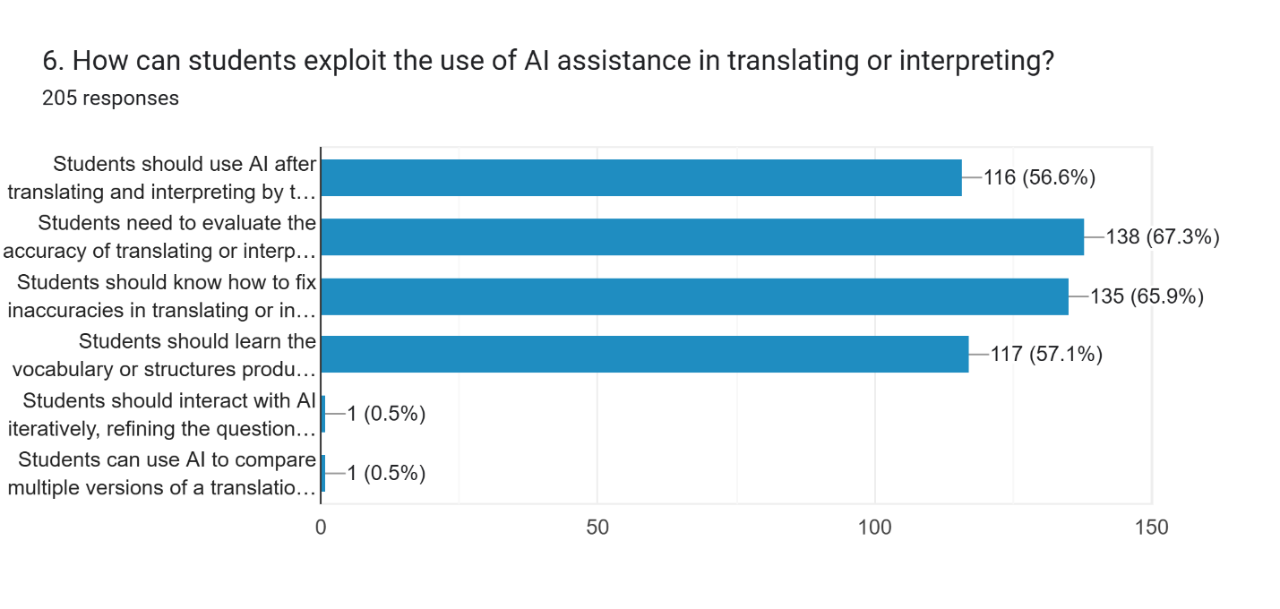

The bar chart depending on 205 responses is an illustration of the possible ways of how students can use help in translation and interpretation with AI applications. In sum, the most referenced ways of utilizing AI are assessing the correctness, fixing the inaccuracies, learning new vocabularies or structures, and the use of AI as a post-translation utility. Iterative interaction and comparison of multiple versions, in their turn, are regarded as less frequent strategies. The largest strategy which mentioned by 138 respondents (67.3%) stated that students must check whether such AI-generated translations or interpretations are correct. Immediately followed, 135 respondents (65.9%) suppose that students need to be able to correct errors in translations or interpretations made by AI. Moreover, a great majority, 117 respondents (57.1%) opine that students ought to be taught the vocabulary or structures generated by AI. Moreover, 116 respondents (56.6 %) speak that students must employ AI after making their first steps in translation and interpretation activities. On the extreme opposite factor, half of a percent only a bare few (1 each) respondents replied that students ought to communicate with AI interactively, edit inquiries, or might work with AI to contrast two or more interpretations of a communication. Such low percentages show that these approaches are not popularly thought of as the main means through which students can use AI in this regard.

5. Discussion

## **5.1. Reference to the Main Purpose of the Study and Literature Review**

The primary aim of this research was the investigation on negative sides of employing AI tools in translation and interpretation tasks within the scope of the HUFLIT students attending related courses. The paper also sought to determine possible solutions that will assist in limiting the adverse effects of the overuse of AI in translating and interpreting training. The results are consistent with other studies that point out both the extent to which AI is beneficial in learning a new language and the dangers inherent in the intensive use of this kind of tool. As an example, Garcia (2010) and Bowker & Ciro (2019) were concerned about the role of machine translation in building student autonomy and vocabulary support, whereas Moorkens (2018) mentioned issues with the loss of critical thinking and fundamentally fewer skills developed as a result of relying on AI.

## **5.2. A Review of the Most Important Results**

The most important results of the survey conducted by these students show that on the one hand, the application of AI tools is highly-investigated and valued by its consequence of speed, convenience, and language support; on the other hand, it is associated with severe challenges. More than 70% of the student participants said that they encounter problems with building critical thinking skills and using AI-generated work extensively. Moreover, the top-mentioned terminology behind the inaccuracy of translation was on the issues arising upon the fact that AI tools may not be able to grasp cultural contexts, translator expressions, and the subtleties of languages. Students also displayed low loyalty to AI engine and showed a strong desire to experiment and consider alternatives products on suggestion of peers or influencers.

## **5.3. Possible Explanations for the Important Results**

These findings can be attributed to the growing availability and deployment of AI technologies in everyday learning processes of students. Most students apply AI to save time or to cope with translating tasks without comprehending the translation process. This is the reason as to why critical thinking and independent problem solving skills are underdeveloped. The issue of AI literacy, as it has been demonstrated in existing literature, can also be a factor behind student naivety when it comes to dependence on machine-generated translations. Additionally, the current educational landscape with a strong digital component promotes speed above all other educational values, which can be one of the reasons that lead to shallow and momentary use of AI tools when carrying out translation and interpretation tasks.

**6. Conclusion**

**6.1. Implications of the Study**

This paper gives significant observations through the disadvantages of AI tools in translation and interpretation training. The results point to the importance of an equal treatment in terms of integrating technology in language training. Although AI has the potential of helping in enhancing speed as well as vocabulary and self-learning, excessive use of AI may hindrance the ability of students to think critically as well as to solve problems effectively. Such connotations indicate that AI should be used with care by students.

**6.2. Practical Application of the Study**

The results of this study may be used as a guideline on the work of the translation and interpretation instructors at HUFLIT and other academic institutions. By selecting AI tools rationally and in a hierarchical pattern coupling them with the practice provided by humans, educators can form more effective lessons that improve students’ language competence. Moreover, these findings can be applied by schools and training centers, offering workshops on AI literacy to students on how to check AI-generated translating products to understand the ways to evaluate, compare, and rectify them. Students will also have an opportunity to examine their learning behavior and become less carefree about AI tools usage.

**6.3. Limitation of the Study**

The research is narrow due to its small scope, because of only one university to be taken as a case study - HUFLIT - and the small number of study samples, which gathered 205 students in this related field. As such, the research results cannot be conclusive among the English language learners or establishments in Vietnam or elsewhere. Also, only self-reported information was used in the research and that has certain biasness or inaccuracy as perceptions of individuals and honesty within respondents. The study has also been restricted to those researching about translation and interpretation courses as opposed to other language skills.

## **6.4. Recommendation for Future Research**

# Further studies would be required where they can increase the sample size and capture students across different universities in Vietnam or other countries to enhance the applicability of the outcomes. Also, the future researchers might follow a mixed research methodology that would include the use of in-depth interviews or classroom observations to better obtain a reality usage of AI on learning translating and interpreting. It is also advisable to research on the long term impacts of this addition of AI in translation accuracy, retention of information by the memory system, and growth of other language skills. Finally, more studies should be conducted to determine how AI tools could be used to contribute to higher levels of translation not limited to language correctness but also creativity and cultural awareness.

# **References**

Agness, K.H. (2020). Mobile-assisted language learning [Revised and updated version]. *Language Teaching*, 179-186.

Alharbi, W. (2023). The use and abuse of artificial intelligence-enabled machine translation in the EFL classroom: An exploratory study. Journal of Education and E-Learning Research, 10(4), 689–701. <https://doi.org/10.20448/jeelr.v10i4.5091>

Al-Rumaih, L. A. (2021). The integration of computer-aided translation tools in translator training programs in Saudi universities: Toward a more visible state, *Arab World English Journal for Translation & Literary Studies, 5*(1), 336-362. <https://dx.doi.org/10.24093/awejtls/vol5no1.23>

Ball, S. (2014). The education debate*.* Policy Press.

Bates, T., Cobo, C., Mariño O., & Wheeler, S. (2020). Can artificial intelligence transform higher education? International Journal of Educational Technology in Higher Education, 17:42. <https://doi.org/10.1186/s41239-020-00218-x>

Bouguesmia, M. T. (2020). Using AI in translation: A technological leap, or a translator’s nightmare. ALTRALANG Journal, 2(2), 78–102. <https://www.asjp.cerist.dz/en/article/137611>

Floridi, L., & Cowls, J. (2019). A Unified Framework of Five Principles for AI in Society*.* Harvard Data Science Review.

Hazaea, A. N., & Qassem, M. (2024). Translation Competence in Translator Training Programs at Saudi Universities: Empirical Study. Open Education Studies. 6: 20240029. <https://www.degruyter.com/document/doi/10.1515/edu-2024-0029/html>

Garcia , I. (2010). Is machine translation ready yet? Target International Journal of Translation Studies, 7-21.

Liu, K., & Afzaal, M. (2021). Artificial intelligence and translation teaching: A critical perspective on the transformation of education. *International Journal of Educational* *Sciences, 33*(1-3), 64-73. [https://doi.org/10.31901/24566322.2021/33.1-3.1159](https://doi.org/10.31901/24566322.2021/33.1-3.1159%20)

McKinley, J., & O' Hara, S. (2017 ). *Ten guidelines for data ethics in education.*

Moorkens, J. (2022). Machine translation for everyone: Empowering users in the age of artificial intelligence*.* Language Science Press.

Odacioglu, M. C., & Kokturk, S. (2015). The effects of technology on translation students in academic translation teaching. *Procedia - Social and Behavioral Sciences, 197*, 10851094.

<https://doi.org/10.1016/j.sbspro.2015.07.349>

Omar, L. I., & Salih, A. A. (2024). Systematic review of English/Arabic machine translation postediting: Implications for AI application in translation research and pedagogy. Informatics, 11(2), 23. [https://doi.org/10.3390/informatics11020023](https://doi.org/10.3390/informatics11020023%20%20)

Phuong P. X. H. (2024). Using ChatGPT in English language learning: A study on I.T. students’ attitudes, habits, and perceptions. International Journal of TESOL & Education, 4(1), 55-68. <https://doi.org/10.54855/ijte.24414>

Pym, A. (2009). Exploring Translation Theorie*s.* Routledge.

Tavares, C., Tallone, L., Oliveira, L., & Ribeiro, S. (2023). The challenges of teaching and assessing technical translation in an era of neural machine translation. Education Sciences, 13(6), 541-559. <https://doi.org/10.3390/educsci13060541>

Tian, Xujun. (2024). Personalized translator training in the era of digital intelligence: Opportunities, challenges, and prospects. *Heliyon, 10*, e39354. <https://doi.org/10.1016/j.heliyon.2024.e39354>

Zhang, J. (2023). Exploring undergraduate translation students’ perceptions towards machine translation: A qualitative questionnaire survey. In *Proceedings of Machine Translation* *Summit XIX*, *2: Users Track*, 1-10. Macau SAR, China. Asia-Pacific Association for Machine Translation. <https://aclanthology.org/2023.mtsummit-users.1/>

**Bionote**

The author of this paper has been a lecturer at universities in Ho Chi Minh City in fifteen years, and sustains a deep interest in subjects such as language skills, translating, interpreting, literature, civilization, and intercultural communication.

Appendices

*Questionnaires*

1. What AI applications do you usually use to assist your translating or interpreting homework? (Please write them down below.)

-----------------------------------------------------------------------------------------------------------------

2. How often do you use translating applications to complete your translating or interpreting homework?

* Always
* Very often
* Sometimes
* Never

3. What are the causes of inaccuracies when using AI machine for translating and interpreting?

* Misunderstanding over cultural contexts.
* Misunderstanding over nuanced language
* Misunderstanding over idiomatic expressions
* Other cause: ______ (please specify)

4. What are the drawbacks to students’ translating and interpreting skills when using AI too often?

* Students find it difficult when translate or interpret texts by themselves.
* Students depend largely upon AI when translating or interpreting.
* Students cannot practice critical thinking and creating language.
* Students cannot recognise and fix inaccuracies in AI’s translating and interpreting.
* Other drawback: ____________ (please specify)

5. How can students overcome the challenges of using AI in translating or interpreting?

* Integrate AI with human expertise to ensure accuracy and avoid cultural misunderstanding.
* Develop ethical guidelines to ensure responsible use of AI in translation and interpreting.
* Develop critical thinking and analytical skills to assist students’ translating and interpreting skills.
* Other solution: ______________ (please specify)

6. How can students exploit the use of AI assistance in translating or interpreting?

* Students should use AI after translating and interpreting by themselves.
* Students need to evaluate the accuracy of translating or interpreting products created by AI.
* Students should know how to fix inaccuracies in translating or interpreting products created by AI.
* Students should learn the vocabulary or structures produced correctly by AI applications.
* Other suggestion: ________________ (please specify)

1. Le Uyen Nguyen, M.A. in TESOL, Faculty of Foreign Languages, HUFLIT, Ho Chi Minh City, Vietnam;

   *Email: uyennl@huflit.edu.vn*