The Impacts of Various Teaching Methods and Assessments Applied in Business Communication Course
Thái Mỹ Linh
Abstract
With globalization increasing the demand for proficient business communication, it is crucial to equip ESL learners with the vital skills to thrive in professional environments. Business Communication is a compulsory subject in the training program for the Business English major, Faculty of Foreign Languages at Ho Chi Minh City University of Foreign Languages ​​and Information Technology. Various teaching methods and innovative forms of on-going assessments for students have been continually applied to enhance their interest and motivation in learning, helping them achieve the course objectives as well as practice important skills to meet the increasing demands of the labor market. This study examines the significance of the course from the students’ perspective as well as the impacts of various teaching methods and evaluations, including role-playing, case studies, AI-enhanced learning tools and presentations on learners' communication proficiency. Data collected from surveys and classroom observations provide insights into the effectiveness of different teaching approaches.

Keywords: Business Communication, teaching methods, evaluations, impacts
- Introduction
Business Communication is a compulsory subject for juniors in Ho Chi Minh City University of Foreign Languages and Information Technology (HUFLIT). For students majoring in Business English at HUFLIT Faculty of Foreign Language, this course is of significant importance because they are provided with useful knowledge such as how to communicate in the digital- age workplace, how to plan and participate in face-to-face and virtual meetings, and the techniques to use and develop expert writing. They also have the chance to practice and improve practical skills like professionalism and business etiquette skills, intercultural workplace skills. However, this course is high-pressure because they have to absorb considerable knowledge and acquire professional skills in business settings, which they almost have no experience and background knowledge before. In addition, with the immense amount of theory combined with several tasks to put the theory into practice, students feel overloaded if appropriate methods are not applied. According to the results of the studies carried out by Tajeddin (2018) and Barnett-Itzhaki (2023), a variety of innovative teaching methods, including case studies, presentations, projects and the applications of digital tools, can boost students' learning outcomes and level of engagement in all activities. The use of social media platforms, for instance, has been proved to generate a more dynamic and motivational learning environment.
Another important thing that needs to take into consideration is how to design tests that can accurately and reliably evaluate students' competencies. In order to have an accurate evaluation of students' abilities, Asemanyi (2015) showed the importance of using a variety of assessment techniques, such as formative assessments, peer reviews, and assignments.
From the challenges mentioned above, the author applied various methods of teaching as well as testing to keep students motivated and help them achieve their goals.
- Literature Review
The field of business communication education has come up with remarkable innovations including the integration of diverse teaching approaches and evaluation methods. These innovations have occurred thanks to the continuous development of technology, which contributes greatly to enhance students’ involvement, facilitate their learning process, and equip themselves for the professional career path in the future.
- Teaching Methods and Assessment Strategies
Various teaching methods have been applied to improve the effectiveness of these courses. Interactive lectures, projects, presentations, case studies, etc,. are among the most outstanding approaches. Research by Berry (2013) highlights the impacts of technology on teaching business communication, emphasizing the need for strategies that align with a culturally diverse audience. The use of social media platforms and collaborative tools has been shown to create a more dynamic and participatory learning environment, fostering more engagement and practical skill development. Additionally, Çelik and Alpan (2023) found that innovative teaching methods can improve certain aspects of student development.
Assessment methods by to role in evaluating and improving students proficiency. To provide accurate evaluations and meaningful feedback, effective assessment tools must uphold the principles of fairness, validity, and reliability. Furthermore, incorporating a variety of assessment approaches enhances the learning experience by offering students multiple opportunities to showcase their skills. This not only accurately evaluates students’ performance but also encourages their continuous improvement and effort to make progress.
- Project-Based Learning
The concept of learning through projects is not new and is increasingly applied in educational institutions around the world. It is undeniable that projects play a vital role in assessing and developing students' teamwork, problem- solving, and interpersonal skills. By replicating real working environments with work-related issues, these projects provide students with opportunities to engage in group work to fullfil the tasks. Asemanyi (2015) noted that group projects help students tackle more complex problems, assign roles and responsibilities, and share diverse viewpoints—skills that are essential in the workplace. Additionally, group projects have been shown to enhance students' time management skills, critical thinking abilities, and deepen their understanding through discussions. According to Yuliansyah & Ayu (2021), in language teaching, project-based tasks can yield tangible products such as presentations or creative products. Solomon (2003) demonstrated that project-based learning requires learners to work together to find solutions to challenging problems that are realistic and based on the curriculum. Accordingly, the value of project-based tasks lies not only in the final product but also in the process of achieving the final goal (Kerimkulova et al., 2016).
- Task-based language teaching
According to Larsen-Freeman and Anderson (2011), tasks have a clear meaning and purpose, and learners need to communicate in a foreign language to achieve the goal. Therefore, this method can be considered to encourage learners to use a foreign language both in the classroom and in real-life contexts. Teachers must set clear goals to accelerate learning by engaging learners in various tasks with clear outcomes. This method focuses on a learner-centered approach. In addition, in lesson design, according to Anderson (2017), each learner's needs should be considered or other needs that may arise during the process of receiving the assigned task. Therefore, not only learning goals but also learning opportunities can be created.
- Simulations
Simulations are considered to be forms of active learning experiences and interactive activities that create realistic scenarios, allowing students to apply language skills in a controlled environment (Lean et al., 2006). Research by Johnson et al. (2018) demonstrates that role-playing activities improve learners’ communication skills, empathy, and adaptability. Simulations, such as virtual sales environments, allow students to practice without real-world consequences.
- Peer-reviewing tasks
Research has demonstrated that peer-reviewing helps students develop motivation and confidence in the learning process, thereby significantly improving learning outcomes. Research by Hojeij and Baroudi (2018) examined the impact of peer-reviewing on student motivation and engagement. The results showed that learners expressed positive attitudes towards peer feedback. Furthermore, students who participated in peer feedback received a number of benefits such as self-reflective thinking skills, problem solving and critical thinking, development of learner autonomy, promotion of self-regulation in learning and development of social skills (Hansen & Liu, 2002). Involving students in the assessment process through peer evaluations enhances their critical thinking skills and provides diverse feedback. This method encourages student responsibility and active participation in learning. According to Boon (2018), peer assessments offer varied feedback and promote critical evaluation skills, fostering student accountability and active learning. Peer evaluations have been shown to improve students' understanding of success criteria, increase their engagement in the learning process, and develop their interpersonal skills. Additionally, peer evaluations create a positive classroom environment where students can assess their own and their peers' work, leading to better learning outcomes.
- Presentations:
In educational contexts, oral presentations are now a common way to assess a variety of student competencies. Both verbal and nonverbal communication skills are essential for success in the workplace, and this approach is especially good at evaluating them. A research by Gilsing (2022) emphasizes the usefulness of oral presentations as a tool for assessment. According to the study, this approach offers a thorough assessment of students' capacity to communicate concepts in a professional setting in an understandable and efficient manner. Gilsing claims that oral presentations enable teachers to evaluate a student's competency in organizing and presenting information in a coherent and persuasive manner, which is essential for professional communication.
- Case Studies:
By analyzing and presenting case studies, students can bridge the gap between theoretical knowledge and real-world business scenarios. This method not only assesses their oral and written communication skills but also enhances their critical thinking and problem-solving abilities. Asemanyi (2015) highlighted that case studies are an effective way to connect academic concepts with practical application. Through this approach, students improve their ability to tackle real business challenges, thereby honing their critical thinking and problem-solving skills. Additionally, presenting their analysis and solutions clearly and persuasively helps evaluate their communication skills. Case studies provide a practical learning experience, equipping students with tactical knowledge and skills that are directly applicable to their future careers.
- Innovated methods applied during the course
The student-centered approaches were applied during the course. Students were required to work in groups of 5 to 6, each of which was responsible for a project to design a training program to improve intercultural communication within an international company. The project needs to cover sessions on the significance of cultural identities, communication styles, etiquettes and taboos, cultural norms and values and conflict resolution. Each group would choose a country to focus on providing deep knowledge with illustrations like clips, short movies, etc,.
Task-based activities and simulations were designed to provide students with opportunities to practice. Students were asked to search linkedIn and Vietnamworks to get information about job vacancies, read job descriptions as well as requirements and choose the one that is most suitable for them. Then they had to conduct and participate in mock interviews, focusing on effective communication techniques, non-verbal language, and answering questions confidently. Based on the theoretical knowledge about low-context and high-context culture, they had to apply the principles of communication styles in convincing the interviewers depending on the culture of that company. They also engaged in role-playing exercises to practice negotiation skills, focusing on persuasive communication, active listening, and finding mutually beneficial solutions.They were also assigned with various writing exercises: complete their own CV and cover letter, draft professional emails for various business situations, such as responding to customer complaints, requesting information, or making an arrangement.
The third task is presentations. Students prepared and delivered presentations on hot business-related topics like how businesses can use social media platforms to reach their potential customers and react in the center of a scandal, workplace communication skills. In this activity, apart from the lecturer’s comments on their communication style, clarity, and the level at which they could engage and maintain the audience’s interest, they would receive feedbacks from their peers as well.
Additionally, related to case studies, students were required to analyze a real-life business crisis. They needed to read a lot and choose one case that impressed them in terms of its impacts. They had to evaluate the company's communication strategy, identify what was done well, and suggest improvements. Another topic for case study is about the success or failure of a company's customer service communication. Students analyzed the communication methods used, the results, and suggest the best practices for handling customer interactions. One last option is investigating a successful or unsuccessful marketing campaign. Students discuss the communication strategies employed, the target audience, and the campaign's impacts.
After the course, the researcher would like to evaluate the significance of the course from the students’ point of view as well as the impacts of various teaching methods and evaluations applied on learners' communication proficiency. Three questions were raised:
Research Questions
- Is it really necessary to include Business Communication in the curriculum?
- How do different teaching methods impact student engagement and learning outcomes in business communication courses?
- What are the effects of various assessment strategies on the development of business communication skills?
3. Methodology
Pedagogical Setting & Participants
The survey was conducted in five Business Communication classes that the researcher was in charge of teaching in the first semester of the school year 2024-2025. The learners were third-year students majoring in Business English, Faculty of Foreign Languages, HUFLIT. In previous courses, students had studied compulsory subjects such as Business English, Office Communication, Negotiation Skills, and Introduction to Management. These subjects equipped students with specialized vocabulary, knowledge and skills in reading and understanding business-related documents, drafting correspondence in business transactions, presenting on specialized topics, etc. 155 out of 208 students in five classes completed the questionnaire.
Design of the Study
A mixed-method strategy was used by the researcher. The combination of quantitative and qualitative research techniques offered a thorough grasp of the effects of various teaching approaches and evaluation methods. The questionnaire was designed including five scales, ranging from strongly agree to strongly disagree, from 1 to 5 respectively. It consisted of three sections: the significance of the course, the impacts of various teaching methods and the students’ feedbacks on the necessity of various evaluation forms. It was designed in Google form and sent to students to the system of Moodle of the university. The researcher asked the students to complete the questionaire in order to collect quantitative information on their experiences and results with various teaching strategies and evaluation techniques. In addition, the researcher also carried out classroom observations to have a better understanding of how students react to the innovated methods. During the course, students’ attitudes, behaviors, and participation in each activity were noted down in the observation checklist weekly.
Data collection & analysis
The researcher created the questionaire on Google Forms and sent on Moodle in the last week of the semester. This is to ensure that students had sufficient time and experiences as well to evaluate and provide reliable feedbacks. They also did not need to worry about the lecturer’s reaction or mood (if any) when receiving negative responses. The researcher had one week to collect the data. Apart from the quantitative data analysis, observations recorded during classes were also analyzed.
- Results
Figure 1
The essential of Business Communication course in developing effective communication skills.
An overwhelming majority of students acknowledged the importance of this course, as seen in Figure 1. 34.8% of students agreed and 60.6% strongly agreed that the course is essential to improve their communication abilities. This means that an overall number 95.4% of the students as a whole appreciated the course's beneficial influence on their competence for effective communication.
Only a tiny proportion of students had neutral viewpoints. Compared to the overwhelming positive responses, this group was not significant. Only two out of 155 students—or just 1.3%—strongly disagreed with the course's importance.
The theoretical knowledge and practical skills that the students gained from this course are obviously advantageous. The overwhelming positive feedback asserts that the course is greatly beneficial to improve students' communication skills.
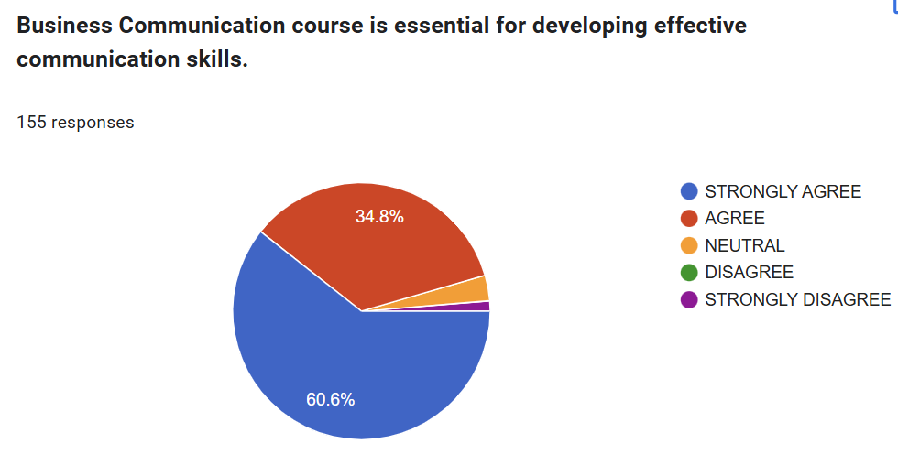Figure 2
Interactive teaching methods (group discussions, role-playing) enhance students’ engagement.
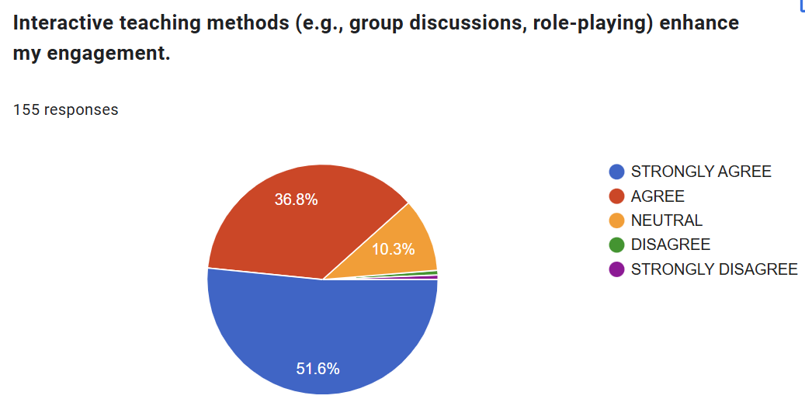
Figure 2 illustrates how various interactive teaching techniques can contribute to increase students' engagement in the learning process. According to the results, appoximately 90% of respondents had extremely positive feedback on the application of diverse learner-centered methods used in the course. This significant proportion shows that students highly valued the effectiveness that these interactive approaches- including role-playing, group debates, and other collaborative tasks- bring to help them improve.
A tiny percentage of students, only 1 out of 155, or 0.6%, strongly disagreed with the effectiveness of these approaches. Additionally, the same percentage of students disagreed, emphasizing the positive comments outweigh the negative ones. The data highlights the effectiveness of applying interactive teaching methods.
In addition, the notes in the researcher's observation checklists during the 12-week period provide supportive evidence for these conclusions. It was noticeable throughout this period that the great majority of students engaged actively in all of the interactive tasks and activities that were organized every week in class. The high degree of participation shows that students were not only interested in these approaches but also appreciated that these methods were truly helpful for their education and future career. Thanks to the application of these methods, a more dynamic and captivating learning environment was established. As a result, students were more engaged in the learning process, which improved their motivation in the process of exploring knowledge.
Figure 3
The roles of case studies and real-world examples
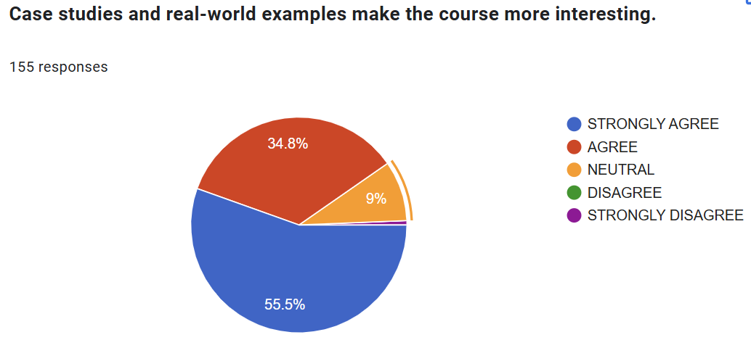
Figure 3 demonstrates the importance of case studies and real-world examples in drawing and maintaining students' attention during the course. According to the data, an overwhelming majority of respondents felt satisfied with the analysis of case studies and business-related examples. 34.8% of students agreed and 55.5% strongly agreed that this was very successful at maintaining their interest. In other words, 90.3% of students had positive feedback about the use of case studies and real-world examples in the curriculum.
Additionally, according to the notes from the observation checklists, the researcher realized that when students participated in discussions and debates based on case studies, they became very enthusiastic and interested. These tasks promoted critical thinking and active engagement. Students were able to apply theory to real-world situations, which motivated them in the precess of exploring knowledge.
Only 9% of students expressed no opinion about how successful case studies and real-world examples are. This proportion can be implied that these methods could be improved and modified further to better cater to the diverse linguistic backgrounds and proficiency levels of every learner. A tiny minority 0.6% of students (1 out of 155) strongly disagreed that case studies and real-world examples were helpful, which is not remarkable.
The results show that case studies and real-world examples play a crucial role in drawing in and retaining students’ attention. The overwhelmingly positive responses demonstrate how effective these methods are in creating an engaging and motivating learning environment.
To sum up, findings from Figure 3 and notes from the observation checklists clearly show that using case studies and real-world examples is a very good way to grab students' interest and improve their involvement in the course. In addition to making learning more fun, these techniques greatly enhance critical thinking and problem-solving abilities, which are crucial for students' success in university and the future career paths as well.
Figure 4
The roles of hands-on activities and practical exercises in helping students retain information
It is evident from Figure 4 that a sizable majority of students-89%-acknowledged the value of practical exercises and hands-on activities in aiding in their memory retention. Because the course gives students a thorough understanding of business topics, covering a wide range of concepts, theories, principles, and more, it would be very difficult for students to remember and apply the knowledge they have learned if proper teaching techniques were not used. These exercises and hands on activities offer students the opportunity to engage with theoretical concepts more practically, enhancing their ability to retain and apply knowledge in real-life situations. This strategy greatly differs from conventional lecture-based techniques, which make students passively learn new knowledge and as a result hinder them from remembering new business concepts. Furthermore, only a small minority were unaware of the usefulness of these techniques. While the neutral responses indicate some variation in learning preferences, the overall positive impact of the different approaches is clear.
The results of on-going exams and assessments provide more evidence of the efficacy of various techniques. Based on their results in these assessments, itv can be concluded that students’ comprehension ability and memory of the subject matter have clearly been strengthened by the frequent inclusion of these exercises and hands-on activities. In summary, the result and evidence from on-going evaluations highlight the significant role of practical exercises and hands- on activities in the learning process. These methods not only enhance students ability to retain information but also prepare them to apply it in real world situations.

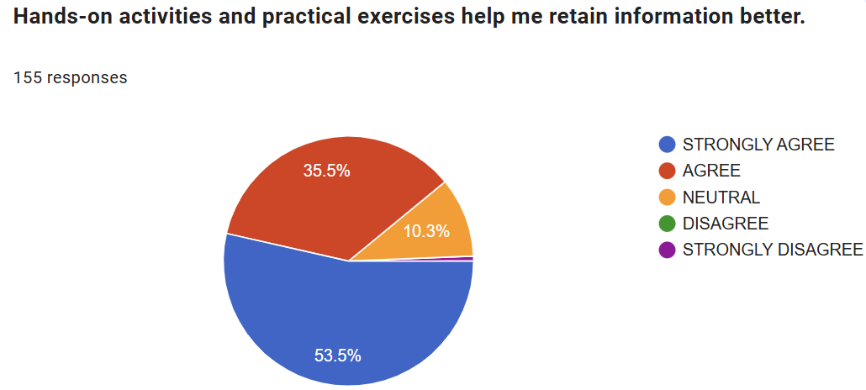
Figure 5
The application of presentations
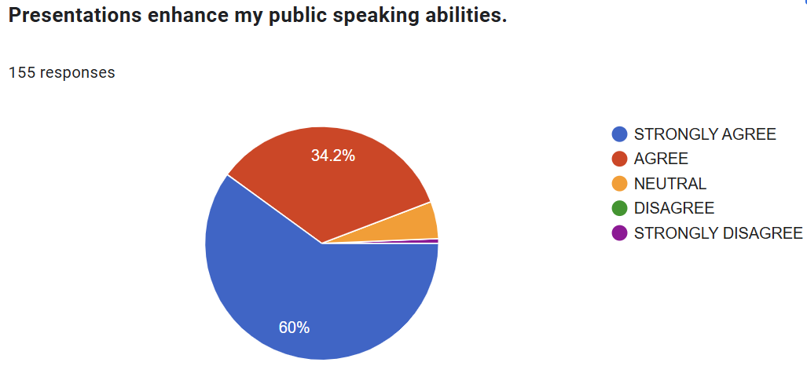
Figure 5 demonstrates how delivering presentations can enhance students’ confidence and their ability to spea speak in public. Presentations clearly play a crucial role in building their self- esteem, as reflected by 34.2% of students who agreed and the 60% strongly agreed that presentations greatly improve this challenging skill. This indicates that an overwhelming number of students overall acknowledged the beneficial effects of presentations on their ability to express ideas in public.These conclusions are further supported by the observations recorded in the checklists. According to the notes, about 70% of students expressed their extreme anxiety when they had to give a presentation for the first time. This anxiety showed out in a number of ways, including stuttering, repeating sentences or even phrases several times, and completely avoiding eye contact with the audience. Furthermore, a lot of students found it difficult to engage with their audience, which is a typical problem for those who are exposed to public speaking the first time.
But as the course went on, there was a remarkable change. Students became more and more confident in their next presentations. They began to communicate more smoothly, interact with their audience more effectively, and maintain eye contact. The continuous practice and feedback they received from their lecturers directly contributed to their increased professionalism and confidence as presenters. Additionally, only 5.2% of students expressed neutral views regarding the effectiveness of presentations. It can be explained that these students could not overcome the tension and stress when delivering a speech and 12 weeks seems not enough for them to struggle.
Just 0.6% of students disagreed that presentations were effective. The positive feedback outnumbered the negative ones, which demonstrates the importance of presentations in helping students become more confident and proficient speakers.
In summary, the results shown in Figure 5 and the observational data clearly indicate that giving presentations is an effective way for boosting students' confidence and communication skills in public. Students gain more experience and practise, their initial discomfort gradually diminished, leading to improved performance and greater professionalism. The widespread agreement among students on the benefits of presentations underscores their importance in the curriculum and establishes them as a key tool for developing essential communication skills.
Figure 6
Project-based assessments
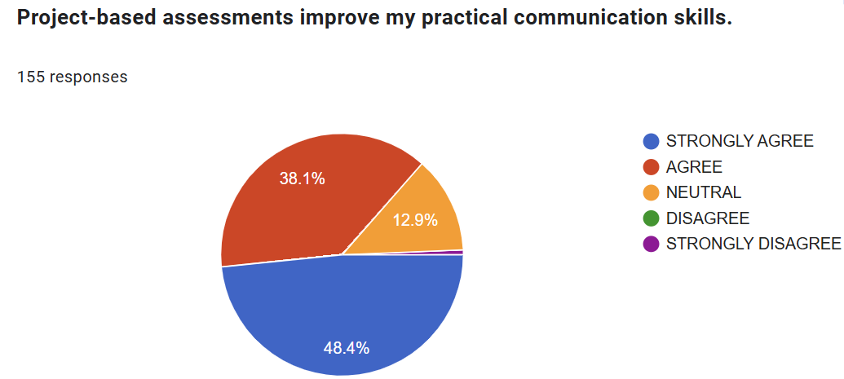
Figure 6 shows students’ feedbacks about project-based assessments. 38.1% of the students agreed, and nearly half strongly agreed, that project-based evaluations greatly improve their communication abilities. This indicates that an overwhelming proportion 86.5% of students in all acknowledged the importance of project-based evaluations in improving their capacity for clear communication. It can be concluded that project-based learning is an effective method for students at this stage of academic career.
12.9% of students expressed no opinion about the benefits of project-based assessments in helping them improve their skill. Based on the notes in the observation checklists, the researcher realized that some students experienced stress when working on projects for a variety of reasons. The fact that group members had different schedules can be challenging to find a time fitting everyone. Moreover, unavoidable conflicts arose impeded the project's advancement and increase their stress levels. Another important reason is that some students might not have good time management skill and interpersonal skill needed to successfully complete group projects. These skills are essential for completing the projects.
In spite of these challenges, it can be said that the project-based approach is still the best option for this subject at the highest level of university education. Instead of relying on the lecturer, students are required to take part in projects and familiarise themselves with the tasks to be fulfilled. By doing this, they are prepared to their future professional employment. This approach gets them ready for the realities of the corporate world, where projects are becoming more essential.
In conclusion, project-based evaluations have a lot of benefits in terms of skill development and preparation for the real-world business. Through encouraging self-reliance, teamwork, and clear communication, project-based learning gives students the skills they need to be successful in university and in the workplace.
Figure 7
The effectiveness of frequent quizzes and tests
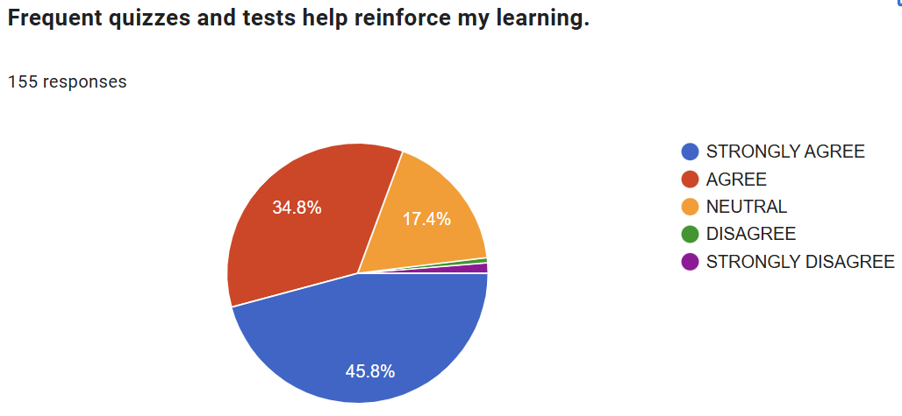
Figure 7 shows the students’ opinions about the implementation of frequent quizzes and tests in class. According to the results, 45.8% and 34.8% of students respectively strongly agreed and agreed that regular tests and quizzes aid in their learning. They acknowledged the advantages of frequent evaluations. According to the notes from the researcher’s checklist, when students received ongoing feedback on their progress from these constant assessments, they knew which areas needed improving. As a result, there would be fewer mistakes or weaknesses in the next tests.
It is noticeable that a comparatively high proportion 17.4% of students had no idea about the benefits of frequent tests and quizzes. According to the notes from the checklists, some students confirmed that they experienced tension and anxiety when they had to take tests and quizzes on a regular basis. This feedback is important because it emphasizes how frequent assessments might affect students in a negative and unexpected way.
According to the requirements in the course detailed outline, at least three mini-tests must be taken throughout a 12-week period. The purpose of this frequent evaluation is to ensure that students can consistently track their progress and identify their weakness. However, this puts a lot of strain on the students and the lecturer as well. The pressure to perform well on these tests led to increased stress and anxiety. This has an adverse effect on the students’ learning process. Students must continuously study for and do well on these tests, and lecturers must constantly create and grade these tests. To tackle the issue, teachers have to consider the different forms of these tests to reduce the pressure on students.
In conclusion, although the data shows that most students recognize the bebefits of regular tests and quizzes, the comments about stress and the sizeable percentage of ambivalent answers emphasize the necessity for a flexible strategy. Teachers should make an attempt to create tests that can effectively evaluate the students’ skills and reduce their stress as well.
Figure 8
The role of peer assessment in helping students improve
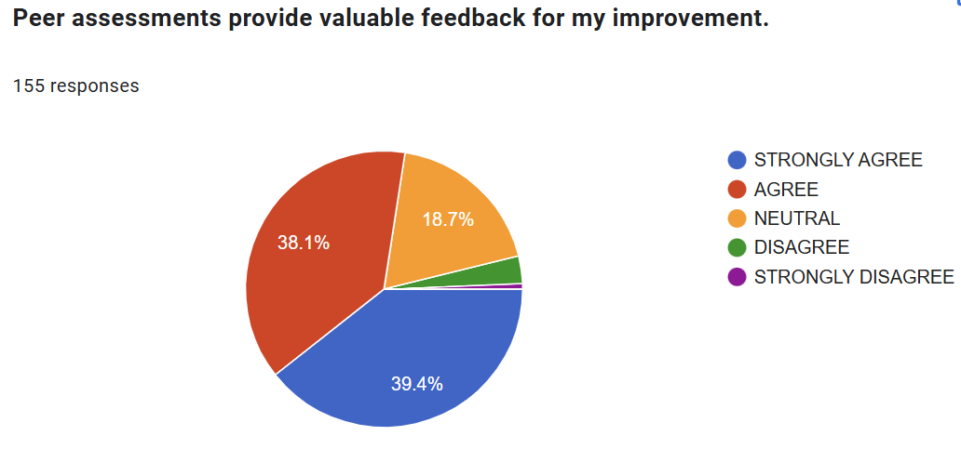Figure 8 illustrates students’ opinions about their peers’ feedback in helping them improve their skills.
According to the results, the percentages of respondents who strongly agreed and agreed that peer assessments much enhance their improvement were approximately the same, accounting for 39.4% and 38.1%, respectively. Noticeably, 18.7% of respondents had neutral idea about how helpful peer evaluations are. The highly subjective remarks and criticism that some students got on their friends' work can be interpreted in conjunction with the observation checklist notes. Despite of the fact that many of the remarks were helpful and constructive, some feedback were not objective, based on prejudice and emotional judgement which might have made some students not value their peer assessments. These results are supported by the notes from the observation checklists, which show that the constructive and justified feedback contributes greatly to the improvement as well as the motivation of the students. They frankly showed that they did not appreciate or value their friends’ comments if it is opinionated or prejudiced. Therefore, it is crucial to guide students how to provide their peers unbiased, helpful, and constructive feedback. It is advisable to provide them with a range of criteria to evaluate their peers in various tasks. Only 3.2% of students didn't agree that peer evaluations are really valuable for them in developing their skills.
Generally, positive responses about peer assessments outnumbered the negative ones, which highlights the potential of this as an valuable teaching tool. Peer assessments promote collaborative learning and a deeper understanding of the theory by encouraging students to critically analyze one another's work. Peer assessments strengthen students’ ability to evaluate the work of others and simultaneously they learn a lot from their peers thanks to the observation process.
In summary, the results and data from the observational notes show that peer evaluations are crucial for assisting students in developing their knowledge and abilities. The overwhelmingly positice responses indicates that peer assessments are an indispensable part of the learning process. In order to improve peer assessments' efficacy and guarantee that every student gains from this collaborative learning strategy, it is necessary to tackle the problems with feedback quality.
- Discussion
According to this research, it can be seen that the overwhelming majority of students- 95.4% positive responses all together- agreed strongly or agreed that the course plays a vital role in improving their communication skills, which are essential for becoming employable in the competitive job market. A study by Ismail (2011) concluded that the prospect of being employed is higher amongst graduates with a good competency of English. As a result, the students’ feedback show that being equipped with the skills and knowledge in this course, they are more confident that they will improve their employability. Another important finding is that approximately 90% of students gave favorable comments, claiming that interactive learner- centered teaching techniques like role-playing and group discussions greatly increase their involvement in all activities, which makes learning more dynamic and efficient. The results are not out of the expectation of the author and supported by the data from the checklist notes. The learner- centered methods proved to be extremely effective in gaining students’ attention and interest. In addition, the vast majority of students found case studies and real-world examples to be very engaging. The same number of students agreed that practical exercises and hands-on activities are really crucial for long-term retention of business knowledge because they allow theoretical concepts to be applied practically. In brief, innovated approaches that focus on the students’ needs are highly appreciated and contribute to increase their level of satisfaction.
Despite of the fact that project-based tasks might be stressful, 88.1% of students acknowledged the benefits they bring. Based on the notes from the observation checklists, the researcher confirmed that students improved several skills during the process of doing the projects. They had to analyze real-world problems and brainstorm to discuss innovative solutions. Therefore, they can be more creative and motivated as well to fullfill the tasks. These projects also greatly foster teamwork and improve their interpersonal skills. They had the chances to explore the issues in depth, leading to better retention and understanding. In short, project-based evaluations are the most suitable option for senior students because they are prepared for future work.
It cannot be denied that frequent quizzes and tests create stress for students. Surprisingly, 80.6% of students felt that they were quite beneficial. It can be explained that the variety of test forms like mini tests, quizzes, presentations, projects, etc. to evaluate different skills reduces the boredom of doing tests and students recognize the benefits of these constant evaluations.
Finally, the number of students who found peer assessments to be useful was not so high, accounting for 77.5%. More than 22% of students were unhappy with their peers’ comments. The writer thinks that because there were some bias in some peer evaluations and comments, nearly a quarter of students were unsatisfied.
This study supports earlier research that highlights the value of hands-on, interactive learner- centered teaching strategies. It asserts the idea that active learning techniques, such project-based learning and practical exercises, improve student interest and memory. In line with past research emphasizing the importance of communication skills in the labor market, the results support the importance of these abilities in enhancing employability. Furthermore, the study's findings about the value of peer evaluations and presentations support other studies that found similar techniques to be essential for fostering students' self-assurance and teamwork. In conclusion, the study adds to the increasing amount of data demonstrating creative and student-centered teaching strategies in higher education.
6. Conclusion
The findings from this study highlight the importance of this course to the students’ employability and adaptability in the future workplace. In addition, a variety of student- centered teaching methods and innovative forms of on-going assessments have been proved to enhance their interest and motivation in learning, help them take ownership of their learning and acquire important skills to meet the challenging demands of the labor market. From the students’ perspective, these various teaching methods and evaluations, including role-playing, case studies, projects and presentations play a significant role in assisting them improve their communication proficiency and explore the knowledge in depth.
One thing that needs to take into consideration is that although regular examinations and quizzes are good for consolidating knowledge, they should be balanced to prevent unnecessary stress for students. During 12-week semester, 3 compulsory tests and a project seem to be a burden for students because they have to meet deadlines in other courses. I suggest that there should be some modification in the course detail outline so that tests are not stressful for both the test maker and test takers.
Another important thing is that even though peer evaluations are a good solution for teachers as they save time and for students as they get valuable feedback from their peers, they must be carefully managed to guarantee helpful and constructive criticism. From my point of view, in order to achieve this goal, the teacher should provide students with a guideline in which there are specific requirements and criteria to evaluate their peers’ performance.
Despite offering insightful information, the study had a number of drawbacks. Only 155 students took part in the survey, which might not accurately reflect all the students majoring in Business English.
A larger and more varied sample size should be taken into account in future studies to improve the findings' generalizability and reliability. Furthermore, investigating how well these teaching strategies work in more classes would support and broaden the conclusions.

Acknowledgments
My sincere appreciation goes out to the following people and institutions for their vital contributions to this study:
The Department of Business English, for supporting me to carry out this research. Their assistance was essential in making the research efforts possible.
The students who took part in the study, whose eager participation and candid criticism were crucial to its success. My results and conclusions were based on their contributions.
For their helpful critiques and support throughout the several phases of this study, I am grateful to my peers and colleagues. Their suggestions enabled me to increase the study's overall quality and hone my methodology.
Thank you to family and friends for your steadfast understanding and support during the study process. Their patience and support were crucial.
I would like to express my sincere gratitude to everyone who helped with this study, and I recognize that without their combined efforts, it would not have been possible.

References
Asemanyi, A. A. (2015). An Assessment of Students’ Performance in Communication Skills: A Case Study of the University of Education Winneba. Journal of Education and Practice, 6(35)
https://files.eric.ed.gov/fulltext/EJ1086368.pdf
Barnett-Itzhaki, Z., Beimel, D., & Tsoury, A. (2023). Using a Variety of Interactive Learning Methods to Improve Learning Effectiveness: Insights from AI Models Based on Teaching Surveys. Ruppin Academic Center, 27(3), 363-367.
https://doi.org/10.24059/olj.v27i3.3575
Berry, P. (2013). The Impact Of Globalization And Technology On Teaching Business Communication: Reframing And Enlarging World View, Methods, And Content. American Journal Of Business Education, 6(1), 60-65.
http://www.cluteinstitute.com
Boon, S. (2018). Using peer assessment as an effective learning strategy in the classroom. Perspective Article
https://my.chartered.college/impact_article/using-peer-assessment-as-an-effective-learning-strategy-in-the-classroom/
Çelik, Ö. C., & Alpan, G. (2023). The Impact of an Effective Communication Course with Enhanced Student Engagement on Communication Skills and Empathic Tendency of Preservice Teachers. Educational Process International Journal, 12(2), 33-58.
https://files.eric.ed.gov/fulltext/EJ1392728.pdf
Gilsing, R., Türetken, O., Grefen, P., Ozkan, B., & Adali, O. E. (2022). Business Model Evaluation: A Systematic Review of Methods. Pacific Asia Journal of the Association of Information Systems, 14(4), 26-61.
https://doi.org/10.17705/1pais.14402
Ismail, N.A. (2011). Graduates’ characteristics and unemployment: a study among
Malaysian graduates. International Journal of Business and Social Science, Vol. 2 No. 16

Khamis, N. (2021). Enhancing Business Communication Skills: An Action Research.
International Journal of Asian Social Science.
https://doi.org/10.18488/JOURNAL.1.2021.117.355.364

Tajeddin, M. (2018). Effectiveness of Teaching Methods in Business Education: A Comparison Study on the Learning outcomes of Lectures, Case Studies and Simulations. International Journal of Management Education, 16(1), 131-142.
https://doi.org/10.1016/j.ijme.2018.01.003

Bionote
The researcher is a full- time lecturer in Ho Chi Minh city University of Foreign languages and Information technology. She has nearly 30 years experience teaching Business English. She’s interested in methodology, language testing and related fields. She regularly attends conferences to learn from other researchers.

