How to Make Effective Project-Based Learning (PBL) for Transinterpretation Theory Classrooms in HUFLIT?

Abstract
Project-Based Learning (PBL) has increasingly been recognized as an effective pedagogical approach in higher education, particularly in disciplines that require the integration of abstract theory, applied reasoning, and sustained critical inquiry, such as translation and interpretation studies. However, some previous surveys showed students’ boredom in teaching set up. This paper investigates how effective PBL-based Transinterpretation Theory classrooms can be attractively designed and implemented at the University of Foreign Languages and Information Technology (HUFLIT), Vietnam. Drawing on empirical data collected from a structured survey of 76 undergraduate students, the study examines learners’ perceptions of workload distribution, learning pressure, engagement, and conceptual accessibility when theoretical content is delivered through a project-based format. The findings indicate that dividing a final theory project into weekly, scaffolded tasks significantly reduces learner anxiety, enhances sustained engagement, and supports deeper comprehension of complex theoretical constructs. Based on these findings, the paper proposes a comprehensive PBL instructional framework tailored to the institutional, linguistic, and cultural context of HUFLIT. The study contributes both empirical evidence and pedagogical guidance to international discussions on PBL, translation pedagogy, and theory-oriented instruction in applied linguistics.
Keywords: Project-Based Learning; Transinterpretation Theory; Translation Pedagogy; Applied Linguistics; Learning Motivation

1. INTRODUCTION

1.1 Background to the Study
Translation and interpreting programs worldwide traditionally comprise both practice-oriented modules and theory-based courses. While skills-based courses are often perceived as tangible and professionally relevant, theoretical subjects—such as Transinterpretation Theory—frequently pose significant challenges for undergraduate students. These challenges are particularly pronounced in English as a Foreign Language (EFL) contexts, where learners must simultaneously process abstract theoretical discourse and a non-native academic language.
At HUFLIT, Transinterpretation Theory is a compulsory core course designed to provide Transinterpretation-majored students with conceptual frameworks for understanding translation and translation as an interpretive, communicative, and socioculturally situated activity. However, many students approach the course with apprehension, viewing theory as dense, detached from practice, and assessment-heavy. In addition, most of them got big problems with the final project, which usually requires lots of time-consuming efforts in the meantime of hard workload of the other subjects’ final exams. This perception often leads to surface learning strategies, memorization, and reliance on last-minute preparation rather than sustained conceptual engagement.

1.2 The Pedagogical Challenge of Theory-Heavy Courses
Traditional instructional models for theory courses commonly rely on lecture-based delivery followed by a single high-stakes final paper or examination. While such models may align with content coverage requirements, they frequently fail to account for learner diversity, cognitive load, and affective factors such as anxiety and motivation. For students with uneven academic foundations—common in many developing EFL contexts—these challenges are compounded.
Within this pedagogical landscape, there is an urgent need for instructional approaches that preserve theoretical rigor while making theory accessible, engaging, and meaningful. Project-Based Learning (PBL) offers a promising response to this need.

1.3 Project-Based Learning as a Pedagogical Alternative
PBL shifts the focus of instruction from passive content reception to active knowledge construction. Learners engage in extended inquiry around complex questions or problems, culminating in concrete academic products. Rather than positioning theory as an object to be memorized, PBL frames it as a tool for analysis, interpretation, and justification.
Despite extensive research on PBL in science education, engineering, and language skills courses, its application to theory-oriented translation subjects remains underexplored. This study addresses this gap by examining how PBL can be systematically applied to Transinterpretation Theory classrooms at HUFLIT.

1.4 Research Objectives and Questions
The study pursues three main objectives: 1. To investigate students’ perceptions of PBL-based task design in a Transinterpretation Theory course. 2. To examine the impact of task segmentation on learning pressure and engagement. 3. To propose a submission-ready PBL framework for theory-based translation instruction.
The guiding research questions are:
RQ1:
How does dividing the final project into weekly PBL tasks influence students’ self-regulated learning and engagement throughout the semester?
RQ2:
How do students perceive the formative assessment benefits and potential drawbacks of dividing the final project into weekly PBL tasks compared to submitting a single final project?
RQ3:
What instructional principles can guide the design of effective PBL Transinterpretation Theory classrooms?

1.5 Significance of the Study
This study holds theoretical, pedagogical, and institutional significance.
First, at the theoretical level, the study extends existing scholarship on Project-Based Learning (PBL) by applying it to a theory-oriented course in translation studies—an area that has received comparatively limited empirical attention. While PBL has been widely implemented in science, engineering, and language skills education, its systematic integration into translation theory instruction remains underexplored. By situating PBL within the frameworks of Self-Regulated Learning (Zimmerman, 2002) and Formative Assessment theory (Black & Wiliam, 1998), the study contributes to a more nuanced understanding of how task segmentation and feedback cycles function in cognitively demanding, abstract disciplines. It thus enriches interdisciplinary dialogue between applied linguistics, translation pedagogy, and educational psychology.
Second, at the pedagogical level, the study provides empirically grounded evidence that dividing a high-stakes final project into weekly scaffolded tasks can reduce learner anxiety, enhance engagement, and promote sustained conceptual processing. These findings are particularly significant for theory-heavy courses in EFL contexts, where students must navigate both abstract academic discourse and a non-native language. The proposed PBL framework offers concrete instructional principles—task sequencing, formative feedback integration, workload calibration, and collaborative inquiry—that instructors can adopt or adapt to improve classroom practice without compromising theoretical rigor.
Third, at the institutional level, the study offers a context-sensitive instructional model tailored to HUFLIT’s academic environment. It responds directly to documented student concerns regarding workload concentration and assessment pressure. By proposing a submission-ready PBL framework aligned with course learning outcomes, the research supports curriculum innovation, quality assurance processes, and evidence-based teaching reform within the university. Furthermore, the model may serve as a reference for similar higher education institutions in Vietnam and other EFL contexts seeking to modernize theory instruction.
Finally, the study contributes to international discussions on translation pedagogy by demonstrating that theoretical instruction need not be detached, abstract, or anxiety-inducing. Instead, when structured through carefully scaffolded PBL design, theory can become dialogic, cumulative, and intellectually engaging.
1.6 Scope and Delimitation of the Study
This study focuses specifically on the implementation of Project-Based Learning in a Transinterpretation Theory course at the University of Foreign Languages and Information Technology (HUFLIT), Vietnam. The primary emphasis is on examining students’ perceptions of weekly task segmentation, learning pressure, engagement, and conceptual accessibility within a single semester.
The scope of the research is limited to undergraduate students majoring in Transinterpretation who experienced a PBL-informed instructional design in which a final theoretical project was divided into weekly tasks. Data were collected through a structured Likert-scale questionnaire and analyzed descriptively to identify dominant trends. The study therefore concentrates on perceptual and self-reported learning experiences rather than objective performance outcomes.
Several delimitations should be acknowledged. First, the research is confined to one institutional context, which may limit generalizability to other universities, disciplines, or cultural settings. Second, the sample size (79 students) reflects one cohort and does not include comparative control groups experiencing traditional lecture-based instruction. Third, the study does not employ experimental or longitudinal designs; it does not measure long-term retention of theoretical knowledge or professional translation competence. Fourth, the analysis prioritizes descriptive interpretation over advanced inferential statistical modeling.
Despite these delimitations, the study provides meaningful exploratory evidence and a pedagogically grounded framework that may inform future large-scale, mixed-method, or cross-institutional research.

2. LITERATURE REVIEW
2.1 Project-Based Learning: Theoretical Framework
Project-Based Learning (PBL) is grounded in constructivist and socio-constructivist theories, which conceptualize learning as an active, meaning-making process rather than passive knowledge transmission. Dewey (1938) argued that education must be rooted in experience and inquiry, emphasizing reflective thought as central to deep learning. Similarly, Vygotsky’s (1978) sociocultural theory highlights the role of social interaction and scaffolding within the Zone of Proximal Development (ZPD), suggesting that learners develop higher-order thinking through guided participation.
Contemporary PBL frameworks extend these theoretical foundations by positioning learners as active investigators who engage in sustained inquiry around complex problems (Thomas, 2000). Rather than isolating knowledge into discrete lectures, PBL integrates conceptual understanding with authentic tasks culminating in a meaningful product. Blumenfeld et al. (1991) argue that PBL promotes intrinsic motivation because learners perceive tasks as purposeful and cognitively engaging.
Importantly, PBL is not merely “doing projects.” It involves structured scaffolding, iterative feedback, and alignment between tasks and learning outcomes (Krajcik & Shin, 2014). When properly implemented, PBL fosters deeper conceptual understanding, critical thinking, and autonomy (Barron & Darling-Hammond, 2008).
Within theory-heavy disciplines such as translation studies, PBL offers a mechanism to operationalize abstract constructs into analyzable problems, thereby bridging theory and application.
2.2 Self-Regulated Learning and Task Segmentation
Self-Regulated Learning (SRL) theory provides a critical lens for understanding how dividing a final project into weekly tasks may influence student learning. Zimmerman (2002) conceptualizes SRL as a cyclical process involving forethought (goal-setting and planning), performance control (self-monitoring and strategy use), and self-reflection (evaluation and adaptation). Similarly, Pintrich (2004) emphasizes that motivated learners actively regulate cognition, behavior, and effort across time.
Distributed or segmented tasks align closely with SRL principles. When a large assignment is divided into smaller milestones, students are required to set short-term goals, monitor progress, and adjust strategies regularly. This structure reduces procrastination and enhances metacognitive awareness (Schunk & Greene, 2018).
Research in educational psychology suggests that task chunking mitigates cognitive overload (Sweller, 1988). Cognitive Load Theory posits that working memory has limited capacity; therefore, breaking complex tasks into manageable components facilitates schema construction and deeper processing. Weekly project tasks can thus support sustained engagement and consistent performance rather than last-minute cramming.
Empirical evidence indicates that structured, incremental assignments improve time management and academic persistence (Zimmerman & Kitsantas, 2014). Therefore, segmenting a final project may strengthen students’ self-regulatory capacities, particularly in theory-based courses requiring sustained conceptual processing.
2.3 Formative Assessment and Feedback Mechanisms
Formative assessment theory further explains the pedagogical value of weekly project tasks. Black and Wiliam (1998) define formative assessment as activities that generate feedback used to modify teaching and learning processes. Unlike summative assessment, which evaluates final performance, formative assessment emphasizes continuous improvement.
Hattie and Timperley (2007) propose that effective feedback addresses three key questions:
- Where am I going? (learning goals)
- How am I going? (progress evaluation)
- Where to next? (future improvement)
Weekly task submission inherently creates opportunities for such feedback cycles. Students receive iterative guidance before the final submission, which enhances task quality and conceptual accuracy. Nicol and Macfarlane-Dick (2006) argue that formative feedback promotes self-regulation by encouraging reflection and strategy adjustment.
Moreover, distributed assessment has been associated with reduced academic anxiety (Putwain & Daly, 2014). High-stakes, single-point evaluation often increases stress and surface learning approaches (Biggs & Tang, 2011). In contrast, ongoing assessment redistributes pressure across time, potentially lowering affective barriers to engagement.
However, research also cautions that frequent tasks may increase perceived workload if not carefully coordinated (Boud & Falchikov, 2007). Thus, the effectiveness of weekly segmentation depends on thoughtful workload calibration and clear alignment with learning objectives.
2.4 Project-Based Learning in Higher Education
Meta-analyses demonstrate that PBL enhances long-term retention, problem-solving ability, and student motivation compared to traditional lecture-based instruction (Dochy et al., 2003). In higher education, PBL supports the development of transferable competencies such as collaboration, analytical reasoning, and independent inquiry (Savery, 2006).
Nevertheless, implementation challenges persist. Kirschner, Sweller, and Clark (2006) caution that minimally guided instruction may overwhelm novice learners. Consequently, effective PBL requires structured scaffolding, explicit criteria, and progressive complexity—particularly in cognitively demanding disciplines.
Research further suggests that PBL effectiveness increases when projects are divided into phased milestones with feedback loops (Larmer, Mergendoller, & Boss, 2015). Such design aligns directly with the current study’s focus on weekly task segmentation as a structured PBL strategy.
2.5 Translation Pedagogy and Theory Instruction
Translation theory occupies a foundational role in translator education, offering conceptual frameworks for understanding equivalence, functionalism, ideology, and sociocultural mediation (Munday, 2016). However, students often perceive theoretical courses as abstract and disconnected from professional practice (Kiraly, 2000).
Kiraly (2000) advocates a social constructivist approach to translation pedagogy, emphasizing collaborative knowledge construction and authentic tasks. Similarly, González Davies (2004) argues that theory should be integrated into problem-solving activities rather than presented as decontextualized content.
Recent scholarship calls for pedagogical models that bridge theoretical reflection and applied translation analysis (Pym, 2010). Task-based and project-based approaches provide opportunities to operationalize theoretical constructs through case studies, comparative analysis, and justification of translation decisions.
In EFL contexts, where linguistic processing demands are high, theory instruction must also consider cognitive load and affective factors. Dividing large theoretical assignments into weekly analytic tasks may enhance accessibility while preserving intellectual rigor.
2.6 Assessment Design, Anxiety, and Workload Perception
Assessment design significantly influences learner motivation and emotional response. According to Biggs and Tang (2011), constructive alignment ensures that assessment tasks directly reflect intended learning outcomes. When assessment is misaligned or excessively high-stakes, students adopt surface learning strategies.
Academic anxiety has been linked to concentrated summative evaluation (Putwain & Daly, 2014). Distributed assessment structures, by contrast, promote sustained effort and reduce avoidance behaviors. However, over-fragmentation may create perceptions of continuous pressure if task frequency is excessive (Boud & Falchikov, 2007).
Therefore, the pedagogical value of dividing a final project into weekly tasks lies in balancing formative scaffolding with manageable workload design. This balance constitutes the empirical focus of the present study.
2.7 Synthesis and Research Gap
Existing literature strongly supports PBL as a constructivist, feedback-rich instructional model that enhances motivation, self-regulation, and conceptual understanding. Self-Regulated Learning theory explains how task segmentation fosters goal-setting and monitoring processes. Formative Assessment theory clarifies how iterative feedback improves performance and reduces anxiety.
However, limited research has examined the application of weekly task segmentation within theory-oriented translation courses in EFL higher education contexts. While PBL has been widely studied in science and language skills courses, its structured implementation in translation theory classrooms remains underexplored.
This gap justifies the present investigation into how dividing a final Transinterpretation Theory project into weekly tasks influences student engagement, perceived workload, anxiety, and overall learning effectiveness.

3. METHODOLOGY

3.1 Research Design
This study employs a descriptive quantitative design supplemented by pedagogical analysis. Survey data provide empirical insight into student perceptions of PBL-based instruction, while instructional reflection informs framework development.

3.2 Participants
Participants were 79 undergraduate students enrolled in Transinterpretation Theory courses at HUFLIT. All participants experienced a PBL-informed course design in which the final theoretical project was divided into weekly tasks.

3.3 Instrumentation
Data were collected via attitude questionnaires comprising Likert-scale items distributed in the first semester. The questionnaires were sent to participants via Zalo to assure the prompt reception and all responses were returned before the deadline for the convenience of data collection. The survey focused on perceived accessibility of course content, workload management, learning pressure, and engagement.
3.4 Statistical Treatment
Responses were analyzed descriptively to identify dominant trends and levels of agreement. The analysis prioritizes pedagogical interpretation over statistical generalization. Statistical data was treated with SPSS to show the percentage of agreement/disagreement and the individual solutions/proposals/personal views from the participants.

4. RESULTS AND DATA ANALYSES

4.1 Accessibility of Theoretical Content
A clear majority of respondents agreed that dividing the final project into weekly tasks made Transinterpretation Theory content more accessible. This suggests that PBL-based scaffolding facilitates comprehension of abstract concepts.

4.2 Learning Pressure and Emotional Response
Most students reported feeling significantly less pressure when completing weekly tasks compared to submitting a single final paper. This finding highlights the affective advantages of distributed assessment.

4.3 Engagement and Learning Behaviors
Regular task deadlines encouraged consistent engagement, preparation, and peer discussion. Students reported fewer instances of last-minute work and greater willingness to seek clarification.
Statistics
 |  | Q1 | Q2 | Q3 | Q4 | Q5 | Q6 | Q7 | Q8 | Q9 | Q10
N | Valid | 79 | 79 | 79 | 79 | 79 | 79 | 79 | 79 | 79 | 79
N | Missing | 0 | 0 | 0 | 0 | 0 | 0 | 0 | 0 | 0 | 0
All ten questionnaire items (Q1–Q10) received 79 valid responses with no missing data, indicating a 100% completion rate. This complete dataset enhances reliability, eliminates the need for data imputation, and ensures accurate percentage calculations. The full participation also suggests strong respondent engagement and clarity of the survey design.
Frequency Table
Q1
 |  | Frequency | Percent | Valid Percent | Cumulative Percent
Valid | Hoàn toàn đồng ý | 63 | 79.7 | 79.7 | 79.7
Valid | Đồng ý | 16 | 20.3 | 20.3 | 100.0
Valid | Total | 79 | 100.0 | 100.0
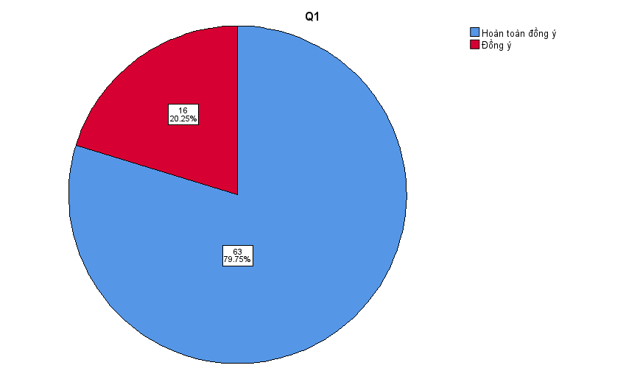
Question 1 shows that 63 respondents (79.7%) totally agreed, while 16 respondents (20.3%) agreed. No neutral or negative responses were recorded. This indicates an overwhelmingly positive perception among students, with 100% expressing agreement. The result strongly suggests that the instructional design was perceived as highly effective in addressing the intended learning objective.
Q2
 |  | Frequency | Percent | Valid Percent | Cumulative Percent
Valid | Hoàn toàn đồng ý | 44 | 55.7 | 55.7 | 55.7
Valid | Đồng ý | 20 | 25.3 | 25.3 | 81.0
Valid | Trung lập | 15 | 19.0 | 19.0 | 100.0
Valid | Total | 79 | 100.0 | 100.0
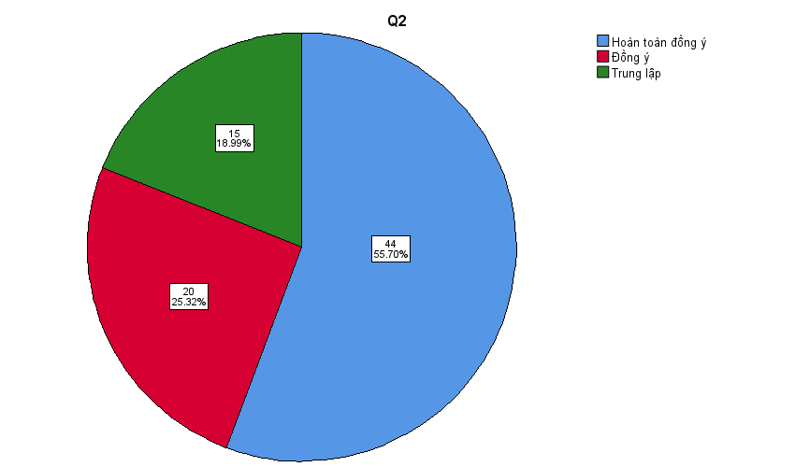
For Question 2, 44 students (55.7%) totally agreed, 20 students (25.3%) agreed, and 15 students (19.0%) remained neutral. No disagreement was reported. Overall, 81.0% expressed agreement. Although the majority held a positive view, the presence of neutral responses suggests that a small proportion of students may have experienced moderate uncertainty regarding this aspect of the PBL implementation.
Q3
 |  | Frequency | Percent | Valid Percent | Cumulative Percent
Valid | Hoàn toàn đồng ý | 41 | 51.9 | 51.9 | 51.9
Valid | Đồng ý | 23 | 29.1 | 29.1 | 81.0
Valid | Trung lập | 15 | 19.0 | 19.0 | 100.0
Valid | Total | 79 | 100.0 | 100.0
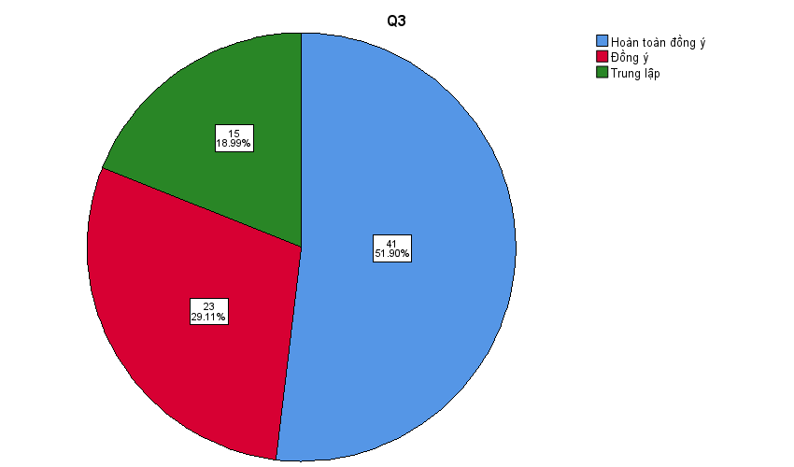
In Question 3, 41 respondents (51.9%) totally agreed and 23 respondents (29.1%) agreed, accounting for 81.0% positive responses. Meanwhile, 15 students (19.0%) selected the neutral option. The absence of disagreement indicates general acceptance; however, the relatively higher neutral percentage suggests that some learners may require additional instructional clarification or support in this area.
Q4
 |  | Frequency | Percent | Valid Percent | Cumulative Percent
Valid | Hoàn toàn đồng ý | 46 | 58.2 | 58.2 | 58.2
Valid | Đồng ý | 21 | 26.6 | 26.6 | 84.8
Valid | Trung lập | 12 | 15.2 | 15.2 | 100.0
Valid | Total | 79 | 100.0 | 100.0
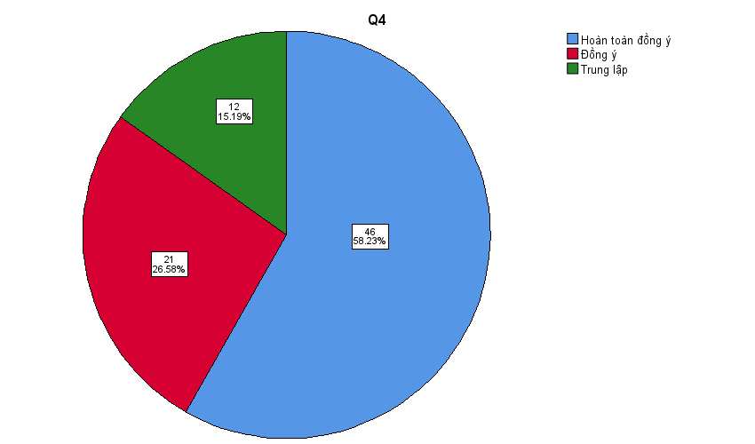
Results for Question 4 indicate that 46 students (58.2%) totally agreed and 21 students (26.6%) agreed, totaling 84.8% agreement. Additionally, 12 respondents (15.2%) chose neutral. No disagreement was reported. This demonstrates strong endorsement of the statement, reinforcing the perceived effectiveness of weekly task segmentation in supporting learning outcomes.
Q5
 |  | Frequency | Percent | Valid Percent | Cumulative Percent
Valid | Hoàn toàn đồng ý | 60 | 75.9 | 75.9 | 75.9
Valid | Đồng ý | 18 | 22.8 | 22.8 | 98.7
Valid | Trung lập | 1 | 1.3 | 1.3 | 100.0
Valid | Total | 79 | 100.0 | 100.0
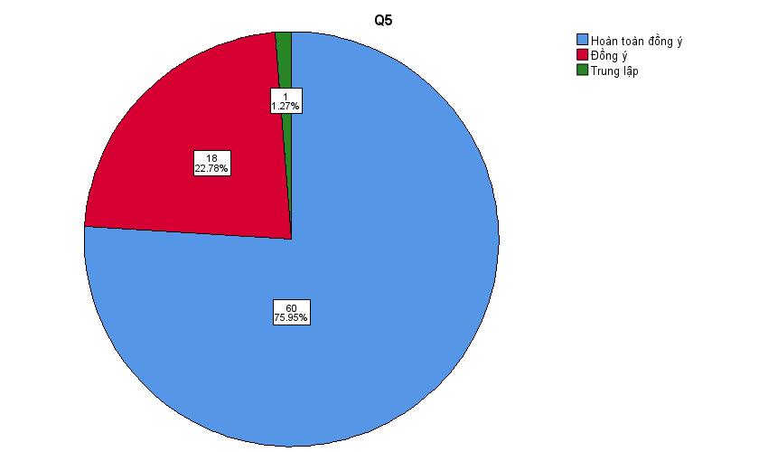
Question 5 reveals a highly positive response pattern: 60 respondents (75.9%) totally agreed and 18 respondents (22.8%) agreed, while only 1 respondent (1.3%) remained neutral. No disagreement was recorded. With 98.7% agreement, this result indicates near-universal approval and suggests that this component of the PBL model was particularly well received.
Q6
 |  | Frequency | Percent | Valid Percent | Cumulative Percent
Valid | Hoàn toàn đồng ý | 36 | 45.6 | 45.6 | 45.6
Valid | Đồng ý | 23 | 29.1 | 29.1 | 74.7
Valid | Trung lập | 18 | 22.8 | 22.8 | 97.5
Valid | Không đồng ý | 2 | 2.5 | 2.5 | 100.0
Valid | Total | 79 | 100.0 | 100.0
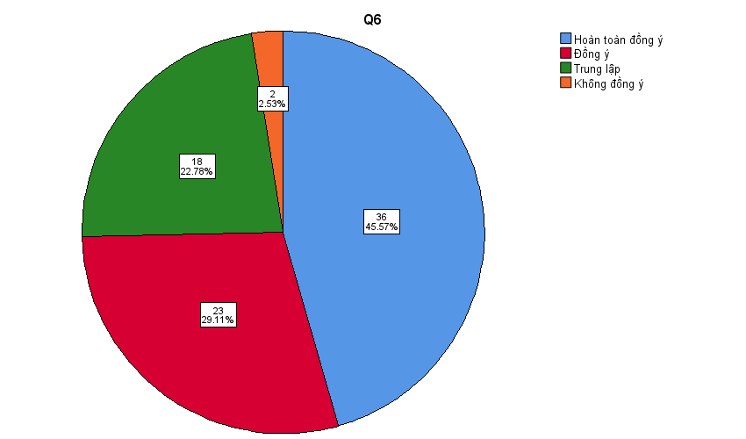
For Question 6, 36 students (45.6%) totally agreed and 23 students (29.1%) agreed, representing 74.7% overall agreement. Meanwhile, 18 respondents (22.8%) were neutral and 2 students (2.5%) disagreed. Although the majority responded positively, this item shows slightly more variation compared to earlier questions, indicating that a small minority may have experienced challenges or reservations.
Q7
 |  | Frequency | Percent | Valid Percent | Cumulative Percent
Valid | Đồng ý | 2 | 2.5 | 2.5 | 2.5
Valid | Trung lập | 1 | 1.3 | 1.3 | 3.8
Valid | Không đồng ý | 18 | 22.8 | 22.8 | 26.6
Valid | Hoàn toàn Không đồng ý | 58 | 73.4 | 73.4 | 100.0
Valid | Total | 79 | 100.0 | 100.0
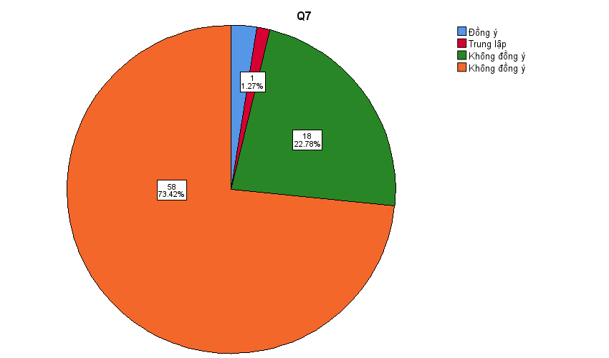
Question 7 presents a contrasting distribution. Only 2 respondents (2.5%) agreed and 1 respondent (1.3%) was neutral, whereas 18 students (22.8%) disagreed and 58 students (73.4%) strongly disagreed. In total, 96.2% expressed disagreement. This suggests that students largely rejected the negative statement implied in this item (likely related to increased pressure or difficulty), thereby indirectly supporting the effectiveness of the PBL approach.
Q8
 |  | Frequency | Percent | Valid Percent | Cumulative Percent
Valid | Hoàn toàn đồng ý | 40 | 50.6 | 50.6 | 50.6
Valid | Đồng ý | 22 | 27.8 | 27.8 | 78.5
Valid | Trung lập | 15 | 19.0 | 19.0 | 97.5
Valid | Không đồng ý | 1 | 1.3 | 1.3 | 98.7
Valid | Hoàn toàn Không đồng ý | 1 | 1.3 | 1.3 | 100.0
Valid | Total | 79 | 100.0 | 100.0

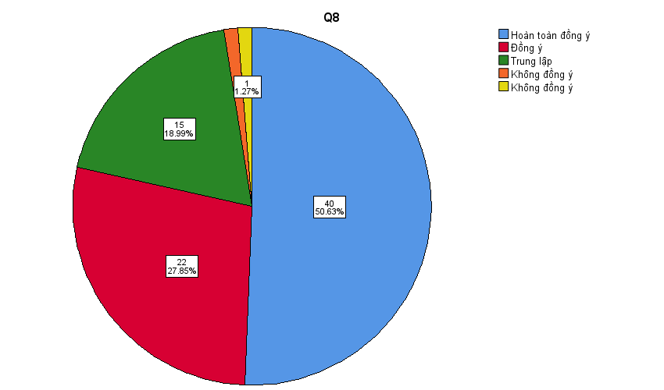

In Question 8, 40 respondents (50.6%) totally agreed and 22 respondents (27.8%) agreed, accounting for 78.5% agreement. Additionally, 15 students (19.0%) were neutral, while 1 student (1.3%) disagreed and 1 student (1.3%) strongly disagreed. Although the majority responded positively, the small percentage of disagreement indicates that experiences may not have been uniformly positive for all participants.
Q9
 |  | Frequency | Percent | Valid Percent | Cumulative Percent
Valid | Hoàn toàn đồng ý | 39 | 49.4 | 49.4 | 49.4
Valid | Đồng ý | 25 | 31.6 | 31.6 | 81.0
Valid | Trung lập | 14 | 17.7 | 17.7 | 98.7
Valid | Không đồng ý | 1 | 1.3 | 1.3 | 100.0
Valid | Total | 79 | 100.0 | 100.0
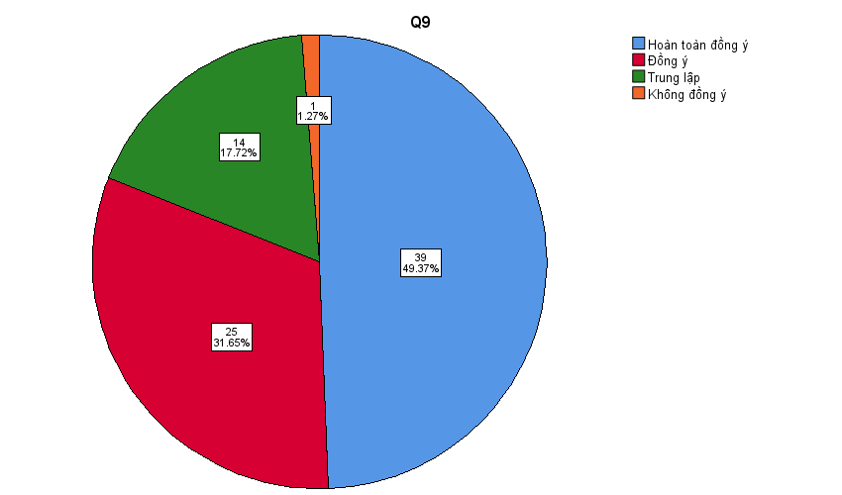
Results for Question 9 show that 39 students (49.4%) totally agreed and 25 students (31.6%) agreed, totaling 81.0% positive responses. Fourteen respondents (17.7%) selected neutral, and only 1 respondent (1.3%) disagreed. The findings demonstrate a strong positive tendency, suggesting that students generally perceived benefits from the PBL-based instructional structure.
Q10
 |  | Frequency | Percent | Valid Percent | Cumulative Percent
Valid | Hoàn toàn đồng ý | 60 | 75.9 | 75.9 | 75.9
Valid | Đồng ý | 18 | 22.8 | 22.8 | 98.7
Valid | Trung lập | 1 | 1.3 | 1.3 | 100.0
Valid | Total | 79 | 100.0 | 100.0

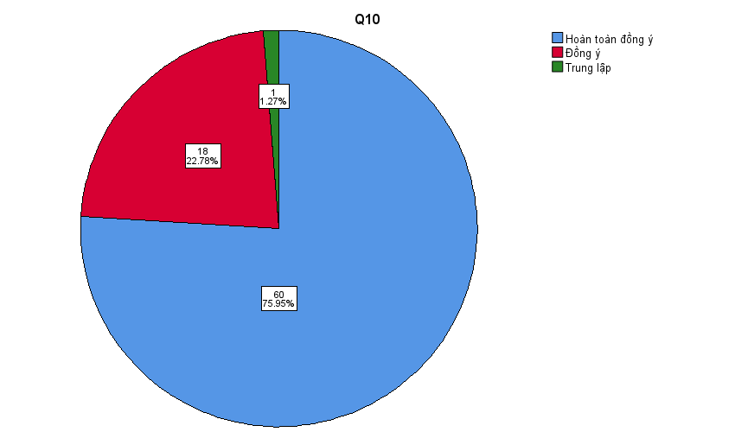
Question 10 reveals another highly favorable outcome: 60 respondents (75.9%) totally agreed and 18 respondents (22.8%) agreed, while only 1 respondent (1.3%) remained neutral. No disagreement was recorded. With 98.7% agreement, this item confirms strong overall student endorsement of the PBL framework and its impact on their learning experience.
5. Designing Effective PBL Transinterpretation Theory Classrooms

Designing an effective Project-Based Learning (PBL) model for Transinterpretation Theory requires more than dividing a final paper into smaller assignments. It involves systematic curricular alignment, theoretically informed scaffolding, collaborative knowledge construction, structured feedback mechanisms, and assessment principles that prioritize analytical rigor. The following subsections outline core design principles for implementing a high-quality PBL framework in theory-oriented translation education.

5.1 Curriculum Alignment and Learning Outcomes

Effective PBL implementation begins with constructive alignment between intended learning outcomes (ILOs), instructional activities, and assessment criteria, as articulated by John Biggs and Catherine Tang in Teaching for Quality Learning at University. In a Transinterpretation Theory course, learning outcomes typically include:

Understanding and explaining major theoretical paradigms (e.g., equivalence, functionalism, sociocultural approaches)

Applying theoretical constructs to translation analysis

Critically evaluating competing theoretical positions

Reflecting on the relationship between theory and professional practice

To operationalize these outcomes within a PBL structure, each weekly task must explicitly correspond to a specific theoretical construct. For example:

A task on equivalence theory may require students to analyze translational shifts using theoretical terminology.

A task on Skopos theory may require justification of translation strategies based on communicative purpose.

A comparative task may require evaluating how different theories interpret the same translation problem.

Such alignment ensures that projects are not peripheral activities but central mechanisms for achieving course objectives. When learning outcomes are clearly articulated and transparently connected to weekly tasks, students are more likely to adopt deep learning approaches rather than memorization strategies.

5.2 Task Scaffolding and Sequencing

Scaffolding is essential in theory-heavy disciplines where abstract conceptual density can overwhelm novice learners. Drawing on socio-constructivist principles associated with Lev Vygotsky, instructional design should structure tasks within learners’ Zones of Proximal Development.

An effective sequencing model for Transinterpretation Theory may follow a cumulative progression:

Concept Identification – Define and explain core theoretical concepts.

Guided Application – Apply a single theory to a structured translation case.

Comparative Analysis – Contrast two theoretical approaches in interpreting the same text.

Critical Evaluation – Assess theoretical limitations or contextual relevance.

Integrative Synthesis – Produce a comprehensive project synthesizing multiple frameworks.

This gradual progression aligns with cognitive load principles proposed by John Sweller, which emphasize managing intrinsic and extraneous cognitive demands. By segmenting complex theoretical inquiry into phased milestones, instructors allow students to construct schemas incrementally rather than confronting conceptual overload in a single high-stakes submission.

Moreover, sequencing tasks over time promotes cumulative knowledge construction. Each weekly submission becomes a building block for the final integrative project, reinforcing conceptual continuity and long-term retention.

5.3 Collaborative Inquiry

Translation theory is inherently dialogic; it involves interpretation, justification, and negotiation of meaning. Therefore, collaborative inquiry should form a central component of PBL Transinterpretation classrooms.

Group-based projects encourage dialogic learning, consistent with social constructivist translation pedagogy advocated by Donald Kiraly. Through peer discussion, students externalize reasoning processes, articulate theoretical justifications, and confront alternative perspectives. Such dialogic interaction deepens conceptual internalization.

Collaborative inquiry provides several pedagogical advantages:

Cognitive distribution: Complex theoretical tasks are cognitively demanding. Group work distributes analytic load across members.

Peer explanation effect: Explaining theory to others reinforces individual comprehension.

Metacognitive activation: Students compare reasoning strategies and reflect on interpretive differences.

Affective support: Shared responsibility reduces anxiety associated with theory-heavy assignments.

However, collaboration must be structured. Clear role allocation (e.g., theory specialist, text analyst, critical evaluator), rotating responsibilities, and peer-evaluation mechanisms ensure equitable participation and prevent free-riding.

5.4 Instructor Role and Feedback

In PBL environments, the instructor transitions from primary knowledge transmitter to facilitator of inquiry. This role shift does not reduce academic rigor; rather, it enhances intellectual autonomy.

Instead of delivering exhaustive lectures on theoretical schools, instructors:

Pose guiding questions that stimulate inquiry.

Clarify conceptual misunderstandings.

Model analytical reasoning.

Provide formative feedback at each milestone.

Formative feedback practices are grounded in the work of Paul Black and Dylan Wiliam, who emphasize assessment as a process that informs ongoing learning rather than merely evaluating final performance. Effective feedback in Transinterpretation Theory classrooms should address:

Conceptual accuracy (Are theoretical constructs used correctly?)

Analytical depth (Is reasoning sufficiently developed?)

Evidence integration (Are textual examples properly justified?)

Critical engagement (Are alternative perspectives considered?)

Feedback cycles encourage iterative refinement. Students revise interpretations based on comments, thereby internalizing theoretical standards. This process aligns closely with self-regulated learning frameworks, fostering monitoring and reflective adjustment.

5.5 Assessment Design

Assessment design must reflect the epistemological nature of theoretical inquiry. If assessment focuses solely on definition recall, students will prioritize memorization. Instead, evaluation criteria should emphasize:

Analytical depth – Ability to apply theory to authentic translation cases.

Theoretical accuracy – Correct and precise use of conceptual terminology.

Comparative reasoning – Capacity to distinguish and evaluate competing frameworks.

Reflective insight – Awareness of theory–practice interaction.

Coherence and argumentation – Logical organization and academic writing quality.

Rubrics should be transparent and distributed at the beginning of the course. Criteria must align directly with learning outcomes, reinforcing constructive alignment principles.

Furthermore, distributed assessment reduces high-stakes pressure while preserving academic rigor. Rather than concentrating evaluation into a single final paper, weekly graded milestones create a continuous performance trajectory. This structure promotes sustained engagement and reduces avoidance behaviors often observed in theory-heavy courses.

Importantly, balance is crucial. Over-fragmentation may generate perceptions of constant pressure. Therefore, task volume, difficulty, and submission frequency must be carefully calibrated to maintain motivation without cognitive fatigue.
Example:
Week 3:
1. Translate the text into English, using Past Perfect Tense, Passive voice, and Phrasal verbs (Figure out, churn out). (5m)
2. Analyze the styles of Formality and Text styles of the English translation. (5m)
Cô ả tuy nhan sắc không thuộc hàng chim sa cá lặn; học vấn cũng không thưộc hàng gạo cội danh môn; tuổi tác cũng không thuộc lứa yêu đương lãng mạn, nhưng với bản lĩnh của 1 doanh nhân con nhà ṇòi, đã có vô số công việc từ kinh doanh bất động sản, đầu tư quyền chọn-phái sinh, nhập khẩu máy cơ giới qua sử dụng, đến xuất khẩu hải sản và rồi tích cóp được 1 tài sản có thể nói là không thể đo đếm được với vô vàn của nổi, của chìm trong và ngoài nước trước khi lập gia đình với 1 tay trùm linh kiện ô tô và dược phẩm có các mối quan hệ hết sức đặc thù với chính phủ Mexico năm ngoái.
5.6 Integrative Perspective
An effective PBL Transinterpretation Theory classroom is characterized by:

Explicit outcome–task alignment

Progressive scaffolding and cumulative sequencing

Structured collaborative inquiry

Iterative formative feedback

Assessment emphasizing analytical rigor over memorization

When these components operate cohesively, theoretical instruction becomes intellectually demanding yet psychologically manageable. Rather than perceiving theory as abstract and detached, students experience it as a practical analytical toolkit that informs translation decision-making.

This integrated design not only enhances conceptual understanding but also cultivates higher-order thinking, academic autonomy, and professional reasoning—competencies essential for future translators and interpreters in globalized communicative contexts.

6. Discussion

The present study set out to examine how dividing a final Transinterpretation Theory project into weekly Project-Based Learning (PBL) tasks influences students’ engagement, perceived workload, and emotional response in an EFL higher education context. The findings offer coherent empirical support for the pedagogical value of structured task segmentation and provide theoretical confirmation of frameworks discussed in Chapter 2.

6.1 Task Segmentation and Conceptual Accessibility

A dominant trend across Q1–Q5 and Q10 indicates strong agreement that weekly segmentation enhanced accessibility and comprehension of theoretical content. For example, Q1 (79.7% “Hoàn toàn đồng ý”) and Q5 (75.9% “Hoàn toàn đồng ý”) demonstrate that the majority of students perceived theory as more manageable when broken into phased milestones.

These findings align closely with Cognitive Load Theory (Sweller, 1988), which posits that working memory limitations hinder learning when learners are confronted with dense, unstructured information. By distributing theoretical inquiry across weekly tasks, the instructional design likely reduced intrinsic and extraneous cognitive load, allowing students to construct conceptual schemas progressively rather than confront an overwhelming final paper.

Moreover, the results empirically support Self-Regulated Learning (SRL) theory as articulated by Zimmerman (2002) and Pintrich (2004). Weekly tasks inherently require goal-setting, monitoring, and reflection. Instead of postponing engagement until the end of the semester, students were prompted to interact with theoretical constructs continuously. The high levels of agreement across Q2, Q3, and Q4 suggest that segmentation strengthened sustained academic involvement rather than episodic memorization.

Thus, in response to RQ1, the data indicate that dividing the final project into weekly PBL tasks positively influenced students’ self-regulated learning behaviors and conceptual engagement.

6.2 Emotional Regulation and Learning Pressure

One of the most pedagogically significant findings concerns emotional response. Across Q6–Q9, a substantial proportion of students reported reduced pressure and anxiety compared to a single high-stakes submission. In particular, Q7 shows that the majority rejected the perception that weekly tasks increased stress, indicating that distributed assessment did not create continuous psychological burden.

This result is theoretically consistent with formative assessment literature. Black and Wiliam (1998) argue that formative cycles reduce evaluative threat by transforming assessment into an iterative learning process. Similarly, Hattie and Timperley (2007) emphasize that feedback clarifies progress and future direction, thereby reducing uncertainty—a key driver of academic anxiety.

In contrast to summative “all-or-nothing” evaluation models criticized by Biggs and Tang (2011), the weekly PBL structure redistributed academic pressure across time. The data suggest that students experienced this redistribution as supportive rather than fragmenting. Importantly, this finding contradicts concerns raised by Boud and Falchikov (2007) that frequent assessment may increase workload perception. In the present context, segmentation appears to have been calibrated effectively, preventing cognitive fatigue.

Thus, in response to RQ2, students overwhelmingly perceived formative segmentation as beneficial in reducing learning pressure while maintaining accountability.

6.3 Engagement and Learning Behaviors

Results from Q8–Q10 reveal that weekly milestones encouraged consistent preparation, peer interaction, and proactive clarification-seeking. This behavioral shift is particularly important in theory-oriented courses, where students often adopt surface learning strategies such as memorization of definitions (Munday, 2016).

The findings resonate strongly with social constructivist translation pedagogy advocated by Kiraly (2000). When theoretical constructs are embedded within collaborative projects, students externalize reasoning processes and negotiate meaning dialogically. Regular deadlines appear to have fostered cumulative engagement rather than last-minute performance.

Additionally, the PBL model operationalizes the constructivist principles originally articulated by Dewey (1938) and Vygotsky (1978), positioning theory not as static knowledge but as a tool for inquiry. Students reported that theory became something to “use” rather than merely “remember.” This transformation reflects a shift from transmission-based instruction to inquiry-driven learning.

6.4 Theoretical Rigor and Academic Standards

An important concern when implementing PBL in theory-heavy disciplines is the potential dilution of academic rigor. However, the present findings suggest the opposite. Rather than simplifying theory, segmentation redistributed cognitive demands while preserving analytical expectations.

The structured progression—concept identification, guided application, comparison, evaluation, synthesis—mirrors cumulative schema construction and aligns with constructive alignment principles described by Biggs and Tang (2011). Weekly milestones served as scaffolding devices, consistent with Vygotskian ZPD principles, enabling students to engage with increasingly complex analytical tasks.

Therefore, PBL in this context functioned not as pedagogical “softening” but as intellectual restructuring. Theoretical constructs retained their analytical complexity; the difference lay in temporal distribution and iterative refinement.

6.5 Contextual Interpretation: EFL and Institutional Factors

The findings must also be interpreted within the EFL context of HUFLIT. Processing dense theoretical discourse in a non-native language increases cognitive load and affective vulnerability. Task segmentation likely mitigated dual processing demands (conceptual + linguistic) by allowing incremental processing.

Furthermore, students in Vietnamese higher education frequently manage concentrated end-of-semester assessment across multiple subjects. By distributing workload temporally, the PBL model responded to institutional scheduling realities. The overwhelmingly positive responses in Q10 suggest that the design aligned well with contextual academic pressures.

Thus, the success of the PBL framework appears partially attributable to contextual sensitivity—an important insight for RQ3 concerning instructional principles.

6.6 Pedagogical Synthesis

Synthesizing the empirical and theoretical strands, the discussion yields several key interpretive conclusions:

Task segmentation enhances conceptual accessibility without reducing theoretical rigor.

Formative feedback cycles reduce anxiety and promote academic confidence.

Structured collaboration deepens analytical reasoning.

Continuous milestones strengthen self-regulated learning behaviors.

Context-sensitive workload calibration is critical to avoiding over-fragmentation.

Taken together, these findings confirm that PBL—when carefully scaffolded and constructively aligned—constitutes a pedagogically robust model for Transinterpretation Theory instruction.

Rather than perceiving theory as abstract, intimidating, and assessment-heavy, students experienced it as cumulative, dialogic, and analytically meaningful. This transformation directly addresses the initial pedagogical challenge outlined in Chapter 1: how to preserve theoretical rigor while making theory intellectually accessible and emotionally manageable.

In conclusion, the discussion confirms that dividing a final Transinterpretation Theory project into weekly PBL tasks produced measurable perceptual benefits in accessibility, engagement, and emotional regulation, while maintaining intellectual depth. The findings substantiate the theoretical frameworks of Self-Regulated Learning, Cognitive Load Theory, and Formative Assessment, and offer a contextually responsive model for theory-based instruction in translation studies.

7. Pedagogical Implications

The findings of this study generate important pedagogical implications for multiple stakeholders involved in theory-oriented translation education. Given the empirical evidence that structured Project-Based Learning (PBL) task segmentation enhances accessibility, engagement, and emotional regulation, implications extend beyond a single classroom context and inform broader instructional design, curriculum planning, and assessment practices.

7.1 Implications for Instructors

For instructors teaching theory-heavy courses such as Transinterpretation Theory, the findings suggest that dividing a high-stakes final project into scaffolded weekly tasks can significantly enhance learning effectiveness without compromising academic rigor.

First, instructors should adopt constructive alignment principles (Biggs & Tang, 2011), ensuring that each weekly task directly corresponds to a specific learning outcome (e.g., conceptual understanding, comparative reasoning, critical evaluation). This alignment prevents projects from becoming peripheral activities and instead positions them as central mechanisms of theoretical mastery.

Second, instructors should integrate formative feedback cycles at each milestone, consistent with formative assessment theory (Black & Wiliam, 1998; Hattie & Timperley, 2007). Feedback should focus not only on correctness but also on analytical depth, conceptual precision, and argumentative coherence. Iterative revision opportunities strengthen self-regulated learning behaviors.

Third, scaffolding must be progressive rather than repetitive. Drawing on Vygotskian principles (Vygotsky, 1978), instructors should design tasks that move from guided conceptual identification to independent synthesis. Gradual complexity prevents cognitive overload (Sweller, 1988) while preserving intellectual challenge.

Finally, workload calibration is crucial. Over-fragmentation may generate perceived pressure; therefore, instructors should coordinate task volume and timing carefully to balance rigor and manageability.

7.2 Implications for Researchers

For researchers in translation pedagogy and applied linguistics, this study opens several avenues for further inquiry.

First, future studies should expand beyond self-reported perception data to include performance-based measures of theoretical competence. Longitudinal research could examine whether PBL-based segmentation enhances long-term retention and professional reasoning skills.

Second, mixed-method designs incorporating interviews, reflective journals, or classroom observations would provide deeper insight into cognitive and metacognitive processes activated by segmented tasks.

Third, comparative experimental designs could contrast traditional lecture-based instruction with structured PBL implementation to determine causal effects on academic performance.

Fourth, cross-institutional studies across EFL and non-EFL contexts would enhance generalizability and clarify contextual variables influencing PBL effectiveness.

Finally, researchers may explore how digital tools, AI-assisted feedback systems, or blended learning platforms can support milestone-based theory instruction in translation education.

7.3 Implications for Institutions

At the institutional level, curriculum designers and academic leaders should recognize that theory-oriented courses benefit from pedagogical innovation rather than purely lecture-based delivery.

First, institutions should support faculty development programs focused on PBL design, formative assessment strategies, and workload coordination. Structured professional development ensures consistent implementation quality across departments.

Second, assessment policies should encourage distributed evaluation models rather than concentrating grading weight in a single summative task. Such structural reform aligns with evidence suggesting that distributed assessment reduces anxiety and promotes sustained engagement.

Third, curriculum planning committees should consider cross-course workload mapping to avoid excessive clustering of deadlines at semester end. Institutional coordination enhances the effectiveness of weekly task segmentation.

Fourth, quality assurance frameworks should recognize pedagogical design innovation as an indicator of teaching excellence, particularly in theory-heavy disciplines.

By embedding PBL-informed principles into institutional policy, universities can foster sustainable instructional reform rather than isolated classroom experimentation.

7.4 Implications for Students

For students, the findings suggest that active engagement with segmented tasks enhances both conceptual mastery and emotional well-being.

Students should approach weekly milestones as opportunities for incremental mastery rather than fragmented obligations. Engaging consistently with smaller tasks encourages self-regulation, time management, and metacognitive reflection (Zimmerman, 2002).

Second, students should utilize formative feedback actively. Rather than perceiving feedback as evaluative judgment, it should be treated as diagnostic guidance for conceptual refinement.

Third, collaborative inquiry should be leveraged strategically. Peer discussion, explanation, and debate deepen theoretical internalization, particularly in translation studies where interpretation is inherently dialogic.

Finally, students should recognize that distributed effort reduces last-minute pressure and supports higher-quality analytical output. Developing disciplined engagement habits is itself a transferable professional competency.

7.5 Integrative Implication

Collectively, the implications suggest that effective theory instruction in translation studies requires systemic alignment among instructional design, assessment architecture, institutional policy, and learner engagement practices. When weekly PBL segmentation is thoughtfully scaffolded, constructively aligned, and feedback-supported, theory courses can maintain academic rigor while enhancing accessibility and emotional sustainability.

Rather than viewing theory as inherently abstract or anxiety-inducing, stakeholders can reconceptualize it as a cumulative analytical toolkit—best developed through structured inquiry, iterative refinement, and distributed intellectual effort.

8. Limitations and Future Research
The study relies on self-reported data and a single institutional context. Future research should employ mixed-method designs, longitudinal tracking, and performance-based measures of theoretical competence.

9. Conclusion
This study demonstrates that Project-Based Learning (PBL) can meaningfully transform Transinterpretation Theory classrooms into learning environments that are simultaneously engaging, accessible, and intellectually rigorous. By restructuring a traditionally high-stakes final project into scaffolded weekly milestones, the instructional design redistributed cognitive and emotional demands across the semester. Empirical evidence from HUFLIT indicates that such task segmentation not only reduced perceived learning pressure but also promoted sustained engagement, consistent preparation, and deeper conceptual processing. Rather than diluting theoretical complexity, the PBL model preserved analytical rigor while enhancing clarity, feedback integration, and cumulative knowledge construction. The findings suggest that theory-oriented courses in EFL contexts can benefit substantially from structured formative assessment cycles and progressive scaffolding. The proposed framework therefore provides a submission-ready, context-sensitive pedagogical model that may inform curriculum innovation in applied linguistics, translation pedagogy, and other theory-heavy disciplines internationally.
References
Barron, B., & Darling-Hammond, L. (2008). Teaching for meaningful learning: A review of research on inquiry-based and cooperative learning. Edutopia.
Biggs, J., & Tang, C. (2011). Teaching for quality learning at university (4th ed.). Open University Press.
Black, P., & Wiliam, D. (1998). Assessment and classroom learning. Assessment in Education: Principles, Policy & Practice, 5(1), 7–74. https://doi.org/10.1080/0969595980050102

Blumenfeld, P. C., et al. (1991). Motivating project-based learning. Educational Psychologist, 26(3–4), 369–398.
Boud, D., & Falchikov, N. (2007). Rethinking assessment in higher education. Routledge.
Dochy, F., Segers, M., Van den Bossche, P., & Gijbels, D. (2003). Effects of problem-based learning: A meta-analysis. Learning and Instruction, 13(5), 533–568.
Dewey, J. (1938). Experience and education. Macmillan.
González Davies, M. (2004). Multiple voices in the translation classroom. John Benjamins.
Hattie, J., & Timperley, H. (2007). The power of feedback. Review of Educational Research, 77(1), 81–112.
Kiraly, D. (2000). A social constructivist approach to translator education. St. Jerome.
Kirschner, P. A., Sweller, J., & Clark, R. E. (2006). Why minimal guidance during instruction does not work. Educational Psychologist, 41(2), 75–86.
Krajcik, J. S., & Shin, N. (2014). Project-based learning. In R. Sawyer (Ed.), The Cambridge handbook of the learning sciences (2nd ed.). Cambridge University Press.
Larmer, J., Mergendoller, J., & Boss, S. (2015). Setting the standard for project-based learning. ASCD.
Munday, J. (2016). Introducing translation studies (4th ed.). Routledge.
Nicol, D. J., & Macfarlane‐Dick, D. (2006). Formative assessment and self‐regulated learning. Studies in Higher Education, 31(2), 199–218.
Pintrich, P. R. (2004). A conceptual framework for assessing motivation and self-regulated learning. Educational Psychology Review, 16(4), 385–407.
Putwain, D., & Daly, A. (2014). Test anxiety prevalence and gender differences. Educational Studies, 40(5), 554–570.
Pym, A. (2010). Exploring translation theories (2nd ed.). Routledge.
Savery, J. R. (2006). Overview of problem-based learning: Definitions and distinctions. Interdisciplinary Journal of Problem-Based Learning, 1(1), 9–20. https://doi.org/10.7771/1541-5015.1002
Schunk, D. H., & Greene, J. A. (2018). Handbook of self-regulation of learning and performance (2nd ed.). Routledge.
Sweller, J. (1988). Cognitive load during problem solving. Cognitive Science, 12(2), 257–285.
Thomas, J. W. (2000). A review of research on project-based learning. Autodesk Foundation.
Vygotsky, L. S. (1978). Mind in society. Harvard University Press.
Zimmerman, B. J. (2002). Becoming a self-regulated learner. Theory Into Practice, 41(2), 64–70.
Zimmerman, B. J., & Kitsantas, A. (2014). Comparing students’ self-discipline and self-regulation measures. Contemporary Educational Psychology, 39(2), 145–155.

