Translation-majored Students’ ChatGPT Usage Pattern and Translation Self- Efficacy
Quan Ngo¹, Chau Nguyen²

Abstract
AI tools such as ChatGPT have radically transformed the teaching and learning processes. While ChatGPT is widely used, its impacts on learners’ confidence and capabilities are concerning. Therefore, this research aims to examine the relationship between translation-majored students’ ChatGPT usage patterns and their reported translation self-efficacy. Fifty-five students majoring in Translation were involved in a three-part survey which includes questions on demographic information, common ChatGPT usage patterns in doing translation tasks, and the self-efficacy levels adapted from the Translating Self-Efficacy Scale (TSE-C). Differences in translating self-efficacy among groups of users with different ChatGPT usage patterns were analyzed using one-way ANOVA, followed by Games-Howell post-hoc tests for pairwise comparisons. The findings reveal higher confidence among students using ChatGPT to analyze and plan their translation tasks compared to those who used ChatGPT for drafting translations. The study results inform lecturers’ instructional design, thus guiding students to effectively use AI tools and develop self-efficacy in translating tasks.

Keywords: ChatGPT, ChatGPT usage patterns, translation self-efficacy

1. Introduction
AI has become increasingly significant in education with its relevance in language learning and translation. There are numerous AI tools available today; however, ChatGPT has gained much popularity because of its ability to provide responses like human beings and provide quick support for educational activities. In translation learning, students use ChatGPT not only to search for information but also to understand vocabulary, explore cultural meanings, revise their translations, and create translation drafts. According to Ngo (2023), ChatGPT is an advanced natural language processing system that supports users through interactive communication. Therefore, the application of AI-based translation has become more widespread today.
The growing use of ChatGPT entails both benefits and concerns. Firstly, AI software can help learners acquire language skills and improve their efficiency in handling translation tasks (Nguyen et al., 2025). Students may feel less anxious while dealing with complex texts since AI will give them immediate explanations. However, some specialists point out that relying too much on ChatGPT will make students less independent and unable to build their translation skills (Ma, 2024; Nguyen et al., 2025). Instead of analyzing texts and solving the problem themselves, students will become too dependent on computer-generated results, which negatively impacts students’ self-efficacy.
In translation pedagogy, students’ translating self-efficacy revolves around their confidence in grasping the source text, diagnosing the challenges of the translation, coming up with the solutions to overcome the challenges, and carrying out effective translation. Many previous studies concentrated on the significant effects of self-efficacy on the students’ motivation, persistence, and performance (Yang et al., 2021; Yuan et al., 2024). Stronger self-efficacy is associated with the students’ willingness to face challenges and the ability to work alone. Although numerous studies examined AI-assisted learning and translation competence, few addressed the connecting point between students’ utilization of ChatGPT and their translating self-efficacy. As ChatGPT is seemingly morphing to become more of a common part of translation, looking into this relationship is critical for educators and researchers.
Thus, the study explores how students are using ChatGPT for translation and how translating self-efficacy manifests in students with diverse usage patterns. The study employs Borg’s (2018) translation process as well as the Human-AI Writing Continuum by Rowland (2023) to analyze students’ AI-assisted translation activities.
This study seeks to answer the following research questions:
- How do students use ChatGPT in translation practices?
- To what extent do the levels of translating self-efficacy differ across students with different ChatGPT usage?
2. Literature Review
2.1. Translation Self-Efficacy
Bandura (1997) described self-efficacy as self-judgment of the capacity to perform a task that demands one’s skill set. Also, these self-beliefs generally play a part in shaping the approach, persistence as well as cognitive and emotional responses to a challenge (Bandura, 1995). Therefore, efficacy beliefs, as well as skills, are required for appropriately performing functions (Bhati & Sethy, 2022). In translation, the term “translation self-efficacy" refers to the confidence of a student in their ability to complete a translation project (Yang et al., 2021). This concept includes the ability to understand, solve problems, make decisions, and produce written output during translation, in addition to the ability to use language effectively.
Research in translation education shows that students with strong self-efficacy are more willing to tackle difficult texts, try out different strategies, and learn from feedback. Self-efficacious people address challenges without much dependence on outside help (Bolaños-Medina & Núñez, 2018). Students who trust their abilities are also more likely to develop self-regulated learning and professional confidence (Liu & Yu, 2019).
Yang et al. (2021) developed the translating self-efficacy scale (TSE-C) - a tool for non-native English speakers, including language learners, translation students, and non-language learners who wish to gain translation skills in preparation for a career as translators. The TSE-C scale is based on Bandura's (1997) self-efficacy framework but is specifically adapted to the actual translation competence required. The TSE-C scale consisted of 15 items grouped into three connected domains: Internal Competence, Psycho-physiological Competence, and External Competence. While Internal Competence (IC) depicts students’ confidence in their language proficiency and abilities to solve translation-related problems, the Psycho-physiological Competence (PPC) reflects emotional and physiological factors that impact translation performance like managing stress and self-regulating. The last domain refers to students’ confidence in handling external aspects of translation like using resources, managing time and communicating with teachers or clients (Yang et al, 2021).
Translation performance is considered non-linear because it involves many different layers, including contextual factors and individual learner characteristics. Instead of focusing only on objective test results, the TSE-C scale pays attention to learners’ self-concepts and provides valuable insights into the relationship between confidence, motivation, and self-regulation. In this way, it helps explain how learners develop translational competence. Therefore, TSE-C is an appropriately developed scale designed to systematically measure these individual differences.
Self-efficacy also affects how student translators analyze texts, make decisions, revise their translations, and use technology tools, including AI systems such as ChatGPT, during different stages of the translation process. In this context, ChatGPT can support students throughout the translation process and help strengthen their confidence.
2.2. Borg’s (2018) Translation Process
Translation can be viewed as a complex task involving multiple stages of translation. In the first stage of the translation process, the translator spends a significant amount of time becoming acquainted with the source text (ST). Acquaintance is achieved through a close reading of the ST, background research, and translation planning. Borg (2018) demonstrated that before the translator even starts on a draft, the translator reads the ST through several times and immerses themselves in the context, using dictionaries and other sources. This is important because studies have shown that some translators do not read the full text in advance (Borg 2018). The goal during this first phase is to make sure the translator fully comprehends the ST.
The next stage was the drafting stage. Borg (2018) stated that the translator divides the ST into smaller work units, used only a few external resources, and produces a quick first draft of the TT. Drafting and revising are distinct stages, unlike older approaches to translation, which would have done both simultaneously.
The translator then takes some time away from the draft and begins the last stages which involves: revising, refining, and editing. In the revision one, the translator goes over the text several times, consulting dictionaries and other works and rewriting passages when necessary. This stage involves close comparison of the source and target texts. The next one concentrates on refining the artistic manner of the target text (TT). Within this period, the focus moves toward the target text (TT) instead of the source text (ST). The translation professional improves the artistic manner, selection of words, coherence, spelling, and punctuation. The final one involves careful reading for errors. The translation professional reads the writing with a loud voice so that the rhythm and human flow of the language can be confirmed. Small fixes are performed by the translation professional before the work is sent. Borg (2018) states that translation professionals do not usually return to the source text (ST) during this final stage. A focus on the natural quality and the ease of reading of the target text (TT) is maintained instead.
According to Borg (2018), the number of translating phases is subject to individual translators and may not be limited to a certain number, specifically three phases as commonly confirmed in previous studies (Mossop, 2000). However, in the current study which examines students’ ChatGPT use behaviors, the three phases after drafting share the underlying utilization pattern of the AI tool, so they are referred to as Post-Drafting in this study.
Figure 1
Translation Process

2.3. ChatGPT and the Application of ChatGPT in Translation
ChatGPT is based on Generative Pretrained Transformers (GPT; Brown et al., 2020; OpenAI, 2023) and trained using the Reinforcement Learning from Human Feedback (RLHF). As a result, it can generate natural responses, answer questions, and support ongoing interaction. With a large amount of human-written data, such as books, articles, reviews, and online discussions, the model was trained to recognize language patterns and respond to different topics more humanlike, thus being widely used in language-related tasks, including translation (Wang et al., 2023). With ChatGPT’s assistance, students can explore difficult source texts before drafting, generate translation suggestions, and identify errors of the translations (Brahmana et al., 2025; Nguyen 2024). ChatGPT was also recognized as a useful tool for students to revise their translated text by prompting the AI tool to provide feedback on their translations (Yang et al., 2025) or to create alternative versions to evaluate different styles of translation (Nguyen, 2024).
The level of AI involvement in translating, however, varies among students. Some mainly use it for background research or improving language quality, while others rely on it more heavily to complete translation tasks. This also leads to the problem of students relying too much on ChatGPT to perform the entire translation process, completely replacing humans, instead of just using it as a support tool. Scholars caution that AI-assisted workflows risk diminishing translators’ autonomous decision-making if used passively or uncritically (Pym, 2014). As a result, examining students’ AI usage patterns requires a comprehensive model that depicts students’ different levels of AI involvement in doing translation tasks.
2.3 The Human-AI Writing Continuum
Rowland (2023) proposed the Human-AI Writing Continuum to model the relationships between human writers and AI tools in writing. This continuum provided a basis to establish the Human-AI Translating Continuum, which is the continuum used in this research. At one end is human-led where no AI is used (level 1), while at the other end is AI-led, where most of the text is generated by AI (level 9).
Between these two endpoints exist several types of human-AI interaction. They include writing guided by AI, wherein the artificial intelligence assists generating ideas; writing assisted by AI, in which AI helps construct sentences and provide linguistic input; and collaborative writing, where human beings and AI work together during the writing process. This model underscores the nonlinear and highly contextual nature of human-AI interaction.
The continuum model is significant because it illustrates that the association between man and machine is dynamic and highly situational. For this study, the model would be used to determine how students use ChatGPT when translating. For instance, students could use ChatGPT to look up cultural words and concepts but become more independent during drafting and revising. By placing students’ behaviors along the continuum, the study can better understand patterns of AI use, levels of dependence, collaboration strategies, and their possible influence on translation self-efficacy.
2.4. Research gaps
Previous works have explored mostly machine translation systems and CAT tools but have rarely looked at conversational AI like ChatGPT and its relationship with translation learning and self-perceptions. Similarly, research on the usage of ChatGPT in education has mostly covered academic writing, rather than translation learning. Accordingly, further research is still necessary to uncover how student translators are using ChatGPT and how this usage relates to their translation self-efficacy. The present study thus intends to examine the relationship between ChatGPT use and translation self-efficacy in student translators.
2.5. Conceptual Framework
The Rowland’s (2023) Human-AI continuum and Borg’s (2018) translating process are adopted to depict the dynamic roles of ChatGPT and human in translation tasks. Instead of treating AI use as a simple “use or not use” issue, the continuum presents a range of interactions in which human contribution and AI assistance vary throughout the translation process. Based on nine levels of Rowland’s continuum, the current study’s seven levels were adopted to represent different patterns of students’ ChatGPT usage during translation tasks. Because translating tasks do not require students to generate new ideas, level 4 of the original continuum was adapted into “Students ask ChatGPT to analyze the assignment topic, explore background information or cultural context, clarify difficult terms, idioms, or technical vocabulary before translating. However, the student translates and reviews the final version.” The nature of the level was maintained with AI assistance in content analysis and human’s control of the translating/writing task. The original levels 6 and 8 were omitted as they are closely related to writing tasks and may not reflect the nature of translation. Specifically, paraphrasing ideas from other sources and generating external texts, e.g. an abstract for student-written paper, are not relevant to translating tasks, thus being removed. The seven remaining levels are adapted and mapped with the proposed translating process as demonstrated in table 1.
Table 1
Levels of Interaction with AI in Translation Phases
Level | Description | Translating Phase wherein AI is used
1 | Students perform all tasks independently, including reading and analyzing the source text, making lexical and stylistic decisions, drafting and revising the target text, and completing quality checks without AI input. | None
2 | As per level 1, but students use ChatGPT to correct grammar, vocabulary, or spelling. | Post-Drafting
3 | As per level 1, but ChatGPT is asked for feedback on how the student translation can be improved. Students adopt or adapt recommended changes. | Post-Drafting
4 | Students ask ChatGPT to analyze the assignment topic, explore background information or cultural context, clarify difficult terms, idioms, or technical vocabulary before translating. However, the student translates and reviews the final version. | Pre-drafting
5 | Students use ChatGPT to translate the whole text, then they review the output and edit it by themselves. | Drafting
6 | ChatGPT generates the first draft translation. After that, the student has a “conversation” with ChatGPT until they can achieve the best version. | Drafting
7 | Students adopt without change, and ChatGPT is in the role of translating the whole translation task. | All

Combining these two frameworks allows researchers to examine both the stages in which students use ChatGPT and the extent of AI involvement during translation tasks. The Pre-Drafting stage aligns with Level 4 of the Human-AI Continuum, in which students apply ChatGPT to get a summary, search for backgrounds, and promote their comprehension, and they translate texts on their own. In this stage, AI works as a tool of support instead of substitution. The Drafting stage includes Levels 5 and 6, where ChatGPT plays a larger role in generating translations. Students revise and edit the AI-generated output based on their own linguistic competence. At Level 6, students repeatedly prompt ChatGPT to revise translations. The last translation phase corresponds to Level 2 and 3, in which students mainly adopt ChatGPT to provide feedback and suggestions. These typologies help explain students' behaviors of using ChatGPT and facilitate in comparing translation self-efficacy differences across different AI user groups.
3. Methodology
3.1. Study design and Participants
This study employs a quantitative design to explore the relationship between translation-majored students’ ChatGPT usage in translating texts and their translation self-efficacy. Data analysis was conducted using descriptive statistics and one-way ANOVA analysis in Jamovi – an open statistical software. The research is divided into two parts: the first part deals with how students used ChatGPT when performing translation tasks, and the second part explores how students rated their confidence when performing the translation task without ChatGPT assistance.
The sample of this study includes 55 students selected from the population of English-majored students from a university in Vietnam. However, two responses were removed for two reasons: (1) one student reported no AI use in their translating practice, so this response is not related to the research questions; and (2) according to standard course sequencing and prerequisite requirement, one student response shows a mis-match between the year of study and the taken translation courses, so their answer is considered not reliable. As a result, there are a total of 53 participants. All of them have or have been taking translation courses as part of their academic program, ensuring a shared foundation in translation theory and practice.
3.2. Instrument:
A Google Forms survey was used to gather data on students’ ChatGPT usage and translation self-efficacy. The survey with the three distinct parts completely addressed the objectives of the study.
The first section contains questions about participants’ background and demographics, including students’ year of study, the number of translation courses they had taken, and their self-assessed English proficiency based on the CEFR framework.
Then, students selected their usage pattern, or the most suitable way of using ChatGPT to translate texts, among seven predetermined options following the Human-AI Translating Continuum, ranging from not using ChatGTP to completely relying on this AI tool.
The third section adapted Yang et al.’s (2021) Translating Self-Efficacy Scale with Likert-scale items that evaluated Internal, Psycho-physiological, and External Competence.
The validity and reliability of the instrument was strengthened by implementing a pilot study and adapting Yang et al. (2021)’s validated scale.
Section 2 of the questionnaire were adapted based on the emergent frameworks of Borg’s Translation Process and Rowland’s (2023) Human-AI writing continuum. A pilot study with 12 senior students who have participated in compulsory and elective translation courses was conducted. Their examples of ChatGPT prompts were used to identify any ChatGPT usage pattern which was not included in the section 2 of the questionnaire. For example, participant 9 of the pilot study explained their ChatGPT usage as follows.
I paste the whole text I already translated as well as the source textand ask Chat GPT “Please evaluate my translation compared to this source text following the rubrics: Grammar Accuracy, Vocabulary Use, and How compatible of the two texts. Also, please provide some improvements related to cultural differences for my translation, clafifying that whether the target language can fully interpret the source language but the target readers can still understand what the translation is about.”
The explanation matches with option 3 in the list of 7 ChatGPT usage pattern which states “I do the task by myself, then use ChatGPT to give feedback on the quality of translation, and I adapt the recommended changes”. The pilot study did not reveal any using behavior that cannot be matched with the 7 predetermined usage patterns of the questionnaire, which confirms the validity of section 2.
Regarding section 3, the scale was mainly adapted from Yang et al.’s (2021) Translating Self-Efficacy Scale. Before Yang et al. (2021) developed the TSE-C scale, there were a lot of preliminary scales measuring students’ translating confidence in translation, such as the scales developed by Stansfield et al. (1992), Bolaños-Medina and Núñez (2018), and Konttinen (2021). However, each of these scales had certain limitations. Stansfield et al. (1992) introduced what was considered the first “translation ability self-assessment questionnaire” (as cited in Abdel Latif & Alhamad, 2025). The scale mainly measured students’ perceived ability to complete translation tasks, but it did not include important translation competencies. Another limitation was the lack of validation data in the published study. Later, Bolaños-Medina and Núñez (2018) developed the first standardized translation self-efficacy scale. However, their research focused mainly on English–Chinese translation and used a relatively small sample size. According to Worthington and Whittaker (2006), small samples may not accurately represent the target population. Konttinen’s (2021) scale was developed more recently, but it focused on students’ self-efficacy in translation company simulations rather than translation practice in educational settings. Taking all the above considerations and gaps of previous translating self-efficacy, the scale by Yang et al. developed in 2021 met all the requirements. The translating self-efficacy scale (TSE-C) is a valid and dependable tool for non-native English speakers, including language learners, translation students, and non-language learners who wish to gain translation skills in preparation for a career as translators. The TSE-C scale is based on Bandura's (1997) self-efficacy framework but is specifically adapted to the actual translation competence required. It views translation self-efficacy as something complex and multilayered that affects students' level of confidence in their ability to translate well.
To ensure the reliability of the Translating self-efficacy scale, reversed items were added into the last construct, External Competence, in order to test if participants pay sufficient attention to reading items and choosing responses. Cronbach’s alpha was measured, and items were removed to ensure the internal consistency.
Efficacy in… | Cronbach’s Alpha | Removed Items | Updated Cronbach’s Alpha
Internal Competence (IC) | .773 | IC2 | .805
Psycho-physiological Competence (PC) | .562 | PC5 | .810
External Competence (EC) | .610 | EC4 | .667

The final version of Translation self-efficacy scale, therefore, includes 12 items with 6 items measuring efficacy in Internal Competence, 2 items for Psycho-physiological Competence, and 4 items for External Competence.
3.3. Data analysis
The data were analyzed using Jamovi to examine differences in translation self-efficacy among students who used ChatGPT for translation in three different stages: Pre-Drafting, Drafting, and Post-Drafting. Descriptive statistics including the frequency and percentage of Agree and Strongly Agree options were reported to provide an overview of students’ confidence when translating without using ChatGPT.
A one-way ANOVA was then conducted to compare translation self-efficacy across three groups of ChatGPT usage. In Jamovi, the dependent variable was labelled as TSE (Translating Self-Efficacy score), which is the sum of participants’ answers for 12 items adapted from Yang et al. (2021). The independent variable was labeled as ChatGPT_Stage and consisted of three groups formed from seven predefined usage patterns based on the Human–AI Translating Continuum and Borg’s (2018) Translation Process model.
4. Results
4.1. Descriptive Analysis of Variables
Most participants (53 out of 54) employed ChatGPT to assist their translation process; however, the data indicates that students employed ChatGPT in vastly different ways when working on their translation tasks. No students used ChatGPT to do the whole translation without any human input, while others utilized the AI tool in different stages.
Table 2
ChatGPT Usage Pattern
ChatGPT is used in | Frequency | Percentage
Pre-Drafting | 22 | 41.51%
Drafting | 20 | 37.74%
Post_Drafting | 11 | 20.75%

The two largest groups of students used ChatGPT for Pre-Drafting and Drafting phases, with 41.51% and 37.74% of participants, respectively. Most students used ChatGPT in the Pre-Drafting phase to explore background information, cultural context, or difficult vocabulary before translating the text independently. A significant part of students (20.75%) employed ChatGPT for revising and editing while producing the draft on their own. However, a large proportion of participants used ChatGPT to generate draft translations and then reviewed as well as edited the output themselves or with ChatGPT assistance. Overall, the finding suggests that most students viewed ChatGPT as a support tool rather than a replacement for translation. In other words, a more balanced and supportive use of ChatGPT was frequently employed rather than using generative AI tools exclusively or minimally․
Table 3
ChatGPT Usage Pattern by English Proficiency
Proficiency | Total Number | Pre-Drafting | Drafting | Post_Drafting
B1 | 5 | 40.00% | 40.00% | 20.00%
B2 | 17 | 29.41% | 41.18% | 29.41%
C1 | 29 | 51.72% | 34.48% | 13.79%
C2 | 2 | 0.00% | 50.00% | 50.00%

As the number of participants with B1 annd C2 levels are relatively limited compared to the other two, their responses should be considered with caution. Regarding the two largest groups of participants, the ones with higher proficiency (C1) has a larger proportion of students using ChatGPT for the Pre-Drafting stage while the B2 group tend to rely on ChatGPT for Drafting.
Table 4
ChatGPT Usage Pattern by Translation Experience (via taken translation courses)
Translation Experience | Total Number | Pre-Drafting | Drafting | Post-Drafting
COMPULSORY | 38 | 50.00% | 36.84% | 13.16%
COMPULSORY_ELECTIVE | 15 | 20.00% | 40.00% | 40.00%

There are significant differences between the utilization of ChatGPT in the Pre-Drafting and Post-Drafting of the two groups. While those with lower exposure to translation courses (only taking compulsory translation courses) mainly used ChatGPT for Pre-Drafting, the more experienced group tend to depend on ChatGPT for Drafting and Post-Drafting. As Post-Drafting is the stage with limited ChatGPT use compared to the other two, this remarkable tendency among the experienced group gives an insightful perspective on students’ ChatGPT using behavior.
Participants’ self-reported Translating Self-Efficacy (TSE) varied across dimensions, including Internal Competence (IC), Psycho-physiological Competence (PC), and External Competence (EC). Reversed items have been reworded for consistent reporting.
Figure 2
Frequency of TSE Responses
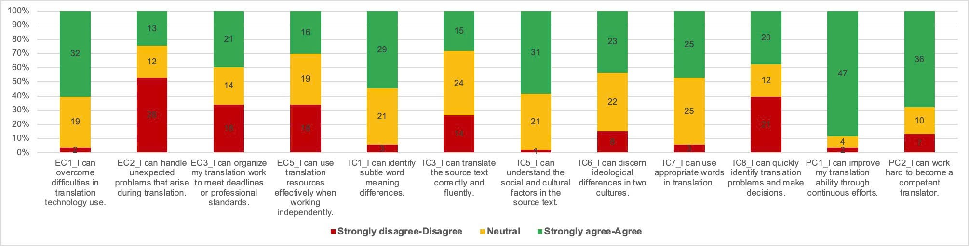
Overall, the results indicate that students reported relatively high levels of translation self-efficacy (TSE), as most responses were concentrated in the “agree” and “strongly agree” categories across items. Higher levels of confidence were particularly evident in items related to translation improvement and self-assessment (PC1, PC2, EC1), where a large majority of respondents selected positive response options. However, confidence was comparatively lower when encountering external challenges (EC2, EC3, EC5) or tasks requiring cognitively demanding skills such as translating source texts correctly and fluently (IC3), as well as identifying and solving translation problems (IC8).
The TSE responses also followed divergent patterns across three ChatGPT usage groups, namely those use ChatGPT in the Pre-Drafting, Drafting and Post-Drafting stages.
Figure 3
Frequency of TSE Responses by ChatGPT Usage Groups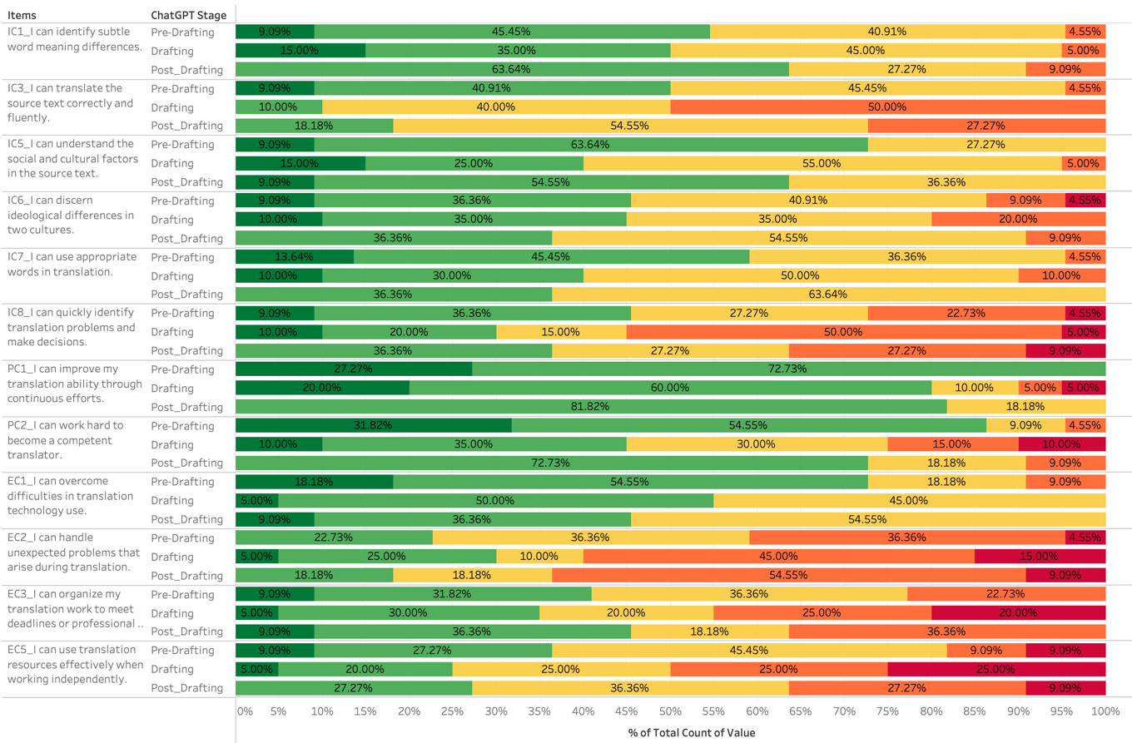
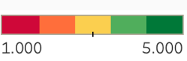
Users of ChatGPT for Pre-Drafting demonstrated the strongest confidence levels. For most items, they consistently exhibit the largest percentages of positive responses and lowest percentages of negative evaluations, whereas Drafting and Post-Drafting users displayed more varied response patterns. Negative responses are limited across ChatGPT usage groups except for some special cases. Specifically, Drafting and Post-Drafting groups’ answers to EC2 (I can handle unexpected problems that arise during translation), Drafting groups’ answers to EC5 (I can use translation resources effectively when working independently), IC3 (I can translate the source text correctly and fluently) and IC8 (I can quickly identify translation problems and make decisions) include a substantial amount of negative choices (more than 50%). More than a third of Post-Drafting participants also reported low confidence in EC3, EC5, and IC8. Nevertheless, in general, positive perceptions dominated across all groups, suggesting that students generally felt capable of performing translation tasks regardless of how they incorporated ChatGPT into their translation process. Their total TSE scores – calculated by adding up scores for 12 items – can be summarized as follows.
Table 5
TSE Scores across ChatGPT Usage Groups
 | ChatGPT_Stage | N | Missing | Mean | Median | SD | Minimum | Maximum
TSE | Pre-Drafting | 22 | 0 | 42.7 | 43.0 | 4.84 | 34 | 53
TSE | Drafting | 20 | 0 | 37.8 | 37.0 | 7.01 | 28 | 54
TSE | Post_Drafting | 11 | 0 | 39.2 | 40 | 2.99 | 35 | 44
Figure 4
TSE Scores Distribution across ChatGPT Usage Groups
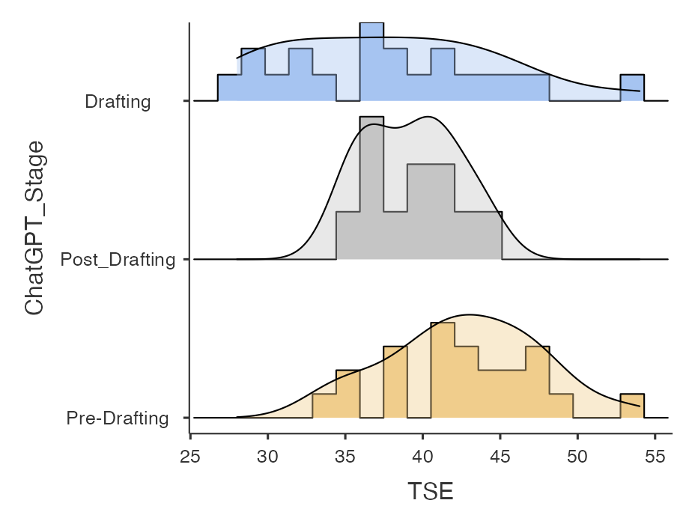
4.2 One-way ANOVA Results
Based on the ChatGPT usage patterns, a one-way analysis of variance (ANOVA) was conducted with the dependent variable being the translating self-efficacy score (TSE) and the independent variable being the 3 groups of ChatGPT usage patterns (Pre-Drafting, Drafting, Post-Drafting). First, Levene’s and Shapiro-Wilk tests were conducted to test the assumption of homogeneity of variance and normality across groups.
Table 6
Assumption Checks
Normality Test (Shapiro-Wilk)
 | W | p
TSE | 0.979 | .462

Homogeneity of Variances Test (Levene's)
 | F | df1 | df2 | p
TSE | 4.14 | 2 | 50 | .022

Shapiro-Wilk were not statistically significant (p = .462 >.05), indicating normally distrubted data. However, Levene’s test is below the .05 threshold, revealing violated homogeneity of variance (p = .022). As a result, Welch’s ANOVA and Games-Howell were used for the data analysis instead of Fisher’s and Tukey’s HSD. The results of the ANOVA analysis are presented in Table 5 below:
Table 7
ANOVA Results for Differences in Translating Self-Efficacy Across ChatGPT Usage Levels
One-Way ANOVA (Welch’s)
 | F | df1 | df2 | p
TSE | 4.60 | 2 | 31.8 | .018

The results showed the statistically significant difference in translating self-efficacy levels between the groups using ChatGPT (p = .018). This suggests that differences in translating self-efficacy levels are associated with different levels of students’ use of ChatGPT.
Table 8
ANOVA Post-hoc Comparison of Translating Self-Efficacy Across ChatGPT Usage Levels
Games-Howell Post-Hoc Test – TSE
 |  | Drafting | Post_Drafting | Pre-Drafting
Drafting | Mean difference | — | -1.38 | -4.88
Drafting | p-value | — | .728 | .036
Post_Drafting | Mean difference |  | — | -3.50
Post_Drafting | p-value |  | — | .042
Pre-Drafting | Mean difference |  |  | —
Pre-Drafting | p-value |  |  | —

Games-Howell post-hoc analysis showed a statistically significant difference in translating self-efficacy between Pre-Drafting and Drafting (p = .036), with students using ChatGPT in the Pre-Drafting phase reporting higher translation self-efficacy. The choices of using of ChatGPT in the Pre-Drafting or the Post-Drafting phases also correlate with the different levels of translating self-efficacy (p = .042). In both cases, students using ChatGPT in Pre-Drafting reported higher level of confidence compared to those employing ChatGPT for the Drafting and Post-Drafting phases. The TSE scores of Drafting and Post-Drafting showed no significant differences (p = .728 > .05).
Further ANOVA tests were run with independent variable being the proficiency and the taken translation courses respectively. Both tests reveal insignificant statistical differences in TSE among these groups. The results are presented as follows.
Table 9
ANOVA Post-hoc Comparison of Translating Self-Efficacy Across Proficiency Levels
Tukey Post-Hoc Test – TSE
 |  | B1 | B2 | C1 | C2
B1 | Mean difference | — | -0.741 | -2.59 | -6.80
B1 | p-value | — | .994 | .796 | .511
B2 | Mean difference |  | — | -1.85 | -6.06
B2 | p-value |  | — | .729 | .514
C1 | Mean difference |  |  | — | -4.21
C1 | p-value |  |  | — | .759
C2 | Mean difference |  |  |  | —
C2 | p-value |  |  |  | —

Table 10
ANOVA Post-hoc Comparison of Translating Self-Efficacy Across Translation Experience (via Translation courses taken)
Tukey Post-Hoc Test – TSE
Taken translation courses that are |  | COMPULSORY | COMPULSORY  & ELECTIVE
COMPULSORY | Mean difference | — | -0.121
COMPULSORY | p-value | — | .947
COMPULSORY_ELECTIVE | Mean difference |  | —
COMPULSORY_ELECTIVE | p-value |  | —

5. Discussion
The findings provide insights into how students use ChatGPT during translation tasks and how different usage patterns relate to translation self-efficacy.
5.1. Students Use ChatGPT to Support Their Translation Skills
From the results presented, the students used ChatGPT at different stages of the translation process. The most common stage that was used is the Pre-Drafting stage, which accounts for 41.54% of the total number of students. At this stage, it is mainly used by the students to gather background knowledge, cultural knowledge, or even unknown words before creating their translations. The use of ChatGPT for Drafting stage was examined in 37.74% of the participants, who employed ChatGPT to produce draft translations and then refined the products through either repeated interaction with the AI tools or on their own. Meanwhile, 20.75% of students mainly used ChatGPT during the polishing, fine-tuning, and proofreading stages, utilizing the tool to check errors and provide feedback after students completed their translations independently. Within this general trend, participants with different proficiency and translation experience demonstrate diverse tendencies in ChatGPT using behavior. Specifically, whie the higher proficiency group mostly use ChatGPT for Pre-Drafting, the lower one rely on the AI tool for Drafting. This is understandable as students with higher English proficiency face less challenges in language use and start focusing on ensuring the accuracy, naturalness and appropriateness in their translation. As a result, they prefer more ChatGPT assistance for gathering background and cultural knowledge before translating texts. ChatGPT utilization of participants with different translation experiences also yields valuable insights. The group with lower translation experience mainly use ChatGPT for Pre-Drafting and Drafting. On the other hand, the higher experience group favor the use of AI support in the Drafting and Post-Drafting. This illustrates the students’ perception of the translator role. While those with fewer experience consider themselves learners and use AI tools to support the process of enriching knowledge and skills, the one taking more translation courses may have familiarized themselves with the translation process and start assigning tasks to their AI assistance.
Unlike previous studies such as Kaiyi (2025) and Dinh (2025), which identified the revision stage as the most common stage of AI use, this study found that students mainly used ChatGPT during the preparation stages. This suggests that students regarded ChatGPT more as a tool for exploring and organizing knowledge than as a complete translation assistant. These differences may be due to differences in students’ backgrounds, language abilities, and learning goals. Overall, the findings reveal ChatGPT’s role as a support tool throughout the translation process rather than a replacement for human translators.
5.2. Levels of Translation Self-Efficacy and Differences among Groups of ChatGPT Usage
The descriptive analysis showed that students’ translation self-efficacy was overall high in all three dimensions: Internal Competence, Psycho-physiological Competence, and External Competence. Among these three competences, students reported higher confidence in Psycho-physiological Competence and lower in External as well as Internal Competence. Based on this information, students had higher confidence in controlling their efforts, persistence, and emotions rather than in their language, decision-making abilities, and external conditions. The low scores for Internal Competence suggest that students still had difficulty analyzing the language, constructing their own meanings, and solving translation problems. Such a conclusion aligns with the results of Dinh's (2025) study, which found that translators experience difficulties when developing their translation strategies and defending their translation choices.
The one-way ANOVA results also revealed a statistically significant difference in translating self-efficacy among groups with different levels of ChatGPT usage (p = .018). Post-hoc analysis showed that this difference was primarily between Pre-Drafting and the other two stages. Students who relied more heavily on ChatGPT for generating translations demonstrated lower confidence in their own translation abilities than students who used the tool more selectively. Additionally, there are no statistically significant differences between students with different English proficiency and translation experience. The findings suggest that proficiency and experience are not significant factors impacting translation self-efficacy, and excessive reliance on AI may reduce opportunities for independent practice and mastery experiences, which Bandura (1997) identified as an important source of self-efficacy development. The results also echo Zhang and Xu’s (2025) paradox of self-efficacy which states leveraging AI can boost students’ confidence but at the same time intensifying their AI reliance. As a result, an appropriate level of AI integration in teaching and learning translation is required to ease the negative impact of the paradox. Overall, the findings indicate that careful and critical use of ChatGPT may support translating self-efficacy, while overdependence on AI tools may weaken students’ confidence in their own translation competence

6. Conclusion
The present study investigated the relationship between the use of ChatGPT and translation self-efficacy among university student translators. Findings from the TSE-C scale (Yang et al., 2021) and one-way ANOVA analysis showed that different levels of ChatGPT use were linked to differences in students’ translating self-efficacy. In general, students who employed ChatGPT strategically and moderately had higher confidence in translation tasks compared to those who heavily relied on AI-generated translations.
The findings also showed that students used ChatGPT in different stages of the translation process. For most participants, they made use of the platform in the Pre-Drafting stage, where they would carry out research about the text, clarify terms, and plan on the best approach to take before embarking on the translation process. The remaining participants resorted to the platform to create translations or for proofreading purposes after creating their own versions. However, different levels of proficiency and translation experience can affect their ChatGPT using behavior.
Regarding translating self-efficacy, students reported moderate levels across the three dimensions of internal competence, psycho-physiological competence, and external competence. Among these, psycho-physiological competence attained the maximum rating because the students felt more competent at putting in effort, persisting, and regulating emotions while undertaking translation. Internal competence, on the other hand, scored the least since the students had problems with linguistic analysis and translation strategy making.
Importantly, the study found significant differences in translating self-efficacy among groups with different ChatGPT usage patterns. The ones who extensively used ChatGPT when translating were less likely to display self-efficacy, while those using the tool moderately, such as for generating ideas and looking up terms, showed more self-confidence. It is possible to infer from the results that moderation in the use of ChatGPT could foster self-efficacy in learners.
The findings also provide several implications for translation education. Teachers should encourage selective and goal-oriented use of ChatGPT rather than allowing students to depend on AI throughout the entire translation process. ChatGPT can be effectively used for brainstorming, terminology clarification, and culture lookup while students remain responsible for the main translation decisions. Universities may also consider providing AI literacy training, including prompt writing, evaluation of AI-generated content, and strategies for revising AI-supported translations. In addition, the study contributes theoretically by combining Borg’s (2018) Five-Phase Translation Model with Rowland’s (2023) Human–AI Continuum to better explain the relationship between AI involvement and learner autonomy in translation tasks.
Despite these contributions, the study has several limitations. First, the sample size was relatively small and limited to students from one university, which may reduce the generalizability of the findings. Additionally, because the study relied on self-reported survey data, participants may have underreported their AI use or overestimated their self-efficacy levels.
Overall, the study suggests that ChatGPT can serve as an effective support tool in translation education when used carefully and critically. However, passive or excessive reliance on AI may weaken students’ confidence and independence in translation tasks. Therefore, maintaining a balance between AI support and human control is important for developing both translation competence and translating self-efficacy in technology-enhanced learning environments.

References
Abdel Latif, M. M., & Alhamad, M. M. (2025). Translation and interpreting self-efficacy: A review of published measures. Frontiers in Psychology, 16. https://doi.org/10.3389/fpsyg.2025.1632366
Bandura, A. (1995). Self-efficacy in Changing Societies. University Press.
Bandura, A. (1997). Self-efficacy: The exercise of control (Vol. 11). Freeman.
Bhati, K., & Sethy, T. (2022). Self-efficacy: Theory to educational practice. The International Journal of Indian Psychology, 10(1), 1123-1128. DOI: 10.25215/1001.112
Bolaños-Medina, A., & Núñez, J. L. (2018). A preliminary scale for assessing translators’ self-efficacy. Across Languages and Cultures, 19(1), 53–78. DOI:10.1556/084.2018.19.1.3
Borg, C. (2018). The phases of the translation process: Are they always three? In Junior College Multi-Disciplinary Conference: Research, Practice and Collaboration—Breaking Barriers (pp. 79–92). University of Malta. https://www.um.edu.mt/library/oar/handle/123456789/38130
Brahmana, C. R., Sofyan, R., & Mono, U. (2025). Evaluating the strengths and limitations of CHATGPT-generated translations in academic post-editing workflows. Language Literacy: Journal of Linguistics, Literature, and Language Teaching, 9(1), 135–151. https://doi.org/10.30743/ll.v9i1.10551
Brown, Tom & Mann, Benjamin & Ryder, Nick & Subbiah, Melanie & Kaplan, Jared & Dhariwal, Prafulla & Neelakantan, Arvind & Shyam, Pranav & Sastry, Girish & Askell, Amanda & Agarwal, Sandhini & Herbert-Voss, Ariel & Krueger, Gretchen & Henighan, Tom & Child, Rewon & Ramesh, Aditya & Ziegler, Daniel & Wu, Jeffrey & Winter, Clemens & Amodei, Dario. (2020). Language Models are Few-Shot Learners. https://doi.org/10.48550/arXiv.2005.14165
Dinh, C. T. (2025). EFL students’ perspectives on chatgpt in translation: Exploring AI assistance, motivation, and learning outcomes. Electronic Journal of E-Learning, 23(2), 99–116. https://doi.org/10.34190/ejel.23.2.4006
Kaiyi, D. (2025). Research on post-editing strategies for Chinese-english translation based on Chatgpt. Lecture Notes on Language and Literature, 8(4). https://doi.org/10.23977/langl.2025.080419
Konttinen, K. (2021). A self-efficacy scale for measuring student progress in Translation Company simulations. Across Languages and Cultures, 22(1), 64–81. https://doi.org/10.1556/084.2021.00004
Liu, C., & Yu, C. (2019). Understanding students’ motivation in translation learning: A case study from the self-concept perspective. Asian-Pacific Journal of Second and Foreign Language Education, 4(1). https://doi.org/10.1186/s40862-019-0066-6
Ma, Y. (2024). The impacts and challenges of CHATGPT on translation teaching in universities. Journal of Education, Humanities and Social Sciences, 38, 155–161. https://doi.org/10.54097/fjp9tb72
Mossop, B. (2000). The workplace procedures of professional translators. In A. Chesterman, N. Gallardo San Salvador, & Y. Gambier (Eds.), Translation in context: Selected papers from the EST Congress, Granada 1998 (pp. 39–48). John Benjamins. https://doi.org/10.1075/btl.39.07mos
Ngo, T.T.A. (2023) The Perception by University Students of the Use of ChatGPT in Education. International Journal of Emerging Technologies in Learning (iJET), 18, 4-19. https://doi.org/10.3991/ijet.v18i17.39019
Nguyen, H. (2024). Integrating ChatGPT in Translation Learning.In Annual SEAAIR Conference Proceedings, 4, 602-611. https://www.researchgate.net/publication/391425619_Integrating_ChatGPT_in_Translation_Learning
Nguyen, T. N. N., Tran, T. T., Nguyen, N. H. A., Lam, H. P., Nguyen, H. M. S., & Tran, N. A. T. (2025). The benefits and challenges of AI translation tools in translation education at the tertiary level: A systematic review. International Journal of TESOL & Education, 5(2), 132–148. https://doi.org/10.54855/ijte.25527.
OpenAI (2023). ChatGPT (Mar 14 Version) [Large Language Model]. https://chat.openai.com/chat
Pym, A. (2014). Translation skill-sets in a machine-translation age. Meta, 58(3), 487–503. https://doi.org/10.7202/1025047ar
Rowland, D. R. (2023). A conceptual framework for discussing the human-AI writing continuum. ResearchGate. https://doi.org/10.13140/RG.2.2.36445.59361
Stansfield, C. W., Scott, M. L., & Kenyon, D. M. (1992). The measurement of translation ability. The Modern Language Journal, 76(4), 455. https://www.researchgate.net/publication/263588437_The_Measurement_of_Translation_Ability
Wang, L., Lyu, C., Ji, T., Zhang, Z., Yu, D., Shi, S., & Tu, Z. (2023). Document-level machine translation with large language models. In H. Bouamor, J. Pino, & K. Bali (Eds.), Proceedings of the 2023 Conference on Empirical Methods in Natural Language Processing (pp. 16646–16661). Association for Computational Linguistics. https://doi.org/10.18653/v1/2023.emnlp-main.1036
Worthington, R. L., & Whittaker, T. A. (2006). Scale Development Research: A Content Analysis and Recommendations for Best Practices. The Counseling Psychologist, 34(6), 806–838. DOI: 10.1177/0011000006288127
Yang, C., Chen, J., Hou, S., Wider, W., & Yi, W. L. (2025). How AI Benefits Student Translators: An Exploratory Study on the Impact of ChatGPT Feedback on Translation Proficiency. Forum for Linguistic Studies, 7(10), 526–541. https://doi.org/10.30564/fls.v7i10.11080
Yang, Y., Cao, X., & Huo, X. (2021). The Psychometric Properties of Translating Self-Efficacy Belief: Perspectives from Chinese learners of translation. Frontiers in Psychology, 12. https://doi.org/10.3389/fpsyg.2021.642566
Yuan, Y., Wu, J., & Wu, Y. (2024). The influence of translation majors’ self-efficacy on their interpreting ability and coping strategies under the guidance of gile’s model. Advances in Social Science, Education and Humanities Research, 420–435. https://share.google/vHPJvKMBBZxPtdnyF
Zhang, L., & Xu, J. (2025). The paradox of self-efficacy and technological dependence: Unraveling generative AI’s impact on University Students’ task completion. The Internet and Higher Education, 65, 100978. https://doi.org/10.1016/j.iheduc.2024.100978

Bionote
Quan Ngo is a fresh graduate from the School of Languages, International University, Vietnam National University HCMC. Her research interest is the integration of AI in translation and English teaching.
Email: ngophamtuongquan@gmail.com
Chau Nguyen is a lecturer in the School of Languages, International University, Vietnam National University HCMC. She has been teaching Intensive and Academic English courses for more than 10 years. Her current research interest includes educational technology and TESOL methodology.
Email: ntnchau@hcmiu.edu.vn

