Students’ Perceptions of Google Meet in ESL-Oriented Online Cambridge Exam Preparation at Private Language Centers in Ho Chi Minh City
Ngô Thị Thu Hiền
Abstract
As digital technology rapidly advances, online learning of English has become a new trend in numerous teaching environments. The purpose of this study is to examine how learners view ESL-focused online English learning using Google Meet in private classes of Cambridge exam preparation in Ho Chi Minh City. The study employed a mixed-method approach involving 35 KET and PET level students, utilizing semi-structured interviews and a Likert scale questionnaire analyzed through SPSS. Results indicated a positive perception of the online learning environment, with students appreciating communication with instructors and peers, and effectively using English. Google Meet features like screen sharing and chat were noted as beneficial for understanding and engagement. Limitations included a small sample size, suggesting future research should involve larger and more diverse groups to further explore digital technologies in online ESL learning.
Keywords: ICT, online ESL learning, Google Meet, digital tools
- Introduction
In Vietnam, English as a foreign language (EFL) has always been taught with the classroom practices focusing more on grammar knowledge and test results than the application of meaningful use of language (Ha et al., 2021). Nevertheless, the growing academic, professional and international requirements towards the English language have contributed to the rising voices in favor of a change into an English as a Second Language (ESL) orientation, which is more communication-oriented, inter-personal and life-based in language use (Hsu, 2015). This shift has emerged as one of the main topics of recent debate about the English language education in Vietnam.
Meanwhile, online learning is now an element of the English language teaching, especially after the Covid-19 pandemic (Rintaningrum, 2023). Synchronous learning has also opened up new possibilities in interaction, sharing and exposure to the English language outside the classroom setting due to digital platforms (Procel et al., 2024). Google Meet is one of these platforms, as its availability, convenience, and integration with other computer technologies that facilitate online learning have become very popular (Ironsi, 2022).
The effectiveness of online applications in enhancing language skills and learning outcomes of students has been investigated in many studies such as studies by Luzyawati et al. (2024), and Popovici and Mironov (2015). Nevertheless, minimal studies have been conducted on the perceptions of ESL-based online teaching of English among learners in Vietnam in private classes of exam preparation in Cambridge English. The majority of past research is inclined to consider the general online learning settings or university setting instead of domestic language classes that prepare students to pass international English exams.
Moreover, there are numerous tools offered by digital platforms like Google Meet that can support the interaction, communication, and engagement of online synchronous lessons (Eraković & Topalov, 2021). These tools could be successful in establishing an ESL-friendly learning atmosphere in which students are motivated to learn English actively during classroom practices. Nevertheless, the success of these tools is highly reliant on the perceptions and experiences of students of online learning.
The following research questions are addressed in the study:
RQ1: How do students perceive ESL-oriented online English learning through Google Meet in private classes of Cambridge exam preparation in Ho Chi Minh City?
RQ2: What is the perception of learners regarding digital tools utilization on Google Meet as an assistant to the processes of interaction, engagement, and communication in English concerning online ESL-oriented courses?
- Literature Review
2.1 Information and Communication Technology (ICT) and development of e-learning
According to AlTameemy and Alrefaee (2021), ICT is becoming an increasingly important component of our daily lives, as it is a natural consequence of the significant advancements in modern technology. Adaptive e-learning is viewed as stimulation to support learning and improve student engagement, so designing appropriate adaptive e-learning environments contributes to personalizing instruction to reinforce learning outcomes (El-Sabagh, 2021). Fee (2012) considered e-learning as “any learning that involves using internet or intranet”. According to Abou El-Seoud et al. (2014), E-learning has become increasingly important as a result of advancements in technology, significantly transforming higher education. The 21st century has witnessed rapid development in online learning, with enrolment increasing by 12-14 percent annually from 2004 to 2009. This growth is largely attributed to the flexibility e-learning offers, allowing students to access education from anywhere and at any time, with options for part-time or full-time study. Additionally, e-learning facilitates easier information sharing among students, enhancing educational experience.
2.2 EFL and ESL in English Language Education
According to Gilquin and Granger (2011), English language teaching has been long conceptualized in the context of the difference between English as Foreign Language (EFL) and English as Second Language (ESL). According to the research by Longcope (2009), ESL and EFL are differentiated by the context of learning and the level of language interaction. In an ESL setting, English exposure is more frequent and varied than in an EFL setting. More significantly, ESL offers greater chances of negotiating the meaning, as learners frequently request clarification and are presented with altered input by interlocutors. The frequency of adjustment and reformulation of the output is also promoted among ESL learners, which allows them to identify and address language issues. Sato and Storch (2022) explained that the difference between ESL and EFL settings is determined by learners' needs and purposes. On the cognitive and structural level, an ESL context facilitates language learning by offering more quality, quantity, and diversity of language input and multiple opportunities for use of the target language in both the classroom and out. Thus, ESL provides more productive conditions for acquiring a second language, compared to EFL.
  - Digital Tools and Synchronous Online English Learning
The quick growth of online education has revolutionized the education of English language, especially by adopting the synchronous digital platform (Moorhouse & Wong, 2022). Real-time communication between teachers and learners is possible with help of synchronous online learning environments providing an opportunity to use communicative language, to provide instant feedback and collaborate with teachers and other learners. A study by Radovan et al. (2020) integrates our experiences and comparative analysis of using different tools for online education during times where the usual teaching methods are not an option because of various restrictions related to travel bans, quarantines or virus pandemics. The tools being analyzed are Skype, Microsoft Teams, Adobe Connect and Zoom. Several aspects are analyzed including starting courses and creating groups of students, enrolling students to the class, delivering the lecture, communicating with the students during the class, getting feedback from the students in a virtual class, tracking student activity, creating live polls and questionnaires, sharing content, recoding audio and video content, submitting assignments and homework and accessing the archived content. Each explored aspect has a direct influence on the whole teaching and learning experience as well as the effectiveness of supporting the educational processes.
Google Meet is one of those that have gained popularity as a widely used platform because of its accessibility, ease of use and compatibility with other Google based applications (Al-Maroof et al., 2021). These characteristics enable educators to create engaging online courses that facilitate ESL-oriented practices even during exam preparation. Besides, the Google Meet platform is widely utilized for video conferencing in online learning, facilitating audiovisual communication between teachers and students in both small and large groups (Nehe, 2021). It offers various features that enhance online learning by allowing teachers to present materials and encourage interactive discussions (Purwoko et al., 2022). According to Yumnam (2021), Google Meet is accessible video conferencing platform suitable for both business meetings and online classes. These services allow users to log in via various devices. They facilitate live interaction between teachers and students, enabling the sharing of presentations and multimedia resources. In ESL classes, teachers can cover essential language skills using PowerPoint and interactive methods (Zahara & Jupri, 2022), while students can practice concepts through direct engagement with instructors, as illustrated in Mesquita et al. (2015), when students are given the opportunity to practice the skills being learnt in real time, and then are provided with scaffolding from their teacher that is empathetic and immediate, they move from being passive recipients to active problem solvers.
2.4 Related Studies
Solihah (2023) discovered that Google Meet was an effective tool that facilitated online learning in a TOEFL preparation course by making the interaction between students and the lecturer real-time, boosting comprehension and motivation. The study by Pham and Hanh (2023) shows that university students in Vietnam positively perceived the use of Google tools—Google Classroom, Google Forms, Google Meet, and Google Sites—for learning English. These tools enhanced their educational experience and improved their progress in English, highlighting the effectiveness of Google products in language instruction and suggesting avenues for further research in online English education technologies. The research by Yumnam (2021) established that e-learning is an efficient means of teaching ESL since it helps improve language of students, boosts their interaction and offers them flexibility in learning, but proper technological support and planning are needed to implement it effectually.
- Methodology
3.1 Research Design
In order to obtain data to conduct this mixed-method study, a questionnaire and semi-structured interviews were used. The questionnaire itself was a set of Likert-scale items created with the help of Cognito Forms with 1-5 inherent to the statement of Strongly Disagree and Strongly Agree respectively. The questionnaire employed in the current study was adapted modified from Delviyanti et al. (2022) for the context of online Cambridge exam preparation classes. The method of questionnaire was chosen because it made it possible to gather systematized information about the opinions of the learners concerning the use of language, interaction, engagement, and the contribution of digital tools into the online learning settings. The research aimed at the description of the perceptions of the learners, not quantifying the learning results or causal relationships. Furthermore, semi-structured interviews were carried out with some volunteer students to gain deeper insights into their perception of online learning of the English language through Google Meet. The interviews were held with the help of Google Meet video calls and took about 25 minutes.
3.2 Participants
The respondents used in this research were 35 students who are taking privately online classes in Cambridge English examination preparation in Ho Chi Minh City in Vietnam. The learners were KET and PET level. Everyone possesses a minimum of 1 year’s experience in utilizing Google Meet for learning purposes. The two levels of proficiency were chosen because the learners were deemed as mature and linguistically competent enough to appreciate the questionnaire items and give credible self-reported answers.
KET and PET learners were generally capable of sufficient reading comprehension and had previous exposure to online learning in English, which allowed them to reflect on the learning experience and attitudes towards ESL-oriented online learning. Younger learners in lower levels of Cambridge were, on the contrary, excluded because of age factors such as cognitive and linguistic constraints that could have compromised the validity of the questionnaire answers.
3.3 Data Collection Procedures
The questionnaire was conducted via Cognito Forms after the students had received ESL-focused English lesson via Google Meet. The participants had one week to answer the questionnaire, guaranteeing time for thoughtful consideration. The questionnaire was administered as an online survey, and students filled it out on their own in preparation time. All responses were received within the allotted seven-day time frame.
Following this step, five students were invited to take part in an online semi- structured interview through Google Meet. The interview took almost 25 minutes. The interviews were conducted and then transcribed and coded thematic interview protocols.
3.4 Data analysis
Data obtained from the questionnaires was analyzed in SPSS Version 26 (Statistical Package for the Social Sciences). All responses were screened for completeness and correct answers before analysis. Descriptive statistical analyses were to summarize the learners’ perceptions, Mean, standard deviation and percentage. The interview data included content analysis, a process that involves collecting and interpreting data based on related concepts and topics. Quantitative data can be dealt with statistical analysis to help explain the patterns and frequency of the issue, while qualitative data from interviews provide profound insights.
3.5 Reliability
The Statistical Package for the Social Sciences (SPSS) version 26 was used to determine the Cronbach alpha in order to make sure that the questionnaire was reliable. The scores revealed that the constructs had acceptable reliability with alpha ranging between 0.879 and 0.912 (see Table 1). This indicates that the questionnaire questions were internally reliable and could be analyzed further.
Table 1
Reliability of the questionnaire and constructs
Constructs | N of items | Cronbach’s Alpha value
Google Meet and Digital Tools | 5 | 0.879
ESL-Oriented Language Use | 5 | 0.891
Teaching Practices and Communication | 5 | 0.897
Engagement and Overall Perception | 5 | 0.907
Total | 20 | 0.963

- Findings
4.1 Findings from questionnaire
4.1.1 Google Meet and Digital Tools
The results shown in Figure 1 indicate that the perceptions of the students about learning English through Google Meet were very positive. There was a high percentage of students who said that they were at ease learning on the platform with 45.71% responding in the affirmative, and 40 percent strongly affirming this statement (M=4.20, S.D.=0.868). Regarding contact with the teacher, 28.57 and 57.14 percent agreed and strongly agreed that they could easily interact with the teacher during online lessons (M=4.37, S.D.=0.910). Likewise, when it comes to communication with classmates, 28.57% agreed and 40% communicate effectively in online classes (M=3.94, S.D.=1.136). Utilization of digital tools also received a positive response with 37.14 percent of the respondents agreeing to the tool and 45.71 percent strongly agreeing that the tool assisted them to understand the lesson better (M=4.23, S.D.=0.910). In addition, 40% and 45.71% responded that the lessons were more interactive with the help of digital tools and strongly agree, respectively (M=4.23, S.D.=0.942). Altogether, the agreement rates are quite high, which proves that Google Meet and its online resources are effective to support the learning of English online among students.
Figure 1
Google Meet and Digital Tools

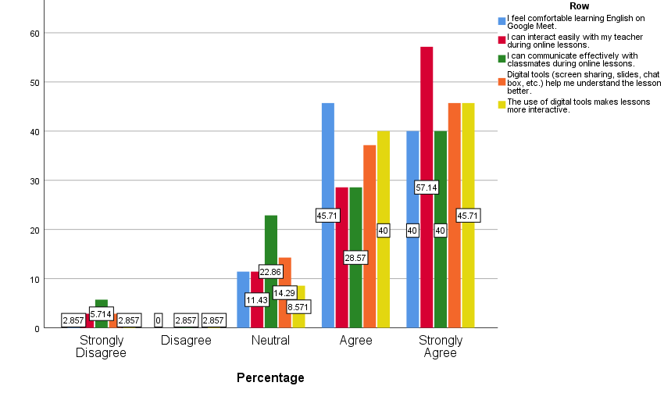

4.1.2 ESL-Oriented Language Use
Figure 2.
ESL-Oriented Language Use

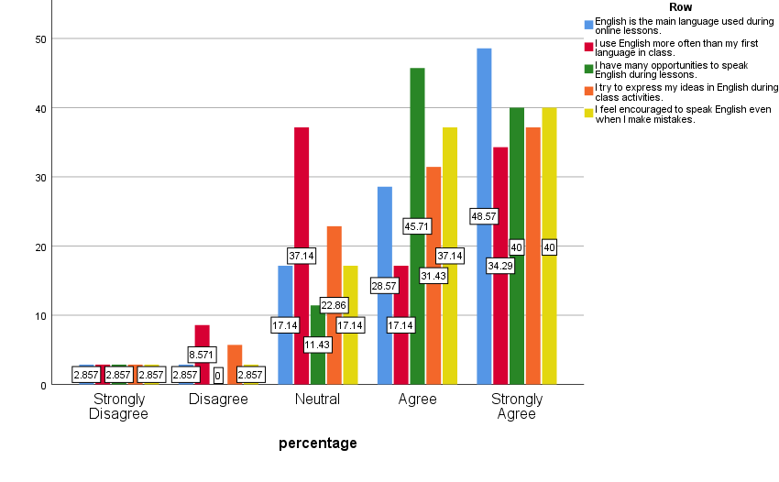
There are also positive results when it comes to the use of English by students during online lessons. Many students also stated that English was the primary language spoken in the classroom with 28.57 percent of students agreeing with this and 48.57 percent strongly agreeing (M=4.17, S.D.=1.014). In the same way, 17.14% answered in the affirmative and 34.29% answered strongly in the affirmative that they more frequently used English than their first language in classes (M=3.71, S.D.=1.126). Concerning speaking opportunities, 45.71% had agreed and 40% strongly agreed that they had numerous opportunities to speak English online classes (M=4.2, S.D.=0.868). Besides, 31.43% of them agreed and 37.14% strongly agreed that they attempted to demonstrate their ideas in English when doing class tasks (M=3.94, S.D.=1.056). Lastly 37.14 percent said yes, and 40 percent said strongly that they were encouraged to talk English even when they made a mistake (M=4.09, S.D.=0.981). All in all, the percentages of agreement are high, which implies that the online learning environment facilitated active use of English among students in classes.
4.1.3 Teaching Practices and Communication
Figure 3.
Teaching Practices and Communication

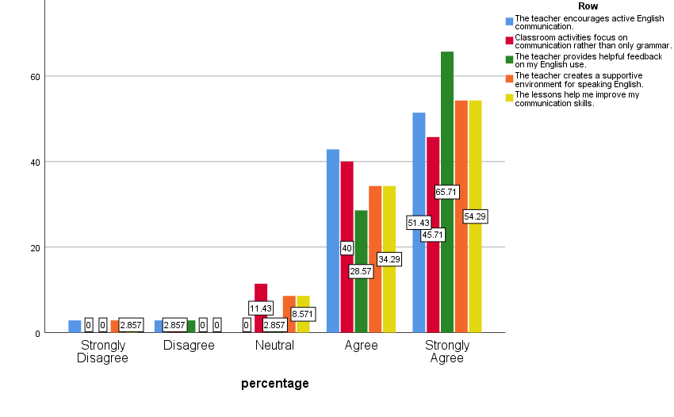
The findings also reveal favorable attitudes of instructional activities in the online English lesson. Most of the students indicated that the teacher supported active communication in English as 42.86% and 51.43% students were of the view that it was true and strongly true respectively (M=4.37, S.D.=0.877). On the same note, 40 percent of them said that they agree, and 45.71 percent strongly agreed that classroom practices centered on communication as opposed to grammar (M=4.29, S.D.=0.789). As far as feedback is concerned, 28.57% of the respondents had to agree and 65.71% strongly agreed that the teacher gave them useful feedback on how they used English (M=4.57, S.D.=0.698). Moreover, 34.29% said that the teacher provided a favorable environment to speak English and 54.29% said strongly (M=4.37, S.D.=0.877). Lastly, 34.29% concurred with the statement that the lessons assisted them in improving their communication skills and 54.29% strongly concurred with the statement (M=4.37, S.D.=0.877). In general, these results indicate that the instructional method was effective in helping students in the online classroom to develop in the communicative language.
4.1.4 Engagement and Overall Perception
Figure 4.
Engagement and Overall Perception

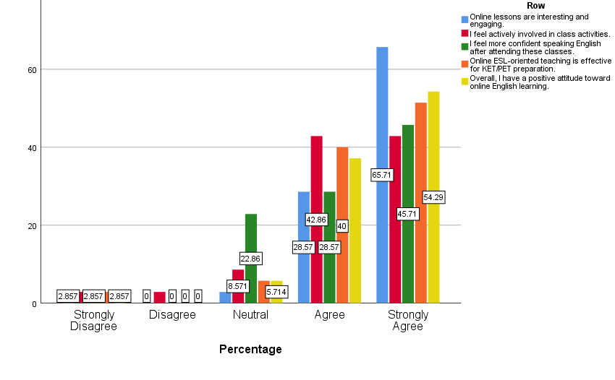
The findings also indicate good attitudes to online learning of English among the students as well as high engagement and effectiveness. Most students said that they found online lessons interesting and engaging with 28.57% agreeing and 65.71% strongly agreeing (M=4.54, S.D.=0.817). Likewise, 42.86% of them agreed and 45.71% strongly agreed that they were actively engaged in the activities in classes (M=4.20, S.D.=0.933). Regarding the aspect of speaking confidence, 28.57 percent answered that they agreed, and 45.71 percent strongly agreed that they felt much more confident speaking English after taking these classes (M=4.14, S.D.=0.974). Besides, 40 percent and 51.43 percent consented and strongly consented to the ESL-oriented teaching approach as effective in the preparation of KET/PET (M=4.37, S.D.=0.843). Lastly, 37.14% chose yes and 54.29% chose strongly yes that they had an overall positive attitude toward online learning of English (M=4.40, S.D.=0.847). Generally, the large percentages of agreement indicate that the online classes were effective in fostering engagement of the students, their confidence, and positive attitudes towards learning.
4.2 Findings from interviews
The thematic analysis was the method used to analyze qualitative data gained during semi-structured interviews. The responses of the students elicited two key themes: positive attitudes towards the online learning of English and supportive functions of digital tools in the online interaction and communication.
4.2.1 Positive attitudes towards the online learning of English
Majority of students indicated that they felt good about learning English via Google Meet. They added that online education was convenient as they could learn at home and at the same time communicate with their instructors and peers. Other students also said that they were comfortable attending online classes and working on speaking exercises. The opinions of some students are as follows:
“I think learning English on Google Meet is very convenient. I can study at home and still talk with my teacher and classmates.” (S1)
“I like learning English on Google Meet because the teacher explains clearly and I can see the slides easily.” (S2)
“For me, learning online is interesting. We can practice speaking and answering questions in class. (S3)
“I think Google Meet helps me feel comfortable when learning English. I am not afraid to speak in class.” (S4)
“I enjoy my online English class because the teacher gives many activities and we can practice English together.” (S5)
4.2.2 Supportive functions of digital tools in the online interaction and communication
Digital tools and the interaction and understanding process. Another aspect is that students emphasized the significance of digital tools applied in online lessons. The use of screen sharing, slides, and the chat box feature enabled the students to have a better comprehension of the lesson and engage in classroom activities. Some of the students said that these tools made the lessons more interesting and made them feel more comfortable speaking English. Indicatively, a student said, “The teacher shares slides on the screen, so I can understand the lesson better” (S1). “When the teacher shows pictures and exercises on the screen, it helps me practice English more easily” (S3). “The chat box helps me answer questions and ask the teacher when I do not understand.” (S2). Likewise, another student observed that Digital tools make it more entertaining, and I feel more engaged in the classroom “Digital tools make the lesson more interesting, and I feel more active in class” (S4). Lastly, there was also more confidence in communication “I think the tools help me speak and answer questions in English more confidently.” (S5).
In general, the interview findings indicated that students gave positive ratings on the perception of online English learning via Google Meet and thought that the digital tools were significant in facilitating interaction, engagement, and communication in online ESL-oriented courses.
- Discussion
This study was aimed at exploring how ESL-oriented online English teaching by using Google Meet is perceived by learners in private classes on Cambridge exam preparation in Ho Chi Minh City. Moreover, the research examined the perceptions of students towards the use of digital tools on Google Meet to facilitate interaction, engagement, and communication during online classes.
RQ1: How do students perceive ESL-oriented online English learning through Google meet in private classes of Cambridge exam preparation in Ho Chi Minh City?
Concerning the general perceptions of online ESL-based learning among the students, the results showed that most of the students had positive perceptions about learning English using Google meet, with 45.71% feeling comfortable using the platform. They actively engaged with teachers and peers and positively viewed the digital tools' role in enhancing comprehension. Approximately 48.57% reported that English was used frequently in class, and many felt encouraged to communicate despite errors. Students expressed favorable attitudes towards instructional activities, appreciating teacher support and feedback effectiveness. Engagement levels were high, with 65.71% finding online lessons engaging and 45.71% feeling more confident in their English-speaking abilities after classes. These findings were further supported by the interview data, in which students reported that learning through Google Meet was convenient and allowed them to communicate effectively. These findings are in line with the earlier studies by Yumnam (2021) and Purwoko et al. (2022) that have indicated that online learning environment can be used successfully as a means of facilitating communication and interaction in language learning settings.
RQ2: What is the perception of learners regarding digital tools utilization on Google Meet as an assistant to the processes of interaction, engagement, and communication in English concerning online ESL-oriented courses?
The results indicated that digital tools are very crucial in improving the learning experience of students. According to the questionnaire results, most students (around 82 percent) found the use of such tools as screen sharing, slides, and chat functions to be helpful in enhancing their understanding and engagement. This was supported by the answers of the interviews where the students said that these tools made lessons engaging, allowed them to follow the material easier and became more confident with their use of English. The results are consistent with the existing studies such as the study by Solihah (2023), suggesting that online learning can be supported using digital tools that can help to improve the engagement of learners, their interaction, and communication.
In general, the findings of the current paper indicate that a successful online learning experience can be achieved through the combination of communicative teaching methods and digital tools when using such a platform as Google Meet. This kind of environment may motivate students to use English actively, communicate with their teacher and colleagues, and attend online ESL-oriented classes with greater confidence.
- Conclusion and Implications
The research examined the perceptions of students regarding ESL-based online teaching of English via Google Meet during the private classes in preparation of Cambridge exams in Ho Chi Minh City. The findings indicated that most of the students were positive about the online learning environment. Students said that they could communicate with their teacher and classmates, speak English in the classroom and feel encouraged to express their ideas. Moreover, online technologies like screensharing, slides, and chat applications assisted students in learning lessons more effectively and provided more interaction in a classroom. All in all, the results indicate that the application of Google Meet along with communicative teaching and digital tools could be effective as an effort to support the process of interaction, engagement, and communication in online ESL classes.
First, the sample size was not very large, consisting of 35 students of the private classes to prepare to Cambridge exams in Ho Chi Minh City, which might affect the generalization of the results. Second, the study involved questionnaires and interviews, but there were only a few participants in interviews, which means that the qualitative data might not be comprehensive and reflect the results of all students. Lastly, the research could not include any learners other than KET and PET; hence, the results are not necessarily applicable to learners with different proficiency levels.
On pedagogical level, educators are advised to develop communicative lessons and competently use digital technology to improve interaction and engage students in online learning. The following studies might include larger samples, learners of varying proficiency, and other types of data collection aimed at further investigation of the influence of online technologies on language learning of students.

References
Abou El-Seoud, M. S., Taj-Eddin, I. A., Seddiek, N., El-Khouly, M. M., & Nosseir, A. (2014). E-learning and students' motivation: A research study on the effect of e-learning on higher education. International Journal of Emerging Technologies in Learning (Online), 9(4), 20.
Al-Maroof, R. S., Alshurideh, M. T., Salloum, S. A., Mohammad AlHamad, A. Q., & Gaber, T. (2021). Acceptance of Google Meet during the spread of coronavirus by Arab university students. Informatics, 8(2). https://doi.org/10.3390/informatics8020024
AlTameemy, F. A., & Alrefaee, Y. (2021). Impact of covid-19 on English language teaching in Yemen: Challenges and opportunities. TESOL International Journal, 16, 238-252.
Delviyanti, M., Ismiyati, Y., & Dinata, R. P. (2022). Students’ perception of English studies uses the Google Meet application at the tenth grade of Senior High School Number 3 Jambi City. JELT: Journal of English Language Teaching, 6(1), 73-79.
El-Sabagh, H. A. (2021). Adaptive e-learning environment based on learning styles and its impact on development students' engagement. International Journal of Educational Technology in Higher Education, 18(1), 53. https://doi.org/10.1186/s41239-021-00289-4
Eraković, B. R., & Topalov, J. P. (2021). Teaching and learning through Moodle, Google Doc and Zoom: Fostering student engagement in (a) synchronous learning environments. Inovacije u nastavi-časopis za savremenu nastavu, 34(4), 122-136. https://doi.org/10.5937/inovacije2104122E
Fee, K. (2012). Delivering e-learning. A complete strategy for design, application and assessment. Development and Learning in Organizations: An International Journal, 27(1). https://doi.org/10.1108/dlo.2013.08127aaa.013
Gilquin, G., & Granger, S. (2011). From EFL to ESL: Evidence from the International Corpus of Learner English
Ha, V. X., Tran, N. G., & Tran, N. H. (2021). Teachers' beliefs and practices regarding assessment in English as a Foreign Language classrooms in Vietnam. The Qualitative Report, 26(11), 3457-3475. Article 8. https://doi.org/10.46743/2160-3715/2021.5063
Hsu, W. (2015). Transitioning to a communication-oriented pedagogy: Taiwanese university freshmen's views on class participation. System, 49, 61-72. https://doi.org/10.1016/j.system.2014.12.002
Ironsi, C. S. (2022). Google Meet as a synchronous language learning tool for emergency online distant learning during the COVID-19 pandemic: Perceptions of language instructors and preservice teachers. Journal of Applied Research in Higher Education, 14(2), 640-659. https://doi.org/10.1108/JARHE-04-2020-0085
Longcope, P. (2009). Differences between the EFL and the ESL language learning contexts. Studies in Language and Culture, 30(2), 203-320.
Luzyawati, L., Rosyad, A. M., & Lissa. (2024, January). Students’ perception concerning e-learning based on moodle platform: A study of learning outcome. In AIP Conference Proceedings, 2982 (1). https://doi.org/10.1063/5.0185392
Mesquita, I., Coutinho, P., De Martin-Silva, L., Parente, B., Faria, M., & Afonso, J. (2015). The value of indirect teaching strategies in enhancing student-coaches’ learning engagement. Journal of sports science & medicine, 14(3), 657.
Moorhouse, B. L., & Wong, K. M. (2022). Blending asynchronous and synchronous digital technologies and instructional approaches to facilitate remote learning. Journal of Computers in Education, 9(1), 51-70. https://doi.org/10.1007/s40692-021-00195-8
Nehe, B. M. (2021). Students’ perception on Google Meet video conferencing platform during English speaking class in pandemic era. English Review: Journal of English Education, 10(1), pp. 93-104. https://doi: https://doi.org/10.25134/erjee.v10i1.5359
Pham, D. T., & Hanh, N. T. H. (2023). University students’ perceptions of Google tools in learning English courses online. International Journal of Emerging Technologies in Learning (Online), 18(13), 45. https://doi.org/10.3991/ijet.v18i13.39857
Popovici, A., & Mironov, C. (2015). Students’ perception on using eLearning technologies. Procedia-social and behavioral sciences, 180, 1514-1519. https://doi.org/10.1016/j.sbspro.2015.02.300
Procel, G. J. O., Medina, M. L. F., Sotomayor, D. J., & Sanchez, M. A. (2024). Using technology in English teaching. Journal of Environmental Research and Public Health, 17(9), 9. https://doi.org/10.37811/cli_w1048
Purwoko, R. Y., Primartadi, A., Efendi, Y., & Amin, T. (2022). The online learning creativity using the Google Meet platform in vocational high schools. Tarbawi: Jurnal Ilmu Pendidikan, 18(2), 111-121. https://doi.org/10.32939/tarbawi.v18i1.1313
Radovan, A., Mihaljević, B., & Žagar, M. (2020). Experiences related to using online communication tools for distance learning. In EDULEARN20 Proceedings, 8386-8389. https://doi.org/ 10.21125/edulearn.2020.2063
Rintaningrum, R. (2023). Technology integration in English language teaching and learning: Benefits and challenges. Cogent Education, 10(1). https://doi.org/10.1080/2331186X.2022.2164690
Sato, M., & Storch, N. (2022). Context matters: Learner beliefs and interactional behaviors in an EFL vs. ESL context. Language Teaching Research, 26(5), 919-942.
Solihah, Y. (2023). Students’ perception on the online learning through Google Meet and Youtube channel during pandemic situation. SALEE: Study of Applied Linguistics and English Education, 4(1), 171-184. https://doi.org/10.35961/salee.v4i1.609
Yumnam, R. (2021). E-learning: an effective mode of teaching English as a second language. Journal of Translation and Language Studies, 2(2), 1–9. https://doi.org/10.48185/jtls.v2i2.275
Zahara, M. A., & Jupri, A. R. (2022). The effect of Microsoft PowerPoint interactive learning media application on reading comprehension skills of 3rd grade elementary school students for Indonesian language subjects. Jurnal Paedagogy, 9(3), 532-539. https://doi.org/10.33394/jp.v9i3.5383

Bionote
Ngo Thi Thu Hien is a master’s graduate in English Language from HUFLIT - Ho Chi Minh City University of Foreign Languages and Information Technology. She is now teaching online from home, including the Cambridge English program. She helps students build language competence and prepare for exams. She has also delivered a conference paper, advancing research in English language teaching methods. Her research includes language teaching, motivation, and classroom techniques.

Appendix A
Questionnaire (English Version)
Learners’ Perceptions of ESL-Oriented Online English Teaching via Google Meet: A Questionnaire-Based Study in Private Cambridge Exam Preparation Classes in Ho Chi Minh City
Hi everyone!
I am researching the Learners’ Perceptions of ESL-Oriented Online English Teaching via Google Meet in Private Cambridge Exam Preparation Classes in Ho Chi Minh City. The findings can offer some information about the potential of using digital tools on Google Meet to help students feel confident and communicate within online ESL learning spaces, so I appreciate your collaboration. Thank you so much!
Part 1: Demographics
Please answer the following question for your personal information
1. Gender:
Male
Female
N/A
2. Age:
6-8
9-10
Over 10
3. How many years have you been learning English?
Less than 3 years
3-4 years
4-5 years
Over 5 years
4. How long have you been learning English online??
1 year
2-3 years
More than 3 years
Part 2: Learners’ Perceptions of ESL-Oriented Online English Teaching via Google Meet
Please choose the appropriate number
1= Strong Disagree
2= Disagree
3= Neutral
4= Agree
5= Strong agree
 |  | 1 |  | 2 | 3 | 4 | 5
Google Meet & Digital Tools
I feel comfortable learning English on Google Meet.
I can interact easily with my teacher during online lessons.
I can communicate effectively with classmates during online lessons.
Digital tools (screen sharing, slides, chat box, etc.) help me understand the lesson better.
The use of digital tools makes lessons more interactive.
 | 1 |  | 2 |  | 3 | 4 | 5
ESL-Oriented Language Use
English is the main language used during online lessons.
I use English more often than my first language in class.
I have many opportunities to speak English during lessons.
I try to express my ideas in English during class activities.
I feel encouraged to speak English even when I make mistakes.
Teaching Practices and Communication | 1 |  | 2 |  | 3 | 4 | 5
The teacher encourages active English communication.
Classroom activities focus on communication rather than only grammar.
The teacher provides helpful feedback on my English use.
The teacher creates a supportive environment for speaking English.
The lessons help me improve my communication skills.
Engagement and Overall Perception | 1 |  | 2 |  | 3 | 4 | 5
Online lessons are interesting and engaging.
I feel actively involved in class activities.
I feel more confident speaking English after attending these classes.
Online ESL-oriented teaching is effective for KET/PET preparation.
Overall, I have a positive attitude toward online English learning.

Thank you for your cooperation!

APPENDIX B
QUESTIONNAIRE (Vietnamese version)
Đề tài: Nhận thức của người học về việc dạy tiếng Anh trực tuyến theo định hướng ESL qua Google Meet: Một nghiên cứu dựa trên bảng hỏi trong các lớp chuẩn bị kỳ thi Cambridge tư nhân tại Thành phố Hồ Chí Minh
Chào các bạn học viên!
Cô đang nghiên cứu về nhận thức của người học về giảng dạy Tiếng Anh trực tuyến theo định hướng ESL qua Google Meet trong các lớp chuẩn bị kỳ thi Cambridge tư nhân tại Thành phố Hồ Chí Minh. Kết quả của nghiên cứu có thể cung cấp một số thông tin về tiềm năng của việc sử dụng các công cụ kỹ thuật số trên Google Meet để giúp học sinh cảm thấy tự tin và giao tiếp trong các không gian học tập ESL trực tuyến, vì vậy cô rất trân trọng sự hợp tác của bạn. Cảm ơn các bạn rất nhiều!
Phần 1: Thông tin cá nhân
Vui lòng trả lời câu hỏi sau để cung cấp thông tin cá nhân của bạn.
1. Giới tính:
Nam
Nữ
Không xác định
2. Độ tuổi:
6-8
9-10
Trên 10
3. Bạn đã học tiếng Anh được bao nhiêu năm?
Ít hơn 3 năm
3-4 năm
4-5 năm
Hơn 5 năm
4. Bạn đã học tiếng Anh trực tuyến được bao lâu rồi?
1 năm
2-3 năm
Hơn 3 năm
Phần 2: Nhận thức của người học về việc dạy tiếng Anh trực tuyến theo định hướng ESL qua Google Meet
Vui lòng chọn số thích hợp
1= Rất không đồng ý
2= Không đồng ý
3= Trung lập
4= Đồng ý
5= Rất đồng ý
 |  | 1 |  | 2 | 3 | 4 | 5
Google Meet & Công Cụ Kỹ Thuật Số
Tôi cảm thấy thoải mái khi học tiếng Anh trên Google Meet.
Tôi có thể tương tác dễ dàng với giáo viên của mình trong các bài học trực tuyến.
Tôi có thể giao tiếp hiệu quả với các bạn học trong các bài học trực tuyến.
Các công cụ kỹ thuật số (chia sẻ màn hình, slide, hộp chat, v.v.) giúp tôi hiểu bài học tốt hơn.
Công cụ số giúp giờ học thú vị hơn.
 | 1 |  | 2 |  | 3 | 4 | 5
Sử Dụng Ngôn Ngữ Hướng Đến ESL
Tiếng Anh là ngôn ngữ chính được sử dụng trong các bài học trực tuyến.
Tôi sử dụng tiếng Anh thường xuyên hơn so với ngôn ngữ mẹ đẻ của mình trong lớp học.
Tôi có nhiều cơ hội để nói tiếng Anh trong các tiết học.
Tôi cố gắng diễn đạt ý tưởng của mình bằng tiếng Anh trong các hoạt động trên lớp.
Tôi cảm thấy tự tin nói tiếng Anh dù có sai.
Thực hành giảng dạy & Giao tiếp | 1 |  | 2 |  | 3 | 4 | 5
Cô khuyến khích tôi nói tiếng Anh nhiều.
Hoạt động trên lớp chủ yếu để giao tiếp, không chỉ học ngữ pháp.
Cô sửa và góp ý giúp tôi nói tiếng Anh tốt hơn.
Cô tạo không khí thoải mái để tôi nói tiếng Anh.
Bài học giúp tôi giao tiếp tiếng Anh tốt hơn.
Sự tham gia & Nhận thức tổng thể | 1 |  | 2 |  | 3 | 4 | 5
Các bài học trực tuyến thú vị và hấp dẫn.
Tôi cảm thấy mình tham gia tích cực vào các hoạt động trên lớp.
Tôi cảm thấy tự tin hơn khi nói tiếng Anh sau khi tham gia các lớp học này.
Giáo dục trực tuyến hướng đến ESL hiệu quả cho việc chuẩn bị thi KET/PET.
Nhìn chung, tôi có thái độ tích cực đối với việc học tiếng Anh trực tuyến.

Cảm ơn sự hợp tác của các bạn!

Appendix C
Interview Questions
- How do you feel about learning English via Google Meet in your Cambridge exam preparation course?
- What do you think of digital tools in Google Meet (screen sharing, slides, chat) that enable you to interact, participate, and communicate in English in an online lesson?

Ngô Thị Thu Hiền, A graduate of the postgraduate program at Ho Chi Minh City University of Foreign Languages and Information Technology; Email: friendship200561@gmail.com

