Developing Intercultural Pragmatic Competence for Real Life Interaction through Role-Play: Teaching the Speech Act of Requests in Vietnamese English Communication Classes in the Transition from EFL-Oriented to ESL-Oriented Pedagogy
Nguyen Hoang Vuong Anh

Abstract
In recent years, English education in Vietnam has increasingly emphasized communicative competence and the use of English for interaction as the country shifts toward a more ESL-oriented context. However, classroom instruction still largely prioritizes grammatical knowledge and linguistic accuracy over pragmatic aspects of communication. Within communicative competence, the ability to perform speech acts appropriately is essential, as effective interaction requires sensitivity to social context, power relations, and cultural norms. Among speech acts, requests are particularly important due to their variability across languages and their role in managing interpersonal relationships. Despite this significance, instructional approaches to teaching requests remain underexplored in Vietnam.
This study examines how role-play activities can be used to teach the speech act of requests in Vietnamese English communication classes and how they support the development of students’ intercultural pragmatic competence. Adopting a classroom-based case study design, the research involved 41 freshmen enrolled in an English communication course at the Faculty of Foreign Languages, HUFLIT University. Data were collected through classroom observations, recordings of role-play interactions, and students’ task performances, and were analyzed using pragmatic discourse analysis.
The findings show that role-play enhances students’ ability to perform the speech act of requests appropriately across diverse social contexts and provides empirical evidence for integrating pragmatic, interaction-based instruction. These results highlight the significance of role-play as a pedagogically effective approach in facilitating the transition from grammar-focused EFL practices to a more communicative, socially grounded ESL-oriented approach in Vietnam.
Keywords: intercultural pragmatic competence, role-play, speech acts (requests), ESL-oriented pedagogy

1. Introduction
Effective English communication involves both grammatical accuracy and contextually appropriate language use. This ability, known as pragmatic competence, is especially important when learners move from EFL to ESL settings, where communication occurs more frequently in real-life situations.
In university contexts, students often need to perform tasks such as emailing lecturers, asking for clarification, or requesting assistance. These interactions require an understanding of politeness and social relationships. Nevertheless, classroom practices in many Vietnamese EFL settings continue to prioritize linguistic forms and vocabulary development, leaving relatively little room for the systematic development of pragmatic abilities.
Previous studies have examined learners’ request strategies and highlighted the effectiveness of role-play activities in developing pragmatic competence and intercultural awareness. However, little research has explored how interaction-based role-play activities help students improve the pragmatic appropriateness of requests, develop request strategies and mitigating devices, and facilitate the shift from grammar-focused EFL instruction to communicative ESL-oriented learning.
Therefore, further research is needed to explore how role-play activities contribute to developing intercultural pragmatic competence among Vietnamese university students.
To address this issue, the study examines how interaction-based role-play activities facilitate students’ use of the speech act of requests and the development of intercultural pragmatic competence. Specifically, it examines the pedagogical implementation and analyzes how these activities facilitate students' transition toward an ESL-oriented communicative approach. To guide this investigation, the following research questions are proposed:
(1) To what extent does the integration of role-play activities improve students’ pragmatic appropriateness in performing the speech act of requests?
(2) How do students develop request strategies and use of mitigating devices during role-play activities?
(3) How do students perceive the role of role-play in supporting the shift toward more ESL-oriented communicative practices?
The study first outlines key concepts related to interlanguage pragmatics and intercultural competence. The next section presents the research design, participants, and data collection process. The findings are subsequently presented and analyzed, followed by a discussion of pedagogical implications. The final section summarizes the findings and offers recommendations for future research.
2. Literature Review
2.1 Pragmatic Competence in Interlanguage and Intercultural Pragmatics
2.1.1. Pragmatic Competence
Pragmatic competence is a key aspect of communicative competence. According to Hymes, D. (1972), successful communication depends on both linguistic knowledge and appropriate language use. Based on this idea, Canale, M., & Swain, M. (1980) regarded sociolinguistic competence as an essential element of communicative competence. Later, pragmatic competence was further described as a fundamental component of language proficiency that combines knowledge of language forms with an understanding of social and cultural contexts (Bachman, L. F.,1990). Collectively, these perspectives indicate that effective communication requires a combination of linguistic resources and context-sensitive language use.
More specifically, researchers commonly describe pragmatic competence as the capacity to select and employ language forms that are appropriate for a given communicative situation. According to Leech, G. N. (1983) and Thomas, J. (1983), successful language use depends on selecting language that fits the communicative context. Pragmatic competence combines language knowledge with an understanding of social and cultural expectations. (Kasper, G., & Rose, K. R., 2002). As a result, communication problems may arise when learners focus on grammar without considering social and contextual appropriateness. (Blum-Kulka, S. et al., 1989).
Pragmatic competence is also closely related to culture. The same expression can have different meanings in different cultural and social contexts, which may lead to misunderstanding (Ishihara, N., & Cohen, A. D., 2010). Thomas, J. (1983) argued that communication problems often result from pragmatic failure rather than grammatical errors. For this reason, teaching pragmatics should go beyond language forms and help learners develop intercultural awareness. This can enable them to communicate more effectively and appropriately in different situations.
2.1.2 Interlanguage Pragmatics
Interlanguage pragmatics investigates learners’ acquisition and use of pragmatic knowledge. Kasper, G., & Schmidt, R. (1996) define the field as the study of learners’ acquisition and use of language in socially appropriate ways. According to Kasper, G., & Rose, K. R. (2002), interlanguage pragmatics explores how learners develop pragmatic competence and apply it in various communicative situations. Similarly, Bardovi-Harlig, K. (2013) argues that learners are required to adapt their language to various communicative contexts..
A substantial body of interlanguage pragmatics research has investigated speech acts including requests, apologies, and refusals, as well as the teaching and assessment of pragmatic competence (Rose, K. R., 2005 & Taguchi, N., 2015). Despite this growing body of research, interactional competence has received less attention, even though it plays a central role in successful communication (Taguchi, N., & Roever, C., 2017). Learners who lack sociopragmatic awareness may have difficulty interpreting social norms and cultural expectations, which can lead to misunderstandings in intercultural interactions. Such difficulties indicate that learners may benefit from explicit pragmatics instruction.
2.1.3 Intercultural Pragmatics
Intercultural pragmatics examines how cultural knowledge and experience shape cross-cultural communication. Kecskés, I. (2014, 2016) explains that people from different cultures may interpret and use language in different ways during communication. McConachy, T. (2022) further argues that learners’ understanding and production of meaning are shaped by their previous experiences and cultural knowledge. As a result, speakers often need to negotiate meaning and build common ground to achieve successful communication.
Pragmatic meanings are also influenced by cultural views of politeness, power, and social relationships rather than being universally shared (Spencer-Oatey, H., 2008; Kádár, D. Z., & Haugh, M., 2013). For this reason, intercultural communication requires flexibility and the ability to mediate between different perspectives. Liddicoat, A. J. (2022) emphasizes the importance of intercultural mediation, while Byram, M. (2011) and McConachy,T. (2018) describe language learners as intercultural speakers who adapt their language use to different contexts instead of simply copying native-speaker norms. These perspectives highlight the need to develop both pragmatic competence and intercultural awareness in language education.
2.2 Requests as Speech Acts in Pragmatics
Requests are important speech acts because they may pressure the listener and threaten their social image (Ellis, R., 2003). Therefore, producing requests requires careful attention to contextual variables such as power relations, social distance, and degree of imposition. In addition, speakers must select appropriate strategies that vary in terms of directness and politeness.
Furthermore, research on request perception shows that indirect requests are highly context-dependent. In particular, Taguchi, N. (2015) demonstrate that hearers rely heavily on contextual cues to interpret intended meaning. Moreover, advanced learners may develop native-like perceptions of politeness, although their judgments are still influenced by instruction and learning experience (Taguchi, N., & Roever, C., 2017).
In addition, research suggests that request strategies vary across cultures because of different sociocultural expectations (Ogiermann, E., 2009 & Dong, X., 2009). As a result, learners with greater exposure to the target language and authentic interaction are generally more capable of producing contextually appropriate requests (Han, S., 2005).
2.3 Learners’ Pragmatic Performance in Using Requests
Braj B. Kachru’s three-circle model classifies countries according to the role of English as an inner-circle, outer-circle, or expanding-circle language (Kachru, B. B., 1982 & Crystal, D., 2003). In this regard, the distinction is important because learning environments strongly influence pragmatic development.
Specifically, learners in ESL contexts are exposed to authentic communication and therefore tend to develop more contextually appropriate request strategies (Bardovi-Harlig, K. & Dörnyei, Z., 1998 & Schauer, G. A., 2006). In contrast, EFL learners often have limited opportunities for real-life interaction and depend more heavily on classroom input. As a result, they are more likely to experience stronger L1 influence and less appropriate request performance (Ishihara, N., & Cohen, A. D., 2010).
Furthermore, Austin’s Speech Act Theory provides an important framework for studying requests. According to Austin, J. L. (1962), language is used not only to convey information but also to perform actions such as requesting or apologizing. Building on this idea, Searle, J. R. (1979) further distinguishes between direct and indirect speech acts, emphasizing that indirect requests are often preferred because they reduce imposition and maintain politeness. Similarly, Brown, P., & Levinson, S. C. (1987) highlight the importance of indirectness in English-speaking contexts.
In addition, cross-cultural studies compare request strategies across languages and cultures, thereby revealing differences in directness and politeness (Blum-Kulka, S., et al., 1989). By contrast, interlanguage studies focus on how learners acquire and use request strategies in a second language while considering factors such as proficiency, learning environment, and L1 influence (Kasper, G., & Dahl, M., 1991).
2.4 Pragmatics Instruction: Theoretical and Empirical Perspectives
Research on pragmatic instruction is generally informed by both cognitive and sociocultural perspectives. From the cognitive perspective, DeKeyser, R. M. (2007) emphasize the roles of noticing, attention, and explicit instruction in developing pragmatic awareness. In contrast, from the sociocultural perspective, Vygotsky, L. S. (1978) stress the importance of interaction and collaborative meaning-making in language learning.
More recently, these perspectives have been viewed as complementary rather than contradictory. In particular, explicit instruction helps raise learners’ metapragmatic awareness, whereas interaction promotes practice and the automatization of pragmatic knowledge (Ishihara, N., 2010 & Taguchi, N., 2015).
Furthermore, empirical studies support the effectiveness of explicit instructional techniques such as metapragmatic explanation and role-play in improving learners’ use of request strategies (Takahashi, S., 2010). At the same time, authentic input and interaction play an important role in developing sociocultural understanding and communicative fluency (Taguchi, N., 2015). However, limited exposure to authentic communication in EFL settings may hinder pragmatic development (Kasper, G., & Rose, K. R., 2002). Therefore, combining explicit instruction with interaction-based activities is widely considered an effective approach to teaching pragmatics.

3. Methodology
3.1 Research Setting
This research was carried out at the Faculty of Foreign Languages, HUFLIT, a private university in southern Vietnam.
The research took place in an English communication course for first-year students, which is a compulsory subject aimed at enhancing learners’ speaking and interactional skills in real-life contexts. The course focuses on developing students’ ability to use English effectively in everyday communication, incorporating interactive teaching methods such as role-play, group discussions, and situational simulations. In particular, role-play activities are regularly employed to simulate authentic communicative situations, allowing students to practice language functions such as making requests, giving suggestions, and expressing opinions.
The course is typically organized into weekly sessions that combine both theoretical input and practical activities. These activities are designed not only to improve linguistic competence but also to raise students’ awareness of sociocultural norms and pragmatic conventions in English communication.
3.2 Participants
The study involved 41 first-year students in an English communication course. Convenience sampling was used, with participants selected based on availability at HUFLIT. Although the study was conducted in a single institutional context, the classroom reflected common characteristics of Vietnamese EFL communication classes that are increasingly incorporating ESL-oriented communicative practices.
3.3 Research Instruments
To examine students’ use of request strategies and the development of intercultural pragmatic competence, this study adopted a mixed-methods approach, employing multiple instruments: a Written Discourse Completion Task (WDCT), a questionnaire, role-play tasks, and classroom observations. Employing multiple sources of evidence strengthened the trustworthiness and credibility of the research outcomes.
The WDCT was used to elicit written request strategies across six scenarios reflecting variations in power, distance, and imposition (Brown, P., & Levinson, S. C., (1987). A questionnaire (25 items) investigated students’ perceptions of role-play and pragmatic development, combining Likert-scale items (e.g., pedagogical effectiveness, pragmatic competence, intercultural awareness, psychological factors) and multiple-choice questions on communicative behavior and L1 influence.
Role-play tasks served as the primary source of spoken data, requiring students to perform requests in interactive contexts based on similar sociopragmatic variables. Their interactions were audio-recorded for analysis. In addition, classroom observations were conducted to capture students’ engagement and interaction patterns, supported by field notes.
3.4 Procedure
Data were collected during regular English communication classes through multiple complementary stages. First, a WDCT with six scenarios was administered online to elicit written request strategies in controlled contexts, providing baseline data.
Second, role-play activities were implemented to simulate real-life interactions. Students performed in pairs or groups, and their interactions were audio-recorded to capture authentic spoken data. Classroom observations were conducted concurrently, with field notes documenting engagement and interaction patterns.
Finally, a 25-item questionnaire was administered to gather students’ perceptions of role-play and its contribution to their intercultural pragmatic development. Responses were collected anonymously to ensure reliability.
Overall, the use of multiple data sources such as written (WDCT), spoken (role-play), observational, and self-reported enabled triangulation and a comparative analysis of students’ pragmatic performance across task types.
3.5 Data Analysis
Data from multiple instruments were analyzed using both qualitative and quantitative approaches to examine students’ use of request strategies and their intercultural pragmatic competence. First, the WDCT responses were exported to Excel and coded deductively based on Blum-Kulka and Olshtain’s framework, focusing on levels of directness and politeness features; subsequently, the data were quantified to identify patterns across contexts. Next, role-play recordings were transcribed and analyzed using pragmatic discourse analysis to examine strategy use, directness, and contextual appropriateness in real-time interaction. Meanwhile, questionnaire data were analyzed quantitatively, with Likert-scale items calculated in terms of frequencies, percentages, and mean scores, and multiple-choice items examined descriptively to identify trends in learners’ perceptions and strategy use. In addition, classroom observation notes were analyzed qualitatively to provide supporting evidence and triangulate the findings.
Overall, the integration of multiple data sources enhanced the validity and reliability of the study.
4. Results
4.1. Vietnamese EFL Learners’ Realization of Speech Act of Requests: Findings from the WDCT
The quantitative analysis of the WDCT provides a comprehensive baseline of the participants’ pragmatic competence. The data were categorized based on the directness levels and specific request strategies following the Cross-Cultural Study of Speech Act Realization Patterns (CCSARP) framework.
4.1.1. Overall Distribution of Request Directness
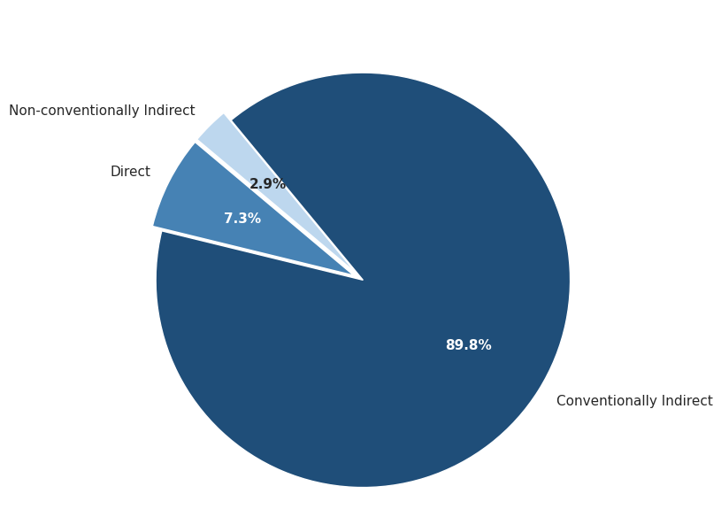

Figure 1. Distribution of Request Directness in WDCT (N=41)

As presented in Figure 1, the participants demonstrated a clear preference for Conventionally Indirect strategies, which accounted for the vast majority of the total requests (89.8%). In contrast, Direct strategies were used far less frequently (7.3%), while Non-conventionally Indirect strategies (Hints) were the least frequently employed (2.9%). The results indicate that participants generally recognized the importance of politeness and indirectness when making requests in English. However, the overwhelming reliance on conventionally indirect forms also indicates a tendency toward formulaic language use, with limited variation in pragmatic strategy selection across contexts. While the learners appeared capable of producing pragmatically acceptable requests in many situations, the findings also suggest that their pragmatic repertoire remained relatively restricted.
4.1.2. Situational Variation in Request Strategies
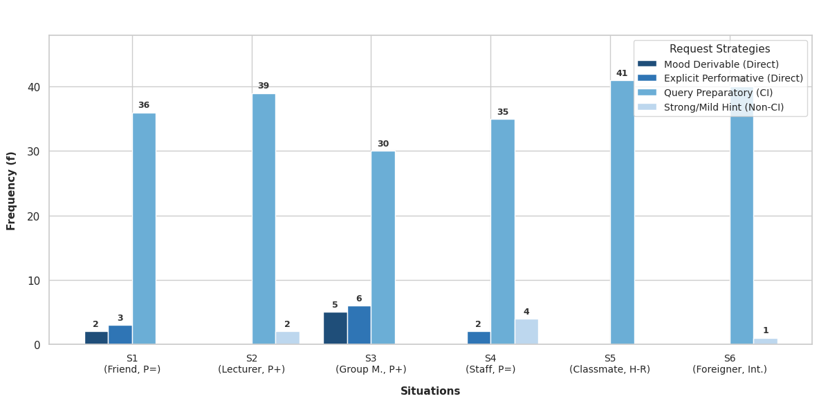

Figure 2. Distribution of Request Strategies across Six Situations (N=41)

Figure 2 demonstrates that the Query Preparatory strategy was the most dominant across all six scenarios, maintaining a near-absolute presence in Situations 5 and 6 (100% and 98% respectively). This indicates that when faced with high imposition (S5) or intercultural contexts (S6), learners almost exclusively resort to safe, conventionalized questions about ability or willingness (e.g., "Can you...").
However, a notable deviation in directness levels was observed in Situation 3 (Group Leader to Member, P+), where Direct strategies (Mood Derivable and Explicit Performative) reached their highest frequency at 27%. This shift suggests that learners are sensitive to the Power (P) variable; they tend to adopt a more authoritative and blunt tone when they perceive themselves in a superior social position.
In contrast, Situation 2 (Lecturer, P+) and Situation 4 (Staff, D+) elicited the most consistent use of polite, indirect formulas. Interestingly, while Non-conventionally Indirect strategies (Hints) remained the least used overall, they appeared more frequently in Situation 4 (10%), as learners attempted to use subtle remarks to address a stranger in a service context.
Overall, the data in Table 2 reinforces the finding that while Vietnamese EFL learners at HUFLIT attempt to calibrate their requests according to social variables like Power and Distance, their pragmatic repertoire remains constrained. They rely heavily on a "one-size-fits-all" indirectness for most scenarios, only occasionally venturing into direct commands when the social hierarchy permits.
4.2. Vietnamese EFL Learners’ Pragmatic Performance in Real-Time Interaction: Findings from the Role-Play Recordings
4.2.1. Patterns of Pragmatic Performance in Role-Play Interaction
Analysis of four role-play recordings revealed a consistent pattern in students’ pragmatic performance during real-time interaction. Overall, the findings indicate that while students demonstrated awareness of polite request strategies in written tasks, they experienced notable difficulty maintaining such politeness when engaged in spontaneous spoken communication.
One prominent trend was a shift from indirect to more direct request strategies. In WDCT, students typically produced longer and more mitigated forms, such as “I wonder if you could help me…”. However, in the recordings, these were frequently replaced by shorter and more direct expressions, including “Give me” or “Can I borrow”. This shift suggests that under time pressure, students prioritized efficiency and immediate comprehensibility over pragmatic appropriateness.
4.2.2. Key Challenges in Real-Time Request Production
The analysis also revealed evidence of first language (L1) pragmatic transfer. In several instances, students appeared to rely on Vietnamese syntactic and pragmatic patterns when formulating requests in English. For example, the utterance “Give me your notebook” reflects a direct translation of a common Vietnamese request form (“Cho mình mượn”), without the use of mitigating devices typically expected in English. Although not intended to be impolite, such forms may be perceived as abrupt in English-speaking contexts.
In addition, the recordings showed clear signs of processing difficulty. Across all four interactions, students frequently produced hesitation markers such as “uhm” and “ah”, along with pauses ranging from two to four seconds. These features suggest a cognitive load associated with simultaneously managing lexical retrieval, grammatical encoding, and pragmatic decision-making during real-time speech production.
Finally, students demonstrated difficulty handling unexpected responses from their interlocutors. When faced with refusals or conditional replies (e.g., a partner indicating that they also needed the item), many students struggled to adapt their requests. Instead of employing supportive moves such as providing justification or negotiation (e.g., “I only need it for a moment” or “I’ll return it immediately”), they often repeated their initial request or responded minimally without further elaboration.
In summary, the findings from the four role-play recordings suggest a gap between students’ declarative knowledge of politeness strategies and their ability to apply this knowledge in real-time interaction. Under communicative pressure, their language use became more direct and was strongly influenced by L1 pragmatic norms.
4.3. Learners’ Pragmatic Perception and Pedagogical Evaluation: Findings from the Questionnaire
4.3.1 Students’ Perceptions toward Role-play Activities
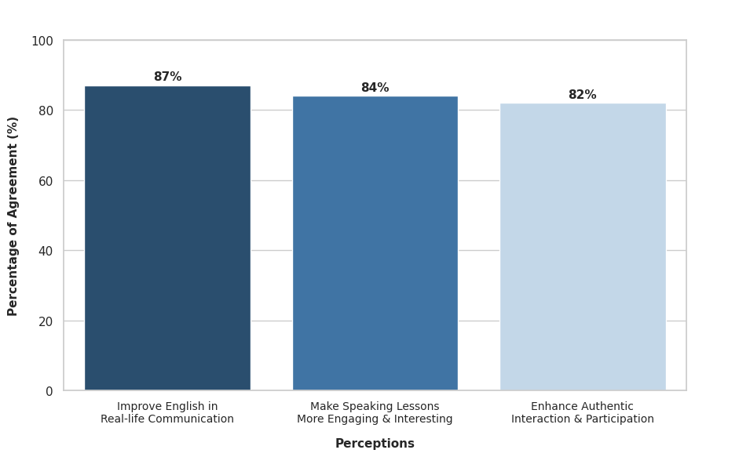

Figure 3. Students’Perceptions toward Role-play Activities

The questionnaire results revealed generally positive attitudes toward the use of role-play activities in English communication classes. Most participants agreed that role-play created a more engaging and interactive learning environment.
As illustrated in Figure 3, approximately 87% of the participants agreed that role-play activities improved their ability to use English in real-life communication, indicating that students perceived role-play as beneficial for communicative development. Similarly, around 84% of the respondents reported that role-play activities made speaking lessons more engaging and interesting. In addition, about 82% of the students believed that role-play activities enhanced authentic interaction and active classroom participation. These findings suggest that role-play was viewed as an effective communicative approach that facilitated meaningful language use in classroom contexts.
Overall, the findings demonstrated that students perceived role-play activities positively and considered them beneficial for improving classroom interaction, learner engagement, and English communication competence.
4.3.2 Role-play and Intercultural Pragmatic Development
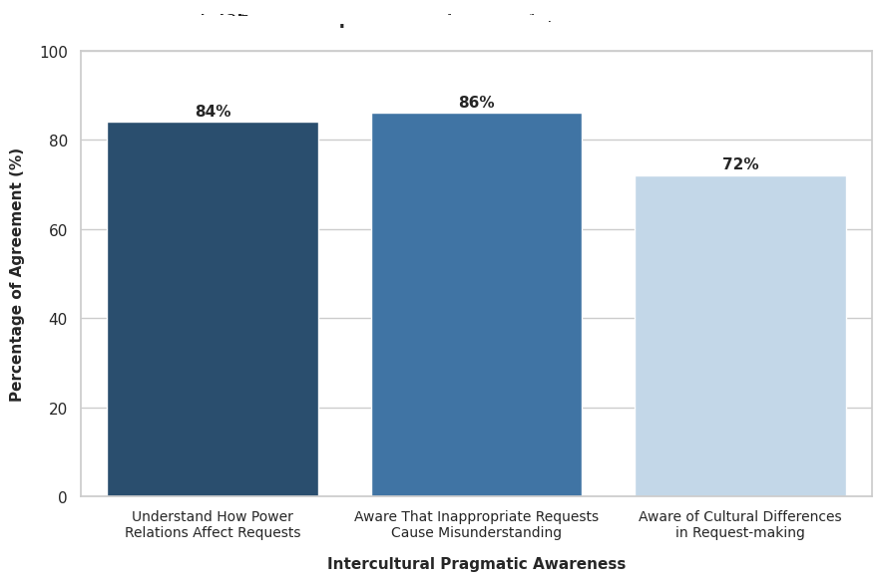

Figure 4. Students’ Perceptions toward Intecultural Pragmatic Development

The findings revealed that role-play activities contributed positively to students’ intercultural pragmatic development. Many participants demonstrated awareness of how social and cultural factors influence communication when making requests in English.
As shown in Figure 4, approximately 84% of the participants agreed that they understood how power relations affect requests, indicating that students recognized the importance of social status and hierarchy in communication. In addition, around 86% of the respondents reported awareness that inappropriate requests may cause misunderstanding in intercultural communication. Students also showed awareness of cultural differences in request-making although the level of agreement for this item was slightly lower, with approximately 72% of participants expressing positive responses. This finding suggests that while students had developed intercultural pragmatic awareness, additional exposure to authentic intercultural communication may still be necessary.
Overall, the findings indicate that role-play activities supported the development of intercultural pragmatic competence by helping students understand contextual appropriateness, politeness, and social relationships in English communication.
4.3.3 Pragmatic Awareness in Using Speech Acts of Request
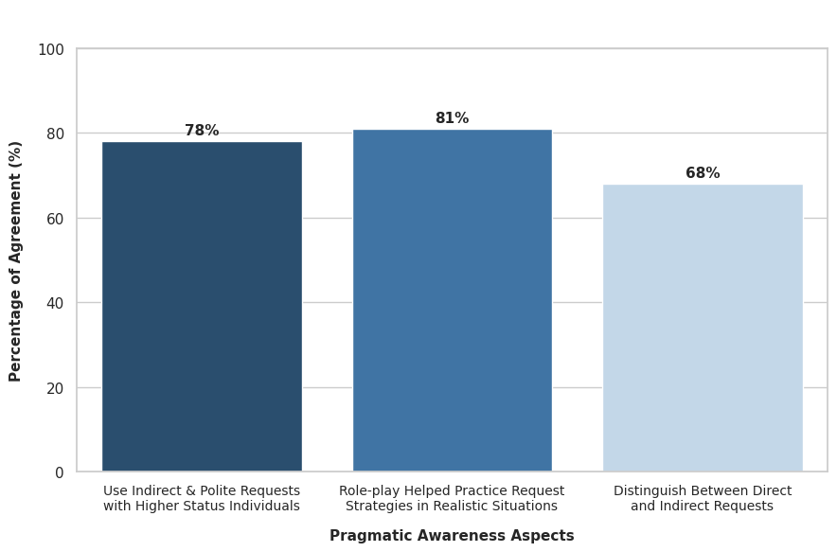

Figure 5. Students’ Pragmatic Awawreness in Using Speech Acts of Request

The questionnaire results demonstrated that students developed a relatively strong awareness of pragmatic appropriateness when using speech acts of request.
Most participants agreed that requests should be adjusted depending on the context, social relationship, and level of politeness required in communication. As illustrated in Figure 5, approximately 78% of the respondents reported that they tended to use indirect and polite requests when communicating with someone of higher social status.
Additionally, around 81% of the participants indicated that classroom role-play activities helped them practice request strategies in realistic situations. Many respondents also stated that teachers frequently provided feedback regarding the appropriateness and cultural use of requests during classroom interaction. However, the item related to distinguishing between direct and indirect requests received a comparatively lower level of agreement, with approximately 68% of students expressing positive responses. This finding suggests that although students demonstrated general pragmatic awareness, some still experienced difficulty identifying and applying different request strategies accurately.
Overall, the findings suggest that role-play activities positively influenced students’ pragmatic awareness and their ability to use speech acts of request more appropriately in English communication.
4.3.4 Emotional and Communicative Effects of Role-play Activities
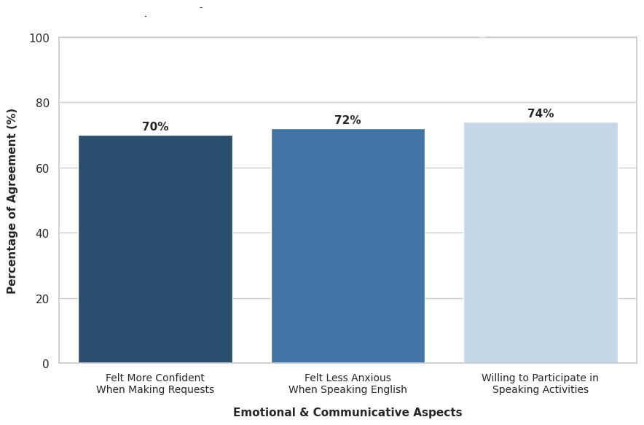

Figure 6. Emotional and Communicative Effects of Role-play Activities

The questionnaire findings also revealed several emotional and communicative effects associated with role-play activities.
Many students reported that role-play increased classroom interaction and encouraged participation in speaking activities. The communicative nature of role-play appeared to help students become more actively involved in the learning process.
As shown in Figure 6, approximately 70% of the participants felt more confident when making requests in English. Similarly, around 72% of the respondents reported feeling less anxious when speaking English during role-play activities. In addition, nearly 74% of the students expressed willingness to participate in speaking activities through role-play tasks. These findings suggest that although role-play created a supportive and interactive learning environment, some learners still experienced hesitation and anxiety when communicating in English.
Overall, the findings indicate that role-play activities had positive communicative effects, particularly in promoting classroom interaction and learner engagement. Nevertheless, emotional barriers such as anxiety and lack of confidence remained challenges for certain students and may require additional pedagogical support and speaking practice.
5. Discussion
5.1 Research question 1: To what extent does the integration of role-play activities improve students’ pragmatic appropriateness in performing the speech act of requests?
The findings indicate that the integration of role-play activities contributes positively to students’ pragmatic appropriateness in performing the speech act of requests. Questionnaire findings presented in Figure 5 revealed that students developed greater awareness of contextual appropriateness when making requests in English. Specifically, approximately 78% of the respondents reported that they tended to use indirect and polite requests when communicating with someone of higher social status, while around 81% stated that classroom role-play activities helped them practice request strategies in realistic situations.
This perceived improvement is further supported by the WDCT findings illustrated in Figure 1, where Conventionally Indirect strategies accounted for 89.8% of the total requests. The dominance of indirect request forms suggests that learners were generally aware of the importance of politeness and social appropriateness in English communication. In addition, Figure 2 demonstrates that learners adjusted their request strategies according to social variables such as power and distance. For example, students consistently employed more polite and indirect forms when interacting with lecturers and strangers, whereas more direct strategies appeared more frequently when learners occupied higher-status roles, such as group leaders.
From a cultural perspective, role-play activities played an important role in helping learners recognize and adapt their communicative behavior across different social contexts. Through simulated interactions, students were able to practice varying levels of directness and modify their language use according to contextual demands. However, findings from the role-play recordings also revealed that although students demonstrated pragmatic awareness in written tasks, they still experienced difficulty maintaining politeness strategies during spontaneous spoken interaction. Under communicative pressure, many learners shifted toward shorter and more direct request forms, reflecting the influence of processing difficulty and first-language pragmatic transfer.
Overall, these findings demonstrate that role-play activities not only improved students’ linguistic performance but also enhanced their pragmatic and intercultural communicative awareness. Nevertheless, the findings also suggest that learners’ pragmatic competence remained somewhat constrained in real-time interaction, indicating the need for continued practice and greater exposure to authentic communicative situations.
5.2 Research question 2: How do students develop request strategies and use of mitigating devices during role-play activities?
The findings indicate that students developed greater awareness of polite and indirect request strategies during role-play activities; however, their ability to use more flexible and sophisticated mitigating devices remained relatively limited.
The WDCT findings presented in Figure 2 demonstrate that the Query Preparatory strategy was overwhelmingly dominant across all six situations and reached nearly absolute frequency in high-imposition and intercultural contexts, accounting for 100% in Situation 5 and 98% in Situation 6. These results suggest that students preferred conventionally indirect and “safe” request forms in order to avoid sounding impolite or inappropriate. In addition, Figure 1 revealed that Conventionally Indirect strategies accounted for 89.8% of all requests, further indicating learners’ strong reliance on indirectness as a politeness strategy.
Questionnaire findings shown in Figure 5 also revealed that approximately 78% of the participants reported using indirect and polite requests when communicating with someone of higher social status, while around 81% agreed that role-play activities helped them practice request strategies in realistic situations. Nevertheless, the findings also suggest that students’ pragmatic repertoire remained somewhat constrained. Although learners demonstrated awareness of contextual appropriateness, many still relied heavily on fixed and formulaic expressions such as “Can you…?” rather than employing a wider range of mitigating devices and supportive moves.
Furthermore, the role-play recordings revealed that under communicative pressure, students frequently shifted from longer and more mitigated forms in written tasks to shorter and more direct expressions in spontaneous interaction. The recordings also showed hesitation markers, pauses, and evidence of first-language pragmatic transfer, such as direct translations from Vietnamese request forms. These findings suggest that students experienced difficulty managing lexical retrieval, grammatical encoding, and pragmatic adjustment simultaneously during real-time communication.
Overall, while students showed improvement in using indirect request strategies and demonstrated greater awareness of politeness and social appropriateness, their ability to soften, modify, and diversify their requests remained limited. This limitation appears to result from both linguistic constraints and continued reliance on first-language pragmatic patterns during spontaneous spoken interaction.
5.3 Research question 3: How do students perceive the role of role-play in supporting the shift toward more ESL-oriented communicative practices?
The findings indicate that students generally perceived role-play activities as supporting a shift from form-focused learning toward more communication-oriented and context-sensitive language use. Questionnaire findings presented in Figures 3, 4, and 6 revealed that learners increasingly valued communicative effectiveness, contextual appropriateness, and interactional awareness in English communication.
Specifically, Figure 3 showed that approximately 87% of the participants agreed or strongly agreed that role-play activities improved their ability to use English in real-life communication, while around 84% reported that role-play made speaking lessons more engaging and interactive. In addition, about 82% believed that role-play activities enhanced authentic interaction and active classroom participation. These findings suggest that learners viewed role-play as an effective communicative approach that encouraged meaningful language use rather than merely focusing on grammatical accuracy.
Furthermore, Figure 4 demonstrated that students developed greater awareness of intercultural and contextual factors in communication. Approximately 84% of the participants agreed that they understood how power relations influence requests, while around 86% recognized that inappropriate requests may cause misunderstandings in intercultural communication. However, only about 72% expressed confidence in understanding cultural differences in request-making, suggesting that although learners had developed intercultural pragmatic awareness, some uncertainty and cultural discomfort still remained.
The role-play recordings also support this perceptual shift. During interactive tasks, students were required to negotiate meaning, respond spontaneously, and adjust their language according to social relationships and contextual demands. Unlike traditional grammar-focused instruction, role-play activities encouraged learners to prioritize communicative effectiveness and immediate interaction over grammatical perfection. Nevertheless, the recordings revealed that many students still experienced hesitation, pauses, and anxiety during spontaneous communication, indicating that the transition toward communicative competence had not yet been fully consolidated.
Overall, these findings suggest that role-play activities played an important role in promoting communication-oriented learning and raising students’ awareness of contextual and intercultural factors in language use. Although students demonstrated a clear shift toward more communicative practices, emotional barriers and limitations in intercultural confidence remained challenges that require continued exposure to authentic communicative interaction.
6. Conclusion
In conclusion, the results provide valuable insights into the ways Vietnamese EFL learners at HUFLIT employ request strategies across different communicative contexts. The findings show that although students are aware of social factors such as Power and Distance, their language use is still limited. They often rely on similar indirect forms in different situations and only use more direct expressions when the context clearly allows it. The analysis of the four role-play recordings also shows a gap between what students know and what they can actually do in real communication. When speaking under pressure, they tend to become more direct and are influenced by their first language. This suggests that students are in a transition stage: they have moved beyond focusing only on grammar, but they have not yet developed flexible and natural communication skills.
From a pedagogical perspective, greater emphasis should be placed on integrating role-play activities into communication-oriented instruction. Students are given opportunities through these activities to practice speaking in realistic situations, which they need to think and respond quickly. Through regular role-play practice, students can gradually learn how to adjust their language, use softer expressions, and become more confident in real interactions. To make role-play more effective, teachers should provide clear guidance, model appropriate language, and give feedback not only on grammar but also on how polite and appropriate the students’ requests are.
This study has several limitations, including a small sample size and data collected from only a few role-play tasks, so the results may not fully reflect real-life communication. Future research should include more participants and longer observation periods. It would also be useful to examine both teacher readiness and the use of AI tools to support the teaching of request strategies through role-play activities in Vietnamese English communication classrooms.

References
Austin, J. L. (1962). How to do things with words. Clarendon Press.
Bachman, L. F. (1990). Fundamental considerations in language testing. Oxford University Press.
Bardovi-Harlig, K. (2013). Developing L2 pragmatics. Language Learning, 63(Suppl. 1), 68–86.
Bardovi-Harlig, K., & Dörnyei, Z. (1998). Do language learners recognize pragmatic violations? Pragmatic versus grammatical awareness in instructed L2 learning. TESOL Quarterly, 32(2), 233–259.
Blum-Kulka, S., House, J., & Kasper, G. (Eds.). (1989). Cross-cultural pragmatics: Requests and apologies. Ablex.
Brown, P., & Levinson, S. C. (1987). Politeness: Some universals in language usage. Cambridge University Press.
Byram, M. (2011). Conceptualizing intercultural (communicative) competence and intercultural citizenship. In J. Jackson (Ed.), The Routledge handbook of language and intercultural communication (pp. 85–97). Routledge.
Canale, M., & Swain, M. (1980). Theoretical bases of communicative approaches to second language teaching and testing. Applied Linguistics, 1(1), 1–47. https://doi.org/10.1093/applin/1.1.1
Crystal, D. (2003). English as a global language (2nd ed.). Cambridge University Press.
DeKeyser, R. M. (2007). Practice in a second language: Perspectives from applied linguistics and cognitive psychology. Cambridge University Press.
Dong, X. (2009). Requests in academic settings in English, Russian and Chinese [Doctoral dissertation, The Ohio State University]. ProQuest Dissertations & Theses Global.
Ellis, R. (2003). The study of second language acquisition. Oxford University Press.
Han, S. (2005). The interlanguage pragmatic development of the speech act of requests by Korean non-native speakers of English in an ESL setting (Publication No. AAI3165689) [Doctoral dissertation, University of Pennsylvania]. ProQuest Dissertations & Theses Global.
Hymes, D. (1972). On communicative competence. In J. B. Pride & J. Holmes (Eds.), Sociolinguistics: Selected readings (pp. 269–293). Penguin Books.
Ishihara, N. (2010). Teaching pragmatics in the classroom. In K. R. Rose & G. Kasper (Eds.), Pragmatics in language teaching (pp. 101–124). Cambridge University Press.
Ishihara, N., & Cohen, A. D. (2010). Teaching and learning pragmatics: Where language and culture meet. Pearson Education.
Kachru, B. B. (1982). The other tongue: English across cultures. University of Illinois Press.
Kádár, D. Z., & Haugh, M. (2013). Understanding politeness. Cambridge University Press.
Kasper, G., & Dahl, M. (1991). Research methods in interlanguage pragmatics. Studies in Second Language Acquisition, 13(2), 215–247.
Kasper, G., & Rose, K. R. (2002). Pragmatic development in a second language. Blackwell.
Kasper, G., & Schmidt, R. (1996). Developmental issues in interlanguage pragmatics. Studies in Second Language Acquisition, 18(2), 149–169.
Kecskés, I. (2014). Intercultural pragmatics. Oxford University Press.
Kecskés, I. (2016). Cross-cultural and intercultural pragmatics. In Y. Huang (Ed.), The Oxford handbook of pragmatics (pp. 1–16). Oxford University Press.
Leech, G. N. (1983). Principles of pragmatics. Longman.
Liddicoat, A. J. (2022). Intercultural mediation in language learning. In I. Kecskes (Ed.), The Cambridge handbook of intercultural pragmatics (pp. 815–835). Cambridge University Press. https://doi.org/10.1017/9781108884303.032
McConachy, T. (2018). Developing intercultural perspectives on language use: Exploring pragmatics and culture in foreign language learning. Multilingual Matters.
McConachy, T. (2022). Pragmatic awareness in intercultural language learning. In I. Kecskes (Ed.), The Cambridge handbook of intercultural pragmatics (pp. 766–787). Cambridge University Press.
Ogiermann, E. (2009). Politeness and indirectness across cultures: A comparison of English, German, Polish and Russian requests. Journal of Politeness Research, 5(2), 189–216.
Rose, K. R. (2005). On the effects of instruction in second language pragmatics. System, 33(3), 385–399.
Schauer, G. A. (2006). Pragmatic awareness in ESL and EFL contexts: Contrast and development. Language Learning, 56(2), 269–318.
Searle, J. R. (1979). Expression and meaning: Studies in the theory of speech acts. Cambridge University Press.
Spencer-Oatey, H. (2008). Face, (im)politeness and rapport. In H. Spencer-Oatey (Ed.), Culturally speaking: Culture, communication and politeness theory (2nd ed., pp. 11–47). Continuum.
Taguchi, N. (2015). Instructed pragmatics at a glance: Where instructional studies were, are, and should be going. Language Teaching, 48(1), 1–50.
Taguchi, N., & Roever, C. (2017). Second language pragmatics. Oxford University Press.
Takahashi, S. (2010). Instructional effects on request strategies in Japanese EFL learners. Language Learning, 60(1), 1–33.
Thomas, J. (1983). Cross-cultural pragmatic failure. Applied Linguistics, 4(2), 91–112. https://doi.org/10.1093/applin/4.2.91
Vygotsky, L. S. (1978). Mind in society: The development of higher psychological processes. Harvard University Press.

Bionote
Anh Nguyen-Hoang-Vuong received a B.A. in English Language Teaching from Ho Chi Minh City University of Foreign Languages and Information Technology (HUFLIT), Vietnam, in 2009, and an M.Ed. in TESOL from the University of Southern Queensland, Australia, in 2013. She has completed various professional development programs in TESOL, action research, language testing and assessment, and intercultural communicative competence. She has been a lecturer at HUFLIT since 2010 and is currently a Ph.D. candidate in TESOL at Ho Chi Minh City Open University, Vietnam. Her research interests include language and culture, teaching methodology, sociolinguistics, and nonverbal communication.
Appendices
Appendix A: Questionnaire on Students' Perceptions of Role-Play and Pragmatic Development
Part 1: Please indicate your level of agreement with each statement by selecting one option from 1 to 5.
1 = Strongly Disagree 2 = Disagree 3 = Neutral 4 = Agree 5 = Strongly Agree
No. | Statements | 1 | 2 | 3 | 4 | 5
1 | Role-play activities helped me learn how to make appropriate requests in different situations. | ☐ | ☐ | ☐ | ☐ | ☐
2 | Role-play activities improved my ability to use English in real-life communication. | ☐ | ☐ | ☐ | ☐ | ☐
3 | Role-play activities made the speaking lessons more engaging and interesting. | ☐ | ☐ | ☐ | ☐ | ☐
4 | I can distinguish between direct and indirect ways of making requests. | ☐ | ☐ | ☐ | ☐ | ☐
5 | I am able to adjust my language depending on the social context (e.g., teacher vs. friend). | ☐ | ☐ | ☐ | ☐ | ☐
6 | I understand how power relations (e.g., student–teacher) affect the way requests are made. | ☐ | ☐ | ☐ | ☐ | ☐
7 | I feel more aware of cultural differences when making requests in English. | ☐ | ☐ | ☐ | ☐ | ☐
8 | I am able to use strategies (e.g., hedging, softening) to make my requests more polite. | ☐ | ☐ | ☐ | ☐ | ☐
9 | I am aware that inappropriate requests may cause misunderstanding in intercultural communication. | ☐ | ☐ | ☐ | ☐ | ☐
10 | I realize that a request might be perceived differently by a native speaker compared to a Vietnamese speaker. | ☐ | ☐ | ☐ | ☐ | ☐
11 | I feel more confident when making requests in English. | ☐ | ☐ | ☐ | ☐ | ☐
12 | I feel less anxious when speaking English in role-play activities. | ☐ | ☐ | ☐ | ☐ | ☐
13 | I would like to continue using role-play activities in future English classes. | ☐ | ☐ | ☐ | ☐ | ☐

Part 2: Please choose the option that best reflects your current practice.
14. When making a request, what do you usually focus on most?
A. Grammar accuracy only
B. Both grammar and appropriateness in context
C. Politeness strategies only
D. Getting the meaning across regardless of forms
15. How do you usually decide which request form to use?
A. I use the same form in all situations
B. I depend on the situation and the listener (Power, Distance, Imposition)
C. I translate directly from Vietnamese
D. I follow my personal habits and natural reflex
16. What difficulty do you face most when making requests in English?
A. Choosing correct grammar
B. Choosing appropriate level of politeness
C. Lack of vocabulary
D. Feeling anxious or shy to ask
17. Your requests are influenced by:
A. Vietnamese language habits (L1 Transfer)
B. Textbook-based learning only
C. A combination of classroom learning and real-life awareness
D. Media influence (movies, social media)
18. Compared to before, your English communication now is:
A. Still mainly textbook-based (EFL-oriented)
B. More practical and flexible (ESL-oriented)
C. Similar to real-life communication
D. No significant change
19. What kind of feedback do you receive from the teacher?
A. Only grammar correction
B. Feedback on appropriateness (politeness, context)
C. Feedback on both language and culture
D. General feedback on participation only
20. When requesting someone with higher status (e.g., a boss or teacher), you usually:
A. Use direct requests to save time
B. Use indirect and polite requests
C. Use very long explanations before the request
D. Feel hesitant and tend to avoid the request
21. When your request is misunderstood, you usually:
A. Repeat the same sentence or stop communicating
B. Change the wording or strategy (negotiation of meaning)
C. Switch to Vietnamese
D. Use gestures or ask for help from others
22. Which factor influences your choice of request strategy the most?
A. Relationship with the listener and social distance
B. The importance or difficulty of the favor
C. English grammar proficiency
D. Personal mood and confidence
23. Where do you mostly practice making requests in English?
A. Grammar exercises in textbooks
B. Role-play activities and simulations in class
C. In real-life communication outside class
D. Through online platforms/social media
24. Which activity helps you understand social variables (Power, Distance) best?
A. Teacher's theoretical explanation
B. Reading textbook dialogues
C. Participating in role-play scenarios
D. Observing native speakers (videos, movies)
25. After the course, how do you evaluate your request performance?
A. No significant change
B. Can perform requests but still feel culturally awkward
C. Can perform requests naturally and appropriately
D. Need much more real-life practice

Appendix B: Written Discourse Completion Test (WDCT)
Please read each situation carefully and imagine that you are in the described context. Write what you would naturally say to make an appropriate request in English.
When responding, please consider:
- The relationship between you and the listener.
- The social context of the interaction.
- The level of politeness required.
No. | Situation | Responses
1 | Equal Power, Informal Context You are talking to your close friend in class. You forgot to bring your notebook today. What would you say to ask your friend to lend you their notebook?
2 | Higher Power, Formal Context You need to ask your lecturer for an extension on an assignment because you have been sick. What would you say to your lecturer?
3 | Lower Power Context You are the leader of a group project, and one of your group members has not completed their assigned task. What would you say to ask them to finish their work?
4 | Stranger, Service Encounter You are in a café, and the music is too loud. You would like a staff member to lower the volume. What would you say?
5 | High-Imposition Request You would like to ask a classmate, whom you do not know very well, to help you with a difficult assignment this weekend. What would you say?
6 | Intercultural Context You are studying abroad. You would like to ask a classmate from another cultural background to explain something that you do not understand. What would you say?
Appendix C: List of Abbreviations

CCSARP: Cross-Cultural Study of Speech Act Realization Patterns
EFL: English as a Foreign Language
ESL: English as a Second Language
HUFLIT: Ho Chi Minh City University of Foreign Languages and Information Technology
L1: First Language
WDCT: Written Discourse Completion Task

