A Literature Review of Appraisal Theory in Language Education: Research Developments and Implications for ESL Teaching
Phan Tuan Ly, Hoang Ngoc Thanh Truc^{2,3} & Pham Thi Thuy Dung^{2,3}

Abstract
This study investigates the development of research on applying Appraisal Theory (Martin & White, 2005) in language education using a bibliometric approach. Grounded in Systemic Functional Linguistics, Appraisal Theory provides an analytical framework for examining how language users express emotions, attitudes, and evaluations in authentic contexts, and has increasingly attracted attention for its pedagogical potential. Using articles indexed in Scopus from 2006 to 2026, 48 publications were selected according to predefined inclusion criteria and analyzed with VOSviewer. The results show that Australia leads the field by a substantial margin. After a decline prior to 2020, the number of publications recovered and continued to rise, reaching a second peak in 2024. Two journals—Journal of English for Academic Purposes and Linguistics and Education—were identified as the most prominent outlets in this research area. Highly influential scholars include Yadan Li, Ana Llinares, and Ryan T. Miller, while Hood (2006) emerged as the most cited work. The bibliometric analysis further revealed six major clusters concerning the application of Appraisal Theory to foreign language teaching. Overall, the findings indicate that Appraisal Theory is becoming increasingly central to the modernization of English language teaching in Vietnam.
Keywords: appraisal theory, bibliometrics, SFL, ESL teaching, language education

1. Introduction
Appraisal Theory is an essential branch of Systemic Functional Linguistics (SFL) that addresses how language expresses the attitudes, evaluations, and viewpoints of speakers and writers. Appraisal Theory has proved a useful tool in discourse studies, especially in language education, where it is especially important for understanding how learners construe attitudes and feelings and also as a way of exploring interpersonal meaning.
The Appraisal Theory has been widely used worldwide in foreign language teaching research, academic text analysis, and evaluation of learners’ writing competence. In Vietnam, however, although the framework has been introduced and used in some studies, its application remains limited, particularly in pedagogical contexts involving English as a Second Language (ESL). Therefore, the mapping of the current research status of Appraisal Theory in language education not only helps Vietnamese scholars to see the research status in the world but also provides orientations for the application of this theory to teaching and researching.
This research tries to examine the development of research on Appraisal Theory Application in language education throughout the years. Two central research questions are posed: (1) What is the current scholarly output in this field in terms of volume of publications, journals, and authors contributing? (2) What are the major research thematic areas, and what are the changes at different stages of development? These questions provide a holistic view of research trends and identify the gaps that need exploration.
For this purpose, this paper takes into account past research, publication trends, and major topics. The article is structured as follows: first, the literature review provides the conceptual foundations of Appraisal Theory, its main categories, and representative studies; second, the methodology, results, and discussion sections introduce the bibliometric analysis and thematic findings; finally, the conclusion summarizes key insights and offers pedagogical implications for ESL teaching in Vietnam.
In summary, this study aims to offer a comprehensive and coherent account of the evolution of Appraisal Theory in language education, which will help researchers and ESL educators in improving their understanding and in the effective application of this framework in both teaching and research contexts.
2. Literature Review
Martin and White (2005), building on the foundations of Systemic Functional Grammar (SFG), developed Appraisal Theory to extend the scope of interpersonality analysis in discourse. Whereas SFG primarily describes the linguistic resources through which meanings are construed, Appraisal Theory advances this perspective by establishing a systematic relationship between linguistic form and the social functions that language performs in particular communicative contexts. Accordingly, the theory is concerned with how language users express attitudes, position themselves, and negotiate social relations through discourse.
According to Martin and White (2005), appraisal constitutes an interpersonally oriented semantic system that enables discourse participants to communicate feelings, propositions, viewpoints, and the degree of commitment associated with their utterances. As such, the framework offers a methodological basis for identifying and explaining how stances are realized across diverse discourse types. As illustrated in Figure 1, the Appraisal System comprises three interrelated subsystems: Attitude, Engagement, and Graduation. In combination, these components respectively account for (i) the expression of affective and evaluative meanings, (ii) the management of alternative sources of voice within discourse, and (iii) the calibration of intensity and explicitness of evaluative content.
Figure 1
An overview of appraisal resources
Source: Martin & White, 2005, p. 38
Within this framework, Attitude occupies the central function and is further differentiated into three categories: Affect, which encodes personal feelings; Judgment, which evaluates human behavior or personal attributes; and Appreciation, which assesses phenomena and objects. Graduation captures the degree of strength–weakness or explicitness–implicitness of evaluations through two mechanisms—Force and Focus—thereby reflecting the speaker/writer’s strategies for modulating the perceived impact on the addressee (Phan, 2022). Engagement concerns the sourcing of viewpoints in discourse and distinguishes between monogloss (single-voiced) and heterogloss (multi-voiced) patterns. This distinction, in turn, reveals the extent to which texts are dialogically open to alternative perspectives.
The application of Appraisal Theory has emerged as a significant research trajectory in multiple disciplines, including literature, communication, law, and academic inquiry (Oteíza, 2017; Wei et al., 2015). By offering a structured approach to organizing evaluative linguistic resources, the theory enables researchers not only to identify affective and evaluative elements, but also to examine how discourse participants construct stances, organize arguments, and cultivate social interaction within particular cultural and sociopolitical settings (Callon et al., 1983; Caputo et al., 2019).
3. Methodology
3.1. Database and Searching Process
This study conducts a bibliometric analysis using publication data retrieved from Scopus. The search was restricted to records containing the keywords “appraisal” and “Systemic functional Linguistics.” The initial Scopus query yielded 303 articles matching both keywords. In this paper, we also employ keywords related to the field of translation, specifically “Translation” and “Legal Translation.” The inclusion of these keywords is justified by the close relationship between translation and language education, particularly in fostering learners’ linguistic competence and discipline-specific professional competence. After applying the exclusion criteria specified in Table 1 and limiting the scope to the education domain, the final corpus comprised 48 English-language articles. These were subsequently used to examine research trends related to this topic.
The Scopus query employed to retrieve the articles is as follows:
TITLE-ABS-KEY (“appraisal” AND “systemic functional”) AND PUBYEAR > 2005 AND PUBYEAR < 2027 AND (LIMIT-TO (DOCTYPE, “ar”) OR LIMIT-TO (DOCTYPE, “cp”)) AND (LIMIT-TO (LANGUAGE, “English”)) AND (LIMIT-TO (EXACTKEYWORD, “Academic Writing”) OR LIMIT-TO (EXACTKEYWORD, “Argumentative Writing”) OR LIMIT-TO (EXACTKEYWORD, “Translation”) OR LIMIT-TO (EXACTKEYWORD, “Teacher Education”) OR LIMIT-TO (EXACTKEYWORD, “Students”) OR LIMIT-TO (EXACTKEYWORD, “Graduation Resources”) OR LIMIT-TO (EXACTKEYWORD, “History Textbooks”) OR LIMIT-TO (EXACTKEYWORD, “Academic Discourse”) OR LIMIT-TO (EXACTKEYWORD, “Legal Translation”) OR LIMIT-TO (EXACTKEYWORD, “L2 Writing”) )
Table 1
Inclusion and exclusion criteria for selection of English papers’
Criteria included | Criteria excluded
Language: English | Not connected to the keywords appraisal and Systemic functional Linguistics
Time: 2006-2026 | Inadequate research
Article type: research articles and conference paper | Books, reviews, book chapters
Subject areas: social sciences; arts and humanities | Others
3.2. Bibliometric Methods
Bibliometric analysis is a methodological approach within scientometrics that applies statistical techniques to examine and evaluate scientific publications within defined subject areas (Broadus, 1987). It is primarily designed to achieve two objectives: (i) assessing research performance and (ii) mapping the structure of scientific knowledge (Aria & Cuccurullo, 2017). Performance analysis typically relies on activity-related indicators to measure the extent and contribution of research outputs, whereas scientific mapping uses relational indicators to characterize how knowledge is structured and evolves within a given field (Iwami et al., 2020).
In the present study, the software VOSviewer (van Eck & Waltman, 2007) is employed to analyze academic works containing the keywords “appraisal” and “Systemic functional Linguistics.”.” Following data collection, the dataset is processed to identify research trends through bibliometric techniques, such as bibliographic coupling, keyword co-occurrence, and co-occurrence based on abstracts. Bibliographic coupling enables the assessment of topical similarity across publications by examining shared cited references. Concurrently, analyses of keyword and abstract co-occurrences help reveal the conceptual organization of the research domain by identifying relationships among key terms (Callon et al., 1983). Overall, the findings show that keywords and abstracts form a densely connected vocabulary network, which plays a critical role in shaping the knowledge structure of the field (Caputo et al., 2019).
To visualize these patterns, the study uses network visualizations and term-density visualizations generated in VOSviewer. These visual outputs are used to clarify both the degree of interconnection among research themes and their relative frequency of occurrence.
4. Results
4.1. An overview of bibliometric data
The chart below presents the number of documents published on Appraisal Theory per year (retrieved from Scopus). In the first decade (2006-2016), the number of publications was not high, with one to two articles per year, which shows the early stages of the research attention to Appraisal Theory. In the next 10 years, the number of publications, however, shows substantial fluctuation, which is a sign of the gradual expansion of research in this field. Accordingly, the figures reach their peaks in 2018 and 2024, which depicts that the academic interest in Appraisal Theory is thriving.
The year of 2020 with global phenomena such as the COVID-19 pandemic resulted in a decline in publications. Consequently, this destructively influenced research activities and the worldwide circulation of scholarly work. Afterwards, the number of publications resumed to grow, reaching a second peak in 2024. This recovery proved the resilience of the research community and the consolidation of Appraisal Theory- a more and more influential theoretical framework in language education.
Figure 2
Publication Trends of Appraisal Theory Research in 2006–2026
Source: Scopus, 2026
The number of publications on Appraisal Theory by country/territory is shown in Figure 3. The data shows that Australia has the most publications, by a wide margin over other countries. The United States and China rank the second with many research on Appraisal Theory. Thanks to the great diversity in their education, Indonesia and Spain witnessed the same trend with considerable quantity paper on the theory. Despite fewer publications, Hong Kong, Japan, the UK, Chile, and Singapore made important contributions to this field around the world. This graph shows that Appraisal Theory is widely used in many parts of the world, especially Asia, Europe, and America.
The distribution of locations shown here can be interpreted that Appraisal Theory has gained interest in various locations, including Asia, Europe, and America. This sets out that the theory has earned its immense importance and flexibility in different linguistic and educational settings globally.
Figure 3
Documents by Country/Territory in Appraisal Theory Research
Source: Scopus, 2026
4.2. The Citation, co-citation, and bibliography coupling analysis
4.2.1. Productive Journals
Table 2 is the analysis of citation, co-citation, and bibliography coupling for important journals in Appraisal Theory research. The data marks the dominance of some journals compared to others. For instance, there are 5 documents, 147 citations, and a total link strength of 50 on the Journal of English for Academic Purposes. For the journal called Linguistics and Education, there are 2 documents worth 93 citations and a total link strength of 49. Therefore, this field is believed to have great influence. The evidence for great interest in Appraisal Theory in a bilingual context is the fact that International Journal of Bilingual Education and Bilingualism has 51 citations and 2 documents. Other sources like Indonesian Journal of Applied Linguistics, Written Communication, and An Introduction to Functional Grammar also help arouse researchers' interest in the field.
Overall, Table 2 shows that the research distribution is concentrated in major international journals and extends to regional sources. The combination of the number of documents, citations, and total link strength forms a comprehensive picture of the influence of each source, thereby highlighting the most important publication channels for scholars interested in Appraisal Theory in language education.
Table 2
Productive Journals in Appraisal Theory Research
Citation |  |  |  | Co-Citation |  |  | Bibliographic Coupling
 | Source | Documents | Citations | Source | Citations | Total link strength | Source | Documents | Citations | Total link strength
1 | Indonesian Journal of applied linguistics | 2 | 2 | An introduction to functional grammar | 27 | 219 | Indonesian Journal of applied linguistics | 2 | 2 | 19
2 | International Journal of Bilingual Education and bilingualism | 2 | 51 | Applied linguistics | 28 | 400 | International Journal of Bilingual Education and bilingualism | 2 | 51 | 26
3 | Journal of English for academic purposes | 5 | 147 | Assessing writing | 25 | 209 | Journal of English for academic purposes | 5 | 147 | 50
4 | Linguistics and education | 2 | 93 | English for specific purposes | 34 | 494 | Linguistics and education | 2 | 93 | 49
5 | Written communication | 2 | 78 | Evaluation in text: Authorial stance and the construction of Discourse | 27 | 249 | Written communication | 2 | 78 | 34
4.2.2. Prolific Authors
Table 3 gives information about the most prolific authors in the field of Appraisal Theory on the basis of the indicators of documents, citations, and total link strength. These reflect the productivity of individual scholars and their academic impact and connectivity to the international research network. The data sets out a clear distinction between authors with many publications and low citations and authors with few publications and high citation counts. For example, Yadan Li with two documents (no recorded citations) and an overall link strength of 67, convinced others that her work is well embedded in the research network despite having a limited direct citation impact. Ana Llinares and Ryan T. Miller are two other authors who have also published two documents each, with 53 and 80 citations, respectively, which shows that they have made a major impact in this field. Gordon Mmyskow and Yilong Yang also each have three documents, and they have strong connectivity with total link strengths of 78 and 86, respectively, which shows their role in linking different strands of research.
Moreover, a number of long-standing influential scholars like M.A.K. Halliday, J.R. Martin, K. Hyland, S. Hood, and D. Rose appear to be distinguished with the number of citations from 24 to 58 and extremely high total link strengths (134–295). Those figures mark their roles in the evolution and utilization of Appraisal Theory. In summary, Table 3 demonstrates authors with considerable contributions to the research on Appraisal Theory, from new scholars who have a strong connection to the network to established figures whose work on theory and pedagogy continues to influence the field.
Table 3
Prolific Authors in Appraisal Theory Research
Citation |  |  |  |  | Co-Citation |  |  |  | Bibliographic Coupling
 |  | Author | Documents | Citations |  | Author | Citations | Total link strength | Author | Documents | Citations | Total link strength
 | 1 | Li, Yadan | 2 | 0 |  | Coffin C. | 40 | 255 | Li, Yadan | 2 | 0 | 67
 | 2 | Llinares, Ana | 2 | 53 |  | Halliday M.A.K. | 26 | 159 | Llinares, Ana | 2 | 53 | 39
 | 3 | Miller, Ryan T. | 2 | 80 |  | Hood S . | 34 | 182 | Miller, Ryan T. | 2 | 80 | 47
 | 4 | Myskow, Gordon | 3 | 34 |  | Hyland K. | 58 | 295 | Myskow, Gordon | 3 | 34 | 78
 | 5 | Xuan, Winfred Wenhui | 2 | 5 |  | Martin J.R. | 45 | 276 | Xuan, Winfred Wenhui | 2 | 5 | 65
 | 6 | Yang, Yilong | 3 | 4 |  | Rose D. | 24 | 134 | Yang, Yilong | 3 | 4 | 86
4.2.3. Highly Cited Article
The list of highly cited articles in the field of Appraisal Theory is displayed in the table below. They are influential works in studies on Systemic Functional Linguistics and language education. Apparently, Hood (2006) has the highest number of citations (108) with the total link strength of 16. The figures imply his influence upon subsequent research. Lancaster (2014) and Miller (2014) also show a strong impact with 77 and 74 citations, respectively, which shows the rising interest of scholars in the application of Appraisal Theory to the analysis of academic texts and discourse studies. Lately, the works by Whittaker (2023) and Szenes (2021) portray the development of Appraisal Theory in modern settings. Those suggest the role of this theory in changing educational and linguistic issues. The scholarly works like An Introduction to Functional Grammar (Halliday, 1994), Working with Discourse: Meaning Beyond the Clause (Rose, 2003) and Evaluation in Text: Authorial Stance and the Construction of Discourse (Thompson, 2000) reaffirm their foundational role in the theoretical setting up of Appraisal.
In short, the table indicates a harmony between classical works and more recent applications. The most frequently cited articles suggested the influence of the theory. At the same time, the new studies reflected the diversification of Appraisal Theory into new domains. The pairing highlights the continuance and vibrancy of research within the domain of language education and additionally consolidates the position of Appraisal Theory as a powerful and thriving analytical instrument.
Table 4
Highly Cited Articles in Appraisal Theory Research
Citation |  |  |  |  | Co-Citation |  | Bibliographic Coupling
 |  | Document | Citations | Cited reference |  | Citations |  | Total link strength | Document | Citations | Total link strength
 | 1 | Hood (2006) | 108 | Coffin C., Historical discourse: the language of time, cause and evaluation, (2006) |  | 8 |  | 11 | Hood (2006) | 108 | 16
 | 2 | Oteza (2008) | 37 | Halliday M.A.K., An introduction to functional grammar, (1994) |  | 9 |  | 19 | Oteza (2008) | 37 | 33
 | 3 | Whittaker (2023) | 32 | Hood S., Appraising research: evaluation in academic writing, (2010) |  | 11 |  | 16 | Whittaker (2023) | 32 | 18
 | 4 | Lancaster (2014) | 77 | Matthiessen C.M.I.M., An introduction to functional grammar, (2004) |  | 6 |  | 11 | Lancaster (2014) | 77 | 28
 | 5 | Szenes (2021) | 29 | Rose D., Working with discourse: meaning beyond the clause, (2003) |  | 9 |  | 15 | Szenes (2021) | 29 | 11
 | 6 | Munday (2012) | 20 | Rose D., Working with discourse: meaning beyond the clause, (2007) |  | 7 |  | 9 | Munday (2012) | 20 | 21
 | 7 | Miller (2014) | 74 | Thompson G., Evaluation in text: authorial stance and the construction of discourse, (2000) |  | 7 |  | 14 | Miller (2014) | 74 | 32
 | 8 | Liardét (2018) | 33 | White P., The language of evaluation: appraisal in english, (2005) |  | 6 |  | 7 | Liardét (2018) | 33 | 24
 | 9 | Llinares (2015) | 34 | White P.R.R., The language of evaluation: appraisal in english, (2005) |  | 17 |  | 28 | Llinares (2015) | 34 | 23
4.3. The Co-occurence analysis
The results of the co-occurrence analysis will identify prominent research trends in recent years and, simultaneously, indicate the degree of keyword prominence (density)—that is, the extent to which particular terms attract scholarly attention and reflect sustained interest within the field.
4.3.1. Dominant Trends
Figure 4 identifies six prominent clusters regarding the application of Appraisal theory to foreign language teaching. Overall, the clustering structure suggests a diversity of implementation scopes and, at the same time, delineates key research directions through central keywords and their discourse-linked networks.
Cluster 1 (yellow) is located in the upper portion of Figure 4, with the central keyword “appraisal” linked to “teacher education,” “higher education,” and “engagement.” This cluster indicates a research trajectory that employs Appraisal theory as an analytical framework to support teacher education, extending to instructional contexts at both undergraduate and postgraduate levels. Notable scholars include Adlington et al. (2024), Godoy-Echiburú and Flores-Calvo (2025), and Nurhadi et al. (2025).
Cluster 2 (green), positioned on the left side of Figure 4, has “academic writing” as the central keyword and connects to “translation,” “discourse analysis,” “L2 writing,” “SFL,” and “attitude.” The cluster reflects research on teaching academic writing, where discourse analysis is treated as a foundational tool for explaining and guiding text production. Importantly, the outcomes of discourse analysis are also applied to translation studies and L2 writing instruction. Representative works include Munday (2012) and Yu and Wu (2018).
Cluster 3 (light blue) appears on the left, below Figure 4, using “appraisal theory” as the central keyword and showing prominent links to “argumentative essays” and “legal translation.” This cluster represents a line of inquiry centered on analyzing texts for specific discourse purposes, particularly argumentative essays and legal translation. Representative authors include Cheung and Low (2019) and Geng et al. (2024).
Cluster 4 (red) is located at the bottom of Figure 4, with “Systemic Functional Linguistics” as the central keyword. It is linked to “disciplinary writing,” “stance,” “corpus analysis,” “academic discourse,” and “engagement resources.” This trend emphasizes investigating interpersonal relations in academic texts and connecting such insights to discipline-specific writing practices. Representative studies include Reznicek-Parrado et al. (2018) and Cederholm (2026).
Cluster 5 (purple) is situated on the right side of Figure 4. With “appraisal framework” as the central keyword, it connects to “classroom discourse and evaluative language.” This cluster suggests growing interest in analyzing classroom discourse and evaluative language in educational settings. Representative authors include Cavanna et al. (2015) and Myskow (2018).
Cluster 6 (sky blue) is also located on the right side of Figure 4, taking “argumentative writing” as the central keyword and linking to “graduation resource” and “appraisal system.” The principal research direction in this cluster concerns the analysis of graduation in texts intended for argumentative writing. Representative scholars include Yang (2016) and Vo and Viet (2025).
Figure 4
Dominant Trends of Appraisal Theory
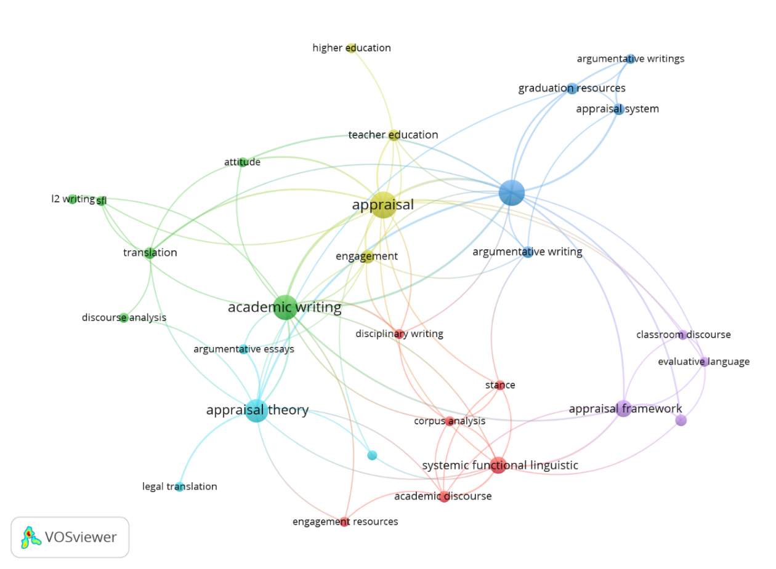
4.3.2. New research trends in the last five years
Figure 5 synthesizes prominent research trends observed over the past five years. The keywords highlighted in bright yellow—L2 writing, higher education, argumentative writings, graduation resources, engagement, and stance—are highly concentrated, indicating that recent studies have largely focused on leveraging appraisal resources, particularly engagement and graduation, to address core issues closely related to writing instruction at the university level. These findings also demonstrate the applicability of appraisal theory in higher education contexts, as evidenced by representative studies such as Cederholm (2026), Hutasuhut et al. (2023), and Ilić (2022).
Figure 5
New research trends in Appraisal Theory over the last five years
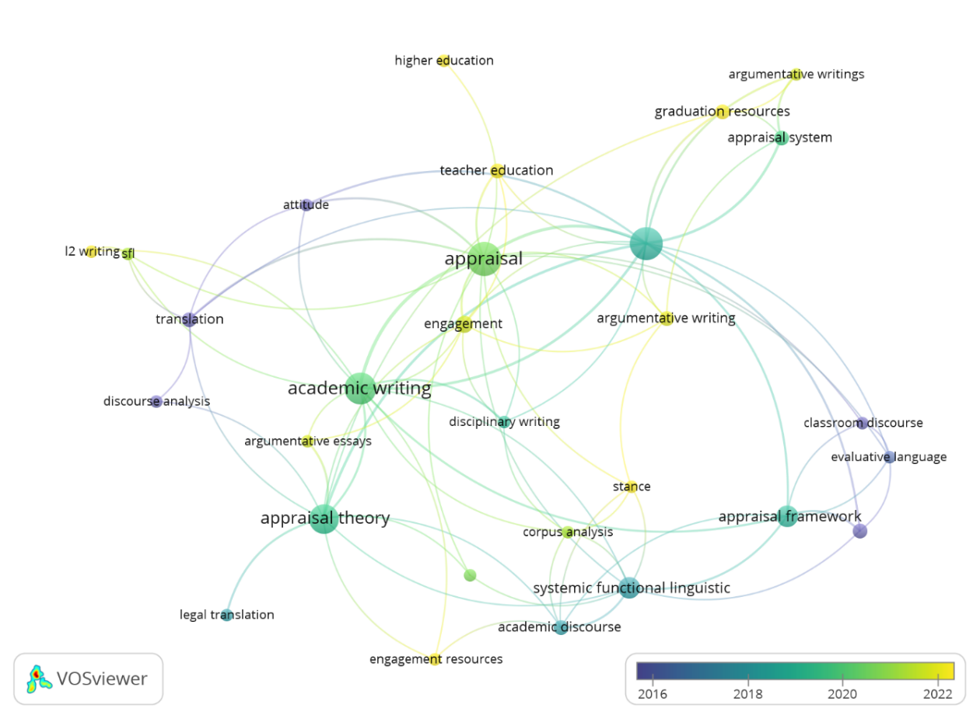
4.3.3. Trend Capturing Scholarly Attention
Structurally, within the appraisal theory framework, the keywords highlighted in dark yellow operate as central nodes and maintain direct linkages with the associated research content. Specifically, most studies in this cluster foreground appraisal and appraisal theory. Moreover, among the key terms, academic writing and argumentative writing exhibit comparatively high density, suggesting that these represent the two most distinctly emphasized research directions. This pattern implies that scholars prioritize using appraisal theory to explain and analyze linguistic phenomena related to the construction of academic texts, while also using such insights to inform the design of teaching and learning activities aligned with writing objectives.
Figure 6
Trends Capturing Scholarly Attention in Appraisal Theory
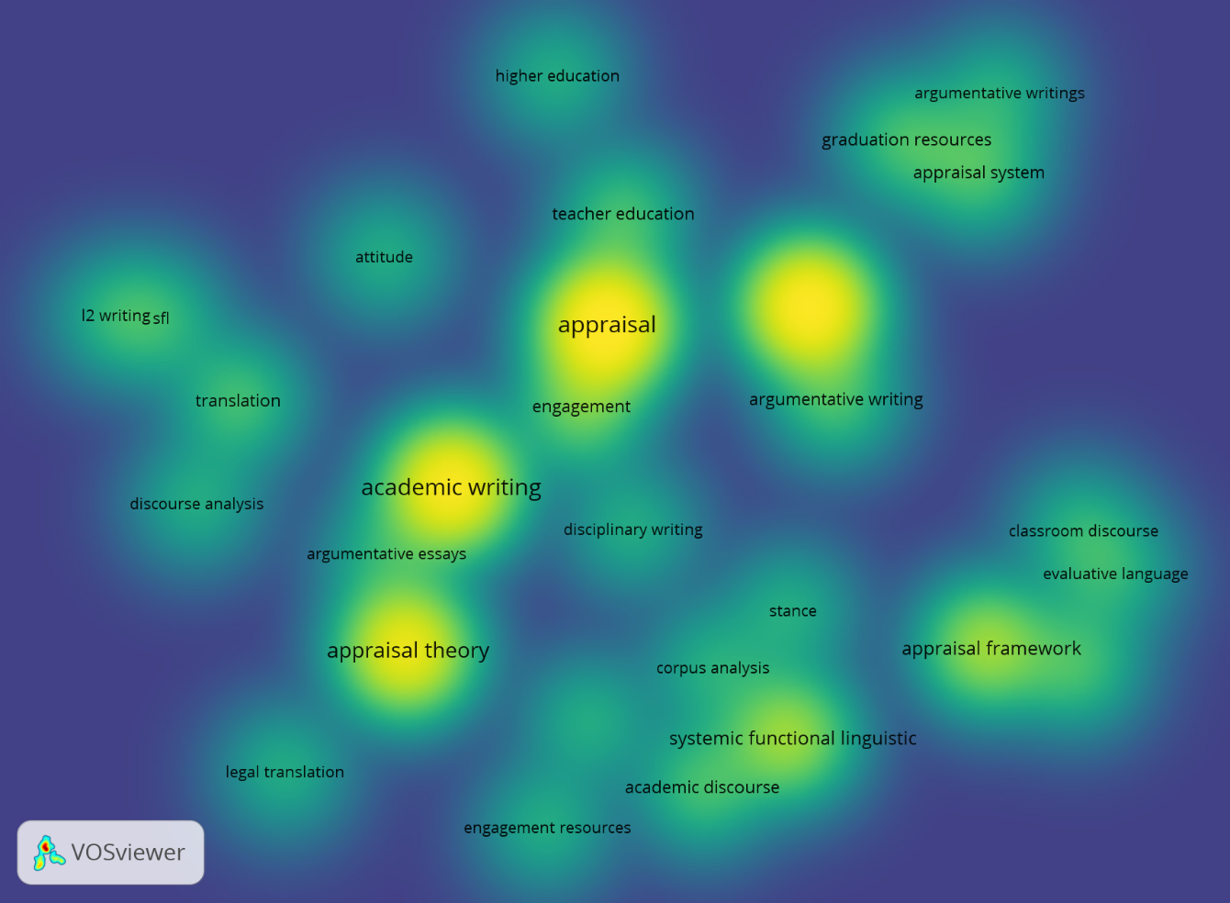
Overall, Figure 6 suggests that the effectiveness of appraisal theory for teaching writing skills has been widely recognized in recent scholarship, as reflected in studies such as Ndoricimpa and Barad (2024) and Li (2025).
4.4. Discussion on the Feasibility of Appraisal Theory in ESL Teaching in Vietnam
In spite of a strong position in linguistics, the application of Appraisal Theory to English as a Language (ELT) teaching in Vietnam remains a potential gap that has not been adequately explored. However, recent studies have been proving the feasibility and high practical value of this theory in complementing the academic competence of Vietnamese learners.
Indeed, Appraisal Theory has indicated its power in contouring 'writers’ authorial voice' which is believed to be a key element of academic discourse. Vo and Viet (2025) inspected the use of Graduation resources in TESOL master's theses by Vietnamese EFL learners. This research confirms the essential role of instructions in Appraisal Theory for helping students manage professional and persuasive academic voice. Similarly, Chung and Crosthwaite (2026), found significant differences in the expression of attitudes between native English speakers and Vietnamese learners who use English as second language. The fact that the latter often express themselves too directly but lack diversity in their choice of assessment language. This demonstrates that Appraisal Theory is necessary for teachers to guide learners in conveying attitudes subtly and for examiners to more accurately assess academic stances.
Apart from written texts, the elasticity of Appraisal Theory is also displayed in studies of spoken discourse. Ngo and Unsworth (2015) suggested powerful clarifications to the Attitude system based on group discussion data from graduate students in both English and Vietnamese. These improvements enrich the theoretical framework and at the same time provide valuable learning resources to enhance the effectiveness of expressing students' positions in multilingual contexts.
In addition to the desired results brought about for language learning, especially for teaching English as second language, this theory can be used as a dynamic accompanying framework to evaluate learners' perceptions of technology support in education. Ngan and Le (2025) delivered a study adopting Appraisal Theory. Their paper explores the awareness of 450 students and 12 teachers about the use of Google Translate. The results of this study bring up penetrating perspectives for policymakers on the role of technology. In addition, they confirm that Appraisal Theory is a functional tool capable of comprehensively improving the teaching and learning of foreign languages by understanding attitudes and promoting ethical technology use.
Although the application of Appraisal Theory appeared not to arouse much attention from researchers in Vietnam, the aforementioned studies have soundly established its implication in both general linguistics and teaching English as a Second Language (ESL). In short, the practicality of Appraisal Theory extends a broad range of academic needs—from decoding the complexities of argumentative writing and spoken discourse to evaluating user perceptions of emerging educational technologies. This implication proves that the framework is a descriptive linguistic tool and it also offers a practical, far-reaching methodology for classroom variation. As educators and researchers have had a shift to more communicative and evaluative-based instruction, Appraisal Theory has been becoming a central part in the modernization of English language teaching in Vietnam. Its adoption assures the prospect that learners are able to employ the “evaluative literacy” necessary to navigate the demands of global academic and professional discourse with confidence and precision.
5. Conclusion
In this paper, we mapped the research landscape of applying Appraisal theory in language education by examining publication development, research trends, and the feasibility of this theory within the context of Vietnam. Overall, the field has shown a clear recovery and growth trajectory: after 2020, publication numbers rebounded and continued to rise, reaching a second peak in 2024. In terms of international contributions, Australia leads the field by a wide margin over other countries. At the journal level, Journal of English for Academic Purposes and Linguistics and Education emerged as the two most prominent venues in this research area. The analysis of authorship impact further indicates that Yadan Li, Ana Llinares, and Ryan T. Miller are key contributors shaping scholarly influence in this domain, while Hood’s (2006) work remains the most cited and has exerted substantial impact on subsequent studies.
Beyond identifying major outlets, authors, and influential prior research, the present study also explored six prominent clusters related to the application of Appraisal theory to foreign language teaching. Importantly, the findings suggest that Appraisal Theory is increasingly becoming a central component in the modernization of English language teaching in Vietnam, offering meaningful theoretical and practical value for advancing how language evaluation, interpersonal meaning, and textual stance can be analyzed and taught in educational settings.
Although bibliometric analysis enables the identification and generalization of research trends regarding the application of Appraisal Theory in foreign language education using Scopus data, this approach presents several limitations. First, the findings are highly contingent on the selection and frequency of keywords. Consequently, less common keywords—or terms not captured within the principal keyword cluster—may be underrepresented, which can distort estimates of the research community’s attention to particular topics (Zahra et al., 2021). In addition, newly published studies, especially exploratory work or research that has not yet attracted substantial citation uptake, may not be fully indexed in the database, resulting in gaps within the analytical dataset (Thelwall, 2018). These constraints are partly attributable to the indexing characteristics of bibliographic databases, particularly open-access data infrastructures.
Second, restricting the analysis to a single database (e.g., Scopus) may limit the comprehensiveness of the study, as relevant publications are not always indexed within the same system. To mitigate these issues, future research should integrate multiple bibliographic sources and adopt complementary analytical methods. For example, time-series trend analysis and author-based citation network construction could be used alongside bibliometric indicators to provide a more nuanced and robust account of how the field has evolved over time. Collectively, these strategies would improve both the completeness and accuracy of the evidence regarding the development of this research area.
References
Adlington, R., O’Neill, K., Volpe, C. R., & Harrington, I. (2024). Promoting a sense of belonging in university online learning: How and why initial teacher education students experience an increased sense of belonging. Australasian Journal of Educational Technology, 40(5), 84. https://doi.org/10.14742/ajet.9487
Aria, M., & Cuccurullo, C. (2017). Bibliometrix: An R-tool for comprehensive science mapping analysis. Journal of Informetrics, 11(4), 959–975. https://doi.org/10.1016/j.joi.2017.08.007
Callon, M., Courtial, J.-P., Turner, W. A., & Bauin, S. (1983). From translations to problematic networks: An introduction to co-word analysis. Information (International Social Science Council), 22(2), 191–235. https://doi.org/10.1177/0306302483222002
Caputo, A., Fiorentino, R., & Garzella, S. (2019). From the boundaries of management to the management of boundaries: Business processes, capabilities, and negotiations. Business Process Management Journal, 25(3), 391–413. https://doi.org/10.1108/BPMJ-08-2018-0256
Cavanna, J. M., Herbel-Eisenmann, B., & Seah, W. T. (2015). Investigating teachers’ appraisal of unexpected moments and underlying values: An exploratory case in the context of changing mathematics classroom discourse. Research in Mathematics Education, 17(3), 163–182. https://doi.org/10.1080/14794802.2015.1112301
Cederholm, P. (2026). Explain and engage: Linguistic resources in Swedish as a second language textbooks to support academic writing. Language and Education, 40(2), 329–346. https://doi.org/10.1080/09500782.2025.2521432
Cheung, Y. L., & Low, T. H. (2019). Pre-university students’ voice construction in argumentative essays. RELC Journal, 50(2), 269–284. https://doi.org/10.1177/0033688217716508
Chung, T. T., & Crosthwaite, P. R. (2026). Stance-taking through appraisal in L1 and L2 English argumentative essays: Insights from Vietnamese L2 English. IRAL - International Review of Applied Linguistics in Language Teaching, 64(1), 265–299. https://doi.org/10.1515/iral-2024-0079
Geng, Y., Chen, G., & Li, M. (2024). Analyzing engagement strategies in argument chain: A comparison between high- and low-scoring EFL undergraduate argumentative essays. Journal of English for Academic Purposes, 71, Article 101428. https://doi.org/10.1016/j.jeap.2024.101428
Godoy-Echiburú, G., & Flores-Calvo, L. (2025). Construction of dialogic stances in work written by students of literature teacher education in Uruguay. Logos: Revista de Lingüística, Filosofía y Literatura, 35(2). https://doi.org/10.15443/RL3550
Halliday, M. A. K. (1994). An introduction to functional grammar. London: Edward Arnold.
Hood, S. (2006). The persuasive power of prosodies: Radiating values in academic writing. Journal of English for Academic Purposes, 5(1), 37–49. https://doi.org/10.1016/j.jeap.2005.11.001
Hutasuhut, M. L., Chen, H., & Matruglio, E. (2023). Engaged at the first sight! Anticipating your audience as a way to think critically in writing an argument. Indonesian Journal of Applied Linguistics, 12(3), 680–693. https://doi.org/10.17509/ijal.v12i3.55170
Ilić, K. M. (2022). Engagement resources in ESP research article abstracts. Filolog, 13(25), 240–264. https://doi.org/10.21618/fil2225240i
Iwami, S., Ojala, A., Watanabe, C., & Neittaanmäki, P. (2020). A bibliometric approach to finding fields that co-evolved with information technology. Scientometrics, 122(1), 3–21. https://doi.org/10.1007/s11192-019-03372-4
Lancaster, Z. (2014). Exploring valued patterns of stance in upper-level student writing in the disciplines. Written Communication, 31(1), 27–57. https://doi.org/10.1177/0741088313515170
Li, R. (2025). Beyond surfaces and depths: An SFL analysis of fine gradations of meaning in undergraduates’ writing about literature. Written Communication, 42(1), 85–119. https://doi.org/10.1177/07410883241286899
Martin, J. R., & White, P. R. (2005). The Language of Evaluation: Appraisal in English. Basingstoke: Palgrave Macmillan.
Miller, R. T., Mitchell, T. D., & Pessoa, S. (2014). Valued voices: Students' use of engagement in argumentative history writing. Linguistics and Education, 28, 107–120. https://doi.org/10.1016/j.linged.2014.10.002
Munday, J. (2012). New directions in discourse analysis for translation: A study of decision-making in crowdsourced subtitles of Obama’s 2012 State of the Union speech. Language and Intercultural Communication, 12(4), 321–334. https://doi.org/10.1080/14708477.2012.722099
Myskow, G. (2018). Changes in attitude: Evaluative language in secondary school and university history textbooks. Linguistics and Education, 43, 53–63. https://doi.org/10.1016/j.linged.2017.12.001
Ndoricimpa, C., & Barad, D. P. (2024). Writing in the disciplines: Comparison of critical stance qualities in literary analyses by university students writing in L1 and L2 contexts. Indonesian Journal of Applied Linguistics, 14(2), 415–428. https://doi.org/10.17509/ijal.v14i2.74890
Ngan, C. H., & Le, T. H. V. (2025). Vietnamese EFL teachers' and students' perceptions of using Google Translate in the classroom. Computer-Assisted Language Learning Electronic Journal, 26(3), 136–161. https://doi.org/10.54855/callej.252638
Ngo, T., & Unsworth, L. (2015). Reworking the appraisal framework in ESL research: Refining attitude resources. Functional Linguistics, 2(1), Article 1. https://doi.org/10.1186/s40554-015-0013-x
Nurhadi, K., Rahman, A., Khasyar, M. L., & Suharwanto, S. (2025). The emotional geography of faculty members engaging in virtual teacher professional development (VTPD): Evidence from Indonesia. Journal of Applied Research in Higher Education, 17(2), 663–674. https://doi.org/10.1108/JARHE-06-2022-0187
Oteíza, T. (2017). The appraisal framework and discourse analysis. Trong G. O. Tom Bartlett, The Routledge handbook of systemic functional linguistics (trang 457-472). Abingdon: Routledge.
Phan, T. L. (2022). Lí thuyết đánh giá trong phân tích diễn ngôn: nghiên cứu thử nghiệm từ cáo trạng tiếng việt. Tạp chí khoa học trường Đại học Sư phạm TP Hồ Chí Minh, 19(12), 2146-2159.
Reznicek-Parrado, L. M., Patiño-Vega, M., & Colombi, M. C. (2018). Academic peer tutors and academic biliteracy development in students of Spanish as a heritage language. Journal of Spanish Language Teaching, 5(2), 152–167. https://doi.org/10.1080/23247797.2018.1538358
Rose, D. (2003). Working with discourse: Meaning beyond the clause. Bloomsbury Publishing.
Szenes, E., & Tilakaratna, N. (2021). Deconstructing critical reflection in social work and business: Negotiating emotions and opinions in reflective writing. Journal of English for Academic Purposes, 49, Article 100931. https://doi.org/10.1016/j.jeap.2020.100931
Thelwall, M. (2018). Dimensions: A competitor to Scopus and the Web of Science? Journal of Informetrics, 12(2), 430-435. https://doi.org/10.1016/j.joi.2018.02.005
Thompson, G. (Eds.). (2000). Evaluation in text: Authorial stance and the construction of discourse: Authorial stance and the construction of discourse. Oxford University Press, UK.
Van Eck, N. J., & Waltman, L. (2007). VOS: A new method for visualizing similarities between objects. In Advances in Data Analysis (pp. 299–306). Springer. https://doi.org/10.1007/978-3-540-73589-6_23
Vo, L.-H., & Viet Le, L. (2025). Exploring EFL writers' authorial voice in academic discussions: A graduation-based appraisal analysis. Forum for Linguistic Studies, 7(5), 932–946. https://doi.org/10.30564/fls.v7i5.8873
Wei, Y., Wherrity, M., & Zhang, Y. (2015). An Analysis of Current Research on the Appraisal Theory. Linguistics and Literature Studies, 3(5), 235–239.
Whittaker, R., & McCabe, A. (2023). Expressing evaluation across disciplines in primary and secondary CLIL writing: A longitudinal study. International Journal of Bilingual Education and Bilingualism, 26(3), 345–362. https://doi.org/10.1080/13670050.2020.1798869
Yang, Y. (2016). Appraisal resources in Chinese college students’ English argumentative writing. Journal of Language Teaching and Research, 7(5), 1002–1013. https://doi.org/10.17507/jltr.0705.23
Yu, H., & Wu, C. (2018). Attitude as mediation: Peritextual commentary in the translation of the Platform Sutra. Text & Talk, 38(5), 633–654. https://doi.org/10.1515/text-2018-0017
Zahra, A. A., Nurmandi, A., Tenario, C. B., Rahayu, R., Benectitos, S. H., Mina, F. L. P., & Haictin, K. M. (2021). Bibliometric analysis of trends in theory-related policy publications. Emerging Science Journal, 5(1), 96-110. https://doi.org/10.28991/esj-2021-01278
Bionote
Ly Tuan Phan earned a PhD in Contrastive Linguistics from the University of Social Sciences and Humanities, Ho Chi Minh City - Vietnam National University. He is currently a lecturer at Ho Chi Minh City University of Law. His research interests include legal discourse and Systemic Functional Linguistics.
Truc Ngoc Thanh Hoang holds an MA in Linguistics and is currently a lecturer at Ho Chi Minh City University of Law. With a focus on the intersection of linguistics and law, her scholarly interests include legal discourse analysis and the application of linguistic theories to the study and teaching.
Dung Thi Thuy Pham holds an MA in TESOL and is currently a PhD candidate in Contrastive Linguistics. With a background in English language pedagogy, her research has evolved to specialize in the intersection of language and law. Her current scholarly work focuses on legal English teaching and the linguistic nuances of legal discourse. Looking forward, her research interests involve contrastive linguistics within legal frameworks, specifically examining the structural and functional disparities between legal languages.

PhD; Faculty of Legal Foreign Languages; Ho Chi Minh City University of Law; Ho Chi Minh City, Vietnam 2 MA; Faculty of Legal Foreign Languages; Ho Chi Minh City University of Law; Ho Chi Minh City, Vietnam; 3 PhD Candidate; Faculty of Literature and Linguistics, University of Social Sciences and Humanities, Vietnam; National University Ho Chi Minh City; Ho Chi Minh City, Vietnam; Email: pttdung@hcmulaw.edu.vn;

