ASSESSING THE EFFECTIVENESS OF QUIZIZZ IN IMPROVING VOCABULARY
LEARNING OF EFL FRESHMEN STUDENTS AT HUFLIT
LÊ THY PHƯƠNG THẢO
Abstract
Gamified learning instruments have received considerable focus in language teaching, especially in vocabulary development. This research examines the effectiveness of Quizizz in improving vocabulary acquisition among freshmen EFL learners at HUFLIT. Employing a combination of methods, information was gathered from 100 students via surveys and evaluations to assess the effect of Quizizz on students’ enthusiasm, participation, and vocabulary retention. The results show a significant link between the use of Quizizz and increased student excitement, engagement, and academic outcomes. Nonetheless, constraints like monotonous question structures and the absence of customized learning pathways were noted. The research indicates that combining multimedia components, various question formats, and personalized learning capabilities could improve the platform’s efficiency. These results underscore the significance of learning powered by technology strategies and offer perspectives for learners looking to enhance digital resources for vocabulary.
Keywords: Gamified learning, Quizizz, vocabulary acquisition, EFL freshmen students, motivation, technology-enhanced learning, digital tools in education.
- Introduction
Background
English vocabulary is essential for communication and professional success in today’s globalized society. The need for creative and engaging ways to improve vocabulary learning continues to grow as English proficiency becomes increasingly crucial. Freshmen HUFLIT students who are prepared for their future occupations frequently struggle to stay motivated and successfully retain language using conventional approaches. This emphasizes the need for more effective and interactive educational resources. Quizizz, a gamified learning platform used in education to make learning more engaging and enjoyable, has seen increased popularity in recent years. However, its precise effect on enhancing freshmen HUFLIT students’ vocabulary acquisition, particularly in terms of preparing them for professional contexts, remains an important topic of research. To fulfill the growing need for efficient vocabulary learning solutions for these students, this study looks at how Quizizz handles these difficulties.
  - Literature Review
To improve learning, English language teaching has undergone substantial change, utilizing cutting-edge resources and techniques (Harmer, 2007). These include e-learning programs like Quizizz, which have become well-known by allowing teachers to design popular online tests (Degirmenci, 2021, & Hidayati, 2019). A dynamic learning environment is promoted by Quizizz’s game-like features, which encourage rivalry and engagement among students (Pagnattaro, 2017). Furthermore, Quizizz has been demonstrated to boost vocabulary acquisition through games, repetition, and images that enhance comprehension, pronunciation, and memorization (Nguyen Thi Huong, 2024). According to Hussain et al. (2023), as mentioned in Law et al. (2021), educational tools like Quizizz, Schoology, and Kahoot are commended for increasing motivation, interaction, prompt feedback, and overall learning efficiency. Additionally, interest is a vital learning catalyst that encourages people to commit time and energy to their academic endeavors (Mesterjon et at., 2024, as referenced in Ratnasari, 2021).
1.2 Objectives
The purpose of the study is to determine how well Quizizz helps freshmen HUFLIT students acquire vocabulary and to make recommendations for methods to improve their motivation, retention, and preparedness for professional use. The results of a study carried out at HUFLIT to ascertain how Quizizz affects vocabulary acquisition and its function in preparing students for future occupations are presented in this research. This study’s objective was to examine the effects of Quizizz on students’ vocabulary acquisition, emphasizing quantifiable gains in their interest and performance. This thesis investigates whether Quizizz can help HULFIT freshmen students acquire the specific vocabulary required for success in both the classroom and the workplace.
1.3 Scopes
This article focuses on HUFLIT freshmen students’ use of Quizizz to learn vocabulary. It seeks to assess how well Quizizz promotes student engagement and improves vocabulary acquisition. Only 100 students, evenly split by gender, will be included in the study; they will all freely and at random participate. The project was from March to April of 2026, giving data collection and analysis a targeted timeframe. Potential biases in self-reported data and differences in participants’ familiarity with gamified platforms such as Quizizz are among the study’s shortcomings. The advantages of gamified learning are highlighted in earlier studies. For example, according to Ridhwan (2023), Quizizz’s gamified platform boosts student motivation and engagement, with its multiple-choice feature helping novice learners overcome challenges with open-ended questions. These observations highlight how important it is to look into how Quizizz might enhance vocabulary learning results.
1.4 Organization
There are five chapters in this report. The backdrop, research objectives, hypotheses, and significance of the study are all introduced in Chapter 1. A thorough analysis of pertinent literature is provided in Chapter 2. The research design, participants, and data gathering techniques are described in Chapter 3. The study’s conclusions, including data analysis and outcomes, are presented in Chapter 4. The study’s conclusions, limits, and suggestions for expanding one’s vocabulary in English round out Chapter 5.
Research questions:
How does applying Quizizz affect students' motivation and participation in vocabulary learning for freshmen students at HUFLIT?
- literature review
2.1 Vocabulary learning
Since vocabulary is the basis for both successful communication and the development of other language abilities, it is essential for language learning. To improve vocabulary acquisition, Harmer (2007, p.229) highlights that students should study words in context and comprehend both their meaning and structure. Improving vocabulary development is still a major goal in English language programs, especially at the fundamental level, because of its significance. Understanding spoken and written language requires a strong vocabulary (Boyinbode, 2018). Learners find it difficult to understand and effectively communicate concepts when they are unaware of word definitions.
According to Afzal (2019), vocabulary is essential for language acquisition and communication. He points out that students’ vocabulary acquisition and academic performance can be greatly improved by employing cognitive and metacognitive techniques in addition to providing learning opportunities. Ghalebi et al. (2021) stated that vocabulary development is crucial for learning a foreign language since vocabulary difficulties can impede communication and reading comprehension, especially for non-native English speakers.
Yawiloeng (2020) emphasizes once more how important vocabulary acquisition is to the development of fundamental language abilities, such as speaking, listening, reading, and writing. Teachers must use efficient teaching techniques to get students interested in acquiring language. According to Teng (2019), the objective of vocabulary learning is for students to commit new words to memory and use them in a variety of conversational scenarios. However, because vocabulary must be actively used in productive abilities like speaking and writing, some students find this process tiresome because of the demands of memory and repetition.
Early exposure to new words greatly improves language development; therefore, young learners must master vocabulary (Ramadhan & Zaharani, 2021). Vocabulary acquisition should be given top priority to promote general language competency and fluency.
2.2 Significance of Vocabulary Learning in English
Before they may utilize new words in speech and improve their language skills, learners must be exposed to them repeatedly through listening (Rowe, 2012). Thus, it is essential to teach vocabulary in the early stages of language learning (Schmitt, 2010). To put it another way, to demonstrate their language skills, learners need to get familiar with a particular collection of vocabulary. It would be challenging to communicate thoughts and comprehend others without a large vocabulary.
By increasing their productive vocabulary, English language learners can develop their communication abilities and achieve fluency and clear expression in the target language. Kilic (2019) discovered that among English as a foreign language learners, vocabulary knowledge is a strong predictor of speaking and writing performance, underscoring the significance of increasing vocabulary to improve communication abilities. This implies that having a strong vocabulary not only makes comprehension easier, but it is also essential for students to be able to express themselves clearly both orally and in writing.
2.3 Challenges in Vocabulary Learning
Even though studying vocabulary is crucial to learning English as a foreign language (EFL), many students encounter a variety of challenges. These difficulties include learning new words, pronouncing, using, spelling, and memorizing them correctly (Afzal, 2019). Additionally, acquiring synonyms, distinguishing words with numerous meanings, and appropriately utilizing prefixes and suffixes, memorizing them (Afzal, 2019, p. 81). Additionally, acquiring synonyms, distinguishing words with numerous meanings, and appropriately utilizing prefixes and suffixes are all challenges that EFL students frequently face (Khan, 2011, p. 1255).
Errors among university students have also been noted in other research (Abdulaal, 2019; Sheir et al., 2016), especially confusion brought on by near-synonyms and similar spellings. These results show that EFL learners continue to struggle with vocabulary acquisition, which impedes their overall language ability. Given the significance of language acquisition, academics have looked for novel ways to improve instruction beyond conventional techniques. Vocabulary education is one of the new instruments for English language teaching brought about by technological advancements. Multimedia software can be included in language instruction to enhance vocabulary acquisition (Astika, 2014).
Recent advancements in technology offer teachers and students unmatched opportunities for vocabulary acquisition (2017, p.45). By boosting student involvement and offering relevant settings for word comprehension, digital tools and media can improve vocabulary learning (Hermagustiana & Resmawaty, 2017, p. 138). In response to these issues, this study looks at how educational apps like Quizizz can help EFL students acquire vocabulary more effectively.
2.4 Quizizz affects freshmen students' motivation and participation in vocabulary learning
The millennial generation, which is strongly associated with technology and contemporary developments, is particularly affected by this problem. Gamification has become a successful tactic in language classes, and integrating technology into language learning is essential for closing this gap (Medina & Hurtado, 2017).
As a digital learning tool, gamification is flexible and provides individualized feedback based on the requirements of every student. It facilitates differentiated instruction and aids in students’ vocabulary acquisition through repetition and context (Abrams & Walsh, 2014). Quizizz is one such gamified tool that enables educators to design captivating, creative, and interactive lessons using kinesthetic and audiovisual components (Aini, 2019).
Teachers can increase student motivation and engagement by integrating Quizizz into vocabulary instruction, which will make learning more pleasurable and productive. Quizizz is an effective teaching tool that uses gamification to improve vocabulary acquisition in English. Its dynamic and captivating features are intended to inspire students and encourage their engagement with the material covered in class.
In contrast to conventional formative assessments, Quizizz offers a fun and competitive setting that discourages cheating while enhancing the learning experience (Amalia, 2020). Additionally, it helps teachers evaluate students’ language skills and curriculum comprehension (Bury, 2017).
Quizizz’s game-based features, which include avatars, themes, memes, and music, are one of its main characteristics that make studying entertaining and interesting. By reviewing vocabulary interactively, students can increase their engagement and recall (Pavita & Nirmala, 2021). Quizizz is a fun way to kill time. Students may learn at any time and from any location thanks to the platform’s accessibility on a variety of platforms, including PCs, laptops, tablets, and smartphones.
Students can find errors and strengthen their vocabulary by using the platform’s instant feedback (Nhu & Tin, 2019). According to research, students feel favorably about utilizing Quizizz as an online assessment tool, especially for formative tests (Pusparani, 2021). Quizizz also provides teachers with comprehensive information, such as reports at the class and student levels that may be saved as Excel files for additional analysis.
2.5 Advantages of Using Quizizz
Quizizz has several advantages for teaching and studying English, especially when it comes to grammatical comprehension, motivation, and self-evaluation. Rahayu and Purnawarman (2019) claim that Quizizz helps students evaluate their strengths and weaknesses, thereby enhancing their academic performance through frequent tests, evaluations, and feedback. According to Razali et al. (2020), Quizizz’s gamification features are essential for encouraging students’ internal and extrinsic motivations.
Bal (2018) found that Quizizz improves vocabulary retention more effectively than conventional approaches. Similarly, Quizizz greatly enhances grammar learning, increasing the effectiveness of knowledge acquisition, according to Dewi et at. (2020). Additionally, according to Lestari’s (2019) comparison of Quizizz and Kahoot, students prefer Quizizz because of its better levels of engagement, challenge, and incentive. Additionally, Quizizz encourages students to adopt a more proactive approach to learning by creating a positive washback effect, according to Pitoyo et al. (2020).
Overall, research results confirm that Quizizz is not only a useful instrument for teaching English but also a strong motivator that improves students’ vocabulary and grammatical acquisition while fostering an interesting and fruitful learning environment.
2.6 Disadvantages of Using Quizizz
Quizizz has drawbacks despite its many benefits. One disadvantage is that students’ scores may be impacted by how quickly they complete the test; the quicker they respond, the higher their scores, which might not necessarily accurately represent their comprehension. Furthermore, Quizizz is dependent on a reliable internet connection; if the connection is poor and unreliable, students may be locked out, which can lead to lost progress.
The fact that some advanced functions, including embedding instructional films, need a premium subscription is a major drawback for educators. This might prevent the full potential of the free version. Internet dependence is a significant obstacle to adopting Quizizz as an assessment tool.
Education has been greatly impacted by the growing availability of the Internet in homes, companies, and educational institutions. Research shows that students’ ability to access online material has a significant impact on their academic achievement. Smartphones are becoming the most common way to access the Internet, which facilitates easy contact among academics and supports learning, research, and assignment completion.
- Methodology
3.1 Overview
This study examines how well Quizizz helps freshmen EFL students at HUFLIT learn vocabulary and how it relates to their future employment. To fully comprehend students’ learning experiences, a mixed-methods approach was used, combining quantitative and qualitative data. A questionnaire that evaluated vocabulary learning difficulties, students’ involvement with Quizizz, and their opinions of its efficacy served as the main instrument for gathering data.
3.2 Sampling Technique
Convenience sampling was used since it is a realistic way to effectively reach a large number of individuals. One hundred HUFLIT freshmen EFL students were chosen to take part in this study. Students who actively participated in Quizizz vocabulary-learning activities were chosen as participants. Although the results’ generalizability was restricted by the convenience sampling technique, it offered insightful information on the experiences of a particular set of students.
3.3 Sample Restriction
To ensure consistency in language proficiency, the study specifically targeted freshmen EFL students at the intermediate level. Students who were not actively involved in vocabulary learning with Quizizz were excluded from the study to maintain reliability in data collection and
analysis. By focusing on this specific group, the study aimed to provide accurate and meaningful
insights into the effectiveness of Quizizz in vocabulary acquisition.
3.4 Materials
A structured questionnaire built with Google Forms served as the study’s main method of data collection. Each of the four sections of the questionnaire was intended to cover a different facet of the study. Name, age, and gender were among the demographic information gathered in the background information. Multiple-choice questions were used in the second part. The third section, Engagement with Quizizz, utilized Likert-scale items to evaluate students’ motivation and interaction levels. The fourth section, Perceived Effectiveness of Quizizz, featured rating scales and open-ended questions to gather insights into students’ experiences and opinions on how Quizizz contributed to their vocabulary learning. Before distribution, the questionnaire underwent a review process to ensure clarity, reliability, and relevance.
3.5 Procedure
The research was conducted systematically in several stages to ensure a thorough investigation into the impact of Quizizz on vocabulary acquisition. The study was carried out from March to April of 2026, during which data collection took place. The first stage involved questionnaire design and validation. The research team carefully constructed the survey, ensuring that the questions aligned with the study’s objectives. Once completed, the questionnaire was reviewed by language educators and peers to confirm its clarity and relevance. In the second stage, distribution of the questionnaire, the finalized survey was shared with participants via a private online group of students. Participants were given detailed instructions on how to complete the questionnaire, ensuring that they understood each question type, including multiple-choice questions, Likert-scale items, rating scales, and open-ended responses. Students were allocated 5-6 minutes to complete the survey at their convenience. The third stage focused on data collection and monitoring. The research team monitored responses to ensure a sufficient number of completed questionnaires. The participation rate was observed daily, and reminders were posted in the online group to encourage full engagement. After reaching the target number of responses, the final stage involved data compilation and preparation for analysis. In April 2026, the questionnaire was closed, preventing further submissions. The collected responses were then organized, cleaned, and prepared for statistical and thematic analysis. By following this structured procedure, the study ensured the reliability and validity of the data collected.
3.6 Statistical Treatment
A combination of quantitative and qualitative analysis methods was applied to analyze the collected data. Quantitative responses, including multiple-choice and Likert-scale items, were
analyzed using descriptive statistical techniques such as frequency distribution, mean scores, and
percentage analysis. This approach provided numerical insights into students' engagement levels,
learning experiences, and perceived effectiveness of Quizizz. Open-ended responses were analyzed qualitatively to identify patterns, themes, and subjective insights regarding students’
perceptions of Quizizz. The mixed-methods approach ensured a well-rounded evaluation of the impact of Quizizz on vocabulary acquisition, integrating numerical data with qualitative feedback for deeper analysis and interpretation.
- Results
4.1 Overview of Findings
An overview of the respondents’ demographics, including gender distribution and educational background, is given in this section. Knowing these demographics guarantees a variety of viewpoints when evaluating Quizizz’s efficacy and aids in placing the results in context.
4.2 Effectiveness of Quizizz in Vocabulary Learning
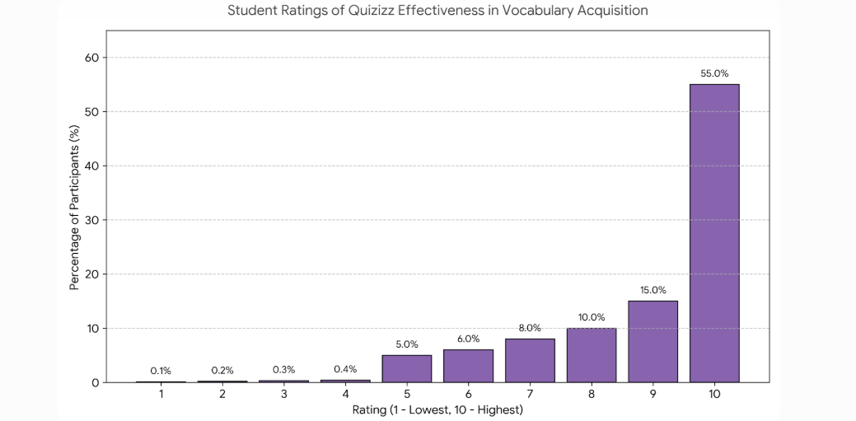
More than half of the participants gave the platform the highest possible rating of ten, while about a quarter of the group rated it slightly lower at nine or eight. A small percentage of students viewed its effectiveness as moderate, scoring it at a seven or six, and roughly one in twenty students gave it a neutral rating of five. On the other hand, dissatisfaction was remarkably low, with fewer than one percent of students assigning a rating of four, three, or two. Overall, these strongly positive reactions highlight that Quizizz successfully supports and enhances vocabulary acquisition for the clear majority of learners.

4.3 Engagement and Enjoyment
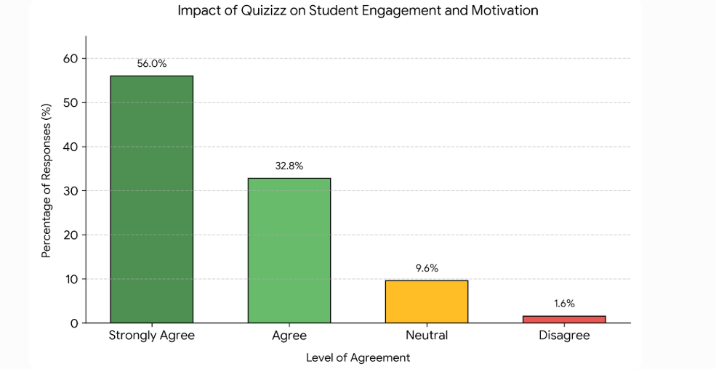
According to the findings, Quizizz greatly increased engagement. There was an 88.8% positive response rate, with 56% of students strongly agreeing and 32.8% agreeing that Quizizz made studying vocabulary more interesting and fun. In the meantime, a small portion disagreed, and 9.6% stayed neutral. This demonstrates how the platform’s gamified and interactive features are essential for boosting motivation and making vocabulary learning more pleasurable.

4.4 Features that Enhance Vocabulary Learning
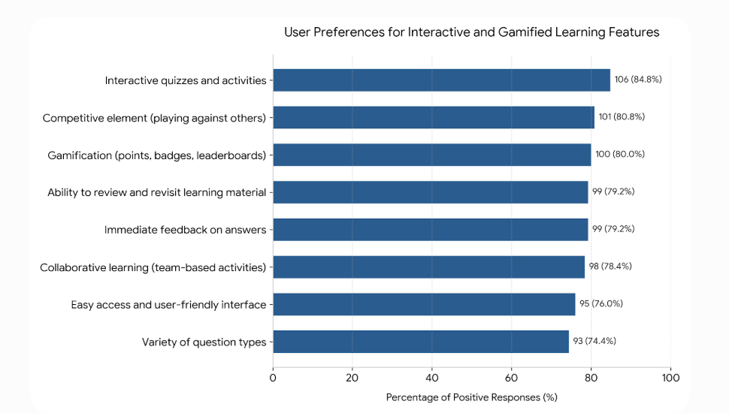
The horizontal bar chart, titled "User Preferences for Interactive and Gamified Learning Features," presents data on what users find most valuable in a modern learning environment, measured by both total count and percentage of positive responses. Out of the surveyed features, "Interactive quizzes and activities" ranks as the most preferred element, securing the highest approval at 106 responses (84.8%). Strong engagement is also seen in competitive and reward-based features, with "Competitive element (playing against others)" closely following at 101 responses (80.8%) and "Gamification (points, badges, leaderboards)" at 100 responses (80.0%). Review and feedback mechanisms also show high, identical utility among learners; both "Ability to review and revisit learning material" and "Immediate feedback on answers" tied at 99 responses (79.2%), while "Collaborative learning (team-based activities)" sits just a fraction lower at 98 responses (78.4%). Rounding out the bottom of the preferences are "Easy access and user-friendly interface" with 95 responses (76.0%) and "Variety of question types" with 93 responses (74.4%). Overall, the chart demonstrates a consistently strong user demand for all listed interactive tools, with even the lowest-ranked feature enjoying an overwhelming popularity rate well above 70%.

4.5 Challenges in Using Quizizz
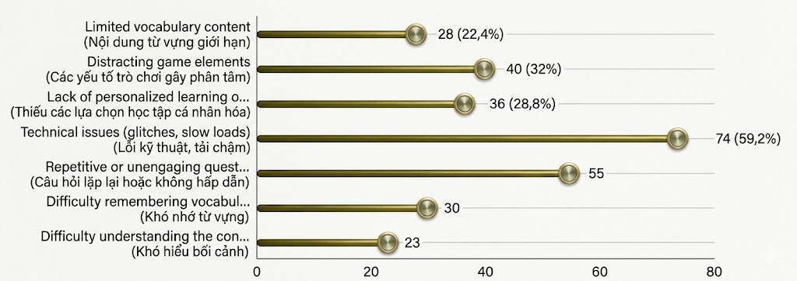
The horizontal bar chart details various challenges and drawbacks encountered by users, detailing both the frequency and percentage of responses for each category. "Technical issues (glitches, slow loads)" stands out as the most prominent problem by a significant margin, reported by 74 respondents (59.2%). This is followed by concerns regarding content and gameplay design, where "Repetitive or unengaging questions" affected 55 users, and "Distracting game elements" were cited by 40 participants (32%). In terms of structural limitations, a "Lack of personalized learning options" was flagged by 36 respondents (28.8%), while "Limited vocabulary content" was noted by 28 users (22.4%). Finally, user-specific learning difficulties were less frequent but still present: 30 participants reported "Difficulty remembering vocabulary", and 23 users noted "Difficulty understanding the context" (18.4%). Collectively, the data indicate that software reliability and content engagement are the primary hurdles users face, while individual comprehension difficulties remain minor pain points by comparison.

4.6 Respondents’ perceptions of how the activity affects their motivation and participation.
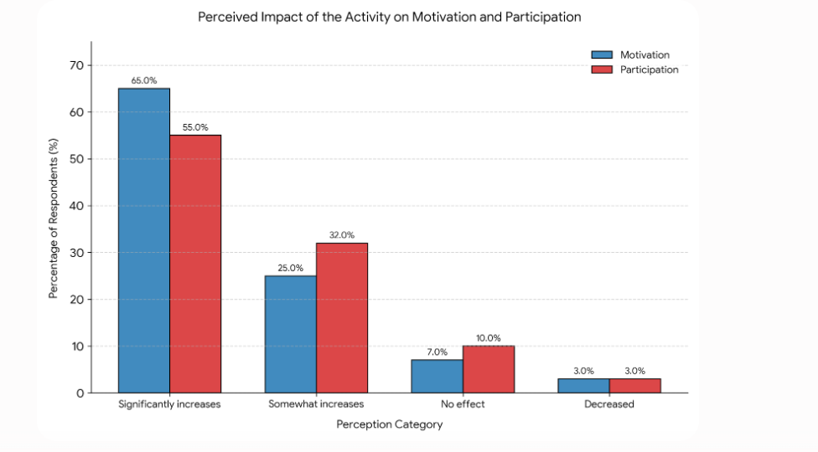
The chart illustrates respondents’ perceptions of how the activity affects their motivation and participation. A large majority of participants reported that the activity significantly increases both their motivation and participation, with the highest percentages shown in the blue bars. Additionally, a considerable number of respondents indicated that the activity somewhat increases these aspects, as represented by the red bars. Only a small proportion believed that the activity had no effect, while very few respondents felt it decreased their motivation or participation. Overall, the findings suggest that the activity has a strongly positive impact on both motivation and participation.

- Conclusion and discussion
5.1 Original hypothesis
The purpose of this study was to evaluate how well Quizizz helped freshmen EFL students at HUFLIT learn vocabulary. In particular, it looked at how Quizizz affected students’ motivation and engagement, the most fulfilling and difficult aspects of the platform, and its function in improving language skills necessary for future employment.
5.2 Findings
The findings show that Quizizz’s interactive and gamified features greatly improve student engagement and vocabulary retention. The study shows that using Quizizz increases student motivation, with many participants expressing a stronger desire to acquire language. The site also offers instant feedback, which promotes active recall and self-evaluation. However, some students encountered challenges such as repetitive question formats and limited opportunities for personalized learning. Despite these drawbacks, the findings confirm that Quizizz serves as an effective tool for vocabulary acquisition.
5.3 Explanation of Findings
The findings are consistent with earlier research highlighting the importance of gamification in language acquisition. Quizizz’s competitive features, which boost motivation and strengthen vocabulary recall through repeated exposure, are responsible for its engagement-driven character. Additionally, by enabling students to track their development and correct errors instantly, the quick feedback system promotes metacognitive techniques. However, some challenges, such as technical issues and repetitive content, may hinder the learning experience. These limitations suggest that while Quizizz is beneficial, its effectiveness can be optimized by
incorporating more diverse question formats and adaptive learning features.
5.4 Limitations
The generalizability of the results is limited by the sample size, as the study only included
freshmen EFL students at HUFLIT. Additionally, external factors such as students’ prior experience with gamified learning and individual learning preferences might have influenced the
findings. The study also did not account for long-term vocabulary retention beyond the
immediate testing period. Future research should consider a broader sample size and a
longitudinal approach to assess the sustained impact of Quizizz on vocabulary development.
5.5 Discussion
Implications
The results highlight the importance of using technology-driven learning resources in language instruction. Students’ favorable reactions to Quizizz demonstrate how gamified platforms can improve learning results and engagement. Additionally, the study contends that interactive learning promotes self-directed learning habits and autonomy, both of which are critical for long-term language acquisition. To get the most out of Quizizz, teachers need to incorporate extra activities like group discussions and writing assignments to guarantee greater vocabulary understanding and real-world applications.
Recommendations
To optimize the effectiveness of Quizizz in vocabulary learning, educators should integrate it into formal instruction by aligning quizzes with course objectives. Enhancing Quizizz with
multimedia elements such as images, audio pronunciations, and contextual examples can
improve vocabulary retention and pronunciation accuracy. Diversifying question formats to
include fill-in-the-blank, sentence construction, and open-ended responses would encourage
critical thinking and deeper understanding. Additionally, incorporating personalized learning
paths within Quizizz can cater to individual student needs, allowing for targeted vocabulary
reinforcement. Finally, conducting follow-up assessments to measure vocabulary retention over
time would provide valuable insights into the platform’s long-term impact. By implementing
these recommendations, Quizizz can become a more dynamic and effective tool for vocabulary
learning, equipping students with essential linguistic skills for academic and professional
success.

References
Abdulaal, M. A. A. (2019). Polysemes and synonym language stock: Linguistic evidence from English to Arabic translation. Nile Valley Journal of Human, Social and Educational Studies and Research, 23(23), 1-32. https://doi.org/10.21608/jwadi.2019.85114
Abrams, S. S., & Walsh, S. (2014). Gamified vocabulary: Online resources and enriched language learning. Journal of Adolescent & Adult Literacy, 58(1), 49- 58. https://doi.org/10.1002/jaal.315
Afzal, N. (2019). A study on vocabulary-learning problems encountered by BA English majors at the university level of education. Arab World English Journal, 10(3), 81– 98. https://doi.org/10.24093/awej/vol10no3.6
Afzal, N. (2019). A Study on vocabulary-learning problems encountered by BA English majors at the university level of education. Arab World English Journal, 10 (3)81 98. https://doi.org/10.24093/awej/vol10no3.6
Aini, Y. I. (2019). Utilization of Quizizz Learning Media for Elementary and Secondary Education Learning in Bengkulu. Journal of Education, 2(25), 1-6.
Alhamami, M. (2016). Vocabulary learning through audio, images, and videos: Linking technologies with memory. CALL-EJ, 17(2), 87-112. https://www.semanticscholar.org
Alsaif, S. A. M., & Deris, F. D. (2019). Vocabulary learning through Duolingo mobile application: Teacher acceptance, preferred application features, and problems. International Journal of Recent Technology and Engineering (IJRTE), 8(2S9), 79-85.
https://doi.org/10.35940/ijrte.B1017.0982S919
Amalia, D. F. (2020). Quizizz website as an online assessment for English teaching and learning: Students’ perspectives. Journal of English Language Teaching, 7(1), 1-8. http://ojs.ikipmataram.ac.id/index.php/joelt
Bal, S. (2018). Using Quizizz.com to enhance pre-intermediate vocabulary knowledge. International Journal of Language Academy, 6(3), 295-303. Boyinbode, O. (2018). Development of a gamification-based English vocabulary mobile learning system. International Journal of Computer Science and Mobile Computing, 7(8), 183–191.
Bury, B. (2017). Testing goes mobile - Web 2.0 formative assessment tools. Conference
Proceedings. ICT for Language Learning (10th Ed.), 87-91. Çevikbaş, G. (2019). The impact of Quizizz on the vocabulary development and motivation of Turkish EFL learners (Master's thesis). Bahçeşehir University, Graduate School of Educational Sciences.
Dewi, K. S., Myartawan, I. P. N. W., Swari, N. K. T. A., & Sugihartini, N. (2020). Quizizz effect
on students’ grammar mastery in higher EFL classroom-based mobile assisted language
learning (MALL). Language and Education Journal Undiksha, 3(1), 15-24.
Ghalebi, R., Sadighi, F., & Bagheri, M. S. (2021). A study of vocabulary learning strategies
among high and low Iranian English vocabulary learners. Cogent Education,8(1). https://doi.org/10.1080/2331186X.2020.1834933
Handoko, W., Mizkat, E., Nasution, A., & Eska, J. (2021, February). Gamification in learning
using Quizizz application as assessment tools. Journal of Physics: Conference Series, 1783(1), p. 012111. IOP Publishing.
Harmer, J. (2007). The practice of English language teaching. Harlow: Longman.
Hermagustiana, I., & Rusmawaty, D. (2017). The use of technology for vocabulary instruction in
EFL classrooms: Support and challenges. Paper presented at the meeting of International
Conference on Education and Technology (2017 ICEduTech), Indonesia. https://doi.org/10.2991/icedutech-17.2018.27
Hwang, G. J., & Wu, P. H. (2012). Advancements and trends in digital game-based learning research: A review of publications in selected journals from 2001 to 2010. British Journal
of Educational Technology, 43, 6–10. https://doi.org/10.1111/j.1467-8535.2011.01242.x
Khan, I. A. (2011). Learning difficulties in English: Diagnosis and Pedagogy in Saudi Arabia. Educational Research, 2(7), 1248-1257. https://www.researchgate.net/publication/234168115
Kılıç, M. (2019). Vocabulary knowledge as a predictor of performance in writing and speaking:
A case of Turkish EFL learners. PASAA, 57, 134–135. https://files.eric.ed.gov/fulltext/EJ1224421.pdf
Lai, C., & Gu, M. (2011). Self-regulated out-of-class language learning with technology. Computer Assisted Language Learning, 24(4), 317– 335. https://doi.org/10.1080/09588221.2011.568417
Lestari, T. W. (2019). Kahoot! and Quizizz: A Comparative Study on the Implementation of Elearning Application toward Students’ Motivation. Karya Ilmiah Dosen,2(2).
Lestari, T. W. (2019). Kahoot! And Quizizz: A comparative study on the implementation of e learning application toward motivation. Journal of English Language Teaching Learning and Literature, 2(2), 13-22. https://journal.stkippgritrenggalek.ac.id/index.php/kid/article/view/150
Ma, Q. (2017). Technologies for teaching and learning L2 vocabulary. In C. A. Chapelle & S.
Sauro (Eds.), The handbook of technology and second language teaching and learning (pp. 45-61). Hoboken, USA: John Wiley & Sons. https://doi.org/10.1002/9781118914069.ch4
Masoud, H. M. A., & Ibrahim, O. L. (2017). The effectiveness of using An e-mind mapping software-based program in developing the faculty of education 2nd year English majors' vocabulary acquisition and use. Journal of Research in Curriculum, Instruction and Educational
Technology (JRCIET), 3(4), 177-224. https://doi.org/10.21608/jrciet.2017.24441
Meng, C. K., Nasir, J. S. B. M., Ming, T. M., & Choo, K. A. (2019). A Gamified Classroom with Technical and Vocational Education and Training (TVET) Students using Quizizz. International Journal of Education, Islamic Studies and Social Sciences Research,4(1).
Ngọc, N. T. B., & Phương, T. T. N. (2022). The application of Quizizz games on vocabulary retention of non-English majors students: A case study at Thai Nguyen University of Education. International Journal of Scientific and Research Publications, 12(5). https://doi.org/10.29322/IJSRP.12.05.2022.p12506
Nhu, H. B., & Tin, D. T. (2019). Impacts of online formative assessment on EFL Students’ writing achievement. Ho Chi Minh City Open University Journal of Science - Social Sciences, 9(1), 55–69. https://doi.org/10.46223/hcmcoujs.soci.en.9.1.271.2019
Pitoyo, M. D., Sumardi, S., & Asib, A. (2020). Gamification-Based Assessment: The Washback
Effect of Quizizz on Students’ Learning in Higher Education.International Journal of Language Education, 4(2), 1-10.
Pusparani, A. D. (2021). The Quizizz platform is the realization of asynchronous learning to
improve students’ vocabulary mastery. ELT Echo: The Journal of English Language Teaching in Foreign Language Context, 6(2). https://doi.org/10.24235/eltecho.v6i2.9312
Rahayu, I. S. D., & Purnawarman, P. (2019, June). The Use of Quizizz in Improving Students’
Grammar Understanding through Self-Assessment. InEleventh Conference on Applied
Linguistics (CONAPLIN 2018). Atlantis Press.
Ramadhan, K., & Zaharani, H. (2021). The effect of word wall media on students’ vocabulary
mastery. Jurnal Mahasiswa Fakultas Ilmu Sosial dan Kependidikan, 2(1), 31-40.
Razali, N., Nasir, N. A., Ismail, M. E., Sari, N. M., & Salleh, K. M. (2020, September). Gamification Elements in Quizizz Applications: Evaluating the Impact on Intrinsic and
Extrinsic Student Motivation. In IOP Conference Series: Materials Science and Engineering (Vol. 917, No. 1, p. 012024). IOP Publishing.
Rowe, M. (2012). A longitudinal investigation of the role of quantity and quality of childdirected speech in vocabulary development. Child Development, 83(5), 1762-1774.
https://doi.org/10.1111/j.1467-8624.2012.01805.x
Schmitt, N. (2010). Researching vocabulary: A vocabulary research manual. Palgrave
Macmillan. https://doi.org/10.1057/9780230293977
Sheir, A. A., Abdel Ghany, A. Y., & El-Hilaly, A. S. (2016). Error Analysis as an effective procedure for improving translation product: Evidence from Egyptian EFL prospective teachers. Educational Sciences, 24(3), 30-49. http://search.mandumah.com/Record/834070
Teng, F. (2019). The effects of context and word exposure frequency on incidental vocabulary
acquisition and retention through reading. The Language Learning Journal, 47(2), 145-158. https://doi.org/10.1080/09571736.2016.1244217
Vitasmoro, P., Jatmiko, & Iwan Candra, A. (2019). Improving students’ English vocabulary
mastery through animation cartoons. In W. Striełkowski (Ed.), Proceedings of the International Conference on Social Science 2019 (ICCS 2019): Advances in Social Science, Education and Humanities Research (Vol. 383, pp. 505-509). Atlantis Press. https://doi.org/10.2991/icss- 19.2019.32
Wibawa, R. P., Astuti, R. I., & Pangestu, B. A. (2019). Smartphone-Based Application “quizizz”
as a Learning Media.Dinamika Pendidikan,14(2), 244-253.
Wu, T., & Huang, Y. (2017). A mobile game-based English vocabulary practice system based on
portfolio analysis. Educational Technology & Society, 20(2), 265–277.
Yawiloeng, R. (2020). Second Language Vocabulary Learning from Viewing Video in an EFL
Classroom. English Language Teaching, 13(7), 76. https://doi.org/10.5539/elt.v13n7p76

