ESL Integration in Japanese Reading Instruction: Exploring the Role of English in Supporting Japanese Reading Comprehension among Senior Japanese-Major Students at VNU-HCM University of Social Sciences and Humanities
Vu Doan Lien Khe, Ph. D.
University of Social Sciences and Humanities, Vietnam National University Ho Chi Minh City
Faculty of Oriental Studies vukhejp@hcmussh.edu.vn, Tel: 0908877336
Abstract:
As Vietnam transitions toward an ESL environment, many students face “language attrition” where their English proficiency declines while focusing on a third language (L3) like Japanese. This case study explores a practical pedagogical approach implemented in Japanese reading classes for fourth-year students at the University of Social Sciences and Humanities (USSH). To tackle this issue, the author introduced a bilingual dynamic that replaces traditional Japanese-Vietnamese translation with Japanese-English “live translation” and vocabulary mapping.
This method encourages students to bridge two foreign languages, gradually creating a cognitive link that may strengthen both. By mapping complex Japanese structures to English counterparts, students deepen their understanding of Japanese nuances while keeping their English active and functional for professional use. To evaluate the model, a mixed-methods research design was employed, involving surveys and qualitative feedback from senior Japanese majors. To make classroom observations more systematic, students’ “live translation” performance was observed in class with a focus on semantic accuracy, lexical equivalence, and response latency.
Findings suggest that ESL integration can enhance Japanese textual analysis and is associated with higher reported confidence and cross-linguistic flexibility for many students. Such results are vital for graduates entering a competitive labor market where “English+1” is a highly sought-after asset. This study offers a practical framework for educators to create English-rich environments within diverse curricula, aligning with the HUFLIT INTESOL 2026 goals of fostering English as a versatile tool for student employability in Vietnam’s evolving education landscape.
Keywords: ESL integration, Japanese reading, L3 acquisition, English attrition, HCMUSSH, multilingualism.
- Introduction
In the current educational landscape of Vietnam, the transition toward an ESL (English as a Second Language) environment has placed unique demands on multilingual learners. At the Department of Japanese Studies, Faculty of Oriental Studies, University of Social Sciences and Humanities, VNU-HCM, senior students often face a subtle but persistent challenge: “language attrition”. While they are heavily focused on mastering Japanese (L3) for their future careers, their English (L2) skills, which they spent years building, tend to stagnate or “fade away” due to a lack of practical use in the specialized curriculum.
For years, the standard approach to teaching Japanese reading has been a direct bridge between Japanese and Vietnamese. While this helps with basic comprehension, it unintentionally creates a linguistic wall that keeps English out of the picture. In today’s job market, where "English + 1" is often the minimum requirement, letting English proficiency slip away during the final years of university represents a missed opportunity for graduates.
The pedagogical approach investigated in this study emerged from the author’s classroom observations while teaching fourth-year Japanese reading courses. Many students demonstrated strong Japanese reading skills yet struggled to maintain confidence in English communication. To address this issue, the author introduced a bilingual instructional model in which students were encouraged to use English as a cognitive bridge when interpreting Japanese vocabulary, grammar, and textual meanings. Rather than relying exclusively on Japanese-Vietnamese translation, students were invited to explore Japanese-English equivalences and participate in spontaneous “live translation” activities. The intention was not to replace Vietnamese but to create additional opportunities for students to activate English in a meaningful academic context.
Despite growing interest in multilingual education, translanguaging, and cross-linguistic transfer, relatively little research has examined the integration of English into Japanese reading instruction within Vietnamese higher education. Previous studies have primarily focused on bilingual education or the acquisition of individual foreign languages, while the pedagogical potential of English as a supporting language for Japanese reading comprehension remains underexplored. Consequently, empirical evidence regarding students’ perceptions, benefits, and challenges associated with this instructional approach is still limited.
Building upon theories of language attrition, cross-linguistic transfer, and multilingual education, this study aims to examine whether the integration of English into Japanese reading instruction can serve as an effective instructional approach for maintaining students’ English proficiency while supporting Japanese language development. More specifically, the study investigates students’ awareness of English attrition, their perceptions of the bilingual instructional model, the influence of English proficiency on those perceptions, and the advantages and challenges associated with using English as a mediating language in Japanese reading classes. In doing so, the study contributes empirical evidence to ongoing discussions surrounding multilingual pedagogical practices in Vietnamese higher education.
Research Objectives
Based on the aforementioned research gap, this study aims to examine the effectiveness of integrating English into Japanese reading instruction as a pedagogical strategy for supporting multilingual language development. More specifically, this study pursues the following objectives: (1) to investigate students’ awareness of English attrition, (2) explore their perceptions of the bilingual instructional model, (3) examine whether these perceptions vary according to English proficiency levels, and (4) identify the benefits and challenges associated with the use of English as a mediating language in Japanese reading classes.
Research Hypotheses
Guided by the theoretical perspectives of language attrition, cross-linguistic transfer, translanguaging, and cognitive load, the study proposes the following hypotheses:
H1: Students will generally demonstrate positive perceptions toward the integration of English into Japanese reading instruction.
H2: Students with higher levels of English proficiency will report more positive perceptions of the bilingual instructional model than students with lower levels of proficiency.
H3: The integration of English into Japanese reading instruction can contribute to maintaining students’ engagement with English while facilitating Japanese reading comprehension.
- Theoretical framework and methodology
2.1 Theoretical framework
2.1.1. Language attrition in the multilingual learning contexts
This study begins with the concept of Language Attrition, which is the gradual fading of a learner’s previously acquired English (L2) as their attention shifts toward mastering Japanese (L3) (Kopke & Schmid, 2004). In a multilingual setting, language systems continuously interact and compete for mental effort rather than functioning independently (Herdina & Jessner, 2002). This research aims to reactivate learners’ underused English by giving it a meaningful role within the Japanese learning environment. Consequently, when learners devote substantial attention to acquiring a new language, previously learned languages may become less accessible over time.
This phenomenon is particularly relevant in the Vietnamese higher education context, where students majoring in Japanese often devote most of their academic efforts to developing Japanese proficiency while using English less frequently. Recent studies suggest that language attrition is not merely a matter of forgetting vocabulary or grammar but also involves reduced confidence, decreased fluency, and diminished willingness to use the language actively (Schmid & Kopke, 2017; Schmid, 2019). Therefore, maintaining meaningful opportunities for English use throughout university education has become an important pedagogical concern.
Within this context, the present study considers ESL integration as a potential strategy for mitigating language attrition by providing students with opportunities to reactivate English while engaging in Japanese reading activities.
2.1.2. The Interdependence Hypothesis and Cross-linguistic transfer
Rather than viewing languages as rivals, this study draws on Cummins’ Interdependence Hypothesis, which proposes that linguistic abilities can be shared and reactivated through a Common Underlying Proficiency (Cummins, 2000). According to this framework, different languages share a Common Underlying Proficiency (CUP), through which linguistic knowledge, cognitive skills, and literacy abilities may transfer across languages.
This perspective is closely associated with the concept of cross-linguistic transfer, which refers to the influence of one language on the learning and processing of another. Research has demonstrated that multilingual learners frequently draw upon previously acquired linguistic knowledge when interpreting new language forms and meanings (Cummins, 2021). Such transfer may occur at lexical, semantic, syntactic, and metacognitive levels.
By encouraging students to connect Kanji meanings with their English equivalents, the model applies Translation in Language Teaching (TILT) not as rote practice, but as a bridge that strengthens both languages in tandem.
In the present study, English is conceptualized as a mediating language that can facilitate Japanese reading comprehension. By encouraging learners to identify connections between Japanese expressions and English equivalents, the instructional model seeks to activate prior linguistic knowledge and strengthen multilingual awareness. Rather than viewing English and Japanese as competing systems, this approach treats them as complementary resources that may mutually reinforce learning.
In the Vietnamese context, the transition towards an ESL environment as part of the National Foreign Languages Project has redefined how students approach multilingualism. Researchers such as Le (2020) emphasize that for Vietnamese learners, the interaction between multiple foreign languages requires a strategic pedagogical shift to optimize cognitive resources (Le, 2020).
2.1.3. Translanguaging as a multilingual pedagogical practice
Recent developments in multilingual education have challenged traditional assumptions that languages should be kept strictly separate in classroom instruction. Translanguaging theory argues that multilingual learners possess an integrated linguistic repertoire from which they flexibly draw according to communicative needs (Garcia & Wei, 2014; Wei, 2018).
The classroom model examined in this study aligns with translanguaging principles by encouraging students to utilize English when interpreting Japanese vocabulary, grammar, and textual meanings. Such practices enable learners to mobilize their full linguistic resources while developing greater awareness of relationships among languages. Furthermore, translanguaging has been identified as an effective approach for supporting multilingual skills in increasingly globalized educational environments (Cenoz & Gorter, 2022).
2.1.4. Cognitive load theory and the language threshold
Despite the potential benefits of multilingual pedagogies, the simultaneous activation of multiple languages may also increase cognitive demands. Cognitive Load Theory proposes that learning effectiveness depends on the limited capacity of working memory to process information (Paas & Ayres, 2014). When instructional tasks require learners to manage several linguistic systems simultaneously, excessive cognitive load may hinder comprehension and learning outcomes.
Related to this concern, the Language Threshold Hypothesis suggests that learners require a minimum level of proficiency before they can effectively benefit from cross-linguistic transfer (Meissel & Meyer, 2017). Students with stronger English proficiency may be better equipped to utilize English as a cognitive support tool when reading Japanese texts, whereas learners with weaker English backgrounds may experience confusion, mental fatigue, or reduced confidence.
Consequently, the effectiveness of ESL integration is likely to vary according to learners’ existing language competence. This perspective provides an important framework for interpreting differences in students’ perceptions and experiences within the bilingual instructional model investigated in the present study.
2.1.5. Conceptual framework of the study
Drawing upon Language Attrition Theory, the Interdependence Hypothesis, Translanguaging Theory, and Cognitive Load Theory, the present study conceptualizes ESL integration as a pedagogical mechanism through which English can function as a cognitive bridge in Japanese reading instruction. The framework assumes that meaningful use of English may help reduce language attrition and facilitate cross-linguistic transfer; however, the effectiveness of such an approach may be moderated by learners’ existing English proficiency and cognitive capacity. These theoretical perspectives collectively inform the investigation of students’ perceptions, experiences, and responses to ESL-integrated Japanese reading activities.
2.2 Methodology
This study employed a mixed-methods case study design to capture the implementation of ESL integration in Japanese reading instruction. A mixed-methods approach was selected because it enables the researcher to combine quantitative evidence with qualitative insights, thereby providing a more comprehensive understanding of students’ perceptions and experiences regarding the bilingual instructional model.
This research was carried out at the Department of Japanese Studies, Faculty of Oriental Studies, USSH, VNU- HCM. The participants consisted of 51 fourth-year students enrolled in a Japanese Reading Comprehension course during the 2025-2026 academic year. These students were selected because they had accumulated substantial learning experience in both English and Japanese and were therefore in a suitable position to reflect on issues related to language attrition, multilingual learning, and cross-linguistic interaction. Furthermore, as students approaching graduation, they represented a population for whom maintaining both English and Japanese proficiency is particularly relevant to future employability.
The scope of this study was deliberately limited to students’ perceptions, attitudes, and experiences regarding the integration of English into Japanese reading activities. The research did not attempt to measure actual improvements in English or Japanese proficiency through standardized language tests. Instead, the study focused on how learners perceived the effectiveness, practicality, benefits, and challenges of the instructional approach. Consequently, the findings should be interpreted within the specific context of Japanese-major students at a single institution and may not be generalized to other educational settings.
Data were collected through a structured survey comprising two complementary parts. The quantitative section used 5-point Likert scale items to measure student satisfaction, vocabulary retention, and perceived cognitive effort. The qualitative section invited open-ended reflections, giving space for students to share their challenges and feelings of mental fatigue. Together, these data sources provided both statistical rigor and a more personal view of the classroom atmosphere. Prior to data collection, the questionnaire was reviewed by two specialists in language education to ensure content validity and alignment with the research objectives. Minor revisions were made based on their feedback to improve clarity and relevance.
The internal consistency of the questionnaire was examined using Cronbach’s alpha. The overall reliability coefficient for the nine Likert-scale items was α=.789, indicating acceptable internal consistency according to commonly accepted standards for educational research (Taber, 2018). Furthermore, the subscale measuring perceptions of ESL integration demonstrated satisfactory reliability (α=.758). These results suggest that the instrument was sufficiently reliable for investigating students’ perceptions of English attrition and ESL integration in Japanese reading instruction.
Table 1. Reliability analysis of the questionnaire
Scale | Number of items | Cronbach’s Alpha
English attrition | 2 | .506
ESL integration effectiveness | 5 | .758
Career relevance | 2 | .638
Overall questionnaire | 9 | .789
As shown in Table 1, the overall questionnaire achieved an acceptable level of internal consistency (α = .789). The ESL Integration Effectiveness subscale demonstrated the highest reliability (α = .758), while the lower coefficients observed in the two-item subscales may be attributed to the limited number of items rather than substantial measurement problems.
Quantitative data were analyzed using SPSS 26.0. Descriptive statistics (Mean and Standard Deviation) established a baseline for student perceptions, followed by a one-way ANOVA comparing three proficiency groups, Pre-intermediate, Intermediate, and Advanced, to examine whether “cognitive overload” differed significantly among them. Finally, thematic coding was applied to the qualitative responses, allowing the numerical findings to be interpreted through the authentic voices and experiences of the participants.
Qualitative responses were analyzed using thematic analysis following the framework proposed by Braun and Clarke (2006). The analysis involved familiarization with the data, generation of initial codes, identification of recurring themes, review and refinement of themes, and interpretation of findings. Coding was conducted iteratively to enhance consistency, and the resulting themes were continuously compared with the original responses to ensure interpretive validity. The qualitative findings were subsequently used to complement and explain patterns identified in the quantitative analysis.
2.3 Research delimitations and limitations
Several delimitations should be acknowledged. First, the study focused exclusively on fourth-year Japanese-major students at the USSH, VNU-HCM. Second, the investigation centered on students’ perceptions and experiences rather than objective measures of language proficiency. Third, the bilingual instructional model was implemented within a Japanese Reading Comprehension course and may not reflect learning conditions in other language courses or institutions.
In addition, the relatively small sample size and the use of self-reported data may limit the generalizability of the findings. Future research could incorporate larger participant groups, longitudinal designs, and direct assessments of language performance to provide a more comprehensive evaluation of ESL integration in multilingual learning environments.
- Discussion and findings
3.1. A multimodal and bilingual approach in the classroom
The intervention implemented in this research was designed as a student-centered, multimodal environment that prioritizes genuine understanding over rote translation. In this model, the classroom is divided into small groups, each responsible for presenting a specific reading passage. The presentation phase follows a “non-Vietnamese” guideline for explanation, but participation in English use remains voluntary. When defining new vocabulary or complex Kanji, the presenting group is encouraged to avoid the mother tongue and to experiment with Japanese definitions, Japanese synonyms, visual aids, realia, gestures, and, where possible, English equivalents to convey meaning. The ultimate aim is not to force English into the classroom, but to help students realize that once Vietnamese is set aside, they can flexibly draw on multiple resources (especially their long-acquired L2 English, to interpret and explain the L3). This force-free, multimodal strategy encourages students to engage with Japanese through various cognitive channels, reducing the immediate reliance on Vietnamese.
Following the vocabulary presentation, the rest of the class participates in a “live translation” challenge. This phase is designed to be low-pressure yet intellectually stimulating. Students are invited to translate the reading content into Vietnamese or, as a preferred challenge, into English without the aid of dictionaries. This spontaneous translation process is intended to test their immediate linguistic reflexes. During this time, both the presenting group and the teacher act as facilitators, monitoring the “live” outputs to provide immediate feedback on accuracy and nuance.
The final stage of this model involves a collaborative confirmation of the text’s meaning. After the students have attempted their translations, the teacher provides the “standard” or polished version prepared by the students in advance. This ensures that while the process is creative and bilingual, the final learning outcome remains academically precise. By treating English not as a mandatory requirement but as an optional tool for those who wish to experiment, this paper argues that the classroom can become a more dynamic space, where Japanese texts are interprted through a broader, more international perspective, not only through Vietnamese.
3.2. Results and findings
3.2.1. Participant profile and engagement rate
This research was conducted within the fourth-year cohort at the Department of Japanese Studies (USSH, VNU-HCM), where the typical class size ranges from 25 to 32 students across three groups. Out of a total population of approximately 85 students, this paper successfully gathered 51 valid responses, achieving a 60% participation rate. This level of engagement provides a reliable snapshot of the student body’s diverse linguistic backgrounds.
The findings revealed a significant “proficiency gap” among the participants. While a majority (72.5%) possess a solid N2 level in Japanese, their English proficiency (L2) is far less uniform. Approximately 45% of respondents are at or below the Pre-intermediate level (IELTS 5.0 equivalent), while only 14% have reached the Upper-intermediate or Advanced stages. This diversity is essential for this paper’s analysis, as it highlights that the effectiveness of the classroom intervention is not one-size-fits-all but varies according to individual linguistic capital (Hulstijn, 2015). This proficiency imbalance is particularly relevant to the theoretical assumptions underlying the study. From the perspective of language attrition, the findings suggest that English proficiency may become increasingly vulnerable when learners devote substantial attention to Japanese language development. At the same time, the diversity of English proficiency levels provides an appropriate context for examining whether students’ responses to ESL integration vary according to their existing linguistic resources. The distribution of English proficiency levels is illustrated in Figure 1.
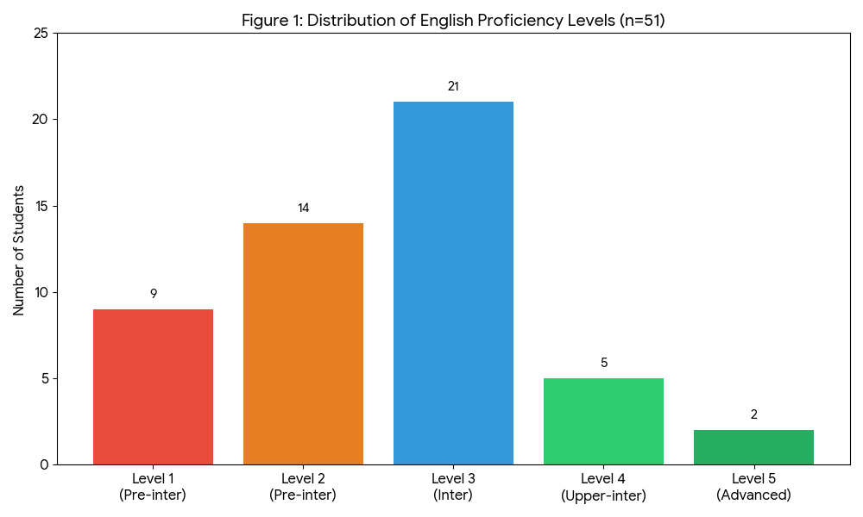
Figure 1. Distribution of English proficiency levels among the surveyed students (n=51)
Source: Compiled by the researcher from survey data.
3.2.2. Quantitative findings
The descriptive statistics indicate a generally high level of awareness regarding English attrition among the participants. The mean score for perceived decline in English proficiency (M=4.18, SD=1.05) reveals that many students recognized a reduction in opportunities to actively use English while concentrating on Japanese language studies. Similarly, the relatively high score for difficulty in switching between Japanese and English (M=4.26, SD=0.89) reflects the linguistic challenges associated with managing multiple foreign languages simultaneously.
Participants also reported generally positive perceptions of the bilingual instructional model. Scores related to vocabulary retention through English equivalents (M = 3.90, SD = 0.98), perceived enjoyment (M=3.63, SD=0.87), and excitement in identifying cross-linguistic connections (M=3.76, SD=0.93) suggest that students viewed ESL integration as a potentially valuable learning strategy. These findings point to a cross-linguistic transfer mechanism consistent with Cummins’ Interdependence Hypothesis, in which prior linguistic knowledge is reused across languages.
Moreover, the highest mean scores were observed in items related to career readiness and employability. Participants strongly agreed that multilingual competence represented an important professional asset, as reflected in the high ratings for confidence in applying to multinational companies (M=4.37, SD=0.72) and the perceived importance of the “English + 1” model (M = 4.36, SD=1.04). These findings suggest that students viewed ESL integration not only as a learning strategy but also as a means of enhancing their future professional competitiveness. Descriptive statistics for the key variables are summarized in Table 2.
Table 2: Descriptive statistics of student perception (n=51)
Survey items (Key variables) | Mean (M) | Std. Deviation (SD)
A. Language attrition awareness
1. Perception of English skills “fading” | 4.18 | 1.05
2. Difficulty in switching between JPN and ENG | 4.26 | 0.89
B. Bilingual model effectiveness
3. Vocabulary retention via equivalents | 3.90 | 0.98
4. Interesting challenge (instead of pressure) | 3.63 | 0.87
5. Excitement in finding linguistic connections | 3.76 | 0.93
C. Practicality & career
6. Confidence in applying to MNCs | 4.37 | 0.72
7. Necessity of “English + 1” model | 4.36 | 1.04
Source: Calculated from the primary survey data (2026) by the author
A one-way ANOVA was conducted to examine whether students’ perceptions differed according to English proficiency level. The analysis revealed a statistically significant difference in perceived interest across proficiency groups (p < .05). Students with higher levels of English proficiency reported more positive attitudes toward the instructional model, whereas learners in the lowest proficiency group expressed comparatively lower levels of interest and engagement.
This finding supports the Language Threshold Hypothesis, which suggests that learners must possess a minimum level of linguistic competence before they can effectively benefit from cross-linguistic transfer. For students with stronger English proficiency, the bilingual instructional model appeared to function as a cognitively stimulating learning strategy that facilitated connections between Japanese and English. In contrast, learners with more limited English proficiency may have experienced difficulties managing the simultaneous activation of two foreign languages.
The findings also align with Cognitive Load Theory. While multilingual interaction can promote deeper processing and transfer of knowledge, excessive cognitive demands may hinder learning when students lack sufficient linguistic resources. Consequently, the effectiveness of ESL integration appears to depend not only on the instructional design itself but also on learners’ existing proficiency levels. Differences in perceived interest across proficiency levels are illustrated in Figure 2.
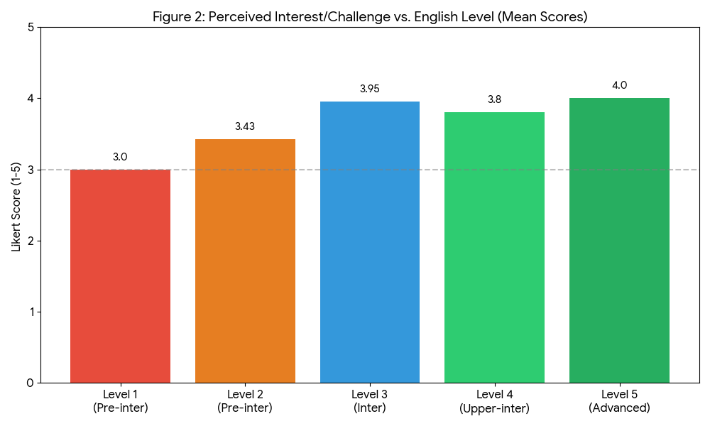
Figure 2. Mean scores of Perceived Interest versus English proficiency levels
Source: Extracted from SPSS analysis of survey responses 2026
3.2.3. Qualitative findings
The qualitative responses provided valuable insights into how students experienced the integration of English into Japanese reading instruction. Through thematic analysis, three major themes emerged, which were English as a cognitive bridge, enhanced multilingual awareness, and cognitive burden associated with linguistic limitations. This thematic analysis revealed three recurring themes in students’ responses: English as a cognitive bridge, enhanced multilingual awareness and learning motivation, and cognitive burden associated with linguistic limitations.
Theme 1: English as a cognitive bridge for Japanese reading comprehension
A recurring theme across participants’ responses was the perception of English as a useful intermediary for understanding Japanese vocabulary and grammatical structures. Many students reported that identifying English equivalents enabled them to process unfamiliar Japanese expressions more efficiently and establish meaningful connections between previously acquired knowledge and new linguistic input.
This finding supports Cummins’ Interdependence Hypothesis, which proposes that knowledge acquired in one language can facilitate learning in another through shared learning capacity. Rather than functioning as separate linguistic systems, English and Japanese appeared to interact dynamically within students’ learning processes. For many participants, English served as a practical scaffold that supported comprehension and promoted deeper engagement with Japanese texts.
Theme 2: Development of multilingual awareness and learning motivation
A second theme concerned the development of multilingual awareness. Participants frequently described feelings of satisfaction when recognizing similarities among languages and successfully drawing connections between Japanese and English. Several students reported that the instructional approach encouraged them to think more critically about language structures and vocabulary relationships rather than relying exclusively on memorization.
These experiences are consistent with recent perspectives on translanguaging and multilingual education, which emphasize the pedagogical value of drawing upon learners’ full linguistic repertoires (Garcia & Wei, 2014; Cenoz & Gorter, 2022). The findings suggest that ESL integration may promote a more flexible and reflective approach to language learning by encouraging students to utilize multiple linguistic resources simultaneously. Furthermore, the ability to engage with more than one foreign language appeared to strengthen students’ confidence in their future academic and professional development.
Theme 3: Cognitive burden and linguistic insecurity
Despite the generally positive responses, a third theme highlighted challenges associated with the bilingual instructional model. Participants with lower levels of English proficiency frequently reported feelings of confusion, mental fatigue, and anxiety when attempting to process Japanese through English. For these students, the additional requirement to activate English sometimes increased the complexity of the learning task rather than facilitating comprehension.
This finding can be interpreted through the lens of Cognitive Load Theory (Paas & Ayres, 2014), which suggests that excessive demands on working memory may negatively affect learning performance. The results also provide support for the Language Threshold Hypothesis (Meissel & Meyer, 2017), indicating that learners may require a certain level of English proficiency before they can fully benefit from cross-linguistic transfer. Therefore, the benefits of ESL integration may vary across learners, particularly according to their English proficiency levels..
Overall, the qualitative findings complement the quantitative results by revealing both the opportunities and challenges associated with ESL integration in Japanese reading instruction. While many students perceived English as valuable cognitive resources that enhanced multilingual awareness and reading comprehension, others experienced difficulties resulting from limited English proficiency. These findings suggest that the implementation of bilingual instructional practices should remain flexible and responsive to learners’ varying linguistic backgrounds.
- Conclusions and pedagogical implications
The present study investigated the integration of English as a supporting language in Japanese reading instruction among fourth-year Japanese-major students at the USSH, VNU-HCM. Drawing upon theories of language attrition, cross-linguistic transfer, translanguaging, and cognitive load, the study explored students’ perceptions of a bilingual instructional model designed to maintain English engagement while supporting Japanese reading comprehension.
The findings indicate that participants generally perceived the integration of English positively. Many students reported that English functioned as a useful cognitive bridge, enabling them to establish meaningful connections between previously acquired linguistic knowledge and new Japanese vocabulary and structures. The results further suggest that ESL integration may contribute to reducing the effects of language attrition by creating opportunities for students to continue using English within their academic learning environment.
At the same time, this study revealed important differences among learners. Students with stronger English proficiency demonstrated greater enthusiasm and adaptability toward the bilingual instructional approach, whereas those with more limited English backgrounds were more likely to experience confusion, frustration, and increased cognitive burden. These findings support both the Language Threshold Hypothesis and Cognitive Load Theory, suggesting that the effectiveness of multilingual instructional practices is influenced by learners’ existing linguistic resources.
Overall, in this study, students reported that integrating English into Japanese reading instruction may provide a practical way to support multilingual language development among Japanese major students. Rather than treating English and Japanese as competing languages, the study supports the view that they can function as complementary resources that mutually reinforce language learning when implemented appropriately.
Several pedagogical implications can be drawn from the findings of this study. First, ESL integration should be implemented gradually and adapted to students’ English proficiency levels. While higher-proficiency learners may benefit from more extensive English-mediated activities, lower-proficiency students may require additional scaffolding to prevent excessive cognitive load. Second, instructors should adopt translanguaging practices that encourage flexible movement between Japanese, English, and Vietnamese rather than enforcing rigid language separation. Such practices may help learners utilize their full linguistic repertoire and facilitate deeper comprehension of reading materials. Third, vocabulary instruction can be enhanced through the systematic incorporation of English-Japanese lexical mapping activities. Encouraging students to identify semantic relationships among languages may strengthen vocabulary retention and promote cross-linguistic awareness. Fourth, multilingual reading tasks should emphasize meaning-making rather than direct translation. Activities such as collaborative discussion, vocabulary comparison, and contextual interpretation may help students engage more actively with texts while maintaining meaningful use of English. Finally, universities may consider incorporating multilingual instructional approaches into language programs as a means of supporting graduates’ employability. In an increasingly globalized labor market, maintaining proficiency in both English and Japanese may provide students with a significant professional advantage.
Several limitations should be acknowledged. First, this study was conducted with a relatively small sample drawn from a single institution, which may limit the generalizability of the findings. Second, this investigation relied primarily on self-reported perceptions rather than objective measures of language proficiency. Third, this intervention was implemented within a specific Japanese reading course and over a limited period of time.
Future studies may expand the sample size, include participants from multiple institutions, and employ longitudinal research designs to examine the long-term effects of ESL integration on both English maintenance and Japanese language development. Furthermore, future research could incorporate standardized language assessments to provide more objective evidence regarding the effectiveness of multilingual instructional approaches.
Form the teacher’s point of view, the bilingual model also made classroom interaction more lively, as students had more options for expressing partial understanding before switching back to Japanese.
References
Braun, V., & Clarke, V. (2006). Using thematic analysis in psychology. Qualitative Research in Psychology, 3(2), pp.77-101. https://doi.org/10.1191/1478088706qp063oa
Cenoz, J., & Gorter, D. (2022). Pedagogical translanguaging and multilingual education. Language Teaching, 55(3), pp. 342-354. https://doi.org/10.1017/S0261444821000062
Cummins, J. (2000). Language, power, and pedagogy: Bilingual children in the crossfire. Multilingual Matters.
Cummins, J. (2017). Bilingual education and bilingualism (6th ed.). Multilingual Matters.
Cummins, J. (2021). Rethinking the education of multilingual learners. Multilingual Matters.
Garcia, O., & Wei, L. (2014). Translanguaging: Language, bilingualism and education. Palgrave Macmillan.
Herdina, P., & Jessner, U. (2002). A dynamic model of multilingualism: Perspectives of change in psycholinguistics. Multilingual Matters.
Hulstijn, J. H. (2015). Language proficiency in native and non-native speakers: Theory and research. John Benjamins.
Kopke, B., & Schmid, M. S. (2004). Language attrition: The next phase. In M. S. Schmid, B. Kopke, M. Keijzer, & L. Weilemar (Eds.), First language attrition: Interdisciplinary perspectives on methodological issues (pp. 1-43). John Benjamins.
Le, V. C. (2020). Language education policy in Vietnam: From regional integration to global citizenship. In Routledge Handbook of Heritage Language Education (pp. 45-58). Routledge.
Meissel, K., & Meyer, B. (2017). The language threshold hypothesis: Reviewing the evidence for a multi-faceted concept. Modern Language Journal, 101(2), pp. 341-355.
Paas, F., & Ayres, P. (2014). Cognitive load theory: A broader view on the role of memory in learning and education. Educational Psychology Review, 26(2), pp.191-195.
Schmid, M. S., & Kopke, B. (2017). The relevance of first language attrition to theories of bilingual development. Linguistic Approaches to Bilingualism, 7(6), pp. 637-667.
https://doi.org/10.1075/lab.17058.sch
Schmid, M. S. (2019). The impact of language attrition. Oxford University Press.
Taber, K. S. (2018). The use of Cronbach’s alpha when developing and reporting research instruments in science education. Research in Science Education, 48(6), pp. 1273-1296.
Wei, L. (2018). Translanguaging as a practical theory of language. Applied Linguistics, 39(1), pp. 9-30.

