AI-Powered Game-Based Vocabulary Practice for Enhancing Vocabulary Retention among Young Vietnamese EFL Learners: A Quasi-Experimental Study
Trang Trinh Khanh Lien¹, & Chi Ho Phuong Nguyen²
Abstract
This quasi-experimental study examined whether Blooket-supported game-based vocabulary practice enhanced vocabulary retention among young Vietnamese EFL learners. Eighty-two A2-level learners aged 10–11 at a private language centre in Ho Chi Minh City participated in an eight-week intervention. The experimental group (n = 42) used Blooket for repeated vocabulary retrieval, while the control group (n = 40) received conventional teacher-led review, textbook exercises, oral repetition, and written practice. Pre-test and post-test scores were analysed using paired-samples and independent-samples t-tests, and classroom observations were used to contextualise the learning process. The experimental group improved from M = 5.26 to M = 7.31, t(41) = 14.59, p < .001, with a very large effect size (Cohen’s d = 2.25), and outperformed the control group on the post-test. Observation data indicated that repeated retrieval, immediate feedback, peer support, and teacher scaffolding contributed to the gains. The findings support the use of Blooket as a supplementary review tool, provided that game-based practice is followed by speaking and writing tasks that promote productive vocabulary use.
Keywords: AI-powered learning, Blooket, game-based vocabulary practice, vocabulary retention, young EFL learners
1 Corresponding author, Graduate Student, Faculty of Foreign Languages, Ho Chi Minh City University of Foreign Languages and Information Technology, Ho Chi Minh City, Vietnam; Email: MES24155@ms.huflit.edu.vn
2 Lecturer, Faculty of Foreign Languages, Ho Chi Minh City University of Foreign Languages and Information Technology, Ho Chi Minh City, Vietnam

- Introduction

1.1. Background and Context
Vocabulary knowledge is essential to English comprehension and production, yet young EFL learners often have limited opportunities to revisit and use new words beyond the classroom. In many Vietnamese language-centre classes, vocabulary review still relies heavily on teacher explanation, textbook exercises, oral repetition, and short written tasks. These practices remain useful, but they may not provide sufficient active retrieval, immediate feedback, or sustained participation for children aged 10–11. Digital game-based platforms may help address this need by increasing the frequency and intensity of vocabulary practice.
This context matters because private language centres serve a substantial number of Vietnamese children who study English in addition to their mainstream schooling. These learners frequently encounter short lesson periods, mixed-ability classes, and limited English exposure outside class. Evidence from this setting can therefore inform teachers who must combine curriculum coverage with motivating, time-efficient vocabulary recycling.
1.2. Problem Statement
Although Blooket is increasingly used to make vocabulary lessons more engaging, classroom enthusiasm does not by itself demonstrate durable learning. Existing studies have often emphasised motivation, enjoyment, or general perceptions, while fewer have compared measurable vocabulary retention outcomes among young Vietnamese EFL learners. It also remains unclear which classroom processes, including repeated retrieval, immediate feedback, peer interaction, and teacher scaffolding, help explain any observed gains. Without such evidence, teachers may adopt game-based tools primarily for their entertainment value without knowing how to integrate them effectively into vocabulary instruction.
1.3. Research Gap
Previous Blooket research has largely focused on university students, older learners, or broad measures of motivation and acceptance (Huynh, 2024; Pham & Ly, 2023; Quyen & Nguyen, 2025; Thu & Dan, 2023). Fewer studies have examined vocabulary retention as the principal outcome among children aged 10–11 in Vietnamese language-centre settings. In addition, limited research has combined pre-test/post-test comparisons with classroom observations to explain how game-based practice operates during instruction. This study addresses these gaps by comparing Blooket-supported and conventional vocabulary review and by using observation data to interpret the quantitative results.
1.4. Research Objectives
The study aimed to:
- determine whether Blooket-supported vocabulary practice improves young learners’ vocabulary retention;
(2) compare the vocabulary gains of learners receiving Blooket-supported practice with those receiving conventional instruction;
(3) use classroom observations to explain the learning processes associated with the outcomes;
(4) identify practical conditions for effective classroom implementation.
1.5. Research Questions
RQ1. To what extent does Blooket-supported game-based vocabulary practice improve young EFL learners’ vocabulary retention compared with conventional vocabulary instruction?
RQ2. How do classroom observations help explain the vocabulary-learning gains observed after the intervention?
RQ3. What pedagogical conditions support the effective integration of Blooket into young EFL vocabulary classrooms?
1.6. Research Hypotheses
H0: There is no statistically significant difference between the vocabulary gains of learners receiving Blooket-supported practice and those receiving conventional vocabulary instruction.
H1: Learners receiving Blooket-supported practice demonstrate significantly greater vocabulary gains than learners receiving conventional vocabulary instruction.
1.7. Scope and Delimitations
The study was delimited to 82 A2-level learners aged 10-11 at one private language centre in Ho Chi Minh City. It examined an eight-week vocabulary intervention using intact classes, with vocabulary retention measured through immediate pre-tests and post-tests. The study focused on Blooket as a supplementary review tool and did not evaluate all language skills, long-term delayed retention, or generative artificial-intelligence tutoring. Classroom observations were limited to the experimental group and were used to contextualise implementation rather than to represent all Vietnamese language-centre classrooms.
1.8. Significance of the Study
The study contributes context-specific evidence on the use of game-based vocabulary practice with young Vietnamese learners. It is practically relevant to teachers and language-centre managers because it identifies not only whether learners improved but also how pacing, feedback, grouping, and follow-up tasks influenced implementation. The findings may support more purposeful decisions about when and how Blooket should be used in vocabulary lessons.
- Literature Review
2.1. Vocabulary Retention and Repeated Retrieval
Vocabulary retention refers to learners’ ability to remember and retrieve lexical items after initial learning. Vocabulary is central to language learning because it supports comprehension and production in listening, speaking, reading, and writing (Nation, 2001). However, knowing a word is not limited to memorizing its meaning; it also includes knowledge of form, use, collocation, and context (Schmitt, 2010). Therefore, vocabulary retention should be understood as the ability to access and use words after repeated learning experiences.
Repeated exposure and retrieval are important for vocabulary development. Learners need to encounter words several times in different contexts to strengthen lexical knowledge (Laufer & Goldstein, 2004; Webb & Nation, 2017). For young EFL learners, repetition should not be purely mechanical because monotonous drills may reduce attention. Instead, vocabulary practice should include interaction, feedback, and meaningful participation, which are suitable for young learners’ cognitive and affective characteristics (Cameron, 2001; Pinter, 2006).
2.2. Game-Based Vocabulary Practice
Game-based learning can make vocabulary review more active and engaging. Gamification refers to the use of game elements, such as points, challenges, rewards, and competition, in non-game learning contexts (Deterding et al., 2011; Kapp, 2012). In vocabulary lessons, these elements may encourage learners to review words repeatedly and participate more actively.
However, games do not automatically lead to learning. Their effectiveness depends on instructional design and classroom management (Hamari et al., 2014; Subhash & Cudney, 2018). In vocabulary teaching, game-based activities are useful when they help learners notice word forms, retrieve meanings, receive feedback, and reuse target vocabulary. Therefore, the game should support the learning objective rather than distract students from it.
2.3. Blooket Interface and Vocabulary Practice
Blooket provides a wide range of game modes that integrate learning tasks with playful competition (Huang, 2022). Each mode introduces different challenges and rewards, giving learners multiple opportunities for repeated practice and motivation:
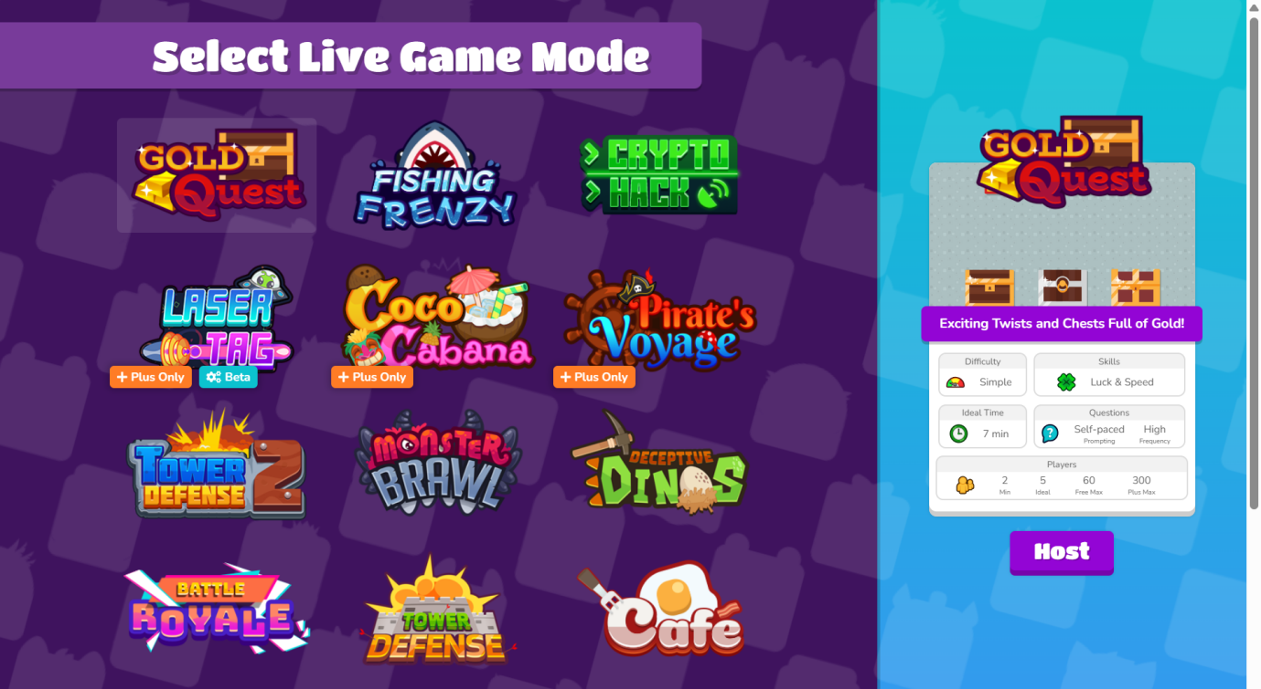
Figure 1
The live game mode options on Blooket
Gold Quest: Players answer questions correctly to open treasure chests, which may contain points or special items, including the ability to steal scores from other players.
Crypto Hack: Learners choose passwords and attempt to “hack” other players’ accounts by answering questions and guessing their passwords correctly to gain currency.
Fishing Frenzy: Players catch fish of different weights by responding accurately, with heavier catches yielding higher points.
Blook Rush: Participants can attack or defend. Correct answers allow players to reduce opponents’ shields or add protection for their team.
Battle Royale: Learners compete individually or in teams, eliminating others through correct responses until a winner remains.
Tower Defense: Players build and upgrade towers to defend against waves of enemy “blooks,” while answering questions to strengthen their defenses.
Café: Students role-play as café staff, answering questions to earn points that are exchanged for serving dishes.
Factory: Players acquire different units that produce resources at varying rates, with correct answers helping them optimize their factories.
Racing: Participants compete to be the fastest to answer all questions correctly, with progress visualized as a race.
Classic: The simplest format where learners answer questions in sequence, similar to a traditional quiz but enhanced with playful animations.
From the teacher’s side, Blooket provides automated scoring, instant feedback, response tracking, and class performance data. These features can help teachers identify difficult vocabulary items and plan follow-up instruction. In this study, Blooket is described as AI-powered only in this cautious operational sense, not as a fully adaptive or generative AI system. This view is consistent with research suggesting that automated feedback and learning analytics can support more responsive teaching (Chen et al., 2020; Hwang et al., 2020; Zawacki-Richter et al., 2019).
2.4. Blooket-Supported Vocabulary Retention
Blooket may support vocabulary retention in three main ways. First, it provides repeated encounters with target words through several rounds of gameplay, which is important for vocabulary learning (Nation, 2001; Webb & Nation, 2017). Second, it encourages active retrieval because learners need to choose or recall answers during the game. Third, it gives immediate feedback, allowing learners to notice and correct errors quickly.
Previous studies have reported that Blooket can increase learners’ enjoyment, motivation, and classroom participation (Huynh, 2024; Pham & Ly, 2023; Quyen & Nguyen, 2025; Thu & Dan, 2023). Some studies have also found positive effects on vocabulary learning outcomes (Phupunna & Hongsamsibkao, 2024; Sinaga et al., 2025; Sulistyanto & Asyhar, 2024). Nevertheless, enjoyment should not be equated with durable vocabulary learning. Teachers still need to connect Blooket activities with lesson objectives, post-game review, and meaningful vocabulary use.
2.5. Conceptual Framework
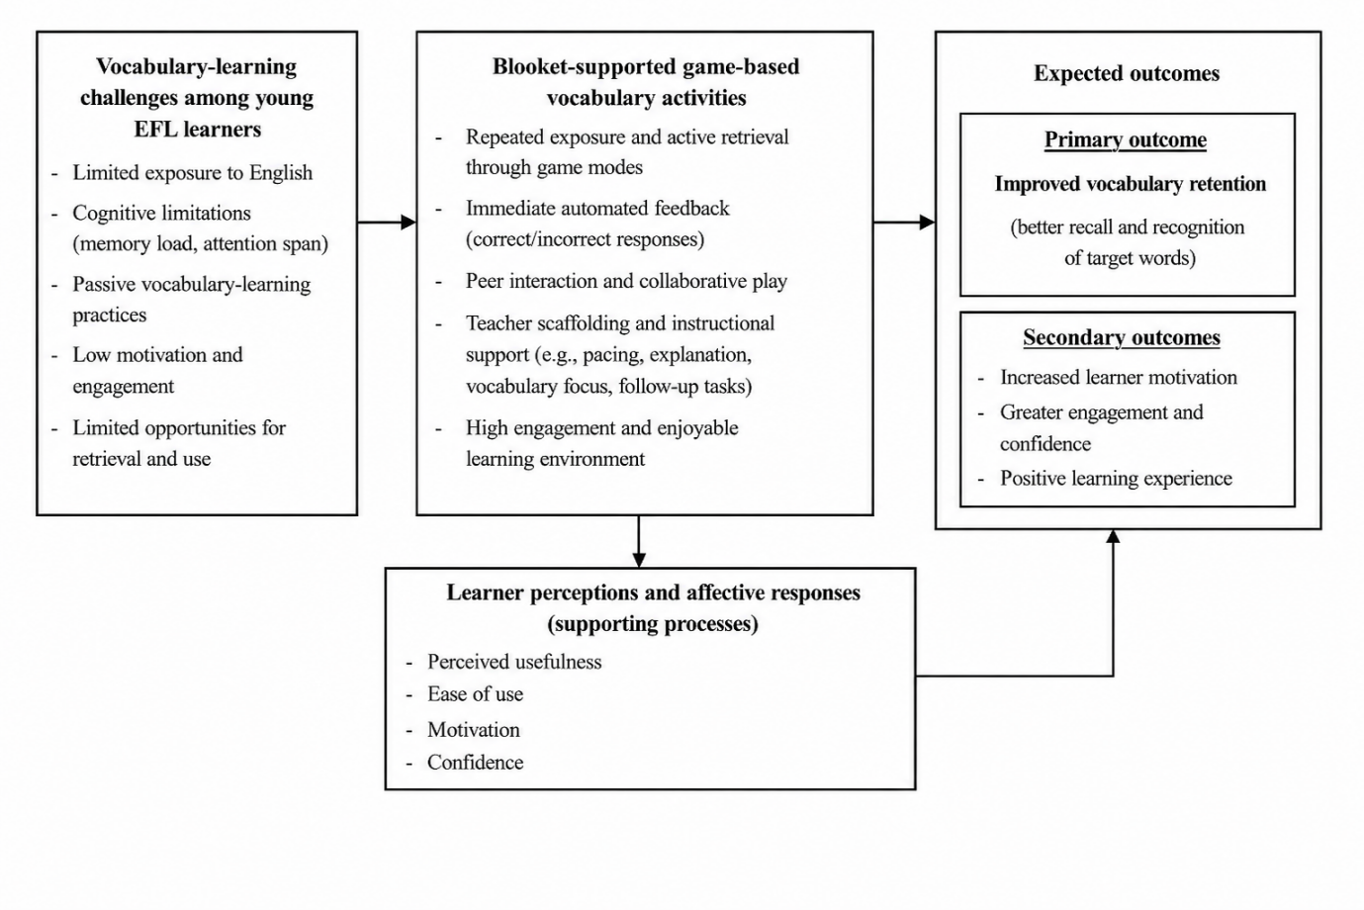
Figure 2
Conceptual Framework of Blooket-Supported Vocabulary Learning among Young EFL Learners
The conceptual framework illustrates how Blooket-supported game-based vocabulary activities may address common vocabulary-learning challenges among young EFL learners. These challenges include limited exposure to English, cognitive limitations, passive vocabulary-learning practices, low motivation, and insufficient opportunities to retrieve and use target words. This context is particularly relevant because young learners require repeated, engaging, and appropriately scaffolded practice to sustain attention and strengthen vocabulary retention.
Blooket-supported activities are proposed to address these challenges through repeated exposure, active retrieval, immediate automated feedback, peer interaction, and teacher scaffolding. Repeated game rounds provide learners with opportunities to encounter and retrieve target vocabulary, while immediate feedback helps them recognise and correct errors. Peer interaction and collaborative play may further support participation, whereas teacher scaffolding, including appropriate pacing, explanation, vocabulary focus, and follow-up tasks, ensures that game participation remains connected to the learning objectives.
The primary expected outcome is improved vocabulary retention, particularly better recall and recognition of target words. Increased motivation, engagement, confidence, and positive learning experiences are treated as secondary outcomes. Learner perceptions and affective responses, including perceived usefulness, ease of use, motivation, and confidence, are included as supporting processes that may help explain learners’ participation in Blooket-based activities. However, these factors are not presented as statistically tested mediating variables.
The framework does not assume that Blooket alone produces vocabulary gains. Instead, it proposes that its educational value emerges from the interaction between game-based features, learner responses, peer participation, and teacher guidance. This framework therefore guides the interpretation of both the vocabulary-test results and the classroom-observation evidence in the present study.
- Methodology

Research Design

The study used a quasi-experimental classroom design. This design was appropriate because the research was conducted in a real language-centre setting where random assignment of individual learners was not feasible, so intact classes were used (Cook & Campbell, 1979). Quantitative data from vocabulary pre-tests and post-tests were used to examine vocabulary retention outcomes. Classroom observation data were used to contextualize how learners participated during Blooket-supported activities and how teacher scaffolding shaped the implementation.
This paper focuses specifically on vocabulary retention outcomes. Questionnaire and interview data are not foregrounded because the purpose of the paper is to examine measurable vocabulary learning gains and classroom implementation rather than learners’ general perceptions of Blooket.

3.2. Context and Participants
The research was conducted at Minds Connect Academy, a private English language centre in Ho Chi Minh City, Vietnam. This setting was selected because private language centres provide substantial supplementary English instruction to Vietnamese children but remain underrepresented in research on game-based vocabulary learning. The participants were 82 A2-level learners aged 10–11, assigned by intact class to an experimental group (n = 42) and a control group (n = 40). The experimental group comprised three classes, coded as SE.9, SE.10, and SE.11 for reporting purposes. Both groups studied the same target vocabulary over the same eight-week period.
The experimental group practiced vocabulary through Blooket-supported game-based activities. The control group received conventional vocabulary instruction, including teacher explanation, textbook-based practice, oral repetition, short written exercises, and classroom review without Blooket. Both groups completed vocabulary pre-tests before the intervention and vocabulary post-tests after the intervention.

3.3. Intervention Procedure
The intervention lasted eight weeks. In the experimental group, Blooket was used as a supplementary vocabulary review tool after the teacher had introduced or practiced the target words. The 42 learners in the experimental condition participated through three separate classes: SE.9, SE.10, and SE.11. Although the classes were organized separately for normal centre scheduling, they followed the same intervention focus, target vocabulary, and general teaching procedure.
Blooket activities were designed to recycle weekly vocabulary through repeated game rounds. Learners were required to recognize meanings, select correct answers, and respond under time constraints. The teacher also used Blooket results and classroom observations to identify vocabulary items that needed further explanation or review. After the game rounds, learners completed short follow-up tasks, such as oral responses, sentence practice, or controlled speaking activities, to extend vocabulary use beyond recognition-level practice. The control group learned the same vocabulary topics through conventional classroom procedures, including teacher-led review, workbook practice, oral repetition, and short written exercises. This comparison made it possible to examine whether the Blooket-supported condition produced stronger vocabulary retention outcomes than regular instruction over the same period.

3.4. Instruments and Data Analysis
The main instruments for this paper were vocabulary pre-tests and post-tests. The tests were adapted from Cambridge-aligned A2 Flyers practice materials and administered under similar classroom conditions. Descriptive statistics were used to compare mean scores and standard deviations. Paired-samples t-tests were used to examine within-group gains from pre-test to post-test. Independent-samples t-tests were used to compare vocabulary performance between the experimental and control groups.
Classroom observations were conducted in the three experimental classes, SE.9, SE.10, and SE.11. Observation notes focused on attention, participation, peer interaction, teacher support, game pacing, and observable vocabulary recall. These qualitative data were not used to make broad claims about perceptions. Instead, they were used to explain how Blooket-supported practice operated during classroom vocabulary review.

3.5. Ethical Considerations
Written permission to conduct the study was obtained from the management of the language centre. Because all participants were minors aged 10–11, parents or legal guardians were informed about the study through the official parent communication groups before data collection. The notice explained the purpose of the study, the classroom procedures, the voluntary nature of participation, the academic use of the data, and the measures used to protect participants’ privacy. Parents or legal guardians were given the opportunity to decline their child’s participation.
Learners also received an age-appropriate explanation of the study and provided verbal assent before participating. Participation was voluntary, and learners could decline or withdraw without any effect on their grades, class standing, or access to regular classroom activities. Learners’ names were removed from the dataset and replaced with codes, while classroom observation records used the class codes SE.9, SE.10, and SE.11. Electronic data were stored in password-protected folders accessible only to the researcher.
No formal institutional ethics approval number was issued for this centre-based study. In addition, no separate written parental consent form was collected. The study therefore relied on centre authorisation, parental notification with an opt-out opportunity, learner assent, anonymisation, and data-protection procedures. These procedures are reported transparently and are acknowledged as a limitation of the study.

4. Results

4.1. Control Group Vocabulary Results
The descriptive statistics for the control group’s vocabulary pre-test and post-test scores are presented in Table 1.
Table 1
Descriptive Statistics of the Control Group's Pre-test and Post-test Scores
 | N | Range | Minimum | Maximum | Mean | Std. Deviation | Variance
CG_Vocabulary_Pre_Test | 40 | 6.00 | 3.00 | 9.00 | 5.575 | 1.412 | 1.994
CG_Vocabulary_Post_Test | 40 | 6.00 | 3.00 | 9.00 | 6.075 | 1.509 | 2.276

As shown in Table 1, the control group showed a small increase in vocabulary performance after the eight-week learning period. The mean score rose from 5.575 (SD = 1.412) in the pre-test to 6.075 (SD = 1.509) in the post-test. The minimum and maximum scores remained unchanged at 3.00 and 9.00 respectively. These results suggest that learners who received conventional vocabulary instruction made some progress, but the improvement was modest.
Table 2
Test of Normality for the Control Group's Vocabulary Pre-test and Post-test Scores
 | Shapiro-Wilk
 | Statistic | df | Sig.
CG_Vocabulary_Pre_Test | .953 | 40 | .097
CG_Vocabulary_Post_Test | .957 | 40 | .136

As presented in Table 2, the Shapiro-Wilk significance values for the control group were greater than .05 for both the pre-test (p = .097) and the post-test (p = .136). Therefore, the control group’s vocabulary scores met the assumption of normality.
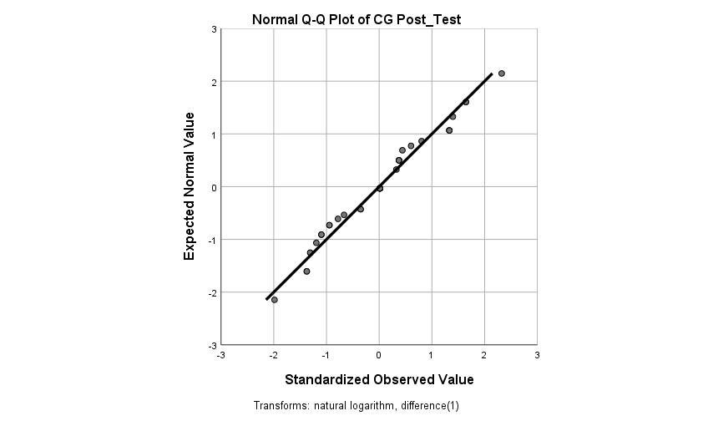
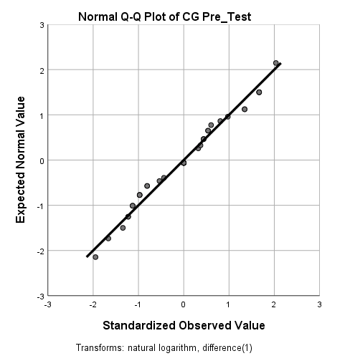
Figure 3
Normal Q-Q Plots for the Control Group's Vocabulary Test Results
The Normal Q-Q plots in Figure 3 also support this conclusion because the data points generally follow the diagonal line. Taken together, the statistical and graphical checks indicate that the control group’s pre-test and post-test scores were suitable for parametric analysis.

4.2. Experimental Group Vocabulary Results
The descriptive statistics for the experimental group's vocabulary pre-test and post-test scores are presented in Table 3.
Table 3
Descriptive Statistics of the Experimental Group's Pre-test and Post-test Scores
 | N | Range | Minimum | Maximum | Mean | Std. Deviation | Variance
EG_Vocabulary_Pre_Test | 42 | 9.00 | 1.00 | 10.00 | 5.261 | 2.084 | 4.344
EG_Vocabulary_Post_Test | 42 | 7.00 | 3.00 | 10.00 | 7.309 | 1.675 | 2.804
As shown in Table 3, the experimental group showed a clear increase in vocabulary performance after the Blooket-supported intervention. The mean score increased from 5.261 (SD = 2.084) in the pre-test to 7.309 (SD = 1.675) in the post-test. The minimum score also increased from 1.00 to 3.00, while the maximum score remained 10.00. The higher mean score and lower standard deviation in the post-test suggest that learners not only improved overall but also became more consistent in their vocabulary performance.
Table 4
Test of Normality for the Experimental Group's Vocabulary Pre-test and Post-test Scores
 | Shapiro-Wilk
 | Statistic | df | Sig.
EG_Vocabulary_Pre_Test | .972 | 42 | .378
EG_Vocabulary_Post_Test | .954 | 42 | .090

As presented in Table 4, the Shapiro-Wilk significance values were greater than .05 for both the pre-test (p = .378) and the post-test (p = .090). This indicates that the experimental group’s vocabulary scores were normally distributed and met the assumption required for a paired-samples t-test.
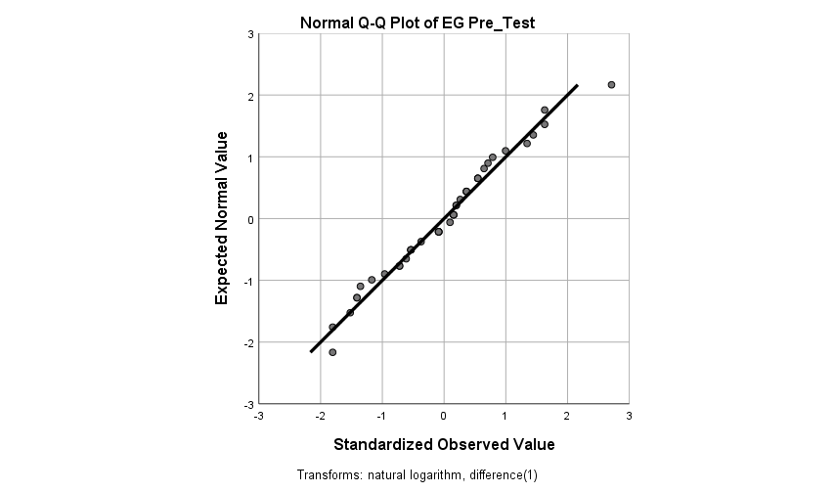
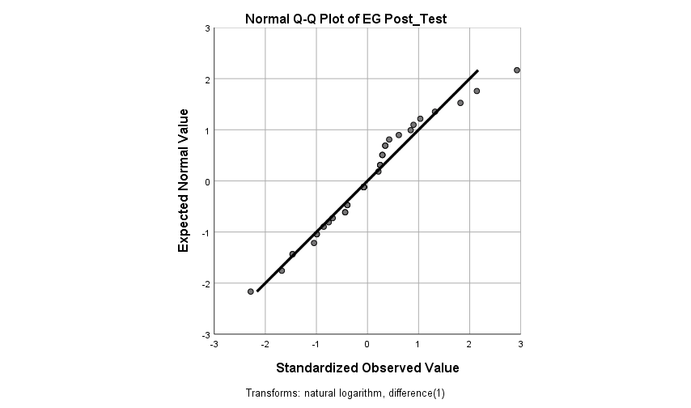
Figure 4
Normal Q-Q Plots for the Experimental Group's Vocabulary Test Results
The Q-Q plots in Figure 4 further confirm the normality assumption because the observed values are generally aligned with the diagonal reference line. Therefore, both the pre-test and post-test scores of the experimental group were appropriate for parametric comparison.
4.3. Between-Group Comparison of Pre-test Scores
Before the intervention, both groups completed the vocabulary pre-test to determine whether their initial vocabulary knowledge was comparable. The control group had a mean score of 5.58 (SD = 1.41), while the experimental group had a mean score of 5.26 (SD = 2.08).
Table 5
Descriptive Statistics for the Control and Experimental Groups’ Pre-test Scores
Group | N | Range | Minimum | Maximum | M | SD
Control group | 40 | 6.00 | 3.00 | 9.00 | 5.58 | 1.41
Experimental group | 42 | 9.00 | 1.00 | 10.00 | 5.26 | 2.08
Because Levene’s test was significant, F = 5.827, p = .018, the unequal-variances result was interpreted. The independent-samples t-test indicated no statistically significant difference between the pre-test scores of the control and experimental groups, t(72.37) = 0.80, p = .427. Therefore, the two groups began the intervention with comparable vocabulary knowledge.
Table 6
Independent-Samples t-test for Vocabulary Pre-test Scores
Variance assumption | Levene F, p | t (df) | p | Mean difference (SE) | 95% CI
Equal variances assumed | 5.827, .018 | .792 (80) | .554 | .313 (.395) | [-.473, 1.099]
Equal variances not assumed | — | .800 (72.373) | .427 | .313 (.392) | [-.467, 1.094]
4.4. Between-Group Comparison of Post-test Scores
After the intervention, both groups completed a vocabulary post-test with the same format and level of difficulty as the pre-test. The experimental group obtained a higher mean score (M = 7.31, SD = 1.67) than the control group (M = 6.08, SD = 1.51). An independent-samples t-test was conducted to determine whether this difference was statistically significant.
Table 7
Independent-Samples t-test for Vocabulary Post-test Scores
Variance assumption | Levene F, p | t (df) | p | Mean difference (SE) | 95% CI
Equal variances assumed | .507, .479 | -3.501 (80) | .001 | -1.235 (.353) | [-1.936, -.533]
Equal variances not assumed | — | -3.510 (79.761) | .001 | -1.235 (.352) | [-1.934, -.535]
Levene’s test was not significant, F = 0.507, p = .479, indicating that the equal-variances assumption was met. The independent-samples t-test showed a statistically significant difference between the post-test scores of the two groups, t(80) = -3.50, p = .001. The experimental group scored significantly higher than the control group, with a mean difference of 1.23 points. This result supports the conclusion that the Blooket-supported condition produced stronger vocabulary outcomes than conventional review during the eight-week intervention.

4.5. Paired-Samples T-test Results for the Experimental Group
After confirming the normality of the experimental group’s test scores, a paired-samples t-test was conducted to determine whether the increase from pre-test to post-test was statistically significant. This analysis directly addressed whether Blooket-supported game-based vocabulary practice contributed to measurable vocabulary gains after the eight-week intervention.
Table 8
Results of the Paired-Samples T-test for the Experimental Group
 | Mean | N | Std. Deviation | Std. Error Mean
Pre-test | 5.26 | 42 | 2.08 | .32
Post-test | 7.31 | 42 | 1.67 | .26

 | Mean Difference | Std Error Mean | 95% CI |  |  | t | df | Sig. (2-tailed) | Effect Size (Cohen’s d)
 | Mean Difference | Std Error Mean | Lower | Upper
Post-test - Pre-test | 2.05 | .140 | 1.69 | 2.27 | 14.59 |  | 41 | < .001 | 2.25

The paired-samples t-test showed that the experimental group made a statistically significant improvement in vocabulary performance. As shown in Table 8, the mean score increased from 5.26 (SD = 2.08) in the pre-test to 7.31 (SD = 1.67) in the post-test. The mean gain was 2.05 points, and the test result was statistically significant, t(41) = 14.59, p < .001. This indicates that students performed significantly better after the Blooket-supported vocabulary practice than before the intervention.
The effect size was very large (Cohen’s d = 2.25), suggesting that the observed gain was not only statistically significant but also educationally meaningful. However, this result should be interpreted as evidence that Blooket-supported practice was effective as part of the classroom vocabulary review cycle, rather than as evidence that the platform alone caused all improvement.
According to Cohen’s (1988) conventional interpretation, effect sizes of approximately 0.20, 0.50, and 0.80 may be considered small, medium, and large respectively. The value obtained in this study was well above the large-effect threshold, which supports the practical value of integrating Blooket into vocabulary review when it is guided by teacher explanation, feedback, and follow-up practice.

Figure 5
Comparison of Mean Pre-test and Post-test Scores
As illustrated in Figure 5, both groups improved from pre-test to post-test, but the increase was much larger in the experimental group. The control group increased by 0.50 points, whereas the experimental group increased by approximately 2.05 points. This pattern is consistent with the paired-samples t-test result and suggests that Blooket-supported vocabulary practice provided stronger support for vocabulary retention than conventional review alone.

4.6. Classroom Observation
Classroom observations were used to contextualize the quantitative test results and to explain how the Blooket-supported vocabulary practice operated during the intervention. The observations focused on students’ attention, participation, peer interaction, vocabulary recall, teacher support, and classroom atmosphere in the experimental group at Minds Connect Academy.
The experimental group consisted of 42 learners divided into three centre-based classes, coded as SE.9, SE.10, and SE.11 for observation purposes. Each class received the same Blooket-supported vocabulary review procedure during the eight-week intervention. The observation checklist was created to capture critical elements of implementation, such as teacher facilitation, student engagement, interactions, pace, and vocabulary recall. During the observed lessons, Blooket was used mainly to review and recycle vocabulary previously introduced by the teacher.
In Class SE.9, students showed high engagement during Blooket vocabulary activities. After a brief teacher-led review, learners completed repeated game rounds and frequently discussed answers with peers. Several students participated more readily than during conventional review, and many were able to reuse target words in short, controlled speaking tasks after the game.
In Class SE.10, scores and leaderboards helped most learners maintain attention. However, some lower-proficiency learners struggled with faster-paced game modes. The teacher responded by pausing the activity, clarifying difficult words, adjusting the pace, and encouraging peer support. This observation suggests that Blooket was most effective when the teacher actively regulated pacing and provided timely scaffolding.
In Class SE.11, learners were placed in mixed-ability groups to reduce pressure and encourage cooperation. Students supported one another with pronunciation, word meanings, and answer selection. This grouping appeared to broaden participation and supported vocabulary recall during the speaking activities that followed the game.
Overall, the observations were consistent with the quantitative improvement. Repeated retrieval, immediate feedback, peer interaction, and sustained attention appeared to support vocabulary learning. At the same time, the observations showed that Blooket worked best as guided supplementary practice rather than as a substitute for teacher explanation or follow-up speaking and writing tasks.

5. Discussion
The findings indicate that Blooket-supported vocabulary practice was associated with stronger learning gains than conventional review in this classroom context. The two groups did not differ significantly at pre-test, t(72.37) = 0.80, p = .427, but the experimental group achieved a significantly higher post-test score than the control group, t(80) = -3.50, p = .001. Within the experimental group, the mean increased from M = 5.26 to M = 7.31, t(41) = 14.59, p < .001, with a very large effect size (Cohen’s d = 2.25). Because the study used intact classes rather than random assignment, these findings should be interpreted as strong classroom-based evidence rather than a universal causal claim.
The observed gains are consistent with research emphasising repeated encounters and active retrieval in vocabulary learning (Nation, 2001; Webb & Nation, 2017). Blooket required learners to retrieve target meanings several times within a short period, while immediate feedback allowed them to notice and correct errors during practice. These features likely made vocabulary recycling more intensive than in conventional review alone.
Classroom observations clarified how the intervention operated. Learners remained attentive, discussed answers, supported peers, and responded to teacher feedback. The benefit therefore appeared to arise from the interaction of technology and pedagogy rather than from the game format alone. Teacher explanation before play, monitoring during activities, and follow-up language use were central to the instructional sequence.
The observations also showed that game modes were not equally accessible to all learners. Faster-paced competition increased excitement for some students but placed additional pressure on lower-proficiency learners. Teachers should therefore adjust timing, pause for clarification, use mixed-ability grouping, and select modes according to learners’ needs rather than assuming that speed and competition are universally motivating.
Blooket was particularly effective for recognition and recall, but these outcomes do not automatically represent productive vocabulary knowledge. Learners still require opportunities to pronounce words, build sentences, answer questions, and use vocabulary in speaking or writing. Game-based review should therefore be followed by tasks that move learners from rapid answer selection to meaningful language production.
The term AI-powered should also be interpreted cautiously. In this study, it refers to automated scoring, immediate feedback, response tracking, and teacher-accessible performance data, not to generative or fully adaptive artificial intelligence. These functions supported instructional decisions, but they did not replace teacher judgement, lesson design, or classroom management.
The study adds context-specific evidence from a Vietnamese private language centre, a setting in which learners often have limited exposure to English outside class and teachers must use lesson time efficiently. The findings suggest that Blooket can enrich conventional vocabulary instruction when it is integrated into a structured cycle of explanation, retrieval, feedback, collaboration, and productive follow-up practice.
6. Pedagogical Recommendations

The pedagogical recommendations are directly based on the findings of the study. Because the test and observation findings suggested stronger support for vocabulary review and recall than for productive sentence use, teachers should introduce or review target words before the activity and follow each game with short speaking or writing tasks. These tasks may include sentence construction, picture description, dialogue completion, or pair questioning so that learners can move from recognition and recall to productive vocabulary use.
Because the classroom observations showed that fast-paced modes were difficult for some lower-proficiency learners, teachers should select game modes according to learners’ proficiency levels and processing speed. Slower or team-based formats may be more appropriate for mixed-ability classes. Mixed-ability grouping and peer support can also reduce pressure and encourage wider participation.
During gameplay, teachers should monitor common errors, pause when learners experience difficulty, and provide further explanation of challenging vocabulary. Blooket response data can also be used to identify items that require additional review. As the findings showed that the effectiveness of Blooket depended on teacher guidance, the platform should be used as a supplementary tool rather than as a replacement for explicit vocabulary instruction.
Language-centre managers should provide teachers with practical guidance on selecting suitable game modes, controlling activity pacing, protecting learner data, and aligning Blooket activities with curriculum objectives. Such support can help ensure that game-based activities remain inclusive, purposeful, and connected to meaningful language learning.

7. Limitations and Future Research
The study was conducted with intact classes at one private language centre, which limits generalisability and does not provide the control associated with random assignment. The intervention lasted eight weeks and used an immediate post-test, so the results do not establish long-term retention. Classroom observations were conducted only in the experimental group and were interpreted by the teacher-researcher, creating possible observer and expectancy bias. The study also focused mainly on recognition and recall rather than broader productive vocabulary knowledge. Future research should include multiple sites, delayed post-tests, independent observers, and tasks measuring sentence-level and communicative vocabulary use.
The study did not use a separate written parental consent form. Instead, parents or legal guardians were informed through the official parent communication groups and were given the opportunity to decline their child’s participation. Although this procedure was consistent with the centre’s usual communication practices, the absence of documented individual parental consent limits the strength of the study’s ethical documentation. Future studies involving minors should obtain formal written informed consent from parents or legal guardians before data collection.

8. Conclusion
This study examined the effects of Blooket-supported game-based practice on vocabulary retention among young Vietnamese EFL learners. The experimental group achieved substantially greater gains than the control group, and observation data linked these gains to repeated retrieval, immediate feedback, peer support, and teacher scaffolding.
Blooket should nevertheless be treated as a supplementary instructional tool rather than a replacement for systematic vocabulary teaching. Its value depends on appropriate pacing, inclusive grouping, teacher mediation, and follow-up speaking and writing activities. Used in this way, Blooket can provide an engaging and instructionally purposeful form of vocabulary recycling for young EFL learners.

Acknowledgments
The author would like to express sincere gratitude to Dr. Nguyen Ho Phuong Chi and Assoc. Prof. Dr. Nguyen Ngoc Vu for their valuable guidance, academic support, and encouragement throughout the research process. This paper was developed as part of a larger research thesis conducted during the author’s Master’s program in English Language Studies at Ho Chi Minh City University of Foreign Languages and Information Technology (HUFLIT). The author also wishes to thank the students at Minds Connect Academy for their participation and support during the classroom implementation.
References
Cameron, L. (2001). Teaching languages to young learners. Cambridge University Press.
Chen, X., Xie, H., Zou, D., & Hwang, G.-J. (2020). Application and theory gaps during the rise of artificial intelligence in education. Computers and Education: Artificial Intelligence, 1, Article 100002. https://doi.org/10.1016/j.caeai.2020.100002
Cohen, J. (1988). Statistical power analysis for the behavioral sciences (2nd ed.). Lawrence Erlbaum Associates.
Cook, T. D., & Campbell, D. T. (1979). Quasi-experimentation: Design and analysis issues for field settings. Houghton Mifflin.
Deterding, S., Sicart, M., Nacke, L., O’Hara, K., & Dixon, D. (2011). From game design elements to gamefulness: Defining gamification. In Proceedings of the 15th International Academic MindTrek Conference: Envisioning future media environments (pp. 9–15). Association for Computing Machinery. https://doi.org/10.1145/2181037.2181040
Hamari, J., Koivisto, J., & Sarsa, H. (2014). Does gamification work? A literature review of empirical studies on gamification. In 2014 47th Hawaii International Conference on System Sciences (pp. 3025–3034). IEEE. https://doi.org/10.1109/HICSS.2014.377
Huang, W. (2022). Blooket: Game on, students! FLTMAG. https://fltmag.com/blooket-game-on/
Huynh, D. P. L. (2024). The effects of Blooket on motivation in learning English among first-year non-English majors at a university in Ho Chi Minh City. International Journal of English Language Education, 12(1). https://doi.org/10.5296/ijele.v12i1.21758
Hwang, G.-J., Xie, H., Wah, B. W., & Gašević, D. (2020). Vision, challenges, roles and research issues of artificial intelligence in education. Computers and Education: Artificial Intelligence, 1, Article 100001. https://doi.org/10.1016/j.caeai.2020.100001
Kapp, K. M. (2012). The gamification of learning and instruction: Game-based methods and strategies for training and education. Pfeiffer.
Laufer, B., & Goldstein, Z. (2004). Testing vocabulary knowledge: Size, strength, and computer adaptiveness. Language Learning, 54(3), 399–436. https://doi.org/10.1111/j.0023-8333.2004.00260.x
Nation, I. S. P. (2001). Learning vocabulary in another language. Cambridge University Press.
Pham, A. T., & Ly, D. T. (2023). EFL students’ perceptions on the use of Blooket in grammar classes. In Proceedings of the 2023 8th International Conference on Distance Education and Learning. Association for Computing Machinery. https://doi.org/10.1145/3606094.3606117
Phupunna, S., & Hongsamsibkao, P. (2024). Enhancing Chinese vocabulary memorization skills through Blooket games combined with active learning for first-year students in the Chinese language teaching program at Rajabhat Mahasarakham University. Journal of Education and Learning, 13(5), 191–198. https://doi.org/10.5539/jel.v13n5p191
Pinter, A. (2006). Teaching young language learners. Oxford University Press.
Quyen, C. T., & Nguyen, H. C. (2025). Perceptions and dominant factors of Blooket as a game-based learning tool among Vietnamese non-English majored students. Dinamika Ilmu, 25(1), 123–144. https://doi.org/10.21093/di.v25i1.10268
Schmitt, N. (2010). Researching vocabulary: A vocabulary research manual. Palgrave Macmillan. https://doi.org/10.1057/9780230293977
Sinaga, N., Widyantoro, A., & Sinaga, A. N. (2025). The effectiveness of Blooket on students’ vocabulary learning among secondary school students. Indonesian Research Journal in Education, 9(2), 1273–1288. https://online-journal.unja.ac.id/irje/article/view/44887
Subhash, S., & Cudney, E. A. (2018). Gamified learning in higher education: A systematic review of the literature. Computers in Human Behavior, 87, 192–206. https://doi.org/10.1016/j.chb.2018.05.028
Sulistyanto, I., & Asyhar, W. I. (2024). The effectiveness of Blooket media toward students’ vocabulary mastery. English Education: English Journal for Teaching and Learning, 12(2), 222–237.
Thu, T. T. M., & Dan, N. T. T. (2023). Students’ perceptions on English vocabulary teaching and learning by using Blooket: A case study. European Journal of Applied Linguistics Studies, 6(1). https://doi.org/10.46827/ejals.v6i1.321
Webb, S., & Nation, P. (2017). How vocabulary is learned. Oxford University Press.
Zawacki-Richter, O., Marín, V. I., Bond, M., & Gouverneur, F. (2019). Systematic review of research on artificial intelligence applications in higher education: Where are the educators? International Journal of Educational Technology in Higher Education, 16, Article 39. https://doi.org/10.1186/s41239-019-0171-0

Bionote
Trang Trinh Khanh Lien is a graduate student in English Language Studies at Ho Chi Minh City University of Foreign Languages and Information Technology, Vietnam. Her research interests include technology-assisted language learning, young learner vocabulary development, game-based learning, and technology-enhanced classroom practice.
Nguyen Ho Phuong Chi is a lecturer at Ho Chi Minh City University of Foreign Languages and Information Technology and holds a PhD in TESOL from RMIT University, Australia. She has more than 15 years of experience in English language teaching and teacher education, having lectured at both Ho Chi Minh City University of Education and Ho Chi Minh City University of Foreign Languages and Information Technology. Her teaching and research interests include TESOL, language teacher education, curriculum development, and technology-enhanced language learning. She is committed to supporting English language learners and contributing to the advancement of English language teaching and learning in Vietnam through research, professional development, and innovative pedagogical practices.

