RESPONSE TO EDITORS’ COMMENTS
Title: Conceptualization of Teachers’ Research Mindset as a Complex Dynamic System in the English Language Teaching Context
Manuscript ID: 115
Author: Hanh Nguyen Thi Minh et al.

Firstly, we would like to thank the Editor for their insightful comments. The comments have greatly helped us improve our manuscript’s quality and clarity. Below, we provide a detailed response to all comments

Comment 1: “The overall format should be revised to align with the conference or journal regulations.”
Response:
We have downloaded the provided template and revised our manuscript to align with the conference regulations. We have uploaded the revised version of the manuscript in a separate file along with this response file.

Comment 2: “Clearly identify the author(s) and affiliation information”
Response:
We have considered and provided our ORCID iD and a brief Author Biography. We also added the following information to the Bio section of the revised version of the manuscript.
- Nguyen Thi Minh Hanh
ORCID iD: https://orcid.org/0009-0004-4902-9864
Biography: Nguyen Thi Minh Hanh is a PhD student in Principles and Methods of Teaching at Can Tho University, Vietnam, where she was honored to be admitted directly to the doctoral program without completing a Master’s degree. In recognition of her early research contributions, her previous work has focused primarily on understanding group work dynamics in language education. Building upon these experiences, Hanh’s current doctoral research explores teachers’ research mindsets in English language teaching practices, with the hope of contributing to professional development practices in Vietnamese higher education.
- Assoc. Prof. Dr. Le Xuan Mai
ORCID iD: https://orcid.org/0000-0002-1300-3804
Biography: Dr. LE Xuan Mai, Head of the Department of General English and English for Specific Purposes, School of Foreign Languages, Can Tho University, Vietnam, obtained her doctorate degree in Education in Australia. Her research interests include English language teaching (ELT), ICT in ELT, teacher education, and teacher professional development.
- Assoc. Prof. Dr. Bui Le Diem Trang
ORCID iD: https://orcid.org/0000-0001-8360-152X
Biography: Dr. Bui Le Diem Trang is a senior lecturer in the Faculty of Foreign Languages at An Giang University, Vietnam National University, Ho Chi Minh City. She has a master's degree in Applied Linguistics from the University of Queensland, Australia, and a PhD in Applied Linguistics from Victoria University of Wellington, New Zealand. She has over 15 years of teaching experience, specializing in training pre-service and in-service EFL teachers. Her professional interests include English teacher education, task-based language teaching (TBLT), and technology in language education.

Comment 3: “reference–citation consistency should be carefully checked”
Response:
We have checked and revised all the in-text references. All references were double-checked to ensure accuracy, and irrelevant references were eliminated. In the revised version, we highlighted any revised/additional references in red.
Examples:
References
Banegas, D. L., Edwards, E., & Villacañas de Castro, L. S. (Eds.). (2022). Professional development through teacher research: Stories from language teacher educators. Multilingual Matters.
Barkhuizen, G. (2011). Home tutor cognitions and the nature of tutor-learner relationships. In P. Benson, & H. Reinders (Eds.). Beyond the language classroom (pp. 161-174). London: Palgrave Macmillan.
Barkhuizen, G. (2014). Revisiting narrative frames: An instrument for investigating language teaching and learning. System, 47, 12-27
Barkhuizen, G., & Wette, R. (2008). Narrative frames for investigating the experiences of language teachers. System, 36(3), 372-387.
Borg, S. (2010). Language teacher research engagement. Language Teaching, 43(4), 391–429. https://doi.org/10.1017/S0261444810000170
…

Comment 4: “Grammatically, “Teacher” should be changed to “Teachers” because the study investigates multiple participants rather than a single teacher. Furthermore, the title is lengthy and could be made more concise and precise” and “The manuscript also contains spelling, grammatical, and stylistic issues that require careful proofreading”
Response:
We have considered and modified the title. Furthermore, we also double-checked and tried to revise any other grammatical or lexical errors in the manuscript. The revised words/phrases were highlighted in red.
Original title: Teacher’ Research Mindset as a Complex Dynamic System in the English Language Teaching context – conceptualization of teachers as graduates
Revised version: Conceptualization of Teachers’ Research Mindset as a Complex Dynamic System in the English Language Teaching Context

Comment 5: “The study lacks clear and separate sections for the study background, problem statement, research objectives, and delimitations. Although a research question appears later in the literature review, there is no dedicated section presenting the research question(s)”
Response:
We have considered and added section 2.5 to clarify the problem statement.
We also provided section 2.6 to clarify the position and aim of the current manuscript, as a part of a larger study.
In this section, we briefly mentioned the aim of the whole study and showed the role and aim of the current findings of this manuscript, as well as the research question.
In-text evidence:
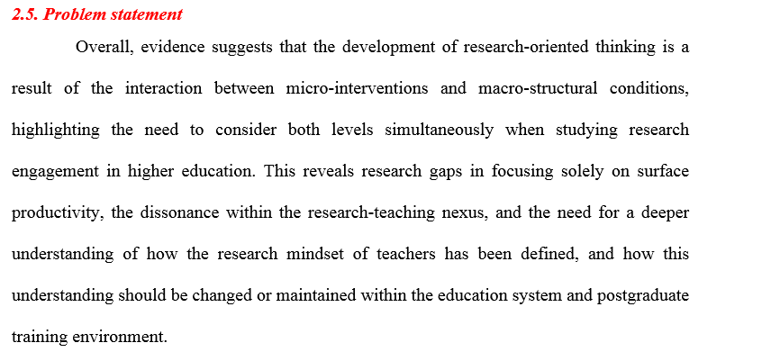
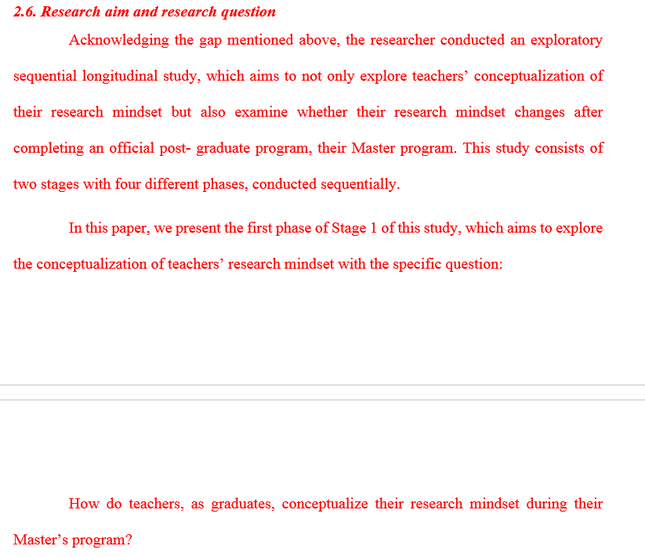

Comment 6: “In addition, Table 1 provides basic participant information but contributes little analytical value and may be unnecessary in its current form.”
Response:
We have used the basic participant information as supporting evidence for our Purposive sampling, showing their diverse backgrounds in teaching and research. This aims to ensure a comprehensive viewpoint, especially in case we can access only four per 30 participants. Furthermore, when unpacking their conceptualization of research mindset under the lens of Complex Dynamic Systems Theory, the basic information helped to clarify situated professional contexts and past experiences (mentioned in the Working definition of the manuscript). Therefore, we decided to keep this table.
However, after consideration, we acknowledged the lack of demonstration in the results report, which caused the disconnect between this table and the following sections. Therefore, we decided to rewrite some parts of the results. The revised paragraphs were highlighted in red.

Comment 7: “There are indications of overreliance on AI-generated writing, particularly in repetitive phrasing, redundancy, and formulaic academic expressions”
Response:
We have considered, double-checked, and accepted that the use of an AI-assisted tool is solely for the purpose of linguistic polishing and stylistic consistency.
However, it is important to emphasize that all the writing and content were generated by the authors with full accountability and remain exclusively our original work.
We still checked and revised any over-polished phrases or sentences. The revised phrases and sentences were highlighted in red.

