Digital Transformation in Formative Assessment: The Design, Implementation, and Evaluation of Testmoz for English General Courses at Vietnam Aviation Academy
Trinh Phan Tu

Abstract
The ongoing digital transformation in higher education has exposed limitations in traditional self-study practices at Vietnam Aviation Academy (VAA), particularly as self-directed learning accounts for up to 30% of course assessment. In General English courses, paper-based homework frequently results in delayed feedback, increased administrative workload for instructors, and low levels of student engagement. Despite national efforts to promote Industry 4.0 integration in Vietnamese higher education, homework and self-study activities at many universities in general and VAA in particular remain largely manual and insufficiently aligned with digital learning environments.
To address challenges, the author needs streamlined digital tools that support rather than complicate the learning process. This study investigates the integration of Testmoz as a solution to modernize formative assessment. Specifically, it examines students’ perceptions of Testmoz’s contribution to feedback quality, learning motivation, homework completion, learner engagement, and autonomous learning. A mixed-methods design following the ADDIE model was employed. Data were collected from 182 undergraduate students who had used Testmoz for formative homework activities over one academic semester through a questionnaire comprising Likert-scale items and open-ended questions. Quantitative data were analyzed descriptively, while qualitative responses provided additional insights into students’ learning experiences.
Moreover, the research aim is to clarify if digitizing these practices from designing Testmoz assignment can be able to not only provide students with more timely feedback but also reduce the daily workload for instructors. By implementing and evaluating Testmoz at the Vietnam Aviation Academy (VAA), the research also hopes to provide a practical roadmap for using digital tools to improve student outcomes in the Vietnamese higher education context.
Keywords: digital transformation, Testmoz, assessment, feedback, student perceptions
1. Introduction
In the age of Industry 4.0 development, the digital transformation of many society fields including education has become a national priority in Vietnam. However, a profound gap remains between traditional assignment and classroom reality. At the Vietnam Aviation Academy (VAA) in addition, self-directed learning contributes 30% of the total course assessment, yet this significant component is still largely managed through traditional, paper-based methods. In General English courses, these manual processes often result in "feedback delays," where the gap between a student’s effort and a teacher’s response is too wide to be effective. This not only increases the administrative burden on instructors but also distracts student motivation.
According to the previous research on digital assessment of management systems (LMSs), It has primarily focused on comprehensive , online learning environments, or large-scale digital assessment platforms (Priyeti et al., 2025). While these studies demonstrate the potential of technology to support teaching and learning, less attention has been paid to lightweight, low-cost assessment tools that can be easily implemented in resource-constrained educational contexts. In particular, few studies have documented how such tools can be systematically designed, implemented, and evaluated using an instructional design framework within General English courses (Pariska & Rayusda, 2026).
To bridge this gap, an urgent need for streamlined digital tools is necessary that they can enhance, rather than complicate, the formative assessment process. This study has concentrated on investigating the integration of Testmoz, a digital platform which is lightweight and versatile, as a strategic solution with the combination of the ADDIE model from Culatta (2018) includings Analysis, Design, Development, Implementation, and Evaluation, the research documents the transition from paper-based homework to a digitized workflow.
Figure 1
ADDIE model
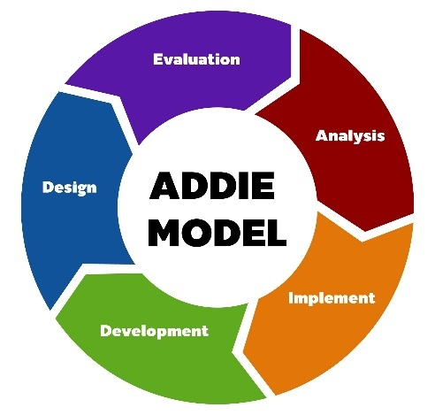
By digitizing homework and self-study activities, the research explores whether Testmoz can facilitate immediate feedback, alleviate the heavy workload of manual grading, and better align the curriculum with digital learning environments. Through the design, implementation, and evaluation of Testmoz at VAA, this study aims to provide a practical roadmap for educators seeking to modernize assessment practices and improve student outcomes by utilizing the digital transformation. From the certain purposes that are to measure the technical success and the "speed" of the new system, to identify the "human" benefit for teachers and to understand the psychological and professional impact on the learners themselves, the paper focuses on addressing 2 research questions.
Research Questions
- How can Testmoz be designed to align with the General English syllabus at VAA, and to what extent does this implementation improve the timeliness of feedback and student completion rates?
- How do students perceive the transition from manual to digital assessment, particularly regarding their motivation and control over their own learning?
2. Literature Review
This literature review has researched on digital transformation and formative assessment in higher education, with emphasis on feedback, instructional efficiency, and learner self-study. It also discusses digital assessment tools and instructional design frameworks, identifying a research gap in the ADDIE-based implementation of friendly platforms such as Testmoz in Vietnamese General English courses.
2.1 Digital Transformation in Higher Education
Digital transformation has been widely being recognized as a critical method of innovation and quality improvement in higher education systems worldwide. According to Selwyn (2016), digital transformation in education is not merely about adopting technology but about reshaping pedagogical practices, assessment models, and institutional cultures. In the current era of Industry 4.0, universities are increasingly required to integrate digital tools to enhance flexibility, student autonomy, and efficiency (Bond et al., 2018).
In Vietnam, the Ministry of Education and Training (MOET) has prioritized digital transformation as a strategic impression, particularly after the COVID-19 pandemic which is accelerated the adoption of online and blended learning models (Pham & Ho, 2020). However, several researches show that while digital platforms are often used for content delivery, assessment practices, especially formative assessment, remain predominantly traditional and paper-based (Tran & Nguyen, 2021). This mismatch reduces the overall effectiveness of digital learning environments limits students’ access to timely feedback and opportunities for self-regulated studying.
2.2 Formative Assessment and the Role of Feedback
The formative assessment plays extremely significantly in supporting learning by giving feedback provision that helps learners identify gaps between current and desired performance (Black & Wiliam, 1998). The quick and effective formative feedback is featured by timeliness, clarity, and actionability (Hattie & Timperley, 2007). When delaying in feedback, as is common in paper-based homework systems, its pedagogical value is crucialy diminished.
Digital formative assessment tools have been clarified to address this issue by permitting immediate or rapid feedback, thereby enhancing student engagement and learning outcomes (Nicol & Macfarlane‐Dick, 2006). In language learning contexts, online quizzes and automated assessment systems are particularly effective in reinforcing grammar, vocabulary, and reading comprehension skills (Chapelle & Douglas, 2006).
2.3 Digital Assessment Tools and Instructor Workload
The increasing administrative workload associated with assessment and grading is one of the major challenges that instructors in higher education face nowadays. The study of “Changing assessment towards a new assessment paradigm using ICT” indicates that automated and semi-automated digital assessment tools can significantly reduce grading time, minimize repetitive tasks, and allow instructors to focus more on pedagogical decision-making (Redecker & Johannessen, 2013).
Platforms such as Moodle quizzes, Google Forms, Kahoot, and Testmoz have been widely adopted due to their ease of use and automatic scoring features (Bennett, Dawson, Bearman, Molloy, & Boud, 2017). Lightweight tools like Testmoz are particularly suitable for educators with the limitation of the technical infrastructure, as they do not require complex learning management systems while still supporting large-scale formative assessment (Tindell, 2012).
For specialized assessments such as rearrangement or sentence transformation within the "Fill in the Blank" format, Testmoz offers rigorous evaluation settings. To ensure exact grading and linguistic accuracy, teachers can set four distinct validation modes: 1. Case Sensitivity: Distinguish between upper and lowercase characters; 2. Accents: Validate the correct use of diacritics; 3. Punctuation: Require exact matches for all grammatical symbols; 4. Whitespace: Monitor the specific spacing between words or characters. It has been used in diverse educational settings due to its ease of use and versatility (Reddy, 2020).
Figure 2
Testmoz interface displaying the four validation settings
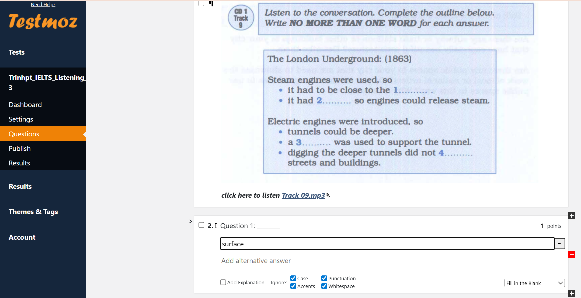

Unlike some other quiz platforms, Testmoz does not require students to create accounts just click on the link type their name and can easily get access to do the homework, which reduces barriers to participation and is very friendly to use. According to the studies from Chou and Chen (2018), they have shown that tools like Testmoz can support continuous assessment and improve homework submission rates. Moreover, its ability to monitor student responses and generate performance reports helps educators to identify areas where learners may need some more additional support.
Figure 3
Student login interface on Testmoz highlighting account-free access via direct link and name entry
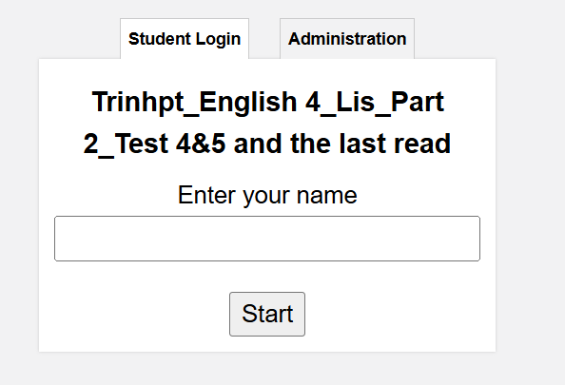

Figure 4
Testmoz administrative dashboard displaying aggregated scores, completion times, and individual item responses for educator analysis
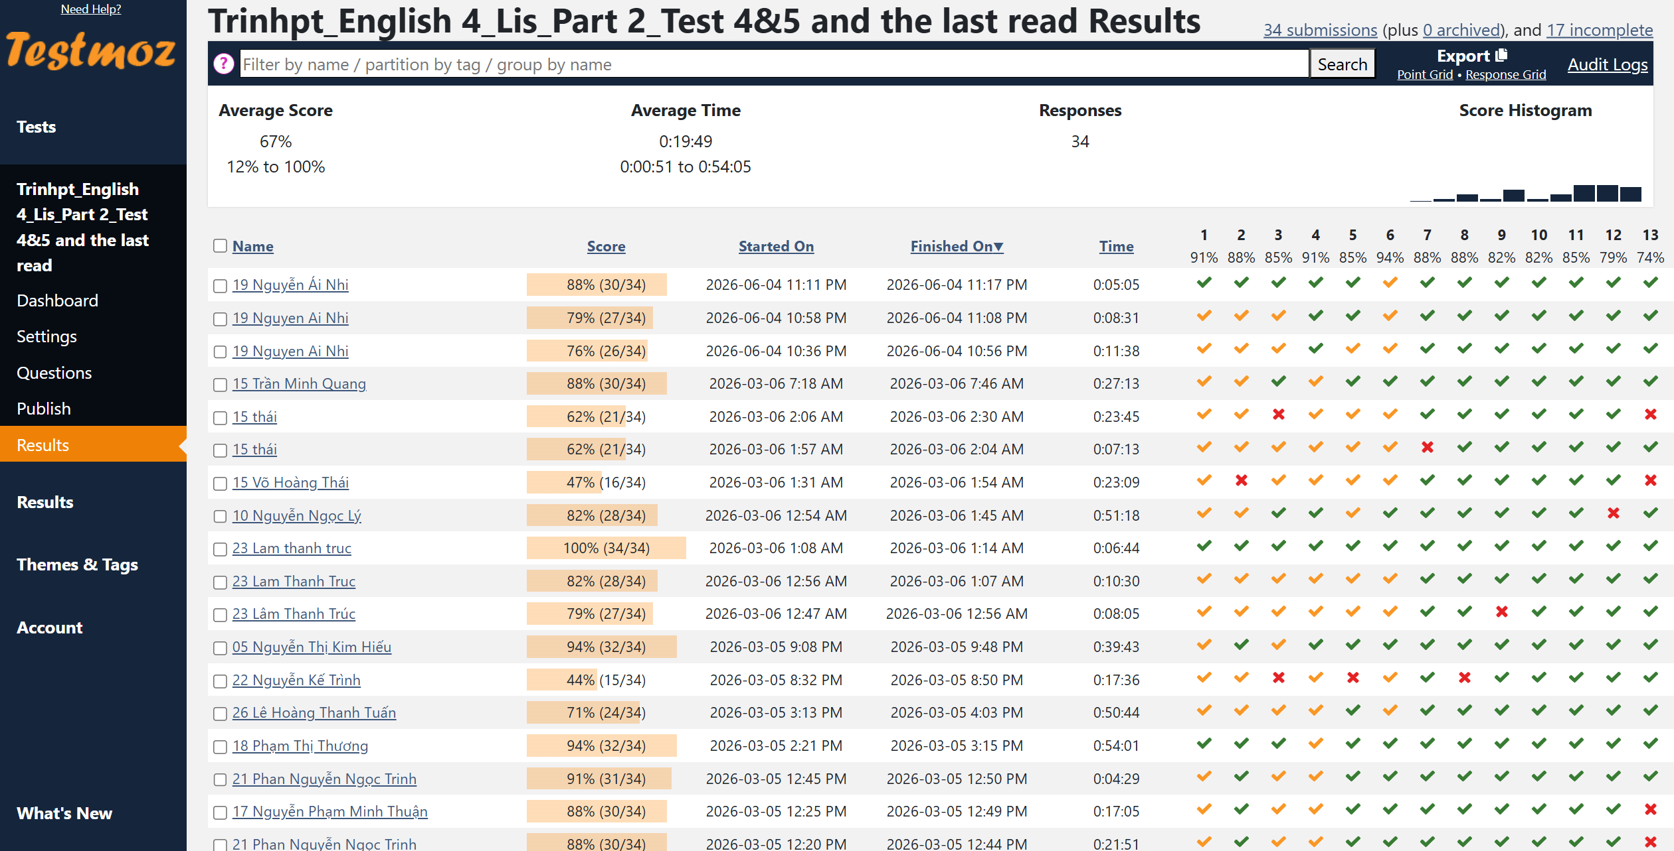

2.4 Student Motivation, Autonomy, and Perceptions of Digital Assessment
Learner perception is a key factor which influences the success of digital assessment implementation. Studies grounded in Self-Determination Theory suggest that digital tools are able to enhance motivation by supporting autonomy, competence, and control over learning pace (Deci & Ryan, 2000). Having immediate feedback and being able to monitor the assignment progress, students can be more likely to take responsibility and interest for their learning (Zimmerman, 2002).
In the Vietnamese EFL context, Nguyen and Dang (2022) have found that students respond positively to online quizzes and digital homework, citing increased convenience, reduced anxiety, and greater transparency in assessment. However, successful adoption depends on clear alignment with course objectives and adequate guidance from instructors.
2.5 Research Gap
While existing literature highlights the benefits of digital formative assessment, there is limited empirical research focusing on lightweight digital tools such as Testmoz in Vietnamese higher education, particularly in General English courses where self-study accounts for a substantial proportion of course assessment. Moreover, few studies adopt a systematic instructional design framework such as the ADDIE model to document the design, implementation, and evaluation of such tools. This study seeks to address this gap by examining both technical efficiency and human-centered impacts on instructors and students at Vietnam Aviation Academy.
3. Methodology
3.1 Research Design
The study combined the ADDIE instructional design model with a convergent mixed-methods approach, in which quantitative and qualitative data were collected at the end of the implementation and interpreted together to evaluate students' perceptions of Testmoz. The project followed the ADDIE model:
- Analysis
- Design
- Development
- Implementation
- Evaluation
The study involved 182 undergraduate students enrolled in General English courses at Vietnam Aviation Academy. Participants represented multiple English classes and completed the survey voluntarily after using Testmoz for formative homework activities over one academic semester. Ramdomly, the proportion of female students and male students accounted for 50% with 91 students for each gender. Smartphones emerged as the most frequently used device for accessing Testmoz with the percentage of 53%, followed by laptops with 45%, indicating the mobile-friendly nature of the platform.
The questionnaire consisted of Likert-scale items measuring ease of use, engagement, motivation, feedback effectiveness, homework consistency, and continuance intention. Open-ended questions explored learner experiences and suggestions. Internal consistency reliability could be assessed using Cronbach’s Alpha to ensure acceptable reliability of the survey instrument.
3.2 Context and Participants
Participants include 182 undergraduate students enrolled in General English courses at VAA. These students, taking English 3 or 4, are familiar with Testmoz and have used it for at least one semester on laptops, smartphones, or tablets to complete quizzes as homework with not only reading and listening but also writing and speaking assignment.
3.3 AI-Supported Assessment Model
Digital quizzes were developed on Testmoz. Features included:
- Automated scoring
- Immediate feedback display
- Randomized question order
- Time limits
- Exportable performance reports
While not generative AI, the system automated assessment processes traditionally performed manually. AI writing tools were discussed in class within ethical guidelines, emphasizing transparency and proper use.
3.4 Ethical Considerations
Participation was voluntary. No personally identifiable information was published. Data were anonymized. Students were informed about data usage and consented prior to survey participation.
4. Findings
4.1 Student Perceptions of Testmoz
Based on the survey results, the data was exported to Excel and categorized into three groups: scores of 1 and 2 were classified as 'Disagree', 3 as 'Neutral', and 4 and 5 as 'Agree'. This grouped data was then analyzed to produce the results shown in Table 1 below:
Table 1
Student Perceptions of Testmoz (N = 182)
Dimension | Disagree (%) | Neutral (%) | Agree (%) | Interpretation
Ease of Use | 4.5 | 8.4 | 87.1 | The vast majority of students found Testmoz easy to use, with only a small proportion reporting difficulties. This indicates that the platform was highly accessible and user-friendly for most learners.
Engagement | 5.6 | 9.6 | 84.8 | A large majority of students reported that Testmoz made homework more engaging than traditional paper-based assignments. The high level of agreement suggests that the platform increased students' interest and participation in learning activities.
Digital Preference | 5.5 | 8.9 | 85.6 | Most students preferred digital assignments over traditional paper-based homework. The high level of agreement indicates strong acceptance of digital formative assessment and suggests that students valued the flexibility and convenience offered by Testmoz.
Motivation | 4.9 | 12.0 | 83.1 | Most students agreed that Testmoz increased their motivation to complete assignments. The high level of agreement suggests that features such as convenience, accessibility, and immediate feedback encouraged greater participation in learning activities.
Feedback Helpfulness | 5.6 | 8.9 | 85.5 | Most students perceived the feedback provided by Testmoz as helpful for identifying mistakes and improving their learning. The high level of agreement highlights the value of immediate feedback in supporting self-monitoring and learning improvement.
Completion Consistency | 4.4 | 8.8 | 86.7 | A large majority of students reported completing assignments more consistently when using Testmoz. The high level of agreement suggests that the platform encouraged regular participation and supported students in maintaining their study routines.
Continuance Intention | 3.8 | 7.7 | 88.5 | The overwhelming majority of students expressed a desire to continue using Testmoz in future English courses. This strong level of support suggests high overall satisfaction with the platform and its perceived value for learning.
In addition, the mean scores from the five-point Likert scale further supported these positive perceptions. Continuance Intention received the highest mean score (M = 4.47), followed by Ease of Use (M = 4.43), Completion Consistency (M = 4.38), Feedback helpfulness (M = 4.30), and Motivation (M = 4.28). Across all surveyed items, over 83% of respondents selected either "Agree" or "Strongly Agree." Specifically, 70% of the total respondents opted for "Strongly Agree," while 30% selected "Agree." These high percentages reflect strong consensus and internal consistency across the dataset.
Moreover, these findings indicate that students adapted favorably to the transition from paper-based assignments to digital formative assessment. While ease of use scored the highest quantitatively, the qualitative responses suggest that the helpfulness of immediate feedback was a primary driver of student satisfaction, encouraging continued participation due to rapid access to results. However, a minor yet important trend emerged regarding a small group of students who reported lower satisfaction levels. This minority likely represents learners facing technological barriers or lower digital literacy. Although they constituted a small percentage of the sample, their feedback highlights the necessity of providing targeted support to ensure equitable participation in digital learning environments.
And some qualitative evidence open-ended responses consistently emphasized the speed and convenience of the platform: “I like Testmoz the most because it gives quick feedback on scores.”; “Online tasks can be done anywhere and quickly.”; “Reviewing the results and mistakes helps me identify my weaknesses and learn from them.” These comments demonstrate that Testmoz improved administrative efficiency while simultaneously promoting learner autonomy by enabling students to independently monitor and evaluate their own progress.
4.2 Challenges and Areas for Improvement
Although student perceptions were generally positive, several challenges emerged from the open-ended responses.
Table 2
Main Challenges Reported by Students
Theme | Representative Comments | Educational Implication
Internet Connectivity | “The internet connection can affect the test.” | Reliable infrastructure remains essential.
Connectivity Anxiety | “I’m worried about losing the connection during the test.” | Digital assessment may introduce new forms of stress.
Limited Explanatory Feedback | “I want the app to point out mistakes more clearly.” | Automated scoring should be supplemented with pedagogical feedback.
Need for More Practice Activities | “I would like more practice exercises.” | Students value opportunities for additional learning and revision.
The most frequently reported challenge concerned Internet stability. Students recognized the convenience of online assessment but also expressed concern about technical interruptions during quizzes. This finding suggests that successful digital transformation depends not only on software adoption but also on reliable technological infrastructure.
Another recurring theme was the demand for explanatory feedback. While students appreciated automatic scoring, several respondents expressed a desire for more detailed explanations of incorrect answers. This indicates that digital tools can improve efficiency but cannot fully replace the instructional role of teachers.
5. Discussion
The purpose of this study was to investigate the implementation of Testmoz in General English courses at Vietnam Aviation Academy (VAA) and to examine students’ perceptions of the transition from paper-based to digital formative assessment. The discussion is organized around the two research questions.
5.1 Discussion of RQ1: Designing and Implementing Testmoz for Formative Assessment
The first research question explored how Testmoz could be aligned with the General English syllabus at VAA and whether its implementation improved formative assessment practices.
The findings suggest that Testmoz successfully supported the transition from traditional paper-based homework to a digital assessment environment. The platform enabled instructors to create not only quizzes that corresponded directly to vocabulary, grammar, reading, and listening objectives but also short answers for writing and collecting assignement of essay and speaking within the General English curriculum. More importantly, the automated scoring system provided immediate feedback, a feature that students consistently identified as the most valuable aspect of the platform.
Table 3
Summary of Student Perceptions
Variable | Mean Score
Ease of Use | 4.43
Feedback Helpfulness | 4.30
Motivation | 4.28
Homework Completion | 4.38
Continuance Intention | 4.47
The high ratings for feedback helpfulness (M = 4.4) and continuance intention (M = 4.4) indicate that students valued the speed and convenience of digital assessment.
The ranging from 4.28 to 4.47 on a five-point Likert scale indicates extremely positive student perceptions across all measured dimensions. Continuance intention received the highest rating (M = 4.47), suggesting that students were strongly willing to accept and continue using Testmoz in future English courses. Ease of use (M = 4.43) and homework completion (M = 4.38) also received particularly favorable evaluations, showing that students found the platform accessible and believed it helped them complete assignments more conveniently.
In addition, these findings support the argument of Hattie and Timperley (2007) that timely feedback plays a critical role in improving learning outcomes. Similarly, Nicol and Macfarlane-Dick (2006) emphasized that rapid formative feedback promotes self-regulated learning by helping learners identify weaknesses and adjust their study strategies.
5.2 Discussion of RQ2: Student Perceptions, Motivation, and Learner Autonomy
The second research question mainly focused on how students perceived the transition from manual to digital assessment, particularly regarding motivation and control over their own learning because of the marks self-directed learning that accounts for up to 30% of course assessment.
Overall, student perceptions were strongly positive. Most respondents described Testmoz as easy to use, convenient, and accessible. Open-ended responses frequently referred to “quick feedback,” “easy use,” and “learning anywhere,” demonstrating that digital assessment was viewed as more flexible than traditional homework.
The findings further suggest that Testmoz enhanced learner autonomy. Students reported that immediate access to results helped them identify mistakes independently and monitor their own progress. This supports the view that formative assessment is most effective when learners actively engage with feedback rather than passively receive grades. The ability to complete quizzes outside class and instantly review performance encouraged greater ownership of learning.
Another noteworthy finding concerns mobile learning. A substantial proportion of students accessed Testmoz through smartphones, indicating that the platform functioned effectively within a Mobile-Assisted Language Learning (MALL) environment. This finding aligns with previous research suggesting that mobile accessibility increases learning flexibility and encourages continuous engagement beyond classroom boundaries. In the context of VAA, smartphone compatibility appears particularly valuable because it allows students to complete self-study activities at convenient times and locations.
Despite these positive perceptions, several challenges emerged. The most common concern involved unstable Internet connections. Students expressed anxiety about potential disconnections during quizzes, suggesting that digital assessment introduces new forms of technological stress that are absent in paper-based environments. Additionally, some students indicated that numerical scores alone were insufficient and requested clearer explanations of errors. These findings demonstrate that successful digital transformation requires attention not only to technological functionality but also to learner support and confidence.
5.3 The E-SAFE Framework for Responsible Digital Assessment
Based on the findings, this study proposes the E-SAFE framework as a practical model for implementing digital formative assessment in higher education.
Table 4
The E-SAFE Framework
Component | Description | Evidence from This Study
E – Ethical Governance | Transparency, informed consent, responsible use of learner data | Low student awareness of data privacy issues
S – Sustainable Infrastructure | Reliable and scalable digital systems | Concerns regarding unstable Internet connections
A – Academic Integrity Protection | Assessment design that discourages misconduct | Time limits and randomized questions reduced opportunities for cheating
F – Feedback Transparency | Clear and meaningful explanations of performance | Students requested more detailed explanations of mistakes
E – Equity | Inclusive access regardless of device or location | Successful use through both smartphones and laptops
The framework extends beyond technological adoption by emphasizing the human and ethical dimensions of digital assessment. In particular, the student comments concerning Internet reliability directly support the need for Sustainable Infrastructure and Equity. Institutions should therefore consider flexible assessment settings, backup submission procedures, and mobile-friendly design to reduce technology-related barriers.
Similarly, the demand for explanations rather than simple scores highlights the importance of Feedback Transparency. Automated grading should be supplemented by teacher interpretation and discussion so that students understand not only what is wrong but also why it is wrong.
The findings also raise broader ethical concerns. Although students demonstrated strong acceptance of digital assessment, only a minority reported understanding how educational platforms store and manage personal data. This suggests that digital literacy training should accompany technological implementation. Universities must ensure that students understand both the benefits and responsibilities associated with digital learning environments.
Finally, while AI-supported assessment tools create opportunities for efficiency, they should not replace professional judgment. Human oversight remains essential for interpreting learner needs, addressing misconceptions, and maintaining academic integrity. The most effective approach appears to be a balanced model in which automated systems handle routine assessment tasks while instructors focus on pedagogical guidance and learner development.
6. Conclusion
6.1 General view
This study investigated the design, implementation, and evaluation of Testmoz as a digital formative assessment tool in General English courses at Vietnam Aviation Academy (VAA). The findings provide evidence that Testmoz is a lightweight and low-cost digital assessment platform and can support the ongoing digital transformation of higher education while remaining practical for institutions with limited technological resources.
Regarding the first research question, the study strongly indicated that Testmoz could be effectively matched the General English syllabus through the development of curriculum-based quizzes targeting not only vocabulary, grammar, reading, and self-study activities but also writing and speaking. The implementation improved the speed of formative feedback and reduced instructor workload through automated grading and reporting functions. Digital transformation helps teachers spend less time on routine administrative tasks and more time on instructional support and curriculum refinement.
Regarding the second research question, students generally perceived the transition from paper-based homework to digital assessment positively. High ratings for ease of use, feedback helpfulness, homework completion, and continuance intention indicate strong acceptance of the platform. Qualitative responses further revealed that immediate feedback, convenience, and accessibility were the most valued features. Many students reported that Testmoz helped them identify mistakes, monitor learning progress, and take greater responsibility for their own learning, suggesting enhanced learner autonomy and self-regulation.
Beyond the local context, the study proposes the E-SAFE framework (Ethical Governance, Sustainable Infrastructure, Academic Integrity Protection, Feedback Transparency, and Equity) as a practical model for guiding responsible digital assessment implementation. The framework emphasizes that successful digital transformation requires not only technological adoption but also attention to ethical governance, equitable access, meaningful feedback, and sustainable infrastructure.
Overall, the study argues that digital formative assessment should be viewed not merely as a technological innovation but as a pedagogical strategy that enhances learning efficiency, supports learner autonomy, and improves instructional effectiveness. For emerging universities seeking sustainable pathways toward digital transformation, Testmoz provides an accessible example of how assessment practices can be modernized without requiring expensive or complex technological solutions.
6.2 Limitations
Here are some of the limitations that can be recognized. First, the study relied primarily on self-reported student perceptions rather than longitudinal measures of academic achievement. Second, the research was conducted at a single institution and within General English courses only. As a result, the findings may not be fully generalizable to other educational contexts, disciplines, or student populations. Third, the study focused on the implementation of one digital assessment platform and did not compare Testmoz with alternative systems. Therefore, it is not possible to determine whether the reported benefits are unique to Testmoz or representative of digital formative assessment tools more broadly. Finally, although issues related to academic integrity, digital literacy, and data privacy were discussed, these dimensions were explored through student perceptions rather than objective behavioral measures.
6.3 Contributions and Future Directions
This study contributes to the growing body of research on digital formative assessment by presenting a sustainable, low-cost, and scalable model for emerging universities. The findings demonstrate that Testmoz can enhance feedback efficiency, support learner autonomy, reduce instructor workload, and function effectively within mobile learning environments. The proposed E-SAFE framework also provides a practical and conceptual guide for responsible digital transformation in higher education.
Building on these contributions, future research should examine the long-term impact of digital formative assessment on language learning outcomes, compare different assessment platforms, and explore integration with AI-enhanced learning systems, learning analytics, and Mobile-Assisted Language Learning (MALL). Further investigation into ethical issues, academic integrity, and self-regulated learning will help ensure that digital assessment practices remain effective, equitable, and sustainable in evolving educational contexts.
References
Bennett, S., Dawson, P., Bearman, M., Molloy, E., & Boud, D. (2017). How technology shapes assessment design: Findings from a study of university teachers. Assessment & Evaluation in Higher Education, 42(4), 672–682. https://doi.org/10.1080/02602938.2016.1181287
Black, P., & Wiliam, D. (1998). Assessment and classroom learning. Assessment in Education: Principles, Policy & Practice, 5(1), 7–74. https://doi.org/10.1080/0969595980050102
Bond, M., Zawacki-Richter, O., & Nichols, M. (2018). Revisiting five perspectives on open and distance learning. Distance Education, 39(4), 1–18. https://doi.org/10.1080/01587919.2018.1525708
Chapelle, C. A., & Douglas, D. (2006). Assessing language through computer technology. Cambridge University Press.
Chou, P.-N., & Chen, W.-F. (2018). Applying a quiz-based learning system to enhance learning motivation and achievement in a flipped classroom. Journal of Educational Computing Research, 56(7), 1043–1061. https://doi.org/10.1177/0735633117746746
Culatta, R. (2018, April 2). ADDIE model. Retrieved September 7, 2018, from http://www.instructionaldesign.org/models/addie/
Deci, E. L., & Ryan, R. M. (2000). The “what” and “why” of goal pursuits: Human needs and the self‐determination of behavior. Psychological Inquiry, 11(4), 227–268. https://doi.org/10.1207/S15327965PLI1104_01
Hattie, J., & Timperley, H. (2007). The power of feedback. Review of Educational Research, 77(1), 81–112. https://doi.org/10.3102/003465430298487
Nicol, D. J., & Macfarlane-Dick, D. (2006). Formative assessment and self‐regulated learning: A model and seven principles of good feedback practice. Studies in Higher Education, 31(2), 199–218. https://doi.org/10.1080/03075070600572090
Pariska, D., & Rayusda, R. A. (2026). Instructional design for meaningful English learning: Bridging pedagogy, technology, and assessment. YASIN: Jurnal Pendidikan dan Sosial Budaya, 6(1), 989–1000. https://doi.org/10.58578/yasin.v6i1.9065
Pham, T. T. N., & Ho, T. T. H. (2020). Digital transformation in Vietnamese higher education: Opportunities and challenges. Journal of Asian Education, 5(2), 45–58.
Priyeti, S., Degeng, M. D. K., & Wedi, A. (2025). Learning Management System vs conventional assessment: Reviewing the best assessment for English subjects. Journal La Sociale, 6(1), 185–198. https://doi.org/10.37899/journal-la-sociale.v6i1.1800
Reddy, B. S. (2020). ICT tools: Testmoz – Build automatically graded tests. Swami Ramanand Teerth Marathwada University. https://srtmun.ac.in/images/Data2020/FDP3/Testmoz.pdf
Redecker, C., & Johannessen, Ø. (2013). Changing assessment—Towards a new assessment paradigm using ICT. European Journal of Education, 48(1), 79–96. https://doi.org/10.1111/ejed.12018
Selwyn, N. (2016). Education and technology: Key issues and debates (2nd ed.). Bloomsbury Academic.
Tindell, K. (2012, May 13). BP6 RILS Testmoz tested. Grading Globally. https://gradingglobally.wordpress.com/2012/05/13/bp6-rils-testmoz-tested/
Tran, L. T., & Nguyen, N. T. (2021). Assessment practices in Vietnamese universities: Current challenges and future directions. Higher Education Research & Development, 40(6), 1205–1219. https://doi.org/10.1080/07294360.2020.1822294
Zimmerman, B. J. (2002). Becoming a self-regulated learner: An overview. Theory Into Practice, 41(2), 64–70. https://doi.org/10.1207/s15430421tip4102_2

Bionote
Ms. Phan Tu Trinh is a dedicated English lecturer and researcher with over a decade of experience in language education and curriculum development. She has led and co-authored numerous research projects on CLT, MALL, discourse analysis, ESP, and flipped classroom models. Currently teaching at Vietnam Aviation, she holds a Master’s in TESOL and multiple teaching certifications. Her work focuses on improving English learning outcomes through innovative methodologies and digital integration. Ms. Trinh is not only passionate about connecting Vietnamese students with global opportunities through English proficiency, but also committed to continuous learning and self-improvement.

Appendices
Student Questionnaire
(link: https://forms.gle/RSGtGtxWkZoEwJneA)
Survey Title: Student Perceptions of Using Testmoz for General English Homework
Participants: 182 students
Type: Mixed-format (Likert scale + open-ended)

Section 1: Background Information
- Gender: ☐ Male ☐ Female ☐ Other
- Device used to access Testmoz: ☐ Smartphone ☐ Laptop ☐ Tablet ☐ Other

Section 2: Student Experience with Testmoz
No. | Statement | Strongly Disagree | Disagree | Neutral | Agree | Strongly Agree
1 | I found Testmoz easy to use. | ☐ | ☐ | ☐ | ☐ | ☐
2 | Testmoz made English homework more engaging. | ☐ | ☐ | ☐ | ☐ | ☐
3 | I prefer doing homework on Testmoz over paper-based assignments. | ☐ | ☐ | ☐ | ☐ | ☐
4 | I completed my homework more regularly when using Testmoz. | ☐ | ☐ | ☐ | ☐ | ☐
5 | Receiving instant feedback helped me learn better. | ☐ | ☐ | ☐ | ☐ | ☐
6 | I feel more motivated to complete assignments on Testmoz. | ☐ | ☐ | ☐ | ☐ | ☐
7 | Testmoz helped me understand my mistakes. | ☐ | ☐ | ☐ | ☐ | ☐
8 | I would like to continue using Testmoz in future English classes. | ☐ | ☐ | ☐ | ☐ | ☐

Section 3: Open-Ended Questions
- What did you like most about using Testmoz for English 3 homework?
- What difficulties did you face (if any) while using Testmoz?
- In what ways do you think Testmoz helped improve your English learning?
- Do you have any suggestions for improving digital homework tools like Testmoz?

Foreign Language Faculty, Vietnam Aviation Academy, Ho Chi Minh City, Vietnam; Email: trinhpt@vaa.edu.vn

