Student Expectations of English Language Teachers:
Navigating the Shift to Vietnam's ESL Transition and AI Integration
Nguyễn Lê Uyên
Abstract
In today's digital age, the amazing development of AI represents an unprecedented information revolution, permeating every profession especially English language teaching and learning. Alongside, Vietnam's transition of English from a foreign language to a second language has pushed a significant navigation in teaching and learning. These two simultaneous circumstances are profoundly changing the approach to English learning at all ages, particularly among Vietnamese students. Therefore, instructors at undergraduate level must re-evaluate their teaching methods and seek appropriate, engaging, and essential approaches for students’ English language learning. This study aims to explore requirements and expectations of students regarding English language instructors' teaching methods in the era of AI and English becoming a second language in Vietnam. Based on a ten-question online survey using Google form carried out by 391 students majoring in English language from the Faculty of Foreign Languages at HUFLIT, its target is to identify the irreplaceable values ​​and capabilities of instructors in English language teaching within the AI integration. The findings demonstrate students’ preference for teachers as mentors, emotional supporters, cultural mediators, and soft-skill developers. As a result, instructors need to develop innovative methods to inspire learners, share learning pathways, and cultivate students' cultural as well as emotional intelligence when learning and using English.
Keywords: English Language Teaching, ESL Transition, AI Integration, Teacher Roles, Student Expectations
1. Introduction
We are living in an era where Artificial Intelligence (AI) is weaving itself into every aspect of life. Simultaneously, English Language Teaching (ELT) in Vietnam is shifting profoundly from a Foreign Language (EFL) to a Second Language (ESL) framework. Currently, we are in a transitional phase from EFL to ESL which is planning a nationwide implementation within several years. Policymakers in Vietnam recognized that English competence is a vital drive for international integration and economy growth. Therefore, the status of English has been altered officially and become an institutionalized medium of communication, collaboration, and global citizenship.
Inevitably, the explosion of AI tools has fundamentally changed traditional English language learning behaviors. University students today are digital natives who no longer rely solely on classroom teachers to access linguistic data, practice pronunciation, or verify grammatical accuracy. Free AI applications can provide personalized writing feedback, instant translation, and simulated conversation practice, so learners possess an unprecedented degree of language learning autonomy. Consequently, the non-stop rise of AI and the transition of Vietnam’s emerging ESL landscape and has created an uncharted territory and immediate challenges for higher education. In an ESL-oriented classroom, students require high-level communicative competencies, critical thinking, and professional soft skills rather than only knowledge providing. The traditional and lecture-heavy pedagogical model is losing its efficacy to today learners when AI can perform basic linguistic corrections with instant response and flawless patience. To navigate this shift successfully, educators must understand the evolving expectations and changing psychology of students. Severe disconnect between classroom instruction and the actual needs of the future workforce may be created if educators fail to adapt curriculum design and teaching methodologies aligning with student realities.
While previous studies have examined the AI usage, teacher roles, and learner autonomy separately, this study explores the changing division of labor between AI tools and human teachers from students’ perspective by examining what they expect from teachers under the combined pressure of AI integration and ESL transition. Therefore, this study is to investigate university student expectations regarding their English language teachers amidst the concurrent navigation toward an ESL framework and AI integration in Vietnam. To achieve its overall goal, the study is organized to answer three research sub-questions:
- What specific roles do students expect from their English teachers in the current AI-driven environment?
- To what extent do students believe AI tools should be integrated into English language pedagogy as Vietnam is shifting toward an ESL system?
- What human-led teaching qualities do students perceive as irreplaceable by AI in their language learning journey?
2. Literature Review
2.1. The shift from traditional to modern roles of English language teachers
2.1.1. From knowledge provider to strategic mentor
According to King (1993), the traditional educators function as “a sage on the stage” with the primary repository of raw information. As higher education environments evolve, the role of an instructor must change to foster critical engagement which is “a guide on the side” who actively structures spaces for collaborative knowledge construction. Moreover, as digital platforms decentralize how structural knowledge is accessed the primary value proposition of university faculty is forced to fundamentally reorganize from basic content delivery to high-level pedagogical support and structural instruction (Zawacki-Richter et al., 2019). Additionally, Nguyen (2021) highlights that within the regional context of Vietnam the transition away from teacher-centered instructional legacies requires a deep reconfiguration of traditional teacher identities as the absolute knowledge authority.
2.1.2. From task-bound compliance to competency-based innovation
Kluckhohn and Strodtbeck (1961) establish that through the framework of value orientations, legacy language classrooms operate on a “Doing” orientation that maximizes immediate, structured task actions over developmental progression. However, according to Hofstede and Hofstede (2004), while short-term orientation frameworks rely heavily on universal guidelines of right versus wrong, long-term oriented environments prioritize situational adaptability and structural perseverance. Therefore, classroom structures must adapt to lower power distance expectations, allowing flat-hierarchy consultation to replace top-down compliance when an educational system transitions toward active real-world utility. Similarly, Kluckhohn & Strodtbeck (1961) note that to align with contemporary competency goals, the pedagogical focus must pivot toward a “Growing”' orientation which prioritizes the internal intellectual evolution of each learner. Beckett & Miller (2006) add that by integrating professional simulations and media creation, innovative educators shift learner expectations from basic passive comprehension to institutionalized workforce competencies. The changing framework of English teaching is inline with results from previous studies, so this research will explore the exact applications in Vietnam’s situation.
2.2. How AI should be integrated into English language pedagogy
2.2.1. In class: a co-facilitator for real-time critical thinking and collaboration
Su and Yang (2023) highlight in their systematic review that AI integration forces a move away from assessing simple linguistic output to evaluating high-level cognitive processes. They stress that AI applications push language education toward fostering high-order thinking skills, critical evaluation, and creativity rather than simply testing memory or basic language mechanics. They also advocate for treating AI as a partner in the learning process, and pedagogy should focus on collaborative problem-solving and prompt-engineering literacy, where students learn to co-create and critically analyze AI-generated content.
Chassignol et al. (2018) emphasize that AI's primary function in the classroom environment is helping teachers save time in routine content delivery and grading and focus on more complex, interactive, and personalized human coaching. Furthermore, Kohnke (2023) argues higher education must adapt to the presence of AI by reshaping in-class hours into active workshops, more complex, interactive, and personalized human coaching. That is the similar scenario of Vietnamese classroom orientation in higher education.
2.2.2. At home: a personalized “linguistic sandbox”
In Koraishi’s (2023) psychological safety concern, to students who are too intimidated to speak in class, interacting with AI provides a low-stakes environment as it offers a non-judgmental space for language production, effectively mitigating foreign language speaking anxiety by removing the fear of negative social evaluation by peers or instructors. In addition, Stockwell (2022) defines the ideal out-of-class digital ecosystem as one that extends learning beyond the physical boundaries of the institution, empowering learners to manage their own linguistic remediation and practice schedules autonomously to build student independence and prepare for real-life interaction. Concurrently, Godwin-Jones (2024) and Zhai (2022) discuss using AI language models at home to manage the heavy lifting of grammar drilling, spell-checking, and foundational editing. This is a fact that Vietnamese students are rushing for using AI to improve English language themselves at la ow cost and high comfort.
2.3. Irreplaceable qualities of human-led teaching in English language pedagogy
2.3.1. Emotional Intelligence (EQ) and relational encouragement
According to Dörnyei & Ushioda (2011), as language learning requires long-term psychological persistence, a teacher’s role cannot be reduced to only transmission of content but an active source of motivational support which deeply depends on the interpersonal rapport and authentic encouragement generated between the teacher and the learner. Furthermore, MacIntyre and Gregersen (2012) said that while an automated tool can correct structural errors, it lacks the emotional intelligence required to diagnose student anxiety and deploy the targeted psychological validation necessary to lower the learner's affective filter. Consequently, Mercer and Dörnyei (2020) emphasize the contemporary language pedagogy must prioritize the socio-emotional well-being and active engagement of the learner - a position that requires educators center on creating a safe, humanistic space for students’ growth. Similarly, Vietnamese students are increasingly showing their needs for teachers as mentors and emotional supporters.
2.3.2. Cultural bridge and social intelligence in communication
The theoretical model of Vygotsky (1978) implies that linguistic competencies are co- constructed within a cultural context which means dialogue with a human mentor is structurally superior to isolated interactions with static machine intelligence. Furthermore, Byram (1997) establishes that authentic intercultural communicative competence requires learners to develop specific cultural attitudes, critical awareness, and the social intelligence to navigate diverse human relationships. He also concentrates on the must of instructors serving as a cultural bridge, guiding students through the sociolinguistic complexities that automated translation models ignore. To expand this, Taguchi (2015) argues that acquiring pragmatic competence involves mastering the complex interplay between linguistic forms and socio-cultural contexts, requiring learners to decode subtle emotional delivery, situational appropriateness, and non-verbal cues. She also highlights that social intelligence cannot be learned from statistical text models alone because pragmatic choices are bound to real-world social consequences and human relationships, which requires a human mentor possessing authentic social intelligence and lived cultural experience.
3. Methodology
A mixed-method (mainly quantitative survey with one qualitative open-ended item) was adopted in this study to capture student expectations, mapping out how learners perceive the boundary between machine-driven automation and human-led mentorship amidst emerging AI integration and the shifting ESL landscape in Vietnam. The nine closed questions, using a 5-point Likert scale or multiple-choice grids, and one open-ended question were distributed through online communication. The instrument development relies on three sub-research questions and a literature framework. In more detail, items 1 to 3 explore expected teacher roles, while questions 4 to 6 show the extension of applying AI in students' learning, and the third examination of irreplaceable human teachers' qualities is covered by numbers 7 to 9. The last question, which is open ended, pertains to students' concept of “a perfect English language teacher”, allowing participants to elaborate freely in their own words. It provides unconstrained qualitative depth in their expectations for future English language teachers. The questionnaires were checked once again by the author's colleague before being sent to participants.
The population for this study comprises 391 undergraduate English majors at the Faculty of Foreign Languages at HUFLIT (Ho Chi Minh City University of Foreign Languages and Information Technology), Vietnam. They are students from the first to final years in their undergraduate program who have learned with this paper's author in some courses, and they were recruited voluntarily online. They have all gone through the English language foundation stage and are fluent users of AI in their learning.
The data collection was bounded within a one-week period (in May 2026) to ensure responses were anonymous and consistent in maintaining objectivity. The collected data were extracted into a centralized spreadsheet and then cleaned to remove incomplete or duplicate entries. Each item was analyzed independently and later synthesized to address the three sub-research questions. For item number 10, data were subjected to iterative cycles of open coding; similar phrases were clustered into codes, which were synthesized into themes to explain the reasons behind quantitative trends.
4. Results
This section includes findings of a survey carried out online by 391 English language students at Faculty of Foreign Languages at HUFLIT, Vietnam.
Figure 1 – The most important role of an English language teacher
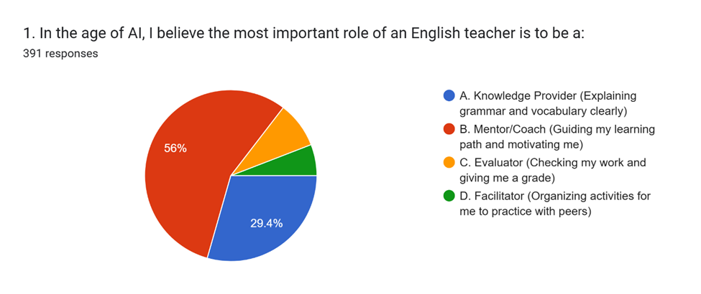
The findings reveal a noticeable shift in students’ expectations of teachers, moving from traditional teacher-centered roles toward more supportive and learner-centered functions. Most respondents (56%) identified the role of mentor or coach as the most important, suggesting that students increasingly expect teachers to provide guidance, motivation, personalized support, and assistance in navigating their learning journey. The role of knowledge provider ranked second, accounting for 29.4% of responses. Although this proportion is considerably lower than that of the mentor/coach role, it still represents nearly one-third of the sample, indicating that students continue to value teachers’ expertise in explaining complex language concepts, correcting misunderstandings, and providing professional insights that AI may not always deliver effectively. In contrast, the roles of evaluator and facilitator received much lower levels of support, with approximately 8.7% and 5.9% of respondents selecting these options, respectively. In brief, this pie chart provides similar findings comparing with that of King (1993). The data suggests that students are actively pushing away from the traditional, transmissive “sage on the stage” (the 29.4% legacy expectation) and demanding a “guide on the side” who acts as a strategic mentor (56%).
Figure 2 – The “Global Citizen” role of an English language teacher in an ESL environment
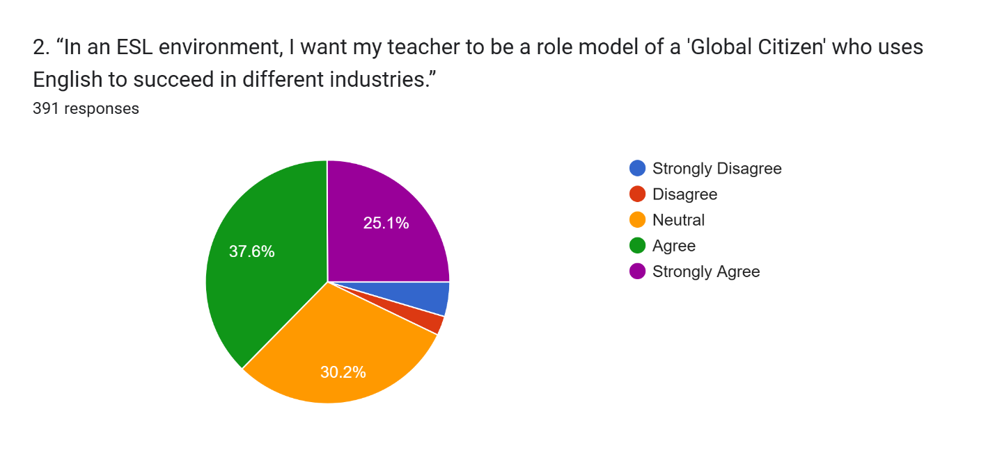
As clearly shown, the largest proportion of respondents selected “Agree” (37.6%), while a further 25.1% chose “Strongly Agree,” resulting in a combined positive response rate of 62.7%. This indicates that nearly two-thirds of the participants expect English language teachers not only to possess strong language proficiency but also to serve as role models who can illustrate how English facilitates success in international communication, career development, and cross-cultural interactions. Meanwhile, 30.2% of respondents remained neutral, representing a substantial proportion of the sample. In contrast, only a small minority expressed negative views, with approximately 3.3% disagreeing and 3.8% strongly disagreeing, accounting for a combined total of 7.1% of responses. In conclusion, this strong positive shift (62.7% combined agreement) directly follow Byram’s (1997) Intercultural Communicative Competence framework. As Vietnam navigates its emerging ESL transition, students look to their lecturers not just for local text comprehension, but to act as lived cultural mediators who model how to negotiate diverse professional industries globally.
Figure 3 – The students’ need for soft skills practicing in class
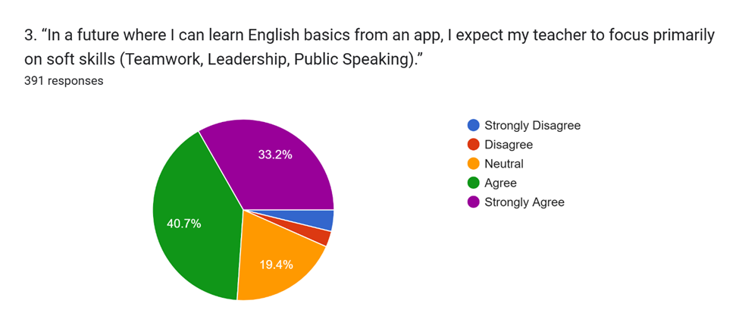
The largest proportion of respondents selected “Agree” (40.7%), while a further 33.2% chose “Strongly Agree,” resulting in a combined agreement rate of 73.9%. This overwhelming majority indicates that most learners expect teachers to devote greater attention to fostering soft skills that cannot be easily acquired through language-learning applications alone. Meanwhile, 19.4% of respondents selected the neutral option, suggesting that although many students support this shift in teaching priorities, a notable proportion remain uncertain about the extent to which soft skills should be integrated into English language education. In contrast, only a small minority expressed disagreement, with approximately 3.3% disagreeing and 3.4% strongly disagreeing, accounting for less than 7% of the total responses. In general, this is a shift from a task-bound “Doing” orientation to a “Growing” orientation (Kluckhohn & Strodtbeck, 1961). Because automated apps can efficiently triage linguistic baselines asynchronously at home (Godwin-Jones, 2024), students need valuable in-class human hours dedicated to socio-adaptive human competencies.
Figure 4 – The importance of sharing teacher’s personal cultural experiences
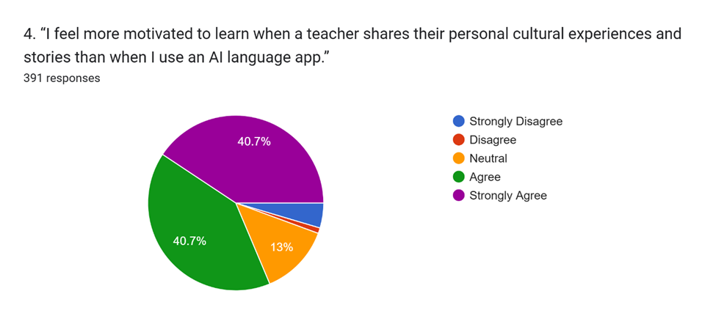
The findings indicate a very strong preference for human interaction and authentic cultural engagement in the language learning process. A majority of respondents expressed positive attitudes toward the statement, with 40.7% selecting “Agree” and another 40.7% choosing “Strongly Agree.” Combined, these categories account for 81.4% of all responses, demonstrating that a substantial majority of learners find teachers’ personal experiences and cultural narratives more motivating than the use of AI-based language learning applications. Meanwhile, 13% of respondents selected the neutral option, indicating that some learners were uncertain or believed that both teachers and AI applications can play complementary roles in supporting motivation. In contrast, only a very small minority expressed negative views, with approximately 1.0% disagreeing and 4.6% strongly disagreeing. All these results are consistent with Dörnyei and Ushioda’s (2011) model of relational motivation. It proves that long-term second language learning stamina cannot be sustained by cold data transfer; it is a dynamic process sparked by real human chemistry, vulnerability, and shared personal narratives.
Figure 5 – The preference for Project-based Learning to Grammar Tests
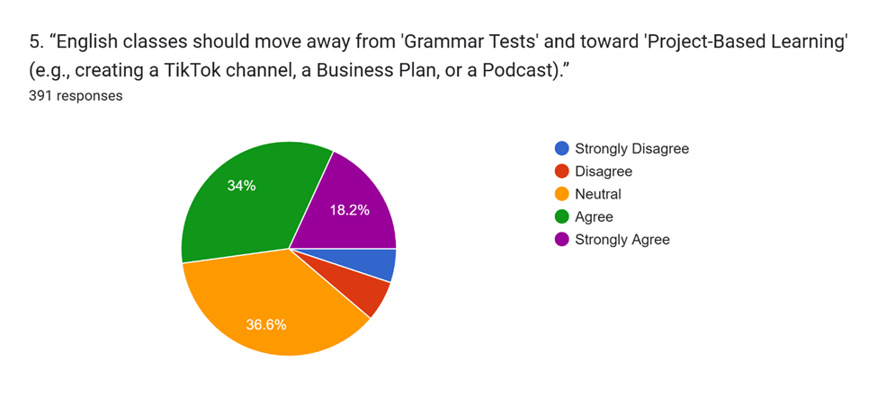
The largest proportion of respondents selected the neutral option (36.6%), indicating that a considerable number of students remain undecided about replacing traditional grammar-focused assessments with project-based activities. Nevertheless, positive responses outweighed negative ones, with 34% of participants agreeing and 18.2% strongly agreeing with the statement. Combined, these categories account for 52.2% of all responses, suggesting that more than half of the respondents support a shift toward more practical, creative, and application-oriented learning experiences. In contrast, only a relatively small proportion of participants expressed disagreement, with approximately 6.9% selecting “Disagree” and 4.3% choosing “Strongly Disagree,” resulting in a combined negative response rate of 11.2%. In general, the 52.2% combined agreement aligns directly with Beckett and Miller (2006) regarding Project-Based Second Language Education. The heavy neutral chunk (36.6%), however, likely reflects the systemic friction noted by Nguyen (2021): changing institutional testing habits from short-term memorization (Hofstede’s STO) to authentic task outputs can trigger learner uncertainty when students are highly conditioned by traditional exam structures.
Figure 6 – The preference for learning “how to say” to “what to say”
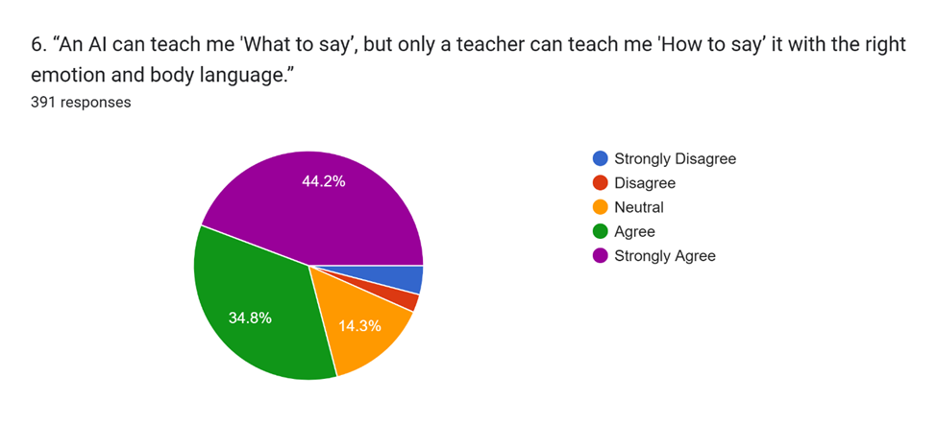
The highest percentage of responses fell into the “Strongly Agree” category, accounting for 44.2% of the total survey sample, which was closely followed by the “Agree” cohort at 34.8%. Combined, these two figures represent a resounding 79.0% of the total respondents who acknowledged that while AI can sufficiently guide learners on factual content (what to say), human teachers remain vital for mastering delivery skills (how to say). In stark contrast, only 14.3% of the surveyed individuals maintained a “Neutral” stance on the matter. The remaining segments represented the dissenting opinions, which altogether comprised less than 8% of the data; specifically, those who expressed “Strongly Disagree” and “Disagree” accounted for approximately 4.3% and 2.4% respectively, highlighting a minimal resistance among the sample to the premise of the statement. In sum, this item’s result reinforces Taguchi’s (2015) research in second language pragmatics. While advanced large language models are exceptional at rectifying syntactic errors (“what to say”), students recognize that the situational appropriateness and non-verbal subtext (“how to say it”) require a human mentor with lived social experience.
Figure 7 – The importance of Encouragement from an English language teacher
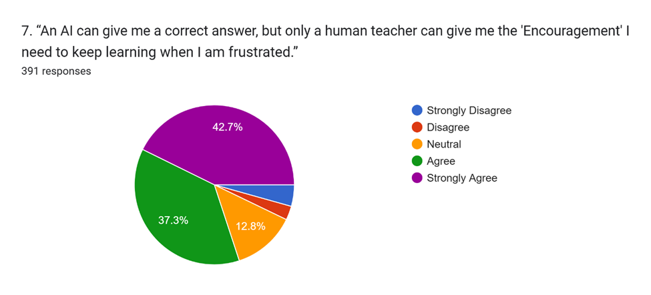
To break down the figures, 42.7% of the respondents expressed the highest level of conviction by selecting “Strongly Agree”, while a substantial 37.3% chose “Agree”. Together, this cumulative 80.0% dominates the chart, validating the hypothesis that technical correctness alone cannot replace a teacher’s emotional support. On the other hand, the proportion of individuals remaining “Neutral” was limited to 12.8%. The remaining minority who questioned the statement accounted for less than one-tenth of the total sample, with 4.3% of respondents stating they “Strongly Disagree” and a mere 2.9% opting for “Disagree”, demonstrating that opposition to the psychological necessity of human educators is statistically minimal. Overall, this is in line with MacIntyre and Gregersen’s (2012) affective filter hypothesis. Language acquisition is emotionally volatile; when students experience cognitive blocks due to anxiety, they require the high emotional intelligence and empathy of a human mentor (Mercer & Dörnyei, 2020) to lower their affective filters.
Figure 8 – The importance of practicing Critical Thinking and debating skills in class
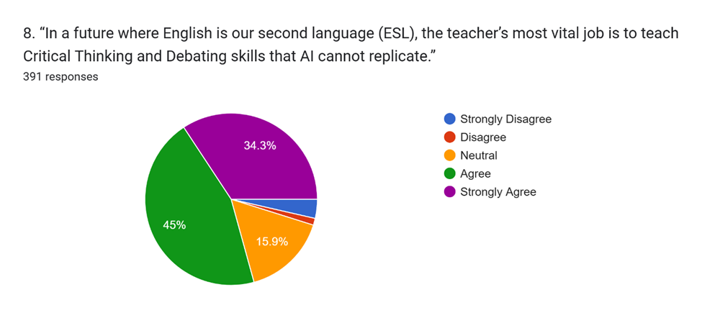
The “Agree” category emerged as the largest segment, accounting for exactly 45% of the total distribution, while the “Strongly Agree” cohort constituted 34.3%. Together, these two figures represent a substantial cumulative majority of 79.3%, indicating a robust belief that pedagogical priorities must evolve toward skills that surpass automated capabilities. Conversely, the proportion of individuals who maintained a “Neutral” attitude stood at 15.9%. Dissenting viewpoints were minimal, collectively representing less than 5% of the survey population; specifically, the “Strongly Disagree” and “Disagree” sectors accounted for minor fractions of approximately 3.5% and 1.3% respectively, confirming that resistance to this predicted shift in ESL instruction is statistically negligible. In brief, this result matches the claims of Su and Yang (2023). Since generative technology can instantaneously fabricate a grammatically flawless essay or script, the instructor's modern role must shift away from checking low-level mechanics to fostering high-order critical evaluation, and active dialectic debate.
Figure 9 – The comparison between Social Intelligence and Data Intelligence
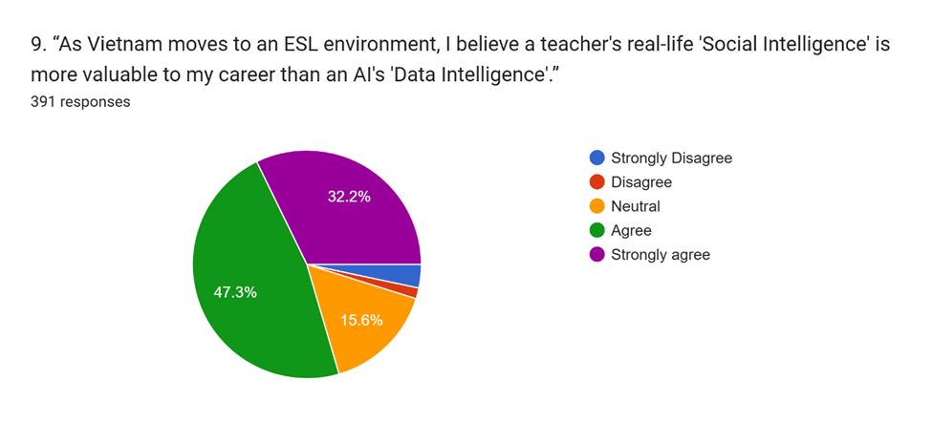
It is highly apparent that a substantial majority of the surveyed individuals expressed a positive attitude toward this notion, reinforcing the perceived superiority of human interpersonal skills over algorithmic data processing in a developing professional landscape, while neutral and negative stances remained in the minority. In detail, the “Agree” cohort constituted the largest share of the dataset, representing nearly half of the total distribution at 47.3%. This was supported by an additional 32.2% of participants who registered a “Strongly Agree” response, bringing the cumulative positive consensus to a significant 79.5%. In contrast, the proportion of individuals who maintained a 'Neutral' position was limited to 15.6%. Active opposition to the statement was extremely minimal, accounting for less than 5% of the total sample; specifically, those who chose “Strongly Disagree” made up approximately 3.5%, while the “Disagree” category recorded the lowest frequency at a mere 1.4%, indicating that skepticism regarding the premium placed on human social intelligence is statistically negligible. In general, this finding serves as a firm support to Vygotsky’s (1978) Social Constructivism. Students are declaring that as language is a social tool meant to navigate real human relationships in the workforce, learning it requires a co-facilitated, socially intelligent environment. They gracefully accept AI’s “data intelligence” as a supportive backend, but guard the upper-level pedagogical space for human-to-human interaction.
Figure 10 – The qualities of a “Perfect English Teacher”' of the year 2030
Core Pedagogical  Theme / Phrase | Exemplary Student Phrase | Frequency of Repetition (N=391)
Communication Skills over Grammar | “Helps every student become a confident communicator instead of only teaching grammar rules.” | 117
Personalized Learning & Individual Needs | “Focuses more on students’ individual needs and personalized teaching methods.” | 94
Creativity & Classroom Engagement | “Uses interactive games, technology, and creative projects to make learning interesting.” | 73
Critical Thinking Facilitator | “Guides students to improve critical thinking, evaluation, and problem-solving.” | 70
Real-life & Workforce Application | “Focuses on real-life English skills, career readiness, and practical applications.” | 70
Strategic Mentor & Guidance | “Acts as a mentor who gives guidance rather than just acting as a traditional knowledge provider.” | 63
Source of Motivation & Inspiration | “An inspiring presence that motivates students to achieve their long-term language goals.” | 62
Empathy & High Emotional Intelligence (EQ) | “Possesses high emotional intelligence to understand student frustration and provide psychological encouragement.” | 39
Holistic Soft Skills Developer | “Uses class time to automate mechanical grading and focus entirely on developing soft skills.” | 19

By coding and counting similar answers (using Excel software) and grouping them into themes with exemplary phrases, the spontaneous and wide range expectation of students about “perfect English language teachers” are simplified into the above table. It can be explored from the table that the highest repetition belongs to Communication Skills (117 counts). This suggests that students recognize the official shift toward an ESL environment where functional, real-world spoken fluency vastly outweighs legacy, task-bound grammar drilling. About the “Guide on the Side” validation, Personalized Learning (94), Critical Thinking (70), and Mentorship (63) score highly which proves an alignment with King's (1993) framework. Students are explicitly asking for teachers to abandon the “Knowledge Provider” monopoly and step into the role of a strategic coach. Concerning the Irreplaceable Human Factor, even though technology is mentioned, the demand for Motivation (62) and Empathy/EQ (39) show that students openly state a teacher's value lies in providing the safe psychological space and encouragement which an AI platform cannot simulate.
5. Discussion
The findings of this study demonstrate a profound shift in undergraduate expectations of English language lecturers within the Vietnamese higher education context. As advanced digital systems democratize baseline language mechanics, students are actively re-evaluating the instructional division of labor between human educators and artificial intelligence.
5.1. The operational shift from knowledge provider to strategic mentor
The quantitative data validate the theoretical transition from a traditional “sage on the stage” to a modern “guide on the side” (King, 1993). When asked to define the primary role of an English teacher in the age of AI (Item 1), a decisive majority (56%) selected “Mentor/Coach”, while only 29.4% favored the legacy role of “Knowledge Provider”. This structural pivot is corroborated by Item 3, where 73.9% of respondents (Agree and Strongly Agree combined) expect instructors to focus primarily on high-level soft skills like teamwork, leadership, and public speaking rather than language basics. However, the neutral group may suggest that students are interested in innovation but still uncertain about replacing familiar assessment practices and the traditional role of teachers as a knowledge provider. Viewed through the value orientation framework of Kluckhohn and Strodtbeck (1961), these percentages indicate an institutional shift from a task-bound “Doing” orientation (focused on immediate test compliance) to a student-centric “Growing” orientation (focused on long-term capability). Students openly expect human-led class hours to be liberated from mechanical instruction, a demand further reflected in the qualitative data where Personalized Learning & Individual Needs (n = 94) and Strategic Mentorship (n = 63) emerged as dominant criteria for the future “Perfect Teacher”.
5.2. Curricular Innovation: Navigating the Emerging ESL Landscape
As Vietnam actively transitions from an EFL toward a formalized ESL framework to cultivate global citizenship, student demands for structural curricular design have evolved. A significant majority of participants (52.2%) expressed agreement or strong agreement that language classes should move away from standard grammar examinations toward complex project-based Learning (item 5), such as producing podcasts or business plans. Furthermore, 79.3% of undergraduates agree that in an ESL ecosystem, the teacher's most vital job is to cultivate critical thinking and debating skills that algorithms cannot replicate (Item 8). This orientation aligns clearly with Hofstede’s (2004) conceptualization of a Long-term Orientation, wherein educational success is measured by situational adaptability and real-world utility rather than short-term rote recall. The evidence proves that students no longer view the classroom as an isolated syntactic training ground, but rather as an incubator for professional readiness, which is echoed in the qualitative findings ranking Communication Skills over Grammar (n = 117) and Real-life & Workforce Application (n = 70) as the highest student priorities.
5.3. The Irreplaceable Human Core: Emotional and Social Intelligence
The most impressive data emerges around the affective and socio-cultural dimensions of language acquisition, exposing the strict limitations of artificial intelligence. While AI tools are recognized for their data intelligence, students display a massive preference for human interaction when navigating the vulnerable process of learning a language. Specifically, 81.4% of students feel more motivated when an instructor shares personal cultural experiences and lived narratives than when interacting with an AI language application (Item 4). 80% agree that while AI can provide accurate technical answers, only a human teacher can deliver the authentic “Encouragement” needed to overcome learning frustration (Item 7). This data provides proof for Dörnyei and Ushioda’s (2011) relational motivation theory and MacIntyre and Gregersen’s (2012) affective filter hypothesis, proving that sustained linguistic stamina requires genuine human empathy and psychological validation. Furthermore, communication is recognized as a deeply contextual, symbolic phenomenon rather than a simple transactional data transfer. This is evidenced by Item 6, where a striking 79% of participants agreed that “An AI can teach me 'What to say', but only a teacher can teach me 'How to say' it with the right emotion and body language.” This realization is reinforced by Item 9, where 79.5% of respondents asserted that a human teacher’s real-world “Social Intelligence” is vastly more valuable to their careers than an AI's “Data Intelligence.”
Consequently, the human teacher remains entirely irreplaceable as a lived cultural bridge (Byram, 1997) and a model for pragmatic social competence (Taguchi, 2015) – which is reinforced by the qualitative clusters identifying Empathy and High EQ (n = 39) and Social Intelligence as core human pillars.
6. Conclusion
6.1. Empirical and theoretical summary
This study maps the evolving expectations of N = 391 undergraduate English majors in Vietnam against the dual backdrops of rapid artificial intelligence integration and an official transition toward an ESL educational framework. The data demonstrate a structural consensus: modern language learners do not view AI as a replacement for human educators, but rather as a tool to catalyze a long-awaited pedagogical evolution. Students explicitly relegate lower-level, mechanical linguistic triage - such as basic grammar explanation and automated text corrections - to machine datasets, viewing out-of-class AI interactions as a safe, low-stakes “linguistic sandbox” to lower foreign language anxiety. Concurrently, this spatial division of labor completely redefines the institutional value proposition of the human lecturer. The physical university classroom is no longer expected to operate as a transmission hub for rote data delivery. Instead, students decisively demand that human educators step into roles as strategic mentors, cultural mediators, and coaches of advanced soft skills. The overwhelming majority of participants emphasize that while an algorithm operates on “data intelligence”, it remains decoupled from the affective, socio-cultural, and relational realities of language acquisition. True linguistic fluency, pragmatic delivery, and professional confidence are co-constructed through human interaction, relying on a teacher's real-world “social intelligence”, empathy, and relational encouragement. Ultimately, the “Perfect English Teacher” of the future is not defined by their mastery over syntactic rules, but by their high emotional intelligence and capacity to guide students toward becoming global citizens.
6.2. Limitations of the study
While this study provides robust data-driven insights, several structural limitations must be acknowledged:
- Geographic and institutional sample isolation
The sample size (N = 391) was strictly recruited from a single private university in Ho Chi Minh City via convenience sampling. Consequently, the findings may not fully represent student expectations in public universities or institutions located in rural and suburban regions of Vietnam, where resource access and baseline digital literacy may differ.
- Static cross-sectional design
The data capture student expectations at a single point in time. Because generative artificial intelligence technologies and national ESL policies are evolving at an accelerated pace, student attitudes and reliance on digital tools may shift dynamically over a longer timeline.
- Self-reported data bias
The study relies heavily on self-reported survey perceptions. While useful for mapping internal attitudes, student expectations of what they want from a curriculum do not always directly correlate with objective measures of learning efficiency or actual academic performance.
- Instrumental insufficiency
The questionnaire is short and developed by the author basing on a simple framework of three sub-research questions, so it lacks full reliability and validity. The study also relies on one open-ended question for qualitative data, which limits the depth of interpretation. Another concern is that the findings capture broad student expectations rather than detailed explanations of why students hold these views.
6.3. Recommendations for future research
To build upon the empirical foundations established by this study, future research should explore the following avenues:
- Longitudinal inquiries
Future studies should deploy longitudinal research designs to track how undergraduate expectations, prompt literacy, and AI dependencies evolve over their four-year university trajectory as generative tools become deeply normalized in secondary education.
- Comparative institutional analyses
Expanding data collection to include a comparative analysis between private and public universities, as well as northern, central, and southern regional institutions, would provide a more generalized national mapping of the ESL transition.
- Multi-perspective triangulation
Future projects should actively capture faculty perspectives, exploring the institutional challenges, anxieties, and training deficiencies experienced by university lecturers as they attempt to transition from traditional “knowledge providers” to “strategic mentors”. Moreover, future research should include interviews, focus groups, or classroom observation to triangulate survey findings.
In brief, future studies could compare student and teacher expectations, examine whether AI literacy changes students’ expectations over time, or test whether redesigned teacher roles actually improve learner engagement, communication confidence, and critical thinking. This would move the research beyond perception mapping toward pedagogical evaluation.

References
Beckett, G. H., & Miller, P. C. Project-Based Second and Foreign Language Education: Past, Present, and Future. Information Age Publishing, 2006.
Byram, Michael. Teaching and assessing intercultural communicative competence. Multilingual Matters, 1997.
Chassignol, M., Khoroshavin, A., Klimova, A., & Bilyatdinova, A. (2019). Artificial intelligence trends in education: A narrative overview. Procedia Computer Science, 146, 16–24. https://doi.org/10.1016/j.procs.2019.01.004
Dörnyei, Z., & Ushioda, E. Teaching and researching motivation. Longman, 2011.
Godwin-Jones, R. Partnering with AI: Large Language Models in Computer-Assisted Language Learning. Language Learning & Technology, 28(1), 1-19, 2024.
Hofstede, G., & Hofstede, G. J. (2004). Cultures and organizations: Software of the mind. (2nd ed.). McGraw-Hill.
King, A. (1993). From sage on the stage to guide on the side. College Teaching, 41(1), 30–35. https://doi.org/10.1080/87567555.1993.9926781
Kluckhohn, F. R., & Strodtbeck, F. L. (1961). Variations in value orientations. Row, Peterson and Company.
Kohnke, L. Generative AI in Higher Education: The Future of Teaching and Learning. Routledge, 2023.
Koraishi, O. Exploratory Study on the Use of ChatGPT in Alleviating Foreign Language Speaking Anxiety. Journal of Education and E-Learning Research, 10(3), 424-432, 2023.
MacIntyre, P. D., & Gregersen, T. (2012). Emotions that facilitate or impede learning: The dual-purpose of affect. Studies in Second Language Learning and Teaching, 2(2), 193–213. https://doi.org/10.14746/ssllt.2012.2.2.4
Mercer, S., & Dörnyei, Z. (2020). Engaging language learners in contemporary classrooms. Cambridge University Press. https://doi.org/10.1017/9781108918718
Nguyen, T. M. H. Teacher Professional Development in Malaysia and Vietnam: Shifting Paradigms in Language Teacher Education. Journal of Asia TEFL, 18(3), 912-926, 2021.
Stockwell, G. Mobile-Assisted Language Learning: Concepts, Contexts and Challenges. Cambridge University Press, 2022.
Su, J., & Yang, W. (2023). Artificial intelligence in language education: A systematic review. Computer Assisted Language Learning, 1–33. Advance online publication. https://doi.org/10.1080/09588221.2023.2246513
Taguchi, N. (2015). Instructed pragmatics at a glance: Where instructional patterns meet learning outcomes. Language Teaching, 48(1), 1–84. https://doi.org/10.1017/S026144481400026X
Vygotsky, L. S. Mind in Society: The Development of Higher Psychological Processes. Harvard University Press, 1978.
Zawacki-Richter, O., Marín, V. I., Bond, M., & Gouverneur, F. (2019). Systematic review of research on artificial intelligence applications in higher education. International Journal of Educational Technology in Higher Education, 16(1), Article 39. https://doi.org/10.1186/s41239-019-0171-0
Zhai, X. ChatGPT for Next Generation Science Learning. XRDS: Crossroads, The ACM Magazine for Students, 2023.

Bionote
The author of this paper has been a lecturer at universities in Ho Chi Minh City in fifteen years, and sustains a deep interest in subjects such as language skills, translating, interpreting, literature, civilization, and intercultural communication.

Appendices
Questionnaires

Student Survey: The Future of English Learning in the AI & ESL Era
Section 1: The Teacher as a Personal Brand & Evolving Role
1. In the age of AI, I believe the most important role of an English teacher is to be a:
- Knowledge Provider (Explaining grammar and vocabulary clearly)
- Mentor/Coach (Guiding my learning path and motivating me)
- Evaluator (Checking my work and giving me a grade)
- Facilitator (Organizing activities for me to practice with peers)
2. In an ESL environment, I want my teacher to be a role model of a ‘Global Citizen’ who uses English to succeed in different industries.
- Strongly Disagree
- Disagree
- Neutral
- Agree
- Strongly Agree
3. In a future where I can learn English basics from an app, I expect my teacher to focus primarily on soft skills (Teamwork, Leadership, and Public Speaking, etc.)
- Strongly Disagree
- Disagree
- Neutral
- Agree
- Strongly Agree
Section 2: Pedagogical Innovation & Practicality
4. I feel more motivated to learn when a teacher shares their personal cultural experiences and stories than when I use an AI language app.
- Strongly Disagree
- Disagree
- Neutral
- Agree
- Strongly Agree
5. English classes should move away from ‘Grammar Tests’ and toward ‘Project-Based Learning’.
- Strongly Disagree
- Disagree
- Neutral
- Agree
- Strongly Agree
6. An AI can teach me ‘What to say’, but only a teacher can teach me ‘How to say’ it with the right emotion and body language.
- Strongly Disagree
- Disagree
- Neutral
- Agree
- Strongly Agree
Section 3: The Irreplaceable Human Element
7. An AI can give me a correct answer, but only a human teacher can give me the ‘Encouragement’ I need to keep learning when I am frustrated.
- Strongly Disagree
- Disagree
- Neutral
- Agree
- Strongly Agree
8. In a future where English is our second language (ESL), the teacher’s most vital job is to teach Critical Thinking and Debating skills that AI cannot replicate.
- Strongly Disagree
- Disagree
- Neutral
- Agree
- Strongly Agree
9. As Vietnam moves to an ESL environment, I believe a teacher's real-life ‘Social Intelligence’ is more valuable to my career than an AI's ‘Data Intelligence’.
- Strongly Disagree
- Disagree
- Neutral
- Agree
- Strongly Agree
Section 4: The "Dream" Classroom
10. Describe the ‘Perfect English Teacher’ of the year 2030. What do they do differently than teachers today?

Nguyễn Lê Uyên, MA in TESOL, Faculty of Foreign Languages, HUFLIT, HCM City, Vietnam; Email: uyennl@huflit.edu.vn

