Equity, Inclusion, and Access in Higher Education: Challenges Faced by Students from Diverse Socioeconomic Backgrounds
Trang Nguyen , Vy Nguyen

Abstract
Equity, inclusion and access are fundamental pillars in education, particularly within tertiary education settings, hosting students from diverse socioeconomic backgrounds. his study examines the systemic and classroom-level challenges related to these principles at two public universities in Vietnam: the University of Social Sciences and Humanities (USSH) and Ho Chi Minh City University of Technology (HCMUT). Employing a convergent mixed-methods design, the study utilized an online survey with 100 undergraduate students (50 from USSH and 50 from HCMUT) and semi-structured focus group interviews with 10 participants to investigate students’ access to academic resources, perceptions of equity in learning opportunities, and experiences of classroom inclusion. Key findings reveal significant disparities: students from lower-income backgrounds reported financial pressure from hidden financial costs (textbooks, devices, internet, software), digital access barriers, reduced study time due to part-time work, feelings of classroom alienation, and perceptions of insufficient institutional support. These challenges shaped students’ everyday learning experiences post-enrollment. The paper proposes evidence-based pedagogical strategies and institutional policy recommendations to promote more equitable and inclusive classrooms. The study also acknowledges its limitations regarding sample representativeness and offers suggestions for future research.
Keywords: equity, inclusion, access, socioeconomic background, higher education

- Introduction

Higher education is a critical pathway for academic and professional development. However, students do not always experience university life under the same conditions. While pedagogical research often focuses on teaching methods and learning outcomes, less attention has been paid to how socioeconomic backgrounds influence students’ ability to participate fully in educational opportunities after enrollment. For many students, the costs associated with learning extend beyond tuition fees and include textbooks, technological devices, internet access, and extracurricular activities. Particularly in Vietnam, where university students come from diverse socioeconomic backgrounds, access to equitable learning experiences sometimes depends on circumstances beyond their control. This difference, however minor, may lead to classroom exclusion rather than opportunity, where a student’s academic success may be determined as much by their financial situation as by their individual efforts to acquire knowledge. Hence, the concepts of equity, inclusion, and access are essential in modern tertiary education. Although these concepts are widely recognized in educational theory, their practical application is often complicated by the socioeconomic realities of different student groups. For this reason, understanding how socioeconomic backgrounds shape students’ access to resources, their sense of inclusion, and their experience of equity within the learning environment has become a crucial concern in Vietnam’s higher education system.
This study contributes to the body of existing research by redirecting the focus from the general academic outcomes or the comprehensive access to higher education to the daily lived experiences of socioeconomic inequality that students encounter after enrolling. It investigates not just whether students join university, but how they experience equity, access, and inclusion during their university education. The research was conducted to address the following question:
In which way do Ho Chi Minh City University of Technology (HCMUT) and University of Social Sciences and Humanities (USSH) students perceive the challenges regarding equity, access and inclusion based on their diverse socioeconomic backgrounds?
2. Literature Review
2.1. Equity, Inclusion, and Access in education
Modern education has to be fundamentally restructured in light of the rapidly changing student demographics brought about by social, political, and cultural shifts. In 21st-century education, to avoid classroom alienation and systemic inequality, the core values of equity, access, and inclusion are no longer optional or theoretical ideas; they are essential for constructing equitable, sustainable, and forward-thinking learning environments (Panigrahi, 2025). To provide a theoretical foundation for the survey instruments used in this study, this section reviews literature surrounding three main constructs: equity, access, and classroom inclusion in education.
According to the Strength through Diversity Project (OECD, 2023), equity in education systems means that all students can achieve their educational potential, regardless of their gender, ethnic origin, Indigenous background, immigrant status, sexual orientation and gender identity, special education needs, or giftedness (Cerna et al., 2021; OECD, 2017). To understand this concept, it is essential to distinguish between equality and equity. Panigrahi (2025) and Iheduru-Anderson et al. (2025) clarified that equity is different from equality in that, whereas equality just means the same treatment for all individuals, equity acknowledges the existence of systemic imbalances and demands interventions to address them. Yasinzai and Ahad (2025) further noted that achieving fairness in education necessitated acknowledging and resolving historical and systemic disadvantages.
Iheduru-Anderson et al. (2025) defined access as the elimination of structural, economical, physical, technical, systemic, curricular, language, and cultural barriers to full participation in educational and professional settings via appropriate accommodations. Although worldwide higher education enrollment has increased, access remains significantly uneven across different regions and social and economic classes (Yasinzai & Ahad, 2025). With a growing dependency on online education platforms, Panigrahi (2025) pointed out that it is critical to ensure educational materials and resources are accessible to students with learning disabilities and those living in distant areas. To him, accessibility also applies to language, pedagogy, and evaluations, ensuring that students may participate meaningfully regardless of where they begin or their personal background.
UNESCO (2009) characterized inclusive education as “an on-going process aimed at offering quality education for all while respecting diversity and the different needs and abilities, characteristics and learning expectations of the students and communities, eliminating all forms of discrimination”. The goal for it is to address all students’ needs, which extends beyond school attendance and achievement, while simultaneously improving their well-being and participation (Cerna et al., 2021), so that diverse individuals can feel valued, welcomed, respected, and able to contribute fully within an environment (Panigrahi, 2025).
Table 1
Defining Equity, Access, and Inclusion
Terms | Definition
Equity | Fairness in treatment, access, and outcomes by addressing structural and systemic barriers.
Access | Removing structural, cultural, institutional, and systemic barriers that limit full participation or advancement.
Inclusion | Creating environments where all individuals feel welcomed, valued, respected, and able to participate and contribute fully.
*Note. Adapted from Iheduru-Anderson et al.( 2025)
2.2. Socioeconomic backgrounds and inequality in higher education
These theoretical distinctions regarding the three concepts are crucial, as socioeconomic backgrounds play an essential role in determining learning opportunities within higher education. As stated by Tomaszewski et al. (2022), people from socioeconomically deprived backgrounds frequently have lower academic performance than those from more socio-economically advantaged backgrounds; this disparity can be linked to their fundamental differences in learning experiences.
The claim was also further supported by previous studies from Sabic-El-Rayess (2012, 2014 & 2020); Sabic-El-Rayess & Mansur (2016), Sabic-El-Rayess & Seeman (2017), Sabic-El-Rayess & Otgonlkhagva (2012), Sabic-El-Rayess, Mansur, Batkhuyag & Otgonlkhagva (2019), Moratti and Sabic-El-Rayess (2009), who demonstrated that elite mechanisms and interests often prevail over the needs of the disadvantaged across social, economic, and educational hierarchies globally. Unfortunately, universities and colleges only help reinforce this existing socioeconomic strata further (Sabic-El-Rayess & Mansur, 2016), unless there is a strong political determination to disrupt the status quo and increase opportunities for the poor (Fadhil & Sabic-El-Rayess, 2021). As a result, students from disadvantaged backgrounds, such as those with disabilities, those living in poverty, ethnic and linguistic minorities, and rural communities, continue to encounter systemic challenges that impede their ability to study, contribute, and achieve (Panigrahi, 2025).
According to Tomaszewski et al. (2022), there are seven different barriers to accessing university, such as low self-efficacy, received youth allowance, low-SES school, school life, no plan for university, parents not wanting university and low PISA (Programme for International Student Assessment) score. The findings in their research showed that individuals from lower socioeconomic origins are far more likely than their more advantaged counterparts to encounter these numerous challenges to attending college.
Applied to our study, these findings suggest that simply providing the same course requirements to every student is insufficient. When learners lack access to standard requirements for higher education learning such as the financial means to purchase coursebooks or afford tuition fees, the “equal” treatment often masks an underlying inequality.
2.3. The Vietnamese higher education context
Many studies have been undertaken on inequities in educational access in Vietnam. Nguyen (2004) observed that while countrywide school enrollment expanded across all educational levels, particularly in higher education, the financial burden of private schooling heavily impacted low-income households. This economic strain further widened the disparity between affluent and disadvantaged students regarding both educational opportunity and quality. Another study by Thach (2020) indicated that children from low-income families’ access to higher education lower than their peers. According to Vu (2012), severe inequalities in school access still exist; hence, significant gaps continue to separate rural and urban students, ethnic minorities and the majority population, and wealthy households from low-income ones.
To operationalize these concepts for the current study, the literature is synthesized around three main constructs that directly inform our survey and interview instruments:
1. Access to resources: focused on structural and material barriers (Iheduru-Anderson et al., 2025), this construct measures students’ ability to afford hidden costs such as laptops, internet, textbooks and proprietary software.
2. Perception of equity: rooted in the acknowledgment of systemic imbalances (Panigrahi, 2025), this construct evaluates the perceived fairness of university support systems and rigid academic policies.
3. Perception of inclusion: based on UNESCO's (2009) framework, this construct assesses students’ psychological sense of belonging and their comfort in participating without fear of socioeconomic alienation.
2.4. Research gap
While existing literature highlights the challenges low-socioeconomic status imposes on higher education students across the globe, there remains a notable lack of contemporary research specifically situated within the Vietnamese higher education context. This study seeks to address this and bridges three specific gaps. First, a contextual gap exists as most prior studies focus on enrollment or broad academic outcomes rather than the everyday classroom experiences in Vietnamese public universities. Second, a conceptual gap remains regarding the intersection of the three pillars of modern education: equity, access, and inclusion; few studies examine how they influence one another simultaneously. Third, there is an empirical gap in qualitative exploration into students’ lived experiences of hidden academic costs and classroom alienation post-enrollment. This study seeks to close these gaps by exploring how these three pillars influence one another, and how they appear differently for students’ daily experiences from diverse socioeconomic backgrounds at two Vietnamese public universities (USSH and HCMUT). By connecting specific barriers that hinder equitable, accessible, and inclusive learning experiences, this research proposes pedagogical strategies and institutional policy recommendations for a just and sustainable educational framework that ensures all learners can achieve their full academic potential, regardless of their socioeconomic backgrounds.
3. Methodology
3.1. Research site
The research was conducted at two member institutions of Vietnam National University Ho Chi Minh City (VNU-HCM): the University of Social Sciences and Humanities (USSH) and Ho Chi Minh City University of Technology (HCMUT). USSH is located in the VNU-HCM Urban Area, Linh Trung Ward, Thu Duc City, Ho Chi Minh City, while HCMUT’s second campus is located in Dong Hoa Ward, Ho Chi Minh City. As two major public universities in southern Vietnam, these institutions attract students from diverse socioeconomic and educational backgrounds across the country. USSH and HCMUT were treated as two sites for exploring shared student experiences rather than as a comparative study; no institutional differences were systematically examined.
3.2. Participants
The participants were undergraduate students from the Faculty of English Linguistics and Literature (EF) and Engineering Faculty. A total of 100 students agreed to take part in the study, with 50 students from USSH and 50 students from HCMUT. The convenience sampling approach was implemented to select the sample. This approach was chosen due to the researchers’ existing connections within the faculties, which is efficient and provides timely data collection. By targeting students based on their availability and willingness to participate, the researchers were able to gather a diverse range of student perspectives regarding academic challenges.
However, this non-probability sampling limits the full representativeness of the findings, meaning the findings cannot be generalized to all students at these universities or Vietnamese higher education broadly, as participation was voluntary and dependent on accessibility. Participant variation included multiple academic years (freshmen to seniors), gender, major, and self-reported family financial status (low income, lower-middle income, middle income, upper-middle income, high income). Detailed data on rural/urban background, scholarship status, and living arrangements (with family or renting) were also not systematically collected; future studies should include these as socioeconomic barriers may differ across conditions.
3.3. Study design
This study employed a convergent mixed-methods design (Creswell & Plano Clark, 2018). Quantitative and qualitative data were collected concurrently during the same period to provide a comprehensive understanding: the survey (quantitative data) captured broad patterns of perceptions, while follow-up focus group interviews (qualitative data) provided deeper explanations of students’ lived experiences. The two strands were integrated during interpretation to complement each other.
3.4. Data collection procedures
For quantitative data, an online questionnaire was distributed via email to 100 participants. The items from the survey were directly developed based on the conceptual definitions outlined in the literature review (Table 1). It consisted of 18 Likert-scale items (1 = Strongly Disagree to 5 = Strongly Agree) and 3 open-ended questions, covering five key sections aligned with the three core constructs:
1. Access to resources: Items derived from structural/material barriers in literature included affordability of textbooks, devices, internet, software, and extracurricular costs.
2. Perception of equity: Items derived from fairness and unequal resources focused on fairness of assessments, influence of external resources, and university support.
3. Perception of classroom inclusion: Items derived from belonging and participation evaluated the sense of belonging, discomfort sharing experiences, and social alienation.
For qualitative data, semi-structured focus group interviews (10 questions) with 10 participants served as follow-up to explore hidden costs, classroom exclusion, policy flexibility, and institutional support in depth. Interviews were conducted in familiar classroom settings, audio-recorded with consent, and supplemented with observation notes.
3.5. Reliability and validity
A pilot test of the questionnaire was conducted with 15 students from similar backgrounds to assess clarity, face validity, and reliability. Internal consistency reliability was evaluated using Cronbach’s alpha for each subscale: access to resources: α = 0.82; perception of equity: α = 0.79; perception of classroom inclusion: α = 0.85. All coefficients exceeded the acceptable threshold of 0.70 recommended for exploratory research in social sciences (Hair et al., 2019), indicating internal consistency. Content validity was further supported through instrument alignment with established definitions and consultation from higher education faculty members.
Regarding the qualitative data, transcript coding was independently conducted and subsequently cross-checked by two researchers to resolve discrepancies and establish consensus, ensuring trustworthiness.
3.6. Data processing procedures
An online questionnaire was distributed via email. Raw data from the questionnaires were processed using the Statistical Package for the Social Sciences (SPSS). The results were extracted and then analyzed using frequency tables and bar charts. Qualitative data from the focus group interviews were transcribed verbatim and analyzed using thematic analysis following Braun and Clarke’s (2006) six-phase approach. An inductive coding process was employed, while also being informed deductively by the three core constructs (access to resources, perceptions of equity, and classroom inclusion) from the literature and survey. Initial codes were generated, collated into potential themes, reviewed, defined, and named. To enhance trustworthiness, two researchers independently coded a subset of transcripts, and discrepancies were resolved through discussion until consensus was reached. Member checking was conducted with two participants to verify the accuracy of interpreted themes.
3.7. Ethical issues
Since the research involves audio recordings, semi-structured focus group interviews, and questionnaires, we ensure that informed consent is obtained from all participants prior to their involvement. For the questionnaires, we sent an invitation via email that included all the necessary details about the study, including its benefits and any possible risks. Before the participants filled out the form, they had to sign a consent statement, which confirmed they were aware of the points and allowed the research to use their data. Regarding the interview, the participants are only asked to discuss topics they are comfortable with and they will have the right to refuse to participate in the research or withdraw from it at any time. To ensure confidentiality in the results, all names were replaced with numbers (e.g., Participant 01). Hard copies of data were stored in secured drawers, and digital files were password-protected.
4. Results
After reviewing the survey responses and conducting focus group interviews, the researchers processed 100 survey questionnaire responses and 10 in-depth interview transcripts.
The quantitative analysis reveals a significant disparity in how students perceive equity, resource access and inclusion at the university. Table 2 shows that most respondents came from middle-income (40%) and lower-middle-income (25%) backgrounds. In addition, 62% of participants reported not having a part-time job, while 38% were engaged in part-time employment.

Table 2
Demographic Information of the Respondents
Variable | Category | Number of students | Percentage
Family financial status | Low income | 15 | 15%
 | Lower-middle income | 25 | 25%
 | Middle income | 40 | 40%
 | Upper-middle income | 15 | 15%
 | High income | 5 | 5%
Part-time job | Yes | 38 | 38%
 | No | 62 | 62%
*Note. Data are based on student responses to survey questions regarding family financial status and part-time employment status. N = 100.
The qualitative investigation, conducted through focus group interviews with 10 survey respondents, provides deeper insights into the lived experiences and challenges students encounter.
To directly address the research questions, the findings regarding students’ learning experiences are organized conceptually around the three core pillars: access to resources, perceptions of equity, and classroom inclusion, integrating both quantitative trends and qualitative depths.
4.1. Access to resources
Figure 1 illustrates students’ perceptions regarding their ability to afford necessary learning resources. While 39% of respondents agreed that they were able to afford the required resources, 26% of students expressed concerns regarding the burden of academic requirements (Mean = 3.21). This suggests that the costs of textbooks, internet access, software, technological devices and other learning expenses remain barriers for a notable minority of students.
Figure 1
Student Responses Regarding Financial Ability to Afford Necessary Learning Resources
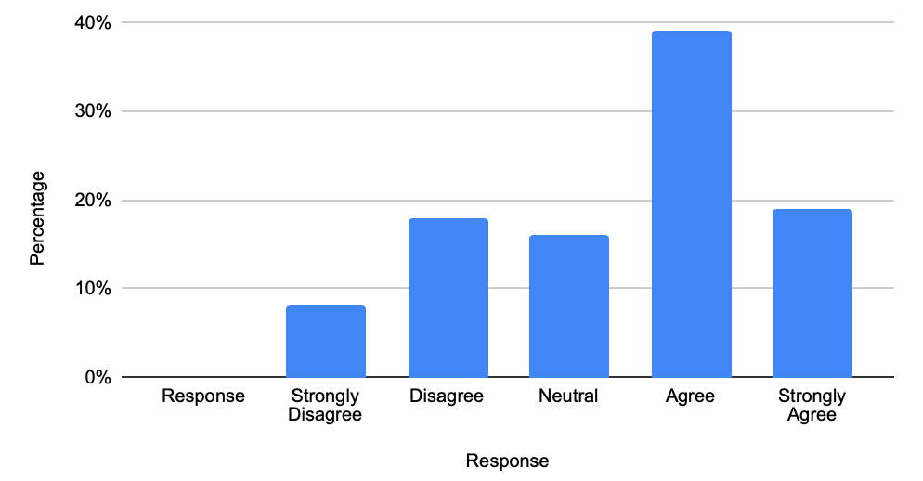
Note. Data are based on student responses to the survey item: “My financial situation allows me to afford all necessary learning resources (e.g., textbooks, specialized software, learning applications, a stable internet connection) and other course-related expenses”.
Figure 2 presents students’ responses regarding the impact of work responsibilities on their studies. Approximately 34% of respondents agreed and 21% strongly agreed that work responsibilities reduced the time and energy they could devote to academic activities. This suggests that balancing work and study can be a challenge for many students.

Figure 2
Students’ Perceptions of the Impact of Work Responsibilities on Study Time and Energy
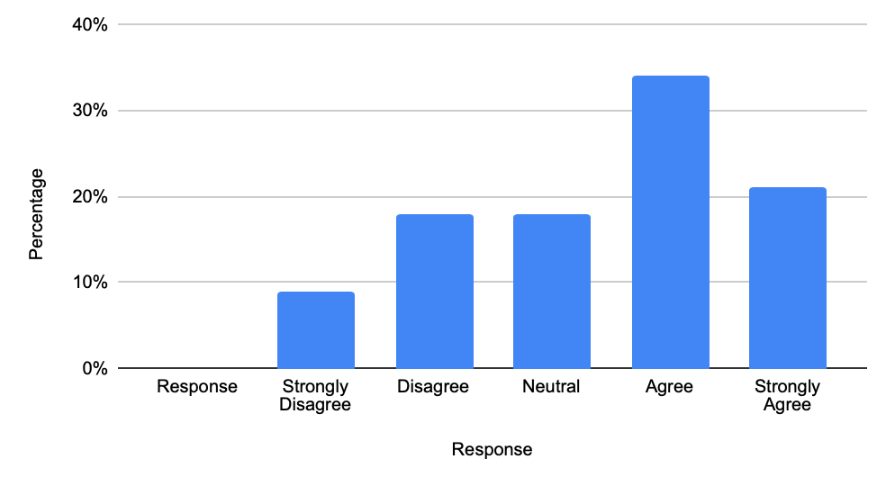
Note. Data are based on student responses to the survey item: “My work responsibilities (eg house chores, part-time jobs) reduce the time and energy I can devote to my studies”.
These statistical patterns were deeply echoed in the focus group interviews as interviewed students expressed severe frustration regarding the “hidden costs of digital and academic learning”. 6 out of 10 students noted that these requirements are often treated as standard, overlooking the financial strain on low-income students.
“For our speech and presentation classes, we are constantly required to create high-quality slides and digital portfolios. My laptop is a second-hand model my family bought years ago so it runs incredibly slow and the battery dies in 20 minutes. When professors require us to buy original international textbooks instead of using photocopies due to copyright rules, it takes a massive chunk out of my monthly allowance. I ended up having to borrow a friend’s book to take photos of the pages.” - Participant 03.
4.2. Perception of equity
While some students acknowledge the support of the university’s support services such as library and computer labs, respondents with lower-income status viewed current university support as insufficient in addressing their needs. Table 3 shows that when assessing proactive institutional support, disparities emerged across income groups. 60% of students with low income, 40% of lower-middle income and 22% of middle income perceived the university support services as inadequate. Although these percentages highlight a stark contrast based on self-reported financial status, it is important to note that inferential statistical tests (e.g., chi-square) were not conducted; thus, these figures represent observed trends within the convenience sample rather than statistically generalized differences.
Table 3
Students’ Perceptions of Proactive University Support by Financial Status
Financial status | Agree/Strongly agree | Neutral | Disagree/Strongly disagree
Low income (15) | 3 (20%) | 3 (20%) | 9 (60%)
Lower-middle income (25) | 8 (32%) | 7 (28%) | 10 (40%)
Middle income (40) | 19 (48%) | 12 (30%) | 9 (22%)
Upper-middle income (15) | 9 (60%) | 4 (27%) | 2 (13%)
High income (5) | 3 (60%) | 2 (40%) | 0 (0%)
*Note. Data are based on student responses to the survey item: “I feel the university takes proactive steps to support students from low-income backgrounds (e.g., providing facilities and scholarships) so that they are not left behind”.
Qualitatively, in the interviews, 5 out of 10 students also emphasized the severe stress of balancing part-time employment with academic deadlines. The strict attendance and submission policies at their universities were cited as lacking the flexibility needed for working students.
“I work as a barista at a coffee shop and do evening tutoring to cover my room rent in the city. My shifts sometimes conflict with morning classes if a coworker gets sick. The university’s attendance policy is incredibly rigid; if you miss more than 20% of classes, you are barred from taking the final exam. If I am late because a shift ran over, my process score suffers.” - Participant 07.
Moreover, 6 out of 10 participants expressed concerns that the university does not truly understand the extent of the equity gap. 2 out of 10 participants felt that policies are designed for the students from more affluent backgrounds, ignoring those facing financial hardship. 3 out of 10 participants also noted that the university’s support systems were often reactive rather than preventive. Assistance was usually available only after students had already encountered difficulties. However, 3 out of 10 participants noted that some instructors show genuine empathy regarding socioeconomic challenges. This includes providing recorded lectures or accepting late submissions due to unavoidable work shifts.
“The school’s administrative system is slow and the computer labs are outdated, which doesn't help much. But some of my instructors have been amazing. When I explained that I didn't have Wi-Fi at home last month, my teacher allowed me to submit my essay a day late.” - Participant 09.
4.3. Perception of inclusion
Figure 3 illustrates students’ perceptions of inclusivity in the classroom. A notable proportion of respondents (32%) reported feeling uncomfortable sharing personal experiences that differed from those of wealthier peers. This finding suggests that socioeconomic differences may influence students’ sense of inclusion and participation in classroom discussions.

Figure 3
Students’ Feelings of Discomfort Sharing Personal Experiences due to Socioeconomic Differences
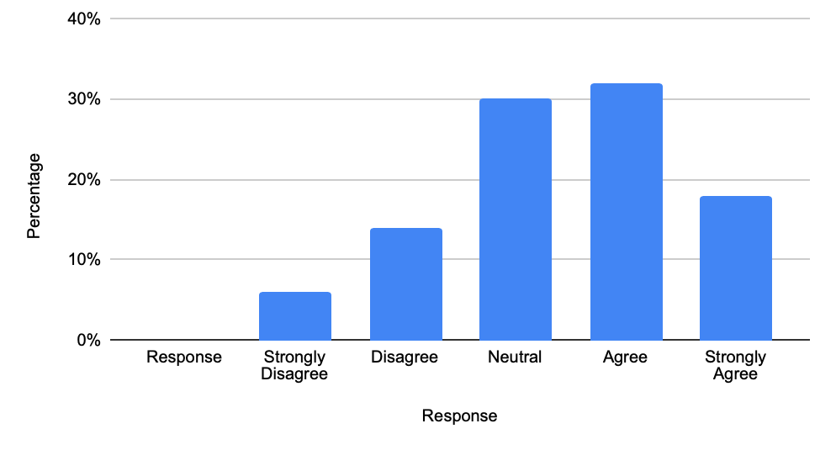
Note. Data are based on student responses to the survey item: “I feel uncomfortable sharing my personal experiences in class as they differ from the “typical” or “wealthy” student experience”.
This sense of subtle exclusion was detailed in the qualitative findings. A recurring theme among interview participants was the feeling of being “out of place” within certain classroom discussions and social interactions. Most students from lower-income backgrounds reported feeling left out when topics related to travel, private tutoring, expensive hobbies, or dining experiences were discussed in class. Although these conversations were not intended to exclude anyone, 3 out of 10 participants noted that they often struggled to relate to such experiences. As a result, they became less willing to participate in discussions or share their own personal experiences, fearing that they would be judged or misunderstood by their peers.
5. Discussion

The findings suggest that socioeconomic differences not only appear to prevent students from entering universities but also continue to influence how students experience university life after enrollment. This extends prior research (e.g., Tomaszewski et al., 2022; Panigrahi, 2025;) by revealing “post-access” barriers inside higher education as challenges that persist even after enrollment and affect equity, access, and inclusion simultaneously.
Access to education therefore extends beyond admission and tuition fees. Reliable internet access, appropriate learning devices, academic materials, and the ability to participate in extracurricular activities all contribute to students’ opportunities to engage fully in their studies. For many respondents with stronger financial backgrounds, these requirements are often treated as a standard expectation. For other notable numbers with lower-socioeconomic backgrounds, they represent additional obstacles that must be overcome alongside academic responsibilities.
The results also raise questions about educational equity. Students in the same classrooms are required to reach the same academic standards, but they do not have the same resources or opportunities. Lower-income students were more likely to regard university support as insufficient and to report problems due to financial pressures. At the same time, students who worked part-time frequently described challenges balancing employment and academic responsibilities. Equal expectations may therefore not always lead to equal opportunities. When students must devote significant time and energy to meeting financial needs, their ability to participate in learning activities can be reduced despite having similar academic potential.
Inclusion appears as a more subtle issue. Within this sample, most participants reported a general sense of belonging within their faculties; however, feelings of exclusion often appeared during everyday classroom interactions rather than through formal institutional practices. Discussions involving travel experiences, private tutoring, or expensive leisure activities occasionally reinforced social differences between students. Such occurrences may seem minor, yet repeated exposure can contribute to feelings of isolation among students from unprivileged backgrounds. This emphasizes the importance of creating learning environments that acknowledge and respect students’ diverse socioeconomic experiences.
The results highlight the interconnected nature of the three pillars: limited access undermines equity, which in turn affects inclusion.
It is important to clarify that this study provides perception and experience-based evidence from a small convenience sample at two specific faculties. The findings suggest patterns within this specific sample rather than broad systemic facts, thereby should not be generalized broadly without qualification. USSH and HCMUT were treated as complementary sites for exploring shared experiences rather than compared directly; no institutional differences were tested.
6. Conclusion

This study provides insights into the socioeconomic barriers affecting students at USSH and HCMUT in relation to equity, access, and inclusion in higher education. The findings suggest that access, equity, and inclusion should not be viewed only as separate concepts. Access to educational resources alone does not necessarily guarantee equitable learning opportunities, while equitable opportunities do not automatically ensure that all students feel included within the learning environment. Students from lower socioeconomic backgrounds often faced additional challenges that were less visible to their peers, particularly in relation to educational expenses, work responsibilities, and participation in university life. Efforts to reduce socioeconomic barriers should therefore extend beyond financial assistance and consider how institutional policies, academic expectations, and support services affect students with different levels of economic resources.
Institutional-level recommendations: for digital and material support, universities should subsidize essential digital subscriptions and improve access to updated computer laboratories to address the technological deficit reported by students lacking adequate devices. To ensure policy flexibility, schools should establish more flexible attendance and assessment deadline policies specifically tailored to accommodate students working part-time, alleviating the severe time pressures identified in the study. Lastly, for proactive communication, communication regarding available financial aid and scholarships should be strengthened so that support systems act preventively rather than reactively.
Teacher-level recommendations: regarding inclusive pedagogy, educators should be trained to avoid making assumptions about students’ financial resources, offering low-cost alternatives (e.g., OER materials instead of standard expensive imported textbooks). Teachers must be more sensitive towards classroom inclusivity by actively guiding class discussions to ensure discussing topics (e.g., daily experiences, hobbies) do not alienate students from disadvantaged backgrounds, fostering a culturally and economically sensitive environment.
While this study sheds light on important issues surrounding equity, access, and inclusion, it has several limitations. First, the reliance on a relatively small convenience sample restricts the generalizability of the findings. Second, the data is self-reported, and socioeconomic status was self-categorized by students rather than measured through objective economic indicators (e.g., household income tax or official pell-grant equivalents). Third, utilizing focus groups for sensitive financial discussions may have introduced social desirability bias, as some students might have hesitated to openly share deep financial hardships in front of peers.
Future research should involve a broader range of participants across different institutions and employ longitudinal approaches to track how socioeconomic factors influence students throughout their academic journeys. Furthermore, conducting one-on-one individual interviews is recommended for future qualitative investigations to provide a safer space for discussing sensitive financial topics. Finally, comparative research designs such as analyzing differences between public and private universities, or urban versus rural student populations would yield a more comprehensive understanding of systemic inequities in Vietnamese education. Ultimately, addressing these barriers is essential to ensuring that higher education remains equitable, accessible, and inclusive for students regardless of their socioeconomic backgrounds.
Acknowledgments
The author would like to express sincere gratitude to all participants for their valuable contributions to this study. Special appreciation is extended to the survey respondents for their time, cooperation, and honest feedback, which were essential to ensuring the reliability of the research data. The author also thanks colleagues and mentors for their insightful comments and continuous support throughout the research process. The author gratefully acknowledges the organizing committee of the HUFLIT International Conference for providing a valuable academic platform for knowledge exchange and scholarly discussion.

References
Braun, V., & Clarke, V. (2006). Using thematic analysis in psychology. Qualitative Research in Psychology, 3(2), 77–101. https://doi.org/10.1191/1478088706qp063oa
Cerna, L., Mezzanotte, C., Rutigliano, A., Brussino, O., Santiago, P., Borgonovi, F., & Guthrie, C. (2021). Promoting inclusive education for diverse societies: A conceptual framework (OECD Education Working Papers No. 260). OECD Publishing. https://doi.org/10.1787/94ab68c6-en
Creswell, J. W., & Plano Clark, V. L. (2018). Designing and conducting mixed methods research (3rd ed.). SAGE Publications.
Fadhil, I., & Sabic-El-Rayess, A. (2021). Providing equity of access to Higher Education in Indonesia: A policy evaluation. Indonesian Journal on Learning and Advanced Education (IJOLAE), 57–75. https://doi.org/10.23917/ijolae.v3i1.10376
Hair, J. F., Black, W. C., Babin, B. J., & Anderson, R. E. (2019). Multivariate data analysis (8th ed.). Cengage Learning. https://www.cengage.uk/c/multivariate-data-analysis-8e-hair-babin-anderson-black/9781473756540/?searchIsbn=9781473756540
Iheduru-Anderson, K., Jayaraman, R., Inungu, J., & Mumford, V. E. (2025). Diversity, equity, inclusion, and access: Confronting the myth of meritocracy in nursing academia. Electronic Journal of General Medicine, 22(6). https://doi.org/10.29333/ejgm/17437
Moratti, M., & Sabic-El-Rayess, A. (2009). Transitional justice and DDR: The case of Bosnia and Herzegovina (Research Brief). International Center for Transitional Justice. https://www.ictj.org/sites/default/files/ICTJ-DDR-Bosnia-ResearchBrief-2009-English_0.pdf
Nguyen, N. N. (2004). Trends in the education sector. In P. Glewwe, N. Agrawal, & D. Dollar (Eds.), Economic Growth, Poverty, and Household Welfare in Vietnam (pp. 415–438). World Bank.
Organisation for Economic Co-operation and Development. (2017). Educational opportunity for all: Overcoming inequality throughout the life course (Educational Research and Innovation). https://doi.org/10.1787/9789264287457-en
Organisation for Economic Co-operation and Development. (2023). Equity and inclusion in education: Finding strength through diversity. https://doi.org/10.1787/e9072e21-en
Panigrahi, S. (2025). Equity, inclusion and accessibility in Education. International Journal For Multidisciplinary Research, 7(6). https://doi.org/10.36948/ijfmr.2025.v07i06.64299
Sabic-El-Rayess, A. (2012). Making of a voiceless youth: Corruption in Bosnia and Herzegovina's higher education (Doctoral dissertation, Columbia University). Academic Commons. https://doi.org/10.7916/D8K361NJ
Sabic-El-Rayess, A. (2014). Acting and reacting: Youth’s behavior in corrupt educational settings. Peabody Journal of Education, 89(1), 70–85. https://doi.org/10.1080/0161956X.2014.862473
Sabic-El-Rayess, A., & Mansur, N. N. (2016). Favor reciprocation theory in education: New corruption typology. International Journal of Educational Development, 50, 20–32. https://doi.org/10.1016/j.ijedudev.2016.04.005
Sabic-El-Rayess, A., Mansur, N. N., Batkhuyag, B., & Otgonlkhagva, S. (2019). School Uniform Policy’s adverse impact on equity and access to schooling. Compare: A Journal of Comparative and International Education, 50(8), 1122–1139. https://doi.org/10.1080/03057925.2019.1579637
Sabic-El-Rayess, A., & Otgonlkhagva, S. (2012). School uniform cost reduction study: Standardization, simplification and supply policy. International Center for Transitional Justice; Columbia University. https://doi.org/10.7916/d8-6e50-8257
Sabic-El-Rayess, A., & Seeman, A. M. (2017). America’s familial tribalism. Academic Commons. https://doi.org/10.7916/d8-7jt8-mh87
Thach, T. T. (2020). Provide equal access to education. Fulbright University Vietnam. https://fulbright.edu.vn/vi/trao-co-hoi-tiep-can-giao-duc-mot-cach-binh-dang/
Tomaszewski, W., Perales, F., Xiang, N., & Kubler, M. (2022). Differences in higher education access, participation and outcomes by socioeconomic background: A life course perspective. Life Course Research and Social Policies, 133–155. https://doi.org/10.1007/978-3-031-12224-8_7
UNESCO (2009). Defining an Inclusive Education Agenda: Reflections around the 48th session of the International Conference on Education. http://www.ibe.unesco.org/sites/default/files/resources/defining_inclusive_education_agenda_2009.pdf
Vu, L. H. (2012). An overview of access to and inequality in the education system of Viet Nam. Asia-Pacific Development Journal, 19(1), 37–62. https://doi.org/10.18356/57405f5e-en
Yasinzai, F., & Ahad, A. (2025). Equity, inclusion, and access in higher education: Challenges, progress, and Future Directions. Research Journal of Psychology, 3(4), 292–295. https://doi.org/10.59075/rjs.v3i4.270

Bionote
Nguyen Thi Thao Trang (Ms) holds a Master’s degree in TESOL through a joint program with Victoria University, Australia. She has over 16 years of experience teaching Non-English-Major learners at Ho Chi Minh City University of Technology and at Language Centers specializing in IELTS and TOEIC. Her research and teaching interests focus on technology-enhanced language learning, soft skills development, and innovation in English education. She has led student teams in award-winning community projects and participated in international professional development programs, including Train the Trainer and online instructional design workshops. She continues to explore innovative approaches to enhance language learning outcomes and foster learner autonomy in higher education contexts.
Nguyen Thi Tuong Vy (Ms.) holds a Bachelor’s degree in English Linguistics and Literature from the University of Social Sciences and Humanities, Vietnam National University Ho Chi Minh City. She has four years of experience teaching English at language centers and is currently an English Teacher at RES English Center. Her professional interests include English language teaching and language learning. She can be contacted at nguyengon196@gmail.com.

Appendices
Appendix A – Survey questions

SOCIOECONOMIC BARRIERS TO EQUITY, ACCESS AND INCLUSION IN EDUCATION FOR STUDENTS WITH DIVERSE SOCIOECONOMIC BACKGROUNDS
Student Information
1. Academic year: __________________
2. What’s your email address? __________________________________
3. Do you work part-time?
- Yes
- No
If yes, what is your part-time job? __________________
4. How would you describe your family’s financial situation?
- Low income
- Lower-middle income
- Middle income
- Upper-middle income
- High income
Instructions: Please indicate your level of agreement using a 5-point Likert scale:
1 = Strongly Disagree, 2 = Disagree, 3 = Neutral, 4 = Agree, 5 = Strongly Agree.
- Strongly disagree
- Disagree
- Neutral
- Agree
- Strongly agree
QUESTIONS
Part 1: Perception of socioeconomic impact on access
- My financial situation allows me to afford all necessary learning resources (e.g., textbooks, specialized software, learning applications, a stable internet connection) and other course-related expenses.
- The cost of participating in extra-curricular activities (e.g., workshops, certificates) is a burden for me.
- I have reliable access to a high-performance computer/laptop to complete digital assignments.
- My home environment (e.g., lack of quiet space, household responsibilities) limits my ability to study outside of class.
- My work responsibilities (e.g., house chores, part-time jobs) reduce the time and energy I can devote to my studies.
Part 2: Perception of socioeconomic impact on equity
- I feel that access to external resources (e.g., private tutors, expensive software) influences academic outcomes more than students’ learning efforts.
- Course assessments are designed in a way that is fair to students regardless of their financial background.
- I feel that students with higher financial resources have an unfair advantage in keeping up with the course pace.
- The university provides sufficient support (e.g., computer labs, library resources) to help students who lack equipment at home.
Part 3: Perception of socioeconomic impact on inclusivity
- I feel uncomfortable sharing my personal experiences in class as they differ from the “typical” or “wealthy” student experience.
- My instructors show awareness of the different socioeconomic challenges students face.
- The language and topics used in my classes are not relatable to my life experiences and background.
- I feel a sense of belonging in the faculty, regardless of my socioeconomic status.
Part 4: Perception of systemic challenges
- Financial concerns negatively affect my participation in activities compared to my peers (e.g., class discussions, group work, workshops).
- Students who experience financial difficulties can easily access information about available support services at the university (e.g., scholarships, financial aid)
- I feel the university’s policies on attendance and deadlines are flexible enough to accommodate students with part-time jobs or financial difficulties.
- I feel the university takes proactive steps to support students from low-income backgrounds (e.g., providing facilities and scholarships) so that they are not left behind.
Part 5: Open-ended questions
- Are there any financial challenges (e.g., learning materials, internet access, devices, transportation, extracurricular costs) that affect your learning experience? Please explain.
- Have you ever felt “different” or “out of place” in a classroom due to your financial or social background? Describe the situation.
- What additional support or changes should the university provide to help students from different socioeconomic backgrounds?
Appendix B – Interview questions
- How does your current financial situation influence your ability to access the tools and resources you need to succeed in your classes?
- Have you ever felt that your socioeconomic background made it harder for you to participate in or keep up with course requirements compared to your classmates?
- Do you believe your instructors are aware of and sensitive to the different personal or financial challenges that students face outside of the classroom?
- Can you describe a time when you felt either included or excluded in a classroom setting based on your social or economic background?
- What is one practical change you think the University could make to ensure that all students, regardless of their financial status, have an equal chance in the program?

Nguyen Thi Thao Trang, Foreign Language Center – HCMC University of Technology, VNU-HCM, Ho Chi Minh City, Vietnam Vietnam. Email:trangnguyen@hcmut.edu.vn 2 Nguyen Thi Tuong Vy, English Language Teaching, English Linguistics and Literature, University of Social Sciences and Humanities, VNU-HCM, Ho Chi Minh City, Vietnam

