AI-Supported Problem-Based Learning for Enhancing University Students’ Public Speaking Performance
Thi Thao Trang Nguyen,
Abstract
Driven by the shift towards learner-centered education and knowledge construction through solving real-world problems, Problem-Based learning (PBL) has demonstrated its effectiveness globally over the past five decades. This study investigates the integration of AI-driven virtual simulations and automated feedback into a Learning Management System (LMS) within a Problem-Based Learning (PBL) framework to improve students’ public speaking skills. Employing a quasi-experimental design, the research involved two intact classes at Ho Chi Minh City University of Technology, divided into an experimental group (AI-supported LMS instruction) and a control group (traditional instruction). Data was gathered through pre-and-post performance assessments and an online survey evaluating students’ perceptions, engagement levels, and attitudes toward AI-integrated learning. The results indicate that embedding AI tools within the PBL cycle significantly improved students’ public speaking performance in fluency and confidence, while fostering greater learner autonomy.
Keywords: Problem-Based Learning (PBL), artificial intelligence, LMS, innovation, public speaking.
- Introduction
In an era where communication competence is increasingly recognized as a critical graduate attribute, the ability to speak confidently and effectively in public has become essential for university students. However, despite its importance, public speaking remains a persistent challenge for many learners, often constrained by anxiety, limited practice opportunities, and insufficient individualized feedback. Traditional instructional approaches, while structured, frequently fail to provide the dynamic and learner-centered environment necessary for meaningful skill development. Against this backdrop, Problem-Based Learning (PBL) has gained prominence as a pedagogical approach that situates learning within authentic problem-solving contexts, encouraging active engagement, critical thinking, and self-directed learning. At the same time, the rapid advancement of Artificial Intelligence (AI) is reshaping educational landscapes by enabling adaptive learning, real-time feedback, and personalized support on a scale. The convergence of these two approaches presents a compelling opportunity to reimagine how complex skills such as public speaking are taught and learned.
This study explores the integration of AI-supported tools within a PBL framework throughout Learning Management System (LMS) to enhance university students’ public speaking performance. Students can practice speaking skills whenever they have a free time at home. By embedding intelligent feedback mechanisms and interactive simulations into a structured problem-solving cycle, the proposed approach aims to create a responsive and supportive learning environment where students can practice, reflect, and improve iteratively. The research seeks to contribute to emerging discussions on technology-enhanced pedagogy while addressing a critical gap in developing both competence and confidence in public speaking among higher education learners.
To achieve these objectives, the study addresses the following research question:
What is the impact of an AI-supported Learning Management System (LMS) integrated within a Problem-Based Learning (PBL) framework on university students' public speaking performance, confidence, motivation, and learner autonomy?
2. Literature Review

2.1. Theoretical Foundations of Problem-Based Learning (PBL)
Problem-Based Learning (PBL) was originally applied in medical education and officially introduced as a methodology by Howard Barrows at McMasterUniversity in Ontario, Canada, in the1960s (Boud &Feletti,1997; Delisle, 1997; Magnussen et al., 2000). The theoretical architecture of Problem-Based Learning (PBL) is rooted in the tradition of experiential learning, which emphasizes that knowledge construction is most effective when situated within meaningful, real-world tasks (Dewey, 1938; Hmelo-Silver, 2004). As Barrows (1996) emphasizes, the value of this approach is not found in memorization, but in providing necessary and effective skills that ensure knowledge remains useful in the future.
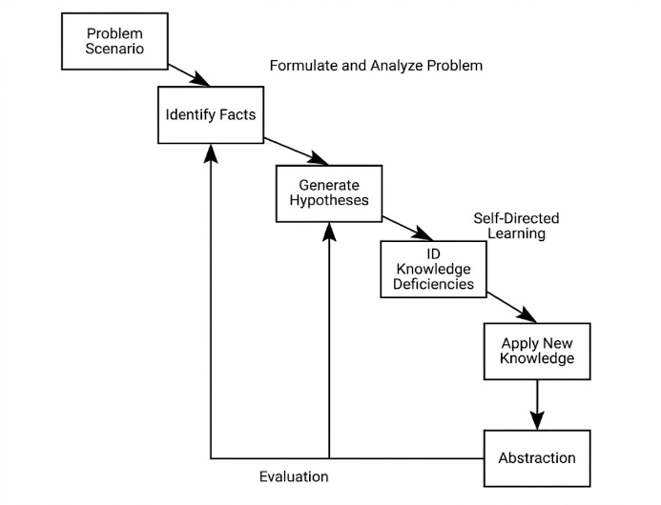
The effectiveness of PBL is fundamentally rooted in its organized, iterative tutorial framework, which transitions the emphasis from passive content absorption to active inquiry and the resolution of genuine challenges, allowing students to learn through problem-solving while teachers assume the role of facilitators (Barrows, 2000; Hmelo-Silver, 2004). According to Hmelo-Silver (2004), as shown in Fig.1, this cycle begins with a problem scenario, which prompts students to identify relevant facts and represent the problem. A critical stage in this process is the identification of knowledge deficiencies, termed “learning issues”, which direct the student’s Self-Directed Learning (SDL). By requiring students to formulate hypotheses and subsequently apply newly acquired knowledge to evaluate them, the PBL cycle ensures that learning is grounded in performance.
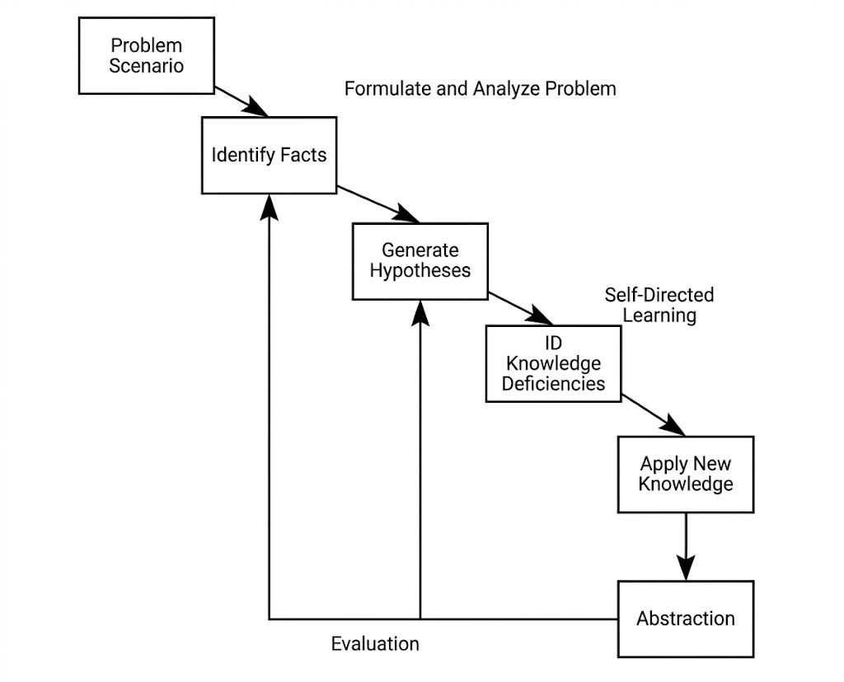
Fig 1. The problem-based learning cycle (Adapted from Hmelo-Silver, 2004)
Vietnam has been using the PBL approach since the 1980s to improve the quality of teaching and learning. Some universities have tried using PBL in certain subjects, and the results showed that it makes students more active and interested in learning (Nguyen et al., 2012). While PBL is becoming more common in different fields, there is still a need for more research on how to use it to teach specific skills at the university level.
2.2. The Integration of PBL and AI
The combination of PBL and Artificial Intelligence (AI) creates a powerful framework for modern education. According to Novak et al. (2025), while PBL provides a student-centered approach focusing on inquiry and collaboration, AI enhances this process by offering personalized learning experiences, real-time feedback, and data-driven insights. For instance, AI can analyze a student's progress and adjust instructional materials to fit their specific needs, helping them navigate complex problems more efficiently. Similarly, Shocheb et al. (2025) stated that AI can also serve as a virtual mentor that offers guidance, support, and resources while students work through problems. Hence, AI-powered tools, such as intelligent tutors and simulation platforms, can guide learners through every stage of the PBL cycle, from defining the problem to testing hypotheses and reflecting on outcomes (Novak et al., 2025).
Integrating AI into the PBL framework also helps more students and teachers participate in digital learning. According to Omeh and Ayanwale (2025), this combination allows learners to immerse themselves in intelligent environments that offer instant feedback, chances to work together, and automatic help with solving problems. These tools make the PBL learning process more accessible and interactive for everyone involved.
2.3. Impacts on Public Speaking: Motivation, Confidence and Learning Autonomy
AI powered learning enhances accessibility, personalization, and digital inclusion, promoting equitable and quality education through tailored feedback and adaptive learning (Hariyanto et al., 2025). These contributions are particularly relevant in higher education, where AI-supported PBL models can support self-directed learning, critical thinking, and digital literacy.
Public speaking is widely recognized as a fundamental component of professional skill, allowing individuals to persuade others, inspire audiences and boost their confidence (Smith, 2020). However, for most learners, managing speech anxiety remains the primary obstacle to proficiency. Research indicates that structured instruction and consistent feedback are the most effective methods to reduce nervousness and improve delivery (Smith, 2020).
As a result, the integration of Artificial Intelligence (AI) has recently opened up new opportunities for speaking practices to address the aforementioned issues in public speaking. Since AI systems enable personalized learning experiences with interaction and feedback, students can engage in repeated practice, correct their own errors, and progressively develop confidence in their speaking abilities (Zhang, 2025). Other research has also proved that AI has had a beneficial impact on the affective outcomes of learners, including the reduction of language anxiety (Bashori et al., 2020; 2021), the enhancement of motivation (Chiu et al., 2023), and the rise in self-confidence. Similarly, a research by Phan (2024) demonstrates that applying AI greatly improves university students' speaking performance while also enhancing their motivation and confidence.
In this study, one of the primary objectives of integrating AI within a PBL framework is to cultivate intrinsic motivation in practicing public speaking, which occurs when learners engage with a task due to personal interest, perceived challenge, or a sense of mastery. Motivation is believed to be significantly amplified when students perceive that the outcome of learning is under their control. Hence, by rewarding profound understanding and independent action rather than comparative performance, the PBL framework fosters an environment where students are intrinsically motivated (Hmelo-Silver, 2004). Therefore, on an AI-PBL platform, students are provided with a “safety net” where they can manage their own learning direction and practice schedules with real-time feedback.
Furthermore, under the PBL framework, proximate, tangible activities, such as successfully navigating a simulated speech, are more motivating than abstract goals according to Bandura (1997) and can boost the learner's self-efficacy. Junaidi (2020) also claims that AI can improve not only the learners’ oral fluency but also their self-confidence.
With regards to self-directed learning, the Problem Based teaching approach was introduced with the desire to integrate language and content, which can facilitate autonomous learning. Moreover, according to Lin and Muenks (2025) and Tozzo et al. (2025), learners' sense of mastery and autonomy may be increased by using AI technologies through adaptive feedback and real-time suggestions. As Hariyanto et al. (2025) noted that students are more likely to remain interested and persistent when they are exposed to information that particularly suits learning speed, personalized learning such as AI-supported systems can therefore promote learner autonomy.
2. 4. Research gap
Despite the growing availability of AI tools for public speaking, empirical evidence remains limited regarding their actual impact on a learner’s holistic development specifically in terms of fluency, confidence, motivation, and autonomy. In Vietnam, this research gap is even more pronounced; while Problem-Based Learning (PBL) has been studied for decades, implementation has still been largely confined to secondary schools, leaving its potential in higher education under-explored (Phan, 2023). Furthermore, the use of combined AI- supported PBL models for teaching soft skills is still a fairly unexplored area, especially in tertiary contexts. This study addresses these gaps by investigating how an AI-supported PBL framework can support the specific communication needs of university students.
3. Methodology
3.1. Research site:
This study was conducted at Ho Chi Minh City University of Technology (HCMUT), Vietnamese National University Ho Chi Minh City (VNU-HCM), one of the leading technical universities in southern Vietnam. The university currently enrolls more than 30,000 students, postgraduates, and doctoral candidates across a wide range of engineering and technology disciplines. This site was selected for its large, diverse student population, which provides a representative sample and facilitates efficient data collection for the study.
3.2. Participants
The participants who took part in the study were students from the Ho Chi Minh City University of Technology (HCMUT). The targets consisted of undergraduate students enrolled in effective communication and English-speaking courses. To minimize potential teacher bias, convenience sampling was used to select two intact classes taught by the same instructor. The experimental group interacted with the AI-supported PBL digital environment, while the control group covered identical course aims using traditional teaching methods.
3.3. Study design
This study employs mixed methods, quasi-experimental research design. Due to rigid academic scheduling at Ho Chi Minh City University of Technology (HCMUT), randomly assigning individual students to experimental and control conditions was not feasible. Instead, two intact, pre-existing classes were utilized. The independent variable is the instructional method. The experimental group engaged with a Learning Management System (LMS) integrated with Artificial Intelligence (AI) within a Problem-Based Learning (PBL) framework, while the control group received traditional classroom instruction. The dependent variables include objective public speaking performance, measured through fluency and confidence, alongside psychological factors such as learner autonomy, cognitive engagement, and attitudes toward AI technology.
3.4. Data collection procedures
Data were gathered using two primary instruments: objective performance assessments and subjective perception surveys. To measure concrete skill development, students in both groups completed a post-test presentation in the final week of the module, in which the speaking performance results of 48 students in experimental class in semester 252 (2026) were compared with data of the control class about 48 students in the same semester who had not used AI popularly yet. These recorded speeches lasted between three and five minutes. Fluency was objectively measured using automated software to track speaking rate and filler word frequency, while confidence and vocal expression were independently graded by lecturer.
Following the post-test, two sets of questionnaires were also utilized in this study, one for participants who engaged with AI-supported PBL instructions on the LMS platform and one for the other group with traditional teaching methods. Firstly, the questionnaires were sent separately via email to two groups of students with 27 students per group. Students’ levels of interest were measured using a five-point Likert scale, ranging from 1 (strongly disagree) to 5 (strongly agree), with higher scores indicating greater levels of interest, and two open-ended questions in both sets of questionnaires. The survey employed a multiple-choice format, including questions related to students’ interest in the two instructional methods. This survey was designed to capture students' subjective experiences regarding their learning autonomy, engagement levels, motivation and overall acceptance of the technology.
3.5. Data processing procedures
Quantitative data
The collected quantitative data were analyzed using statistical procedures appropriate for both paired and independent sample comparisons. After this data-cleaning process, a final sample of 27 valid responses per group was retained for analysis, while the remaining responses were discarded due to corrupt or insufficient data. All performance scores and survey responses were imported into SPSS (Statistical Package for the Social Sciences) software for processing. Descriptive statistics, including means, standard deviations, and standard errors of the mean, were first computed to summarize the central tendencies and distribution of scores within each dataset.
To assess students' levels of interest in the two instructional methods, a Paired Samples T-Test was conducted. The questionnaire comprised 27 items with identical content administered to the same group of 27 students under both conditions, yielding two related sets of scores: d₁ (interest in the traditional public speaking method) and d₂ (interest in the AI-supported PBL method), each ranging from a minimum of 27 to a maximum of 135 points. Because each student contributed one score to each method, the data constituted matched pairs rather than independent samples, making the paired t-test the appropriate procedure for isolating the effect of instructional method on perceived interest while controlling for between-subject variability. The null hypothesis proposed that no difference existed in students’ mean interest scores between the two methods.
To evaluate the effectiveness of AI-assisted practice on students’ speaking performance, an Independent Samples T-Test was applied to compare the post-test scores of the Control Group (without substantial AI support) and the Experimental Group (with extensive AI support). As these two groups consisted of distinct, unrelated participants, the data were treated as independent samples. Prior to conducting the t-test, an F-Test on the ratio of two variances was performed to verify the assumption of homogeneity of variance between the two groups, determining whether the subsequent t-test should be conducted under the assumption of equal or unequal variances. Once variance equality was confirmed, the pooled estimator of variance was calculated, and the independent samples t-test was conducted to determine whether the difference in mean performance scores between the two groups was statistically significant or attributable to random variation.
In addition, Cronbach’s Alpha will be calculated to verify the internal reliability of the psychological survey scales, ensuring that the items within each section of the questionnaire (e.g., cognitive engagement, learning autonomy, fluency and self-efficacy) consistently measure their intended underlying constructs.
Qualitative data
For the qualitative data derived from the open-ended survey questions, a thematic analysis approach will be employed. Students' written responses detailing the most helpful AI features, their specific learning challenges and their changes after applying either learning methods will be systematically reviewed, coded, and categorized into core themes. This qualitative data serves a vital explanatory purpose, providing deeper context to the quantitative statistics and revealing the mechanisms of how the AI-enhanced learning environment influenced student motivation, self-efficacy and autonomy.
Ethical issues
All participants provide formal institutional consent and are assured that their academic records and personal data will remain strictly anonymous. They will have the right to refuse to participate in the research or withdraw from the study at any stage. The information provided by the students will only be used for research purposes and will not be shared with anyone or any organization other than the researchers. The names of each participant in the report will be a random number from 1 to 48, so their identities will also be kept anonymous. Lastly, all hard copies of data related to our research will be safely stored in a locked file drawer while digital files are password protected.
4. Results
The questionnaire consisted of 27 items with identical content administered to assess students’ interest in the two instructional methods. Responses were recorded on a 5-point Likert scale (1 = Strongly disagree, 2 = disagree, 3=neutral, 4 = agree, and 5 = Strongly agree) and converted into numerical scores. Let d₁ and d₂ denote the total converted scores reflecting students’ interest in the traditional public speaking method and the AI-supported PBL method, respectively. Given 27 items per method, the minimum and maximum possible values of d₁ and d₂ were 27 and 135, respectively. Boxplots were generated to visualize the distribution of both samples. The boxplot 1 and the results presented in Table 1 indicate that the two datasets exhibit relatively similar distributions. The Posttest scores for the Traditional method (N = 27) yielded a mean of M = 98.52 (SD = 26.41, SE = 5.08), while the Posttest scores for the AI-supported PBL method (N = 27) yielded a mean of M = 100.63 (SD = 26.96, SE = 5.19).

Boxplot 1: The result of students’interest through online survey
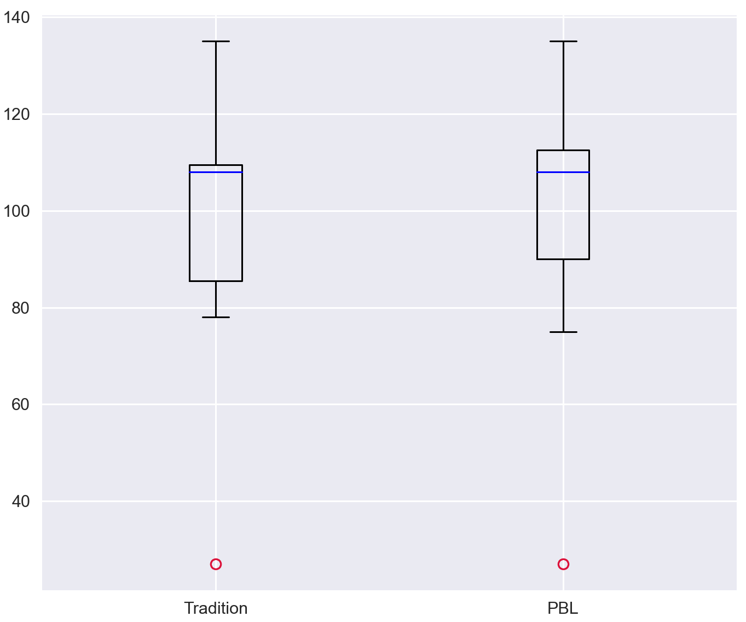
Table 1
Descriptive Statistics for Interest Scores through online Survey
 | Group | N | M | SD | SE
Online Survey | Traditional | 27 | 98.52 | 26.41 | 5.08
Online Survey | AI-supported PBL | 27 | 100.63 | 26.96 | 5.19
Although the descriptive results suggested that the AI-supported PBL sample (d₂) produced a slightly higher mean score than the traditional sample (d₁), this difference could plausibly be attributable to chance. To determine whether the observed difference was statistically meaningful, a paired-samples t-test was conducted, given that both sets of scores were obtained from the same cohort of 27 students, with each participant contributing two related data points.
Let Δd = d₂ − d₁ represent the difference in converted interest scores between the PBL method and the traditional public speaking method. Three possible outcomes were defined: Δd > 0 indicates greater interest in the PBL approach; Δd = 0 indicates equal interest in both methods; and Δd < 0 indicates greater interest in the traditional approach. The mean difference score was Δd̄ = 2.11 (SD = 4.81). The null hypothesis (H₀: μΔd = 0) proposed that students’ interest levels did not differ between the two instructional methods. At a significance level of α = .05 with 26 degrees of freedom, the critical value was t (26) = 1.71. The paired-samples t-test yielded t (26) = 2.24, p = 0.017, which exceeded the critical threshold and fell below the significance level. The null hypothesis was therefore rejected, indicating that students demonstrated significantly greater interest in the AI-supported PBL method than in the traditional public speaking method, t (26) = 2.24, p = 0.017.
A second analysis examined the effectiveness of speaking practice with and without substantial AI support, using students’ speaking performance scores. The dataset comprised two independent samples: a Control Group, representing speaking practice without significant AI assistance, and an Experimental Group, representing speaking practice with AI support.
As shown in Table 2, descriptive statistics indicated that the Control Group (N = 48) had a mean performance score of M = 6.59 (SD = 0.58, SE = 0.08), while the Experimental Group (N = 48) had a mean performance score of M = 7.25 (SD = 0.76, SE = 0.11).
Table 2
Descriptive Statistics for Speaking Performance Scores by Groups
 | Group | N | M | SD | SE
Posttest | Control | 48 | 6.59 | 0.58 | 0.08
Posttest | Experimental | 48 | 7.25 | 0.76 | 0.11

Boxplot 2: The speaking performance of groups
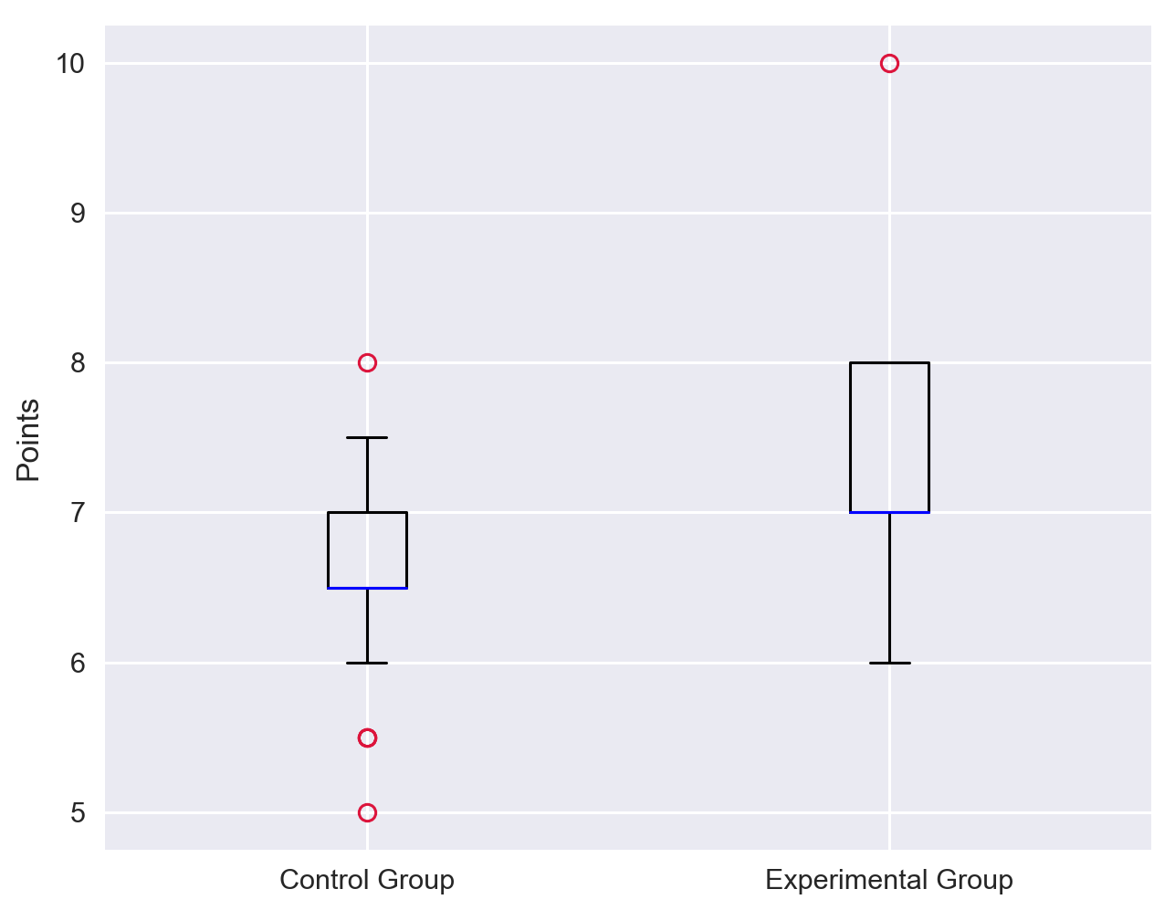
Note: The boxplot shows points between control group and experimental group.
The boxplot 2 and descriptive results (table 2) indicated that scores in the Experimental Group were generally higher than those in the Control Group. To determine whether this difference was statistically significant, an independent sample t-test was conducted. Prior to this analysis, an F-test on the ratio of two variances was performed to examine the homogeneity of variance between the two independent populations.
The F-test, conducted at α = 0.05, yielded F = 0.58, p = 0.061, indicating no statistically significant difference between the variances of the two populations. Consequently, an independent-samples t-test assuming equal variances was applied. The null hypothesis (H₀) proposed that there was no statistically significant difference between the mean performance scores of the Control and Experimental Groups, and that any observed difference was due to random variation. The pooled estimator of variance was calculated as 0.46.
The independent-samples t-test yielded t (94) = 4.74, p < 0.001, providing strong evidence to reject the null hypothesis. This result indicated that the Experimental Group’s speaking performance scores were significantly higher than those of the Control Group, suggesting that AI support meaningfully enhanced students’ speaking skills.
Taken together, the findings from both datasets indicate that students demonstrated greater interest in practicing speaking skills through the AI-supported PBL model relative to the traditional public speaking method, t (26) = 2.24, p = 0.017. Furthermore, students’ speaking performance improved significantly when AI-assisted practice was incorporated.
5. Discussion
The findings provide empirical support for the central premise of this study: that embedding AI-driven tools within a Problem-Based Learning (PBL) framework benefits university students’ public speaking development across performance, motivation, autonomy, and confidence. Students’ stronger speaking performance under AI-supported practice is consistent with Phan’s (2024) finding that AI integration enhances university students’ speaking performance alongside their motivation and confidence, and with Bandura’s (1997) self-efficacy theory, which holds that repeated, tangible success in a low-stakes practice environment builds confidence more effectively than abstract instruction alone.
This gain in performance was accompanied by a parallel rise in interest, which can be explained through Hmelo-Silver’s (2004) account of PBL as a framework that fosters intrinsic motivation by rewarding independent action and authentic problem-solving rather than comparative performance. Because the questionnaire items were identical across both conditions, this difference can reasonably be attributed to the AI-supported PBL approach itself rather than to extraneous content effects.
This heightened engagement, in turn, points to a plausible gain in learner autonomy: students who found the AI-supported method more interesting were likely also exercising greater control over their own practice and pacing, an arrangement Hmelo-Silver (2004) describes as a “safety net” within the PBL cycle. Taken together, the consistency between greater interest and stronger performance suggests that engagement and skill development are mutually reinforcing within the AI-supported PBL model, lending empirical weight to AI-PBL integration as a pedagogical strategy. While the use of independent samples for the performance comparison limits the strength of causal inference, the convergence of both effects offers reasonable support for the conclusion that AI-supported PBL instruction meaningfully improves students’ public speaking outcomes, both in measurable performance and self-reported interest in learning.
Overall, the consistency between the two outcomes—greater interest and superior speaking performance in the AI-supported PBL group—indicates that engagement and skill development are mutually reinforcing within this model. This pattern lends empirical weight to the integration of PBL and AI as a pedagogical strategy and addresses the research gap identified by Phan (2023) regarding the limited empirical evidence on AI integrated PBL implementation in Vietnamese higher education. While the use of independent samples for the performance comparison limits the strength of causal inference, the consistency of both effects provides reasonable support for the conclusion that AI-supported PBL instruction meaningfully improves university students’ public speaking outcomes, both in terms of measurable performance and self-reported interest in learning.

Limitations
Despite the promising findings, several limitations should be acknowledged. First, the sample size was relatively small and drawn from a single university context, which may limit the generalizability of the results. Future studies should include a larger and more diverse population across different institutions and cultural settings. Second, the duration of the intervention was relatively short. A longer experimental period may provide deeper insights into the long-term effects of AI-assisted learning on speaking performance and learner autonomy. Third, the study relied partially on self-reported data, which may be subject to response bias. Although efforts were made to ensure anonymity, students may have overestimated their perceived improvements. Finally, while this study focused on speaking skills, other language competencies such as listening and pronunciation accuracy were not examined in depth. Future research could adopt a more comprehensive approach to evaluating language proficiency. These limitations suggest that while the findings are encouraging, they should be interpreted with caution.
6. Conclusion
This study set out to determine the impact of an AI-supported Learning Management System integrated within a Problem-Based Learning framework on university students' public speaking performance, confidence, motivation, and learner autonomy. The findings answer this question clearly: students in the AI-supported PBL condition achieved significantly stronger speaking performance and reported significantly greater interest in their instructional method than their peers in the traditional condition. It also produces a coherent, mutually reinforcing improvement across performance, motivation, and self-directed engagement. This suggests that AI is best treated not as a supplementary tool but as a structural component of the PBL cycle itself.
In addition, the findings highlight the potential of AI technologies to transform traditional language learning environments into more interactive, personalized, and learner-centered experiences. From a pedagogical perspective, the results suggest that educators should consider incorporating AI-driven platforms into their teaching practices to provide students with more opportunities for practice and feedback. Such integration not only improves learning outcomes but also fosters greater learner independence and confidence. Future research is encouraged to explore the long-term impact of AI-assisted learning and to examine its effectiveness across different educational contexts and disciplines.
Acknowledgments
The author would like to express sincere gratitude to all participants for their valuable contributions to this study. Special appreciation is extended to the survey respondents for their time, cooperation, and honest feedback, which were essential to ensuring the reliability of the research data. The author also thanks colleagues and mentors for their insightful comments and continuous support throughout the research process. The author gratefully acknowledges the organizing committee of the HUFLIT International Conference for providing a valuable academic platform for knowledge exchange and scholarly discussion.
Notes
¹ Nguyen Thi Thao Trang, Foreign Language Center – HCMC University of Technology, trangnguyen@hcmut.edu.vn

References
Bandura, A. (1997). Self-efficacy: The exercise of control. W. H. Freeman and Company.
Barrows, H. S. (1996). Problem-based learning in medicine and beyond: A brief overview. New Directions for Teaching and Learning, 68(1), 3–12.
Barrows, H. S. (2000). Problem-based learning applied to medical education. Southern Illinois University, School of Medicine.
Bashori, M., van Hout, R., Strik, H., & Cucchiarini, C. (2020). Web-based language learning and speaking anxiety. Computer Assisted Language Learning, 35(5–6), 1058–1089. https://doi.org/10.1080/09588221.2020.1770293
Bashori, M., van Hout, R., Strik, H., & Cucchiarini, C. (2021). Effects of ASR-based websites on EFL learners’ vocabulary, speaking anxiety, and language enjoyment. System, 99, 102496. https://doi.org/10.1016/j.system.2021.102496
Boud, D., & Feletti, G. (1997). The challenge of problem-based learning (2nd ed.). London: Psychology Press.
Chiu, T. K. F., Moorhouse, B. L., Chai, C. S., & Ismailov, M. (2023). Teacher support and student motivation to learn with artificial intelligence (AI) based chatbot. Interactive Learning Environments, 32(7), 3240–3256. https://doi.org/10.1080/10494820.2023.2172044
Delisle, R. (1997). How to Use Problem-Based Learning in the Classroom. ERIC Clearinghouse.
Dewey, J. (1938). Experience and education. Macmillan.
Hariyanto, Kristianingsih, F. X., & Maharani, R. (2025). Artificial Intelligence in adaptive education: A systematic review of techniques for personalized learning. Discover Education, 4(1), Article 32. https://doi.org/10.1007/s44217-025-00908-6
Hmelo-Silver, C. E. (2004). Problem-based learning: What and how do students learn? Educational Psychology Review, 16(3), 235–266. https://doi.org/10.1023/b:edpr.0000034022.16470.f3
Junaidi, J. (2020). Artificial intelligence in EFL context: rising students’ speaking performance with Lyra virtual assistance. International Journal of Advanced Science and Technology Rehabilitation, 29(5), 6735-6741.
Lin, S., and Muenks, K. (2025). How students' perceptions of older siblings' mindsets relate to their math motivation, behavior, and emotion: a person-centered approach. Soc. Psychol. Educ. 28:65. doi: 10.1007/s11218-024-09968-2
Magnussen, L., Ishida, D., & Itano, J. (2000). The impact of the use of inquiry-based learning as a teaching methodology on the development of critical thinking. Journal of Nursing Education, 39(8), 360-364.
Nguyen, T. H., Bui, T. T. H., Ha, V. N., & Le, T. T. H. (2012). Ket qua ap dung phuong phap giang day dua tren van de (PBL) va phuong phap giang day dua tren tinh huong (SBL) tai Truong DH Y te cong cong [Results of applying problem-based learning (PBL) and case-based learning (SBL) at the University of Public Health]. Tap chi Y hoc Thuc hanh[Journal of Practical Medicine], 843(10), 69–74.
Novak, L., Kovač, A., & Zupančič, L. (2025). Integrating problem-based learning with artificial intelligence: Transforming student-centered education in the digital era. International Journal of Educational Technology and Artificial Intelligence, 4(1). https://topazart.info/e-journals/index.php/ijetai/article/view/84
Omeh, C. B., & Ayanwale, M. A. (2025). Artificial Intelligence Meets PBL: Transforming Computer-Robotics programming motivation and engagement. Frontiers in Education, 10. https://doi.org/10.3389/feduc.2025.1674320
Phan Thị, N. L. (2024). Investigation into the effectiveness of using problem-based learning in teaching communication skills in English to engineering students. Interdisciplinary Journal of Problem-Based Learning, 17(1). https://doi.org/10.14434/ijpbl.v17i1.33869
Phan, L. T. (2024). Application of AI in enhancing speaking performance of students in Hanoi. Vietnam Academy of Social Sciences’s VSSRA, 218(1), 105–128. https://doi.org/10.56794/vssr.1(218).
Shocheb, A., Ibrohim, I., & Muntholib, M. (2025). The effect of the problem-oriented project-based learning model assisted by artificial intelligence on students’ problem-solving and communication skills. Edubiotik: Jurnal Pendidikan, Biologi dan Terapan, 10(02), 424–441. https://doi.org/10.33503/ebio.v10i02.1551
Smith, R. (2020). The power of public speaking: Confidence and influence in professional life. New York Publishing.
Tozzo, M. C., Reis, F. J. J. D., Ansanello, W., Meulders, A., Vlaeyen, J. W., and Oliveira, A. S. D. (2025). Motivational impact, self-reported fear, avoidance, and harm perception of shoulder movements pictures in people with chronic shoulder pain. Eur. J. Phys. 27, 136–146. doi: 10.1080/21679169.2024.2359968
Zhang, X. (2025). Enhancing oral English learning through AI: A case study on the impact of AI-driven speaking applications among Chinese University students. Frontiers in Psychology, 16. https://doi.org/10.3389/fpsyg.2025.1595818

Bionote
Ms. Thi Thao Trang Nguyen holds a Master’s degree in TESOL through a joint program with Victoria University, Australia. She has over 16 years of experience teaching Non-English-Major learners at Ho Chi Minh City University of Technology and at Language Centers specializing in IELTS and TOEIC. Her research and teaching interests focus on technology-enhanced language learning, soft skills development, and innovation in English education. She has led student teams in award-winning community projects and participated in international professional development programs, including Train the Trainer and online instructional design workshops. She continues to explore innovative approaches to enhance language learning outcomes and foster learner autonomy in higher education contexts.

Appendix A
Experimental Group
SURVEY ON LEARNING EXPERIENCE WITH AI AND THE PBL MODEL
Student Information
Student ID: _____________________________
Note: The student ID is used solely to match your performance improvement results. All personal information will be kept strictly confidential.
Instructions: Please indicate your level of agreement on a scale from 1 (Strongly Disagree) to 5 (Strongly Agree).
Section 1: Perceived Usefulness of Traditional Learning Methods
1. Instructor feedback in class helps me clearly identify my strengths and weaknesses.
2. Practicing speaking directly with peers/instructors provides a realistic learning environment.
3. Course materials and the instructional structure help me understand the lesson content systematically.
4. In-class practice activities help me learn how to handle real presentation situations.
5. Feedback from instructors and peers helps improve my speaking fluency.
6. I find the current speaking instruction method effective in improving my skills.

Section 2: Cognitive Engagement
7. I feel fully engaged when participating in class discussions or presentations.
8. I spend considerable time reviewing and correcting my mistakes based on instructor feedback.
9. I am willing to rehearse my presentations multiple times to prepare thoroughly for class presentations.
10. In-class activities require me to think carefully about delivering the most persuasive presentation.
11. I remain fully focused and undistracted during speaking practice activities.
12. I proactively seek additional learning materials to improve my speaking skills.

Section 3: Learning Autonomy
- I set personal goals for each AI practice session (e.g., avoiding reading notes, controlling speaking pace).
- I monitor my progress by comparing results across different attempts on the system.
- AI tools enable me to practice effectively without direct teacher guidance.
- I independently identify ways to correct errors highlighted by AI (e.g., practicing pronunciation until recognized as correct by the system).
- I feel fully in control of managing my own learning (e.g., choosing when to practice without waiting for instructor instructions).
- AI evaluation criteria help me assess my speaking performance objectively.
- I feel comfortable identifying areas for improvement without external reminders.

Section 4: Fluency and Self-Efficacy
- I feel confident in delivering a fluent presentation in front of a real audience.
- I believe I can effectively manage presentation anxiety (e.g., nervousness, forgetting content).
- I am confident in using body language (gestures, movements) to enhance my presentation.
- I am able to maintain natural eye contact with the audience.
- I believe I can organize ideas logically and clearly when presenting them.
- My confidence has increased due to repeated practice in a safe AI-supported environment.
- I can maintain a stable speaking pace without being too fast or too slow.
- I am able to minimize filler words (e.g., “um,” “uh,” “you know”) when speaking in public.

Section 5: Technology Acceptance
- The LMS interface and AI tools are user-friendly and easy to operate.
- I rarely encounter technical issues that interrupt my practice.
- I would like to continue using these AI simulation tools in other courses.

Section 6: Open-Ended Questions (Optional – for qualitative analysis)
- Which feature of this AI system do you like the most? (e.g., virtual audience, detailed feedback reports, ability to repeat practice multiple times, etc.)
- How has learning through problem-based learning (PBL) combined with AI changed the way you prepare a presentation? (Please briefly describe your changes.)
……………………………………………………………………………………………
Appendix B
Control Group
SURVEY ON LEARNING EXPERIENCE IN PUBLIC SPEAKING SKILLS
Student Information
Student ID: _____________________________
Note: The student ID is used solely to match your skill improvement results. All information will be kept confidential.
Instructions: Please rate your level of agreement from 1 (Strongly Disagree) to 5 (Strongly Agree) based on your learning experience during this semester.

Section 1: Perceived Usefulness of Traditional Learning Methods
- Instructor feedback in class helps me clearly identify my strengths and weaknesses.
- Practicing speaking directly with peers/instructors provides. a realistic learning environment.
- Course materials and the instructional structure help me understand the lesson content systematically.
- In-class practice activities help me learn how to handle real presentation situations.
- Feedback from instructors and peers helps improve my speaking fluency.
- I find the current speaking instruction method effective in improving my skills.

Section 2: Cognitive Engagement
- I feel fully engaged when participating in class discussions or presentations.
- I spend considerable time reviewing and correcting my mistakes based on instructor feedback.
- I am willing to rehearse my presentations multiple times to prepare thoroughly for class presentations.
- In-class activities require me to think carefully to deliver the most persuasive presentation.
- I remain fully focused and undistracted during speaking practice activities.
- I proactively seek additional learning materials to improve my speaking skills.

Section 3: Learning Autonomy
- I set personal goals after receiving feedback from instructors or peers.
- I monitor my progress by recording myself or practicing speaking at home.
- I am able to practice effectively without constant supervision from the instructor.
- I independently identify ways to correct the errors I notice during practice.
- I feel capable of managing my own learning pace and schedule.
- I can objectively evaluate my speaking performance based on the criteria provided by the instructor.
- I feel comfortable identifying areas for improvement without external reminders.

Section 4: Fluency and Self-Efficacy
- I feel confident that I can deliver a fluent presentation in front of a real audience.
- I believe I can effectively control presentation anxiety (e.g., nervousness, forgetting content).
- I am confident in using body language (gestures, movements) to enhance my presentation.
- I am able to maintain natural eye contact with the audience.
- I believe I can organize my ideas logically and clearly when presenting them.
- My confidence has increased as a result of repeated practice during the course.
- I am confident that I can maintain a stable speaking pace without speaking too fast or too slowly.
- I believe I can minimize the use of filler words (e.g., “um,” “uh,” “you know”) when speaking in public.

Section 5: Feedback (Optional)
- Which teaching method or classroom activity has helped you improve your speaking skills the most?
- What is the biggest difficulty you face when practicing speaking skills using the current learning approach?

Foreign Language Center – HCMC University of Technology, Email: trangnguyen@hcmut.edu.vn

