Enhancing Student Engagement In Interpretation Courses Through AI-assisted Self-Practice
Dang Thi Anh Tuyet

Abstract
In interpretation courses, students are typically expected to engage in independent practice on their own to develop these complex skills. However, many students encounter difficulties in practicing interpreting autonomously. The study examined how Artificial Intelligence (AI) integration can facilitate students’ self-practice in interpretation courses. This research adopted a qualitative-dominant mixed-methods design, incorporating supportive quantitative analysis to gain better insights into the research questions. The study was conducted with the participation of eighty-two third-year students from three business interpretation classes at the Faculty of Foreign Languages, HUFLIT. The participants were encouraged to utilize AI tools to support their independent practice for self-study. The findings reveal that the majority of students perceived AI-assisted self-practice as both useful and engaging while also offering several recommendations for improving its implementation. For more generalizations and pedagogical implications, it is recommended that further studies on a large-scale and on the negative aspects of the approach should be conducted to examine the effectiveness of AI as a facilitator in self-regulated practice for interpreting skills among university students.

Keywords: engagement, AI integration, interpretation courses, interpreting training, self-practice

1. Introduction
1.1. Background of The Study
With the application of Artificial Intelligence (AI) in all aspects of life, necessary transformations have taken shape in education to adapt to the new trends. AI integration in higher education is currently not only a trend but also a requirement for educators with a view to optimizing learning outcomes. Tertiary education has recently experienced vivid AI integration in many fields since AI applications have proved to benefit teaching and learning considerably, saving both time and effort. In terms of motivation, AI-powered platforms have supposedly enhanced students’ engagement and autonomy that are crucial for improvement. Furthermore, with the popularity of AI applications in recent years, students’ desire for the freedom of utilizing AI in academic work has risen, which has obliged educators to take it seriously as to how to integrate AI into pedagogical approach effectively.
Business Interpretation course is among the author’s favorite subjects at HUFLIT Faculty of Foreign Languages (FFL). However, this module can sometimes be seen as a “nightmare” for many students of different majors, for this subject requires a comprehensive competence in many factors with oral communication skills and cognitive processing reflexes as the prerequisites. Students are supposed to carry out regular practice to hone their interpreting skills on their own. Therefore, students with low levels of proficiency usually find this subject immensely challenging. Before AI applications came into life, students mostly had to practice alone or occasionally with peers. This is indeed demanding work which requires tremendous effort and motivation; otherwise, giving up half-way through may result in failure, giving rise to students’ intimidation in learning this subject. Under such circumstance, students supposedly need some new kind of motivation for self-study. In seeking new inspiring and engaging ways to facilitate students’ self-practice, the author had a burning desire to take advantage of AI integration. Nevertheless, interpretation courses have intrinsic features that require particular integration approach as the ultimate learning outcomes of this subject is learners’ capability to perform their genuine interpreting skills.
1.2. Research Problem
In interpreting training, reality has showed that “practice makes perfect” significantly necessitates students’ improvement; what matters is how to engage students to practice interpreting skills frequently. In order to enhance engagement, students would be encouraged to practice with peers in addition to practicing independently. However, practicing with peers is sometimes hindered by several reasons including the matters of time-matching, high pressure from peer feedback. At the outset, the use of AI in interpreting training was mostly restricted, but it has gradually proved to be beneficial in many aspects and has become increasingly applicable. For this study, in empowering students with AI integration into their self-practice in interpretation courses, the author wondered how the approach can benefit students and enhance their engagement.
1.3. Research Objectives

In allowing AI integration into self-practice in interpretation courses, it is hoped that students’ self-regulated learning is recognized, thereby helping promote their engagement and motivation. In alignment with this view, this study aims to investigate the efficacy and pedagogical impacts of AI integration on students’ engagement in learning interpretation whereby pedagogical implications and recommendations can be proposed for further implementation.

1.4 Research Questions

With the research objectives in mind, my research questions were designed accordingly as follows:
- To what extent do students find AI assistance engaging and useful for their self-practice in interpretation courses?
- What are students’ perceived benefits from using AI tools to support their self-practice in interpretation courses?
- What are common challenges students may encounter while using AI support for self-practice in interpreting training, and their recommendations for improvement?

1.5 Significance of The Study

The wave of AI approaching and effecting tertiary education was welcomed as a supplementary drive for boosting students’ engagement. With more and more students relying on AI for their translation and even interpretation regardless of not being permitted, I would rather openly allow them with guidelines for proper use than leave them with hidden misleading manner. Therefore, empirical findings from this study can provide insights into the efficiency of AI integration in enhancing learner engagement in interpreting training, thereby hopefully contributing to subsequent implications and pedagogical recommendations for further studies.
2. Literature Review
With the above-said core research questions, the investigation from former researcher on this practice was carried out. In light of the literature, the rapid wave of Artificial Intelligence (AI) has significantly impacted language teaching and learning, prompting novel approach for interpreter training. Interpreting competence requires more than just one element; it in fact involves an intensive cognitive process and particular skills like note-taking, memorizing, etc., of which continuous rigorous practice really matters. In this aspect, AI-assisted self-practice has emerged as a highly welcoming and promising addition for students’ self-training. This literature review has drawn on recent papers on the enhancement of interpreting skills through AI supports. It examines the topic through four key themes: current trends, practical applications, pedagogical benefits, and possible challenges.
2.1 Trends in AI Integration in Interpreting Training
In recent years, Translation and Interpreting (T&I) education has undergone paradigm transformation. At the outset, AI was viewed as a disruptive threat that was not welcomed and encouraged for use in T&I pedagogy. However, AI has now been embraced as a pedagogical necessity. Cui (2025) and Šveda (2025) highlighted that modern interpreter training must take the initiatives to adapt to the "era of AI," moving from traditional methodologies to integrating technological competencies directly into the curriculum. This trend is echoed globally; for example, Tran (2026) noted the popularity of using AI translation and interpreting tools among Vietnamese students, indicating a dramatic shift where students independently and eagerly employ AI tools for linguistic support and practice. Besides that, as Gutiérrez (2025) put it, the gap between academic training and professional reality has now become mitigated. AI assistance in interpreting teaching and learning is increasingly welcomed as valuable, supportive tools for future careers instead of a threatening mechanism for job displacement. In line with the new trends, educators are prompted to align pedagogical practice with these new technological applications.
2.2 The Application of AI Tools for Enhancing Interpreting Practice
The application of AI tools in training interpreting skills has proved to be popular in various ways. Particularly, with generative AI chatbots, AI can be utilized as simulated interlocutors and automated feedback providers. For self-guided practice, AI can perform various interactive and analytical modalities to simulate real-world interpreting environments. Hatiarová (2025) emphasized AI’s role in generating accessible, simulated practice scenarios as requested among its diverse applications in interpreter training. With regard to interactivity, Yu (2025) examined how generative AI chatbots have been employed to deliver targeted critique in comparison with using traditional peer-review mechanisms. Likewise, Chien, Chan, and Hou (2024) noted the efficiency of using generative AI as scaffolding for role-playing educational games. With AI simulating consecutive or simultaneous interpreting environments outside the classroom, giving instant feedback on students’ performance, learning outcomes can significantly improve. Going beyond conversational interaction, AI tools can also performs tasks analytically. According to Tang, J. (2023), with AI-based needs analysis in digital environments, self-practice materials can be tailored for specific linguistic deficits or professional domains whereby student’s independent study regimen in interpretation can be personalized.
2.3 The Benefits of AI-Assisted Learning in Interpreting
According to researchers, the pedagogical benefits of AI assistance in self practice primarily involve enhancing self-regulated learning, providing instant feedback, and promoting student motivation. High levels of student satisfaction is reported by Consuelo Sáiz-Manzanares et al. (2023) when self-regulated learning is facilitated by chatbots. Similarly, Ng, Tan, and Leung (2024) claimed that students’ autonomy could be empowered with popular platforms like ChatGPT during their educational journeys. Particularly in interpreter training, the availability of 24/7 instant feedback from AI tremendously benefit students in terms of refining their delivery and accuracy while independent and constant practice is essential for cognitive process reflex (Chien et al., 2024; Yu, 2025). Interestingly, Yu, 2025 pointed out that AI feedback strategies can also help interpreting students identify semantic errors, adjust their grammar structures, and eventually refine their overall performance at their own pace. Notably, in terms of motivation, Tran (2026) pointed out that the these tools can be integrated to positively affect learners' motivation. Specifically, students’ anxiety can be reduced, and confidence be increased thanks to immediate scaffolding provided by AI in a low-pressure environment.
2.4 Challenges and Limitations
In spite of profound benefits of integrating AI into interpreting training, notable challenges and limitations also come alongside. One of the most striking limitations is the shortcoming of technology in replicating the nuanced human cognition which can be required in complex, dynamic communicative contexts. As argued by Gómez (2026), in in high-stakes contexts that require cultural mediation, empathy, and situational awareness, AI show incapability in replacing humans due to its inherent deficiencies. Tang, L. (2025) also pointed out "other minds" - an intuitive, empathetic understanding of human intention that AI lacks whereas this cognitive capability is vital for coherence interpreting. The most note-worthy challenge in terms of pedagogy are concerns about learner real autonomy which is a common concern among educators in integrating AI in other domains as well. According to Darvishi et al. (2024), student agency can be negatively impacted if over-reliance on AI assistance is committed. As frequently warned by other researchers, over-reliance on AI support can lead to passive learning and degraded critical thinking skills instead of active cognitive engagement.
Eventually, researchers emphasized that integrating "critical AI literacy" into interpreter training is a urgent necessity. The ultimate goal is to ensure that while using AI for self-practice to possess the skills, students can also critically assess AI outputs, avoid hallucinations, and fully be aware the ethical implications of the tools they use (Giustini & Dastyar, 2024). Despite multiple benefits of utilizing AI assistance in self-practice for interpreting training such as accessible simulations, personalized feedback, and enhanced learner motivation, learners should not consider AI applications a ‘magic cure-all’. There should be a balanced pedagogical approach. Leveraging the practical applications of AI as well as actively fostering critical AI literacy should be catered in order to address ethical challenges thereby preserving student agency, and navigating the inherent drawback in machine cognition.
3. Methodology

3.1. Research Design

With an interpretative epistemological stance, this research primarily adopted qualitative methodology; in addition, to evaluate the extent of student engagement and perceived utility, quantitative measures were also incorporated. Overall, this research employed a qualitative-dominant mixed-methods design, incorporating supportive quantitative analysis to gain better insights into the research questions.

3.2. Study Setting

This study was conducted at the Faculty of Foreign Languages (FFL) at HUFLIT with regard to Business Interpretation course which serves as a significant module for students of different majors. This course is considered advanced, requiring comprehensive proficiency in various aspects, such as good speaking and listening skills, vocabulary and general knowledge on daily life and business settings. In addition to independent practice and practice with peers in a traditional manner, the students were allowed to use AI-powered platforms to enhance their engagement for self-practice. In this study, my pedagogical intent is utilizing AI as supportive tools for students’ self-practice. Students were intentionally empowered with AI support for their self-practice so that engagement can be promoted. Accordingly, students were encouraged to consult with AI-powered platforms during self-practice. The extent of AI utilization is supposedly limited around mediating functions such as generating learning materials (e.g. a text or speech), transforming text-to-speech, composing a vocabulary list, doing role-playing, giving feedback for interpretation work. The restriction on AI facilitation is definitely set: interpreting skills must be performed by students themselves.

3.3. Participants

The participants in this study were 82 third-year students from three Business Interpretation classes at HUFLIT FFL, being randomly selected by volunteering with informed consent in alignment with institutional ethical guidelines.

3.4. Research Instruments

In order to ensure robust data collection, gaining insights into instructional efficacy with regard to enhancing student engagement in interpretation courses through AI integration, the following three research instruments were employed:

3.4.1. Structured Classroom Observations: Observations were conducted across the nine class sessions using a checklist to document student engagement and behavioral responses during AI-assisted self-practice.

3.4.2. Student Survey: Informed by preliminary observational data, a structured questionnaire comprising 5-point Likert scale questions, multiple-choice questions, and open-ended question(s) was administered to explore student perceptions and experiential outcomes. The online survey questionnaire was sent to students via Google Forms.

3.4.3. Semi-structured Interviews: Semi-structured focus group interviews were conducted with a sample of nine student volunteers; the interviews lasted approximately five minutes each to examine learner attitudes, identify perceived benefits and constraints, and to gather pedagogical recommendations regarding AI mediation in interpreting self-practice.

Overall, these data collection instruments provided a comprehensive, multi-perspective data, yielding deep insights into the dynamics of the contemporary pedagogical practices.

3.5. Procedure

The study was conducted over a nine-week period during the academic term, including three phases:

3.5.1. Preparation Phase: Guidelines were provided to students, showing how to use AI support for self-practice. The ultimate goal of this approach was clarified at the outset - using AI assistance to improve students’ independent interpreting performance. Students should be fully aware that AI-powered tools can only serve as facilitators for their self-practice and that AI can by no means be utilized as an interpreter in lieu of students themselves. To ensure compliance, the instructor stressed the importance of maintaining cognitive autonomy, warning of the adverse effects of AI over-reliance on critical thinking and analytical reasoning and that students’ performance from this practice can be appreciated as their efforts, but not be evaluated as formal testing results in class. The awareness of this rule necessarily prevents the students from intentional cheating or over-reliance on AI in their self-practice.

3.5.2. Implementation Phase: Students were encouraged to experience the approach - AI integration in their self-practice, both in class and in self-study, following the provided guidelines. Recommended AI supportive activities basically involve creating materials (e.g. a text or speech), transforming text-to-speech, composing vocabulary list, doing role-playing, giving feedback for interpretation job.

3.5.3. Data Collection Phase: Class observations were carried out during the 9 weeks with field notes being documented while the students engaged in self-practice with AI facilitation. Prominent trends identified during the observations guided further empirical inquiry. Specifically, salient themes derived from these observations facilitated the development of a structured questionnaire including two 5-point Likert scale questions, two multiple-choice questions, and one open-ended question to elicit participant perceptions and qualitative feedback. The survey was administered electronically via Google Forms nearing the end of the course. For the last two week, semi-structured interviews incorporating open-ended questions were conducted in person. All interview sessions were recorded with prior participant consent and subsequently transcribed verbatim for analytical processing.

3.6. Data Analysis

Data analysis was conducted based on qualitative, thematic analysis approach. Accordingly, qualitative data from open-ended responses from online surveys and interviews were analyzed. Transcripts from the interviews were coded to identify recurring themes. Besides, the quantitative data of the first two Likert scale questions in the survey questionnaire were also analyzed using SPSS software platform to strengthen the reliability of the data. Meanwhile, notes from class observations were used to triangulate findings, increasing the validity of interpretations.

In particular, thematic analysis of the interview transcripts revealed several emergent categories: (a) the engagement and utility of AI applications as learning scaffolds, (b) perceived benefits, including personalized learning experience and exposure to more topics for practice, (c) common challenges including student over-reliance and misuse in employing the approach, and (d) student recommendations for optimizing AI integration in interpretation courses. Collectively, these themes offered critical insights into student dispositions, highlighting both the benefits and constraints of embedding AI technologies in interpreting training. Furthermore, quantitative and qualitative data obtained through Google Forms was analyzed to discern broader trends regarding student attitudes and perceptions. The integration of close-ended Likert scales alongside open-ended qualitative prompts provided both statistical breadth and contextual depth to the findings. Ultimately, this mixed-methods analytical framework yielded triangulated insights into the efficacy of AI support in enhancing learner engagement for self-practice in interpretation courses.
4. Results
4.1 Addressing Research Question 1: Students’ Showing Interest and Confirming the Usefulness of Utilizing AI to Assist Their Self-practice in Interpretation Courses
TABLE 1
Item Statistics
 | Mean | Std. Deviation | N
Q1 | 4.02 | .785 | 82
Q2 | 4.20 | .744 | 82
*Note: Q1: Question 1, Q2: Question 2 in the survey questionnaire

Figure 1
Students’ expressing engagement in using AI support for their self-practice in interpretation courses
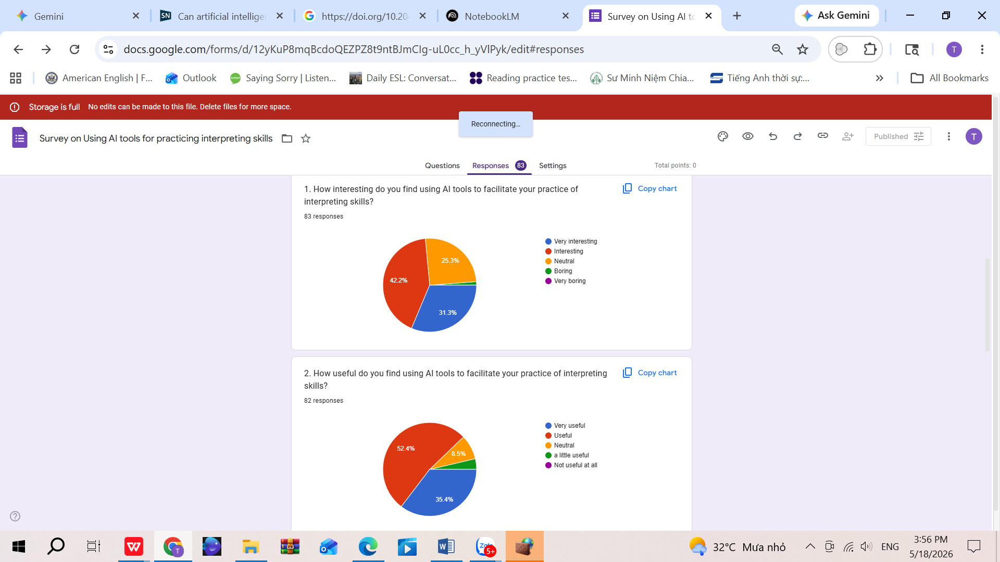
Figure 1 shows that a high proportion of participants welcome the approach, taking interest in utilizing AI to support their self-practice in interpreting training. The majority of students claimed their engagement with AI integration into their self-study as a facilitator; specifically, approximately 75% of students found the approach interesting and very interesting. This phenomenon accords with the data generated from classroom observations where most of them showed high level of interest and engagement during their self-practice, interacting with AI tools as mediators.
The data reliability can be reinforced in quantitative analysis (in Table 1): for Q1, a standard deviation of 0.785 is relatively low for a 5-point scale, showing a strong consensus among the cohort. Most responses are categorized around the "Interesting" and "Very interesting". A mean score of 4.02 indicates that the average respondent finds using AI tools to facilitate interpreting skills to be "Interesting".
Figure 2
High level of usefulness of utilizing AI-powered platforms in practicing interpreting skills
Figure 2 presents students’ perceived usefulness of AI tools in interpreting training with regard to usefulness of employing AI as mediator and facilitator in practicing interpreting skills. Impressively, 100% of the participants confirmed the approach to be useful; the majority claimed the high level of usefulness of this approach with almost 90% rating as useful and very useful while no one found it not useful at all. These proportions align with the research findings from the literature review that AI can benefit interpreting training in many ways including enhancing self-regulated learning, providing instant feedback, and promoting student motivation. Additionally, AI mediation can also help identify semantic errors, adjust grammar structures, and eventually refine overall performance at one’s own pace, enhancing autonomy.
Regarding quantitative analysis, the data reliability can be reinforced (as shown in Table 1): for Q2, a standard deviation of 0.744 is relatively low for a 5-point scale, showing a strong consensus among the cohort. Most responses are around the "Useful" and "Very useful" categories. A mean score of 4.20 shows that the average respondent finds using AI tools to facilitate their interpreting training to be "Useful".
4.2 Addressing Research Question 2: Student Perceived Benefits in Using AI to Support Self-Practice in Interpretation Courses
Figure 3
Common perceived benefits of utilizing AI tools in self-practice of interpreting skills
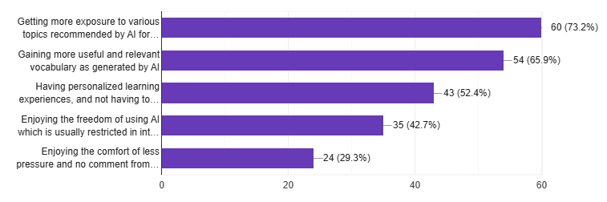
When being asked about common benefits of AI support in facilitating self-practice, many students admitted such benefits as “gaining more useful and relevant vocabulary as generated by AI”, accounting for almost 66%. of the students. “Having personalized learning experiences, and not having to rely on peers for practice” is noted by more than half of the students under survey. Many students pointed to the activity’s benefits such as “enjoying the freedom of using AI which is usually restricted in interpreting courses” and “enjoying the comfort of less pressure and no comment from instructor/peers” with the proportion of approximately 43% and 30% respectively. Notably, more than 73% agreed on “Getting more exposure to various topics recommended by AI for practice”. Some students put forth their comments:
“Use AI as a real-time partner to simulate live interpreting scenarios and provide immediate feedback on linguistic nuances and delivery speed.”
“AI can improve interpreting through real-time practice, instant feedback, and personalized learning.”
“Using ChatGPT helps me practice interpreting more easily by generating scripts and giving quick feedback.”
Similar comments on the benefits were also noted from the focus group interviews:
“AI helps me practice interpreting with instant feedback and flexible topics.” (S4)
“AI tools like ChatGPT, Gemini help me practice interpreting by providing many topics and speeches. I can practice anytime, which improves my vocabulary and understanding.” (S6)
4.3 Addressing Research Question 3: Common Challenges for Students in Utilizing AI Support for Interpreting Training, and Student Recommendations for Improvement
Figure 4
Common disadvantages/difficulties in employing AI tools to facilitate interpreting practice
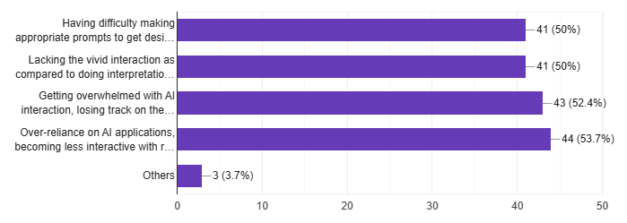
The graph shows the challenges of using AI as a facilitator for interpreting training are recorded not critical. Regarding the difficulties/disadvantages in utilizing AI tools for interpreting training, “having difficulty making appropriate prompts to get desired AI-generated content for practice” represents 50%. Similarly, also 50% of the students admitted “Lacking the vivid interaction as compared to doing interpretation with people” as one of the disadvantages. More than half of the students agreed on “Getting overwhelmed with AI interaction, losing track on the major task_practicing interpreting” (52%). And the most notable challenge facing the students is ‘Over-reliance on AI applications, becoming less interactive with realistic situations for interpretation”, which was confirmed by more than 54%. This figure echoes the observation-generated fact showing a phenomenon that while students were engaged in interacting with AI-mediated tools, many apparently allocated more time for other related tasks than for performing their interpreting job.
Some of students’ comments from the survey:
“Users should use it actively, not depend on it.”
“It cannot fully simulate real-life pressure or natural speaking situations.”
“AI speech is sometimes not natural…I should also review my performance to find mistakes. AI is useful, but it should be used in a smart and active way.”
Likewise, group interviews echoed similar findings from the survey results. Some students voiced their concerns over common challenges, of which some notable drawbacks can be the lack of vivid interaction as compared to human interactions, and the risk of overwhelm with or over-reliance on employing AI tools.
Students’ Recommendations for Improvements
It is noted that many of the students’ suggestions and recommendations are insightful, showing their serious attitude in AI employment and reflection. Multiple interesting opinions from students being gained from their practice using the approach were notably recorded. Their inputs centered around proposing some strategies for utilizing AI-mediated tools for interpreting training effectively and recommending some useful AI tools as facilitators in self-practice.
Some note-worthy features in students’ recommendation as below:
“I think the Natural Reader is a really useful tool for interpretation skills.”
“Elevenlabs”
“Use Gemini, Chatgpt, Copilot”
“Increase difficulty gradually and practice both languages direction, focusing on specialized topics.”
“Verify the information provided by the AI because it may not be accurate.”
“Use AI as a real-time partner to simulate live interpreting scenarios and provide immediate feedback on linguistic nuances and delivery speed.”
“ To improve efficiency, I should combine AI with self-recording, practice under time pressure, and balance AI use with real interaction practice.”
Similar suggestions and recommendations were echoed in comments given by participants in the focus group interviews:
“...The most efficient use of AI is to make practice more deliberate. Many learners use AI only to generate random texts or check vocabulary. That is useful, but limited. A better approach is to use AI at each stage of the interpreting cycle: input, performance, feedback, and reflection (S1)
“I recommend use Grok because this AI platform can create some ideas”(S6)
“... To improve, I should use different tools together, practice with increasing difficulty, and simulate real situations. I should also review my performance to find mistakes. AI is useful, but it should be used in a smart and active way.”(S8)
“Balance between using AI for interpreting and studying.”(S5)
“ To improve, I should simulate real situations, review my performance, and combine AI with real-life practice.”(S9)
5. Discussion

5.1 Discussion of Findings

The empirical findings provided valuable insights into one of the most significant contemporary issues in ELT: integrating Artificial Intelligence (AI) into pedagogical practice. Despite the advantages and disadvantages associated with the use of AI-powered platforms in interpreting training, AI integration has been apparently welcomed by both teachers and students as supplementary facilitators for teaching and learning interpretation. This approach aligns with the necessity of pedagogical adaption in the era of AI being highlighted by Cui (2025) and Šveda (2025).

Regarding the benefits for students in self-practice, AI-powered platforms seemingly outperform many existing technological applications in several aspects. According to students’ feedback, AI has offered tremendous facilitation such as providing adaptive feedback and assistance 24/7, thereby enhancing self-regulated learning and autonomy. These findings are consistent with Consuelo Sáiz-Manzanares et al. (2023) and Ng, Tan, and Leung (2024) claiming that AI-powered platforms can help improve learners’ autonomy. Data collected from group interviews also revealed another advantage: by interacting with AI-powered platforms and receiving instant feedback, students has immensely improved their cognitive process reflex, which was pointed out by Chien et al. (2024) and Yu (2025). Last but not least, increased motivation was also reported by students due to the freedom of utilizing AI support and the comfort of learning in a more relaxing and low-stress practice environment. This prominent feature aligns with findings from Tran (2026) pointing out that the AI tools can be integrated to positively affect learners' motivation, together with reduced anxiety and increased confidence.

Regarding the obstacles encountered learners while using AI to facilitate their interpreting training, the research indicates several adverse implications. Students may find it difficult to generate prompts in utilizing AI platforms; to mitigate this disadvantage, it is advocated that explicit guidelines should be provided. Another drawback in practicing with AI-powered platforms is the feeling of missing human vivid interaction. Students reported the lack of the nuanced human cognition in complex, dynamic communicative contexts. This reflection aligns with the concerns from literature review by Tang, L. (2025) and Gómez (2026) arguing about AI’s incapability in replacing human interaction. In addition, a primary challenge involves embedding AI into self-practice without compromising learners' active cognitive involvement and skill acquisition. In other words, learners’ efficient autonomy can be questioned because their engagement in self-practice is predominantly self-regulated and lacks formal oversight. The matters of overwhelm or over-reliance with AI interaction is disputable with detrimental effect of degrading learners’ critical thinking and analytical reasoning. This challenge echoes the findings from Darvishi et al. (2024) who also warned that student agency can be negatively impacted if over-reliance occurs. In interpreting training, over-reliance or misuse of AI tools may result in even more deteriorating consequence. In light of literature review, over-reliance on generative AI supposedly degrades the cognitive working memory reflexes required in real-time interpretation. Since interpreting skills require instant reflexes, it takes prompt and effective cognitive process that can be achieved only by consistent practice on one's own. With AI over-reliance, students tend to utilize AI not only as a facilitator but also as a substitute interpreter for them, which may deprive them of the chance to train their cognitive process reflexes, resulting in poor skills performance. Therefore, as mentioned previously, AI integration in interpreting training aims to facilitate learners with their self-practice as supportive tools only. Importantly, AI must not replace students in performing the major function - interpreting if students are to improve their skills.

It is assumed that certain challenges are inevitable in employing advanced technology. In practice, considerable attention has been given to the underlying challenges associated with AI integration into interpreting training. Overall, based on the literature review and empirical findings of this study, the benefits of AI integration in interpreting training, particularly for learners’ self-practice, supposedly outweigh the limitations in various respects. Benefits should be optimized while challenges can be mitigated with consideration to students’ reflections and recommendations.

Regardless of whether this practice is fully supported or debated, the integration of AI remains an contemporary trend in English Language Teaching (ELT) in general and interpreting training in particular. Moreover, this pedagogical approach is consistent with the learner-centered philosophy of education which emphasizes the promotion of learner autonomy and the maximization of learners’ benefits.

5.2. Limitation of The Study

As common sense, certain limitations of this study are inevitable. Firstly, the research was conducted on a relatively small number of students at the Faculty of Foreign Languages of HUFLIT. For more empirical insights and profound pedagogical implications for AI integration in this particular context, more interpretation classes should be observed with more instructors and students involved in different academic settings. Secondly, further research should also cater to keeping track of students’ progress over a given period of implementation for proven efficiency of the pedagogical approach. Lastly, these advanced digital applications have recently been integrated into pedagogical practices for several years only, it takes more time for proven efficacy, including scrutinizing and evaluating the integrity of AI feedback to students' interpreting outputs, and investigating negative aspects of the approach such as misuse and over-reliance.

5.3. Recommendations

With a view to enhancing the benefits and alleviating the drawbacks of AI integration into interpreting training, following strategies are recommended. First, students should be made fully aware of the intent of utilizing AI in their self-practice where interpreting skills acquisition fundamentally necessitates rigorous, independent practice. The actual cognitive task of interpretation remains strictly students’ responsibility - a boundary that must be maintained for genuine skills improvement. Accordingly, the extent and restrictions of using AI in self-practice should be clarified to students at the outset: AI integration must comply with the provided guidelines; AI serves as a mediator/ facilitator only and will never replace students in producing interpreting outputs at any cost if students are to hone their skills. Second, students should be warned against the adverse effects of AI over-reliance on their cognitive competence. Thus, they should stay alert, using critical thinking and logical reasoning to determine the effectiveness of AI feedback, not be overly optimistic or complacent with AI comments that can be flattering occasionally. To avoid inflated expectations, continuous effort is essential. On the part of instructors, this approach advocates for transparent, explicit guidelines for proper utilization over prohibition that may lead to misuse. No ban is imposed on student use of AI-powered platforms, but ethical use should be taught. Furthermore, oral tests should be given in class on a regular basis to monitor and evaluate students’ genuine performance of interpreting skills, keeping track of their continued progress. Last but not least, students’ performance from self-study with AI assistance should be considered for on-going assessment, not for formal testing, which should be well informed to students in advance in order to prevent intentional cheating or misuse.
- Conclusion

To conclude, in tertiary education, AI integration has recently transcended a mere trend to become an essential pedagogical requirement. In interpreting training where AI applications were initially restricted, AI-powered platforms have become gradually recognized as beneficial and supportive. However, the extent and methodology of AI integration in interpreting training require careful consideration by educational stakeholders. In alignment with the literature review, this study has yielded empirical findings with insightful implications regarding enhancing student engagement through AI-assisted self-practice in interpretation courses. Despite certain inevitable drawbacks, the benefits of utilizing AI as a facilitator for self-practice in interpreting training have prevailed in many respects. AI integration makes self-regulated learning process more personalized and engaging for students. Particularly, AI integration for self-practice in interpreting training may help enhance students’ engagement and promote their autonomy, aligning with the learner-centered pedagogical philosophy that should be embraced.

References
Braun, V., & Clarke, V. (2006). Using Thematic Analysis in Psychology. Qualitative Research in Psychology, 3(2), 77-101.
Chien, C., H. Chan, and H. Hou. 2024. “Learning by Playing with Generative AI: Design and Evaluation of a Role-Playing Educational Game with Generative AI as Scaffolding for Instant Feedback Interaction.” Journal of Research on Technology in Education 57 (4): 894–913. 1–20. https://doi.org/10.1080/15391523.2024.2338085.
Consuelo Sáiz-Manzanares, M., R. Marticorena-Sánchez, L. J. Martín-Antón, I. González Díez, and L. Almeida. 2023. “Perceived Satisfaction of University Students with the Use of Chatbots as a Tool for Self-Regulated Learning.” Heliyon 9 (1): e12843. 10.1016/j.heliyon.2023.e12843.
Cui, F. (2025). Introduction: Transforming translation education through artificial intelligence. The Interpreter and Translator Trainer, 19(2), 115–124.https://doi.org/10.1080/1750399X.2025.2561258
Darvishi, A., H. Khosravi, S. Sadiq, D. Gašević, and G. Siemens. 2024. “Impact of AI Assistance on Student Agency.” Computers and Education 210:104967. https://doi.org/10.1016/j.compedu.2023.104967.
Giustini, D., & Dastyar, V. (2024). Critical AI literacy for interpreting in the age of AI. Interpreting and Society: An Interdisciplinary Journal, 4(2), 196–213. https://doi.org/10.1177/27523810241247259
Gómez, L. P. (2026). Beyond the hype: Why AI still cannot replace human translators and interpreters in high-stakes contexts. FITISPos International Journal, 13(1). http://fitisposij.web.uah.es/OJS/index.php/fitispos/article/view/450
Gutiérrez, C. C. (2025). AI-assisted interpreting: Valuable tool for professional interpreters or job displacement? Traduction et Langues, 24(1), 263–281.
Hatiarová, P. (2025). AI in interpreting training. L10N Journal, 4, 1-15. https://l10njournal.net/index.php/home/article/download/48/48
Hidayat, D. N., Ramadhan, S., Mahlil, M., Mason, J., Hartono, R., & Muslimin, A. I. (2023). Research trends in artificial intelligence in English language teaching (ELT): A bibliometric analysis. Studies in English Language and Education, 10(2), 421-445.
Ng, D. T. K., C. W. Tan, and J. K. L. Leung. 2024. “Empowering Student Self‐Regulated Learning and Science Education Through chatgpt: A Pioneering Pilot Study.” British Journal of Educational Technology 55 (4):1–26. https://doi.org/10.1111/bjet.13454.
Pöchhacker, F., & Liu, M. (2024). Interpreting technologized: Distance and assistance. Interpreting, 26(2), 157-177. https://doi.org/10.1075/intp.00112.poc
Šveda, P. (2025). Interpreter Training in the Age of AI. L10N Journal. https://l10njournal.net/index.php/home/article/download/51/49
Tang, L. (2025). The lack of other minds as the lack of coherence in human–AI interactions. Philosophies, 10(4), 77. https://doi.org/10.3390/philosophies10040077
Tang, J. (2023). Artificial intelligence-based needs analysis for English specific purposes in digital environment. Learning and Motivation, 83, 101914. https://doi.org/10.1016/j.lmot.2023.101914
Tran, T. M. P. (2026). Current use of AI translation and interpreting tools among Vietnamese students: A preliminary survey of their impact on motivation to learn Japanese. VNU Journal of Foreign Studies, 42(2), 127-143. https://doi.org/10.63023/2525-2445/jfs.ulis.5634
Yu, Y. (2025). Comparing learners' engagement strategies with feedback from a Generative AI chatbot and peers in an interpreter training programme: A quasi-experimental study. The Interpreter and Translator Trainer. https://doi.org/10.1080/1750399X.2025.2533069

Ethics Statement
The research was conducted in accordance with accepted ethical standards for academic research, including voluntary participation, informed consent, and protection of participant confidentiality.

Bionote
Dang Thi Anh Tuyet is a Master of TESOL and a Bachelor of Economics with almost 20 years of teaching English in both academic and business settings. Tuyet is currently a lecturer at Faculty of Foreign Languages, HUFLIT, a dynamic working environment. She is a devoted lecturer, passionate about bringing values to learners, connecting theory with the reality.

Appendices
Appendix A. Classroom Observation Checklist
Observation Criteria High/Moderate/Low Notes
1. Students show interest in employing AI tools such as ChatGPT, Gemini, etc. ☐ ☐ ☐
in interpreting self-practice.
2. Students exhibit engagement, actively interacting with AI as a facilitator ☐ ☐ ☐
in interpreting self-practice.
3. During implementing, students mostly follow the guidelines, only using AI as ☐ ☐ ☐
a facilitator for self-practice.
4. Students have difficulty in making appropriate prompts for AI chatbots. ☐ ☐ ☐
5. Students exhibit overwhelm with AI interaction, not focusing on ☐ ☐ ☐
training interpreting skills.

Appendix B. Survey Questionnaire
Survey on Utilizing AI support for Interpreting Practice
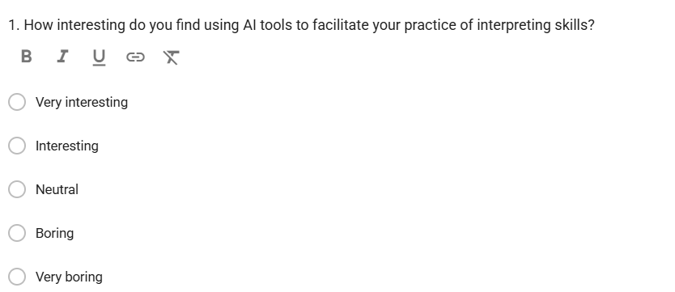
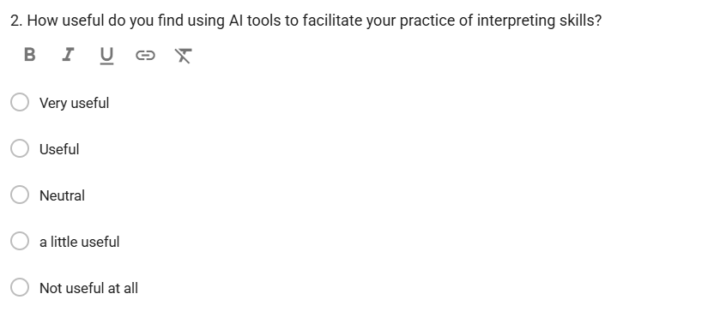
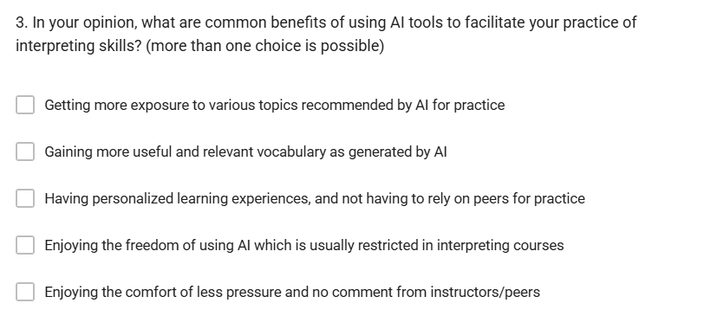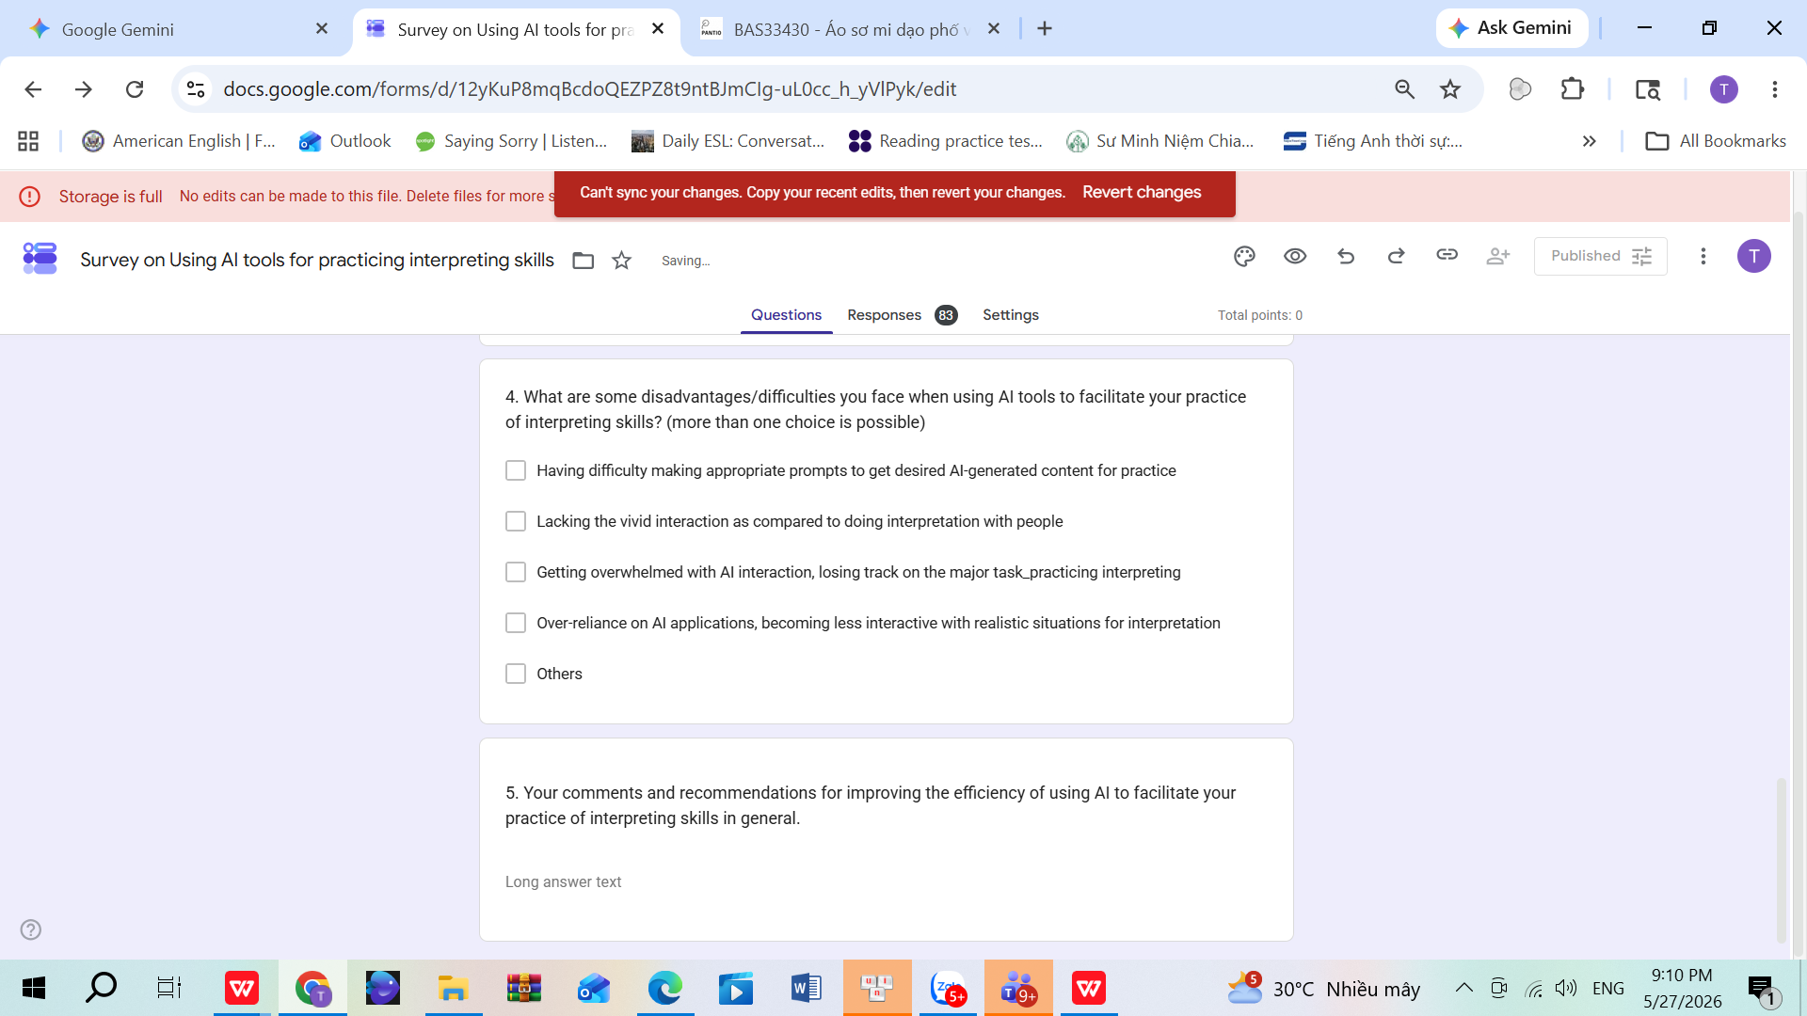
Appendix C. Interview Questions
1. In your opinion, what are some common benefits of using AI tools to facilitate your self-practice of interpreting skills?
2. What are some disadvantages/difficulties you face when using AI tools to facilitate your self-practice of interpreting skills?
3. Your comments and recommendations for improving the efficiency of using AI to facilitate your self-practice of interpreting skills in general.

Lecturer, Faculty of Foreign Languages, Ho Chi Minh City University of Foreign Languages and Information Technology (HUFLIT), Ho Chi Minh City, Vietnam

